The solution of nuclide kinetic equation for fast reactor in the OpenBPS code with options of choosing calculation method and uncertainties analysis.

I.R. BUKHTIIAROV
National Research Nuclear University “MEPHI”
Moscow, Russia
Email: van4elotti@gmail.com

I.I. DROBYSHEV
All-Russian Research Institute for Nuclear Power Plants Operation
JSC ("VNIIAES JSC")
Moscow, Russia

S.A. KARPOV
All-Russian Research Institute for Nuclear Power Plants Operation
JSC ("VNIIAES JSC")
Moscow, Russia

E.F. SELEZNEV
All-Russian Research Institute for Nuclear Power Plants Operation
JSC ("VNIIAES JSC")
Moscow, Russia

Abstract

The knowledge about fuel nuclear concentration behavior, fission product etc. both in fast reactor core and after withdrawing fuel from reactor is necessary from the point of view of nuclear safety as well as in future for fuel cycle closing up. There are a lot of methods and calculation codes in practice of burnup equation solution. Three different approaches can be identified: a solution of nuclear kinetics equation using one of the matrix exponent method, iteration method solution with ability of uncertainties analysis or direct analytical solution method.
The software with open source code OpenBurnuPSimulation (OpenBPS) provides for users a huge amount of means both for working with input data and choosing a solution method. This software is based on other open source tools and approaches for solution burnup equation accessible in literature.
The Chebyshev Rational Approximation Method is implemented in the OpenBPS for matrix exponent solution. An ability of using uncertainties analysis of the output nuclear concentration is provided by the iteration approach based on uncertainties of input, decay and nuclear cross-section data. The authors developed an analytical calculation method using modified Bateman functions (Analytical Solution of Burning Equations) for the accelerated solution of the burning equations. The calculation code ASBE was created on the basis of this method to calculate changes in the fuel concentrations during the operation of the BN-600 and BN-800 reactors. The speed of obtaining a solution in this code is more than an order of magnitude higher than the speed of obtaining a solution in programs of the iterative method with high accuracy of the solution.
The program based on open source software provides a flexible and user-friendly interface with a choice of any of the listed solution methods and has unlimited potential for using at all stages of the fuel cycle from fabrication and placement into a reactor core to assessing of the activity and residual heat release during processing and preservation of used material.

INTRODUCTION
In the global practice of writing applications for commercial use freely distributed open source programs are becoming increasingly popular [1]. This is due to the fact that such a product allows involving interested resources both in the development and testing of a ready-to-use software tool. In the practice of nuclear reactor calculations, many similar programs have also been created and made publicly available. Examples can be found on the most well-known hosting of program codes GitHub [2]. Many calculation codes along with the data are also stored on the IAEA Nuclear data site [3]. It is worth noting that among the many such programs, only a small number of programs are devoted to the actual problem for fast nuclear reactors and fuel cycle technologies, the problem of changing the nuclear composition of reactor materials before, during and after their operation.

The open-source program OpenBurnuPSimulation (OpenBPS) is designed to fill the void among freely distributed software. The program provides the user with a large number of tools both for working with input data and for choosing a solution method. The code is developed on the basis of other freely distributed tools and the approaches available in the free literature to solve the burnout problem.

OpenBPS architecture for nuclear calculations in an Opensource software environment
As mentioned earlier, OpenBPS among other things is being developed to maximize the use of programs and reactor databases that are already available in the public domain. An example of the proposed software ecosystem for conducting design reactor calculations is shown in Figure 1.

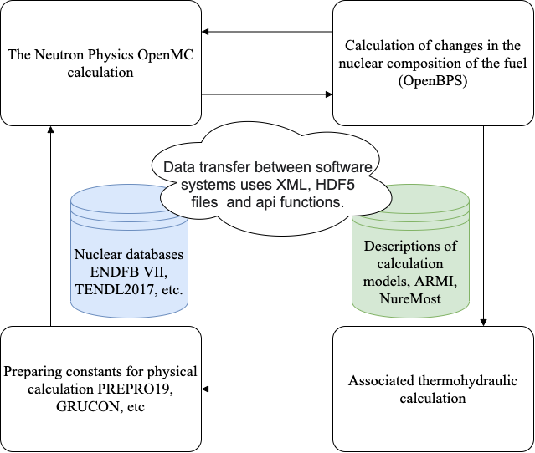

FIG. 1Example of a scheme of operation of a full-fledged reactor design calculation in a single software architecture.

Engineers can perform full-fledged reactor calculations using open source software from IAEA ONCORE initiative [4]. Data preparation in such a complex can begin with the description of the model in programs such as NuReMost [5] and ARMI[6] using the ENDFB-VII, TENDL nuclear data libraries [7]. Then, in the calculation part, PREPRO [8] can be used for preparing the constants. For a full-fledged reactor calculation, we can use both the deterministic method for solving the transfer equation and the Monte Carlo method in the OpenMC code [9]. The calculation of changes in the isotopic composition both in the reactor and in the entire fuel cycle is proposed to be carried out using OpenBPS. For the calculation of thermal-hydraulic indicators can be used OpenFOAM.

OpenBPS description and applied algorithms for solving the burnout problem
The developed OpenBPS software is set of programs based on freely distributed open source C++ and Python. It can be used for different goals starting with the preparation of source data for the nuclide kinetics problem, ending with the solution and the formation of results based on the specified sample.

According to the idea of the authors of the program, the user

- prepares input data in a standardized XML format, including a configuration file, a file with nuclide compositions of materials for calculation, a file of sections and chains. To facilitate the process of data preparation, need to use Python scripts (OpenMC etc.) that can automate the build chain directly from file with a nuclear data in format ENDFB and setting sections in the group format of the data CONSYST, TALYS, XMAS;
- specifies the calculation method (matrix exponential, iterative with/without analysis) in the configuration file;
- starts the calculation and sets the output format.

The main task of the program is to solve the system of equations of nuclide transformations, which is an inhomogeneous linear system of equations

$$\frac{dy_{i}}{dt}=\sum_{j=1}^{n}{}a_{ij}y_{j}+q_{i},(i=1,2,…,n)$$ | (1)
with an initial condition
$$y_{i}(0)=y_{i0},(i=1,2,…,n)$$ | (2)

or in matrix form
$$\frac{d\overset{→}{y}}{dt}=\overset{^}{A}\overset{→}{y}+\overset{→}{q},(A≡[a_{ij}])$$ | (3)
$$\overset{→}{y}(0)={\overset{→}{y}}_{0}$$ | (4)
with constant coefficients a_{ij} has a general analytical solution, which is the sum of any particular solution of it and the general solution of the corresponding homogeneous linear system of equations
$$\frac{dy_{i}}{dt}=\sum_{j=1}^{n}{}a_{ij}y_{j},(i=1,2,…,n)$$ | (5)
with an initial condition
$$y_{i}(0)=y_{i0},(i=1,2,…,n)$$ | (6)
The general solution has the form
$$y(t)=e^{At}y_{0},(t≥0)$$ | (7)
where the matrix function e^{At} is a matrix of size nn. It is known[4] that each square matrixsatisfies its own characteristic equation
$$F_{A}\left(A\right)=0 \text{(Cayley-Hamilton theorem)}$$ | (8)

where the spectrum of eigenvalues of a square matrix of order n coincides with the set of roots of an algebraic equation of the nth degree.

The OpenBPS software implements the most modern method of Chebyshev rational approximation (CRAM) for solving the matrix exponent. The ability to analyze the uncertainty of the obtained nuclear concentrations is provided by the iterative method, considering the errors of the initial, decay, and cross-section data, implemented on the basis of the exponential representation of the increment of the nuclide concentration at the calculated step (BPSE). To accelerate the solution of the burn-up equations for the chains of transitions between nuclides of fixed length, the authors are developing an analytical calculation method based on the use of modified Bateman functions ASBE (Analytical Solution of Burning Equations).

CRAM
One of the methods implemented in the program is the Chebyshev rational approximation algorithm or CRAM, introduced by Maria Puza in 2011[10] and also included in one of the modern versions of the ORIGEN program[11]. There are two main considerations for the matrix exponent (A) in terms of its eigenvalues. Firstly, one estimate of the matrix A usually has eigenvalues in the range λ ∈ [-1021, 0]. Secondly, the matrix A is usually quite sparse, about 0.2%. The basis of the algorithm is the approximation of the matrix exponent via the fractional-rational function r_{k,k}(x) in the complex plane, based on the application of Cauchy's theorem to the matrix exponent function.

The Chebyshev Rational Approximation Method (CRAM) is a relatively simple algorithm. It was found that 𝑟^_{𝑘,𝑘}(𝑥) minimizes the maximum error in respect of the scalar exponent along the negative real axis determined by the equation (9), where 𝜋_{𝑘,𝑘}is the set of all rational functions with numerator and denominator 𝑘. As 𝑘 increases, the accuracy of the approximation also increases.

$$\sup_{x∈R_{-}}|{\overset{^}{r}}_{k,k}(x)-e^{x}|=\inf_{r_{k,k}∈π_{k,k}}\{\sup_{x∈R_{-}}|r_{k,k}(x)-e^{x}|\}$$ | (9)

If the function 𝑟^𝑘, 𝑘(𝑥) is known, it can be rebuilt for further cost reduction or numerical stability improvement. The partial fraction (NPF) form shown in Equation (10) is a good combination of numerical stability and efficiency. The values 𝛼_{𝑙}and 𝜃_{𝑙} are available for different values 𝑘 up to 48. In the form of the LPF, only sparse matrix solutions are needed to calculate operations on vectors.
$${\overset{^}{r}}_{k,k}(x)=α_{0}\prod_{l=1}^{k/2}{(1+2R\{\frac{{\overset{\sim }{α}}_{l}}{x-θ_{l}}\})}$$ | (10)
As any other approximation, CRAM has a number of advantages and disadvantages. The Chebyshev Rational Approximation Method (CRAM) is a relatively simple algorithm. CRAM is both efficient and highly accurate. However, eigenvalues with large imaginary components or positive real components will reduce the accuracy. One of the advantages is the weak dependence of the result obtained on the value of the time step or several time steps. Also, as the dimension of the problem increases, the execution speed increases in proportion to the number of elements in the first degree, and not in the quadratic one, as, for example, for the iterative method. As for the disadvantages of CRAM it is not recommended to use it in problems with highly fluctuating values or problems with possible exponential growth, such as reactor dynamics. Also, isotopes with a low concentration and a small half-life value may have negative numbers in the solution.

Iterative solution method
The essence of the method is finding a solution with the knowledge of the derivative, i.e., in fact it is the Euler method[12]. This method with linear approximation is implemented in programs of the BPS series[13], where the solution is determined iteratively with a linear time representation of the concentration increment
$$y_{n}^{k}(τ)=y_{n-1}^{k}(τ)+\sum_{m_{n}≠k}{}\frac{λ^{m_{n}→k}}{λ^{m_{n}}}\frac{1-e^{-λ^{k}τ}}{λ^{k}τ}{(1-\frac{1-e^{-λ^{k}τ}}{λ^{k}τ})}^{n-1}\prod_{j=1}^{n-1}{(\sum_{m_{j}≠k}{}\frac{λ^{m_{j}→k}}{λ^{m_{j}}})}dy_{0}^{m_{1}}$$ | (11)
where n is the number of iteration steps, τ is the the time step, k is the nuclide index,$λ^{m}$ half-life ofm nuclide

$$\left|y_{n}^{k}-y_{n-1}^{k}\right|≤ε, \text{for all }"k"$$ | (12)
The iterative process ends according to some law, for example, by performing an inequality for all “k”, (12) where ε is the maximum allowable deviation of the nuclide concentrations at two adjacent iterations. This method provides an estimate of the error of the solution based on an estimate of the error of the input data (reaction rates, neutron cross sections, source, etc.):
$\begin{aligned}δy_{0}^{k}(τ)=y^{k}(0)e^{-λ^{k}τ}[\frac{δy^{k}(0)}{y^{k}(0)}+λ^{k}τ(\frac{δτ}{τ}+\frac{δλ^{k}}{λ^{k}})] \\ +q^{k}τ\{\frac{δq^{k}}{q^{k}}\frac{(1-e^{-λ^{k}τ})}{λ^{k}τ}+[\frac{(1-e^{-λ^{k}τ})}{λ^{k}τ}\frac{δλ^{k}}{λ^{k}}+\frac{e^{-λ^{k}τ}}{λ^{k}}(\frac{δτ}{τ}+\frac{δλ^{k}}{λ^{k}})]\}\end{aligned}$ | (13)
where q is the external neutron source, $δy_{}^{}$is the uncertainty of nuclear concentration, $δλ^{}$ is the uncertainty of half-life.

The main advantage of the method is the possibility of obtaining an estimate of the uncertainty in the main cycle of solving a system of equations. However, there are also disadvantages, since the algorithm is sensitive to the choice of the time step τ and the speed of obtaining a solution depends on the N-dimension of the matrix as N².

ASBE
An algorithm for the analytical solution of a system of equations of nuclide kinetics with a complete transition matrix, perhaps the first algorithm for solving the burnout problem, was proposed in 1910 by Bateman [14] using the Bateman functions of the first order
$b_{i}\left(t;λ_{1},λ_{2},…,λ_{i}\right)=\sum_{j=1}^{i}{ }d_{j}e^{-λ_{j}t}$ | (14)

of the second order
$$B_{i}\left(t;λ_{1},λ_{2},…,λ_{i}\right)=\sum_{{j=1 \atop j≠l,m}}^{i}{ }d_{j}\frac{1-e^{-λ_{j}t}}{λ_{j}}-\left(\sum_{{j=1 \atop j≠l,m}}{ }d_{j}\right)\frac{1-e^{-λ_{l}t}}{λ_{l}}+\frac{\prod_{j=1}^{i-1}{ }λ_{j}}{\prod_{{j=1 \atop j≠l,m}}^{i}{ }\left(λ_{j}-λ_{l}\right)}\frac{1}{λ_{l}}\left(\frac{1-e^{-λ_{l}t}}{λ_{l}}-{te}^{-λ_{l}t}\right)$$ | (15)
where
$$\begin{aligned}&d_{j}=1,(i=j=1) \\ &d_{j}=\frac{\prod_{k=1}^{i-1}{ }λ_{k}}{\prod_{{k=1 \atop k≠j}}{ }\left(λ_{k}-λ_{j}\right)},(i≥2,j=from1-toi)\end{aligned}$$ | (16)
Today, the most famous software based on this method in the world is the DCHAIN program [15]. This program shows the most accurate solutions, including the first seconds of the burnout process.

The algorithm of the analytical solution has problems due to the presence in the denominator of the solution of the difference in the decay rates of nuclides, since some of the nuclides have the same decay rates. This problem, according to [15], is circumvented by the representation of the ratio of the difference of exponents with the same exponents divided by the difference of these exponents by the value of the duration of the time interval under consideration, which is correct mathematically. But this algorithm has not previously considered this problem for the next nuclides in the chain after these two, and for them the solution is no longer represented by the specified functions. In addition, in this algorithm, there is a problem of using such a solution when considering cyclic chains [15].

The solution algorithm for the created program for calculating the burnout of actinides and fission fragments (Analytical Solution of Burning Equation (ASBE)) is based on the analysis of the physical process of decays in nuclide chains and, in the absence of singularities, coincides with the solution based on the modified Bateman functions (17).
$$\begin{aligned}y_{i}(τ)=y_{i}^{0}(τ)+\sum_{n=1}^{i-1}{(\prod_{j=1,n}{}\frac{λ^{j→j+1}}{λ^{j}})}\{y_{n}(0)\sum_{j=1}^{n}{}\frac{\prod_{k=1}^{n}{}λ^{k}}{\prod_{{l=1 \atop l≠k}}^{n}{(λ^{l}-λ^{k})}}(e^{-λ^{j}τ}-e^{-λ^{i}τ}) \\ +\sum_{n=1}^{i-1}{}q_{n}(0)[\frac{(1-e^{-λ^{i}τ})}{λ^{i}}-\sum_{m=1}^{n}{}\frac{\prod_{j=1}^{n}{}λ^{j→j+1}}{λ^{m}\prod_{{j=1, \atop j≠m}}^{n}{(λ^{j}-λ^{m})}}(e^{-λ^{m}τ}-e^{-λ^{i}τ})]\}\end{aligned}$$ | (17)
Analysis of the physical process of nuclide decay in the presence of features related to the characteristics of the decay rates of other nuclides in the chain provides individual solutions for each of the nuclides in the chain that are not Bateman functions.

This algorithm has sufficient speed in obtaining a solution, but the automatic construction of transition chains is extremely difficult for large-dimensional problems. The application of this solution method is assumed only for a fixed set of chains.

OpenBPS verification and validation
The main purpose of OpenBPS verification and validation is to apply the code to the problems relevant for fast reactors and closed fuel cycle technologies. The changes in nuclear concentrations over time were calculated for the following three tests:
- "flash" experiment to determine the residual energy release after irradiation in the fast neutron spectrum of a sample of ²³⁸U[16];
- benchmark model of the MOX fuel reactor MOX3600[17];
- fuel burnout in the BN600 nuclear reactor[12];

Lowell Residual Heat Measurement Experiment (University of Massachusetts)
At the University of Massachusetts, Lowell spectrometrically measured the gamma and beta residual heat release at ²³⁸U fission for an exposure time of approximately 0.2 to 40,000 seconds after. The experiment belongs to the class of" pulse " experiments. Fast neutrons from a 1 MW basin-type research reactor were used for fission in ²³⁸U. The gamma-ray spectrometer consisted of 5 x 5 inches NaI (Tl) scintillation detectors operating in a matching pattern with a thin beta detector. The beta spectrometer consisted of 3 x 3 inches of plastic scintillation detectors on the surrounding thin scintillator surfaces. The detectors covered the energy range from 0.1 to 8 MeV.
The measured gamma and beta spectra were unfolded using an energy reaction function detector to obtain the actual energy spectra, from which the average energies and total heat release were derived.
The calculations were performed using CRAM and iterative methods. The results of the calculation indicate a good coincidence of the residual energy release for the predominant fuel isotope of the fast reactor ²³⁸U with the experiment and are shown in Figure 2.
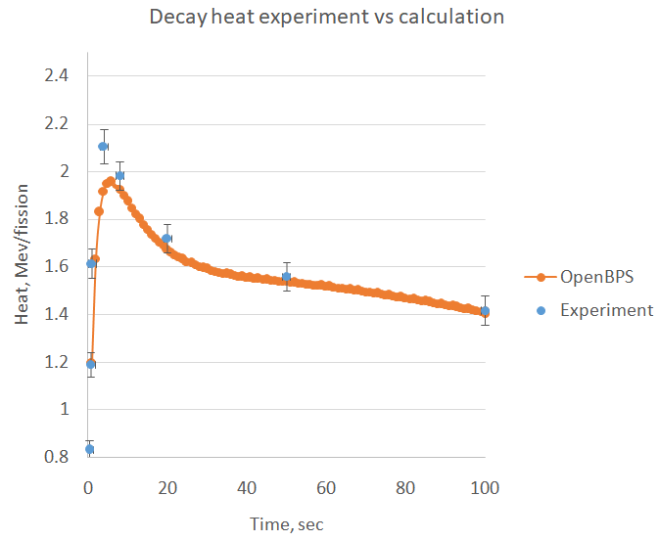
FIG 2. The results of the calculation of the "pulse" experiment to determine the residual energy release of 238U by OpenBPS compared to the experiment for first 100 second

Benchmark model of the MOX3600 fast reactor
SFR MOX-3600 is a benchmark proposed by the French research institute (CEA Cadarache) in the framework of the international forum "Generation IV" [17]. It describes a model of a fast neutron reactor with a thermal capacity of 3600 MW with a sodium coolant and an oxide fuel.

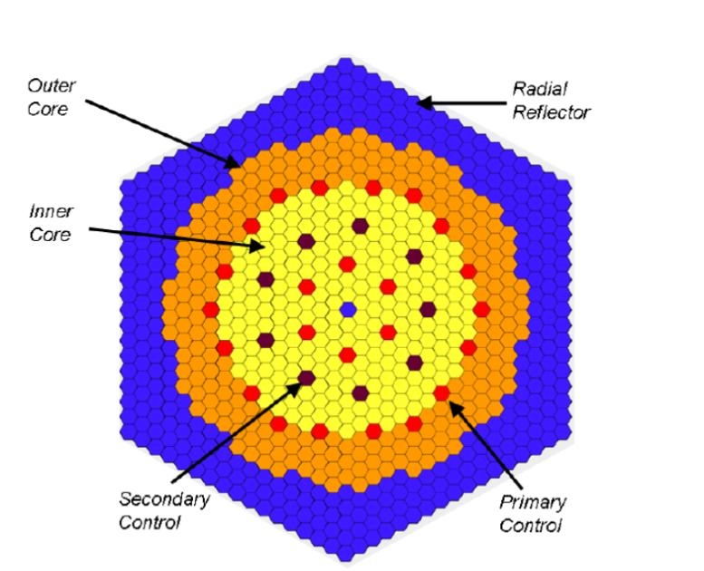
FIG 3. SFR MOX-3600 loading cartogram
The core consists of 453 fuel assemblies (of which 225 are in the central part, 228 are in the periphery), 330 side reflector assemblies and 31 control rods (24 main and 9 auxiliary). In the benchmark fuel zones are profiled by ten compositions. The calculation was carried out using the Monte Carlo reactor calculation method in the OpenMC code with OpenBPS depletion code during 410 effective days. In table 1 is shown a good level of agreement of the results obtained by OpenMC + OpenBPS in a value of effective multiplication factor relatively benchmark average values results. Meantime is provided deviations of nuclear concentration calculation results of OpenMC and OpenBPS for all ten zones.
TABLE 1. OPENMC AND OPENBPS BENCHMARK “MOX3600” CALCULATION RESULTS IN THE CORE EIGENVALUE AND NUCLEAR CONCENTRATION DEVIATIONS.
К_{eff} | Deviation OpenMC + OpenBPS/benchmark, %
Begin of cycle | 0.00
End of cycle | 0.65
Nuclear concentration for fuel zones | Deviation OpenBPS/OpenMC.%
Material №1  inner core | 4.42Е-4
Material №2  inner core | 3.83Е-4
Material №3  inner core | 7.94Е-4
Material №4  inner core | 9.35Е-4
Material №5  inner core | 8.27Е-4
Material №1  outer core | 1.16Е-4
Material №2  outer core | 1.93Е-4
Material №3  outer core | 7.25Е-4
Material №4  outer core | 1.20Е-3
Material №5  outer core | 7.21Е-4

BN-800 reactor model
To test the operation of the new algorithm, a comparison was drawn with the results of the calculation of the fuel assembly of the BN-800 nuclear reactor located at the site of the Beloyarsk Nuclear Power Plant (BAES), with the standard calculation for the GEFEST800 complex [12].
PC GEFEST800 is a software tool for supporting the operation of neutron-physical calculations, including solving the problem of nuclear isotope burnout in the BPS module. The BPS module solves the nuclide kinetics problem using an iterative method implemented in this paper as an option of the OpenBPS code. The transition matrix is compiled on the basis of the Brookhaven National Laboratory (BNL) decay data for the 1819 nuclide [20-21]. For comparison, two compositions with fissile material were selected. The first is the most energetically stressed fuel high-altitude layer of the assembly. The second one corresponds to the nuclide composition of the end zone of reproduction with depleted uranium for the same assembly. The calculation was made for 30 effective days, as shown in [12]. For the OpenBPS calculation, a chain based on the estimated ENDFbvVII.1 Los Alamos National Laboratory (LANL) nuclear data for 3819 nuclides was used. Since the iterative method is already implemented and is used in GEFEST, the Chebyshev method of the 16th order decomposition of the matrix exponent was chosen for comparison Table 2.

TABLE 2. Calculation result of nuclear concentrations AND UNCERTAINTies caused by UNCERTAINTy of THE HALF-life FOR FUEL AND FERTILE NUCLIDE COMPOSTIONS
Material |  | Fertile | Fuel
Nuclide | GEFEST/BPS-1561 nuclides BNL | OpenBPS-3819 nuclides. ENFB-VII | The uncertainty of the world constant, %
U235 | 0.036% | 0.055% | 0.002%
U236 | 0.648% | 0.059% | 0.062%
U238 | 0.002% | 0.000% | 0.002%
Pu239 | 1.162% | -0.067% | -0.013%
Pu240 | 1.539% | -0.243% | 0.070%
Pu241 | 1.803% | 0.091% | 0.068%
Pu242 | 2.930% | 0.142% | 0.089%
Pa231 | 1.186% | -0.034% | 0.036%
Np239 | 0.509% | 0.000% | 0.002%
Am241 | 2.125% | 0.174% | 0.053%
Am243 | 5.070% | -0.518% | -0.878%
Cm246 | 13.424% | -0.212% | -0.684%
Ge70 | 0.000% | -0.417% | -6.108%
Ge72 | 0.000% | -5.589% | 0.570%
Kr83 | 0.000% | 0.085% | 0.009%
Rb87 | 0.000% | -0.293% | -0.260%
Y89 | 0.000% | -0.084% | -0.268%
Sr90 | 0.298% | 0.231% | 0.356%
Y90 | 0.575% | -1.080% | -5.753%
Nb94 | 21.622% | -5.437% | 0.545%
Tc97 | 20.250% | -30.425% | -16.209%
Tc99 | 1.825% | 0.035% | 0.488%
Mo100 | 15.635% | 0.206% | 0.124%
Ru106 | 1.407% | -0.424% | 0.427%
Cs133 | 0.000% | 0.242% | 0.583%
Xe136 | 0.000% | -0.232% | -0.400%
Ba138 | 0.000% | -0.015% | 0.017%

The results obtained for OpenBPS, despite the use of a fundamentally different decay chain and solution method, are in satisfactory agreement with the results of calculations using the standard software tool and do not exceed the uncertainty in the half-life value.

Conclusion
The OpenBPS code is designed as an opensource software product that based on opensource tools and shared on GitHub [19]. The documentation is available on the read the docs website [20]. The program provides the user with a set of options for preparing the initial task, manipulating the nuclear data and constants, selecting the method to solve and filtering the result. The OpenBPS verification results indicate that the code can be applied at all stages of the fuel cycle, including operation in a fast neutron spectrum reactor.
References
- Thakker Dharmesh, Schireson Max, Nguyen-Huu Dan. Tracking the explosive growth of open-source software(2017), https://techcrunch.com/2017/04/07/tracking-the-explosive-growth-of-open-source-software/
- Linksvayer Mike Open innovation will be the winning strategy for digital sovereignty and human progress in the new decade (2021), https://github.blog/2021-03-22-open-innovation-winning-strategy-digital-sovereignty-human-progress/
- IAEA Nuclear Data and Codes (2021), http://www-nds.org.in
- Open-source Nuclear Codes for Reactor Analysis (2021), https://nucleus-new.iaea.org/sites/oncore/SitePages/List%20of%20Codes.aspx
- Bartra C, Krivintsev V. et al., “Nuclear reactor modelling and simulation toolkit (nuremost) –numerical reactor model configuration system with interface to simulation codes”, Fast Reactors and Related Fuel Cycles: Next Generation Nuclear Systems for Sustainable Development FR17 (Proc. Int. Conf., Yekaterinburg, 2017), IAEA, Vienna (2018), Paper CN245-0.
- Chadwick M.B. et al, ‘ENDF/B-VII.0: Next Generation Evaluated Nuclear Data Library for Nuclear Science and Technology’ , Volume 107, Issue 12, December 2006, Pages 2931-3060
- Koning A.J., Rochman D., J.-Ch. Sublet, N. Dzysiuk, M. Fleming, S. van der Marck, "TENDL: Complete nuclear data library for innovative nuclear science and technology", Volume 155, January 2019, Pages 1-55.
- Cullen Dermott E. PREPRO 2019 (2019), http://redcullen1.net/HOMEPAGE.NEW
- Romano Paul K., Horelik Nicholas E., Herman Bryan R., Nelson Adam G., Forget Benoit, and Smith Kord, “OpenMC: A State-of-the-Art Monte Carlo Code for Research and Development,” Ann. Nucl. Energy, 82, 90–97 (2015).
- ISOTALO A., PUSA M. Improving the accuracy of the Chebyshev rational approximation method (CRAM) by using substep. PO. Box 14100 FI-00076 AALTO Finland, 22p, 2015.
- ORIGEN-S: SCALE system module to calculate fuel depletion, actinide transmutation, fission product buildup and decay, and Association source terms, NUREG/CR-0200.-Revision 4.-Vol.2, Section F7.-[S.1], 1995
- Seleznev E.F. Fast breeder reactor kinetics, M., Science, 2013, 240p
- Seleznev E. F., Belov A. A. SOLUTION OF NUCLIDE KINETICS PROBLEM WITH FULL MATRIX OF NUCLIDES, Energetika - 2013, - No. 3, pp. 27-40
- Bateman H.: Proc.Cambridge Phil.Soc.15, 15, 423 (1910)
- Tasaka K.: “DCHAIN: Code for Analysis of Build-up and Decay ofNuclides”, JAERI 1250 (1977)
- P.-I. Johansson, "Integral Determination of the Beta and Gamma Heat in Thermal- Neutron-Induced Fission of 235U and 239Pu, and of the Gamma Heat in Fast Fission of 238U", pp. 857-860 in Proceedings of the Specialists Meeting on Nuclear Data for Science and Technology, Mito, Japan, 1988
- Benchmark for Neutronic Analysis of Sodium-cooled Fast Reactor Cores with Various Fuel Types and Core Sizes. OECD NEA/NSC/R(2015)9, 85p.
- Bukhtiyarov I.R., Artemieva A.B.,Saifullin D. R., Ivanushkina K. A. ‘SOLVING NUCLIDE KINETICS EQUATIONS USING THE OPENBOX COMPLEX’, Student(2020), Vol 3, No 10, p.235
- The OpenBPS source code (2021), https://github.com/FastReactor/OpenBPS
- The OpenBPS (Open source code of BurnuP Simulation) documentation (2021), https://openbps.readthedocs.io/en/latest/

