Safety Analysis of Small Modular Sodium Fast Reactors in Anticipated Transients Without Scram Scenarios

Xin JIN
School of Nuclear Science and Engineering, Shanghai Jiao Tong University
Shanghai, China

Kuaiyuan FENG
School of Nuclear Science and Engineering, Shanghai Jiao Tong University
Shanghai, China

Hui GUO
School of Nuclear Science and Engineering, Shanghai Jiao Tong University
Shanghai, China
Email: hui.guo@sjtu.edu.cn

Hanyang GU
School of Nuclear Science and Engineering, Shanghai Jiao Tong University
Shanghai, China

Abstract

The small modular sodium-cooled fast reactor (SFR) is an important component of Generation-IV reactors. For SFR, one type beyond design basis accidents (BDBA) that has received special attention is the anticipated transients without scram (ATWS) events including unprotected loss of coolant flow (ULOF) accident, unprotected loss of heat sink (ULOHS) accident, and unprotected transient overpower (UTOP) accident. The modular design for multiple purposes and remote region operation requires usually a very infrequent refueling strategy. During a long-lived operation, the neutronic characteristics of SFR core, for instance, the coolant void effect and the Doppler effect, vary and hence the reactor safety performance in ATWS events. The paper focuses on the analysis of safety performance of a 300 MW(th) small modular MOX SFR from its beginning of life (BOL, 0 GW∙d/tHM) to its end of life (EOL, 75 GW∙d/tHM). The burnup calculation is conducted by using Monte-Carlo code OpenMC with pin-by-pin depletion mesh. The elementary reactivity feedback coefficients are compared at different burnup depth. The transient behavior is simulated by using the mono-channel point kinetic system code dedicated to fast reactors. The inherent reactivity feedback mechanism in ATWS is classified and discussed. Based on the results above, some suggestions or measures for reactor designing are proposed in the view of mitigation of the ATWS impact and the inherent safety performance for a long operating lifetime.

INTRODUCTION
Fast neutron reactors have the flexibility to operate either as a breeder to achieve the net creation of fissile fuel or operate as a transmuter to convert nuclear fission products and long-lived minor actinides [1]. Therefore, three fast neutron reactor systems have been selected by the Generation IV International Forum (GIF) for further research and development, in which the sodium-cooled fast reactor (SFR) is by far the most tested and promising candidate system [2–4].
Important efforts have been devoted to developing the small modular sodium-cooled fast reactor (SMSFR), in order to reduce the impact of capital costs and achieve multiple purposes [5–7]. On some occasions, such as power supply in remote regions, the non-refuelling strategy is pursued by SMSFR for optimizing the system economy and operability [8, 9]. During a long-lived operation, neutronic characteristics of SMSFR core, for instance, the coolant void effect and the Doppler effect, vary and the impact on the intrinsic safety behaviour of SMSFR core should be evaluated [10, 11]. The anticipated transient without scram (ATWS) [12] event refers to an event in which initiator occurs, but the plant protective system of the SFR fails to function. It has been demonstrated that a properly designed SFR can survive ATWS without damage to the fuel or other barriers to radiation release [1]. Given that ATWS transient safety analysis is the base of design and safe operation of fast reactors, it is necessary to evaluate the safety performance of the SMSFR in ATWS events during the whole lifetime with the change of neutron characteristics [13].
The paper is based on a 300 MW(th) small modular MOX SMSFR in non-refuelling operation strategy, from its beginning of life (BOL, 0 GW∙d/tHM), to its end of life (EOL, 75 GW∙d/tHM). Details of the SMSFR model, the method for burnup calculation and safety performance simulation are presented in Section 2. Section 3 discusses the results of the simulation in ATWS, in which the influence of the fuel burnup, the control rod positions are investigated. The conclusion is given in Section 4.

Models and Calculation tools

SMSFR core description
The SMSFR studied in this work is a 300 MW(th) sodium fast reactor loaded with MOX fuel. The configuration of the core is illustrated in Fig.1. The assembly pitch is 13.4 cm. Two different plutonium content zones, 66 inner core assemblies and 84 outer core assemblies, are used to optimize the power distribution.

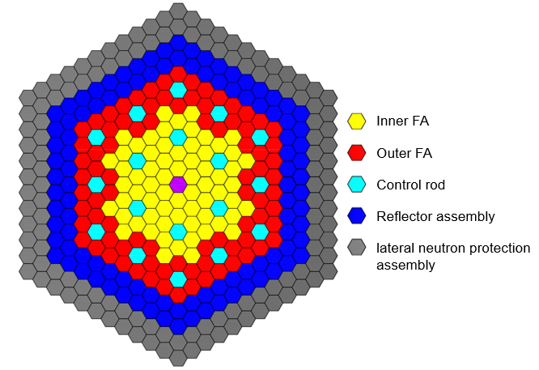
Fig.1. Core configuration of SMSFR
The main characteristic of SMSFR is presented in Table 1. The total irradiation time of fuel is 1825 equivalent full power days (EFPD). The average power density in the fissile zone is 151 W/cm³ corresponding to an average linear heat rating of 185 W/cm in fuel pins.

TABLE 1. Main characteristics of SMSFR
Core power | 300 MW(th)
Fuel irradiation time | 1825 EFPD
Fuel assembly number (C1|C2) | 66 | 84
Fuel type | MOX fuel
Primary coolant | Sodium
Plutonium content (C1|C2) | 21.96% |26.87%
Core volume (fissile|fertile) | 1.983 m³ | 0.45 m³
Average power density in fissile zones | 151 W/cm³
Average linear heat rating | 185 W/cm
Control rod assembly number | 18
Absorber material | B₄C in 90%¹⁰B

Neutronic calculation
To simulate the neutronic characteristic of SMSFR reactor, a community-developed Monte Carlo neutron and photon transport simulation code OpenMC is adopted [14–16]. OpenMC is designed as an extensible code for Multiphysics modeling and a scalable parallel algorithm for high-performance computers.
The SMSFR OpenMC neutronic model is described in Fig. 2. The geometry of fuel assemblies (FAs), control rods (CRs), and reflector assemblies are exactly depicted in a pin-by-pin way. The cross-section library ENDF-B-VII.1 is used. The reactivity feedback and the axial power density distribution are calculated by OpenMC and inserted into the mono-channel point kinetic system code.

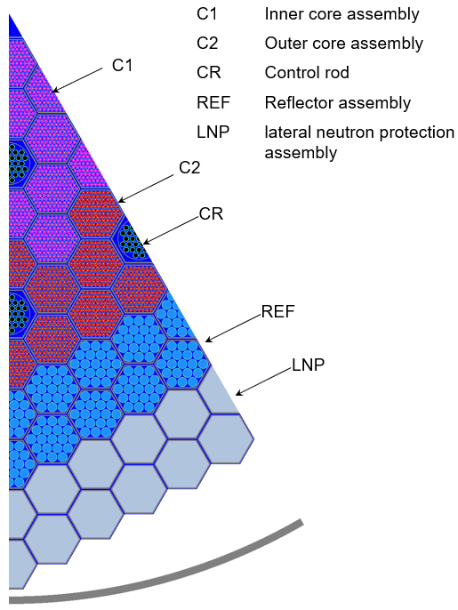
（a） 1/12th core geometry | (b) Longitudinal section view of depletion structure
Fig. 2. Cross-sections of SMSFR OpenMC model
As shown in Table 2, with the deepening of fuel burnup in reactor, the temperature coefficient of different reactivities shows different trends. Among them, the obvious one is the coolant expansion coefficient turns from negative to positive with fuel burnup. Meanwhile, the Doppler constant decreases with the increase of fuel burnup, standing for a decreasing negative feedback. It could be seen that with the control rod upshifting to satisfy different excess reactivity control requirements along lifetime, the differential worth of the control rod declines.
TABLE 2. Core kinetics of SMSFR
Core power | BOL | MOL | EOL
Time (EFPD) | 0 | 912.5 | 1825
Average fuel burnup (GW∙d/tHM) | 0 | 37.5 | 75
Insertion depth (cm) | 55 | 35 | 0
Differential worth of control rod (pcm/cm) | 256 | 216 | 25
Core excess reactivity (pcm) | 9173 | 4263 | 0
Coolant expansion coefficient (pcm/K) | -0.05 | 0.01 | 0.07
Structure expansion coefficient (pcm/K) | 0.05 | 0.06 | 0.07
Diagrid expansion coefficient (pcm/K) | -0.91 | -0.93 | -0.97
Axial fuel expansion coefficient (pcm/K) | -0.13 | -0.14 | -0. 16
Doppler constant (pcm) | -628 | -572 | -565

Summary of ATWS events
In this work, the ATWS event is investigated to obtain insights into the intrinsic safety behaviour of SMSFR. Given a steady-state condition in which the rate of heat generation is just balanced by the rate of heat removal, a damaging condition could arise due to an increase in the heat generation term, or due to a loss of heat removal term [1]. Hence, the ATWS event representative for the safety analysis of SMSFR could be identified as follows,
- Unprotected transient over power (UTOP), in which a reactivity insertion may be caused by an uncontrolled withdrawal of a single control rod, fuel assembly flow blockage, or core compaction [17]. Meanwhile, the primary circulation pumps as well as secondary circuits work normally.
- Unprotected loss of flow transient (ULOF), in which the transient is initiated by the loss of primary pumps, but the secondary circuits remain operation in forced circulation [18].
- Unprotected loss of heat sink transient (ULOHS). The transient could be initiated by the failure of secondary sodium pumps, secondary system piping, steam generators, and decay heat removal systems.
This paper use a mono-channel point kinetic system code for fast reactor to simulate the transient behaviour of the primary circuit. The accuracy of this homemade code should be further validated. During the transient simulation, the CR adjustment is not considered The boiling and freezing point of coolant are 880 ℃ and 98 ℃ in the SMSFR analysed. Based on the plutonium enrichment of fuel in the core, the melting point of MOX fuel is calculated as 2703 ℃ [19], while the cladding temperature should be less than 1427 ℃ under ATWS condition and 550 ℃ under normal condition, considering the choice of 316 stainless steel as cladding material [1].

Results and Discussion

UTOP event analysis
In the UTOP transient, an abrupt reactivity insertion of 250 pcm in 10 s is simulated with the reactor scram assumed to fail. Meanwhile, the primary and secondary circuits remain in the normal operation of forced circulation. This hypothetical event is used to compare the reactor behaviour at different burnup depth.
As can be seen in Fig. 3(a), the total reactivity of the core restores balance under the negative feedback effect brought by its inherent properties, after experiencing a positive pulse of 60 pcm. In Fig. 3(a), “Ext.” refers to external reactivity insertion; “Doppler” refers to reactivity brought by the Doppler effect of fuel; “coolant” stands for the reactivity caused by changing of sodium density in the whole assembly height; the “axial fuel Exp.”, “clad Exp.”, as well as “Dia. Exp.” refers to the reactivity derives from the expansion of fuel, cladding and diagrid at the lower positon of assemblies correspondingly, and the “ctr. Exp.” refers to the reactivity feedback due to the relative displacement between control rods and the fuel fission zone. Among these reactivity feedbacks, the major contribution comes from the reactivity of “Doppler” and “Ctr. Exp.”.
Fluctuations of total reactivity lead to changes in the core power, temperature of coolant, as well as fuel pellet and cladding (shown in Fig. 3(b)). The simulation results show that under the limitation of inherent properties, no sodium boiling, cladding melting and fuel melting accidents occur in the core (with the coolant temperature 691 ℃ in the hottest channel and peak fuel temperature 2154 ℃).
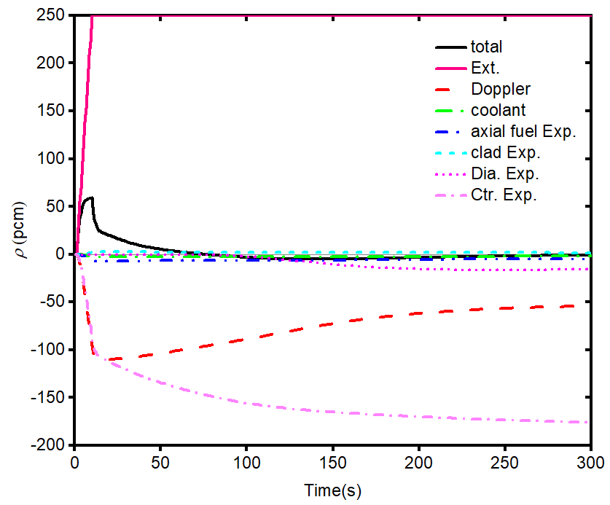 | 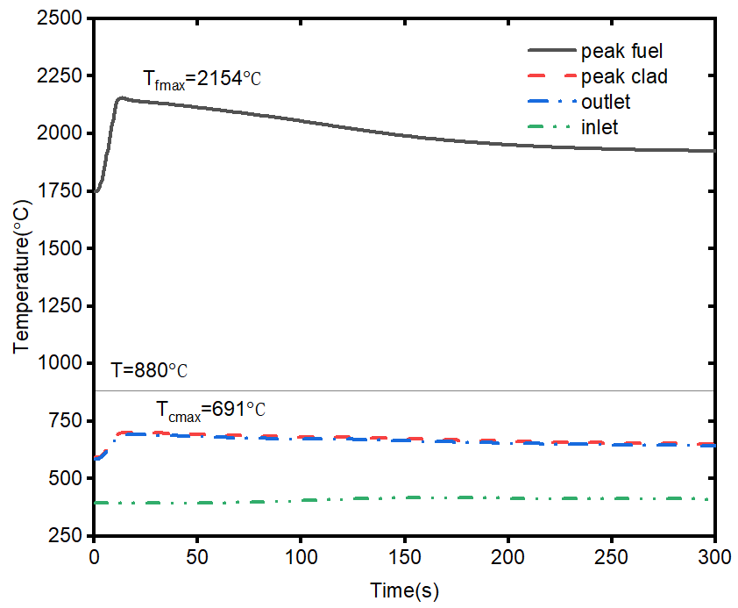
- Reactivity feedback | - Temperatures of coolant, fuel and cladding in the hottest channel
Fig. 3. Results for UTOP at BOL
The variation of core power over UTOP transient at different core life time shown in Fig. 4(a) indicates that the deeper the reactor burnup, the lager the core power peak value caused by the same reactivity insertion. Considering that control rods have been fully withdrawn from the core at EOL, it is assumed that the UTOP event is caused by the other causes described in 2.3 (a) at EOL. As mentioned earlier, the dominant feedbacks are that caused by “Doppler” and “Ctr. Exp.”. The reactivity of the Doppler effect is mainly related to the Doppler constant (K_{Doppler}) and change of fuel temperature (Equation 1) [20].
(1)
Although the Doppler constant decreases with the increase of fuel burnup (as shown in Table 2), the significant increase in the range of fuel temperature change over UTOP (shown in Fig. 4 (b), in which Δt_{max}=768 ℃ at 1825 EFPD vs. Δt_{max}=407 ℃ at 0 EFPD) still makes the negative feedback caused by the Doppler effect increase as fuel burnup deepens (shown in Fig. 4 (c)).
When considering the reactivity feedback caused by the “Ctr. Exp.”, it is noticed that the insertion depth of the control rod gradually decreases to compensate for burnup reactivity. This leads to differences in the reactivity feedback caused by the differential value of control rods: a small depth increase at BOL has a much greater negative reactivity feedback than that at EOL. This result is clearly shown in Fig. 4(d). This is the main reason for the increase of reactivity fluctuation with the deepening of fuel burnup.
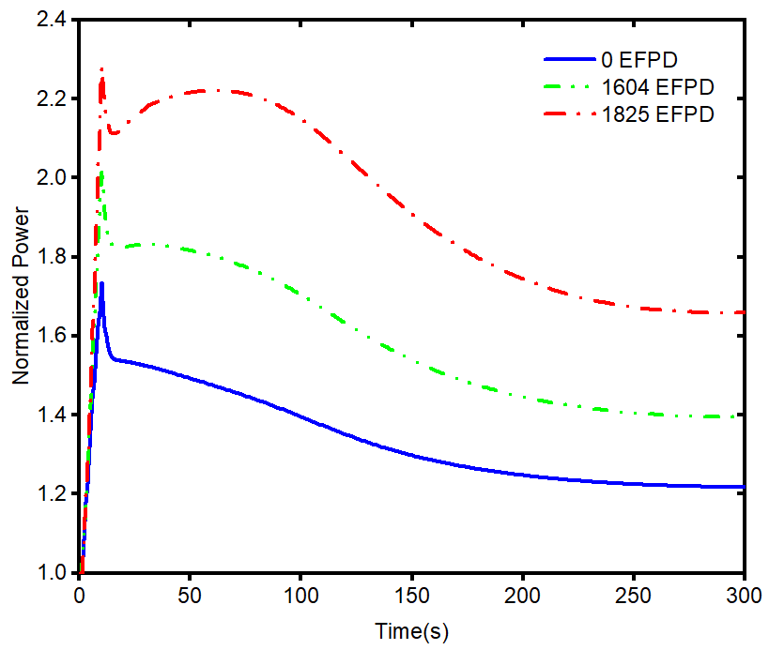 | 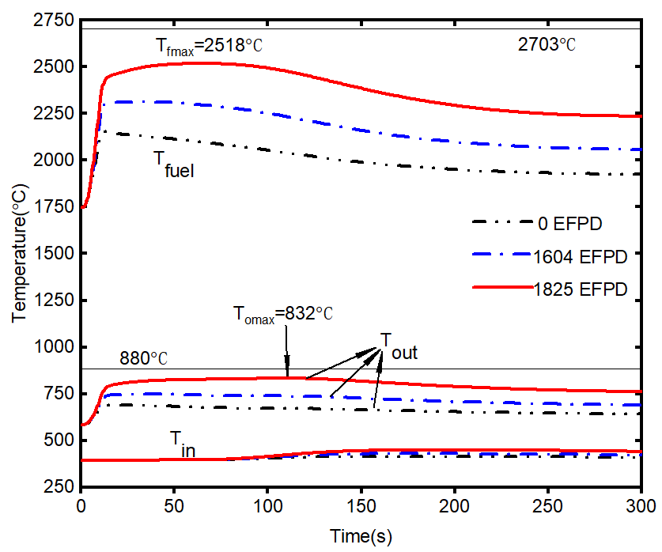
- Normalized core power | - Temperature of fuel, coolant in the hottest channel
- Doppler reactivity feedback | - Reactivity feedback
Fig. 4. Results for UTOP with lifetime (EFPD)
In order to clarify the safety performance of the core under various reactivity insertions during lifetime, the maximal fuel and coolant temperature at BOL and EOL are compared here. To avoid local boiling and fuel cladding melting accidents, there is an upper limit on the positive reactivity insertion into the core. When reactivity is inserted into the SMSFR accidentally, the effect of reactivity feedback due to the relative displacement of control rods could be seen in Fig. 5. It can be seen in Fig. 5(a) that the reactivity insertion allowed at EOL (225 pcm) is lower than that at BOL (250 pcm). Considering the effect of the reactivity feedback due to the relative displacement of control rods (in Fig. 5(b)), the allowable reactivity insertion value increases, especially at BOL: 550 pcm at BOL and 280 pcm at EOL, respectively. It should be noted that the temperature limitation in the graph didn’t take any safety margin into account.
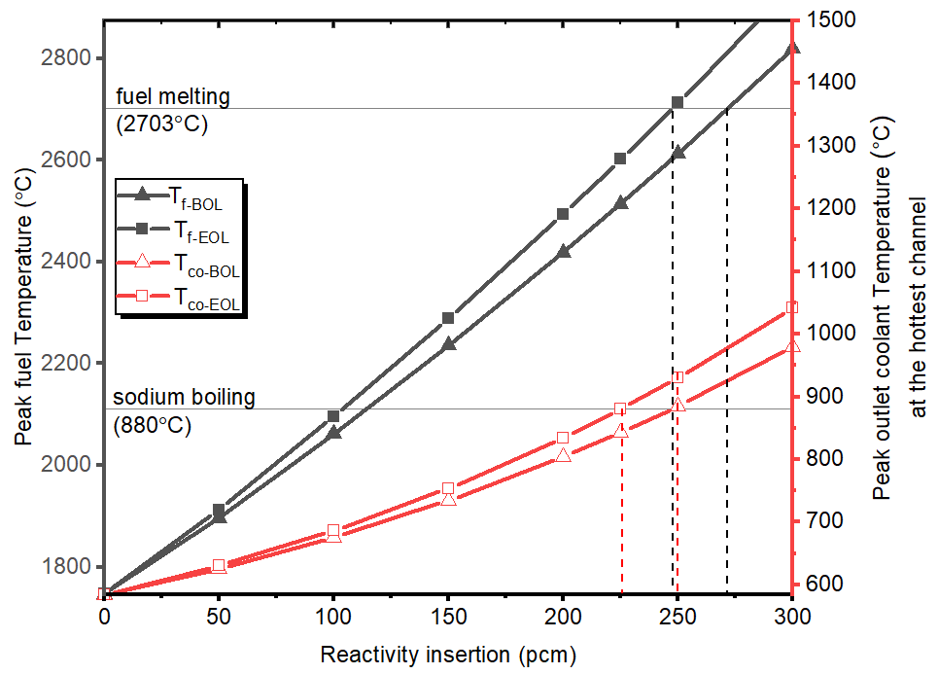 | 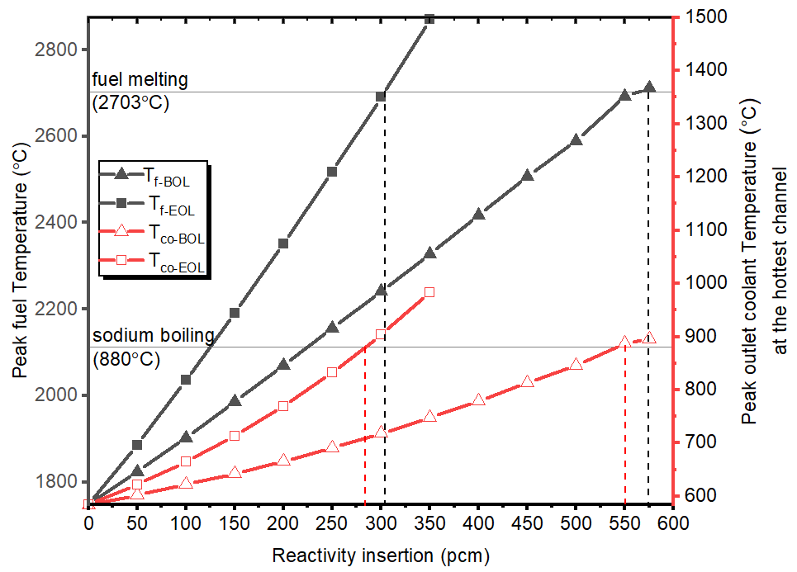
- Response of SMSFR without consideration of control rods displacement influence | - Response of SMSFR with consideration of control rods displacement influence

Fig. 5. Response of SMSFR to the reactivity insertion

ULOF event analysis
In the ULOF analysis, a transient is assumed that three of the four primary pumps lose power as t=0 s, and the primary flow decays exponentially (with a half-time of 40 s) to 25% of the initial value. Meanwhile, the secondary loop of the reactor maintains normal operation.
In Fig. 6(a), the calculation result at BOL shows that the core power reduced to an asymptotic value about 43% of the initial value as the flow decreases. The temperature of the primary circuit coolant has a significant rise due to the mismatch between the core power and the coolant flow, and the corresponding peak temperature of the core outlet coolant is on the verge of boiling (Fig. 6(b)). In Fig. 6(c), it can be seen that the reactivity feedback of “Doppler effect” (due to the decrease of fuel temperature) and “Dia. Exp.” (due to the diagrid shrinkage caused by decrease of core inlet temperature) bring positive effects, counterbalanced mainly by the negative feedback effects resulting from the coolant temperature rise. From the discussion in 3.1, the effect of “Ctr. Exp.” is weakest at EOL, when the reactor is also in the most insecure state over lifetime. As shown in Fig. 6, although the same flow attenuation was initiated at EOL, the core reaches a new steady state with a higher power, fuel and medium temperature than that at BOL. The reason could be found in Fig. 6(c), in which the negativity feedback brought by the control rod expansion at EOL is weaker than that at BOL.
- Normalized core power
- Temperature of fuel and coolant (“fmax”, “comax” for the temperature of fuel and outlet coolant in the hottest channel)
- Reactivity feedback
Fig. 6. Results for ULOF
Based on the assumption of the transient, the impacts of the flow decay rate (measured by halving time, T_{1/2}) and the steady flow after transient (measured by the proportion of the initial flow, q) on the safety performance are discussed here. As shown in Fig. 7 and Fig. 8, the corresponding temperature changes of the outlet coolant temperature of the hottest channel are obtained under different flow decay speeds and stable flow rates after ULOP. The result indicates that, a higher flow stable value and longer halving time is beneficial to avoid the sodium boiling, hence improve the safety performance, no matter at BOL or EOL. For example, installing idler flywheel in main pump to increase inertia rotation time after shutdown. Moreover, some measures for increasing the natural circulating force, as well as reducing the flow resistance, such as lifting the relative height of heat trap, expanding the flow section within the assembly, will be beneficial to increasing post-transient flow.
Fig. 7. The influence of T_{1/2} (halving time) on coolant outlet temperature(q = 0.25)
Fig. 8. The influence of q (proportion of initial flow) on coolant outlet temperature(T_{1/2} = 40 s)

ULOHS event analysis
In this transient event, the sodium pumps in the secondary loop were assumed to fail at t=0 s, while the primary pumps are assumed operational thereby assuring an efficient heat distribution throughout the primary cooling system with a nominal coolant flow rate.
Fig. 9 displays changes of the core reactivity feedback, temperature and power during ULOHS at BOL and EOL. Both of the inlet and outlet coolant temperature of the hottest channel increases sharply resulting from the loss of heat sink. Correspondingly, the reactivity feedbacks are generated, in which the negative feedback brought by the expansion of diagrid due to the inlet coolant temperature increasing is particularly significant. Under the limitation of the overall negative feedback, the core power experienced a rapid drop, and finally stabilise below 20% of the initial power, resulting in a significant decrease in fuel temperature (reason for the Doppler effect producing positive reactivity feedback). It is worth noting that the increase of coolant temperature will cause the control rod to expand and produce an “insertion” effect. But here in ULOHS, the significant drop in fuel temperature (over 800 °C) makes the reactor fuel contract toward the bottom of the core axially. The latter effect occupies the main position, generating an “upward” effect of the control rod, and introducing positive reactivity into the core. It can be predicted that as the increase of lifetime while the differential worth of control rod decreases, this positive feedback effect will also weaken: this makes the reactor safer in ULOHS transients at EOL.
Since the core is still generating power (shown in Fig. 9(c)), the temperature of coolant in the core increases slowly with time and eventually reaching the boiling point of sodium after a time (t=1472 s) at BOL.
The calculation results of ULOHS transient at EOL shown in Fig. 9 confirm the above analysis: the positive reactivity introduced by the control rod is significantly reduced, and the coolant temperature is below the sodium boiling point in a lengthy process.
- Reactivity feedback
- Temperatures of fuel, cladding and coolant
in the hottest channel
- Normalized core power
Fig. 9. Results for ULOHS

Conclusions
In the SMSFR with non-refuelling strategy, neutron characteristics of the core vary considerably with the change of fuel burnup during lifetime, which will affect the safety performance of the reactor. In this paper, the burnup calculation is conducted, the performance of SMSFR in ATWS events are calculated, and the safety behaviour during lifetime is analysed and compared.
With the deepening of fuel burnup, the coolant expansion coefficient changes from negative to positive, and the Doppler constant decreases gradually. Meanwhile, with the control rods been withdrawn from the core, its differential value at EOL decreases significantly compared with that at BOL.
In the UTOP event, the negative reactivity feedback brought by the fuel Doppler effect and the relative insertion of the control rod is essential to the safety of the reactor. Without considering the reactivity feedback caused by the expansion of control rods, the reactivity insertion that the core can withstand in the UTOP is about 250 pcm at BOL, which will gradually decrease with the increase of fuel burnup.
With the increase of fuel burnup, the challenge to core safety caused by ULOF event increases, resulting from the decreasing of the negative feedback brought by the expansion of control rods. However, this negative influence can be mitigated by prolonging the flow decay time and increasing the post-transient steady flow.
In the ULOHS event, the positive reactivity is generated by the relative displacement of control rods. This effect is especially obvious at BOL when control rods are over-inserted. In conclusion, over-deep insertion of control rods should be avoided in the control of excess reactivity in SMSFR. Even though a greater insertion depth of the control rod brings stronger negative feedback effects during UTOP and ULOF events, however, it increases the risk of UTOP caused by the accidental ejection of the control rod: the deeper the control rod positioned, the larger the positive reactivity inserted. Moreover, a higher positive reactivity will be released in the ULOHS event by a deeper insertion of control rods. Since the temperature safety margin and calculation uncertainties are not considered in the analysis of this paper, the influence of these factors needs to be further studied.
ACKNOWLEDGEMENTS
This work is sponsored by Shanghai Sailing Program (No. 20YF1420700). The computations in this paper were run on the π 2.0 cluster supported by the Centre for High-Performance Computing at Shanghai Jiao Tong University.
References
[1] WALTAR, A.E., TODD, D.R., TSVETKOV, P., Fast Spectrum Reactors, (2012) p. 720.
[2] Fast Neutron Reactors | FBR - World Nuclear Association, https://www.world-nuclear.org/information-library/current-and-future-generation/fast-neutron-reactors.aspx.
[3] Small nuclear power reactors - World Nuclear Association, https://www.world-nuclear.org/information-library/nuclear-fuel-cycle/nuclear-power-reactors/small-nuclear-power-reactors.aspx.
[4] Technology Roadmap Update for Generation IV Nuclear Energy Systems, 66.
[5] AYDOGAN, F., “20 - Advanced small modular reactors”, Handbook of Generation IV Nuclear Reactors, Woodhead Publishing Series in Energy (PIORO, I.L., Ed), Woodhead Publishing (2016) 661–699.
[6] GUO, H., BUIRON, L., SCIORA, P., KOOYMAN, T., Optimization of reactivity control in a small modular sodium-cooled fast reactor, Nuclear Engineering and Technology 52 7 (2020) 1367.
[7] HUSSEIN, E.M.A., Emerging small modular nuclear power reactors: A critical review, Physics Open 5 (2020) 100038.
[8] M.D. CARELLI, D.T. INGERSOLL (EDS.), Handbook of Small Modular Nuclear Reactors, Elsevier, Cambridge, UK (2015).
[9] CHANG, Y. et al., Small Modular Fast Reactor design description., (2005).
[10] GUO, H., BUIRON, L., SCIORA, P., KOOYMAN, T., Designs of control rods with strong absorption ability for small fast reactors, Nuclear Engineering and Design 368 (2020) 110799.
[11] GUO, H., SCIORA, P., KOOYMAN, T., BUIRON, L., RIMPAULT, G., Application of Boron Carbide as Burnable Poison in Sodium Fast Reactors, Nuclear Technology 205 11 (2019) 1433.
[12] HORIE, H., MIYAGI, K., NAKAHARA, K., MATSUMIYA, H., Safety performance of the 4S reactor on the ATWS events – statistical estimation of uncertainty, Progress in Nuclear Energy 50 2 (2008) 179.
[13] H. GUO, P. SCIORA, T. KOOYMAN, L. BUIRON, Evaluation of the Control Rods Withdrawal in a Small Modular Sodium Fast Reactor and Analysis of the Impact on the Core Design, France, Juan-les-pins (2019).
[14] ROMANO, P.K., JOSEY, C.J., JOHNSON, A.E., LIANG, J., Depletion capabilities in the OpenMC Monte Carlo particle transport code, Annals of Nuclear Energy 152 (2021) 107989.
[15] ROMANO, P.K. et al., OpenMC: A State-of-the-Art Monte Carlo Code for Research and Development, CARUGE, D., CALVIN, C., DIOP, C.M., MALVAGI, F., TRAMA, J.C., Eds, (2014) p. 06016.
[16] ROMANO, P.K., FORGET, B., The OpenMC Monte Carlo particle transport code, Paul Romano (2012).
[17] SHEN, C., ZHANG, X., WANG, C., CAO, L., CHEN, H., Transient safety analysis of M2LFR-1000 reactor using ATHLET, Nuclear Engineering and Technology 51 1 (2019) 116.
[18] BANDINI, G. et al., Safety Analysis Results of Representative DEC Accidental Transients for the ALFRED Reactor, 11.
[19] CARBAJO, J.J., YODER, G.L., POPOV, S.G., IVANOV, V.K., A review of the thermophysical properties of MOX and UO2 fuels, Journal of Nuclear Materials 299 3 (2001) 181.
[20] ZAETTA, A. et al., CADOR “Core with Adding DOppleR effect” concept application to sodium fast reactors, EPJ Nuclear Sci. Technol. 5 (2019) 1.

