# Neutronics Benchmark of CEFR Start-Up Tests: Temperature Coefficient, Sodium Void Worth, and Swap Reactivity

J. CHOE1, B. BATKI2, U. DAVIES3, M.J. LEE1, J.H. WON1, V. KRIVENTSEV4, C. BATRA4, P. SCIORA5, A. PETRUZZI6, S. DI PASQUALE6, V. GIUSTI7, M. SZOGRADI8, H. TANINAKA9, R. LOPEZ10, A.M. GOMEZ TORRES10, M. JARRETT11, T.K. KIM11, E. FRIDMAN12, M. TÓTH13, I. PATAKI13, T. QUOC TRAN14, D. LEE14, X. DU15, Y. ZHENG15, K. MIKITYUK16, J. BODI16

1Korea Atomic Energy Research Institute, Daejeon, Republic of Korea

2Hungarian Academy of Sciences Centre for Energy Research, Budapest, Hungary

3University of Cambridge, Cambridge, United of Kingdom

4IAEA, Vienna, Austria

5French Alternative Energies and Atomic Energy Commission, Saint-Paul Lez Durance Cedex, France

6Nuclear and Industrial Engineering, Lucca, Italy

7Università di Pisa, Pisa, Italy

8VTT Technical Research Centre of Finland, Espoo, Finland

9Japan Atomic Energy Agency, Ibaraki, Japan

10Instituto Nacional de Investigaciones Nucleares, La Marquesa, Mexico

11Argonne National Laboratory, Lemont, United States

12Helmholtz-Zentrum Dresden-Rossendorf, Dresden, Germany

13Centre for Energy Research, Budapest, Hungary

14Ulsan National Institute of Science and Technology, Ulsan, Republic of Korea

15Xi'an Jiaotong University, Xian, China

16Paul Scherrer Institute, Villigen, Switzerland

Email contact of corresponding author: jchoe@kaeri.re.kr

**Abstract**

The China Institute of Atomic Energy (CIAE) proposed some of the China Experimental Fast Reactor (CEFR) neutronics start-up test data for the IAEA benchmark within the scope of the IAEA’s coordinated research activity. The coordinated research project (CRP) on “Neutronics Benchmark of CEFR Start-Up Tests” was launched in 2018. The benchmark aims to perform validation and verification (V&V) of the physical models and the neutronics simulation codes by comparing calculation results against collected experimental data. Twenty-nine participating research organizations finished performing independent blind calculations and refined their calculation results by referring to measurement data. The paper introduces the following three kinds of reactivity measurements in the CEFR start-up test and presents the results by participants: temperature coefficient, sodium void reactivity, and swap reactivity. First, for measuring temperature coefficients, ten sets of data were obtained by increasing and decreasing the temperature. The control rod position is changed for each temperature to maintain the reactor as critical. Second, sodium void reactivity is measured by replacing a fuel SA with vacuum-sealed SA and searching for the critical position of control rods. Third, for measuring the swap reactivity, fuel subassembly is replaced by stainless subassembly, and stainless subassembly is switched with one fuel subassembly. Swap reactivities are measured in two different ways, with more than two control rods moving to find the criticality of the core in the ‘Multiple Rods’ case and only one control rod moving in the ‘Single Rod’ case. All three reactivities are obtained by combining control rod worth for changed rod position and criticality difference. The comparison shows that uncertainty of calculations, modeling errors, and inaccurately determined control assembly worth make it challenging to calculate the temperature coefficient precisely. Meanwhile, the void worth and the swap reactivity results have similar trends and show good agreement with measurement.

## INTRODUCTION

China Experimental Fast Reactor (CEFR) is a 20MWe sodium cooled fast reactor fuelled with uranium oxide. Several start-up tests were performed from 2010 to 2011, and six different measured data has been provided through the CRP: criticality, control rod worth, reaction rate, temperature coefficients, sodium void worth, and subassembly (SA) swap reactivity [1]. Twenty-nine participating research organizations finished performing independent blind calculations and refined their calculation results by referring to measurement data. The paper introduces the following three kinds of reactivity measurements in the CEFR start-up test and presents the results by participants: temperature coefficient, sodium void reactivity, and swap reactivity. Sixteen deterministic codes and fifteen stochastic neutronics simulation codes with 16 cross-section libraries have been used. Simulation codes and cross-section libraries used by each organization are summarized in Tables I-II. Detailed results analysis will be found in the IAEA TECDOC planned for publication in 2022 [2].

TABLE 1. PARTICIPANTS WITH STOCHASTIC CODES

|  |  |  |  |
| --- | --- | --- | --- |
| Country | Organization | Cross-section | Simulation Code |
| Belgium | SCK-CEN | ENDF/B-VII.1 | OpenMC-0.10.0 |
| China | CIAE | ENDF/B-VIII.0 | RMC |
| China | INEST | HENDL3.0 | SuperMC |
| Finland | VTT | ENDF-B/VII.0, JEFF 3.1.2 | Serpent 2.1.31 |
| France | CEA | JEFF 3.1.1 | TRIPOLI4 |
| Germany | HZDR | JEFF 3.1, JEFF 3.3, ENDF/B-VII.1,  ENDF/B-VIII.0 | Serpent 2.1.31 |
| Germany | GRS | ENDF/B-VII.1 | Serpent |
| Hungary | CER | ENDF/B-VIII.0 | Serpent 2.1.31 |
| IAEA | IAEA | ENDF/B-VII.1 | OpenMC, Serpent 2.1.27 |
| India | IGCAR | ENDF/B-VIII.0, JEFF 3.3, JENDL-4.0, ROSFOND 2010, CENDL 3, TENDL 2017 | OpenMC-0.10.0 |
| Italy | NINE-UNIPI | ENDF/B-VIII.0 | Serpent 2.1.31 |
| Japan | JAEA | JENDL-4.0 | MVP-II |
| Korea | KAERI | ENDF/B-VII.1 | McCARD 1.0 |
| Korea | UNIST | ENDF/B-VII.1 | MCS |
| Mexico | ININ | ENDF/B-VIII.0 | Serpent 2.1.30 |
| Romania | RATEN | ENDF/B-VIII.0 | Serpent 2.1.31, MCNP6.1 |
| Russian Federation | IPPE | ROSFOND10+ | MMKC |
| Russian Federation | NRCKI | JEFF 3.3 | Serpent 2.31, MCNP |
| Slovakia | VUJE | ENDF/B-VII.1 | Serpent 2.1.31 |
| USA | NRC | ENDF/B-VII.1 | Serpent 2.1.30 |

TABLE 2. PARTICIPANTS WITH DETERMINISTIC CODES

|  |  |  |  |
| --- | --- | --- | --- |
| Country | Organization | Cross-section | Simulation Code (Lattice/Nodal) |
| China | CIAE | ENDF/B-VIII.0 | PASC/NAS |
| China | XJTU | ENDF/B-VII.0 | SARAX (TULIP v1.5/LAVENDER v1.5) |
| France | CEA | JEFF 3.1, JEFF 3.1.1 | ECCO/ ERANOS, APOLLO3 |
| Germany | GRS | ENDF/B-VII.0 | Serpent 2.1.31/FENNECS |
| Germany | KIT | JEFF 3.1 | ECCO/VARIANT |
| Hungary | CER | ENDF/B-VIII.0 | Serpent 2.1.31/KIKO3DMG |
| India | IGCAR | ABBN-93, ERALIB-1 JEF-2.2 | FARCOB/ERANOS |
| Japan | JAEA | JENDL-4.0 | SLAROM-UF/DIF3D10.0/PARTISN5.97 |
| Korea | KAERI | ENDF/B-VII.0 | MC2-3/DIF3D-VARIANT11.0 |
| Korea | UNIST | ENDF/B-VII.1 | MCS/RAST-K |
| Mexico | ININ | ENDF/B-VIII.0 | Serpent2.1.31/AZNHEX |
| Russian Federation | NRCKI | ABBN-93 | JARFR |
| Swiss | PSI | JEFF 3.1.1 | Serpent 2/PARCS v27 |
| UK | UoC | JEFF 3.1.2 | WIMS 11 |
| USA | ANL | ENDF/B-VII.0 | MC2-3/DIF3D |
| Russian Federation | SSL | ENDF/B-VII.0 | DYNCO/DYNCO |
| Ukraine | KIPT | BNAB-76 | FANTENS-2 (2D code) |

The core consists of a fuel region of 450 mm and a blanket region of 350 mm located above and below the fuel region. The fuel region had subassemblies with annular fuel pellets using the UO2 fuel with 64.4 wt.% of 235U, and the blanket region had subassemblies with traditional fuel pellets using the UO2 fuel with 0.3 wt.% of 235U. Boron carbide with different 10B enrichment is used in boron shielding subassemblies and control rod subassemblies. The layout of the core loading operation is depicted in Fig. 1 [1].

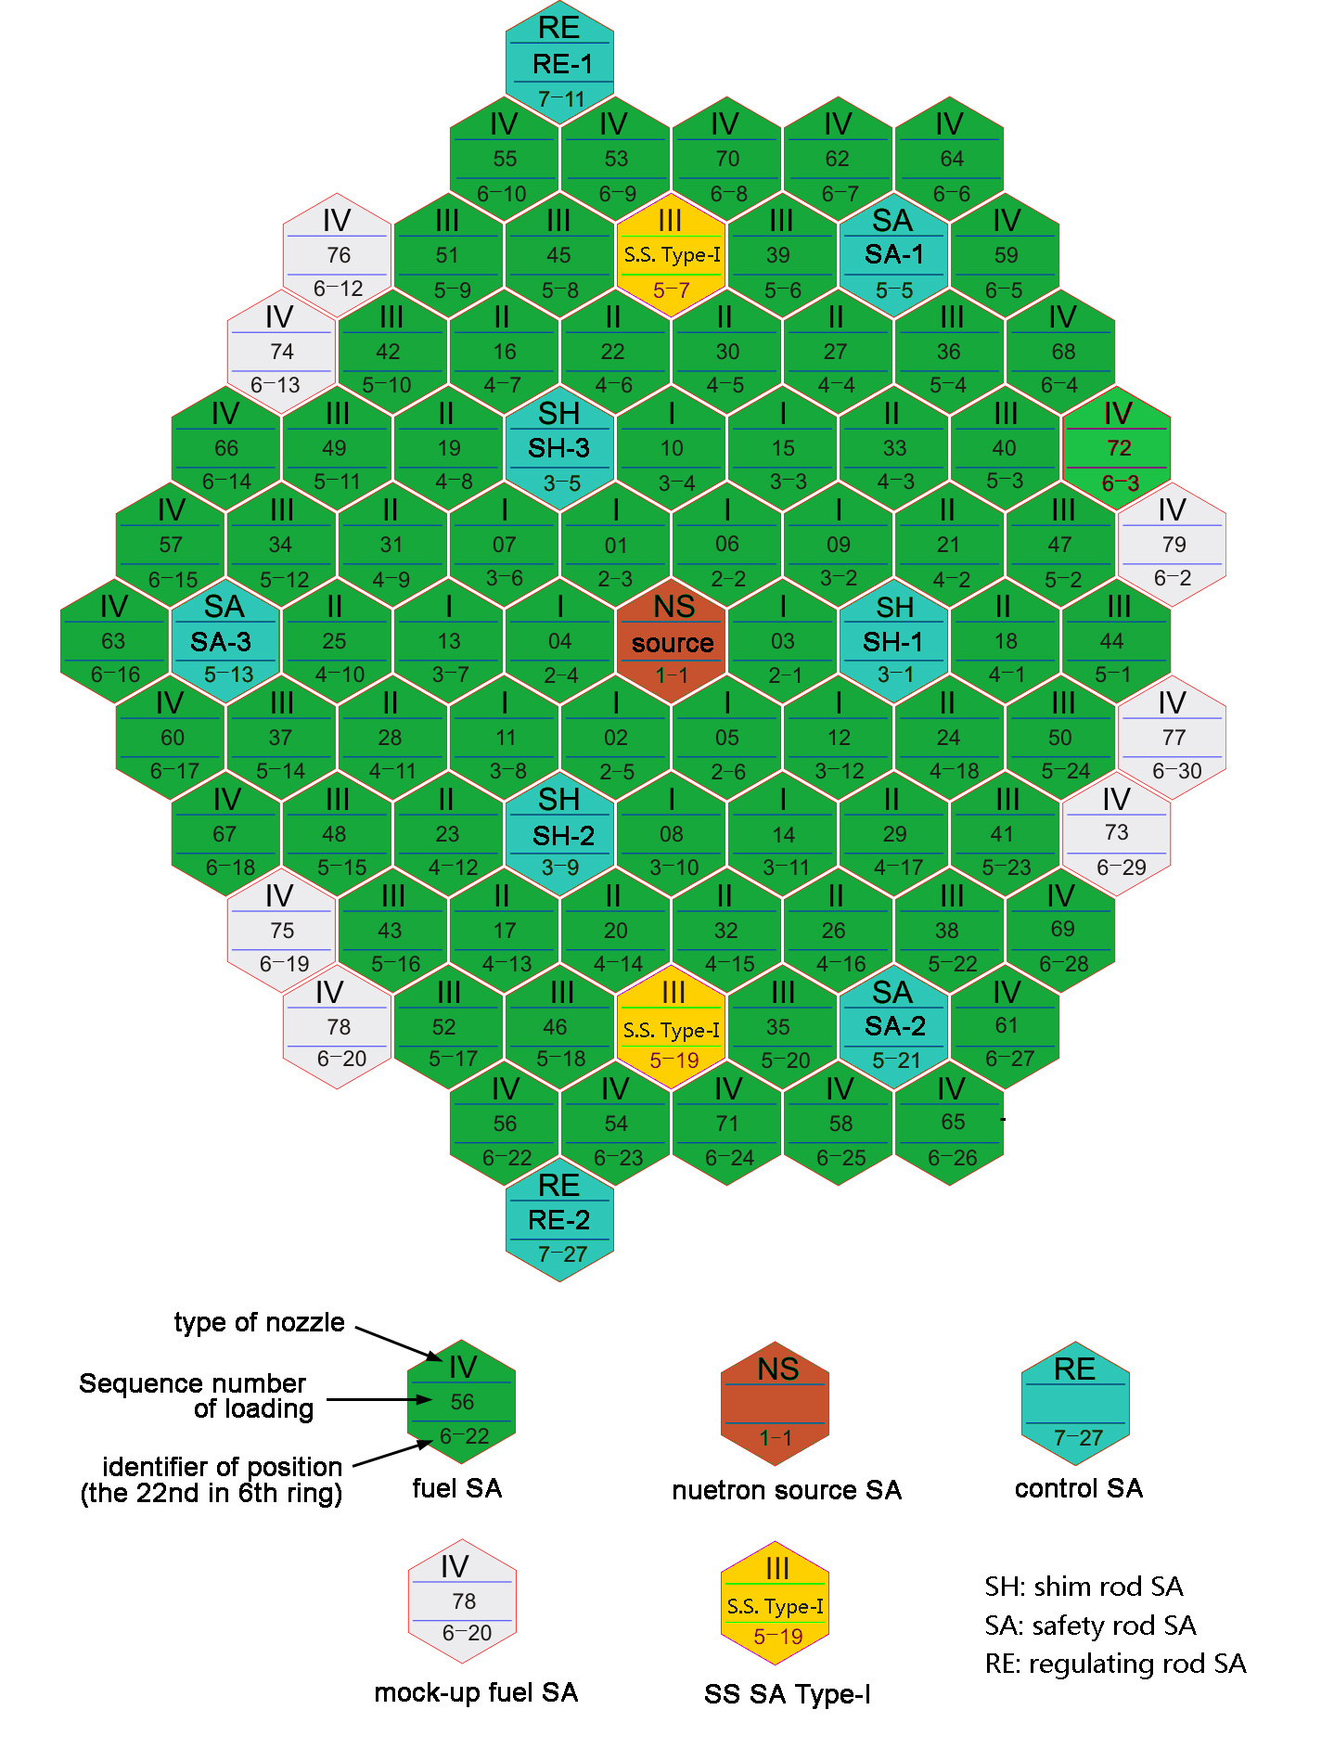

Fig. 1. Fuel loading pattern.

Basically, the reactivity is obtained by summation of the control rod worth and the reactivity calculated by keff difference as given in Eq. (1) below:

|  |  |
| --- | --- |
| $ρ_{w}=\sum_{i=1}^{N}{ρ_{rod}^{i}}+\frac{k_{p}-k_{o}}{k_{o}∙k_{p}}×{10}^{5} \left[pcm\right]$, | (1) |

where $ρ_{w}$ can be temperature reactivity, sodium void worth, and swap reactivity, $N$ is the number of control rod used in the measurement, $ρ_{cr}$ is control rod worth of $i$ bank, $k_{o}$ is measured *keff* before perturbation, $k_{p}$ is measured *keff* after perturbation, such as changing temperature, replacing by sodium void fuel SA, or swapped SA. This calculation follows the experimental process, and most of participants followed Eq. (1). Some participants generated reactivities with fixed control rod positions.

## TEMPERATURE COEFFICIENTS

The two temperature coefficients according to increasing process and decreasing process studied, and the core states are obtained from Table 3. Different effects appear depending on how the core is modelled. The expansion of fuel followed by density decrease reduces the reactivity. The radial expansion is more effective than the axial expansion. The radial expansion of cladding leads to decreased sodium volume, and radial expansion of diagrid leads to increased sodium volume between subassemblies and increased core size. Wrapper expansion also may affect sodium volume change, but most of the participants included the wrapper into the cladding. Sodium density change, which decreases with increasing temperature, brings a negative reactivity. It was challengeable how to treat the control rod expansion.

TABLE 3. CORE STATES AT TEMPERATURE COEFFICIENT TESTS

|  |  |  |  |  |  |  |
| --- | --- | --- | --- | --- | --- | --- |
| Process | Temperature [℃] | Control rod positions [mm] | | | | |
| RE1 | RE2 | SH1 | SH2 | SH3 |
| Increasing | 250 | 207.2 | 207.7 | 247.9 | 247.7 | 248.0 |
| 275 | 212.3 | 212.9 | 253.6 | 253.1 | 253.8 |
| 283 | 239.7 | 239.3 | 253.4 | 253.1 | 254.0 |
| 293 | 282.8 | 283.4 | 253.4 | 253.0 | 253.7 |
| 302 | 307.5 | 307.0 | 254.7 | 254.6 | 255.9 |
| Decreasing | 300 | 407.7 | 408.5 | 501.5 | 162.3 | 162.2 |
| 290 | 283.4 | 283.8 | 254.0 | 253.7 | 254.4 |
| 281 | 285.2 | 284.6 | 502.0 | 162.2 | 162.2 |
| 270 | 232.4 | 232.2 | 501.9 | 162.2 | 162.2 |
| 250 | 118.5 | 118.9 | 501.8 | 162.2 | 163.0 |

There are three kinds of calculation approaches to obtaine temperature coefficients. The refined phase template has been supplemented and distributed to the participants. The template for the refined phase includes items as follows: 1) Calculation according to the experiment (Experimental): CR reactivity correction should be performed according to the integral rod worth, 2) 3-step method (3-step): summation of three reactivities; reactivity with the temperature and rod position at the A state, reactivity with the temperature at the B state and rod position at the A state, reactivity with the temperature and rod position at the B state, 3) Calculation with fixed control rod positions.

Most participants reflect important phenomena, such as the Doppler effect, expansion of fuel, expansion of structures, density change of sodium. Most participants using stochastic codes modeled the heterogeneous core, and some participants using deterministic codes modeled the homogenous core. XJTU and CEA modeled the core partially heterogenous: heterogeneous model for fuel and CR SA and homogenous model for reflector and other SAs. NINE modeled the core partially heterogeneous: homogenous modeling for the handling head region of SAs. All the refined phase results show negative values and show agreement with the measurement data in general. The temperature coefficient of increasing process calculated by the experimental method is shown in Fig. 2. The mean value of the temperature coefficient is -4.04 pcm/K with 12.6 % standard deviation. The temperature coefficient of increasing process calculated by the 3-step method is shown in Fig. 3. The mean value of the temperature coefficient is -3.98 pcm/K with 14.3 % standard deviation. The temperature coefficient of decreasing process calculated by the experimental method is shown in Fig. 4. The mean value of the temperature coefficient is -4.07 pcm/K with 17.2 % standard deviation. The temperature coefficient of decreasing process calculated by the 3-step method is shown in Fig. 5. The mean value of the temperature coefficient is -3.97 pcm/K with 14.9 % standard deviation.



Fig. 2. Temperature coefficient of increasing process from the experimental method.



Fig. 3. Temperature coefficient of increasing process from the 3-step method



Fig. 4. Temperature coefficient at decreasing process from the experimental method



Fig. 5. Temperature coefficient at decreasing process from the 3-step method

Table 4 shows the mean value of temperature coefficients. Stochastic results have a relatively larger standard deviation and underestimate the coefficient. Deterministic results have a relatively smaller standard deviation and overestimate the coefficient. In general, the results show good agreement with the measurement data. There is no significant difference in the two different calculation ways: 3-step method and experimental method in increasing process. There are a few cases that show a large difference between the experimental method and the 3-step method.

TABLE 4. MEAN VALUE OF TEMPERATURE COEFFICIENTS [PCM/K]

|  |  |  |  |  |  |
| --- | --- | --- | --- | --- | --- |
| Calculation Way | Process | Measurement | Mean value | Stochastic | Deterministic |
| Experimental | Increasing | -3.76±0.51 | -3.95±0.31 | -3.40±1.05 | -4.20±0.72 |
| Decreasing | -4.38±0.61 | -3.85±0.57 | -3.43±1.09 | -4.29±0.72 |
| 3-step method | Increasing | -3.76±0.51 | -3.91±0.42 | -3.64±0.27 | -4.10±0.60 |
| Decreasing | -4.38±0.61 | -3.97±0.46 | -3.27±0.46 | -4.16±0.93 |

## SODIUM VOID REACTIVITY

The sodium void reactivity is measured by replacing a fuel SA with a specially designed ‘voided’ SA and measuring the change of critical positions of control rods; as the control rod worth curve was already known, the sodium void reactivity was obtained. In total 5 different fuel SA locations were measured at (2-4), (3-7), (4-9), (5-11), and (6-13). Firstly, the control rods were moved to reach criticality, and the rod positions were recorded as a basic state for the experiment; then a fuel SA was replaced by a specially designed experimental SA, which has a vacuum sealed by welding to simulate the sodium void; the control rods were moved again to reach criticality, and the new positions were recorded; the reactivity change was obtained based on the change of critical positions of control rods and the worth curve of rods already obtained in previous experiments. As the moving of control rods could not reach an exact criticality, the remaining small reactivity was measured by reactivity meter and period method, and accordingly the measured void reactivity was corrected. The measured reactivities were also corrected for the change of coolant temperature during the experiment and the difference of the composition of fissile nuclides between the fuel SA and the experimental SA. Figs. 6-10 show deterministic code results compared to the measurement, and Figs. 11-15 show stochastic code results compared to the measurement of each location.

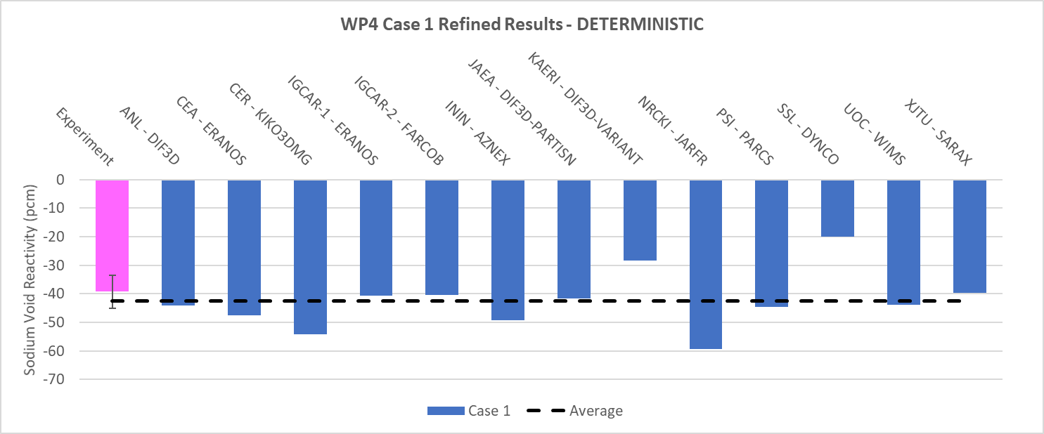

Fig. 6. Deterministic results for Case 1

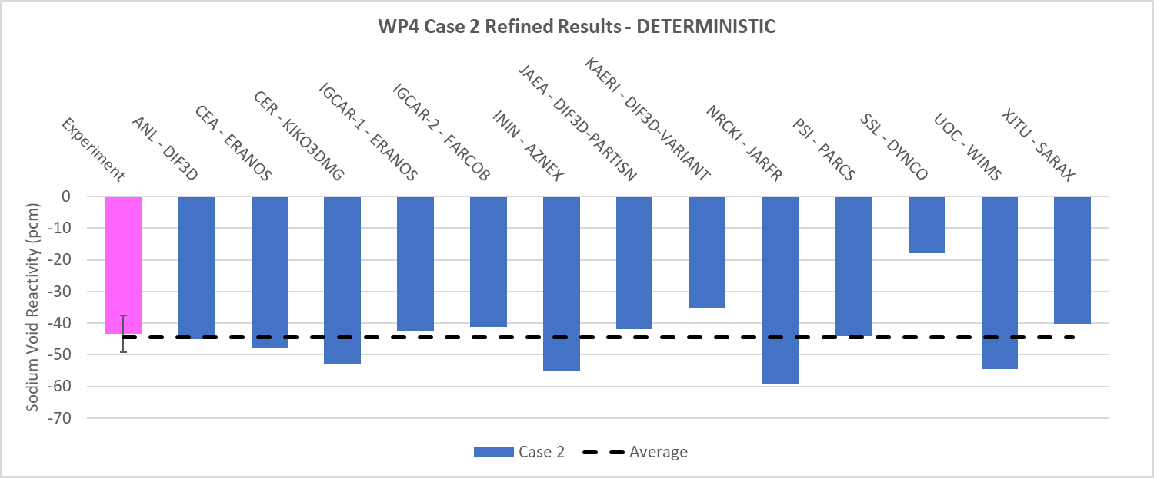

Fig. 7. Deterministic results for Case 2

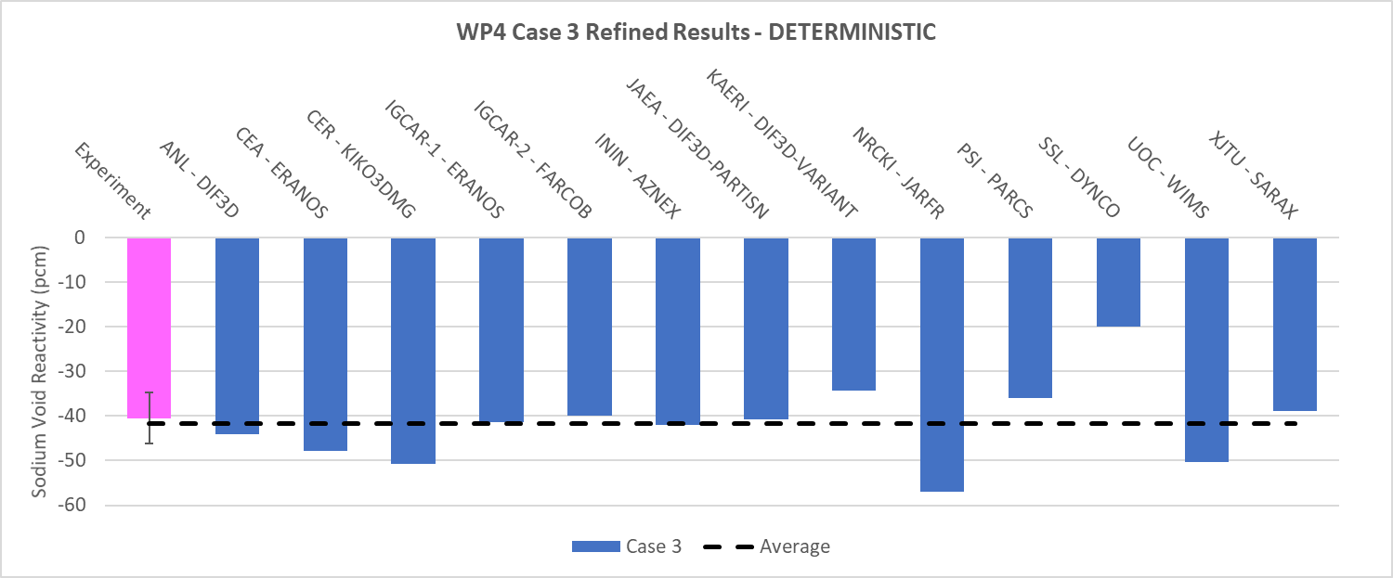

*FIG. 8. Deterministic results for Case 3*

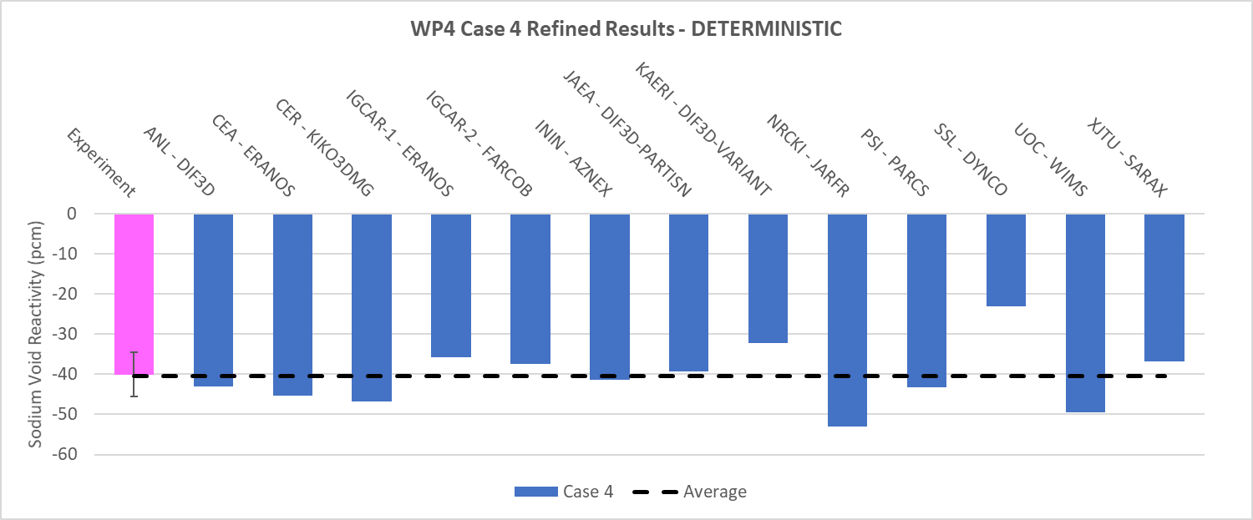

*FIG. 9. Deterministic results for Case 4*

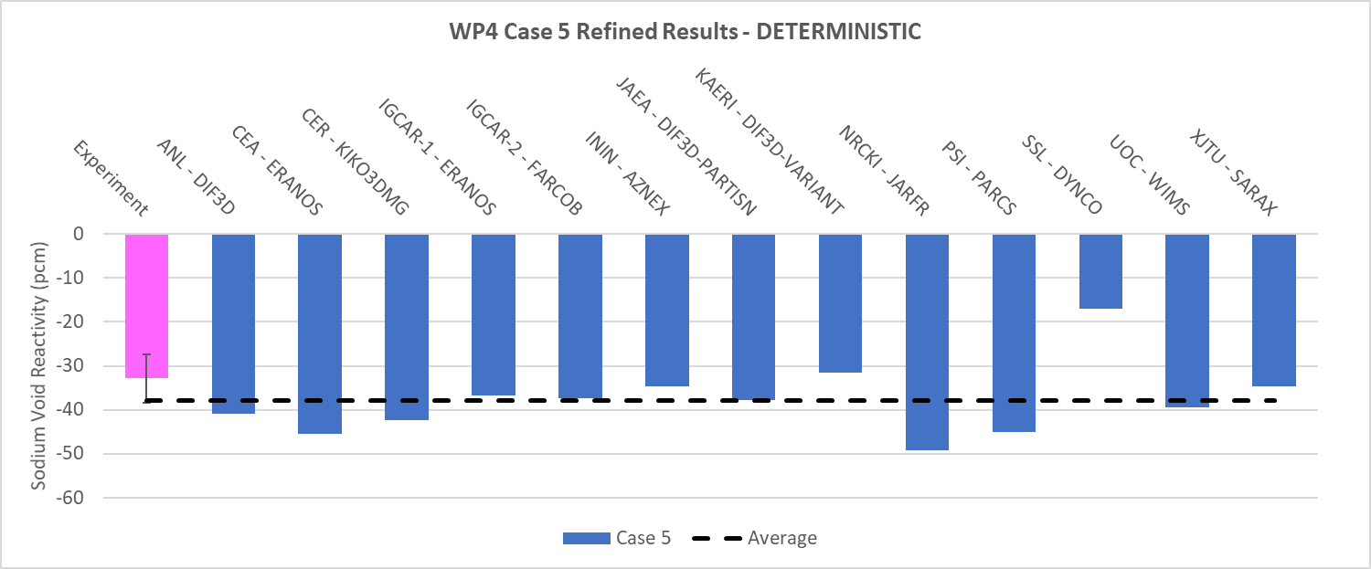

*FIG. 10. Deterministic results for Case 5*

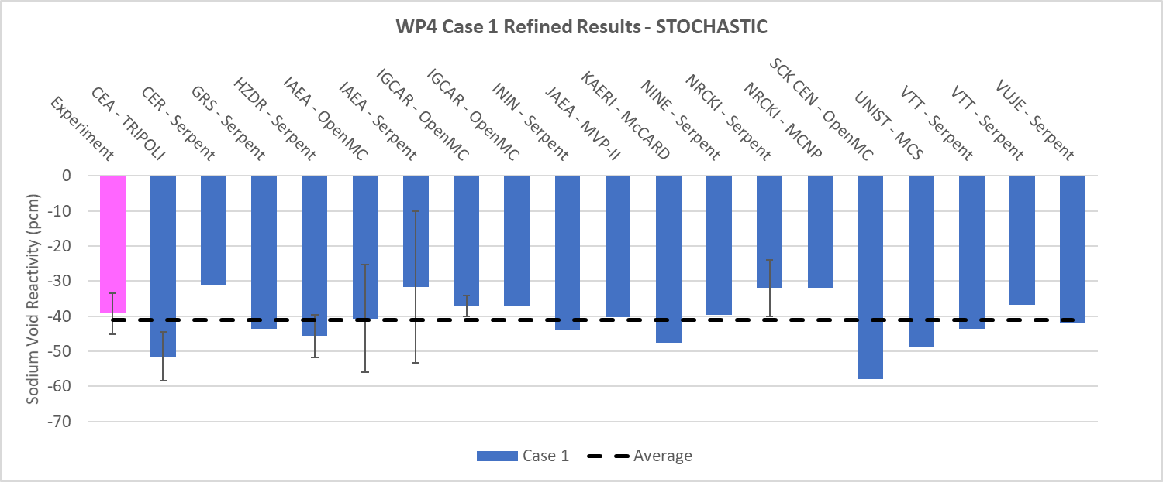

*FIG. 11. Stochastic results for Case 1*

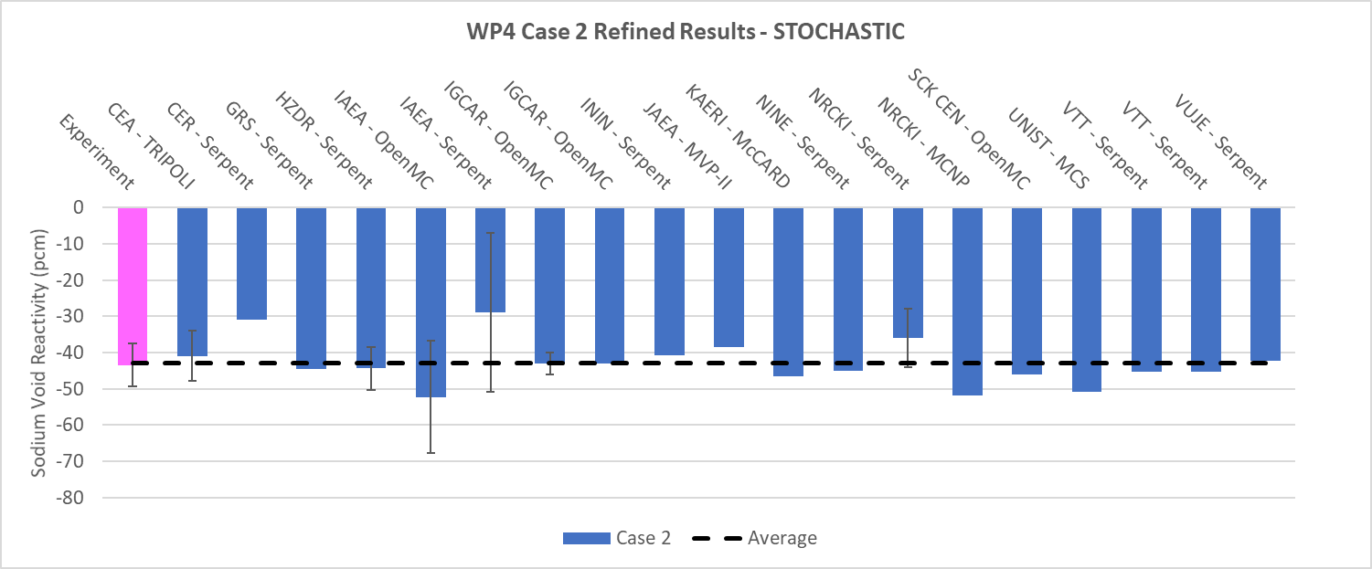

*FIG. 12. Stochastic results for Case 2*

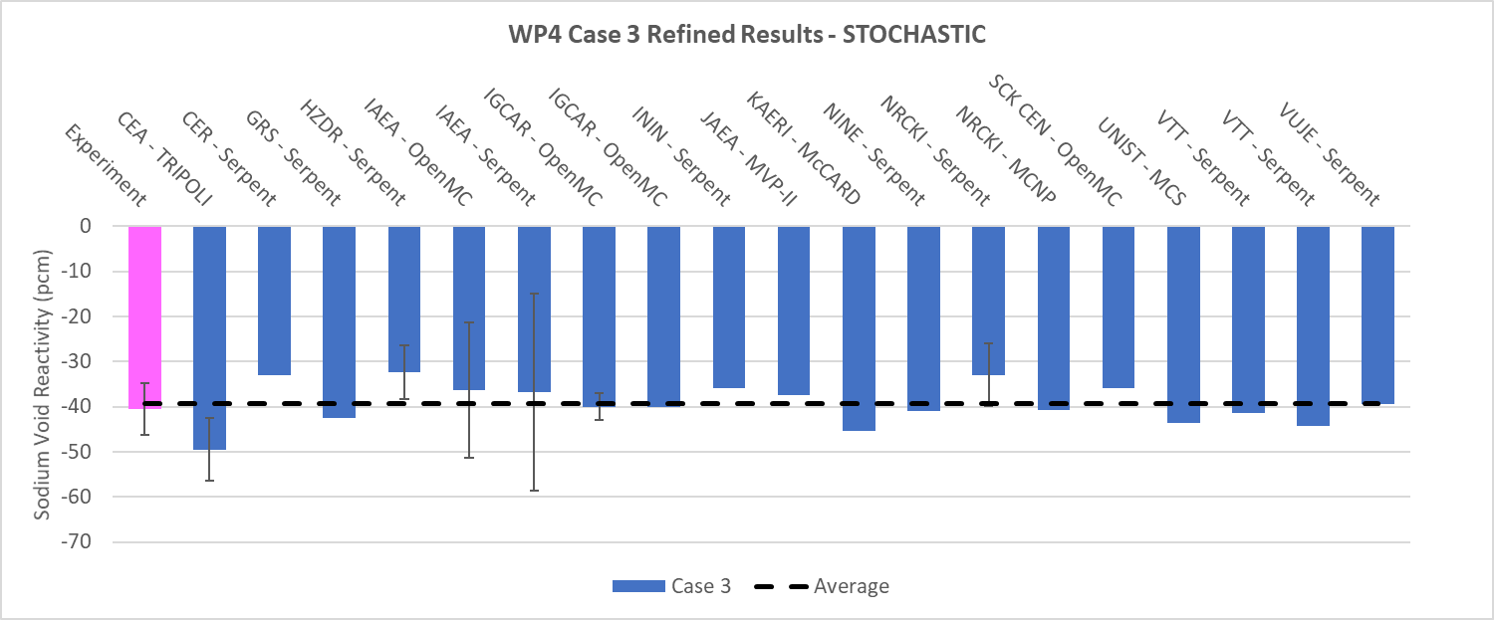

*FIG. 13. Stochastic results for Case 3*

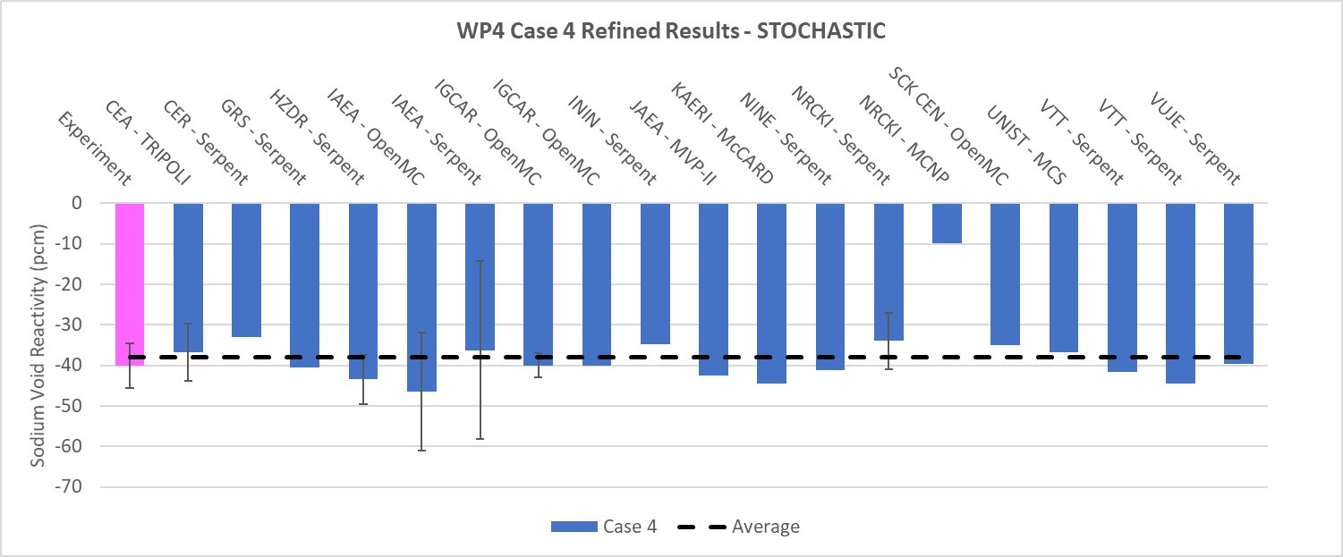

*FIG. 14. Stochastic results for Case 4*

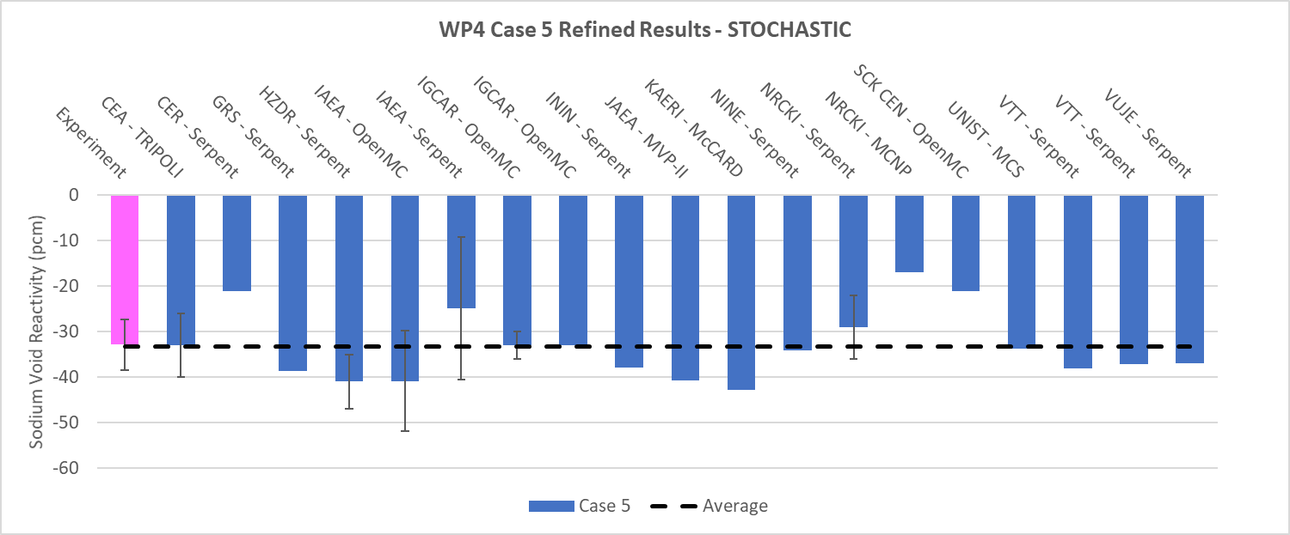

*FIG. 15. Stochastic results for Case 5*

Table 5 shows the mean value of sodium void reactivities and experimental results. These results show good agreement with 1-σ of experimental data.

TABLE 5. MEAN VALUE OF SODIUM VOID REACTIVITY [PCM]

|  |  |  |  |  |  |
| --- | --- | --- | --- | --- | --- |
| Position | Case1: (2-4) | Case2: (3-7) | Case3: (4-9) | Case4: (5-11) | Case5: (6-13) |
| Experimental | -39±6 | -43±6 | -41±6 | -40±6 | -33±6 |
| Deterministic | -31.6 | -36.4 | -34.1 | -34.3 | -27.6 |
| Stochastic | -32.2 | -37.4 | -36.1 | -36.2 | -27.3 |

## SUBASSEMBLY SWAP REACTIVITY

In the subassembly swap reactivity measurements, eight SAs were selected for measurement. Six of them were fuel SAs and they were swapped by stainless (SS) SAs. The remaining two were SS SAs and they were swapped by fuel SAs. The positions of each SA are (2-6), (3-11), (4-17), (5-19), (5-22), (5-23), (6-29), and (7-31), shown in Fig. 1. The position (7-31) is located southeast of (6-26). In the measurement of a SS SA swapped by a Fuel SA, to keep the reactor safe, a SS SA was not replaced by a fuel SA directly. Instead, the measurement of a SS SA replacement is merged into a fuel SA replacement. That means one fuel SA was swapped to the SS SA first, and then target SS SA was swapped to fuel SA. The number of fuel SAs loaded was kept not to exceed 79 in the whole process, which is important to keep the safety of reactor. The submitted results are categorized into three: i) multiple rod measurement, ii) single rod measurement, and iii) fixed rod measurement.

The mean values of computation results and experimental data are depicted in Tables 6-7 and Figs.16-17. Calculation results tend to underestimate swap reactivity values. For example, even though measurement uncertainty is ±13 %, most of the swap reactivities from fuel to SS underestimate more than 13%. Relative errors are smaller for the case of the swap reactivities from SS to fuel, but it still underestimates the experimental data.

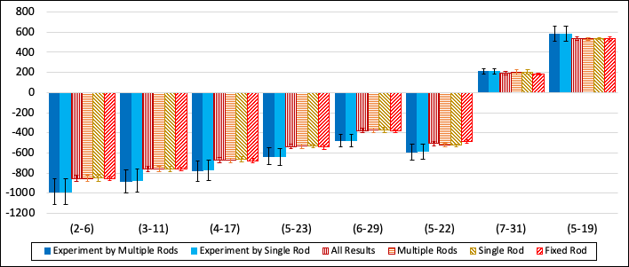

*FIG. 16. Average SA Swap Reactivity Calculation Results (Deterministic)*

TABLE 6. AVERAGE SA SWAP REACTIVITY CALCULATION RESULTS (DETERMINISTIC)

|  |  |  |  |  |  |  |  |  |  |
| --- | --- | --- | --- | --- | --- | --- | --- | --- | --- |
| Unit: pcm | | Fuel SA 🡪 SS SA | | | | | | Fuel SA 🡪 SS SA | |
| (2-6) | (3-11) | (4-17) | (5-23) | (6-29) | (5-22) | (7-31) | (5-19) |
| All results | Avg. | -852.5 | -759.7 | -671.3 | -536.5 | -377.8 | -506.6 | 192.8 | 535.1 |
| Std.dev | 29.4 | 25.2 | 24.2 | 20.2 | 22.4 | 24.0 | 21.2 | 16.9 |
| Error (%) | -15.6 | -15.5 | -15.8 | -18.7 | -25.8 | -16.1 | -8.8 | -8.8 |
| Multiple rods measurement | Avg. | -853.2 | -758.8 | -673.0 | -534.2 | -375.5 | -521.8 | 200.3 | 533.4 |
| Std.dev | 30.8 | 29.0 | 24.1 | 19.8 | 24.2 | 18.3 | 25.6 | 13.3 |
| Error (%) | -15.6 | -15.9 | -15.5 | -18.7 | -26.3 | -13.1 | -4.7 | -9.1 |
| Single rod measurement | Avg. | -848.4 | -759.6 | -662.3 | -529.4 | -371.3 | -524.0 | 202.1 | 538.7 |
| Std.dev | 37.9 | 28.2 | 27.6 | 17.7 | 26.9 | 13.9 | 22.2 | 10.4 |
| Error (%) | -16.0 | -15.2 | -17.3 | -20.8 | -28.3 | -11.8 | -3.8 | -8.0 |
| Fixed rod simulation | Avg. | -854.5 | -760.4 | -675.8 | -542.4 | -383.4 | -486.2 | 182.4 | 534.0 |
| Std.dev | 20.9 | 20.3 | 20.0 | 20.3 | 15.8 | 14.8 | 9.8 | 21.3 |
| Error (%) | -15.3 | -15.4 | -15.0 | -17.4 | -24.0 | -20.9 | -15.0 | -9.0 |

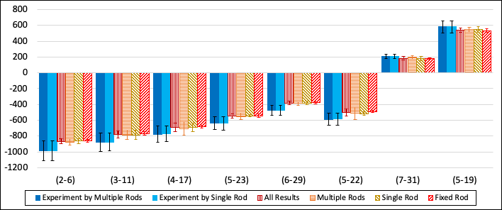

*FIG. 17. Average SA Swap Reactivity Calculation Results (Stochastic)*

TABLE 7. AVERAGE SA SWAP REACTIVITY CALCULATION RESULTS (STOCHASTIC)

|  |  |  |  |  |  |  |  |  |  |
| --- | --- | --- | --- | --- | --- | --- | --- | --- | --- |
| Unit: pcm | | Fuel SA 🡪 SS SA | | | | | | Fuel SA 🡪 SS SA | |
| (2-6) | (3-11) | (4-17) | (5-23) | (6-29) | (5-22) | (7-31) | (5-19) |
| All results | Avg. | -866.4 | -778.9 | -689.7 | -545.6 | -381.6 | -503.3 | 184.3 | 540.9 |
| Std.dev | 31.8 | 47.0 | 55.4 | 27.5 | 20.3 | 46.5 | 21.8 | 29.8 |
| Error (%) | -13.7 | -12.6 | -12.7 | -16.7 | -24.5 | -16.8 | -13.8 | -7.6 |
| Multiple rods measurement | Avg. | -876.4 | -785.7 | -703.6 | -552.4 | -386.8 | -513.1 | 195.7 | 545.7 |
| Std.dev | 40.5 | 55.6 | 81.4 | 40.4 | 21.6 | 76.4 | 25.0 | 33.8 |
| Error (%) | -12.5 | -11.9 | -10.5 | -14.8 | -22.6 | -15.0 | -7.2 | -6.7 |
| Single rod measurement | Avg. | -863.8 | -788.0 | -691.9 | -542.2 | -380.4 | -514.9 | 181.7 | 548.7 |
| Std.dev | 29.0 | 58.9 | 53.9 | 17.3 | 20.5 | 24.0 | 26.8 | 31.8 |
| Error (%) | -14.0 | -11.1 | -12.3 | -17.9 | -25.3 | -13.8 | -15.5 | -6.0 |
| Fixed rod simulation | Avg. | -861.7 | -768.6 | -679.2 | -543.4 | -379.0 | -489.4 | 178.6 | 532.7 |
| Std.dev | 25.0 | 24.9 | 24.8 | 21.0 | 18.5 | 21.4 | 10.0 | 22.7 |
| Error (%) | -14.3 | -14.1 | -14.4 | -17.2 | -25.4 | -20.2 | -17.5 | -9.3 |

## CONCLUSIONS

This work presents and discusses reactivity coefficients results of the neutronics benchmark of CEFR start-up tests. During the second refined phase of the IAEA coordinated research project (CRP) on "Neutronics Benchmark of CEFR Start-Up Tests", 29 participating research organizations have updated the physical and mathematical models that allowed improvement of their final simulation results compared to experimental data provided by CIAE. The refined phase results are compared to the experimental data, which include temperature reactivity coefficient, sodium void reactivity, and subassembly swap reactivity. Sixteen deterministic codes and fifteen stochastic codes with 16 cross-section libraries are used. For the critical core, the resulting effective neutron multiplication factors from stochastic and deterministic codes are slightly higher and lower than unity, respectively. Reactivity coefficients are in good agreement with the experimental data mostly, but the absolute mean value of the calculated results is lower than in the experiment. Detailed modelling methods and results analysis of each participant will be discussed in the IAEA TECDOC planned for publication in 2022 [2].

ACKNOWLEDGEMENTS

The data and information presented in the paper are part of an ongoing IAEA coordinated research project on "Neutronics Benchmark of CEFR Start-Up Tests"(I31032). Authors thank all CRP participants who provided their simulation results for the comparison and reviewed this manuscript.

This work was supported by the National Research Foundation of Korea (NRF) grant funded by the Korea government (MSIT) (No.NRF-2020M2D4A1067573).

References

1. HUO, X., HU, Y., CHEN, X., XU, L., ZHANG, J., CHEN X., CAO, P., LIU, X., ZHU, Q., GUO, M., DUAN, T., Technical Specifications for Neutronics Benchmark of CEFR Start-Up Tests (CRP-I31032), Presentation at 2nd RCM of the IAEA CRP I31032 in China Institute of Atomic Energy, Beijing, 2019.
2. INTERNATIONAL ATOMIC ENERGY AGENCY, Neutronics Benchmark of CEFR Start-Up Tests, IAEA-TECDOC-TBD, IAEA, Vienna, 2022.