Generation IV International Forum Webinar initiative

PATRICIA PAVIET
Pacific Northwest National Laboratory
Richland, WA, USA
Email: patricia.paviet@pnnl.gov

JUN SUN
Tsinghua University
Beijing, China

Abstract

Collaboration and support among national laboratories, industry, universities, and research & development organizations are vital to not only maintain a skilled and competent nuclear workforce, but also to avert the risk of human resource shortages. However, despite numerous efforts in coordinating and promoting nuclear education, there is still much to be done for both developed and developing countries to either maintain and/or build a skilled nuclear workforce to address the increasing demand for technical skills. The Generation IV International Forum (GIF) Education and Training Working Group (ETWG) was created in November 2015 to respond to this demand, by proposing webinars that focus on advanced reactors systems and cross-cutting subjects. As of today (07 March 2022), the GIF ETWG has produced, podcasted and posted 62 webinars covering the six Gen IV systems and various subjects addressing, for example., the economics of the nuclear fuel cycle, sustainability aspects of Gen IV systems, nuclear fuels and materials challenges, the thorium fuel cycle, energy conversion systems, and lessons learned for knowledge management and preservation. The GIF webinars are presented live by internationally recognized subject matter experts. These are recorded and archived at www.gen-4.org, and have been recently converted to the YouTube channel as videos (https://www.youtube.com/channel/UCEHOQ63gD01fSKbClY9XvSQ). The development of GIF webinars, with their expansion of topics, are intended to inform and stimulate not only junior scientists' interest, but also managers, key decision makers and the general public about advanced reactors including foreseen advantages and key R&D to be developed. Details and examples of the GIF webinar modules from the initial concept to the full realization will be presented. Future topics for webinars that are planned beyond May 2022, will be announced.

INTRODUCTION
Growth in the world's population and economy, coupled with rapid urbanisation, will result in a substantial increase in energy demand over the coming years. The United Nations (UN) estimates that the world's population will grow from 7.6 billion in 2017 to 9.7 billion by 2050 [1]. In addition, with the need for a sustainable low-carbon energy supply which includes nuclear energy, it is vital the nuclear sector has access to the talent pipeline it needs to thrive. To meet the current and future nuclear skills demands worldwide, and to avert the risk of human resource shortages, the Gen IV International Forum (GIF) Education and Training Working Group (ETWG) has been proactive since its inception in 2015 with the creation of webinars focusing on Gen IV reactor systems and cross-cutting subjects. As stated in a recent IAEA paper [2], the world nuclear electrical generating capacity is projected to increase to 554 GW(e) by 2030 and up to 874 GW(e) by 2050 (Fig. 1). This represents a 42% increase over current levels by 2030 and a doubling of the current capacity by 2050. The GIF webinars, which are presented by internationally recognized subject matter experts, provide support to the future nuclear workforce, both in existing nuclear power countries and emerging nuclear power countries, by offering opportunities to the international nuclear community to learn from shared experience and gain knowledge on new advances in advanced reactor systems.

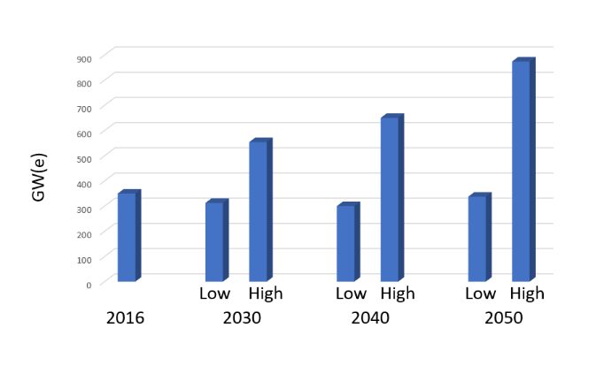
Fig.1. World Nuclear electrical Generating Capacity (adapted from [2] )

GEN IV INTERNATIONAL FORUM WEBINAR sWries from 2016 to 2022
The GIF ETWG has partnered with numerous university professors, scientists and engineers to create and deliver 62 webinars as of March 2022 focused on advanced reactor systems, and on numerous areas such as fuels, materials, fuel cycle (Table 1). These webinars in GIF related-topics are intended to be of interest to a various audience from scientists/engineers who are already in the workforce and may need a refresher course or a better understanding of specific topics, to managers, quality assurance officers, data validators, technicians, regulators, students who may benefit from an enhanced understanding of advanced reactor concepts in their work. As depicted in Table 1, webinars have been grouped on a specific topic such as Introduction, Gen IV systems, Operation experience, Fuel types, Sustainability of the Fuel cycle, and Pitch Competition Winners. The development of the webinars is guided by the webinar attendees who are asked to complete a survey at the end of each webinar requesting topics that may be of interest.

TABLE 1. GIF WEBINAR SERIES PRESENTED AND ARCHIVED FROM 2016 TO 2022

 | GIF webinars presented and archived from September 2016 to March 2022
Introduction 3 webinars | Atoms for Peace - John Kelly, USA (2016)  Introduction to Nuclear Reactor Design - Claude Renault, France (2016)  European Sodium Fast Reactor, An Introduction - Konstantin Mikityuk, Switzerland (2019)
Gen IV  Systems  19 webinars | Sodium cooled Fast Reactor - Bob Hill, USA (2016)  Lead Fast Reactor - Craig Smith, USA (2017)  Gas cooled Fast Reactor, Alfredo Vassile, France (2017)  Very High Temperature Reactors - Carl Sink, USA (2017)  Supercritical Water Reactors (SCWR), Laurence Leung, Canada (2017)  Fluoride cooled-High Temperature Reactors - Per Peterson, USA (2017)  Molten Salt Reactors - Elsa Merle, France (2017)  MYRRHA An Accelerator driven System Based on LFR Technology – H.A. Abderrahim, Belgium (2018) Molten Salt Actinide Recycler & Transforming System with and without Th-U Support: MOSART - Victor Ignatiev, Russia (2018)  Lead containing mainly Isotope Pb-208: New Reflector for Improving Safety of Fast Neutron Reactors - Evgeny Kulikov, Russia (2019)  Gen IV Coolants Quality Control - Christian Latge, France (2019)  Czech Experimental Program on MSR Technology Development, Jan Uhlir, Czech Republic (2019)  GIF VHTR Hydrogen Production Project Management Board, Sam Suppiah, Canada (2020)  Thermal Hydraulics in Liquid Metal Fast Reactor, Antoine Gerschenfeld, CEA, France (2020)  Micro-reactors: A Technology Option for Accelerated Innovation, D.V. Rao, USA (2020)  Overview of Small Modular Reactor Technology Development, Frederik Reitsma, IAEA (2020)  Experimental R&D in Russia to Justify Sodium Fast Reactors, Iuliia Kuzina, Russia (2021)  Metal Fuel for Prototype Generation-IV SFR :Design, Fabrication and Qualification, Chan Bock Lee, ROK (2021)  ESFR SMART a European Sodium Fast Reactor concept including the European feedback experience and the new safety commitments following Fukushima accident, Joel Guidez, France (2022)
Operational  Experience  13 webinars | Feedback Phénix and Superphénix - Joel Guidez, France (2017)  Design, Safety Features and Progress of HTR-PM - Yujie Dong, China (2018)  Astrid Lessons Learned - Gilles Rodriguez, France (2018)  Advanced Lead Fast Reactor European Demonstrator, ALFRED Project – A. Alemberti, EC (2018)  Russia BN 600 & BN 800 - Ilya Pakhomov, Russia (2018)  Safety of Gen IV Reactors - Luca Ammirabile, EC (2019)  The ALLEGRO Experimental Gas Cooled Fast Reactor Project - Ladislav Belovsky, Czech Republic, (2019)  Passive Decay Heat Removal, Mitchell Farmer, ANL USA (2019)  Molten Salt SFR Safety Design Criteria (SDC) and Safety Design Guideline (SDG), S. Kubo, Japan 2020)  Reactor Safety Evaluation - A U.S. Perspective, David Holcomb, USA (2020)  Introducing New Plant Systems Design Code, Nawal Prinja, UK (2021)  Experience of HTTR Licensing for Japan’s New Nuclear Regulation, Etsuo Ishitsuka, Japan (2021)  In Service Inspection and Repair Developments for SFRs and Extension to Other Gen4 Systems, François Baqué, France (2021)
Gen IV  Cross  Cutting  Topics  11 webinars | Energy Conversion, Richard Stainsby, United Kingdom (2017)  Estimating Costs of Gen IV Systems - Geoffrey Rothwell, NEA/OECD (2017)  Materials Challenges for Gen IV Reactors - Stu Maloy, USA (2018)  Proliferation Resistance and Physical Protection of Gen IV Reactor Systems, Robert Bari, USA (2018)  Maximizing Clean Energy Integration: The Role of Nuclear and Renewable Technologies in Integrated Energy Systems, Shannon Bragg-Sitton, USA (2020)  Global Potential for Small and Micro Reactor Systems to Provide Electricity Access, Amy Schweikert, USA (2020)  Neutrino and Gen IV Reactor Systems, Jonathan Link, USA (2020)  Overview of Waste Treatment Plant, Hanford Site, David Peeler, USA (2021)  Opportunities for Generation-IV Reactors Designers through Advanced Manufacturing Techniques, Isabella Van Rooyen, USA (2021)  Graded Approach: Not just Why and When, but How, Vince Chermak, USA (2021)  Geometry Design and Transient Simulation of a Heat Pipe Micro Reactor, Jun Wang, USA (2021)  Artificial Intelligence in support of NE Sector, Nawal Prinja, UK (2022)
Fuel Types 5 webinars | General Consideration on Thorium as a Nuclear Fuel - Franco Michel-Sendis, NEA/OECD (2017)  Metallic Fuels for SFRs - Steven Hayes, USA (2017)  Advanced Gas Reactor TRISO Particle Fuel - Madeline Feltus, USA (2019)  Performance Assessments for Fuels and Materials for Advanced Nuclear Reactors, D. LaBrier, USA (2020)  MOX Fuel for Advanced Reactors, Nathalie Chauvin, CEA France (2021)
Fuel Cycle 4 webinars | Closing the Fuel Cycle, Myeung Seung, Republic of Korea (2016)  Sustainability, A Relevant Approach for Defining Future Nuclear Fuel Cycles - Christophe Poinssot, France (2017)  Scientific and Technical Problems of Closed Nuclear Fuel in Two-Components Nuclear Energetics – Alexander Orlov, Russia (2019)  Comparison of 16 Reactors Neutronic Performance in Closed Th-U and U-Pu Cycles. J. Krepel,  Switzerland, (2020)
Winners of  Pitch  Competition  7 webinars | Formulation of Alternative Cement Matrix For Solidification/Stabilization of Nuclear Waste - Matthieu de Campos, France (2019)  Interactions between Sodium and Fission Products in case of a severe Accident in a Sodium-cooled Fast Reactor - Guilhem Kauric, France (2019)  Security Study of Sodium Gas Heat Exchangers in Frame of Sodium-Cooled Fast Reactors - Fang Chen, France (2019)  Development of Multiple Particle Positron Emission Tracking for Flow Measurement, Cody Wiggins, USA, (2020)  Evaluating Changing Paradigms Across the Nuclear Industry, Jessica Lovering, USA (2021)  Development of an austenitic/martensitic gradient steel connection by additive manufacturing, Flore Villaret, France (2021)  Scale effects and thermal-hydraulics: application to French SFR, Benjamin Jourdy, France (2022)

The topical lectures, delivered as 60 to 90 minutes live webinars, present a comprehensive overview of different subjects of interest. They are advertised at international levels at www.gen-4.org. The webinars consist of lectures and provide an opportunity for the audience to comment or ask questions at the end of each presentation. The system is designed for web conferencing and includes many features such as:

- Attendee registration
- Attendee questionnaires about the webinar they followed
- Scheduled reminders for the registered participants and follow up questionnaires, if desired.

The conferencing capabilities allow 200 attendees at one time.
The lectures presented since September 2016, along with the number of attendees per live webinars is presented in Fig. 2. These webinars are recorded live and are an efficient way to reach new audiences as well as to retain previously engaged audiences. Since the first webinar presented in September 2016, the ETWG has coordinated 62 free, live, interactive webinars and one special webinar featuring the past and current Chairs of the Generation IV International Forum, celebrating the 20th anniversary of GIF. As of March 2022, attendance during the live webcasts totals 5760 (Fig. 2A); it is worth mentioning that the live attendance was of 2179 in 2019. The number of viewing of recorded webinars in the online archive is 6772 (Fig. 2B), a strong increase when compared with the attendance of 3747 in 2019. The total of webinar viewing is 12538 in five years.

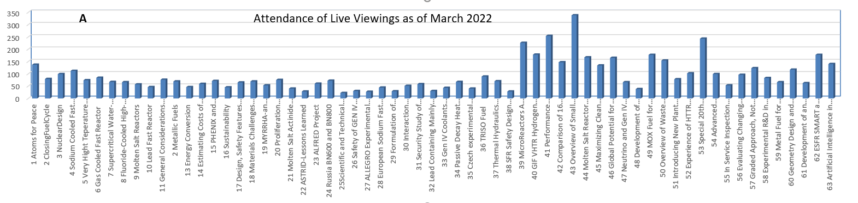

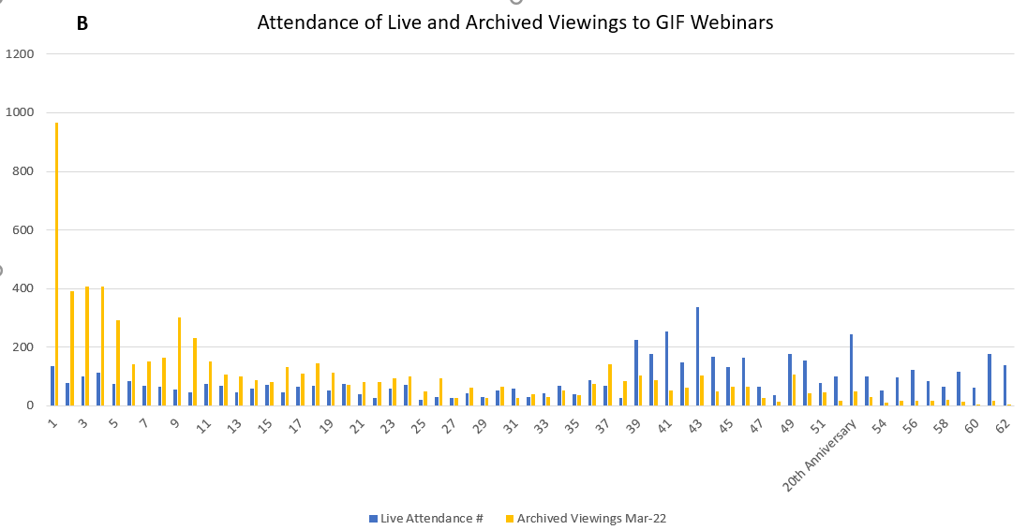

Fig. 2A and 2B. Attendance of Live and Archived Viewings to GIF Webinars

The participants in the GIF webinars include representatives from multiple organizations such as federal agencies, national laboratories, various state agencies, universities, international organizations, contractors, and commercial organizations. Fig. 3 presents the comparison of the GIF webinar attendance distribution for a total of 36 webinars presented at the end of 2019 with those added until March 2022 (total of 62webinars). There is an increase of viewing by international organizations as evidenced by the following numbers: 35% of international organizations in 2019 and 55% in 2022.
Recordings are not only accessible online at www.gen-4.org but we recently converted all the archived webinar as YouTube videos that can be viewed at https://www.youtube.com/channel/UCEHOQ63gD01fSKbClY9XvSQ.

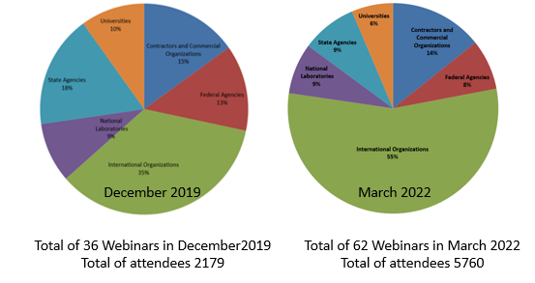
Fig. 3. Comparison of the GIF webinar attendance distribution in 2019 and 2022

This increase of international participation is also reflected by an increase in the number of countries which are participating in either the live webinar presentation or watching the recorded webinars (Fig. 4). In October 2019, participants from 20 countries followed the live webinar. From 20 countries in 2019, the number of participants who viewed at least one live webinar, went up to 76 countries in March 2022. That is a remarkable increase.

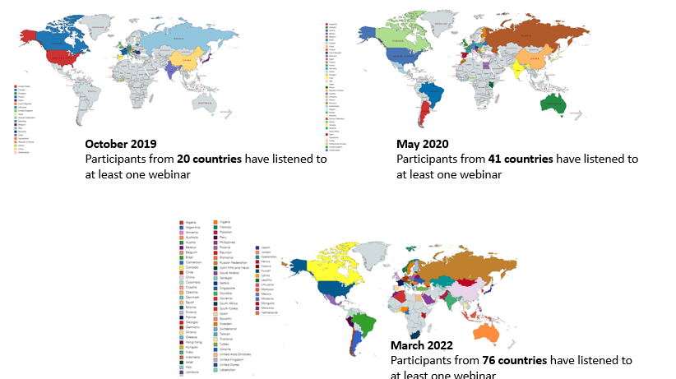
Fig. 4. Comparison of International Participation in the Attendance of GIF Webinar Series

GEN IV INTERNATIONAL Education and TraininG activities in 2021
Webinars are planned until November 2022 and are displayed in Table 2. The presenter scheduled in May 2022 was 3rd placed winner of the first-ever ETWG “Pitch your Gen IV Research Competition”. This competition was launched on the 1st of February 2021 and was open to a) currently enrolled PhD students and b) Post-Doctoral fellows and junior researchers who defended their Ph.D. after January 1, 2019. The research had to be related to GIF Advanced Nuclear Energy Systems and could have been either an independent research project or one working with a research mentor. Participants submitted a 750-word executive summary and up to 25 finalists were invited to record a three-minute video pitch of their project. The 1st and 2nd winners presented their webinars in December 2021 and March 2022 respectively. Including the junior workforce is as important as training and educating, so the ETWG expects to be able to repeat the competition every 2 years, which offers an opportunity to PhD students, post-doctoral fellows as well as junior scientists and engineers to present a GIF webinar on their dedicated research. In addition, the first winner of the competition is invited to participate in the upcoming GIF Industry Symposium in Toronto, Canada (October 2022).

TABLE 2. GIF WEBINAR SERIES FROM MARCH TO NOVEMBER 2022

Presenter | Title of Webinar | Date
Benjamin Jourdy, CEA, France  2nd winner of the Pitch your Gen IV Research Competition | Scale effects and thermal-hydraulics: application to French SFR | 23 March 2022
Joint GIF/IAEA/NEA Webinar  Diane Cameron, NEA  Wei Huang, IAEA  Shannon Bragg-Sitton | Role of Nuclear Energy in Reducing CO₂ Emissions | 19 April 2022
JiHo Shin, KAIST, ROK  3rd winner of the Pitch your Gen IV Research Competition | Development of nanosized carbide dispersed advanced radiation resistant austenitic stainless steel (ARES) for Generation IV systems | 11 May 2022
John Vienna and Brian Riley, PNNL, USA | Nuclear Waste Management Strategy for Molten Salt Reactor Systems | 15 June 2022
Junghyun Bae, Purdue University, USA  Winner of the ANS Pitch your PhD competition | A Gas Cherenkov Muon Spectrometer for Nuclear Security Applications | 27 July 2022
ShigeruTakaya, JAEA, Japan | Development of In-Service Inspection Rules for Sodium-Cooled Fast Reactors Using the System Based Code Concept | 28 September 2022
Jewhan Lee , KAERI, ROK | Sodium Integral Effect Test Loop for Safety Simulation and Assessment (STELLA) | 26 October 2022
Mark Deinert, Colorado School of Mines, USA | Visualization tool for comparing energy generation options | November 2022

conclusion
Because of its easy access at no cost, the ETWG decided to present webinars and exploited this modern internet technology to reach the interests of a broader audience. After five years of non-stop presentations, the very successful GIF webinars have demonstrated a strong need of such resources for the nuclear energy community to maintain its level of expertise on Gen IV reactor systems and to increase interest in this technology. In addition, because of the passion and grass root efforts from professionals and educators, the ETWG’s goal of creating an archive of online GIF webinars has become a reality. The webinars are accessible online in two formats: audio-video recording and .pdf slides. This is a free public access resource that makes it even more attractive to the nuclear energy community.

REFERENCES
- WORLD NUCLEAR ASSOCIATION, https://www.world-nuclear.org/information-library/current-and-future-generation/world-energy-needs-and-nuclear-power.aspx, (December 2020)
- IAEA, “Energy, electricity, and nuclear power estimates for the period up to 2050”, IAEA-RDS-1/37, Vienna, (2017)

