Treatment of sodium of Superphenix Fast Breeder Reactor

D. VILLANI
Framatome
Lyon, France
Email: dominique.villani@framatome.com

P. ROSSAT-MIGNOD
EDF-DP2D
Lyon, France

I. PIGNON
Cyclife Engineering
Lyon, France

Abstract

A large quantity of sodium is contained in fast breeder reactor and its neutralization is a major step of Decommissioning &Dismantling of this type of reactor. Indeed, sodium treatment greatly reduces operating costs, eliminates chemical hazards (hydrogen, sodium hydroxide) and reduces radiological hazards associated mainly with tritium releases.
Sodium elimination step is based on 3 main types of activities, draining performed under operating procedures with existing equipment or under specific procedures with dedicated equipment, bulk sodium treatment in a specific facility designed to treat a large quantity of nuclear sodium and finally residual sodium treatment after draining.
The paper presents how the sodium (more than 5520 tonnes) of the largest FBR (Superphenix reactor or SPX) ever built in the world was neutralized and how the filling with water of the primary circuit was made possible afterwards.

INTRODUCTION
The definitive shutdown of SPX reactor was announced in June 1997 and enacted by a decree in late 1998. EDF rapidly decided to start the reactor dismantling for technical reasons (not keeping in liquid form large amounts of sodium) and for human resources availability.
Preliminary studies were carried out from 1999 to 2002 to define the reference scenario of SPX dismantling by considering the international experiences on sodium reactors [1]. EDF got in 2006 the decree authorizing its definitive shutdown and dismantling which allowed it to start sodium treatment and nuclear dismantling and to have completed by 2015 the entire sodium destruction. Radioactivity of primary sodium is low, in 2015, activies of major contributing isotopes were in Bq/kg 1x10⁷ of ³H and 4x10⁴ of ²²Na. Associated with the decree for dismantling, a new set of release authorizations was provided in 2007 for 10 years. As the release of tritium is a major issue during sodium treatment, all major sodium treatments must be completed in 2017.
A description of activities on SPX site was presented in FR17 [2] from 1998 to the end of 2016 with the beginning of the treatment of the residual sodium of the primary vessel by carbonation.
The current paper presents how the sodium (more than 5520 tonnes) of SPX was neutralized and how it was made possible the filling with water of the primary circuit in 2017 and then to store it without any use of cover gas, but only air. First activities on sodium were carried out under the existing decree to drain sodium in the storage tanks and treat sodium with existing systems (fuel assemblies washing for example). Other activities on sodium treatments (bulk sodium and residual sodium) were launched under the 2006 decree. The draining strategy implemented (main and additional draining) made it possible to supply the bulk sodium treatment facility as continuously as possible and to take advantage of its high efficiency.

Draining
Sodium draining should be as complete as possible in order to reduce costs associated with dismantling operations and make it safer. Activities on residual sodium treatment are greatly reduced if draining operations are managed with specific attentions (presence of counter slope, draining time, …).
During the preliminary studies, the tanks kept in operation for the storage of sodium are determined and the associated sodium circuits used to transfer sodium from storage to the bulk sodium treatment facility (TNA facility) are defined, see Fig. 1.
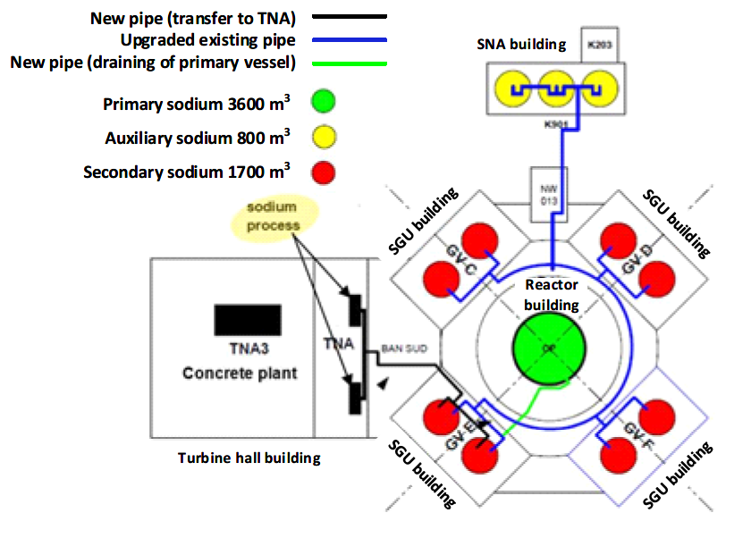
Fig. 1. Implantation of sodium storage and associated sodium circuit for transfer to TNA facility (NOAH Process).
Draining can be a normal operating activity or an exceptional activity of draining in situ or in a dedicated workshop after transfer of components. These 2 types of exceptional operations are presented in the following paragraphs.

Exceptional in situ draining operation

Draining of primary vessel
Regarding SPX primary circuit, draining was carried out after an in-depth study phase to detect retentions and define the means to reduce it. Theses means can be setting up siphons to eliminate the retention during the vessel draining phase, drilling (before main draining or after), pumping, or melting of sodium in the top closures of the slab (around components and plugs), see details in [2].
To limit sodium retentions, the draining of the primary vessel is implemented after the unloading of all assemblies and neutral protection shields. Likewise, the extraction of removable components begun before the start of the primary draining to provide access for equipment and finished few months after to take advantage of the biological protection linked to the presence of sodium.
Primary sodium was transferred to the sodium treatment facility via temporary storage in secondary sodium storage tanks of Steam Generator building “E” using a drain module with immersed Electromagnetic pump. Twenty batches alternately of 140 or 240 m³ of sodium were carried out to fill the storage tanks.
The main draining of primary vessel began in November 2010 and finished in January 2013. The temperature of primary sodium was 180°C for all the draining at the exception of the last batches where the temperature was increased near to 200°C. The electromagnetic pump is placed in the module just above the grid plate. The bottom of the module is extended by a drain nozzle (straight tube until the bottom of the vessel). The remaining sodium was estimated by visual inspection.
From January 2013 to October 2014, activities were carried out to treat some retentions by cutting at ambient temperature by laser. This duration includes the necessary time for the cooling of the primary vessel to begin activities in the vessel and the duration to heat the vessel from ambient temperature to the required temperature for additional draining.
The additional draining of primary vessel began in October 2014 and finished in January 2015. Two similar pumping were carried out with the drain module with a flexible hose located at the bottom of the vessel then another one located in the double wall of the core catcher. A special handling was carried out between the 2 operations to change the draining nozzles. The temperature of the primary sodium was between 140 and 180°C.
After draining the 3,500 tonnes of sodium from primary circuit, the visual inspections confirmed that the objectives of the draining were achieved and that the quantity of residual sodium was compatible with carbonation treatment followed by the flooding of the primary vessel. Afterwards, by analyzing the hydrogen signal recorded during carbonation and water flooding of the primary vessel, an amount of approximately 1,650 kg of residual sodium was determined as being still present at the end of the draining, both in the form of film and retention.

Draining of Component in situ
Heat exchangers
The draining of component was carried out in situ mainly because it was not possible to transfer the component to be drained in a dedicated workshop and in some case because the draining workshop was not available before the start of the bulk sodium treatment.
The first activities were aimed at separating heat exchangers located on the slab of primary vessel from the associated sodium loops. After draining, exchangers were extracted from the primary vessel and treated as described in §4.1.2 . The draining operations were carried out as follows:
- The 8 heat exchangers of the 4 secondary loops were drained by pressurization with a dip tube. About 40 m³ of sodium was transferred in secondary storage tanks for each loop.
- The 4 heat exchangers of the 4 emergency cooling loops were first drained by pressurization in secondary storage tanks and then by gravity, in an oven after modification, in a shuttle tank.
Tanks
Activities were scheduled to liberate rooms from sodium by considering the possibility to gather sodium in the selected sodium storage tanks as presented in Fig. 1 until the starting of the bulk sodium treatment (2010). Once sodium transferred towards TNA facility, sodium tanks were drained of sodium retentions.
For tanks with diameter larger than 2 m (19 tanks), heels of all tanks were drained by creating a low point drain connection. Depending on the configuration of the sodium circuits, the drained sodium is transferred in sodium storage tanks or in shuttle tank. The “In gas fuel transfer station” which has replaced the “External vessel storage tank” and the 3 Primary sodium storage tanks were drained in a shuttle tank.
Cold traps
6 Small cold traps, 2 MAB (External vessel cooling system) and 4 RUR (emergency cooling system), were drained in situ in 2006 to be used to qualify the process treatment of large secondary and primary cold traps. Four secondary cold traps (BAS) were drained in situ because the handling of those components filled with sodium was complicated. The draining was scheduled by the necessity to wait for a partial draining of secondary sodium storage tank. All these cold traps were drained in secondary storage tanks by creating a low point drain connection. Table 1 presents the volume of sodium drained and the year of the draining.
Table 1 Synthesis of in situ sodium draining
Components | Volume m³ | Shuttle | year
4 Heat Exchanger of Emergency cooling loop | 4 | No | 2002-2003
8 Heat Exchanger of Secondary loop | 160 | No | 2004
3 Primary sodium storage tanks | 0,6 | Yes | 2007
1 Purification sodium tank for External Storage | 1 | No | 2009
In gas fuel transfer station | 2 | Yes | 2011
8 Secondary sodium storage tanks | 54 | No | 2012-2014
4 Emergency cooling loop storage tanks | 1,2 | No | 2012-2014
3 Auxiliary sodium storage tanks | 0,6 | No | 2014
10 Cold traps (2 MAB, 4 RUR, 4 BAS) | 25 | No | 2006-2014

Draining of NaK components
NaK eutectic was used at SPX in a number of applications: waveguide for VISUS (under sodium visualization device for fuel handling), coolant in secondary cold trap double envelope, filter in bubblers to purify argon, and liquid for hydraulic safety valves.
About 7 tonnes of NaK were drained and diluted mainly in primary sodium from June 2010 to March 2011 before the start of the primary sodium draining (primary sodium was kept liquid and was ready for dilution). Additionally, from August 2010 to end of 2013, NaK was diluted in secondary sodium to be treated with bulk sodium in TNA facility (when secondary sodium in storage tanks was liquid for sodium transfer to TNA facility).

Component draining in a dedicated workshop
A dedicated workshop named TND was designed and set up for draining removable capacities. This workshop was used to completely drain capacities containing any grade of sodium. The sodium collected was decanted and then filtered in order to be massively treated in a continuous flow facility (TNA facility). The design of the workshop considered a high risk of sodium leaks due to capacities histories (risk of cracking) and to the necessity to create new connections on the capacities.
TND workshop was studied from March 2004 to January 2006. Assembly began in April 2008 and the system was qualified on the basis of an initial sodium drainage operation in October 2009. Thanks to the design of the system, one tank was drained each month by creating the necessary connections for satisfactory drainage.
This system incorporates the risk of sodium fires and leaks with the use of a retention tray and jet deflector, sodium fire and leak detectors. Extinguishing devices such as MARCALINA powder or inert gas are also set up.
From 2009 to 2014, around 20 capacities (including shuttle tanks used for in situ draining) were drained in TND workshop and more than 40 m³ of sodium were transferred to TNA facility for treatment.
Fig. 2 presents on the left a photo of a shuttle tank on its stand in TND workshop. This tank is around 2 m in diameter and 2,5 m³ of volume. Fig. 2 presents on the right a photo of a MAS (auxiliary circuit of external vessel sodium storage) cold trap on its stand in TND workshop. Under the cold trap, a sodium retention of 6 m³ is implanted to collect the sodium in case of leak.

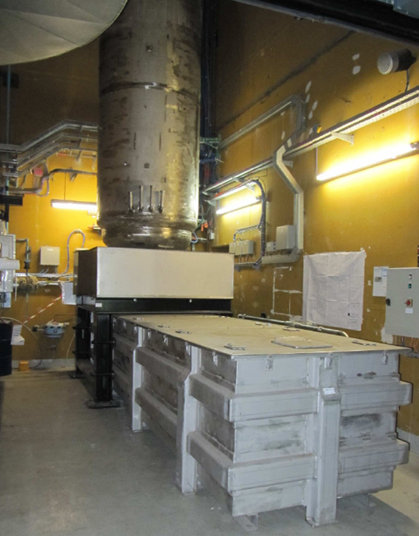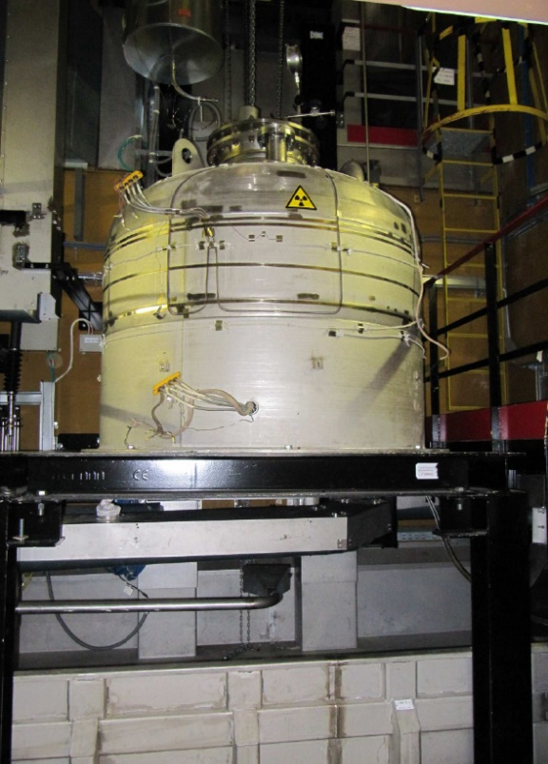
Fig. 2. Photos of sodium capacities prepared for draining in TND workshop

Bulk sodium Treatment
Principle of sodium hydrolysis was developed by CEA for bulk sodium treatment of Rapsodie reactor in 1994. This so-called "NOAH" patented process was industrialized by Framatome for sodium treatment (1,500 tonnes) of the Prototype Fast Reactor in Scotland. The PFR facility, named SDP, has treated sodium in Dounreay until 2008. The produced soda was neutralized and purified (cesium trapping) before the release to the sea.
EDF has adopted NOAH process for the treatment of the 5,520 tonnes of SPX sodium which were neutralized from 2010 to October 2014 in the TNA facility. As presented in [2], the sodium hydroxide produced by the TNA facility was introduced in concrete blocks and the blocks are stored on site.
As presented in Fig. 1, the main sodium storage tanks were connected to transfer the sodium towards the TNA facility passing through the header tanks in the steam generator building of the “E” secondary loop.
Until November 2011, the sodium of the secondary loops E and F was treated in TNA facility (about 350 tonnes).
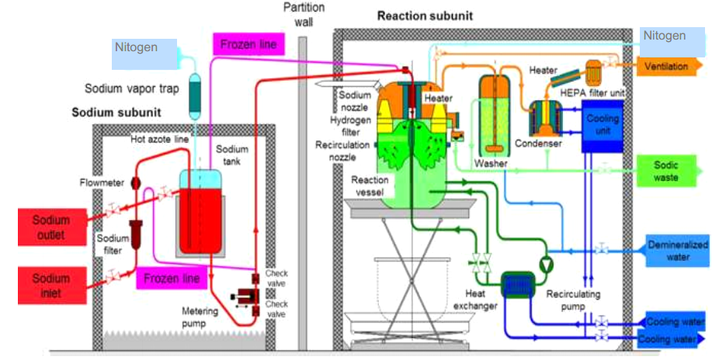
Fig. 3. Schematic diagram of the TNA facility (NOAH Process)

From November 2011 to January 2013, the primary sodium was transferred in the steam generator building of the “E” secondary loop and was treated in line with the draining of the primary vessel. During this period, the storage area of steam generator building E and the TNA facility in the turbine hall building was integrated in the radioactive controlled area of the reactor. The sodium temperature at the inlet of TNA facility is required at 125°C and is increased regularly until reaching the sodium injection nozzle. The 2 header tanks in the steam generator building E are used to cool the primary sodium from 180°C (draining temperature) to 125°C (TNA inlet temperature). According to the useful volumes of the tanks, the time to treat the sodium of a tank is 3 weeks for the small one (140 m³), 5 weeks for the big one (240 m³). The primary sodium processing actually started in TNA on January 17th 2011.
After the treatment of the primary sodium (about 3500 tonnes), the sodium of the secondary loops C and D and the sodium stored in SNA building was treated in TNA facility (about 1050 tonnes) from January 2013 to March 2014. TNA facility was definitively shutdown in November 2014 after a last run for the treatment of sodium coming from draining of retentions (end of sodium treatment on October 10th 2014).
As indicated in the paragraphs above, the operation of the TNA facility was the dismantling driver on this period and determined the scheduling of a lot of surroundings activities as indicated in the paragraphs above:
- Draining and dilution of NaK eutectic in sodium to be treated in TNA facility.
- Draining of component in situ or in TND workshop.
- Handling of removable components of the primary circuit before the partial draining of the primary vessel to keep the biological protection of sodium against radiation, ….
Thus, the high availability of the TNA facility (about 82%) has made it possible to make all these related activities more reliable.

Residual sodium treatment
The treatment of residual sodium on SPX was carried out by classical means used during the operation of the reactor:
- Treatment of residual sodium of assemblies by washing in pit of handling cells (fuel and steel assemblies).
- Treatment of residual sodium of component by washing in pit associated to special handling with casks.
- Treatment of residual sodium directly by workers in dedicated room (scrapping of sodium and hand washing) on small component.
New treatments were developed for the dismantling of the reactor depending on the characteristics of residual sodium (chemical characteristics, geometrical characteristics of sodium and environment, radiological aspects). Three configurations were used:
- Carbonation in situ of main sodium circuits and tanks,
- Carbonation in washing pits of main removable components,
- Thermolysis and High temperature Wet Vapor Nitrogen (WVN) for specific components as cold traps.
Carbonation is completed by rinsing depending on the radiological environment as it was done for the primary circuit. These treatments (carbonation, Thermolysis and High temperature WVN, rinsing) were carried out under the dismantling decree of 2006 and were scheduled according to the dismantling plan to free up rooms to set up specific workshops. In particular, rooms of secondary circuits in the reactor building are used for the dismantling of Core cover plug, rotating plugs and the diagrid supporting the core.
The treatment of residual sodium which was linked to the treatment of bulk sodium by TNA facility had a deadline imposed by the authorizations of release (a decrease by a factor 50 of tritium release in August 2017). As a result, a detailed planning of the activities was carried out to treat the majority of the residual sodium before August 2017 (carbonation of the primary vessel, treatment of the primary and secondary cold traps).

Carbonation
As the residual sodium, after draining, is essentially in the form of films on the walls, the techniques of carbonation by venting with wet CO2 in nitrogen matrix enable to effectively neutralize this residual sodium and transform it into a thin solid layer of stable carbonate, see details on Fig. 4. Then the dismantling of these circuits or components can be carried out without rinsing, in particular when the radioactivity of sodium and structure is very low. During the treatment, most of the tritium activity is released with the treatment gas in the atmosphere (stack of the site). The discharge rate is controlled by the water content while respecting the discharge authorizations. Very little tritium remains present in the components.
This treatment is well known and has been already implemented on SPX in 1988 to dismantle the vessel of the assemblies’ external vessel storage (named Barillet) following the leakage of sodium.
To optimize SPX decommissioning, EDF has defined its carbonation strategy by considering CEA tests and results of dismantling of 2 sodium systems on SPX site with and without carbonation. The chosen strategy was to use carbonation treatment for piping above 200 mm in diameter. Indeed, small diameter piping networks, due to retentions and local clogging risks presents more difficulties to be treated and less difficulties to be dismantled without treatment.
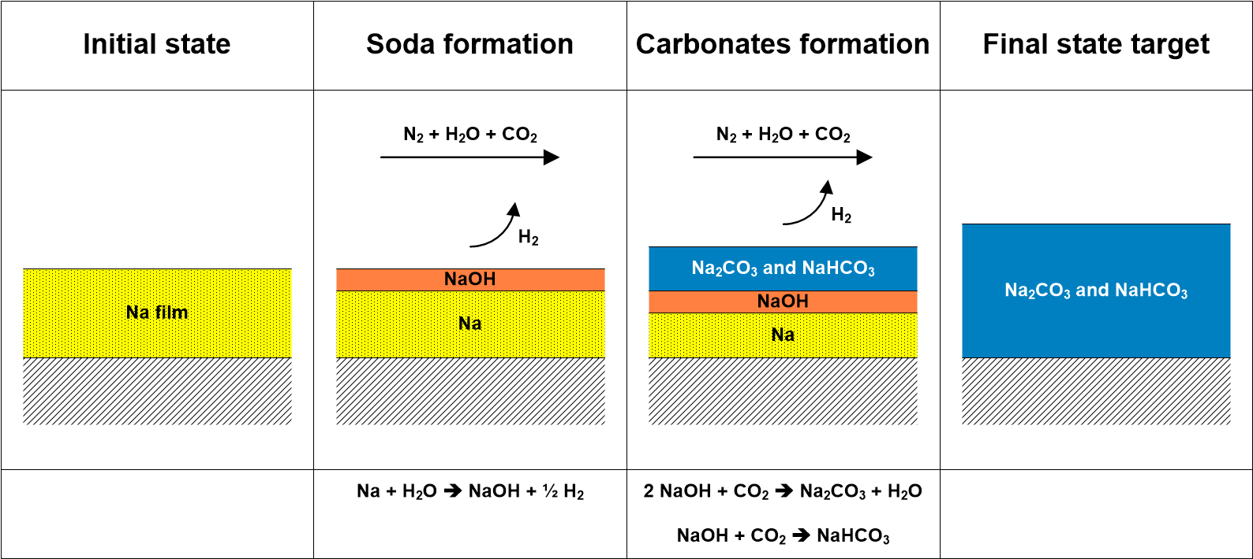
Fig. 4. Principles of the carbonation treatment.

Carbonation in situ of circuits and tanks
Industrial implementation of carbonation was validated by successive treatment of 4 secondary loops of SPX from 2007 to 2008. The carbonation network is defined by the secondary sodium loop after the isolations of the 2 IHX (isolation for draining in 2004 see Table 1), and of the 2 storage tanks used for the storage of sodium to transfer the sodium towards TNA, see Fig. 1.
The characteristics of the carbonation networks of the secondary loops are:
- Total volume: 310 m³
- Total surface: 5180 m²
- Residual sodium: 100 kg (Steam generator 75 kg),
- Tritium activity: 14,8 GBq
The principle of constitution of the carbonation network of the secondary loop are presented on Fig. 5.
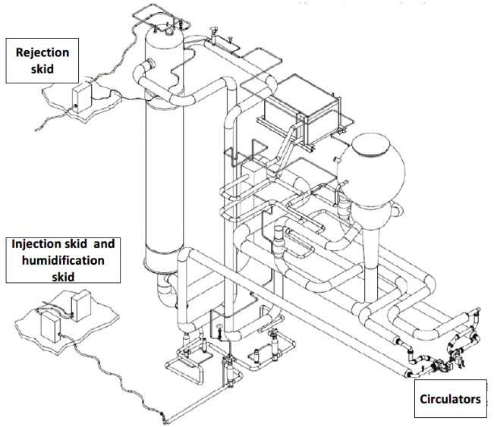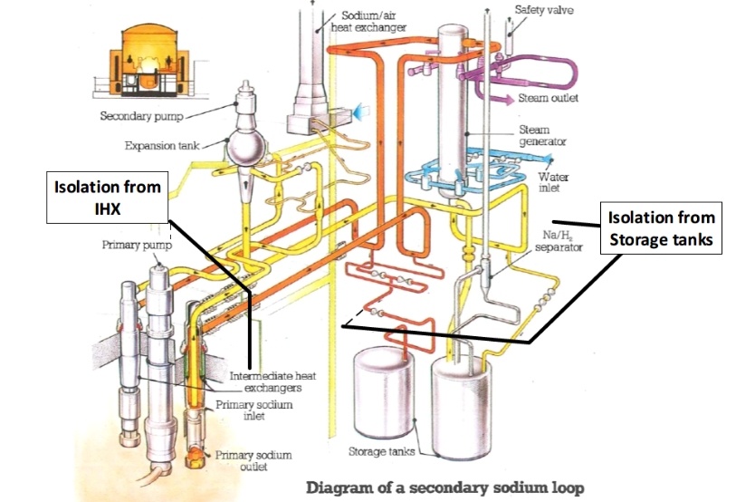
Fig. 5. Carbonation treatment network for secondary loops

The carbonation parameters were optimized on the basis of the treatment of the first loop (content of CO2, content of water). The injection rate was 300 m³/h, the temperature of sodium circuit was around 50°C, the water content until 1,1%. The recirculation rate was 2 x 4400 Nm³/h by the use of 2 circulators.
The treatments were carried out by combining open mode (permanent injection of reactants and release of reaction products) and closed mode (filling the network with reactants, waiting for the carbonation and releasing reaction products while refilling). The duration of treatment was approximately 6 weeks, including 1 week of open-mode treatment. The amount of residual sodium treated by carbonation was around 100 kg by loop with à release by loop varying from 14 to 25 GBq of tritium.
Table 2 presents the carbonations which were carried out in situ on SPX site. All these components are then kept in dry air atmosphere after treatment. All these treatments were carried out by using the same skids (injection, humidification, rejection and analysis) connected to the carbonation circuits by flexible pipes. The carbonation of primary vessel is presented in a dedicated paragraph, § 4.1.3.

Table 2 Synthesis of in situ carbonation of circuits and tanks
Sodium circuit | Na (kg) | Tritium (GBq) | year
4 Secondary loops (except sodium storage tanks) | 330 | 76 | 2007-2009
Rotating lock between primary vessel and PTC | 5 | 300 | 2011
5 Primary sodium storage tanks (RAS) | 140 | 145 | 2015-2016
In gas fuel transfer station (PTC) | 114 | 501 | 2017
3 Auxiliary sodium storage tanks (SNA) | 150 | 16 | 2020
Secondary sodium storage tanks (3 by loop, 4 loops) | 120 | 700 | 2020

Carbonation of removable components of primary circuit
After industrial qualification on secondary loops as presented in the above paragraph, carbonation was then applied from 2010 to 2012 to treat all removable components of primary circuit. Carbonation was realized in washing pit and components were dismantled afterwards in a dedicated workshop without eliminating sodium carbonate by water dissolution. See details in reference [2].
On Fig. 6 is presented the principle of carbonation of primary components in pit. The carbonation system is based on the skids developed for the carbonation of secondary loop. The treatment gas is injected at the bottom of the existing washing pit and extracted at the top.
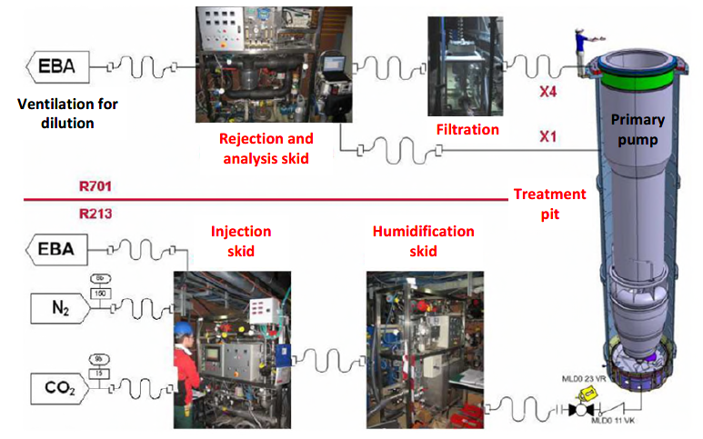
Fig. 6. Carbonation of primary pump in pit

In Table 3 are listed the primary components which were treated in the MLD treatment pit. The results of the RPI component must be analyzed separately because this component received the removable cartridge of primary cold trap. Due to the functioning with internal cooling system, sodium was trapped on the envelope of the module in the slab penetration and sodium hydride was trapped inside the module. The treatment of these components was finished by thermolysis according to the process presented in § 4.3. The results of the other primary components show that the tritium amount is very sensitive to the surface with heat transfer (the treatment of IHX of secondary loops released a factor 3 times higher of tritium by kg of sodium).

Table 3 Synthesis of carbonation of removable components in pit
Primary component | Na (kg) | Tritium (GBq) | year
4 primary pumps | 28 | 77 | 2010
8 intermediate heat exchanger (IHX) of secondary loop (BCS) | 160 | 1 322 | 2011-2012
4 intermediate heat exchanger (IHX) of emergency cooling loop (RUR) | 8 | 44 | 2012
2 integrated purification modules (RPI) | 80 | 28 000 | 2011-2012

Carbonation of primary vessel
The carbonation of the primary vessel (volume: 4500 m³) is implemented after the complete draining of the sodium, the extraction of all removable components, the unloading of all assemblies and neutral protection shields and the dismantling of rotating transfer lock to reduce sodium retentions and provide access for equipment of carbonation. See on Fig. 7 the schematic view of the carbonation system of the primary vessel of SPX.
The heating system of the primary vessel implanted for fuel unloading and that of the slab are used to maintain the temperature of structure above 40°C and prevent the risk of condensation. The treatment gas is injected in the vessel at a rate of 500 m³/h. Injection and rejection are carried out by skids implanted on the slab. 4 recirculating loops are set-up to force gas circulation in the primary vessel through connections of primary pumps. The flow rate of each loop is around 3750 m³/h.
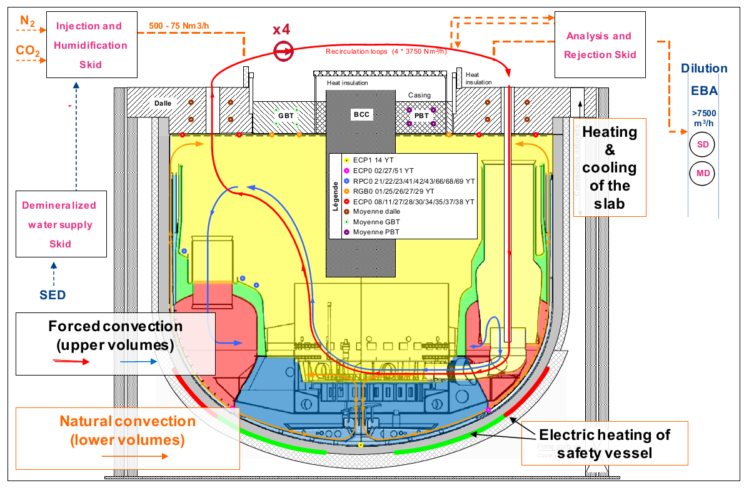
Fig. 7. Carbonation of primary vessel
The carbonation started on 22/11/2016 until 23/12/2016 in open mode. Carbonation ended on 22/02/2017 after discontinuous carbonation mode. Around 1500 kg of remaining sodium were treated during carbonation (500 kg of film) and 5.3 TBq of tritium was released.

Rinsing of primary vessel
Due to the high radiological activities of structures in the primary vessel (diagrid in particular where assemblies were supported), rinsing of the primary vessel was chosen. The water in the primary vessel acts as a biological shield and allows operations to be carried out on Core Cover Plug and Rotating Plugs with a reduced dose rate.
To manage the sodium water reaction induced by the flooding, as presented before, a lot of operations were carried out during draining as complete as possible and continued by carbonation. In addition, a detailed scenario for flooding was also determined to treat successively the residual sodium still present under carbonates in the identified retentions of sodium. The flooding of the primary vessel is carried out using nitrogen as inert gas.
The flooding scenario is the following:
- Start of the flooding on 1/06/2017 by a slow immersion from the bottom of the primary vessel.
- Treatment of the triple point (connection of the core support and the primary vessel) by using acid to increase the dissolution rate of carbonates in this specific environment.
- Slow immersion and rinsing of slab penetrations.
- Filling in of the primary vessel until the low plate of the core cover plug until 10/10/2017. The primary vessel has been filled with 2330 m³ of demineralized water.
- Venting cover gas of primary vessel with air on 31/10/2017 with elimination of the risk of anoxia.
Around 150 kg of remaining sodium were treated during flooding and 0.1 TBq of tritium was released. During sodium retention washing, some reaction noises were detected but no large increase of pressure was measured.

Thermolysis and High temperature WVN
Cold traps, during the reactor life, are used to trap sodium oxides and hydrides but they trap also tritium, caesium, corrosion products and fission products in the event of clad failures. Due to geometrical considerations, carbonation is not well suited to the treatment of cold traps, the expansion of carbonates in the mesh blocks the passage of treatment gas.
A specific treatment process has been developed for the treatment of SPX cold traps by combining a Thermolysis phase for the sodium hydrides followed by a high temperature WVN phase for residual metallic sodium and sodium oxides, see details in [3]. This treatment is applied after the draining of sodium at low temperature and the transfer of sodium towards the bulk sodium treatment plant, see § 2.1.2 and 2.2.
During the Thermolysis phase, the temperature rise of the component is precisely increased by controlling the release of hydrogen and tritium. Metallic sodium is collected at the bottom of the component and can be transferred to the bulk treatment plant. Most of the tritium trapped in the cold traps is released during this phase.
During the high temperature WVN phase (also called Superheated Steam or SHS), the temperature of the component is maintained at about 350°C to produce anhydrous liquid sodium hydroxide. This liquid sodium hydroxide is collected at the bottom of the component.
Nine large cold traps for secondary and auxiliary circuits were treated from 2013 to 2015. 11 cartridges of primary cold traps and 2 envelopes were processed from 2016 to 2017 with the same process, in a pit. Thanks to this process, 850 kg of sodium hydride, 700 kg of sodium, 850 kg of sodium oxide were treated and 120 TBq of tritium were released. After this treatment, all the cold traps and cartridges were dismantled without any difficulty by Cyclife France in CENTRACO melting facility, see details in [4].

Conclusion
Following the treatment of the bulk sodium and the residual sodium, in particular that in the primary vessel, major steps in the dismantling of SPX were achieved successfully in 2019 with the extraction of the Core Cover plug in July 2019 and of the small rotating plug in September 2019, see photos on Fig. 8. These 2 components have been transferred in 2 dedicated workshops in the reactor building, dismantling is in progress.
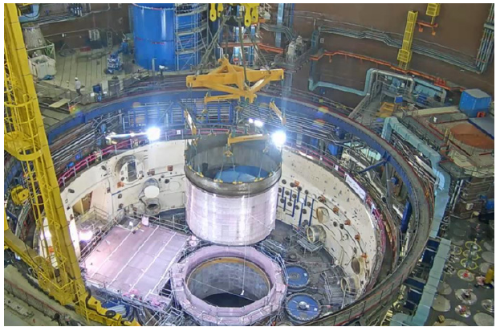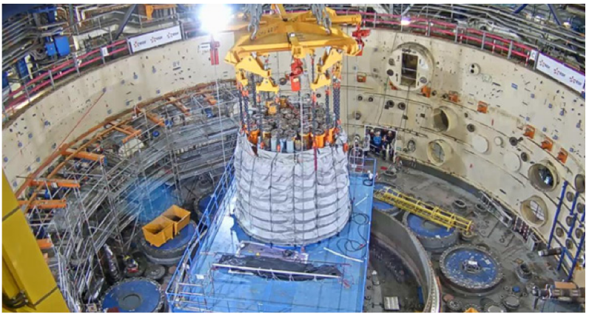
Fig. 8. Extraction of the Core Cover Plug (left) and small rotating plug (right).
Next step in the dismantling of the primary vessel will be the extraction of the Large Rotating Plug, scheduled at the beginning of 2022. This component must be cut in 3 parts to be handled by the polar crane (the mass of the large rotating plug is 570 tonnes).
Thus the treatment of sodium (in mass and residual) allowed a safer dismantling and an evacuation of the waste without problem. Indeed, the risks incurred during dismantling are greatly reduced by eliminating the anoxia risk, the sodium risk and the chemical risk (soda). The tritium risk has been completely managed by allowing its elimination by controlled release to the atmosphere at the stack of the site during sodium treatment.
References
- JOULIA, E., “SUPERPHENIX – Creys Malville strategy for dismantling the reactor block”, IAEA-TECDOC-1663
- BOUILLY, V. et al., “SUPERPHENIX Dismantling – Status and lessons learned”, Fast Reactors and Related Fuel Cycles: Next Generation Nuclear Systems for Sustainable Development FR17 (Proc. Int. Conf., Yekaterinburg, 2017), IAEA, Vienna (2018), Paper CN245-560.
- CARRA, O. “Secondary cold traps treatment at Superphénix”, IAEA-TECDOC-1663
- VILLANI D., “Treatment of cold traps of Superphenix Fast Breeder Reactor by Thermolysis and Hot WVN” DEM 2018 France, Avignon – 2018 October 22-24

