DESIGN, EXPERIMENTAL TRIALS AND QUALIFICATION
OF EXPLOSIVE WELDING TECHNIQUE FOR PLUGGING
OF DEGRADED PFBR STEAM GENERATOR TUBES
P. Visweswaran^{1*}, Jatinder Kaur², Dinesh Kumar², Jaspreet Singh², D. Jagadishan¹,
H.C. Dey³, Manam Sambasiva Rao¹, S. Joseph Winston¹, Niraj Srivastava²
¹Reactor Design & Technology Group, Indira Gandhi Centre for Atomic Research, Kalpakkam, India
² Terminal Ballistics Research Laboratory, Chandigarh, India
³Metallurgy & Materials Group, Indira Gandhi Centre for Atomic Research, Kalpakkam, India
*email of corresponding author: visweswaran@igcar.gov.in

Abstract

The PFBR Steam Generator is monitored for failure of the SG tubes using periodic in-service inspection. In case of a tube failure, the particular tube has to be isolated from service by plugging the tube at both the ends. The paper discusses the plugging process using explosive welding technique for PFBR steam generator tubes. The design of the plug should be carried out such that the plug is able to withstand the operating conditions of the SG and also compatible to carry out the explosive welding of the plug with the tubesheet block. Since, the explosive welding process involves a large number of process parameters; it is planned to optimize through various experiments. The explosive welding experiments were conducted on certain number of samples. The explosive welded samples were subjected to non-destructive and microstructure examination in order to qualify the explosive welds. From the results it is found that an average bond length is greater than 4 mm is obtained from the explosive welded joints.

1. Introduction
The Prototype Fast Breeder Reactor (PFBR) is a 500 MWe capacity sodium cooled fast breeder reactor under commissioning in Kalpakkam, India. The PFBR has 8 Steam Generators (SG) in the two secondary sodium loops. The SG contains sodium in the shell side and water/steam in the tube side. Since the sodium-water reaction is exothermic in nature, the safe operation and availability of the SG depends on the healthiness of the tube wall thickness which is the primary barrier between the high temperature sodium and water/steam. Hence, the tube integrity is of utmost importance for the safe operation of the plant. The SG tubes experience a high pressure of 172 bar at high temperature of 525ºC causing mechanical degradation to the SG tubes and the water/steam environment causes corrosive degradation to the tubes. Hence, degradation of the tubes under operation of SG is inevitable. Worldwide experience on operation of nuclear steam generator show that the degradation of the SG tube has resulted in extensive repair and replacement of steam generators [1].To avoid extended downtime of SG and avoid replacement of total SG module, plugging of the particular degraded SG tube using remotely operated device will be a cost-effective and time saving in nature. In this paper, the plugging of degraded SG tubes using explosive welding technique is discussed from the design, plan of experiments for arriving at the process variables and the qualification of the explosive welded plugs is explained in detail.

1.1 PFBR Steam Generator and SG Tube Inspection
The Steam Generator is a once through type vertical counter-flow shell and tube heat exchanger. The SG has 547 tubes running through 23 m from top tubesheet to the bottom tubesheet with expansion bends at 5 m from the bottom tubesheet. Sodium flows on the shell side and the water/steam flows on the tube side. The SG is made of Mod.9Cr1Mo ferritic steel. The SG tube dimensions are 17.2 mm OD and 2.3 mm wall thickness. The wall thickness of the tube acts as the only barrier between the liquid sodium and water/steam and hence, the healthiness of the tubes is of utmost importance.
To avoid large scale repair/replacement of steam generators due to SG tube failure, pre-service inspection (PSI) and periodic in-service inspection (ISI) of the SG tubes is mandatory. For PFBR Steam Generators based on various codes and standards, a detailed PSI and ISI procedure is followed to monitor the SG tube degradation [2]. For the inspection of the SG tubes in PFBR SG, a manhole port is provided on both the top and bottom header to carry out the inspection from the tube-side. The SG tube volumetric inspection is carried out using a probe type remote field eddy current (RFEC) inspection method and the inspection is mandated to be carried out for the entire 23 m length of the tube. The SG tubesheet diameter is around 900 mm diameter, the manhole diameter is 380 mm and the distance between the manhole flange and top of tubesheet is around 1300 mm. Hence, for the inspection of the all the 547 SG tubes, a remotely operated robotic device capable of compressing itself to a diameter of 380 mm for insertion and retrieval of the device and expanding to a diameter of 900 mm for inspection of all the SG tube was required. For this purpose, an indigenously developed robotic device called the PFBR SG Inspection system device has been employed to carry out the SG tube inspection. The details of the design and development of the robotic device can be found in [3].

1.2 Tube Plugging Techniques:
The Tube Plugging Techniques adopted in various nuclear steam generators and general shell and tube heat exchangers can be broadly classified into three different categories, namely
- Mechanical plugging
- Weld plugging
- Explosive plugging
The Mechanical plugging technique is widely used in general shell and tube heat exchangers, plugging of SG tubes in VVER, PWR and CANDU type reactors [4, 5, 6]. It is also reported that the mechanical plugging can be employed to withstand an operating pressure up to 50 MPa and temperatures of 595ºC.Mechanical plugging is generally not employed for plugging of Fast reactor SG tubes.
The weld plugging technique is also widely used in the plugging of PWR, VVER and Fast reactor steam generator tubes[5, 7]. In the weld plugging design of Fast reactor SG, more emphasis is placed on the inspection of the weld region. Hence, in the Fast reactor SG of Monju Reactor, SNR-300 reactor a double weld design for plugging of the SG tubes is adopted. This design is followed to perform a satisfactory inspection of both the weld regions. The challenge in fusion weld plugging of SG tubes in PFBR is carrying out the post-weld heat treatment and the inspection of the weld region using remotely operated tools in a satisfactory manner.
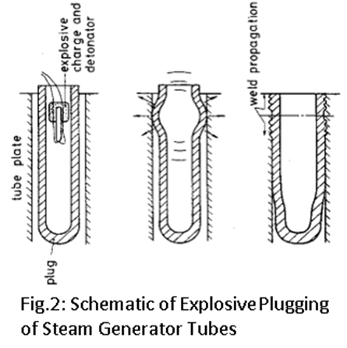The Explosive plugging of SG tubes is used in Fast reactors and advanced Gas-cooled reactors [8, 9]. Unlike the weld plugging technique, the explosive plugging is more a cold working process and require no preheat or post-weld heat treatment. Also, in the case of PFBR SG explosive plugging is more preferred compared to fusion weld plugging as the process of explosive plugging can be carried out satisfactorily using remotely operated tools.
FIG. 1. Schematic of Explosive Plugging of Steam Generator tubes
As per ASME section XI, for fast reactor steam generator tube plugging using fusion weld plugging and explosive plugging techniques are only accepted methods. Hence, fusion weld plugging and explosive plugging techniques are only envisaged for PFBR SG tubes. Since, the material of SG is made of modified 9Cr1Mo material; the fusion weld plugging requires in-situ post-weld heat treatment and the qualification of the SG tube plugging has to be carried out using remotely operated tools.This particular requirement makes explosive plugging technique more advantageous for PFBR SG tube plugging. Hence, the explosive plugging technique is explored for PFBR SG tube plugging and its details are explained in the following sections.

2. Explosive Plugging Technique
Explosion welding (EXW) is a solid state welding process where welding is accomplished by accelerating one of the components at extremely high velocity through the use of chemical explosives. Explosion welding can produce a bond between two metals that cannot necessarily be welded by conventional means. The process does not melt either of the metals; instead the metal deforms at very high strain rate and impacts on the other metal, causing them to come into intimate contact sufficient to create a weld. Due to this nature of the process, producible geometries are very limited. Typical geometries produced include flat plate cladding, tube-to-tubesheet joints, explosive plugging and pipe-to-pipe welding.
The explosive plugging of SG tubes have been widely used in Monju reactor (Japan), Prototype Fast Reactor (UK) and Advanced Gas cooled reactor (UK) [7]. A detailed survey on the explosive plugging of various heat exchanger tubes can be found in [9]. The plug employed in the process is a thin tube with spherical closure at one end and open end condition at the other end. The explosive material is filled inside the plug and the explosive charge is detonated during the plugging process. The high pressure generated during the explosion concentrically expands the plug and make it impact on the tubesheet surface at very high velocity causing a permanent joining/welding of the two mating surfaces. Fig.1 shows the schematic of the explosive plugging of Steam Generator tubes.

2.1 Proposed Explosive Plugging of PFBR Steam Generator Tubes
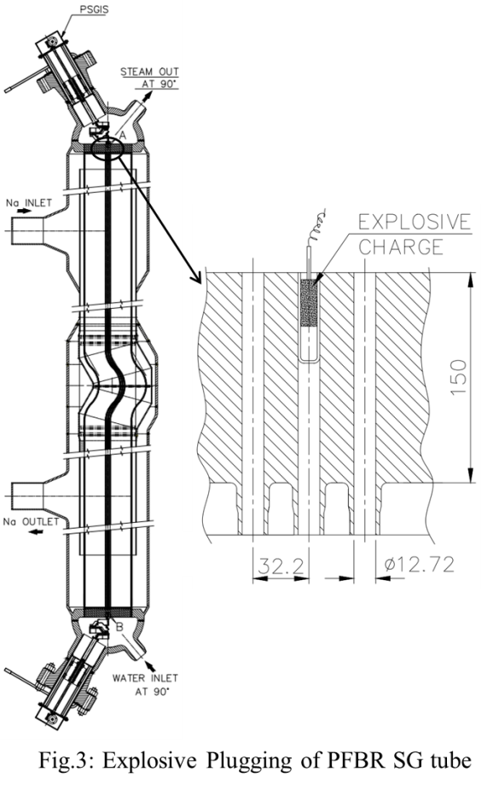 For the PFBR steam generator tube plugging using explosive welding, the plugging has to be carried out remotely using the PSGIS device to deploy the plug containing explosives to the required hole. The PSGIS device is capable of orienting plug to the specified hole. After deploying the plug with explosives into the hole as shown in Fig.2, the explosive is triggered remotely from outside the steam generator and the explosive welding is done. A similar procedure is adopted for plugging the same SG tube in the bottom tubesheet also so that the degraded tube is removed from service.
FIG. 2. Explosive Plugging of PFBR Steam Generator tubes

2.2 Parameters involved in Explosive Welding
The explosive welding process involves triggering of chemical explosives to accelerate the flat plate/tube to very high velocity to cause welding. The success of the explosive welding process depends on the choice of the explosive welding parameters. The parameters involved in Explosive welding are
- Mass of the Explosive
- Thickness of the plug
- Detonation velocity of the explosive
- Stand-off distance between the plug and tubesheet
- Maximum permissible impact energy of the material
- Density of the material
- Oblique angle of impact
- Sound velocity of the material
- Static yield strength and dynamic yield strength of the material
- Surface Roughness of both the surfaces

3. Design of Explosive Plug for PFBR SG Tube plugging

3.1 Design Objectives of Explosive Plug for SG Tubes
The following design objectives are conceptualized for successful plugging of the SG tubes and safe operation of the steam generator.
- The tube plug after installation should be capable of withstanding the steam pressure of 172 bar at the temperature of 525ºC.
- The plug and the weld should not breach/deform during operation, emergency and transient conditions.
- The explosive plug dilation by explosive pressure should be more than the stand-off distance provided.
- The explosive plug bottom spherical closure portion should not rupture during the plugging process due to the explosive pressure.
- The explosive plug should qualify all the examinations carried out for checking the adequacy for strength and leak tightness.
- The plug should be designed such that the plug is capable of handling and installation into the SG using remotely operated robotic devices.
- In case of improper welding of the plug with the tubesheet, maintenance possibility for plugging the tube again.
3.2 Geometric Design of the Explosive Plug
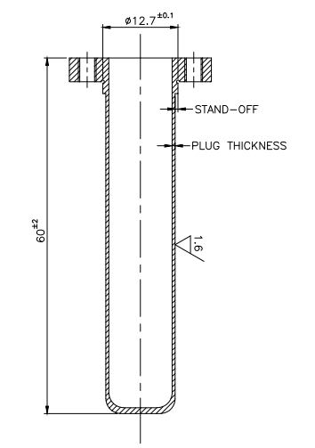The explosive plug is a cylindrical tube with a closed end on one-side and an open end on the other side to fill the explosive charge and detonator as shown in fig.3. The geometric design of the plug involves the selection of plug thickness, outer diameter of the plug and length of the plug and each parameter selection is described below.
FIG. 3. Plug design for Explosive Welding
3.2.1 Selection of Plug Thickness
The plug thickness governs the strength of the plug at SG operating conditions and also the choice of the impact parameters and explosive mass required for the explosive welding of the plug. Thus the choice of the thickness of the plug should be compatible for the SG operating conditions and for the choice of explosive welding parameters.
The explosive plug thickness for SG operating conditions is calculated based on the steam pressure and strength of the material at steam temperature of 525ºC.
The explosive plug thickness based on explosive welding parameters is determined using the density of the material, the required velocity of the plug during explosion for sound bonding and permissible expansion of the explosive plug without rupture. From the preliminary calculations, a range of plug wall thickness is feasible for explosive welding for the PFBR SG tube dimensions.
3.2.2 Selection of Outer Diameter of the Plug
The initial outer diameter of the plug is selected based on the required stand-off distance to provide sound explosive welding of the plug with the tubesheet. As suggested in [10], the stand-off distance of the plug having wall thickness greater than 1.2 mm should be at least half the wall thickness of the plug and for plugs having wall thickness less than 1.2 mm should be equal to the wall thickness of the plug. With the phenomena, various thicknesses and dimensions are considered and planned to carry out explosive welding experiments on plugs with stand-off varying from half the thickness of the plug to the actual wall thickness of the plug. Hence, the outer diameter of the plug will vary with the wall thickness of the plug in each of the experiments and the optimum value will be determined based on the experiments.
3.2.3 Selection of Length of the Plug
The length of the plug is decided based on weld length required for withstanding the pressure differential across the plug without failure of the weld and during the explosion the length of the plug should provide adequate expansion volume for the explosive charge to avoid failure of the plug due to excessive gas pressure [10]. The minimum weld length required to avoid weld failure is 3 times the plug thickness [11]. Various cases of the minimum plug thickness and the required weld length are planned considering the expansion volume required for the explosive charge. At present no data about expansion volume is directly available for any explosive. Hence, various experiments for optimizing the plug dimensions are planned and completed.
3.2.4 Surface preparation for explosive welding
For the explosive welding of the plug with the tubesheet, the surface finish of plug and tubesheet is generally required to be better than 1.6 µm [12] and the surfaces should be free of oxide and grease.

4. Development of Explosives for PFBR SG Tubes
4.1 Explosive Welding Arrangement for SG Tube Plugging
The explosive welding process is accomplished by accelerating the plug material to very high velocity to impact on the tubesheet surface through the use of chemical explosives. The two basic explosive welding arrangements for plug to tubesheet welding are the parallel and inclined configurations. Detailed description about parallel and inclined configuration of explosive welding arrangement maybe found in [13].With respect to PFBR SG tube dimension and configuration, the advantage of the parallel configuration is it does not require any additional machining on the tubesheet for conducting the explosive welding process. But the limitation is that the detonation velocity of the explosive should be less than the sound velocity of the material, which is achievable only through special preparation of the explosive and is not directly available. In the inclined configuration the tubesheet surface is made inclined to the plug by introducing a taper angle on the tubesheet hole. The advantage of this technique is that, it permits supersonic detonation velocity of the explosive as the taper angle counter balances the high detonation velocity and delivers subsonic tube velocity during the impact. Hence, the explosives can be directly used to perform the explosive welding of the plug to the tubesheet. But the disadvantage of this technique is that it requires, machining of the tubesheet surface for inclusion of taper angle to carry out the explosive welding. For the PFBR SG tube design, the parallel configuration is more preferred than the inclined configuration as it avoids the machining of the tubesheet. Since, special explosives have to be employed in the parallel configuration the development of explosives is explained in the following subsections.
4.2 Parameters of the Explosives governing the Explosive Plugging
The success of the explosive welding process depends on the choice of the variable parameters of the explosives. The parameters involved in explosive welding of plug-to-tubesheet for tube plugging are detailed and inter-relationship is discussed as follows:
- Detonation velocity, VD
The detonation velocity depends on the characteristics of the explosives chosen for the application. The detonation velocity is also a function of the density of the explosive. The detonation velocity of the explosive can be tailor made by addition of suitable ingredients like wax, sodium chloride etc. To make explosives for the welding of the given material, a wide knowledge about the nature of explosives, the right combination of explosive and its ingredients should be known.

- Oblique angle of impact, β
The angle of impact plays a crucial role in producing quality welds during the explosion. The angle of impact is required to be oblique to the receiving surface for producing quality welds since; the normal impact collision produces no welding of the components. The tangent of the angle of impact is the ratio of the plug velocity to the detonation velocity of the explosive.
- Mass of the explosive/explosive loading ratio, R
The explosive loading ratio is defined as,
$R=\frac{mass of the explosive}{mass of the tube/plug}$ …(1)
The R value is the most significant parameter in defining the impact velocity of the plug during collision with the tubesheet surface. The relation between the plug velocity and R value is defined by the Gurney’s equation for cylindrical geometry. The plug velocity is varied in the experiment by varying the mass of the explosive inside the plug to obtain different loading ratio, R.
- Impact Energy of collision, IE
The impact energy during the collision process in the explosive welding is defined as,
$IE=\frac{ρtV_{t}^{2}}{2}$ …(2)
where, ρ – density of plug material, t- thickness of the plug, Vt – velocity of plug. The velocity of the plug is varied using the mass of the explosive and by selecting varying thickness of the plug impact energy IE can be varied. From different combinations of Vt and t, the lower limits for producing acceptable quality welds for plugging of SG tubes can be obtained.
Based on the above discussion on explosive welding parameters, it can be seen that all the parameters are inter-related to each other and cannot be independently chosen. From these preliminary formulae, the plan of experiments for determining the optimum explosive welding parameters is derived and shall be discussed in the next section.

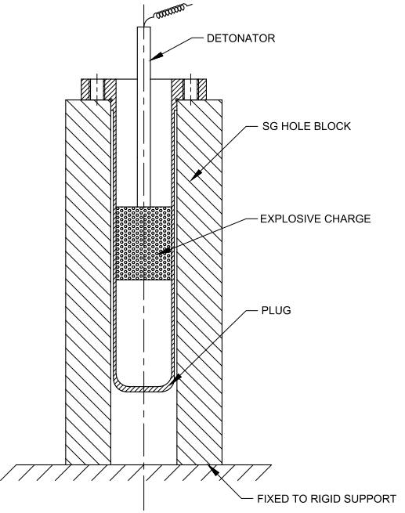5. Experimental Test setup for Explosive Welding of SG tube plugs
FIG. 4. Experimental setup for Explosive Plugging of SG tubes
The experimental test setup devised for explosive welding of SG tube plugs is shown in fig.4. The SG tubesheet is simulated in the experiment using a rectangular block with a through hole of diameter 12.7 mm is machined at the centroid of the block. The plug is placed inside the SG hole block with a close tolerance. The explosive charge is packed inside the plug and the detonator is connected to the explosive. The SG hole block is held to a rigid support during the explosion.
Two types of SG hole blocks are used for carrying out the experiments. One type of the SG hole block of dimension 29 x 34 x 68 mm contain only single through hole of 12.7 mm diameter. Another type of the SG hole block of dimension 29 x 98 x 68 mm contain three holes of 12.7 mm diameter and the holes are separated by a pitch distance of 32 mm simulating the actual condition. This also gives the effect of the explosion on the thickness between the tubes.
6. Plan of Experiments for Optimization of Explosive Welding Parameter
The geometric design of the plug for explosive plugging of SG tubes has been carried out. In order to understand the interplay between geometric parameters of plug, the impact parameters such as the velocity of the plug, impact energy during collision and properties of the explosive like mass of the explosive, detonation velocity of the explosives, plugs of 4 different wall thickness was envisaged and for each plug wall thickness, different stand-off distances have been selected. Thus, geometrically different explosive plugs have been chosen for optimizing the geometric design of the plug. Five number of identical specimen for each plug in Table 1 has been fabricated for the optimization
Table 1: Plug dimensions for Explosive Plugging Experiments
S.No. | Specimen ID | Plug Thickness  (t)  in mm | Stand-off distance  (s_{o})  in mm | Length of the Plug  (L)  in mm
1 | AA | 0.5 | 0.5 | 60
2 | AB | 0.5 | 0.4 | 60
3 | AC | 0.5 | 0.3 | 60
4 | AD | 0.5 | 0.2 | 60
5 | BA | 1 | 1 | 60
6 | BB | 1 | 0.8 | 60
7 | BC | 1 | 0.6 | 60
8 | BD | 1 | 0.5 | 60
9 | CA | 1.2 | 1.2 | 60
10 | CB | 1.2 | 1 | 60
11 | CC | 1.2 | 0.8 | 60
12 | CD | 1.2 | 0.6 | 60
13 | DA | 1.5 | 1.5 | 60
14 | DB | 1.5 | 1.2 | 60
15 | DC | 1.5 | 1 | 60
16 | DD | 1.5 | 0.8 | 60

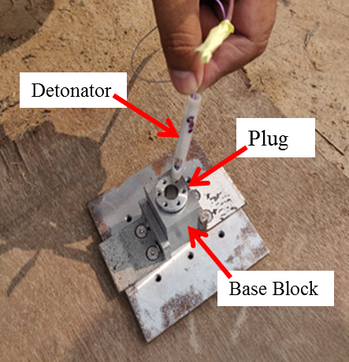of the explosive welding parameters like mass of the explosive, detonation velocity of the explosive and indirectly the velocity of the plug and impact energy during the collision.
FIG. 5. Photograph of Explosive Welding setup for SG tubes
The range of plug thickness from 0.5 mm to 1.5 mm was envisaged. For conducting the initial set of experimental trials, the plugs of thickness 0.5 mm and length of 60 mm were fabricated (Table 1). Experiments were conducted by varying the stand-off distance from 0.5 mm to 0.2 mm for plug thickness of 0.5 mm. Specimen ID of AA, AB, AC and AD are fabricated for the experiment. For each specimen ID, 5 No. of identical specimens have been fabricated for carrying out the repeatability in achieving the sound weld.
7. EXPLOSIVE Welding Tests on SG tube Plugs
The explosive welding tests were conducted on 12 samples. The tests were conducted on site exclusively maintained for carrying out such explosive based experiments. The trigger of the explosives was placed at far away distance and all the personnel were evacuated from the explosive before the test. All safety measures were strictly adhered during the tests. The photograph of the assembly of the explosive welding test setup is shown in Fig.5. The Table 2 below shows the details of the experiments conducted and the process parameter values for each test.
8. QUALIFICATION of the EXPLOSIVE WeldED Plugs
To qualify the explosive welded plug samples for the required strength and leak tightness, various non-destructive examinations, microstructural examinations and microhardness tests were carried out. Initially the helium leak test and radiography test were carried out on all the samples. From the radiography test, bonding at some regions along axial length of the plug could be observed in most of the samples. Fig.6 shows the radiography
Table 2: Explosive Welding Tests conducted
Expt. No. | Plug ID | Stand-off distance | Explosive material | Ratio of Explosive to filler material
1 | AA01 | 0.5 | Specially made Explosive | 60:40
2 | AB01 | 0.4 | Specially made Explosive | 60:40
3 | AC01 | 0.3 | Specially made Explosive | 70:30
4 | AD01 | 0.2 | Specially made Explosive | 60:40
5 | AA02 | 0.5 | Specially made Explosive | 60:40
6 | AB02 | 0.4 | Specially made Explosive | 60:40
7 | AC02 | 0.3 | Specially made Explosive | 60:40
8 | AD02 | 0.2 | Specially made Explosive | 60:40
9 | AA03 | 0.5 | Specially made Explosive | 90:10
10 | AD03 | 0.2 | Specially made Explosive | 90:10
11 | AD04 | 0.2 | Specially made Explosive | 80:20
12 | AA04 | 0.2 | Specially made Explosive | 80:20
image of one of the explosive welded samples. From the figure the deformation of the plug due to explosive welding is visibly seen.
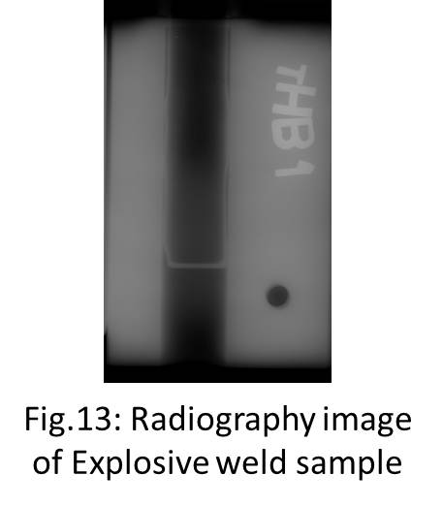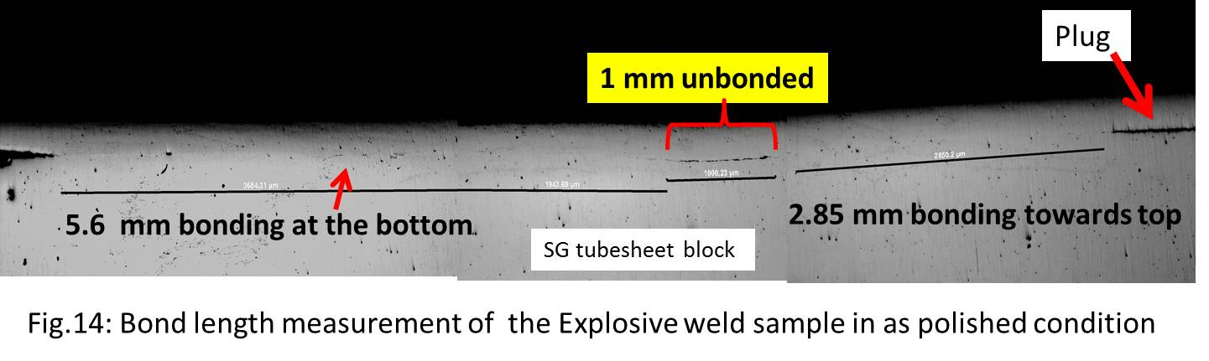After the non-destructive test, the explosive welded samples were axially cut into 2 parts using wire-cut EDM process. In the axially cut samples, certain number of samples were detachable into plug and the tubesheet block. Thus, the explosive welding has not taken place in certain number of samples. The axially cut samples which showed bonding between the plug and the tubesheet block were polished and the bond length of the samples were measured under the microscope. Fig.7 shows the explosive welding of the plug to the tubesheet block in one of the samples in as polished condition. The bonding obtained is similar to the characteristic explosive bonding achieved in tube/plug to tubesheet joints. An unbounded region of 1mm is present between the bonded regions. The total bond length of 8.45mm is achieved for this sample. After the measurement of the bond length, the samples were etched and the microstructure along the interface of the samples was examined. Fig.8 shows the microstructure at the interface of the explosive welded sample and also shows the images of bonded region at 20X magnification of the microscope. The bonded region in the top side shows a characteristic wavy interface between the plug and tubesheet, which is considered in explosive welding literature as a signature for a strong bonding. In a few samples, melt zones were found during the microstructural examination. The microstructural observations show that the average bond length of the explosive welded samples is found to be 4 mm. The micro-hardness tests were also carried out to find the joint strength. The micro-hardness values found to vary between 220 HV to 320 HV across the interface, these variations are considered nominal for Mod.9Cr1Mo material in fusion weld joints after post-weld heat treatment.
FIG. 6. Radiography image of Explosive weld sample
FIG. 7. Bond length measurement of Explosive weld sample in as polished condition
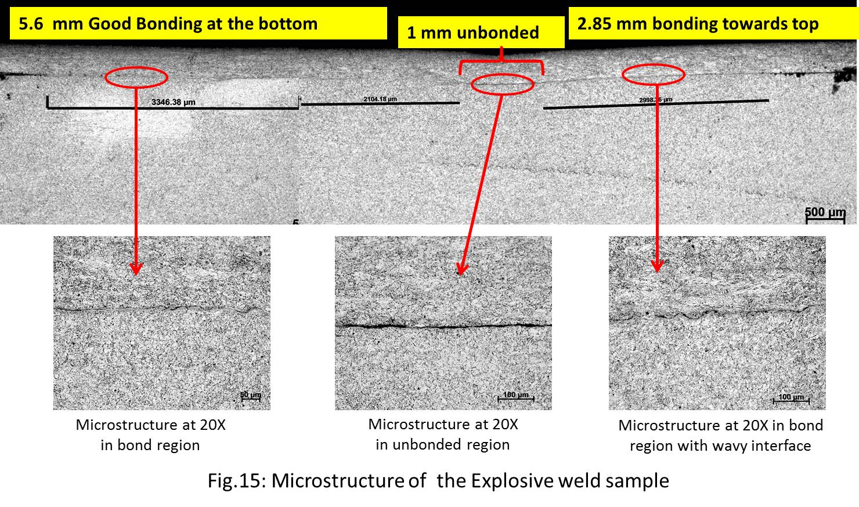
FIG. 8. Microstructure of the Explosive weld sample
9. Conclusion
In this paper, the plugging of SG tubes using the explosive welding technique is discussed in detail. The motivation for using the explosive welding technique is, it eliminates the requirement of post weld heat treatment of the weld region for Mod.9Cr1Mo material. In PFBR SG, the plugging process has to be carried out remotely using robotic devices and explosive welding is very much suitable for the same. The design of the explosive plug, the plan of experiments to optimize the explosive welding parameters is discussed. The explosive welding experiments were conducted on 12 samples and the details of the same are presented. The qualification of the explosive welding samples was carried out using non-destructive and microstructure examinations. From the various tests conducted it is found that very good bonding between the plug and the tubesheet block has been obtained. Hence, with the explosive welding technique, the plug to tubesheet welding for PFBR SG tube dimensions can be successfully carried out.
Acknowledgements
The support and motivation provided by Dr. A.K. Bhaduri, Director, IGCAR and Shri Prateek Kishore, Director, TBRL to carry out the work is gratefully acknowledged. The encouragement for performing the work given by Shri S. Raghupathy, Group Director, Reactor Design & Technology Group, IGCAR is duly acknowledged. The constant support and motivation provided by Dr. S. Murugan, Former Associate Director, CDHG, FRTG, IGCAR and Dr. P. Selvaraj, Former Group Director, FRTG, IGCAR is gratefully acknowledged.
References
[1] J. Guidez, L. Martin, S. C. Chetal, P. Chellapandi, Baldev Raj, “Lessons Learned from Sodium-cooled fast reactor operation and their ramifications for future reactors with respect to enhanced safety and reliability”, Nuclear Technology, Vol. 64, Nov. 2008, pp. 207-220.
[2] R.Sritharan et.al., “Preservice and Inservice inspection manual”, IGCAR Internal document
[3] Joseph Winston S. et al., “Prototype Fast Breeder Reactor Steam Generator Inspection System for Tube Inspections”, In: Badodkar D., Dwarakanath T. (eds) Machines, Mechanism and Robotics, Springer Singapore, 2019.
[4] ASME PCC-2-2015 standard “Repair of Pressure Equipment and Piping”, pp.133-135.
[5] Assessment and Management of Ageing of Major Nuclear Power Plant Components important to Safety: Steam Generators, IAEA-TECDOC-1668, 2011-update, pp.230-232.
[6] J. Beck, R. Ziegler, N. Schonheit, “Roll-expanded plugs for steam generator heating tubes verification of leak tightness over the component lifetime”, Nuclear Engineering and Design, Vol. 263, 2013, pp. 179-186.
[7] Proceedings of Specialist’s Meeting on “Maintenance and Repair of LMFBR Steam Generators”, IWGFR/53, Japan, June 1984.
[8] B. Crossland et al., “Explosive Welding of Tubes to Tube-plates”, Welding and Metal Fabrication, Vol.35, No.3, March 1967, pp. 88-94.
[9] Bernard Crossland, “Explosive Welding of Metals and its Application”, Clarendon Press, Oxford 1982.
[10] A. S. Bahrani et al., “Parallel Technique of Tube to Tubeplate welding applied to plugging of Heat Exchangers”, Pressure Vessel and Piping (1), pp.17-35.
[11] A. Kubota et.al., “Development of Explosive Plugging for Steam Generator Tubes”, Proceedings of Specialist’s Meeting on “Maintenance and Repair of LMFBR Steam Generators”, IWGFR/53, Japan, June 1984, pp. 2-131 to 2-144.
[12] P. W. Jackson et al., “Explosive Welding of Ferritic/Ferritic and Ferritic/Austenitic Steel Jo7ints”, Ferritic Steels for fast reactor steam generators, BNES, London, 1978, 488-495.
[13] T. Z. Blazynski, “Explosive Welding, Forming and Compaction”, Applied Science Publishers, England, 1983.

