Advanced in-situ Calibration and Probe Release Mechanism for PFBR SG Inspection System (PSGIS)

JOEL JOSE¹, JAGADISHAN D¹, SAKTHVEL S¹, DEEPAK KUMAR¹, VISWESWARAN PADMANABHAN¹, PURUSHOTHAMAN K¹, MAHENDRAPRABHU N¹, JOSEPH WINSTON S ¹

¹Indira Gandhi Centre for Atomic Research, Kalpakkam, India

Email contact of corresponding author: joel@igcar.gov.in

Abstract

Prototype Fast Breeder Reactor (PFBR) has 8 Steam Generators (SG). Pre-Service Inspection (PSI) and periodic In-Service Inspection (ISI) of the SG tubes are required as a part of safety and reduce cost by increasing the plant availability. The tube wall thickness being the only barrier between sodium on the shell side and water/steam on the tube side, it is critical to ascertain the healthiness of the tubes to avoid any sodium-water reactions. The Remote Field Eddy Current testing (RFEC) has been the choice of testing the SG tubes. There are 547 tubes connecting the top and bottom header of the SG. During the reactor operation, SG tubes experience hostile conditions such as high temperature, pressure and corrosive environment and due to which the progressive damage of the SG tubes may takes place. Since the tube sheet is about 1.3 m from the manhole flange top and the manhole is only 381mm in diameter, the direct insertion of the probe and pushing into the tubes is not possible. PFBR SG Inspection System (PSGIS) is an indigenously developed robotic device for the inspection of SG tubes which has 7 modules to perform various tasks to carry out the comprehensive tube inspection. It is observed that during the operation, often the probe needs to be changed or recalibrated to ensure the sensitivity of the probe which leads to extended down time for maintenance. Moreover the PSGIS device needs to be recalibrated again after probe replacement. In order to make the probe replacement and calibration easy, an advanced in-situ calibration has been designed and incorporated in to the existing inspection system by attaching the calibration tube in the Device Deployment Module (DDM) along the pathway of the probe. Using Probe Release Mechanism which is made of modified Cable Pusher Module (CPM) and Cable Dispenser Module (CDM) of PSGIS, the probe can be inserted and retracted without decoupling the PSGIS device from the SG module. This feature helps in reducing the downtime and eases the process of probe change and calibration. This paper details the design, operation and qualification of advanced in-situ Calibration and Probe Release Mechanism of PSGIS.
.

INTRODUCTION
Prototype Fast Breeder Reactor (PFBR) has 8 Steam Generators (SG). Inspection of tubes requires pushing and retrieving of the probe along with the cable for 23m. There are 547 tubes connecting the top and bottom header of the SG as shown in fig.1. The inspection probe can only be pushed from the top header as bottom tube sheet is fixed with orifices on all tubes. Since the tube sheet is about 1.3 m from the header flange top and the manhole is only 381mm in diameter, the direct insertion of the probe and pushing into the tubes is not possible. Hence the comprehensive PFBR SG Inspection System (PSGIS) [1] has been developed for the inspection of SG tubes. The PSGIS has 7 modules to perform various tasks to carry out the tube inspection. Cable Pusher Module (CPM) axis acts as end effector of the robotic arm. The cable pusher module (CPM) [1] delivers adequate radial force through the pulleys on the cable for pushing and retrieval. A pair of active pulleys driven by the electric motors generates the required cable force whereas the passive pulleys are connected with encoders. These encoders provide the actual location information based on the number of revolutions made by the pulley. The active pulleys are set to deliver radial loads on the cable of diameter 8.1mm and the typical RFEC probe of diameter 11.6mm. Hence the replacement of probe and cable requires the total PSGIS system to be removed from the manhole and placed in the transit support structure for the probe and cable replacement. This gives extended downtime during inspection. In order to circumvent this problem and to reduce the down time it was required to modify the design to incorporate the probe release mechanism. The probe release mechanism will help to move the pulleys away during such maintenance and the cable & probe replacement can be done. A calibration tube is also placed inside the device to carry out in-situ calibration of the probe.
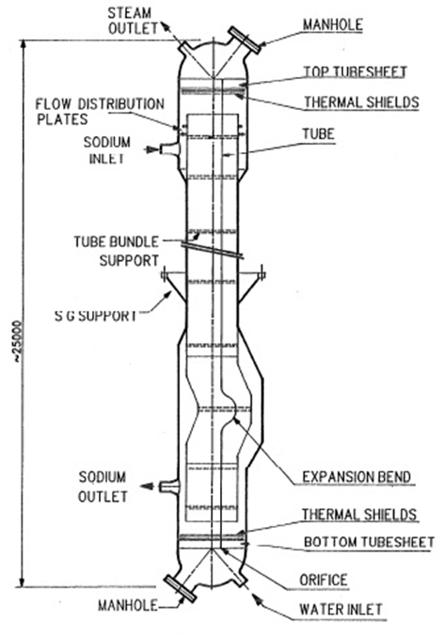
This paper details the design, analysis, operation and qualification of the probe release mechanism and advanced in-situ calibration of the PSGIS. Figure 1 shows the PFBR steam Generator Overview which is a once-through type.

Fig. 1.PFBR Steam Generator overview

Table 1.0 shows the major specification of Steam Generator including the dimensions

TABLE 1. Steam Generator Parameter

Sl No | Parameter | Value
1 | Tube sheet diameter (inside) | 910 mm
2 | Manhole diameter | 380mm
3 | Tube array pitch | 32.2 mm
4 | Total number of tubes | 547 Nos
5 | Tube size | 17.2 mm OD
6 | Tube thickness | 2.3 mm
7 | Material | Modified 9Cr1Mo
8 | Tube Length | 23 m

DESCRIPTION OF PSGIS
For the inspection of SG, prime requirement is to deploy the device from the manhole flange into the top header, then to orient to all the 547 tubes and push the probe with cable to 23m down the SG tubes till the bottom spigot weld and to obtain the RFEC signature. The requirement of inspection is to qualify the tubes for operations.

The PSGIS device has 7 modules which are as follows:
- Device deployment Module (DDM).
- Tube Locator Module (TLM).
- Cable Pusher Module (CPM).
- Cable Dispenser Module (CDM).
- Comprehensive Control Module (CCM).
- Inspection System Module(ISM).
- Eddy current and Probe analysis system (EPAS).
- Vision probe and analysis system (VPAS).
- Cable take up Module (CTM).
TLM module has two axis robotic arms operated by shoulder and elbow to position the end effector to all 547 tubes in the SG tube sheet in planar task space in precise manner through the inverse kinematics algorithm.
The cable pusher module and cable dispenser module help to push the cable from top header to the bottom making inspection probe travel 23 meter down. Synchronous servo motion is applied on 4 motors to achieve this pushing & pulling.
Comprehensive Control Module consists of standalone distributed motion controller, Human Machine Controller (HMI), Power supplies, SMPS, Vision system module, Raspberry Pi modules and accessories properly integrated in to a standard industrial rack mountable control panel.CCM is designed to control all modules through the distributed control system architecture and thereby facilitating the inspection of SG tubes.
Modular design is envisaged in the mechanical, electrical & electronics system in order to have ease of assembly and maintenance of various modules used in the device. Fig.2 shows the layout of all the modules involved in the system.
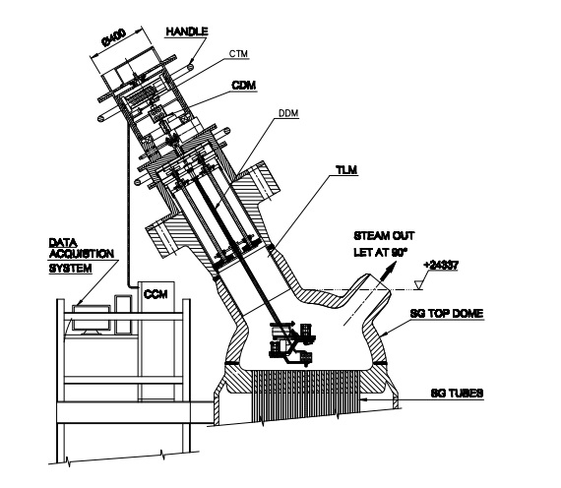

Fig. 2.PFBR Steam Generator Inspection System (PSGIS) mounted in the SG manhole

It is observed that during the operation, the probe needs to be changed or recalibrated to ensure the sensitivity of the probe. Probe changing is a laborious task which requires lot of skilled manpower and time. Moreover the PSGIS device needs to be recalibrated again after fixed cycles of operation. In order to make the probe replacement and calibration easy, an advanced in-situ calibration has been designed and incorporated in to the existing inspection system by attaching the calibration tube in the Device Deployment Module (DDM) along the pathway of the probe. Using Probe Release Mechanism which is made of modified Cable Pusher Module (CPM) and Cable Dispenser Module (CDM) of PSGIS, the probe can be inserted and retracted without decoupling the PSGIS device from the SG module. This helps to carry out the probe and cable replacement without decoupling the PSGIS from SG manhole. Subsequent session details the overview and design of PRM.

OVERVIEW OF PROBE RELEASE MECHANISM (PRM) AND IN-SITU CALIBRATION
Different modules are used for the Probe Release Mechanism for ease of replacement of RFEC probe and Cable without the need for decoupling PSGIS from SG manhole. It makes use of Cable Pusher Module (CPM) and Cable Dispenser Module (CDM) for the probe release. Once the probe is replaced it is mandated to calibrate the probe using a calibration tube with standard flaws. A standard calibration tube is also inserted between CDM and CPM to provide in-situ calibration. This provides in-situ calibration as it is integrated as a part of PSGIS. Fig 3 shows the overview of PRM used for the release of cable and probe and calibration tube for in-situ calibration
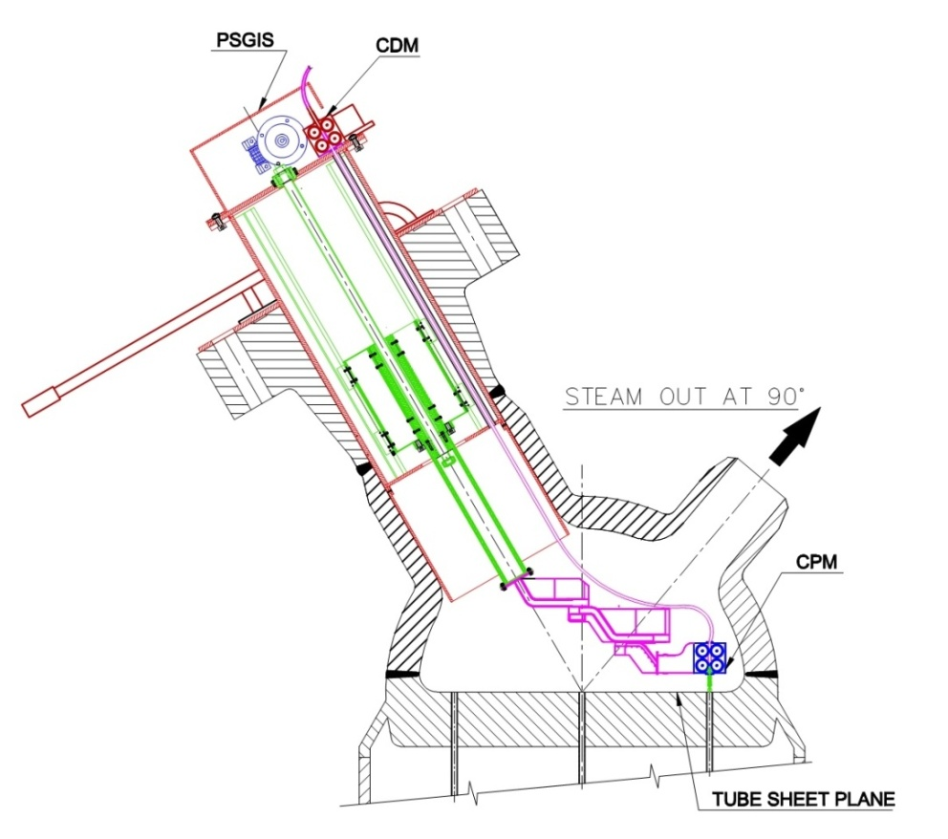

Calibration Tube

Fig. 3.Probe Release Mechanism Overview

The following are the modules of PSGIS involved in the cable probe release
- Cable Pusher Module (CPM).
CPM inserts and retraces the RFEC probe in to the SG tube and with the incorporation of release mechanism; RFEC probe can be tightened or released at the CPM.
- Cable Dispenser Module (CDM).
CDM assists the motion of RFEC probe from the top and with the incorporation of release mechanism, RFEC probe can be tightened or released at the CDM.
- Calibration Tube.
Calibration tube is placed between CDM and CPM with standard reference flaws used for calibrating the probe without the need for removal of PSGIS from the manhole. The Calibration tube is manufactured as per the ASME Section V, Article 26, SE 2096, 2010.
The major advantage of this scheme is that RFEC probe replacement and in-situ calibration is carried out without the need of removing PSGIS from manhole, which is highly labor intensive task. Using this approach the time required for probe replacement and calibration is reduced to large extent and thereby facilitating the fast completion of inspection task. Following section discusses in detail about Probe Release Mechanism (PRM).

PROBE RELEASE MECHANISM (PRM)
Probe Release Mechanism is designed by modifying CPM and CDM of PSGIS.CPM and CDM module is used to feed the RFEC probe into the SG tubes. CPM axis acts as end effecter of the TLM, and is present at the end of elbow arm. CDM mechanism is similar to CPM; synchronous servo motion is applied on four motors to achieve pushing & retrieval; since the CPM is placed in the TLM it is not serviceable during inspection and hence backup module CDM is incorporated at the top of DDM to assist the CPM during cable insertion & retraction. In the event of failure of CPM, CDM can assist to retract the cable out of the tube for the removal of device. However in the event of failure of CDM, it is easily serviceable during inspection since it is present outside the device and easily accessible.

Fig.4. shows the schematic of Probe Release Mechanism. It consists of modified CPM and CDM which are intended for insertion and retraction of cable along with ECT probe in the SG tubes. The PRM design is such that pulleys are placed on cradle which is supported through a pin and pre compressed springs. The springs are designed to develop adequate radial force on the pulleys to avoid any slip during the pushing operations. Even if any extra force comes from the cable to the pulleys, the cable force moves the pulleys; the springs ensure a positive contact pressure on the cable to avoid any slip. This also helps to reduce the loads in the cable which extends the cable life by the compliance offered in form of spring supported pulleys. During the probe replacement the linear actuator pushes the wedge arrangement to make the pulleys deflect radially by 2mm such that the probe passed through the pulleys.

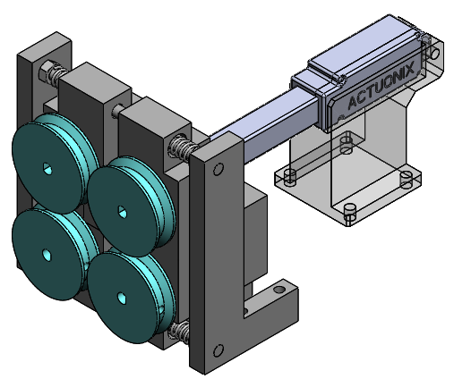
Actuator
Spring Mechanism

Active Pulleys

Idler Pulleys

Fig. 4. Probe Release Mechanism

In order to sense the slip of cable and stop the CPM & CDM if cable slip exceeds the set limit the idler pulleys attached with idler encoders are used. Slip of cable is calculated by comparing CPM/CDM motor encoder values with Idler encoder values as shown in equation (1). Idler encoder shall also be used to report the actual travel of EPAS/VPAS cable/probe during the inspection. Slip during operation is calculated using the following formula.
$$Slip\left(\%\right)=\frac{Motor encoder\left(CPM or CDM\right)-Idler Encoder Values}{Motor encoder\left(CPM or CDM\right)}*100$$ | (1)

Construction details of Probe Release Mechanism (PRM)
The pair of active pulleys and the pair of passive pulleys are fixed on the floating cradle with required design force applied on cable through pre compressed springs. Fig.5 shows the pulley position while cable motion and also during the cable release. It is thus required to design the spring force to avoid slip and also required to estimate the actuator force required to push through the wedge to separate the pulleys. It is also required to arrive at required wedge angle.

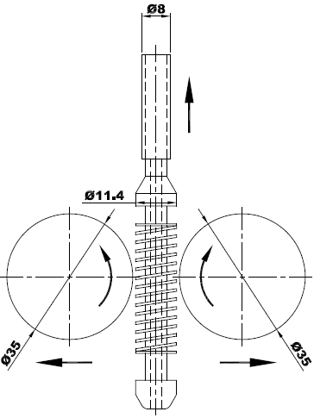
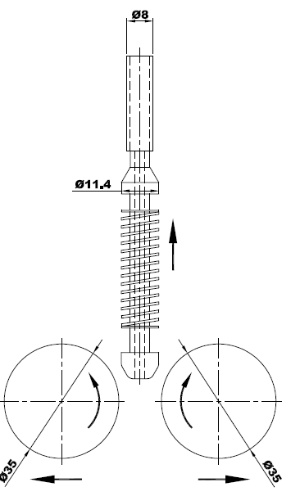
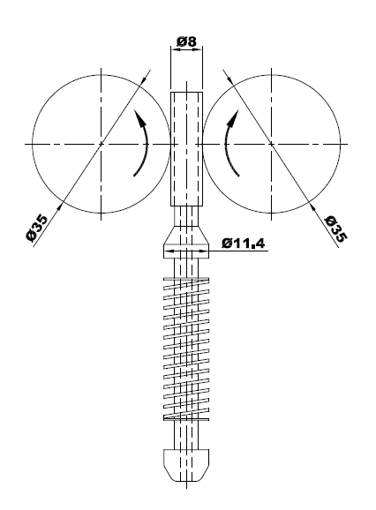

Fig. 5 Radial Outward Movement of Pulleys for Probe Release Mechanism

As already discussed there are four rollers in the system two of them being rotated by PMDC motor and two of them being idler roller placed below the powered roller for measuring if there is any slip between cable and rollers so that the probe along the tube axial direction can be precisely located.
Fig.6. shows the linear actuator used to push the wedge arrangement to move the pulley radially outward by 2 mm such that the probe can pass through the pulleys without getting damaged. During the cable pushing operation the pulleys have to exert force on the cable to avoid slip and must get separated during the cable/probe release.
Spring Mechanism
Active Pulleys
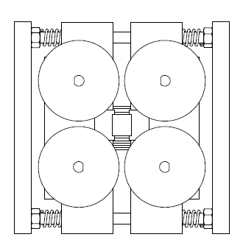
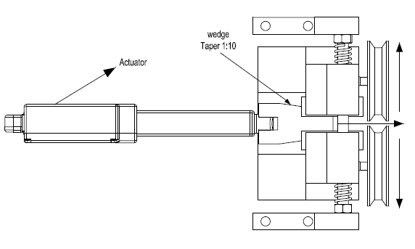

Idler Pulleys

Fig. 6 Construction details of Probe Release Mechanism

Design of Wedge Mechanism
This section details about the design of wedge mechanism for cable insertion/ retrieval. It has been designed with a taper of 1:10, so that force required to create gap between pulleys be optimum. A parametric study has been carried out to find the optimum actuator force requirement and optimum stroke required to achieve this force and to determine what will be optimum taper required for given design criteria. Fig.7. shows the internals of Wedge Mechanism and actuator for driving the mechanism.

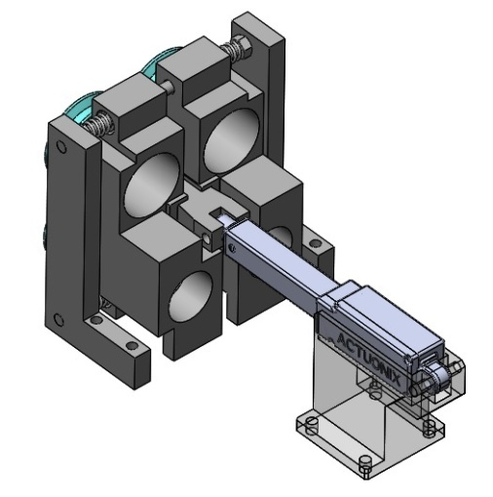

Wedge Mechanism

Actuator

Fig. 7 Wedge Mechanism and Actuator of Probe Release Mechanism

Analysis of Wedge Mechanism
Following section details about the analysis of wedge mechanism. It involves design of actuator, taper size and optimum configurations for PRM.

Design Calculation for Actuator
In this section the design calculation of Actuator is discussed in detail. Table 2.0 shows the various parameters and their values involved in the design.

TABLE 2.0 Actuator Design Parameters
Sl No | Parameter | Value
1 | Cable weight (N) (f_{w}) | 24.52 N
2 | Tube friction (N) (assumption) (f_{f}) | 27.46N
3 | Diameter of the pulley | 35.70mm
4 | Coefficient of friction between cable and pulley (μ) | 0.3
5 | Cable force experienced by one motor | fc
6 | Spring Force(Radial) | fs
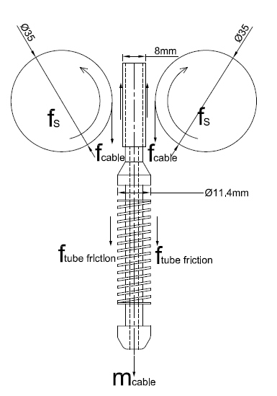
The values of the parameters 5 and 6 have to be computed and a free body diagram of cable and pulley is shown in the Fig.8.

Fig. 8 Free body diagram Cable and Pulley
From Table 2.0 Cable weight = 24.52N and Tube friction = 27.46N are already given
fc = $\frac{f_{w}+f_{f}}{2}$ =26 N
Spring force (fs)=$\frac{f_{c}}{μ_{s}}$ = (26/ 0.3) = 86.3N (2)
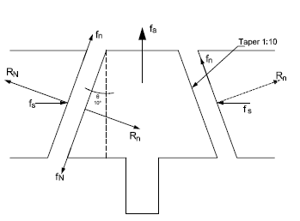
Fig. 9 Free body diagram Wedge and Block
Fig.9 shows free body diagram of wedge and block arrangement and the different external force acting on the system. From Newton’s second law [3] of motion actuator force required to achieve this motion was calculated using parameters shown in Table 3.0.
TABLE 3.0 Actuator Parameters for Design

Sl No | Parameter | Value
1 | Force applied by actuator on wedge | fa
2 | Force developed by the spring | fs
3 | Reaction Force | Rn
4 | Friction force between wedge and block | Fn
5 | Coefficient of Friction force between wedge and block | µb

From the known values of µb(0.3) spring force (fs) and a taper (1:10) using the force balance using free body diagram in Fig. 9. Force applied by actuator on the wedge is given by the formula
$fa=2\left(R_{N}\sin{ɸ+f_{N}}\cos{ɸ}\right)$ (3)
= 72 N.

Parametric Study on Actuator force for various taper configurations
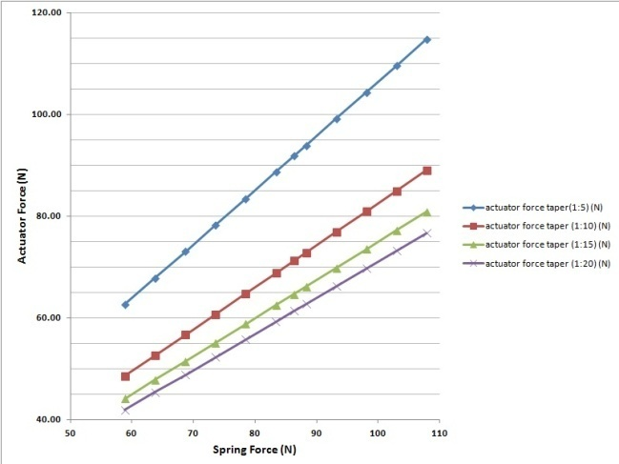
It is obvious that the wedge taper will also affect the actuator force requirement. Hence study has been performed to see the variation of required actuator force for different taper size. As expected a linear increase is seen and a maximum of 115.75 N for the taper of 1:5 is observed. The fig.10 shows the actuator force for different in choosing the right actuator for the CPM

Fig. 10.Actuator force for various taper angle configurations

Optimal taper configuration for CPM
It is quite evident that on reducing taper size of the wedge will demand more stroke length. Hence the study was further extended to see the stroke length required for the cable and probe release. Further from geometry as shown in Fig.11. It can be seen that a distance of 2mm radially is required for the release of probe through the pulleys. Such 2 mm will be require a linear increase in the actuator operating length due
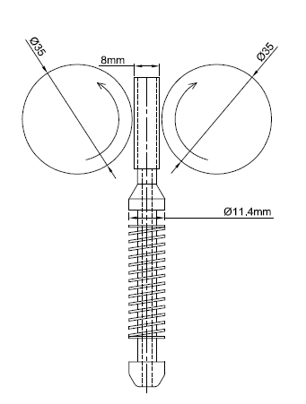
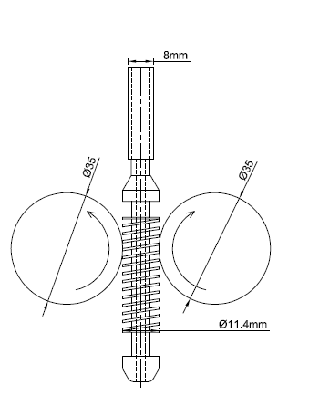

Fig. 11 Variation of radial gap between the pulleys

Radial gap required for insertion of probe between pulleys = 12mm
Radial gap required for insertion of cable between pulleys = 8mm
Change in gap for each side = (12-8)/2 = 2mm
Stroke length required for 2 mm radial gap = (1/taper)* radial movement for each side

TABLE 4.0 Force and Stroke Length for different taper angle

Taper angle | Actuator Force(N) | Stroke Length (mm)
1:20 | 61.35 | 40
1:15 | 64.66 | 30
1:10 | 71.20 | 20
1:5 | 91.84 | 10

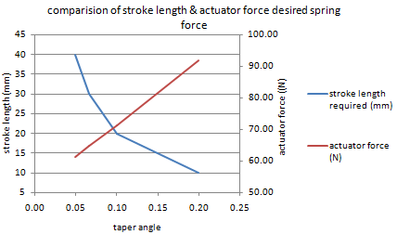
The values from the Table 4.0 are plotted as shown in Fig .12 and it shows the variation of stoke length and actuator force with taper angle

FIG.12 Variation of stoke length and actuator force with taper angle

From Fig. 12 it can be observed that with an increase in taper angle required actuator force is increasing and at the same time stroke required to achieve this force is decreasing. From fig. 12 it can also be seen that for taper of 1:10 actuator force and stroke length both are optimum. So, wedge design of taper 1:10 has been done to generate necessary gap between pulleys.
TABLE 5. Optimum parameters for actuator

Parameter | Value
Taper | 1:10
fa | 71.2 N
Stroke length | 20 mm
Table 5 shows optimal parameter i.e. actuator force and the required operating stroke length. With factor of safety of 2, the design actuator force requirement is 146 N and hence from the standard linear actuator data sheet actuator of max force 200N is selected.

PROBE RELEASE MECHANISM SEQUENCE OF OPERATIONS
The events that call for probe/cable replacement is broadly classified into two; system maintenance events and operation events. The lists of events are listed in the Table 6. In the table Sl No 1 to 6 are maintenance events and Sl No 7 is an operational event.

TABLE 6. Events to trigger probe/cable replacement

Sl No | Event | Description
1 | Discontinuity in the RFEC coil | This may occur due to the discontinuity in the exciter or receiver coil
2 | Probe Integrity Failure | In case probe integrity is affected
3 | Loss of Sensitivity of RFEC probe | In case RFEC probe is not sensitive to report weld region or support plate signals
4 | Damage to the embedded tether rope | This is mainly due to the breaking of tether rope to take out the probe in the event of probe disconnected from cable.
5 | Damage to the RFEC cable sheath | This is due to the wear and tear of the sheath
6 | Loss of probe cable integrity to the data acquisition system | RFEC probe is not properly integrated to the data acquisition system
7 | Periodic Calibration of RFEC probe | Calibration of the probe as per guidelines

Fig. 8 shows the probe sequencing in a maintenance event. The total operation sequence is divided in to two phases namely probe release and probe insert. In the probe release phase the faulty probe is taken for replacement. In the first four sequences of operations during system maintenance event shows how the probe is taken out for replacement. Initially probe is in operational and CPM and CDM are in engaged condition as shown in the first part of Fig 13.0. In the next step CPM is released and as shown in the second part, probe is taken out using CDM through the calibration tube as in part three of Fig 13 and in the fourth part CDM is disengaged and Probe is taken out for replacement.

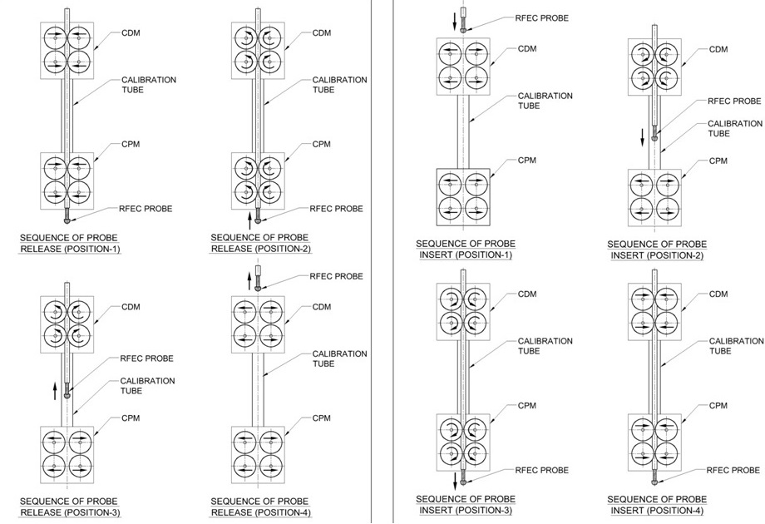

Fig. 13 Probe sequencing in maintenance event

In the case of operation event the sequencing is same as maintenance event with one difference. In the operation event probe is not replaced. It is taken up to CDM and is kept above the Calibration Tube for calibration. Initially probe is in operational and CPM and CDM are in engaged condition. In the next step CPM is released, probe is taken out using CDM through the calibration tube and in the fourth step Probe is kept above the Calibration Tube for calibration. Now the steps are followed in the reverse order for carrying out calibration and placing the probe for further operation.

PROBE RELEASE MECHANISM CONTROL SYSTEM
The PRM control system has been designed and integrated in to CCM panel. It is operated in manual fashion. The Cable probe release is augmented in the control panel through switches for both CDM and CPM. The control panel layout consists of HMI and switches as shown in Fig 14. Apart from the up and down rotating switches are provided for CDM and CPM linear actuator control. Three way switches are provided for CDM and CPM. When Switch is on the Right Position Linear actuator is moved forward and CDM/CPM is released and When Switch is on the Left Position Linear actuator is retracted and CDM/CPM is in engaged condition. No action is taken when the switch is on the central position and this position is the default position of switch.
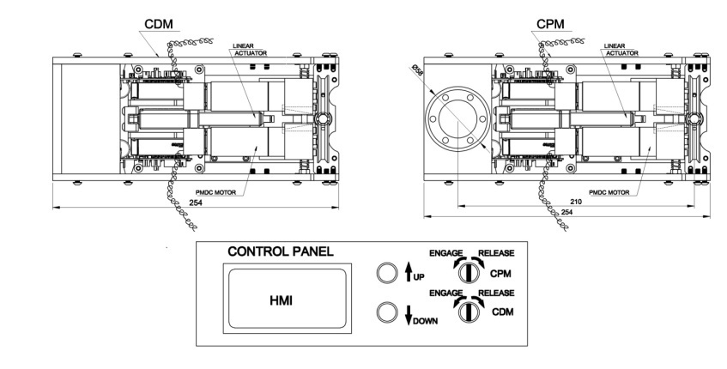

Fig. 14 Probe Release Mechanism Control System

OPERATION AND QUALIFICATION OF PROBE RELEASE MECHANISM
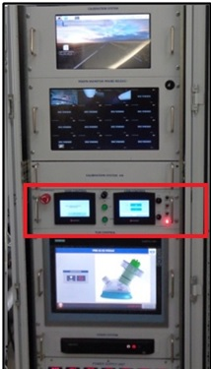
The control panel of PRM is integrated to the PSGIS as shown in Fig. 15. DDM with integrated TLM, CDM and CPM are integrated is mounted on the Device Support Structure (DSS). PRM is operated from the CCM control panel where the PRM control panel HMI is mounted and all the sequence of operation are tested and verified.
PRM Control Panel

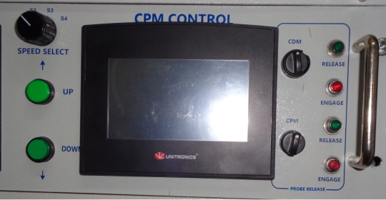

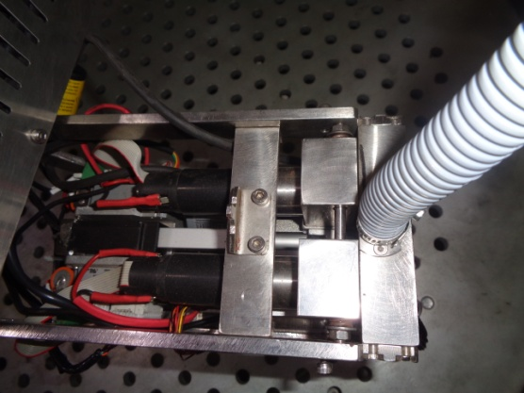

Fig. 15 Probe Release Mechanism Control System integrated to CCM.

Integration testing of PRM is done by step by step execution of Insertion operation and Retrieval operation. PRM control panel is integrated with CCM of PSGIS and all operations and testing is carried out remotely. PRM operation is verified and by running several trials such operations are carried out before qualifying the PRM. During each trial the in-situ probe calibration [4] is also carried out .The ECT signal captured during in-situ calibration is shown in Fig. 16.
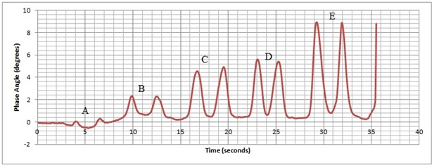
Fig. 16 In-situ Calibration RFEC Data.
The Calibration tube is manufactured as per the ASME Section V, Article 26, SE 2096, 2010 and it incorporates only five standard flaws as shown in the Table 7
TABLE 7. Standard Flaws of Calibration tube

Flaw | Flaw Type | Dimension
A | Through Hole | Diameter of 2.3 mm(Tube Wall Thickness(WT))
B | Flat mill (simulate impingement damage) | Diameter 8.6 mm (half of the tube diameter), Depth 1.15 mm (50% WT)
C | Groove | Length 15.88 mm, Depth 0.46 mm (20% WT)
D | Wear scar (simulate damage under tube bundle support) | Length 15.88 mm, Extending over 180°, Depth 0.92 mm (40% WT).
E | Tapered flaw (simulate erosion near tube bundle support and bend regions) | Length 20 mm, Depth 1.38 mm (60% WT), Extending over 90°

Conclusion
PFBR SG Inspection System (PSGIS) uses Inspection System Module(ISM) which manages the inspection probe, cable and data acquisition system. In the event of any sensitivity loss of the inspection probe or any problem in the inspection cable, it requires a total replacement of cable & probe of the ISM of PSGIS. In such case during the inspection it is required to decouple the device from SG system and place the device in the Transit Support Structure for PSGIS maintenance. Such cable and probe replacements are manpower intensive and often lead to long down time for inspection. Hence in order to quickly perform such cable probe replacement, a new scheme is designed and used in the PSGIS system which makes use of probe release function remotely from the control panel. All the events that call for the probe-cable replacement and also the sequence of operation involved in the cable probe replacement are discussed in detail. The in-situ calibration of the RFEC probe is highly desirable as it significantly reduces the time and effort for the recalibration of the PSGIS device. Moreover it significantly reduces the down time during the inspection. The PSGIS incorporates In-situ calibration of the RFCE probe by attaching the Reference Calibration Tube in the Device Deployment Module. The Calibration is carried out at LAB prior to the installation of the Reference Calibration Tube in to the DDM. The in-situ calibration is carried out using the Probe Release Mechanism of PSGIS. During each Calibration the signal obtained from Reference Calibration Tube is collected and evaluated by a Level -III ET Certified personnel. The PRM and advanced in-situ calibration has been qualified for use in the PSGIS system.
ACKNOWLEDGEMENTS
We are grateful to Shri V Arjun NDED/MMG/IGCAR for helping in conducting the Calibration of Calibration Reference Tube for qualification before integrating with PSGIS.
References
- Joseph Winston, S et.al "Prototype Fast Breeder Reactor Steam Generator Inspection System for Tube Inspections" " Lecture Notes in Mechanical Engineering , Machines, Mechanism and Robotics ,Proceedings of INACOMM 2017 Pages 713-728
- Joel Jose et.al “Design and Development of a Control and Drive System for Cable Pusher Module for PFBR Steam Generator Tube Inspection”, Proceedia Engineering on Structural Integrity, Volume 86, 2014, ISSN 1877-7058, pages 546-553.
- S.Timoshenko and D.H Young "Engineering Mechanics" ,The McGraw-Hill Companies ,Fourth edition
- S. Thirunavukkarasu, “Procedure for Remote Field Eddy Current Inspection of Installed Steam Generator tubes of PFBR ’’, Internal report, PFBR/33130/DN/1053/Rev-B, IGCAR Kalpakkam, 2019.

