Reactor Core Viewing System for the Pre-Commissioning Stage Inspection of Reactor Core Components of Prototype Fast Breeder Reactor
R. Chellapandian, Saji Jacob George, V. Rakesh, D. Jagadishan, S. Sakthivel,
Joel Jose, Deepak Kumar, P. Visweswaran, S. Joseph Winston
Reactor Design & Technology Group, Indira Gandhi Centre for Atomic Research, Kalpakkam, India *email of corresponding author: rcn@igcar.gov.in

Abstract

Prototype Fast Breeder Reactor is a 500MWe nuclear reactor under commissioning at Kalpakkam, India. During the commissioning stage of the reactor, it is often required to view the core internals to ascertain that the assembly of components inside the reactor does not impair the structural integrity of the reactor core and to scan for any foreign debris in the core before starting up of the reactor. Addressing the above need, a Reactor Core Viewing System (RCVS) has been designed and developed. The reactor core viewing system is designed to deploy the probe camera to the core top and negotiate through the extracted sub-assembly slot to reach down up to the Grid Plate top surface for inspection of the region around. The system is designed to be mounted on the observation port in the small rotatable plug on the reactor roof slab. The combined rotational motion of large rotatable plug and small rotating plug facilitate positioning of the probe camera of the RCVS on any location over the core top. The RCVS is designed to have a precise radial motion, rotary motion, vertical motion and azimuth motions to localize the probe camera to target position. The RCVS also features a vacuum arrangement for clearing the debris observed by the probe camera. The RCVS system has been fabricated and successfully tested on full scale mock-up test setup with 19 dummy sub-assemblies on dummy grid plate, maintaining the same reactor core dimensions and grid plate top distance from the observation port.

- INTRODUCTION
In the Prototype Fast Breeder Reactor (PFBR), the primary containment structures comprise the main reactor vessel (MV), the safety vessel (SV), and the reactor roof structure. The primary containment structure, primary circuit equipment and reactor internals require remote ISI devices and techniques. The active core where most of the nuclear heat is generated consists of 181 fuel sub-assemblies. The general half cross-sectional view of the PFBR main vessel showing a single array of core sub-assemblies is depicted in Fig. 1.
The core subassemblies are supported on the grid plate, which in turn is supported on the core support structure. A core catcher provided below the core support structure, is designed to take care of melt down of seven subassemblies and prevents the core debris from coming in contact with the main vessel. The main vessel is closed at its top by top shield, which includes roof slab, large rotatable plug (LRP) and small rotatable plug (SRP) and control plug. The elevations at the various locations are indicated in Fig. 1. SRP and LRP are used to position the transfer arm over any fuel subassembly location during fuel handling in the reactor.
As part of the commissioning activities, the reactor assembly was boxed up for preheating with nitrogen at 150 °C before filling the sodium. In the midst of these activities, it required to view the core internals to ascertain the structural integrity of the assembly of components inside the reactor core and to scan for any foreign debris in the core before loading the fuel sub-assemblies. Since, it is difficult to do visual inspection (VI) manually inside reactor assembly in the pressurized nitrogen environment, it is imperative to carry out the inspection remotely, and so there is an exigent requirement for a reactor core viewing system (RCVS) to visually examine the reactor core components with a focus on viewing the neighborhood of the sub-assembly array through an extracted sub-assembly slot.
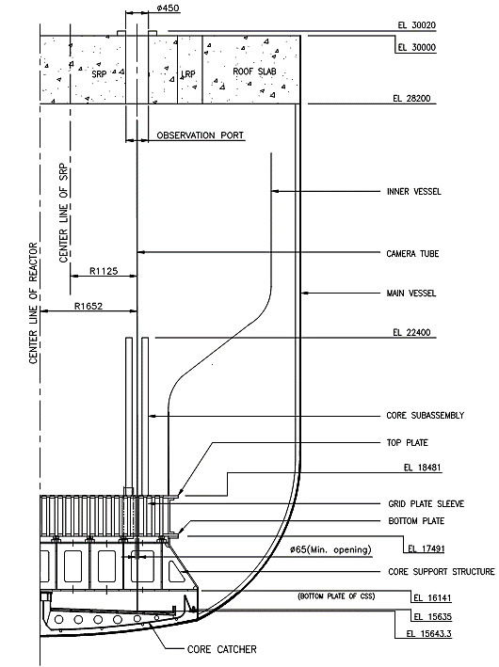
The observation port in the SRP on the roof slab of PFBR is to be considered for accessing the MV internals. Hence, a remotely operated viewing device called RCVS has been developed for the visual inspection of the region, surface condition on top & inside of the grid plate, outer surface condition of sub-assemblies, to identify the type, size & location of debris, if found during inspection and core catcher. A vacuuming arrangement for sucking the debris and to collect it at the operating platform through a hose was also required to be incorporated in the system. The RCVS has been designed, manufactured and successfully tested on a full scale reactor core mock test setup with 19 dummy sub-assemblies maintaining the same reactor core dimensions and grid plate top from the observation port. This paper details the design and mock-up tests carried out using the RCVS system for the reactor core viewing during commissioning stage inspections.
Fig.1. Half vertical cross-sectional view of the PFBR main vessel with roof slab, grid plate, core-catcher, a single array of fuel sub-assemblies and gap depicting a central sub-assembly removed.
- DESCRIPTION OF THE REACTOR CORE VIEWING SYSTEM (RCVS)
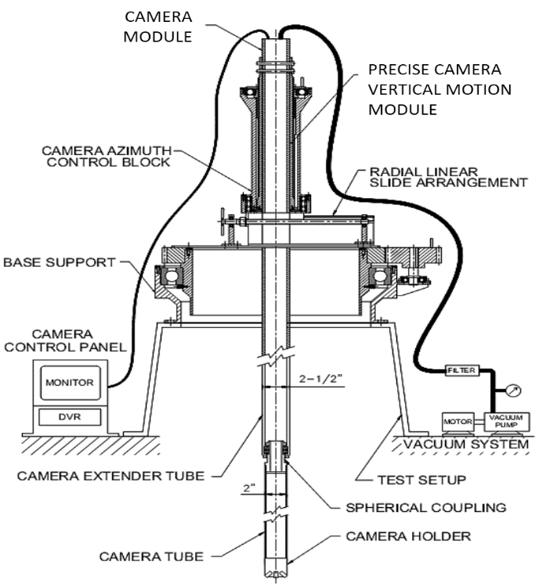
The Reactor Core Viewing System (RCVS) has been designed and developed to address the pre-commissioning inspection requirements for the reactor internals at room temperature as a remote viewing inspection tool. The RCVS is designed to be mounted on observation port on the roof slab of the reactor and enters into the core through the slot of extracted sub-assembly to view the top of grid plate and extracted sub-assembly seating area. The system has been designed to restrict the range of motions needed in respective degrees-of-freedom to position and orient the probe camera of the RCVS within the extracted sub-assembly slot under the observation port viewing area. The schematic of the RCVS is shown in Fig. 2.
Fig.2. Schematic of RCVS showing various modules
The grid plate top is 11.5 m below the top of top shield and hence, a number of spool pipes are used to enable the RCVS probe camera to reach the top of the grip plate. The visual inspection camera module is attached at the end of the pipe which will help viewing the top surface of the grid plate. The pipes provide structural integrity to the camera modules from the top of roof slab location and also act as carrier for all the signal and power cables and vacuum hose. The design and operation are such that during the operation, the RCVS should not come in contact or touch the reactor internals.
2.1 Design and Features of RCVS
The top of the grid plate is about 11.5 m below the roof slab, within the MV. The visual inspection unit, accesses the core support structure (CSS) and core catcher (~6.5 m below sub-assembly top), by maneuvering adroitly through a narrow circular (mini) opening of ∅ 65 mm, in the bottom of grid plate sleeve. The RCVS is a pre-service inspection (PSI) device designed for deployment through the observation port in SRP of PFBR for visual inspection of the reactor core and its sleeves in grid plate by negotiating through a hexagonal fuel subassembly slot. The RCVS has a precise manual radial motion (R), rotary motion (Ɵ), vertical motion (Z) and azimuth motion to localize the probe camera to target position. Fig.3 shows the CAD model of RCVS with control panel and probe camera module and fig.4 shows the photograph of RCVS.
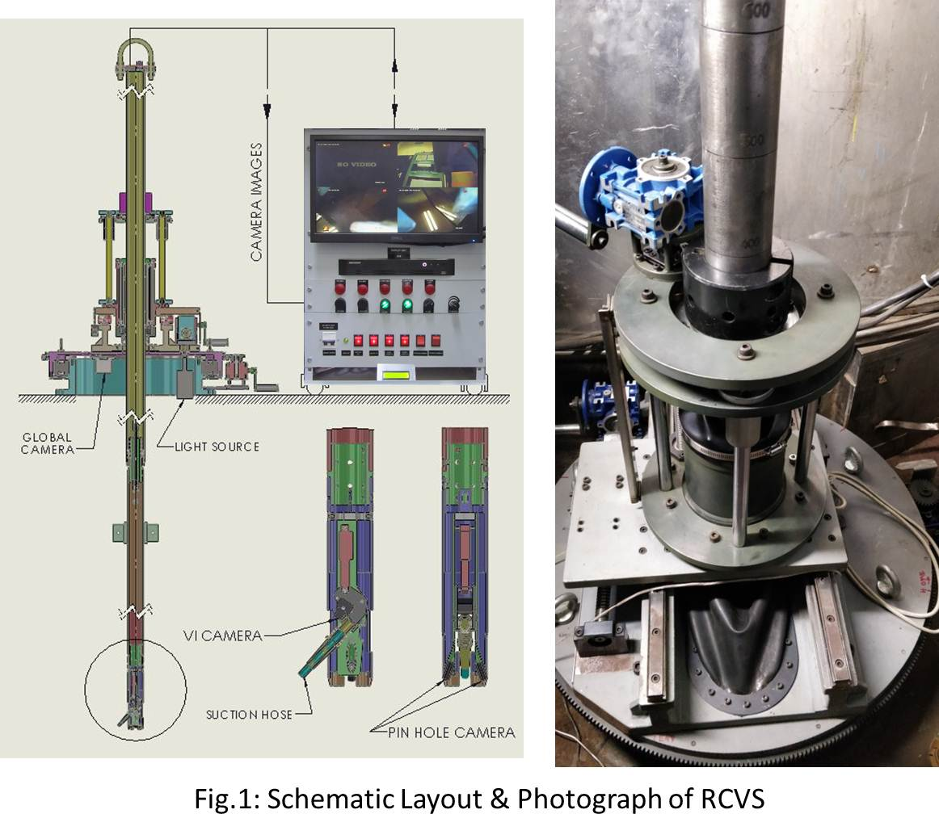
The major challenge in the design of RCVS is that the system must have a reasonably good accuracy with a very high ratio of longitudinal to lateral motion. The RCVS has to deploy the vision probe into the extracted sub-assembly slot in the core. The camera module which has extender pipes, reaches up to the grid plate top from the observation port. The camera extender pipes are designed to have spherical coupling at the end to maintain verticality and to transmit azimuth rotation of the inspection camera. End-to-end connected assembly of spool pipes form the spine of the RCVS and the lengths and diameters are judiciously chosen with due considerations for the constricted spaces at different elevations within the core, and to facilitate the handling and deployment through the observation port at SRP top. A 6 m long ∅ 2.5”, 6 m long ∅ 2” pipe and 1 m long ∅ 2.5” pipes are fastened together during deployment vertically into the reactor. For the assembly of 2.5” pipe to 2” pipe, the friction clamp (Fig.5) is fixed on the 2” pipe and rested on the thrust bearing in the Z-stage module. CAD drawing of the pipe joint is shown in Fig.6. The two pipes are connected by screws as shown in Fig.7. The camera extender pipes have spherical coupling to maintain verticality and to transmit radial (R), rotary (Ɵ), vertical (Z) and azimuth motions to the inspection camera probe.
Fig.3. CAD model of RCVS with control panel and probe camera module
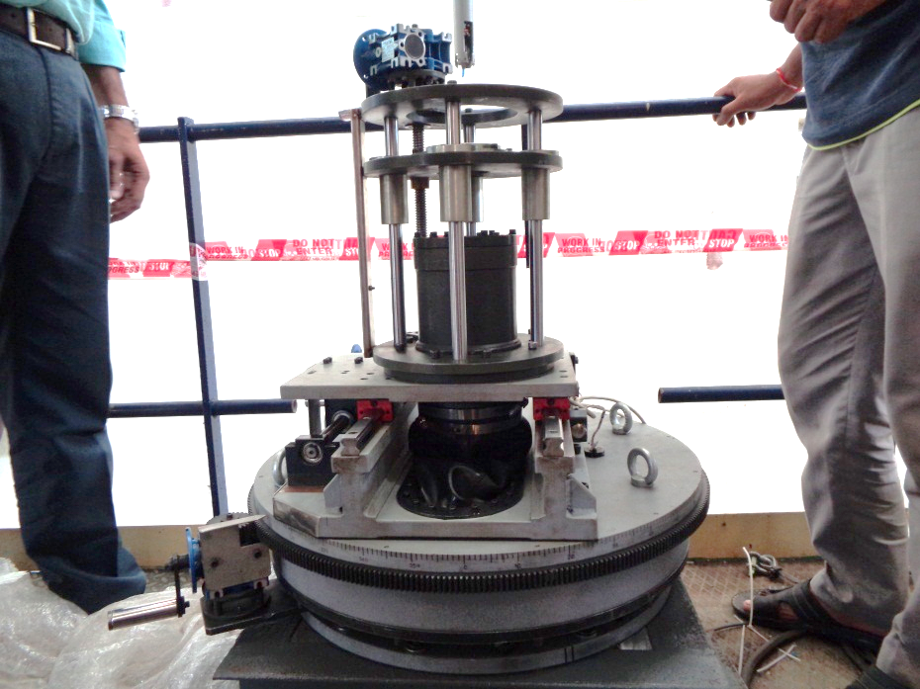
An augmented unit has been incorporated into the RCVS to extricate light-weight foreign objects (debris) by vacuuming. The visual inspection camera and vacuum hose form an integrated unit on a linear actuator which enables swing of the integrated unit with a range of 30° with respect to vertical axis.
Fig.4. Photograph of RCVS base module
R-Motion
θ -Motion
Azimuth
Motion
Z-Motion
The base support module is designed to suit the observation port of 𝜙 450 mm on the roof slab. This module also gives the complete structural support to all the modules of the RCVS. It houses the sub-assemblies which enable rotary (θ), azimuth and radial motions (R) to guide the movement and positioning of the RCVS. The rotary motion is achieved with a suitable ball bearing of bore diameter of 500 mm on the base support, mounted on the observation port flange. The rotary motion is effected by a simple spur gearing which is driven a 1:10 worm gear drive. The pipes and camera extender tubes of the RCVS pass through radial linear slide sub-module. Linear motion is precisely controlled by lead screw mechanism driven by 1:10 worm gear box. The combination of radial and rotational motions facilitates positioning of the visual inspection unit at any location within the observation port circular area to reach the centre of the extracted sub-assembly slot. Graduations are conveniently provided for the radial and rotational motions to achieve the required value for the movements. The entire system is specially sealed for all the radial, rotational and vertical motions to mitigate leaks through the RCVS system during inspection in the reactor core.
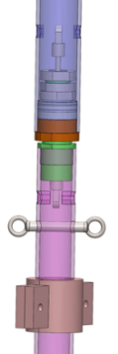
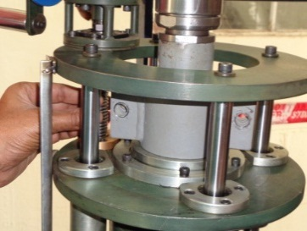
The camera tube module (Fig.8 and 9) is a three-piece assembly with 200 mm long ∅ 2” pipe housing a probe camera, two pin hole cameras and linear actuator. The probe camera module is designed to have axial and radial viewing vision sensors to view the required target position with proper LED lighting. The azimuth control module holds the vertical motion (Z) module and azimuth motion module for probe camera positioning. With the camera radial focus view, the azimuth motion facilitates a 360° rotation of probe camera with circumferential viewing at targeted location. This also helps the vacuum hose to sweep 360° around to clean if any debris is present over the grid plate top.
Fig. 6: CAD drawing of connecting pipes
Fig. 7: Joint between 2.5” and 2” pipes
Fig. 5: Friction clamp for connecting 2.5” and 2” extender pipes
To provide a precise vertical motion to the camera, a ball screw/nut actuated vertical travel (Z-axis) of 100 mm is provided and the ball screw is driven by a 1:10 worm gear box. This travel is utilized for precise vertical movement of camera module, once the camera module reaches the grid plate top surface. This movement provides fine control to enable the camera to have a closer view of the grid plate top.
Fig. 9: Photograph of Camera tube module module
Fig. 8: CAD model of Camera tube module module
The power and signal cables pass through the RCVS pipes and hence the illumination intensity and swing of the suction unit can be controlled appropriately at the operator station, based on the visual feedback from the cameras on the display unit. A camera with illumination below the base mounting block, is provided for a global view of the reactor internals and aiding the deployment of the RCVS towards extracted sub-assembly slot. A neoprene rubber hood has been designed and provided at the base unit to ensure minimal or nil nitrogen leak from the MV.
The vacuum system module consists of a vacuum pump having a volumetric capacity of 1500 lpm to facilitate the removal of any foreign particle at the target location (Grid Plate top). In order to clean the target location, a 𝜙 10 mm hose is run from the vacuum pump at the operator platform up to the crevice end which is 𝜙 8 mm to provide better suction effect. The suction hose is also terminated at the probe camera end to suck and remove any small debris during the inspection.
The control panel of RCVS consists of the display monitor to show the images captured by all the 4 cameras, the linear actuator position control buttons, brightness adjustment for the LED lights on the probe camera and switch control of the camera devices.
- MOCK-UP TEST SETUP
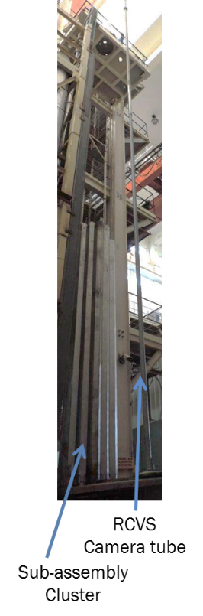
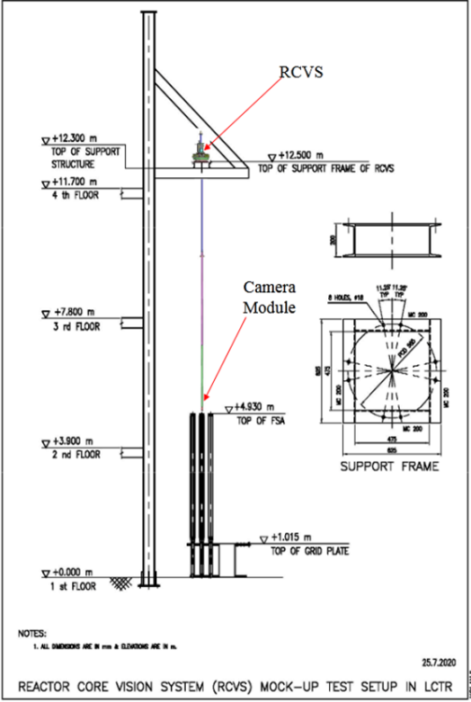
To carry out the design validation and functional qualification of RCVS, the RCVS was installed in the full scale sector mock-up test setup. Figs.11 shows schematic of the mock test setup for the RCVS qualification. The mock-up test setup simulates the conditions of the observation port in SRP and the 19 sub-assemblies core cluster for the reactor core. The elevation of observation port with respect to the grid plate top is 11.5 m and mock-up test setup also simulates the same distance between the observation port and the grid plate top. The observation port flange is simulated with the support frame. The control module of RCVS can be placed at 12.3 m elevation to simulate the reactor conditions. The dummy sub-assemblies used are of the same dimensions as that of the sub-assemblies of PFBR core.
Fig.11. Photograph of the mock-up test setup and RCVS Camera Module with connecting pipes in assembled condition

Fig.10. Schematic of the mock-up test setup to test and qualify the RCVS

- DESIGN VALIDATION AND FUNCTIONAL QUALIFICATION
RCVS was installed in the mock-up test set up shown in Fig.11. The base support module with linear motion stage of the RCVS device was installed in the platform provided at EL 12.500 m using the overhead crane. The weight of the table is around 220 kg. After installation of the above module, the movement of all the axes was verified. Subsequently, the Camera tube Module with connecting extender pipes is assembled and deployed in the mock-up with sub-assembly array.
Markings on the 6 m long 2.5” pipe are put at 1050 mm location signifying the entry of the camera tube module inside the core region. The marking on the 2.5” pipe at 4700 mm location signifies the grid plate top surface elevation of camera tube module.
The global camera positioned at the RCVS table bottom surface is helpful in identifying the entry of camera module inside the core. The bottom hole in the grid plate top surface is ∅ 80 mm and the probe camera image is varied as the camera is brought closer to grid plate surface. This variation is calibrated using a vernier height gage setup to identify the axial distance of the camera with grid plate top surface. Fig. 12 shows the images of the grid plate top surface acquired by the probe camera at different elevations.
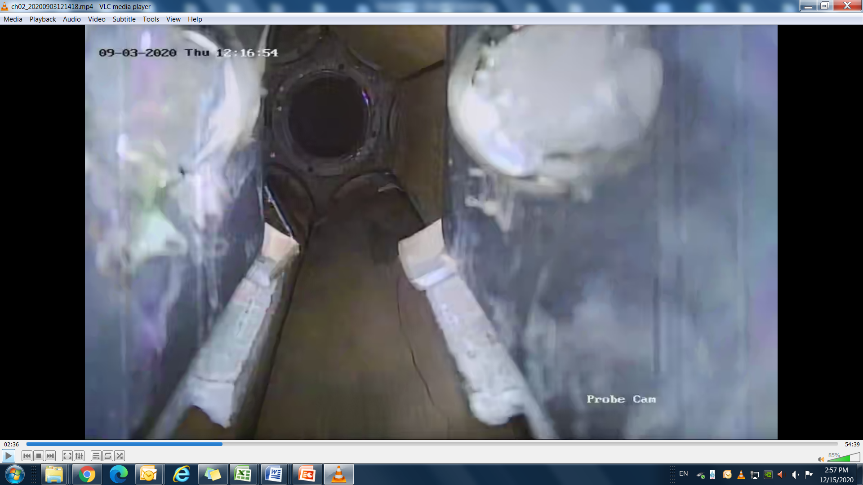
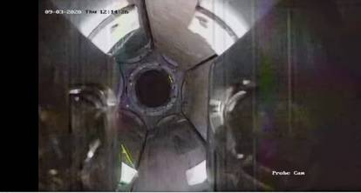
- LIMITATIONS OF RCVS: DESIGN & FUNCTIONALITIES
Fig.12: Probe Camera Image showing Grid Plate top surface in the mock-up test setup
The RCVS has been designed and developed for conducting visual examination through the observation port of the SRP. Hence, the spine/tube of the RCVS system is expected to be aligned with the zone of operation and interest (i.e. an extracted subassembly slot) for the camera tube to conduct detailed visual investigation. During operation of RCVS, after the transfer arm picks and clears the core location of subassembly, the small rotating plug (SRP) is rotated into position so that the exact location of the slot created by the removed subassembly matches the observation port in the SRP. Further, to accommodate any mismatch between the actual core location and the position of observation port, the radial (R) and rotational (θ) motion features have been incorporated into the RCVS in order to position the RCVS tube with the slot created by the removal of SA. This eliminates any concerns with regard to the reachability of the RCVS to the grid plate top which is the intended/planned location for conducting visual inspection. Nevertheless, in order to visually investigate the presence of debris and foreign particles, by reaching further zones of inspection beyond the grid plate i.e., passing through the grid plate sleeve into the core support structure region, it is required to incorporate auto self-orientation feature into the RCVS. This is planned to be incorporated as an enhanced feature for the next version (Mark II) of the RCVS. Notwithstanding this aspect, in the event that the misalignment is minimal between the observation port and slot, attempts will be made with the current RCVS itself to progressively enter the grid plate sleeve, during the examination of the grid plate top.
- CONCLUSION
A Reactor Core Viewing System (RCVS), for the PFBR core within the MV, has been developed at Indira Gandhi Centre for Atomic Research (IGCAR), Kalpakkam, India. The RCVS has been tested and qualified for deployment in reactor at room temperature. In the current stage of the pre-commissioning activities, the RCVS would fulfil its role for a pre-service inspection before sodium filling in the main vessel. Hence, RCVS is designed to operate at room temperature (RT) condition. The design can be upgraded for use in high temperature (HT) conditions, if necessary, with suitable design modifications for reactor inspections.
Acknowledgements
The support and motivation provided by Dr. A.K. Bhaduri, Director, IGCAR to carry out the work is gratefully acknowledged. The encouragement for the development of RCVS system by Shri S. Raghupathy, Director, Reactor Design & Technology Group, IGCAR is duly acknowledged.
References
[1] Deepak Kumar et.al, “Conceptual Design and Development of Reactor Core Viewing System for Pre-commissioning stage inspection of PFBR Core”, IGCAR Internal document

