# EXPERIENCE IN PREHEATING OF PFBR REACTOR ASSEMBLY

P RAJAVELU1, P RAJESH KUMAR1, NISHANT SAHU1, R PRASANNA1, Y S RAMASWAMY1, V V SUBRAHMANYAM1, A JYOTHISH KUMAR1

1Bharatiya Nabhikiya Vidyut Nigam Limited, Department of Atomic Energy, Kalpakkam, India

Email contact of corresponding author: rajavelu_bhavini@igcar.gov.in

**Abstract**

Preheating of Reactor Assembly (RA) internals is one of the important milestones in the commissioning activity of Prototype Fast Breeder Reactor (PFBR). The reactor assembly internals need to be preheated using hot nitrogen to a minimum temperature of 423K (150˚C) before initial sodium filling in the primary sodium circuit, to avoid solidification of sodium and also avoid thermal shocks on components during sodium filling. Preheating strategy adopted for PFBR is to increase the circulating gas temperature in steps to a maximum of 5˚C/day to achieve uniform temperature rise among internals, as necessitated by thermal and structural analysis. Uniform heating of all the components to 150˚C was a challenging task due to presence of multiple complicated parallel flow paths for Nitrogen flow in deviation to the originally envisaged scheme, which could not be adopted due to site constraints. Prior to pre-heating, Reactor Assembly, annulus of Main Vessel (MV) & Safety Vessel (SV) and pre-heating circuit were purged with nitrogen. After achieving purity, trial preheating was done up to 90°C as a part of commissioning of preheating system. Secondary sodium loops and SGDHRs main circuits were isolated and blanketed with Argon. Secondary sodium, Primary auxiliary circuits and SGDHR systems were preheated along with Reactor Assembly. Preheating was continued till the main vessel temperature achieved to a minimum of 150˚C. Sufficient soaking time was given at every 30˚C temperature set point rise for stabilisation of Reactor Assembly temperature to ensure near uniform temperature distribution and resultant induced thermal stresses in the reactor assembly structures are within limits. As the rate of temperature rise was not sufficient to preheat the system as intended, design changes were incorporated to increase the flow rate of hot nitrogen. This paper details the methodology used, the challenges faced and the commissioning experience gained during pre-heating of reactor internals.

## INTRODUCTION

BHAVINI is commissioning Prototype Fast Breeder Reactor (PFBR), a 500 MWe sodium cooled, pool type, mixed oxide (MOX) fuelled reactor at Kalpakkam. Fig. 1 shows the cross section of PFBR reactor assembly. Reactor assembly of PFBR, consists of primary sodium circuit contained by main vessel (MV) made of SS 316 LN material supported at the top with Top Shield (TS) containing Roof Slab (RS), large and small rotatable plugs and control plug. The core subassemblies are supported on grid plate (GP) and the load is transferred to main vessel through core support structure (CSS). Safety Vessel (SV) made of SS 304 LN is positioned concentric to main vessel on outer side. Inner vessel (IV) separates the hot and cold pools of primary sodium and houses two primary sodium pumps (PSP) and four intermediate heat exchangers (IHX) at the bottom end. Reactor assembly (RA) is housed in a concrete vault lined with carbon steel. The main vessel is welded with roof slab, which in turn is welded to RS support embedment provided in the reactor vault concrete. Two thermal baffles, outer and inner form a part of the main vessel cooling system and welded concentric to inside of MV.

Preheating of reactor assembly is an important milestone in commissioning of the project. Reactor assembly internals are to be preheated to a minimum of 413 K (150˚C) prior to initial sodium filling in the primary sodium circuit in order to avoid solidification of sodium, as well as, to avoid undue thermal shocks on components during sodium filling. Considering the non-uniformity in the temperatures of various parts of the reactor assembly, it was envisaged to preheat the internals to 150 - 180˚C with a heating rate of 5˚C/day [6]. Hence, the temperature difference between reactor assembly structures is limited and induced thermal stresses are within limits. The preheating of Reactor assembly and internals to a minimum of 150˚C was expected to be completed in around 10 weeks.

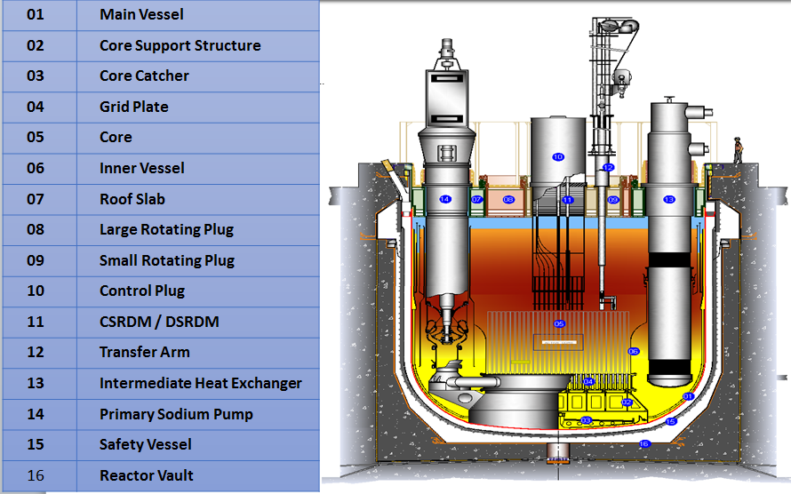

*Fig. 1. Reactor Assembly of PFBR adopted from [1]*

## HEATING METHODOLOGY

Preheating is carried out by circulating hot nitrogen gas through the reactor assembly. Hot gas would be led into the hot pool through pipe spools inserted through the penetrations in the top shield. Inlet of nitrogen to the reactor assembly is made through (a) an opening in Large Rotating Plug (LRP),(b) through an opening in Small Rotating Plug (SRP) and (c) through In-Service Inspection (ISI) openings in the annular space between main vessel (MV) and safety vessel. The fluid returning from the above components was routed through (c) through Cold pool level detector (CPLD) opening in the roof slab and (d) through ISI openings in the annular space between MV and safety vessel. The schematic of preheating scheme is shown in Fig.2.

This preheating circuit has four parallel blowers and three parallel heater banks of total capacity 270 kW. Initially, the Reactor Assembly, annulus of Main Vessel & Safety Vessel and circuit was purged with nitrogen to completely purge out the air in the system. The purging operation was continued till required nitrogen purity level is achieved. Before starting the preheating of reactor assembly, readiness of connected circuits like secondary sodium circuit, primary sodium purification, Primary fill & drain circuit, SGDHR circuit, Primary argon circuit piping, etc., is ensured. The preheating of Reactor assembly and its internals is initiated by starting with two nitrogen blowers and electrical heaters. The nominal nitrogen flow rate expected is ~ 10 kg/s and the nitrogen outlet temperature from the heater bank is set to rise by 5˚C per day [6]. This ensures the uniform temperature rise in the reactor assembly structures. Hence, the temperature difference between reactor assembly structures is limited and induced thermal stresses are within limits. Safety vessel is getting heated as it is enveloping the boundary of interspace heating though it is not required to be heated.

The temperature evolutions in various structures such as inner vessel, grid plate, pump vessel, pump shaft, main vessel, safety vessel, dummy subassemblies etc., depend on the rate of change of nitrogen admission temperature, flow fraction of hot nitrogen to various components and mass / surface area of the components. Hence, there will be a temperature difference among them during pre-heating.

*Fig.2.Preheating circuit schematic adopted from [1]*

**e**

**d**

**c**

**b**

**a**

The temperature difference between the connected structures should be less than 23˚C. Heating rate of Nitrogen was limited to 5˚C/day from the considerations of limiting the differential temperature between the grid plate and inner vessel [6]. The upper limit of nitrogen inlet temperature to RA was set 230˚C to limit the top plate temperature of top shield to a maximum of 150˚C.

## integrated preheating

Initially, the Reactor Assembly, annulus of Main Vessel & Safety Vessel and circuit was purged with nitrogen till required nitrogen purity level is achieved [1]. Main vessel purging was carried out in pressure swing method (100 mbar - 5 mbar swings) and rest of the circuit was purged later with flow purging method. The schematic for the above process is shown in Fig.3.

This process was carried out continuously for 75 times and Nitrogen purity was achieved (Oxygen < 400 vpm, Moisture < 200 vpm) at the end of 67th cycle [2]. MV-SV interspace and MV preheating circuit was purged with Nitrogen continuously with a flow of ~ 40 m3/hr (flow purging method). Purity achieved at the end of 78th hour [2]. Subsequently, nitrogen atmosphere inside main vessel and MV preheating circuit were connected and purging was continued to achieve Oxygen < 100 vpm. Main vessel Nitrogen filling was carried out predominantly through the preheating circuit & partially through centre location to replace air by Nitrogen effectively in the volume below the Grid plate. Nitrogen would flow from Core support structure to 24 Nos MV cooling pipes and reaches hot pool.

The preheating of Reactor Assembly was initiated by starting the nitrogen blowers and electrical heaters. Main vessel preheating was carried out with two blowers and three heater banks in service. Secondary sodium loops and SGDHRs main circuits were isolated and blanketed with Argon. Main vessel, SGDHR systems and primary auxiliary systems are preheated concurrently.

Initially, trial preheating was attempted to heat the internals to 90˚C as a part of commissioning MV preheating system. Blower performances, Thermocouple response, heater performance in auto ON/OFF control, low flow trip and auto operation of feed and bleed valves were checked. The Nitrogen inlet temperature was controlled such that the heat rating rate of MV and its internal is limited to 5˚C/day. Rate of heating was controlled by manipulation of heater input power. Sufficient soaking time was given at every 30˚C temperature set point rise for stabilisation of Reactor Assembly temperature to ensure near uniform temperature distribution and resultant induced thermal stresses in the reactor assembly structures are within limits.



*Fig.3.Purging Scheme adopted from [1]*

Initially, trial preheating was attempted to heat the internals to 90˚C as a part of commissioning MV preheating system. Blower performances, Thermocouple response, heater performance in auto ON/OFF control, low flow trip and auto operation of feed and bleed valves were checked. The Nitrogen inlet temperature was controlled such that the heat rating rate of MV and its internal is limited to 5˚C/day. Rate of heating was controlled by manipulation of heater input power. Sufficient soaking time was given at every 30˚C temperature set point rise for stabilisation of Reactor Assembly temperature to ensure near uniform temperature distribution and resultant induced thermal stresses in the reactor assembly structures are within limits.

The temperature of Nitrogen at IHX inlet and outlet windows were monitored carefully during pre-heating. Outlet window is very important since it represents the bottom tube sheet temperature. After IHX outlet Nitrogen temperature is stabilized at 150˚C, 4 days soaking time was given to top tube sheet to reach 150˚C whereas two weeks soaking time was given to the bottom tube sheet to reach 150˚C. This is mainly because of three thermal shields provided to the bottom tube sheet.

Secondary and SGDHR systems are heated using surface heaters up to 180-200˚C. Steam generators are preheated by admitting and circulating hot water through SG tubes. Schematic of integrated preheating is given in Fig.4. At the end of 10 weeks, temperature got stabilized in various elevations of MV. Main vessel temperature stabilized at 149˚C Max in Top elevation and 138˚C as min, in bottom of the main vessel i.e., crown area [8]. Secondary sodium loops were filled with sodium and secondary sodium pumps were commissioned and operated. Main vessel temperature reached above 150˚C with running SSP in secondary sodium loops. The temperature of secondary sodium loops is 200°C.

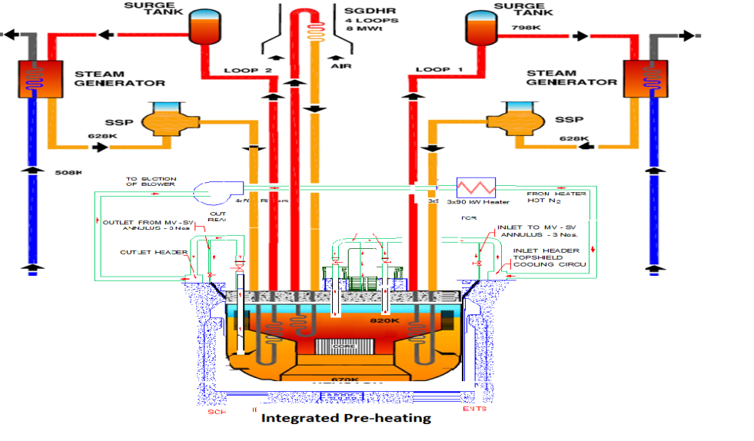

*Fig.4. Schematic of integrated preheating*

## COMMISSIONING EXPERIENCE

Preheating strategy adopted for PFBR is to increase the temperature at a maximum rate of 5 ˚C/day to achieve uniform temperature rise among internals, as necessitated by thermal and structural analysis. Uniform heating of all the components to 150 ˚C was a challenging task due to presence of multiple complicated parallel flow paths for Nitrogen flow and also in deviation to the originally envisaged scheme, which could not be adopted due to site constraints. Based on the preheating carried out in PFBR, the total activity could be split into two stages. The first stage involves preheating of IHX to 150 ˚C so that sodium can be filled in the secondary sodium main circuit. The second stage involves preheating of entire reactor assembly to 150 ˚C for filling sodium into the main vessel. A brief description of experience and challenges faced during preheating activity carried out in PFBR is given in the following paragraphs.

There was a concern about the purging of space below grid plate where purging gas may not flow much as per theoretical studies. An option for purging below grid plate/CSS was discussed and a concept of using purging tool (very long pipe having varying dimensions) was conceived and implemented. The bottom size of the tool was 21.3 mm and the top portion was sized to suit central canal plug. It seats at grid plate similar to a Fuel Sub-assembly. Below grid plate elevation, the pipe extended further for 2.4 m. Multiple holes (6 mm) were provided in the bottom length of pipe (1.5 m), for better distribution of Nitrogen in CSS area.

Main vessel samples were analysed for oxygen and moisture (by measuring dew point) after every cycle of purging. All the sampling points are from cover gas system represents the cold pool volume. Temporary arrangement made in primary sodium purification system to sample Nitrogen from cold pool to ascertain the isotropic nature of nitrogen chemistry. Cold pool sample result found to be very close to hot pool.

Purging tool modified with as thermocouple tree and installed in central canal plug location before start of preheating for temperature monitoring of grid plate and core support structure. The temperature indicated by thermocouple at SA mid-point is taken as the central SA temperature for comparison. Similarly, temperature indicated by thermocouple at grid plate and CSS are taken as grid plate and CSS temperature for comparison.

Another thermocouple tree was installed in sodium sampling point for measuring the SA top temperature. Thermocouple tree helped in profiling of core support structure (CSS), grid plate (GP) and sub-assembly (SA) central temperatures. Grid plate temperature found to be higher than CSS. This measurement has enhanced our understanding of temperature distribution. Linear correlations were made for grid plate and core support structure temperature calculation with respect to main vessel crown temperature. The GP and CSS temperature could be estimated from the correlations for the known crown temperature.

As the structures were maintained at a temperature of around 25°C prior to preheating, moisture and the oxygen levels were increasing initially with temperature due to the release of oxygen and moisture traces from the surfaces of the Reactor assembly internals. These parameters were found to be stable after attaining a temperature of 150°C

Data acquisition system was used for monitoring and recording the data. Representative thermocouples are selected which fairly represent the overall temperature of the component to reduce the pooling of large thermocouple readings. The difference between the average and the representative thermocouple was in the order of 2 to 6˚C. Rate of heating was controlled by manipulation of heater input power wherein, the heating rate of the Nitrogen entering to the reactor assembly was maintained within 5˚C/day.

The mass flow rate of nitrogen for reactor internal heating and inter-vessel heating achieved in the plant was lower than the values taken for design analysis. Consequently, the heating rate achieved in the plant was lower than that predicted in the design calculations. The achieved heat-rating rate of Reactor assembly was around 1.8 to 2.3 ˚C/day [8].

Heat losses were found to be more through the surroundings from the surfaces of various parts of the system like preheating circuit, safety vessel, SGDHR system, Top shield and components supported over it. The complementary shielding and its configuration is one of the major contributors for the increased heat loss from the reactor assembly which was not accounted during the theoretical estimations [3]. Nevertheless, the present configuration of preheating circuit will be able meet the requirements for sodium filling in secondary and primary sodium circuits within a reasonable timeline.

Evolution of temperature in various parts of reactor internals, viz., central dummy fuel SA, grid plate, pump inlet, main vessel, IHX and safety vessel with respect to nitrogen inlet temperature was checked with theoretical estimations. The temperature of various RA components was found to be increasing gradually within permissible limits.

The rate of increase of Central SA temperature was less than the estimated values and this difference was consistent throughout the preheating activity. Temperatures of central SA closely followed the inlet nitrogen temperature. The evolution of Grid plate and core support structure temperature was found following Nitrogen inlet temperature. The predicted MV temperature was in line with the observed values. The predicted rate of increase in SV temperature was found to be greater than the plant data. This is probably due to additional heat losses to reactor vault [7].

In few locations in RS top plate, temperatures were found to be higher compared to bottom plate. However, field measurement on the top of the top plate was taken physically at various locations especially at the suspected areas. All the measurement taken on top surface of top plate found to be in the range of 60-65˚C. The box structure thermocouples on the same radius and elevation between the top and bottom plate were also showing 60-65˚C.

Pre-heating nitrogen flow measured with the Pitot tube anubar. Flow meter is kept in the common discharge header to know the total flow delivered by the blowers. Flow meter reading was found decreasing continuously during heating with same damper opening and with different combination of blowers with minor variation in gross value of flow and stabilizes for a constant temperature. This is due to decrease in density of Nitrogen with increase in temperature.

It was expected in the beginning that the preheating could be completed in 30 days with design flow rate of 10 kg/s. The extended duration for preheating is mainly attributed to significantly large heat losses observed in the plant compared to that considered in the design. The design flow rate could not be achieved because of the high resistance of some circuit components, viz., filters at the inlet of reactor assembly and corrugated tubes in the inter-vessel space. The Nitrogen flow rate that could be achieved in the plant was ~ 5.7 kg/s. The flow rate achieved in the inter vessel space was ~1.25 kg/s as against the design requirements of 2 kg/s [4]. The preheating of Reactor assembly and internals to a minimum of 150˚C was expected to be completed in around 10 weeks with the achieved flow rate of Nitrogen.

MV-SV interspace heating was essential to ensure requisite reactor assembly temperature to be maintained prior to commissioning of PSPs. Secondary sodium system would supply the heat till PSPs commissioning. The nitrogen flow rate in MV-SV interspace was enhanced to ~1.97 kg/s with certain modification of heating circuit in order to avoid cool down of reactor assembly, in an unlikely event of stoppage of both secondary sodium systems [4].

## SUMMARY AND CONCLUSION

Preheating of Reactor Assembly (RA) internals in Prototype Fast Breeder Reactor (PFBR) is one of the important milestones in the commissioning activity of the project. Preheating strategy adopted for PFBR is to increase the temperature at a maximum rate of 5 ˚C/day to achieve uniform temperature rise among internals, as necessitated by thermal and structural analysis. Uniform heating of all the components to 150 ˚C was a challenging task due to presence of multiple complicated parallel flow paths for Nitrogen flow. Based on the preheating carried out in PFBR, the total activity could be split into two stages. The first stage involves preheating of IHX to 150 ˚C so that sodium can be filled in the secondary sodium main circuit. The second stage involves preheating of entire reactor assembly to 150 ˚C for filling sodium into the main vessel. It is evident from the experience that IHX could be preheated to a level required for secondary sodium filling within ~ 10 weeks and 12 weeks for raising the temperature of entire reactor assembly above 150˚C for sodium filling in main vessel by running of secondary sodium pumps.

References

1. RAJAVELU, P., Commissioning Procedure for MV Purging, internal report, Bharatiya Nabhikiya Vidyut Nigam Limited, Kalpakkam, India,2017.
2. RAJAVELU, P., Commissioning Report for MV Purging and Preheating, Bharatiya Nabhikiya Vidyut Nigam Limited, ,Kalpakkam, India,2019.
3. ANURAG SAMANTARA et al., Investigation of Nitrogen purging in Reactor Assembly before Pre-heating , Indira Gandhi Centre for Atomic Research, Kalpakkam, India,2016.
4. VIKRAM G., Study of Different Options to Increase Nitrogen Flow Rate in the Inter Vessel Pre-heating Circuit, Indira Gandhi Centre for Atomic Research, Kalpakkam, India, 2018.
5. JAGRUTE MOTE, et al., Estimation of Heat Balance during PFBR Reactor Assembly Preheating, Indira Gandhi Centre for Atomic Research, Kalpakkam, India, 2017.
6. RAJENDRA KUMAR M., Thermal Hydraulic Analysis of Reactor Assembly Preheating with Nitrogen Temperature rise of 5oC per day, Indira Gandhi Centre for Atomic Research, Kalpakkam, India,2016.
7. RAJENDRA KUMAR M., Thermal Hydraulic Analysis of Reactor Assembly Preheating with Hot Nitrogen Flow and Temperature as achieved in the Plant, Indira Gandhi Centre for Atomic Research, Kalpakkam, India,2019.
8. Data sheets of PHNC, Bharatiya Nabhikiya Vidyut Nigam Limited, Kalpakkam, 2017-2019,