Commissioning and Operating Experience for Secondary Sodium Systems and Auxiliaries of PFBR

NISHANT SAHU¹, RAJAVELU P¹, MANOJ KANNAN S¹, RAMASWAMY Y S¹,
ALLU ANANTH¹, SUBRAHMANIYAM V V², KRISHNAMOORTHY M¹, JYOTHISH KUMAR A¹

¹Bharatiya Nabhikiya Vidyut Nigam Limited, Kalpakkam, India
² Indira Gandhi Centre of Atomic Research, Kalpakkam, India

Email contact of corresponding author: nishant_bhavini@igcar.gov.in, nishant@bhavini.in

Abstract

In Prototype Fast Breeder Reactor, Secondary Sodium circuits transfer the heat from primary sodium system in the pool through intermediate heat exchangers to the steam water system for the production of steam & thereby electrical energy. These two circuits are located in Steam Generator (SG) buildings and are engineered to avoid direct ingress of hydrogenous material to primary sodium system, so as to avoid reactivity transients. These circuits have sub-systems such as Fill & Drain system, Sodium purification system, Steam Generator Tube Leak Detection system and Sodium Water Reaction Product Discharge system. The Auxiliary circuits include Sodium pipe penetrations air cooling system, Secondary Argon system, Lubrication and bearing oil cooling system of Secondary Sodium Pumps. The initial Sodium filling & purification requirements are taken care by two number of reflux type Electromagnetic pumps. Owing to the complexity of the circuit, an innovative cost effective methodology of purging air with nitrogen and subsequently with high purity argon helped in reducing argon consumption, as well as, in reducing purging time to less than 10 days which served as a benchmark. Consequent to achieving purity of argon, melting and purification of sodium in the respective Secondary Sodium Storage Tanks were carried out. Initially, the impurities in sodium were cold-trapped by circulating the sodium using Electromagnetic (EM) pumps through Cold Trap and subsequently main sodium loops were filled and the main pumps were operated only after required purity level was achieved. During commissioning, issues such as increased vibrations and subsequent malfunctioning of the EM pumps were experienced. The problems could be resolved by detailed analysis and by incorporating suitable modifications in EM pumps and the pipe supports. Main sodium circulating pumps were commissioned and operated. However, during operation of one of the two pumps, an increased torque was detected. Consequently, based on the detailed study and analysis, the clearances at wear ring and labyrinth regions were increased. Then the pumps were operated continuously without any problem and the secondary sodium system was commissioned successfully.
The paper details the methodology used, the challenges faced and the commissioning experience gained in operation, modification and subsequent verification of Secondary heat transport circuits which have laid a basis for improvements and modifications in other similar systems.

KEYWORDS: Commissioning, Operation, PFBR, Sodium

ABBREVIATIONS

PFBR | Prototype Fast Breeder Reactor
IGCAR | Indira Gandhi Centre for Atomic Research
EM | Electromagnetic
IHX | Intermediate Heat Exchanger
SG | Steam Generator
SSP | Secondary Sodium Pump
HSDS | Hydrogen in Sodium Detection System
SSMC | Secondary Sodium Main Circuit
SGDHR | Safety Grade Decay Heat Removal System
ISFC | Initial Sodium Filling Circuit
SGB | Steam Generator Building
RCB | Reactor Containment Building
SSST | Secondary Sodium Storage Tank
PI | Plugging Indicator
SSPC | Secondary Sodium Purification circuit
SGTLDS | Steam Generator Tube Leak Detection System
SWRPDC | Sodium Water Reaction Product Discharge Circuit
SAC | Secondary Argon Circuit
SSFDC | Secondary Sodium Fill and Drain Circuit
VFD | Variable Frequency Drive
ALIP | Annular Linear Induction Pump
RMS | Root Mean Square
PIA | Pump Internal Assembly
DG | Diesel Generators

INTRODUCTION
PFBR consists of two identical secondary Sodium heat transport loops which transfer the heat generated during the nuclear fission, through IHX to the steam and water system through Steam Generators. Schematic of the heat transport circuit are depicted in Fig.1.
The major components of each secondary sodium main, fill and drain system are two IHXs, one surge tank, four steam generators (SG), one Secondary Sodium Pump (SSP), two SG isolation valves per SG, two reflux type Electromagnetic Pumps, one Secondary Sodium Storage Tank and associated piping. The purpose of EM pump is to fill Sodium in the main system and maintain constant Sodium level in Surge tank by compensating for SSP leak off flow, Surge tank over flow and drain flow through HSDS loops. The SG is a once through type vertically oriented, counter current shell and tube heat exchanger with sodium flow from top to bottom. It transfers heat to steam and water system in order to produce high quality steam for production of electricity through steam turbine and generator set. SSP is used to circulate Sodium in the secondary Sodium main system. Surge tank acts as the expansion tank to accommodate the volumetric expansion of Sodium due to temperature variations and hence it is situated at highest elevation in SGB. It also provides a cover gas space to absorb the surges caused by Sodium-Water reactions in the case of SG tubes failure. The sodium flow path is SSP-IHX-Surge Tank-SG and back to SSP. Sodium purity in the system is maintained by cold trapping the oxide and hydrides of Sodium formed. The paper discusses the major experiences gained during commissioning and operation of the Secondary Sodium systems of PFBR in the upcoming sections.

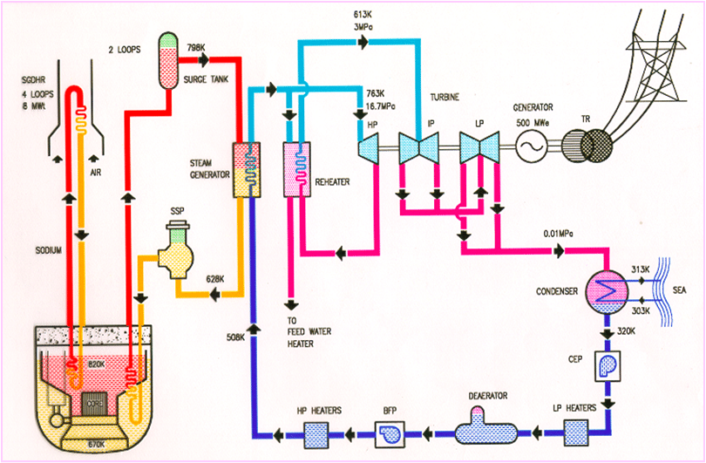

FIG. 1. Schematics of Prototype Fast Breeder Reactor (adapted from [17])

COmmissioning and operating experience gained for Secondary Sodium systems and its auxilliaries
Sodium is selected as a coolant for PFBR due to its excellent thermal and nuclear properties. PFBR employs about 205 t of Sodium in the Secondary Sodium systems in each loop during operation. Initially, the Sodium was stored in the Secondary Sodium Storage tank with nitrogen cover gas space. Handling of the large quantity of Sodium (≈1750t) without a single incident demonstrated the sodium handling capabilities. Major activities and experience gained are described subsequently in the following subsections.

- Transfer of Sodium to Sodium storage tanks

In PFBR, the estimated quantity of Sodium required is about 1750 t inclusive of reserve quantity. Sodium is required for Primary Sodium systems, Safety Grade Decay Heat Removal Systems (SGDHR) and Secondary Sodium systems. Initial Sodium transfer was done through ISFC. For initial Sodium transfer to various Sodium Storage tanks from Sodium tanker, heating of sodium was done by melting Sodium from room temperature to about 120-125°C using hot oil circulation at about 130 °C in tubes laid over the surface of the Sodium tanker. The method of Sodium transfer adopted was pressure difference transfer instead of forced transfer through pump as it was considered safer and simpler in execution.
Sodium was initially stored in the various storage tanks of varying capacities under inert nitrogen atmosphere before transferring to the concerned systems. All the operations were done by group of personnel trained in Sodium handling operations at IGCAR. Error free and incident free sodium transfer operations with utmost importance to safety and adherence to procedures embarked economical sodium handling and transfer operations without interfering the ongoing construction and erection activities in Steam Generator Buildings (SGB) and Reactor Containment Building (RCB).

- Pressure hold tests, cold purging, melting Sodium in Secondary Sodium Storage Tank, preheating and hot purging activities

Sodium, slight in excess was stored in Secondary Sodium storage tank to cater for the requirements of SGDHR loops sodium apart from the secondary Sodium System requirement of about 205 t. The cover gas used was Nitrogen during Sodium transfer and storage in tanks.
Argon purity is generally measured with respect to moisture and oxygen content in argon by volume in Parts per Million (PPM). It is expected to have Oxygen and Moisture content less than 50 ppm each before Sodium charging in the loops. Argon purity is achieved in two steps namely, cold purging and hot purging. Since Argon is heavier than nitrogen or air, it provides a very good purging media.
Integrated Secondary Sodium loop is generally referred as interconnected system of SSMC, SSMFDC, SSPC, SWRPDC and SGTLDS. After completion of erection and integration of all the Secondary Sodium systems and components situated in SGB-1, integrated loop was filled with Argon. The committed value of argon purity limit after completion of cold purging was less than 1000 ppm of Oxygen and Moisture each. Hence, cyclic Degassing, Vacuum pulling and Argon filling method was adopted but due to slow argon filling rate into the system through Argon cylinder banks argon purity could not be improved to below 100-200 ppm of Oxygen and Moisture in cover gas. To overcome this, an innovative method of Sectional Purging was adopted. Integrated secondary sodium loop was sectionalised and isolated by use of existing isolation valves. Each section was provided by Argon supply at the bottom most portion from Argon distribution header and vent to next impure section or to vent to atmosphere through argon vent circuit.
Argon purity was achieved in each section and all the sections were communicated at the end of the cold purging operation. This procedure reduced the argon requirement drastically as compared to the traditional method of cyclic Degassing, Vacuum pulling and Argon filling method. Traditional method is now used only for initial first one or two cycles of purging operation. It is worth noting that inerting and cold purging operations were done without heating the Sodium systems.
The above method was adopted for integrated secondary sodium system situated in SGB-1.To further make the method more economical for other integrated secondary sodium systems situated in SGB-2, all the operations were done with nitrogen having Oxygen and moisture content less than 10 ppm each which was used in place of Argon as purging media. After achieving cold purging limit on purity, nitrogen was replaced with Argon by sweep method following the sectional purge method.
On completion of cold purging activity, Pressure hold test was carried out in the integrated secondary sodium systems situated inside SGB-1 and SGB-2 to estimate the leak rate from the system. This was done by pressurising integrated secondary sodium systems with Argon till 3 bar and observing the pressure drop for a day. The internal volume of each integrated Secondary Sodium loop was estimated to be approximately 300m³. The leak rate observed for both the integrated loops was less than 1mbar/h at 3bar pressure. This was considered satisfactory.
In Integrated secondary sodium loops, the target Argon purity level after cold purging was 1000 ppm each for Oxygen and Moisture, but with the innovative method of Sectional purging, the argon purity achieved was less than 50 ppm each for Oxygen and Moisture in Argon. This method proved to be more economical and less time consuming. For integrated Secondary Sodium loops in SGB-1 purging activities were done intermittently based on the ongoing construction and erection works but for integrated loop in SGB-2, the total operation took only 10 days including hot purging. This provided a base line for cold purging and hot purging time for about 300m³ internal volume of secondary Sodium systems excluding the Sodium stored in SSST.
The next step after cold purging was melting of Sodium stored in Secondary Sodium Storage tanks. A detailed analysis considering the various schemes of heating were studied at IGCAR. The traditional method of sequential heating was followed to avoid and limit the stresses developed on tank due to expansion of Sodium during heating and melting process. A base line of Sodium melting time in storage tank with surface heaters was obtained to be about a week if sodium was heated up to 150°C.
Once Sodium stored in SSST was heated up to 150-200°C , the hot argon purging was done by raising integrated secondary Sodium system temperature to about 150°C to 200°C and purging with argon. After completion of hot purging activity, corresponding hot purging limit on Argon purity i.e. Oxygen and moisture content less than 50 ppm each was achieved. Although the first heating of Sodium lines and components doesn’t require sequential heating, the heating was done following sequential heating procedures as an opportunity to verify the procedure of sequential preheating the integrated secondary sodium systems. This activity provided the base line for preheating and adequacy of heater capacity to preheat systems up to 150-200°C.

- Purification of Sodium in cold traps

Sodium stored in the SSST was purified using purification system through cold trapping method. Principle of purification is based on the property of the decreased solubility of the oxides and hydrides of Sodium when temperature is lowered. Sodium purity is measured using the plugging indicator (PI).
Cold trap is basically a heat exchanger with crystallisation chamber. Cold trap is cooled by forced air circulation over the surface of Cold trap using cold trap blowers in ON-OFF mode. As part of system improvement and economical operation, VFD control for cold trap blowers is being provided. The designed Sodium flow rate through Cold trap is 40 m³/h. Sodium flows through the wire mesh zone and due to temperature reduction precipitates oxide and hydride impurities. Cold trap is designed for 40 years of operation with regeneration of Cold trap in every 5 years.
The purification of Sodium was performed in SSPC-loop-1 and then followed by SSPC-loop-2.Based on the initial plugging temperature obtained cold point was set accordingly and Sodium stored in SSST-1 and SSST-2 was purified within 10 days each. The purification, operation provided the baseline for the expected value of surface impurities in the system and the verification of procedures with respect to purification system.

- Commissioning and operation of Electromagnetic Pumps

In PFBR, filling of sodium to each secondary sodium main circuit (SSMC) is carried out through secondary sodium fill & drain circuit. The Secondary Sodium Fill and drain system is provided with two numbers of EM Pumps (ALIP), each of 100% capacity with one pump in operation at a given time and the other in hot standby. The ALIP is basically a horizontal annular linear induction type pump with reflux arrangement in order to facilitate removal of outer coil without cutting the sodium duct in case of maintenance requirements. The schematic of EM pump internal arrangements and major components are shown in the Fig. 2.
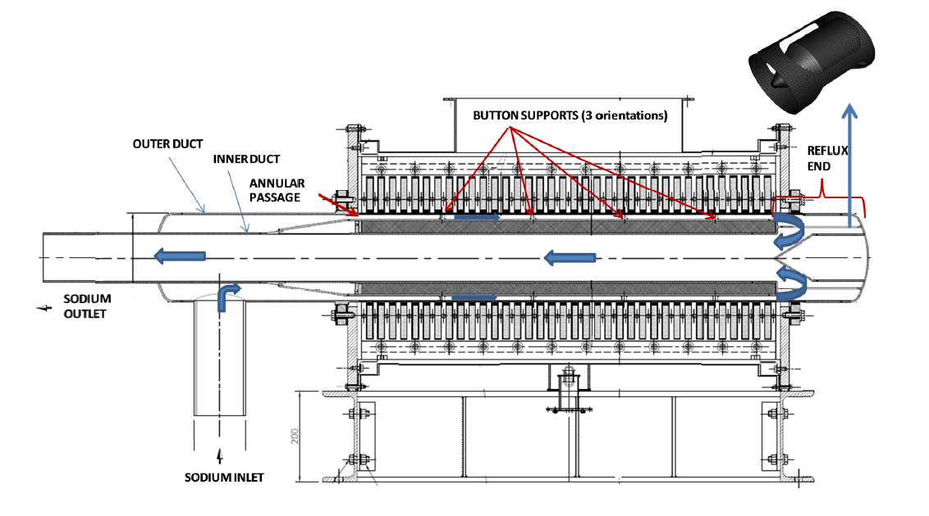
FIG. 2. Schematic of Reflux type of Electromagnetic pump (adapted from [5])

The primary functions of the EM pump are:

- To facilitate sodium purification in SSPC by pumping sodium through Cold trap.
- To fill the secondary sodium loop with sodium from the storage tank which is located at lowest elevation in SGB.
- To maintain the Sodium level in surge tank by compensating sodium flow through leak-off flow from secondary sodium main pump tank, overflow from surge tank and out flow from HSDS loops.

The availability of EM Pumps is essential to maintain and operate the secondary sodium loops. Thus, the EM pumps are also provided with DG backed class III power supply for their continued operation in case of failure of class IV power supply.
During the initial commissioning and operation of EM pumps in the loops, slight vibrations at dished end of the duct and flow fluctuations were observed. During the continuous operation of secondary Sodium systems failures like damage to internals of EM pumps were encountered. The detailed analysis brought up the probable reason of failure to be the high vibration of the inner duct and differential thermal expansion between inner and outer ducts.
Based on the detailed analysis, following modifications were done in the EM pumps

- Welded webbed shell was replaced with the porous shell with sliding support.
- Addition of hard faced sliding spacer supports at the front and rear ends of the inner duct.
- All the intermediate button locations were provided with spacer pads.
- Modification of the discharge piping support (at flow meter and valve) to increase the natural frequency of piping.
- Procedural modifications such as observation of vibrations at dished end of EM pump and throttling of leak-off flow and Surge tank over flow.
- Additional electrical protections as part of improved protections.

Following figure depicts the modified EM Pump duct arrangements.

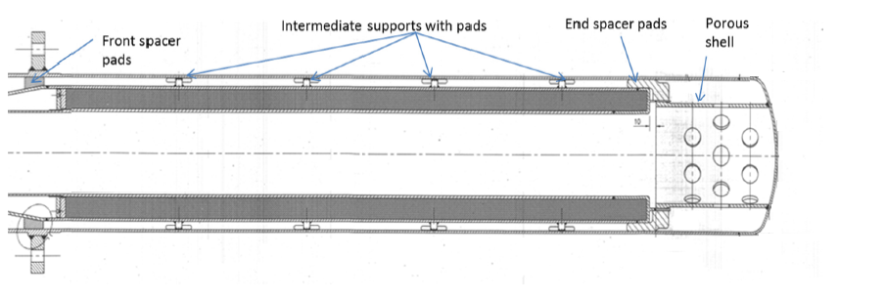
FIG. 3. Modified EM Pump Duct schematic (adapted from [12])

After completion of the modifications, stable operation of EM pumps continuously for about 9 months was demonstrated in various configurations of loop operation. The observed values of vibrations were also found less than 1mm/sec (RMS).The continuous operation of modified EM pumps in various configurations validated that EM pump remedial modifications are effective and EM pump fulfils all the functional requirements as per the system requirements.

- Commissioning and Operation of Secondary Sodium Pumps

Secondary Sodium Pump (SSP) circulates the sodium in Secondary Sodium Main Circuit (SSMC) of PFBR. The SSP in SSMC-loop-1 and SSMC-loop-2 were operated from 180 rpm to about 865 rpm as part of commissioning checks and integrated performance checks of SSP. Although SSPs were operated through its entire range of operation, it was operated mostly between 380 rpm and 550 rpm for longer durations in view to limit the temperature of sodium in secondary sodium main circuit below 250°C. SSPs were operated up to 865 rpm, to estimate the maximum flow rate delivered by the pump in each loop and to obtain various basic operating data.
During commissioning and operation of Secondary Sodium main loop situated in SGB-2, SSP - 2 PIA had undergone severe rubbing and seizure. Based on the root cause analysis of seizure of SSP-2, the close running clearances at wear rings and labyrinth were increased in pump internal assembly. After installation of PIA of SSP-2, both SSP-1 & 2 were operated for about eight months continuously in various configurations. The performance of both the pumps were studied during this period and found satisfactory. Based on the performance of SSP-2 with modified PIA, it was decided to modify SSP-1 PIA.
Following figure depicts the modified SSP internal arrangements in SGB-2.

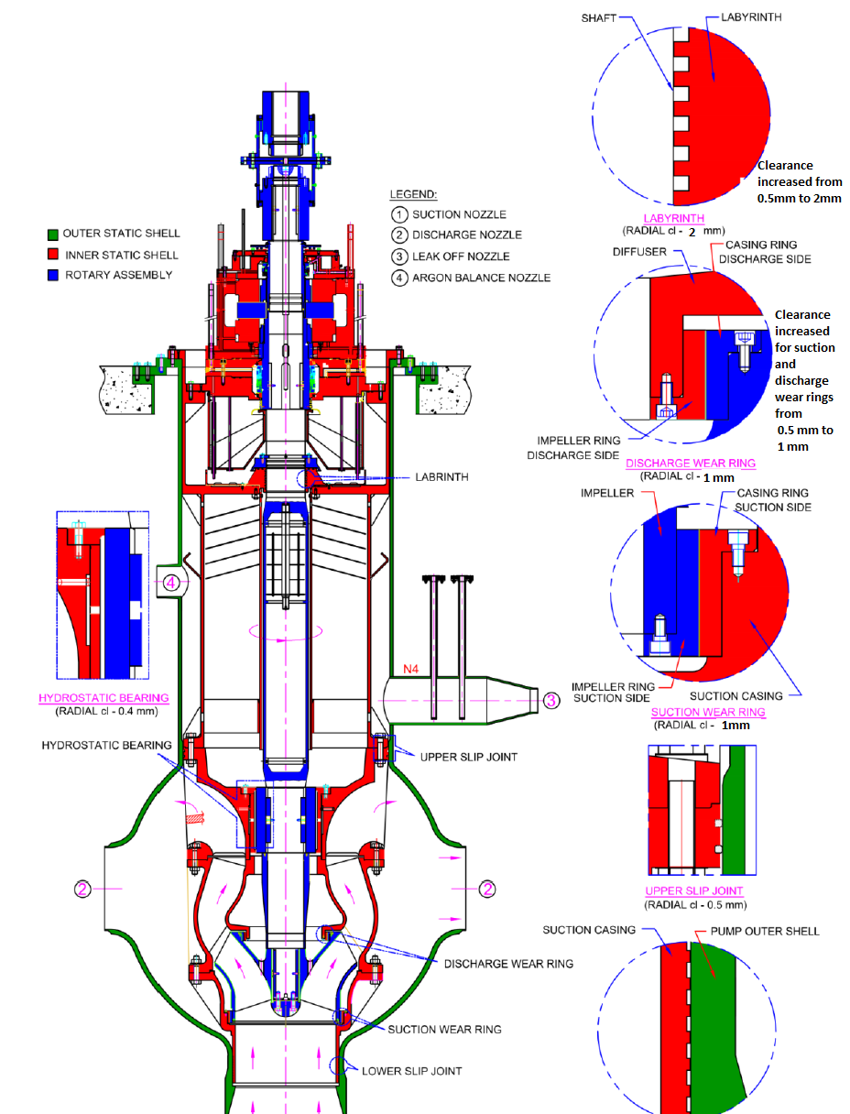

FIG. 4. Schematic arrangement of SSP internals (adapted from [2])

- Integrated operation of Secondary Sodium systems

After required modifications, error free and successful continuous operation of integrated Secondary Sodium system and components in SGB-1 and SGB-2 with utmost priority to safety and procedure adherence were demonstrated for about 9 months. The integrated operation verified the effectiveness of modifications performed for EM Pumps and SSP-2 PIA in the Secondary Sodium Main, Fill & drain system till the limiting temperature of Sodium at 250 °C. It was demonstrated that EM Pumps, SSPs and other components fulfil all the functional requirements as envisaged in design.
Following Table 1 provides the important operating parameters during integrated operation of secondary sodium systems.
TABLE 1. SYSTEM PARAMETERS FOR INTEGRATED SODIUM SYSTEMS WITH SSP AT 700RPM

Parameters | Secondary Sodium Loop in SGB-1 | Secondary Sodium loop in  SGB-2
EM pump flow | 110-115 m³/h | 95-105 m³/h
SSP rpm | 700 rpm | 700 rpm
SSP flow | 9650-9921 m³/h | 8427-9003 m³/h
Leak off flow | 80-82 m³/h | 80-82 m³/h
Surge tank Over flow | 30 m³/h | 10 m³/h
Maximum Cold trap flow | 38-40 m³/h | 38-40 m³/h

SUMMARY AND CONCLUSION
The commissioning and operation experience of Secondary Sodium system and its auxiliaries has demonstrated the safe, continuous and reliable operation of the EM pumps and SSPs. Commissioning and operation brought out the need to go for few design changes not only to solve completely the problems faced but also to improve the system performance and safety. The experience gained during commissioning and operation has proved that the functional requirements of Secondary Sodium systems are fulfilled in all the expected configurations i.e., during sodium purification, during Sodium filling up to Surge tank, operation of SSP up to desired flow etc. and serves as a reference for future FBRs.

ACKNOWLEDGEMENTS
I would like to acknowledge the support extended by the Operation Directorate for providing the insights of operational challenges faced during commissioning and testing of Secondary Sodium systems and components. I would also like to appreciate the technical and design team of IGCAR for research and multidimensional analysis of problems observed during commissioning and operation phase of Secondary Sodium System.
References
- INDIRA GANDHI CENTRE FOR ATOMIC RESEARCH, Analysis of onside performance of Secondary Sodium Pumps of PFBR, PFBR/33110/DN/1060 R-A (Internal document).
- INDIRA GANDHI CENTRE FOR ATOMIC RESEARCH, Review of wear rings and labyrinth clearance for SSP-1, PFBR/33110/DN/1078/R-A (Internal document).
- INDIRA GANDHI CENTRE FOR ATOMIC RESEARCH, Operation note on Initial Sodium Filling Circuit, PFBR/33390/ON/1001/R-0(Internal document).
- INDIRA GANDHI CENTRE FOR ATOMIC RESEARCH, Process design for Secondary Cold trap, PFBR/33260/DN/1001/R-A (Internal document).
- INDIRA GANDHI CENTRE FOR ATOMIC RESEARCH, Design modifications to achieve a robust electromagnetic pump based on detailed thermo‐mechanical and CFD analysis, PFBR/33310/DN/1004/R-A (Internal document).
- INDIRA GANDHI CENTRE FOR ATOMIC RESEARCH, Operation note for Secondary Sodium Purification System, PFBR/33200/ON/1001/R-0(Internal document).
- INDIRA GANDHI CENTRE FOR ATOMIC RESEARCH, Operation note for Secondary Sodium Main System PFBR/33100/ON/1000/R-A (Internal document).
- INDIRA GANDHI CENTRE FOR ATOMIC RESEARCH, Operation note for Secondary Sodium Fill and drain system, PFBR/33300/ON/1001/R-0(Internal document).
- INDIRA GANDHI CENTRE FOR ATOMIC RESEARCH, Operation note for Secondary Argon System PFBR/33400/ON/1000/R-0(Internal document).
- INDIRA GANDHI CENTRE FOR ATOMIC RESEARCH, Hydrodynamic parameters for secondary sodium pump, PFBR/33110/DN/1071/R-A (Internal document).
- INDIRA GANDHI CENTRE FOR ATOMIC RESEARCH, Feedback experiences gained from PFBR, PFBR/01000/DN/1000/R-A (Internal document).
- INDIRA GANDHI CENTRE FOR ATOMIC RESEARCH, EM Pump Failures and remedies Route Cause Analysis Report (Internal document).
- NISHANT SAHU et al., PFBR Commissioning reports for Secondary Sodium Main, fill and drain system (PFBR Internal document).
- NISHANT SAHU et al., PFBR Commissioning procedure and reports for Secondary Sodium purification system (PFBR Internal document).
- NISHANT SAHU et al., PFBR Commissioning procedure and reports for Secondary Argon System (PFBR Internal document).
- PROTOTYPE FAST BREEDER REACTOR, Final Safety Analysis Report,Chapter-6(PFBR Internal document)
- SANKAR, B. et al., Modelling and simulation of inclined fuel transfer machine in prototype fast breeder reactor operator training simulator’, Int. J. Simulation and Process Modelling, Vol. 11, No. 5, pp.339–352, 2016

