EXPERIENCE OF OPERATIONAL CHEMICAL CLEANING OF BN-600 STEAM GENERATOR EVAPORATORS FROM CORROSION PRODUCT DEPOSITS
K.G. Legkikh
IPPE JSC
Obninsk, Kaluga region, Russian Federation

V.B. Smykov, PhD
IPPE JSC
Obninsk, Kaluga region, Russian Federation
Email: smykov@ippe.ru

V.F. Tiapkov, PhD
VNIIAES JSC
Moscow, Russian Federation
Email:

Yu.V. Nosov
Beloyarsk NPP
Zarechny, Russian Federation
Email:

D.V. Gvozdikov
Beloyarsk NPP
Zarechny, Russian Federation
Email:

Abstract

This report presents the experience of operational chemical cleanings (washings) (OCC) of the BN-600 steam generator evaporator modules for the entire period of operation from 1981 to the present. The report describes the stages of OCC, depending on the composition of accumulated deposits during the inter-washing period, the change in the total amount of washed out deposits, the OCC effect on the corrosion rate of 10Kh2M steel of evaporator tubes, and the stages of the OCC process. Consideration is given to the technology of chemical passivation of washed pipes after OCC and the problem of disposal of the passivating solution.

INTRODUCTION
Steam generators (SG) of any reactor facility are subject to certain conditions that lead to degradation of structural materials and capacity decrease. The accumulation of corrosion products and corrosive substances on heat transfer surfaces is associated with corrosive degradation of tubes. In addition, the accumulation of corrosion products can lead to severe blockages and, as a result, to problems in water level regulation, as well as heat losses due to deposits on the tube surfaces and, thus, failure to reach the design power output. However, this is not the most critical outcome. For instance, at the Phoenix reactor in 1983, depressurization of two SG modules occurred (the operating time of the modules was 79 700 hours and under nominal conditions - 52 000). As a result of the research conducted, it was shown that the cause of this incident was fouling of the evaporator-preheater with deposits [1]. A similar situation occurred at the BN-350 reactor facility in 1989. Micromodular steam generators No. 4 and 5 “Nadezhnost” were out of order due to formation of holes in two evaporator modules [2]. Therefore, OCC is an indispensable technology to ensure the SG accident-free operation life.
The composition of deposits for once-through sodium-water steam generators, which operate as part of a power unit with the BN-600 reactor, includes corrosion products, various non-volatile salts and bases, degradation products of ion-exchange materials, organic impurities, etc. The chemical composition of these deposits is based on iron oxides impregnated with water-soluble salt impurities. This local chemical media is a corrosive electrolyte in which depassivating agents are concentrated, which can ultimately cause localized corrosion of structural material in the tube bundle. It necessitates periodic chemical cleanings of the steam generator evaporators from the deposits accumulated over the inter-washing period of operation.
Chemical cleanings are carried out at all reactor facilities of nuclear countries. For instance, during the period of BN-600 operation from 1981 to 2020, all the steam generator evaporators were subject to regular operational chemical washing once every 3-4 years. Since 1985 steam generators of reactor facilities in the USA, Canada, Korea, Belgium and France have undergone chemical cleaning. Cleanings were carried out according to various recipes, throughout the entire height of the steam generator and in separate parts of the steam generator surfaces. For the recipes aimed at removing iron- and copper-containing deposits, the tube bundle cleaning efficiency was ranged from 258 to 1082 kg (removed deposits); for the steam generator entire height the cleaning efficiency was ranged from 1893 to 6720 kg. When the solutions aimed at removing iron-containing deposits were used, the cleaning efficiency for the tube bundle was 955-1134 kg; for the steam generator entire height the cleaning efficiency was 418-2988 kg [3].

1. EXPERIENCE in OPERATIONAL CHEMICAL CLEANING OF EVAPORATORS of the BN-600 once-through STEAM GENERATOR

When steam generators operate at power, the inter-washing period was 15.000-20.000 hours, and over the past decade it has been increased up to 25.000-30.000 hours. With regard to BN-600, chemical washings are carried out with circulating sodium in the secondary circuit to continuously monitor the inter-circuit density of the evaporators washed. The experience of the BN-600 chemical washing showed that over 40 years of use there has never been a case of the inter-circuit density loss of the evaporators in the course of this type of work.
BN-600 steam generator PGN-200M RU has a modular design, see Figure 1. As a result of systematic examinations of the corrosion state of the PGN-200M steam generating surfaces, it was reliably established that almost all impurities of corrosion products and salts of the tertiary circuit water coolant are precipitated in the evaporator modules. Moreover, the deposits are considerably non-uniform and form a “peak” of specific fouling in the steam superheating zone, thus leading to the local (pitting) corrosion evolution in the evaporator tubes’ metal. To prevent the development of pitting corrosion induced by copper present in the deposits, the inter-washing period of PGN-200M operation was limited to 15.000 – 20.000 hours. This limitation has proven its value in practice. In the main steam superheater (MSS) and the steam reheater (SR), the corrosion product deposits are insignificant, and they do not cause concerns about the local corrosion development in the stainless steel tubes of the MSS and SR modules. Therefore, MSS and SR are not subject to chemical cleaning.
Throughout the BN-600 operational experience, three recipes of the washing solution were used in relation to chemical washings of the steam generator, each of them was carried out at certain temperatures. The difference in recipes is determined by the peculiarities of structural materials.
The first operational washings of the 1980s were carried out in two stages. At the first stage, washing was carried out with the solution based on EDTA salt with a corrosion inhibitor at pH 9.0 and a solution temperature of 165-180°C. After stabilization of the values to be determined (iron and copper content, pH value, concentration of free EDTA, hydrogen content in the solution, value of Red/Ox– potential), the solution was drained from the evaporator and the washed circuit. The washed circuit was filled with demineralized water, washed, and then drained again. Then it was continued with the second stage of washing (passivation), which was carried out in a closed circuit: feeding electric pump (FEP)-high pressure heater (HPH)-evaporator modules-deaerator. Hydrogen peroxide was used for passivation, followed by the addition of ammonia. However, the use of hydrogen peroxide turned out to be ineffective.
This recipe turned out to be relatively ineffective due to the intention to wash off iron oxide deposits with a significant copper content in one stage at high temperatures. As a result, metallic copper precipitated from the solutions, and it caused an increase in the 10X2M steel corrosion rate during washing. The imbalance between the amount of EDTA introduced into the washed circuit and its detectable concentration in the washing solution was accounted for by the error in the chemical analysis of EDTA (total) and a reduced content of EDTA in the initial reagent.
The first recipe had been used until 1985 and was replaced by a three-step recipe in order to improve the efficiency of removing copper from the deposits. In accordance with the selected recipe, an additional detergent composition was introduced to remove copper-containing deposits, then the magnetite deposits were washed and the surfaces were passivated with the solution of the first stage with a reduced concentration of reagents. This technology has been successfully applied multiple times at BN-600 and has proven its efficiency in removing deposits and thereby preventing the formation of local corrosion of 10X2M steel under accumulating deposits [5]. The flowchart for carrying out chemical washings is shown in Figure 1.

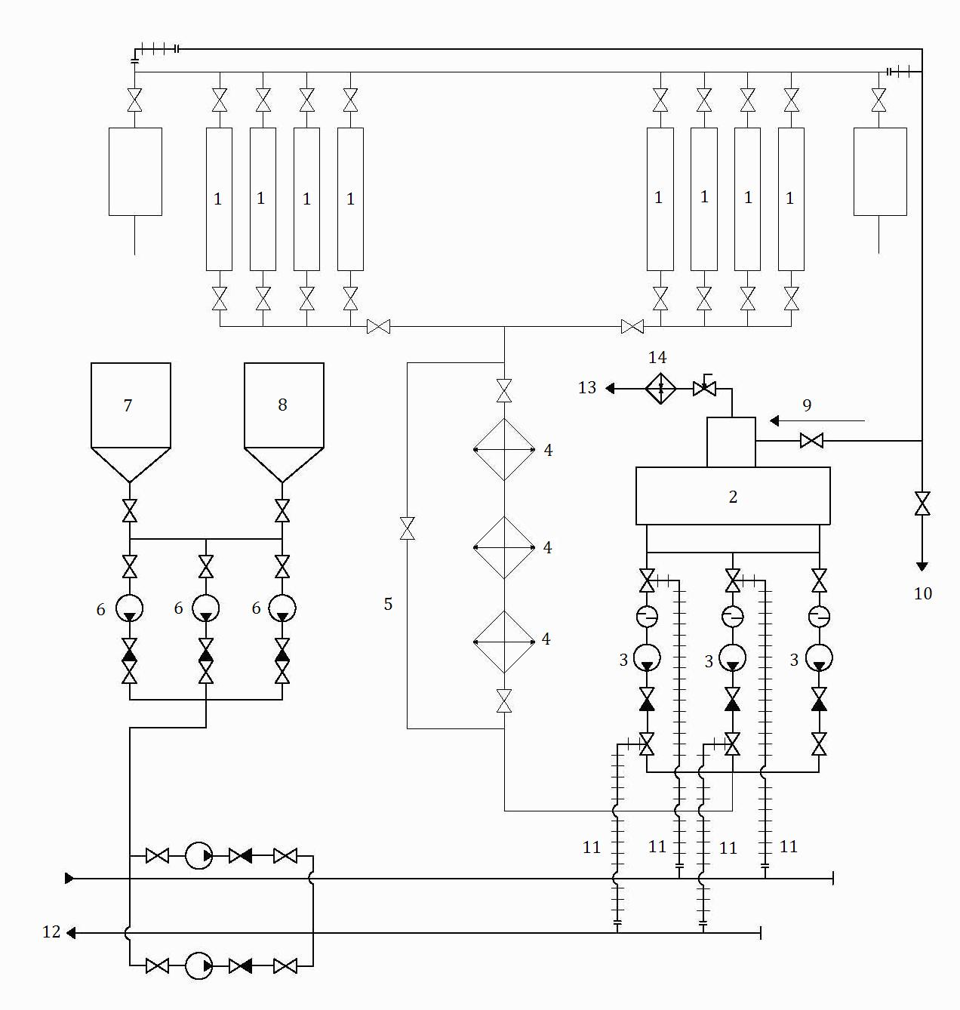

Figure 1. Flowchart of PGN-200M evaporator chemical cleaning
1 – Evaporator modules; 2 – Deaerator; 3 – Feed electric pump; 4 – High pressure heater (HPH); 5 – HPH bypass; 6 – Reagent dosing pumps; 7 – Disubstituted EDTA dosing tank; 8 – Ammonium acetate and sodium nitrite dosing tank; 9 – Desalted water and heating steam (6 ata) supply to the deaerator; 10 – Cleaning solution discharge to the neutralization tank; 11 – Temporary pipe-lines; 12 – Cleaning solution supply to evaporators of the neighboring loops; 13 – Gas discharge from the deaerator;14 – Deaerator air-drain heat exchanger.

From 2003 to 2005, copper-containing structural materials in the tertiary circuit were replaced with stainless steel 08Х18Н10, for this reason, the source of copper entering the steam generator practically disappeared in the water circuit. All-steel condensate feed circuit provided for the chemical washing technology simplification, therefore the last evaporator washings were carried out in one stage - dissolution of magnetite deposits with a solution based on EDTA, followed by passivation of the washed surfaces [2].
Based on the experience of BN-600 operation with regard to operational cleaning, a comparative analysis of the efficiency of the two tried and tested recipes can be performed. For the study, the amount of data was used which was contained in records on operational cleaning of the steam generator evaporator modules from 1981 to 2020. The main indicators of the washing efficiency were compared with changes in the recipe of washing solutions and the process methodology.
As a result of data analysis, it was revealed that the amount of corrosion products removed according to the one-step recipe (in the period from 2005 to 2020) significantly exceeds the similar indicators achieved during the three-step washings. For example, when the evaporator of the fourth loop steam generator was washed (Figure 2), the maximum amount of removed iron was 1071.7 kg, while according to the three-step recipe, the maximum of 833.2 kg was removed; for IPG-5 the maximum values of removed iron were 1249.6 kg and 813.7 kg, respectively; for IGP-6: 1162.5 kg and 1007.5 kg, respectively. It should be noted that the washings of 2005-2020 are characterized by a longer inter-washing period, in comparison with the cleanings of 1981-2004 (Figure 3, 4).

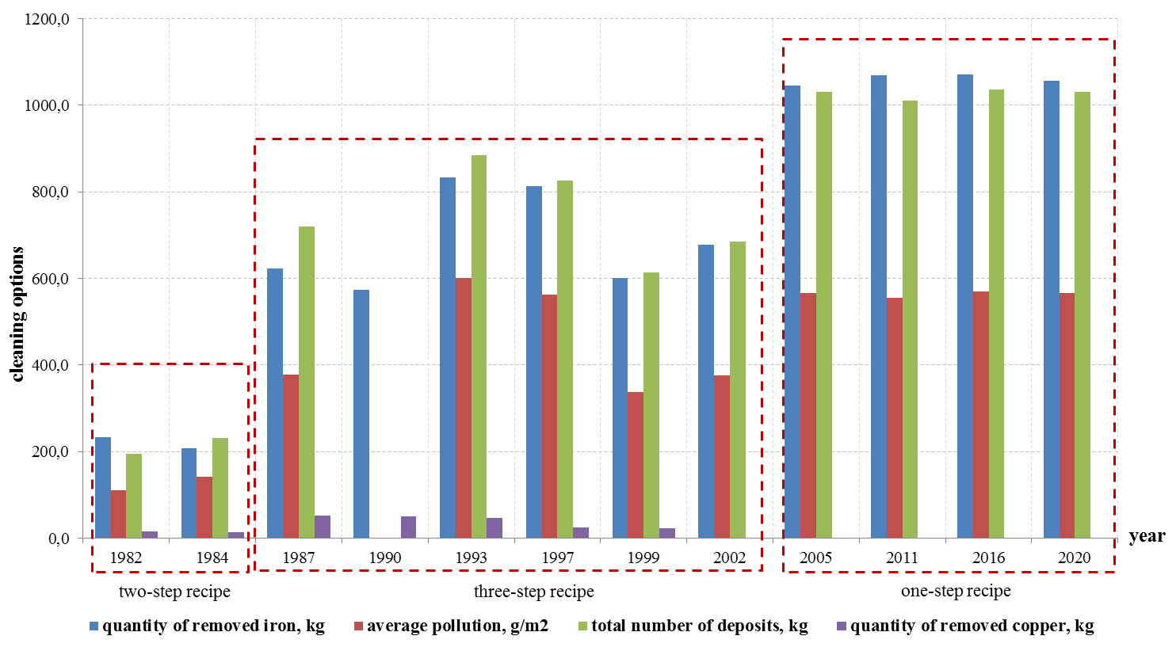
Figure 2. Main efficiency indicators of operational chemical cleaning of the evaporators of the steam generator of the BN-600 power unit fourth loop

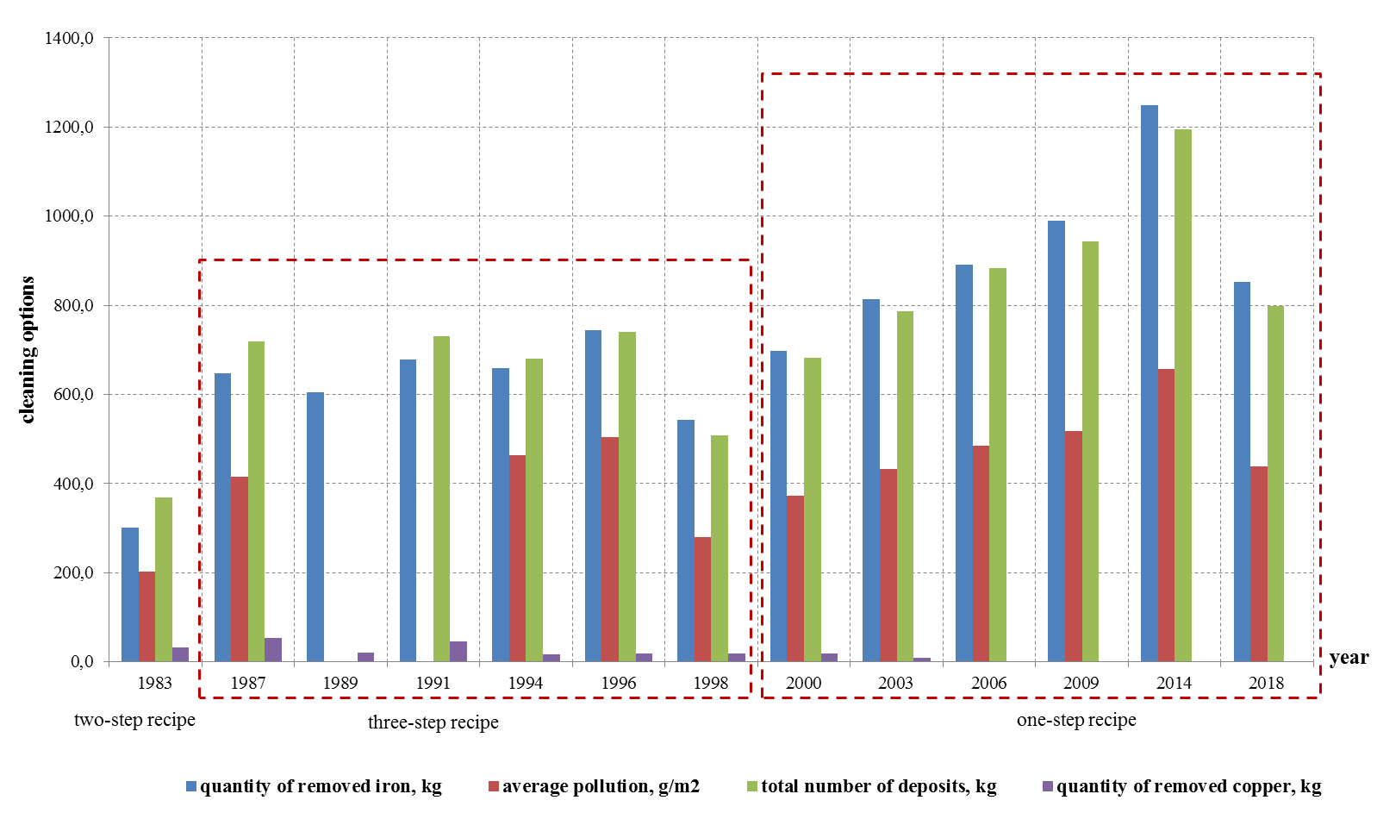

Figure 3. Main efficiency indicators of operational chemical cleaning of the evaporators of the steam generator of the BN-600 power unit fifth loop

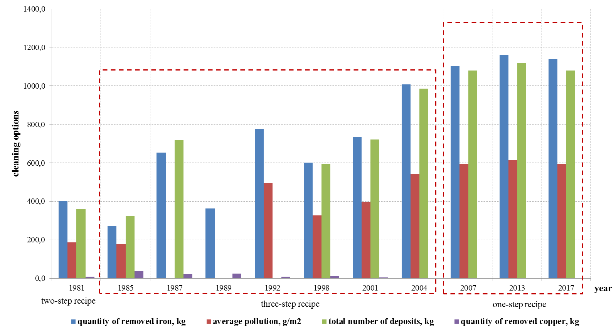
Figure 4. Main efficiency indicators of operational chemical cleaning of the evaporators of the steam generator of the BN-600 power unit sixth loop

2. OPERATIONAL CHEMICAL CLEANING INFLUENCE ON CORROSION RATE OF STRUCTURAL STEEL

The comparative analysis of corrosion rates in the course of washing the evaporator modules shows that an increase in washing efficiency does not entail an increase in the aggressive impact on structural materials (Figure 5-7). Thus, the maximum corrosion rate during IPG-4 washing was 6.5 g/m²/h, when washing according to a three-step recipe, -3.5 g/m²/h; for IPG-5: 18 g/m²/h and 3.54 g/m²/h, respectively; for IPG-6: 16 g/ m²/h and 4.02 g/m²/h, respectively. However, the statement that the entire concentration of hydrogen is associated with the corrosion processes only is not correct, since hydrazine is present in the solution, which in turn is also a source of hydrogen during thermal decomposition.
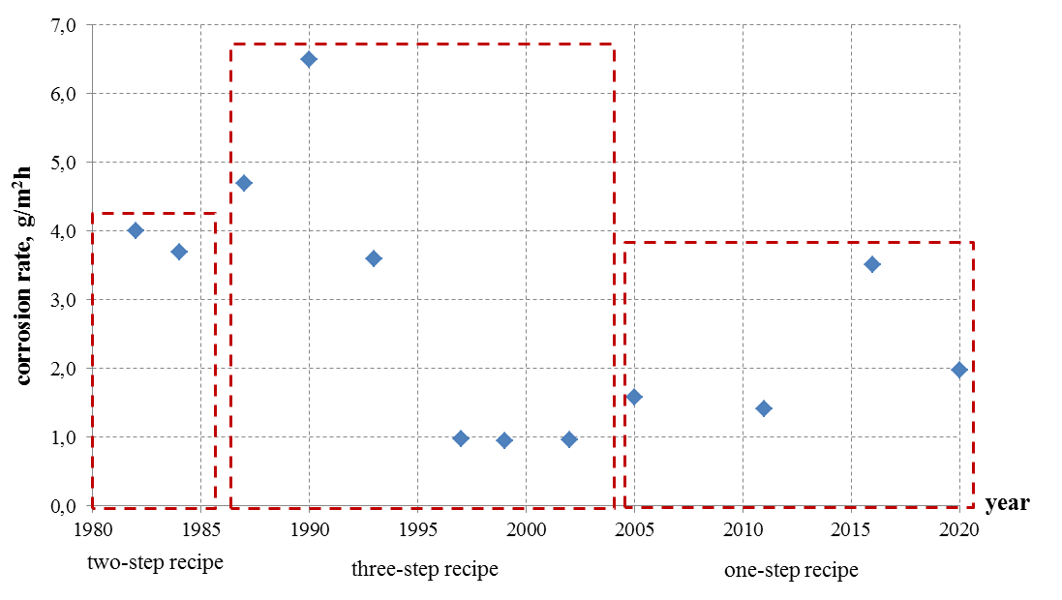
Figure 5. Corrosion rate of operational chemical cleaning of the evaporators of the steam generator of the BN-600 power unit fourth loop

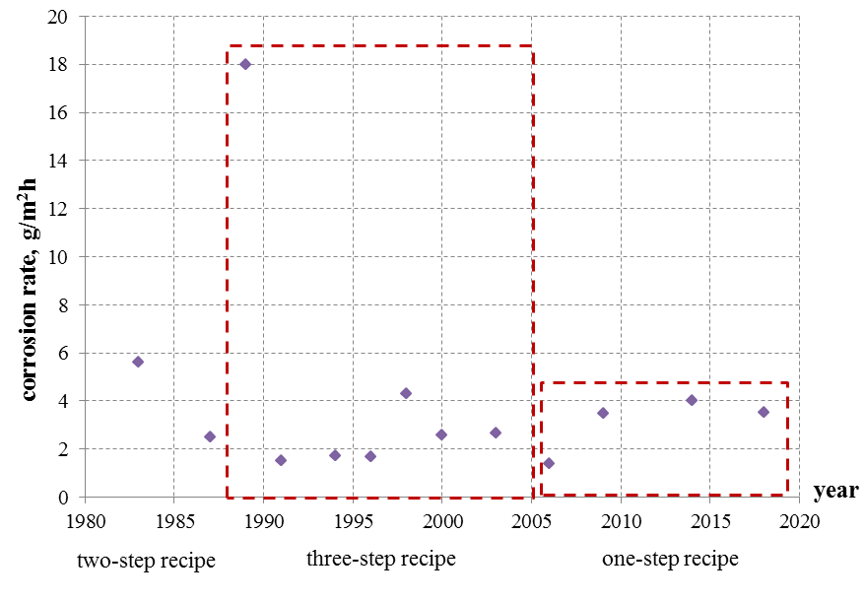
Figure 6. Corrosion rate of operational chemical cleaning of the evaporators of the steam generator of the BN-600 power unit fifth loop

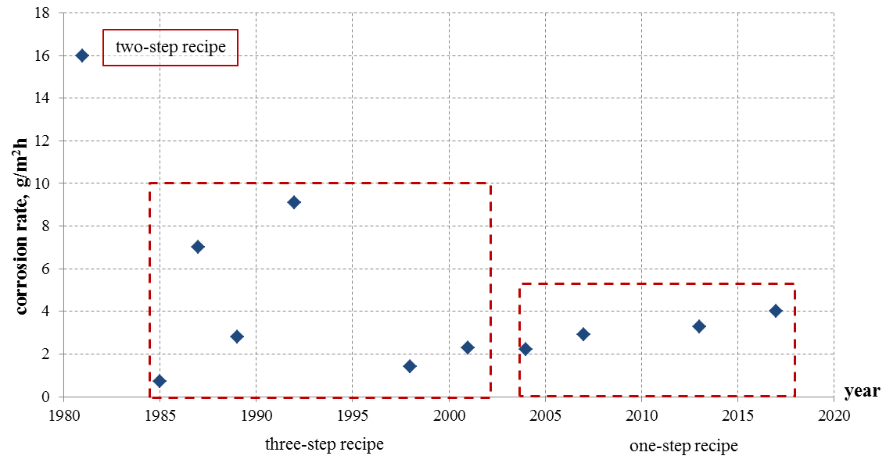
Figure 7. Corrosion rate of operational chemical cleaning of the evaporators of the steam generator of the BN-600 power unit sixth loop

Based on the processed data array, it can be concluded that the used one-step recipe of operational washing makes it possible to effectively clean the evaporator modules and at the same time does not lead to an increase in the corrosion rate and, consequently, to acceleration of structural material wear.

3. INDIRECT INDICATORS OF THE STAGES OF THE OPERATIONAL washing PROCESS

The hydrogen content is an extremely important indicator, since it indirectly indicates the stage of the operational washing process. Any deposits on the surfaces of structural materials are always non-uniform. Therefore, the dissolution time of deposits will be different depending on their thickness.
After the deposit dissolution stage along the entire length of the tube starts, the parallel processes of dissolution of thicker deposits and sorption passivation of the already cleaned surface will inevitably take place. All these stages are accompanied by an increase or decrease in the concentration of evolved hydrogen. This parameter is easy to monitor on-line, which will make it possible to make a reasonable conclusion about the continuation or termination of operational chemical cleaning. Figure 4 shows the dependence of the hydrogen content in the tertiary circuit of the BN reactor facility on the time of chemical operational washing. The first peak of this curve corresponds to the end of the stage of dissolution of thin areas of the deposits and passivation of the cleaned surface. The repeated increase in hydrogen concentration indicates the next stage of decomposition of thicker areas, but the washing process is completed without reaching its final stage. Accordingly, if the process is not completed, then the circuit remains fouled.

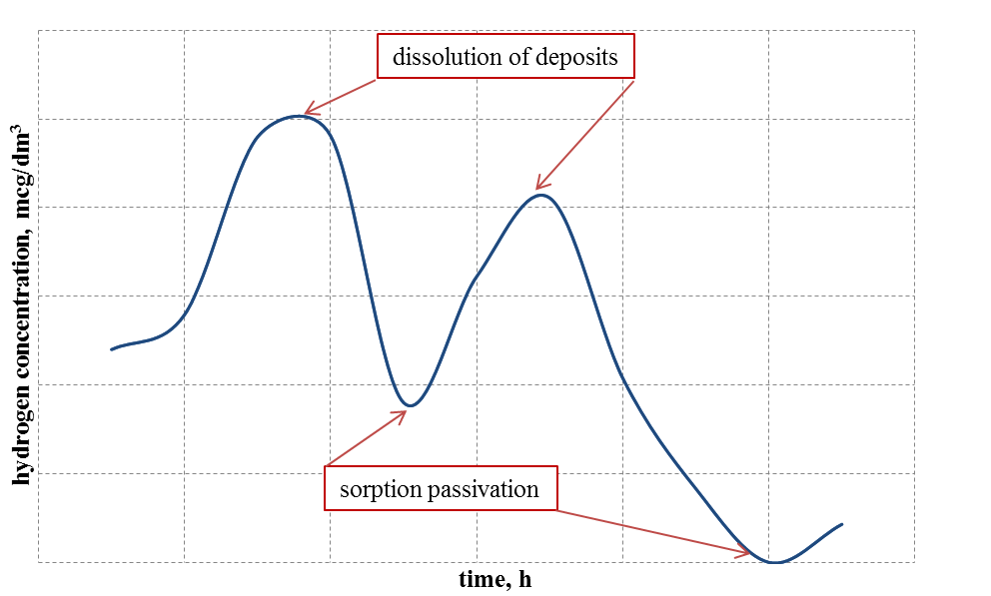
Figure 4. Dependence of hydrogen content on operational chemical cleaning time

4. HIGH TEMPERATURE PASSIVATION OF THE STEAM GENERATOR AFTER CHEMICAL CLEANING

Being the main corrosive component of the cleaning solution, EDTA salts in the course of the steam generator washing process not only dissolve the deposits, but also dissolve the protective oxide film, thereby activating the surface of ferrite-pearlite steel of the steam generator tubes washed from the deposits. Due to the considerable nonuniformity of corrosion product deposits distribution along the height of the evaporator tube bundle, the chemical washing process takes several hours and is accompanied by corrosion of the tube sections with an initial low specific fouling, which are quickly washed away from deposits. The specific fouling of approximately 80-90% of the tubes inner surface area of the BN-600 evaporators before cleaning is not more than 150-200 g/m² (economizer zone, zone of developed boiling, zone of deteriorated heat transfer), while in the zone of residual moisture drying (RMD zone) in the steam-superheating section, the specific fouling by deposits is 3-5 times higher and these deposits dissolve more slowly. Therefore, after the end of the cleaning process, almost the entire inner surface of tubes is in a highly corrosive state.
To prevent intensive corrosion of the BN-600 evaporator tubes, the method of passivation of washed surfaces with a hydrazine alkaline solution at a temperature of 160-165 °C in a closed circuit has been adopted and applied in recent years. The process is over when the iron content in the solution stabilizes. Then the spent passivating solution is drained and the circuit is washed with chemically demineralized water. It is important to emphasize that this method of passivation at BN-600 corresponds to the hydrazine-ammonia water chemistry of the tertiary circuit - the protective film of the magnetite structure formed as a result of passivation in a reducing medium on steel surfaces does not undergo transformation and restructuring in the reducing water chemistry during startup of the power unit.
For sodium cooled reactors with steam generators made of steel 10X2M, the hydrazine passivation technology will be ineffective. The reason is that at the stage of passivation, the protective oxide film will be resistant and will not be susceptible to restructuring only if it is formed in the medium with the chemical characteristics corresponding to the water chemistry of the tertiary circuit.
The passivation stage should be carried out with the use of the solution of the following composition: ammonium acetate and sodium nitrite. In this case, passivation will be more effective when oxidative water chemistry is applied [2].
The problem of passivation solution disposal has also been investigated. Several methods are known to bring sodium nitrite to the maximum permissible concentration level (1 mg/kg) in waste waters while using the recipe (ammonium acetate + sodium nitrite + ammonia) for SG passivation after chemical washings:
- decomposition of sodium nitrite with carbamide (NH₂)₂CO in an acidic medium (H₂SO₄);
- decomposition of sodium nitrite by sulfamic acid NH₂SO₃H;
- decomposition of sodium nitrite with iron sulfate on a catalyst (sulfocarbon);
- decomposition of sodium nitrite by filtration through aluminum chips (or its alloys) with the addition of alkali (NaOH) to the initial solution;
- decomposition of sodium nitrite by filtration through magnesium chips with addition of alkali (NaOH) to the initial solution;
- decomposition of sodium nitrite with potassium permanganate with the addition of sulfuric acid, while at a certain stage of the process, ammonium acetate decomposes to gaseous products;
- neutralization of waste flushing solutions based on organic acids and their salts (as well as passivation solutions) by filtration through powdered activated pyrolusite MnO₂, while the organic part of the solutions decomposes to gaseous products [6].
All of these methods have their advantages and disadvantages, and require experimental development and chemical-analytical substantiation in relation to a specific problem.

References
- GIDE Zh. Consequences of Fouling of Preheater-Evaporators of the Phoenix Steam Generators for Their Operation. Improvements Introduced by Chemical Cleaning Carried out on the IG I Preheater-Evaporator in 1984, Internal Report, СЕА Collaboration in the Field of Fast Reactors on the Topic “Steam Generators”, Obninsk, USSR, 1986.
- ERMOLAEV N., SMYKOV V., SHEVCHENKO N. Experience of Operational Chemical Cleanings of Steam Generator Evaporators of Power Units with Fast Reactors BN-600 and BN-350. Teploenergetika No. 8 1997, ISSN 0040-3636, 25-30.
- Dow B., Thomas R. Chemical Cleaning Review. Nuclear Engineering International, Vol. 40 No. 495 October 1995, 38-39.
- Fujiwara K., Kawamura H., Kanbe H., Takiguchi H. Applicability of Chemical Cleaning Process to Steam Generator Side: Journal of Nuclear Science and Technology, Vol. 41 N1, p. 44-54, 2004.
- Margulova Т. The Use of Complexing Agents in Heat Power Engineering. Energoatomizdat, Moscow, 1986.
- Smykov V., Legkikh K. Method of Cleaning LRW from Organic Impurities. RF Patent for Invention 2597242 Dated 10.09.2016.

