KEY ASPECTS OF COMPETITIVENESS FOR INDUSTRIAL ENERGY COMPLEX WITH FR AND CLOSED NFC

D.A. Tolstoukhov, O.M. Garagulya, P.V. Atnyukova, S.A. Panov, I.V. Presnyakov
JSC «Proryv»
Moscow, Russian Federation
Email: tda@proryv2020.ru

D.V. Poprygin
JSC «Atomenergoproekt»
Moscow, Russian Federation

Abstract

Long-term sustainable development of nuclear power in Russia and worldwide is possible only if NPPs are competitive in comparison with other types of generation. At the same time, it is crucial to demonstrate a cost-effective solution to the systemic problems of the industry, including the issue of accumulating the SNF. Modern NPPs with thermal reactors operated in an open NFC, given the achieved technical and economic indicators, cannot guarantee further effective competitive development of nuclear power. It prevents the growth of the share of nuclear power in the structure of energy production in the near future. As the report also reflects, the competitiveness of nuclear generation is determined not only by technical and economic indicators of promising NPP projects and corresponding NFC facilities. The competitiveness of NPPs is also influenced by technical and economic indicators of alternative energy technologies, taking into account the prospects for their optimization (improvement), the dynamics of prices for hydrocarbon fuel and the macroeconomic environment (discount rate). Current competitiveness requirements for NPPs with fast reactors and closed NFC, achievement of which ensures sustainable economic efficiency in comparison with alternative energy technologies, are reviewed as well.

INTRODUCTION
According for the current forecasts of the leading analytical agencies in the electric power industry (International Energy Agency, U.S. Energy Information Administration, ERI RAS and al. [1, 2, 3]), by the middle of 21st century, main part of the growth in global electricity production will be carbon-free types of power plants based on renewable energy sources (RES). At the same time, the share of nuclear power plants in the global generation structure will remain steady at ~10%. Projected drop in share of nuclear power in Europe and United States is offset by growth in China and India.
In Russia, share of nuclear power in the total electricity balance by the middle of 21st century may grow from the current 20% to ~25-30%. Sustainable competitiveness of nuclear power in the long term is traditionally determined by the level of capital investments, as well as by the regional conditions of placement.

APPROACH TO ASSESSMENT COMPETITIVENESS OF ENERGY TECHNOLOGIES
Competing energy technologies in relation to their location in Russia: power units with combined cycle gas turbine (CCGT), Solar and Wind power plants, NPPs with thermal neutron reactors (TR) and NPPs with fast neutron reactors (FR). Assumed that NPPs with FR are part of industrial energy complex, which include production facilities for reprocessing SNF and fabricating nuclear fuel from reprocessed fuel (so called «regenerate»).
The competitiveness of energy technologies was carried out for the Russian conditions in terms of Levelized Cost of Electricity (LCOE), taking into account the predicted long-term inflation.
Dynamics of optimization (improvement) technical and economic parameters (TEP) of RES forecast for 2035-2040 adopted on the analysis global trends in the development of electric power industry, taking into account load factor of Wind and Solar power plants in Russia.
Predicted that on the horizon of 2035 in Russia there will be decrease by ~20% in capital investments in the construction of power units with CCGT [3].
A key feature of CCGT power units, which significantly affects their competitiveness, is their dependence on natural gas prices during operation. The basic option of LCOE calculation was carried out a favorable scenario of fuel price indexation with annual nominal growth within inflation.
Key TEP of NPPs projects with TR and FR were adopted according to indicators from «The development strategy of nuclear energy in Russia until 2050 and prospects for the period up to 2100» [4], further – Nuclear Strategy. It is taken into account that NPPs with TR operate in an open NFC, and NPPs with FR operate in a closed NFC.
The costs of closed NFC include reprocessing of SNF, fabrication fresh nuclear fuel from reprocessed nuclear materials at the fuel production facilities that are part of the industrial energy complex with FR, taking into account the costs of disposal radioactive waste. The costs of closed NFC include fabrication fresh nuclear fuel and reprocessing SNF with disposal of the resulting volumes radioactive waste.

RESULTS LCOE CALCULATIONS OF energy technologies
On Fig. 1 shows results of calculating LCOE considered types of generation for conditions of Russia (forecast for 2035-2040), two discount rates - 7% and 10%. The calculations are carried out on the basis of the relevant methodology guidelines of the State Corporation “Rosatom”, which take into account macroeconomic indicators in relation to conditions of Russia.

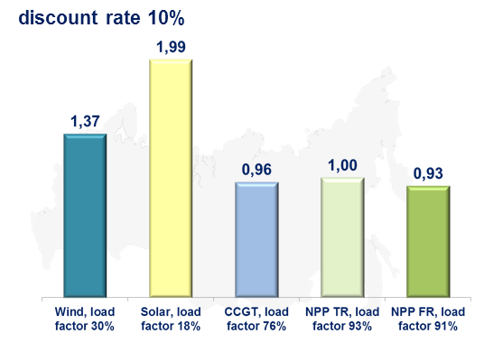 | 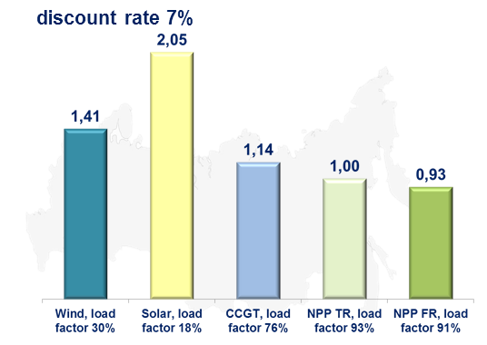
FIG. 2 - LCOE energy technologies in Russia (forecast for 2035-2040), relative units

The main conclusions based on results of calculating LCOE for the horizon 2035-2040:

- Achievement of the target indicators Nuclear Strategy leads to competitiveness of NPPs with TR compared to CCGT for discount rate below 10%;
- Upon reaching the set requirements, NPPs with FR will be competitive in comparison with CCGT for all considered discount rates.

POTENTIAL COMPETITIVENESS OF NPPS into account limitations of hydrocarbon energy
The competitiveness of power units with CCGT significantly depends on the dynamics of prices for fuel (natural gas) during operation. In addition, in many countries of the world greenhouse gas emission charges have been introduced or are planned to be introduced.
In this regard, additional calculations of LCOE were carried out for conditions of Russia, taking into account the following factors:

- Introduction of emission fee at the level of $20/t СО₂ (minimum rate in European countries) [3];
- Harmonization of export and domestic gas prices, transition to a competitive pricing model [3].

On Fig. 2 shows results of calculating LCOE for power units with CCGT and perspective NPPs with TR and FR for conditions of Russia (forecast for 2035-2040), carried out taking into account the limitations of gas generation.

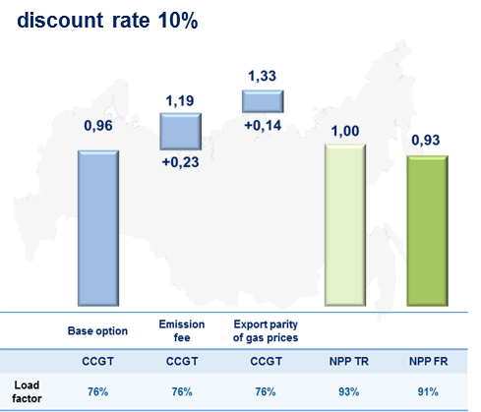 | 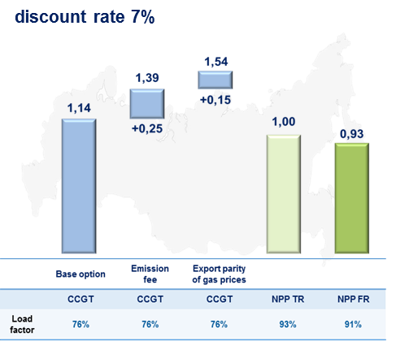
FIG. 2 - LCOE energy technologies in Russia (forecast for 2035-2040) into account limitations of hydrocarbon energy,
relative units

The main conclusion based on results of calculations: resistance to external factors allows to talk for the competitiveness of nuclear energy technologies in the long term.

ECONOMIC EFFICIENCY NFC of the BR in comparison with NFC of the TR
Assessment of the economic efficiency NFC TR option was carried out for current favorable market conditions for natural uranium and enrichment services. Costs of the closed NFC FR are taken according to the target indicators (competitiveness requirements) by Nuclear Strategy.
Fuel costs for NPP electricity generation are calculated for the NFC TR and FR options:

- Option 1. NFC TR with UO₂-fuel and reprocessing SNF;
- Option 2. Closed NFC FR with Mixed NITride UPu-fuel (MNIT-fuel).

Results of calculating fuel costs for generating electricity on nuclear plants with TR and FR are shown on Fig. 3.

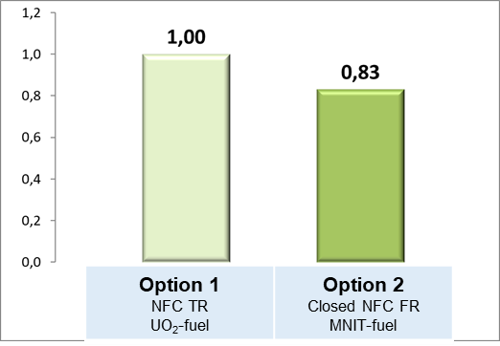
FIG. 3 - Fuel costs of NPP with TR and FR, relative units
The main conclusion based on results of calculations: option of a closed NFC with MNIT-fuel for the accepted competitiveness requirements is more efficient than the NFC TR.

Further, calculated costs of disposal radioactive waste from NFC TR or FR for the entire life cycle for one power unit. The following NFC implementation options are considered:

- Option 1. NFC TR with UO₂-fuel and reprocessing SNF, disposal generating radioactive waste;
- Option 2. Closed FR with MNIT-fuel, start on regenerate of SNF UO2-fuel, further work in the fuel self-supply mode, radioactive waste management according to the «Proryv+» option (separation of minor actinides and final reprocessing radioactive waste (fission products) after 60 years of storage, then disposal).

The classification and volumes of radioactive waste were adopted based on the published data of State Atomic Energy Corporation Rosatom [5] and current results of studies leading industry enterprises and organizations within the framework of the Proryv Project.
Calculations of the costs directly disposal radioactive waste for NFC options under consideration were carried out taking into account the tariff rates of FSUE «NO RWM» [6]. The calculation results are shown on Fig. 4.

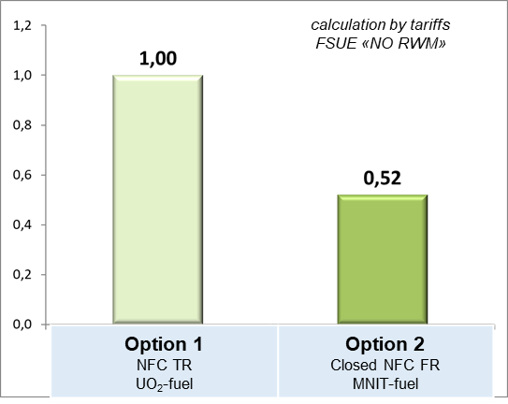
FIG. 4 - Radioactive waste disposal costs for the entire life cycle, relative units

The main conclusion based on results of calculations: the most efficient option for organizing NFC is a closed NFC with FR when handling radioactive waste according «Proryv+» option.

CONCLUSION
The obtained results assessments of the competitiveness NPPs with TR and FR indicate following:

- For conditions of placement on the territory of Russia in medium term, the main competitor for NPPs are power units with CCGT.
- NPPs with FR and TR, that meet the target indicators of the Nuclear Strategy, will be competitive in comparison with CCGT.
- Resistance to external factors allows to talk for the competitiveness of nuclear energy technologies in the long term.
- Option of closed NFC with FR and MNIT-fuel is more efficient than the traditional NFC with TR and UO₂-fuel.
REFERENCES
- International Energy Agency (IEA), «World Energy Outlook 2019», 2019.
- Energy Information Administration (EIA), U.S. Department of Energy, «International Energy Outlook 2019», 2019.
- The Energy Research Institute of the Russian Academy of Sciences (ERI RAS), The Energy Centre Moscow School of Management SKOLKOVO, «Global and Russian Energy Outlook 2019», 2019.
- State Atomic Energy Corporation Rosatom, «The development strategy of nuclear energy in Russia until 2050 and prospects for the period up to 2100», 2018.
- Kashcheev V.A., Shadrin A.Yu., Rykovanov G.N. , Dyrda N.D., Makeeva I.R., Khmelnitsky D.V., Alekseev P.N., «Radioactive waste volumes from reprocessing of VVER-1000 spent nuclear fuel. Fractionation options», Atomic Energy Journal, Volume 127, No. 2, 2019.
- FSUE «National Operator for Radioactive Waste management», http://www.norao.ru/about/tarify/

