EFFICIENT FUEL SUPPLY OF A TWO COMPONENT nuclear energy system WITH VVER-TYPE AND BN-TYPE REACTORS

e.V. Marova, S.F. Shepelev
JSC “Afrikantov OKBM”, Nizhny Novgorod, Russian Federation
A.V.Gulevich, V.M. Dekusar, A.F. Yegorov, D.A. Klinov, V.V. Korobeynikov, A.L. Moseyev, V.M. Troyanov
JSC SSC RF-IPPE, Obninsk, Russian Federation
P.N. ALEKSEYEV, A.L. BALANIN, V.A. NEVINITSA, P.S. TEPLOV, P.A. FOMICHENKO
NRC “Kurchatov Institute”, Moscow, Russian Federation

Abstract

To date the readiness level of thermal and fast nuclear reactor technologies that has been approached in Russia enables the transition to a two component nuclear energy system with closed nuclear fuel cycle based on the next generation advanced VVER and BN reactors that ensure the solution to system-based problems in the nuclear industry associated with resource provision and management of the spent nuclear fuel and radioactive waste in the long run. The paper considers various scenarios of the nuclear industry development and provides a comprehensive comparative analysis of their efficiency. CYCLE, MESSAGE, IDEAL and SUSA codes were applied for multi-criteria decision analysis including Uncertainty and Sensitivity Analyses. Multicriteria comparative analysis showed that the rating of the two-component scenario with closed nuclear fuel cycle is significantly higher than the single-component scenario with open nuclear fuel cycle.

INTRODUCTION
The strategy of the nuclear industry development in Russia approved by the Presidium of the Scientific and Technical Board of the State Corporation Rosatom in 2018, determines the nuclear industry long-term development trend in Russia through implementing the scenarios of transition to a two component system based on the thermal reactors and fast neutron reactors operating in a closed nuclear fuel cycle (NFC) [1, 2, 3]. A significant experience in developing thermal VVER reactors and fast reactors with sodium liquid-metal coolant has been accumulated in Russia which will determine the concept of the national advanced nuclear energy system. It can be assumed that the most efficient way of implementing a two component nuclear energy system takes into account the possibility of rendering a package of services in management of the front-end and the back-end stages of the nuclear fuel cycle for the foreign customers alongside with solving the problems of both the Supplier States, which obtain the technologies of various types of reactors and the respective nuclear fuel cycle technologies, and the User States which obtain solely the experience in operating thermal neutron reactors.
The development and advancement of such systems within the nuclear power technologies involve phased approach which in the short term will yield reduced specific Levelized Cost of Electricity (LCOE), enhanced references associated with the technologies of reactor systems and components of the closed NFC. Over a mid-term horizon, it will lead to reduced consumption of natural resources, allow for implementing decisions taken on spent nuclear fuel (SNF) and radioactive waste management and ensure competitiveness of the technologies. The long-term horizon offers prospects of completely closed NFC and coming to fuel self-sufficiency mode for the nuclear energy systems.
The standpoint of the design engineers involved in design development of a high-power sodium-cooled fast reactor (a BN-type reactor) providing various levels of fuel breeding appears to be logically reasoned with regard to the goal aimed at creating a two-component nuclear energy system. The standpoint lies in the fact that to justify the proposed solutions, a system approach shall be applied to assessment of the system competitiveness. The approach considers the integrated intercorrelation of indicators characterizing the system role of power technologies, such as natural and economic characteristics, safety, environmental impact, readiness levels of technologies and production, implementation risks, development prospects, including the assessment of the resource availability and efficiency of using the resources, state of the infrastructure, compliance with nonproliferation conditions.

CURRENT STATUS AND PROBLEMS OF NUCLEAR INDUSTRY IN RUSSIA AND THE WORLD
According to latest estimates, the share of the nuclear power in the energy mix is not expected to grow neither in Russia (not more than 9%) nor in the world (approximately 6%) until 2035. This trend has been traced worldwide in the policy of replacing power units rather than expanding the nuclear capacity fleet despite the observed aging of facilities [4]. It is anticipated that China will substantially increase the share of nuclear power generation by mid-century, as part of an extensive program on energy system modernization aimed at reducing the carbon emission intensity of the economy. The share of electricity generated by Russian NPPs in 2020 reached its all-time maximum (of 20%), which is associated with the construction projects of new nuclear power plants and the efficiency improvement of the existing power units. In accordance with the instructions of the President and the Government of the Russian Federation, an ambitious goal has been set to increase the electricity generation at nuclear power plants up to 25%, which should play an important role in implementing Russia's strategy of long-term development with low greenhouse gas emissions. It is obvious that the challenges facing the industry require a rethinking of approaches to technological development today, due to the long planning cycles typical of the nuclear industry.
Existing and proven economically viable uranium reserves are projected [5] to be limited. The increase in the number of nuclear power plants will lead to a shortage of cheap uranium and a transition to a high price range, which will inevitably increase the fuel component of prime electric energy cost.
In addition, at the beginning of 2020 the world had more than 400 thousand tons (in terms of heavy metal) of spent nuclear fuel (not including India and Pakistan), of which about 250 thousand tons are in storage, and only one-third is reprocessed. More than 80 percent of the accumulated SNF is stored in on-site storage facilities, and only about 15 percent is stored in off-site interim storage facilities. Moreover, the wet storage prevails, which is characterized by a higher probability of corrosion than the dry storage. The annual rate of SNF generation is about 10.5 thousand metric tonnes [6, 7, 8]. At the same time, there is no growth in the volume of SNF reprocessing. Estimates show that the potential of the uranium accumulated in the world in the form of SNF is equivalent to about 1 million tons of natural uranium [8].
The level of Sodium Fast Reactor (SFR) commercialization is lagging significantly behind the level of VVER commercialization. At the same time, at present, for effective operation in the closed fuel cycle, in parallel with the development of the BN-1200M project, viewed as the key element of the two-component nuclear energy system, an evolutionary VVER-S with neutron spectral shift regulation and an innovative VVER-SCP with water at supercritical pressure are being designed based on the existing national experience in VVER technologies aimed at diversification and risk reduction.
The sodium-cooled fast reactors with high plutonium breeding ratio that are being introduced into the two-component nuclear energy system will help to “enrich” the isotopic composition of recovered plutonium from thermal reactors to enable its use in VVER-type reactors, should such an option be in demand in the Russian nuclear industry. In addition, it is possible that improving the plutonium isotopic composition will attract the foreign customers who do not have a fleet of fast reactors.
In parallel with the closure of the nuclear fuel cycle, the efficiency of using natural and reprocessed uranium in the existing VVERs shall be enhanced.
Taking into account the decisions made on the Strategy for Nuclear Industry Development [1-3], the scenarios under consideration may differ only in a smaller or larger share of fast reactors in the developing nuclear energy system in Russian Federation.
In many respects the deviations from the previously made forecasts on the rates of nuclear industry development are determined both by the level of readiness of nuclear power technologies, which caused the difference in the characteristics of nuclear and conventional power systems at all stages of the life cycle from the stage of technology development to decommissioning, and by the decrease in demand for electric power due to the slowdown of economic development and implementation of energy-saving technologies. These problems led to the failure to achieve the planned technical and economic indicators and deterioration of public attitudes towards nuclear industry. The risks of creating a competitive system are significantly reduced when the system is dominated by key and progressive technologies. It is the system approach in the analysis of the nuclear energy system that mitigates the outcomes of overestimating the effect of technologies in the short term and underestimating this effect in the long term.

DEVELOPMENT OF A TWO-COMPONENT NUCLEAR ENERGY SYSTEM. REQUIREMENTS FOR EFFICIENT FUEL SUPPLY FOR FUTURE NUCLEAR INDUSTRY
In Russia the most developed nuclear power technology is based on thermal reactors, first of all VVER, that ensures acceptable production of electricity with an efficiency factor of about 33% and uses mainly enriched natural uranium and, to a lesser degree, reprocessed uranium as fuel. The nuclear industry development based on thermal reactors determines the growth of volumes of spent nuclear fuel with plutonium and minor actinides (MA), the increase in the loading of enrichment facilities, and the volume of depleted uranium in storage facilities. In addition to that, the technology of thermal reactors has limitations on the temperature potential of the generated heat. Among other things, proceeding from the forecasts on the balance of uranium demand and supply, there is a risk of reduction in the efficiency of fuel supplied for VVER.
It should be noted that Russian specialists strive for continuous improvement of VVER [9] technical and economic performance by developing and implementing the following solutions:
- development of a VVER reactor with spectral regulation aimed at improving safety and ensuring efficient fuel utilization in open and closed fuel cycle and in variable load mode;
- development of a VVER-SCP reactor with overcritical coolant parameters in order to enhance the efficiency factor and breeding ratio;
- development and justification of advanced fuel types (RepU fuel, REMIX and MOX) allowing for VVER operation in a closed fuel cycle along with establishing a relevant most suitable NFC structure (aimed at improving fuel utilization);
- improvement of consumer appeal (reliability, safety, maneuverability, expansion of the capacity range, etc.).
Development of the advanced types of fuel contributes to dealing with urgent problem of SNF reprocessing and fissile material recycling, in particular, through multiple recycling of uranium and plutonium (6-7 recycles) as part of REMIX fuel. Two options for REMIX fuel are possible: (a) from a mixture of plutonium and enriched reprocessed uranium, or (b) with their heterogeneous arrangement. This engineering solution will enable to: reduce the SNF accumulation rate, decrease the demand in uranium mining, and significantly cut down on the amount of RAW subject to disposal or long-term storage provided that the further nuclear energy system development is associated with using a smaller fraction of BN reactors.
It should be noted that a more effective way of resolving the accumulated problems related to SNF and RAW management consists in involving of a larger share of sodium-cooled fast reactors with mixed uranium-plutonium fuel in nuclear energy system.
Russia possesses the BN (SFR) technology which is continuously developing and accumulates the positive experience in the design engineering, construction and operation of BN reactors. The said technology is not critical for the isotopic composition of the plutonium to be loaded, it can use depleted uranium, and breed high quality plutonium. The latter circumstance is very important in the context of developing the structure of a two-component nuclear energy system: it provides an opportunity to improve the quality and normalize the isotopic composition of plutonium in VVER fuel batches with REMIX or MOX fuel by using plutonium from BN SNF while effectively using plutonium from VVER SNF in fast reactor fuel batches. It is known that in case of using MOX fuel in VVER thermal reactors, the plutonium quality degradation limits the possibility of plutonium multiple application in such reactors to only two or three recycles. The possible solution to the problem consists in using plutonium from BN SNF instead of VVER plutonium, and at the same time, the plutonium from VVER SNF can replace the plutonium missing in the BN fuel batch, if necessary. Thus, the transition to a two-component nuclear energy system can be carried out in a natural way, in which power units with BN reactors are "partners" of the VVER reactors, rather than competitors in the market of energy sources.
To date, documentation have been developed on the design of a power unit with a high capacity BN reactor providing various levels of fuel breeding and co-generation of heat and electricity with the efficiency factor of more than 43% gross. The design ensures the use of depleted uranium in the fuel batch to be loaded thereby eliminating the need for natural uranium along with the developed fuel supply schemes aimed at reducing the volume of spent nuclear fuel produced by the VVER and BN reactors and efficient use of plutonium of any isotopic composition. Active work is underway on the BN reactor option designed for disposal of neptunium and americium from SNF, including SNF produced by thermal reactors.
BN technology provides virtually unlimited potential for increasing the two-component nuclear industry’s share in the market of nuclear power sources owing to the benefits of technology ownership:
- national energy security for centuries to come without the consumption of hydrocarbon natural resources;
- plutonium with an improved isotopic composition that meets the requirements for nuclear and radiation safety at an acceptable value of the fuel component of prime electric energy cost when using MOX fuel not only in BN, but also in VVER;
- breeding of plutonium (if necessary) in the amount determined by the needs of the nuclear industry development strategy;
- possibility to change the breeding parameters;
- high burnup of the discharged fuel;
- solution to environmental problems by reducing the volume of SNF and RAW;
- elimination of carbon and nitrogen oxides emissions or their reduction through substitution of conventional energy sources;
- burning of minor actinides;
- possibility to locate a power unit in any region;
- possibility to create a sufficiently wide capacity range;
- expansion of international business by providing NFC closing services in addition to efficient heat and electricity production;
- potential to expand the range of services provided through, at least, co-generation of potable and technical water, breeding of isotope products.
The modern requirements for energy technologies [4], defining their multipurpose use, aimed at improving the quality of life of the population, provide new niches for application of nuclear energy sources, including non-electric applications. What is more, the advances in nuclear industry contribute to the development of non-nuclear technologies in the area of medicine and energy storage systems.
In fact, nuclear energy system based on VVER and BN reactors establishes the competitiveness of nuclear industry at the dynamically developing market of energy sources and the associated market which renders nuclear fuel cycle services. The BN technology enables to produce electric power in the base load mode; however, it is not excluded that at the initial stage the generated electricity will be more expensive than the one generated by the VVER reactors. At the same time the VVER technology makes it possible to produce “cheap” electricity and to operate in the load follow mode. BN reactors use waste uranium or reprocessed depleted uranium from spent MOX fuel or breeding zones for fuel makeup. Such reactors produce plutonium that is maximum suitable for production of mixed uranium-plutonium fuel for VVER, and burn minor actinides (MA) released when reprocessing the SNF produced by both BN and VVER. It is possible to partially load into a VVER core mixed uranium-plutonium fuel instead of uranium oxide fuel. The growth of the domestic fleet of fast reactors and the corresponding infrastructure of the closed nuclear fuel cycle will make it possible to expand the export of the VVER reactors along with services that include returning of the SNF to Russia for reprocessing and fabrication of fuel from recovered materials In this case, the plutonium separated from VVER SNF, depending on the isotopic composition, goes to the production of mixed uranium-plutonium fuel for the BN or VVER reactors. At the same time it is necessary to ensure that the nuclear energy system technical and economic indicators which provide the competitiveness of nuclear industry with other energy sources. In particular, the decrease in LCOE can be achieved through cost reduction of the fuel component and operating component without impairing the safety characteristics.
In the mid-term, the most attractive option of a two-component nuclear energy system operation with the VVER and BN reactors is when the BN reactors use uranium-plutonium fuel based on reprocessed plutonium from VVER SNF, and the VVER reactors use uranium- plutonium fuel based on reprocessed plutonium from BN SNF.
The following may be involved at the initial stage aimed at implementing the nuclear energy system in the existing system of centralized nuclear fuel cycle (NFC) with operating and developing fuel cycle facilities: REMIX fuel to be loaded in the operating VVER reactors; as well as power units which are newly being developed with high capacity BN reactors using MOX fuel; and medium power VVER-S and VVER-SCP power units using MOX fuel.
To ensure the development of nuclear energy systems, it is necessary not only to develop a schedule of replacing those VVER and RBMK power units with service life close to completion with new-generation BN and VVER reactors, but also to analyze the possibility of using NFC production facilities that have already been created and are currently being created. In addition, it is necessary to take into account the development of appropriate fuel technologies and the demand for plutonium production, as well as burning of MA.
The commissioning of BN-800 and the use of MOX fuel in it with its subsequent reprocessing and fabrication of a new MOX fuel, along with the prospects of building power units with BN-1200, is the beginning of forming a two-component nuclear energy system.
With the start-up of BN-800 and the positive experience of BN-600 operation the basis has been created for further development of the BN technology, as well as the development of pilot technologies aimed at closing the nuclear fuel cycle. Today, the BN technology is already ready for commercial implementation.
The obligatory requirements for the use of nuclear fuel are high performance reliability, energy output and prospects of increasing the achieved technical and economic indicators [3]. Currently these requirements are met by uranium oxide fuel and MOX fuel, the justification of mixed nitride uranium-plutonium fuel (MNUP fuel) is underway. In the future, it is expedient to consider mixed metal fuel for the BN as well.
The current practice shows that the cost of the mixed fuel production is one of the constraining factors for closing down the nuclear fuel cycle, as well as the cost of SNF management. A serious factor driving down the cost of fabrication and refabrication of fuel and SNF reprocessing is the scale of production. At the same time, in a two-component nuclear energy system with thermal and fast reactors, to achieve the objective aimed at reducing fuel costs, it is necessary to apply standardized mixed uranium-plutonium fuel in both power components of a nuclear energy system, when fuel production for VVER and BN is based as much as possible on the use of the same type of equipment and technology. This approach seriously increases the scale of production. The proposed MOX technology is the most validated one at present and it is equally acceptable for both thermal and fast reactors. The need to reprocess VVER SNF from NPPs distributed throughout the country, and what is more SNF from foreign sources, requires centralization of reprocessing production using already existing NFC facilities in Russia. Naturally, in this case, reprocessing of SNF from BN reactors is expedient at the same centralized production facility. Centralized separation of secondary nuclear materials should naturally be associated with centralized fabrication and refabrication of fresh fuel for BN. This also leads to an increase in the utilization of fuel fabrication capacity and, consequently, to a reduction in the unit cost of fuel fabrication.
This approach meets all the requirements of the regulatory documents in the field of the use of atomic energy to separate the functions of the organizations operating NPPs and those operating the NFC production facilities, and it is also convenient for rendering NFC export services.
Operation of a two-component nuclear energy system with a closed nuclear fuel cycle is possible and expedient with the participation of foreign consumers [3]. In this case it is possible for Russian enterprises to render a set of services for reprocessing SNF from NPPs with VVER reactors built by ROSATOM abroad and fabrication of fresh fuel using reprocessed nuclear materials. One of the possible options is shown in Fig. 1.
As a result, a foreign Customer (NPP owner) which has a limited number of power units and has no plans to build SNF management facilities, but which seeks to reduce the amount of RAW subject to disposal, receives a power unit with VVER-1200 (VVER-S, VVER-SCP) and a complete set of NFC services. The nuclear energy system provides plutonium management, burning of minor actinides, production of mixed uranium-plutonium fuel for VVER reactors.
At the same time the centralized closed NFC with high-capacity BN power units are in the Supplier’s (State Corporation "Rosatom") area of responsibility on the territory of Russia.

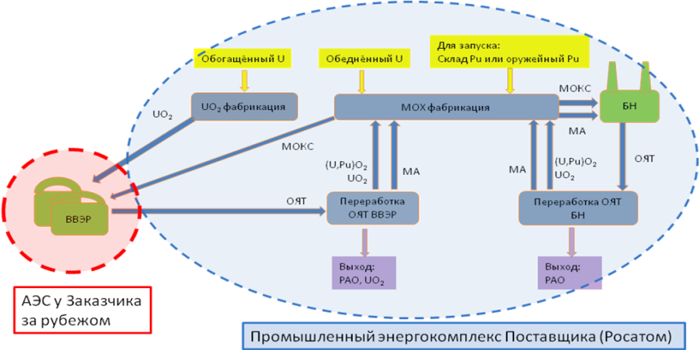
UO₂ fuel
fabrication
Reprocessing of
VVER SNF
Reprocessing of
BN SNF
Output:
RAW
Supplier’s (Rosatom’s) industrial power facilities
Customer’s NPP
located abroad
Output:
RAW, UO₂
SNF
MOX
Enriched U
MOX fuel fabrication
For startup:
PU storage or weapon-grade Pu
Depleted U
MOX
SNF
MA
MA
MA
BN
VVER
Fig. 1 Organization of work in the two-component nuclear energy system with a closed nuclear fuel cycle with participation of foreign consumers.
It should be noted that the fuel cycle under the scheme given in Figure 1 does not fully include the reprocessed uranium obtained from VVER SNF reprocessing. However, it can be used to make fuel from additionally enriched reprocessed uranium (reprocessed uranium fuel) or a mixture of additionally enriched reprocessed uranium and plutonium (REMIX fuel). Current uranium enrichment technologies in Russia allow for uranium enrichment with simultaneous purification from the isotope ²³²U for multiple recycling in light water reactors.
Possible options of organizational schemes for handling reprocessed products generated during reprocessing of SNF received from a foreign customer are as follows:
(a) return of conditioned RAW, rendering of services for storage of separated nuclear materials pending a decision on them;
(b) return of conditioned RAW, return of some separated nuclear materials as part of fresh nuclear fuel, and storage of minor actinides pending a decision on them;
(c) return of conditioned RAW, rendering of services for burning minor actinides in fast reactors and partial in-process storage, and return of an equivalent amount of separated nuclear materials as part of fresh nuclear fuel;
(d) decision made by the Nuclear Fuel Supplier on all issues on its own if the fuel was leased to the Customer.
The listed advantages and benefits of the application of two-component nuclear energy system technologies in the nuclear industry containing these technologies are mostly not easy to assess directly in the financial and commercial aspect. Nevertheless, their significance is large enough for all of them to be taken into account in the analysis of technology competitiveness [10].
In a comprehensive scenario-dynamic analysis of nuclear energy system the main risks should be taken into account, which are determined by:
- specific cost of power generation, first of all, a high capital component;
- peculiarities of NPP operation as a nuclear hazardous facility;
- dependence on natural resources, the amount of which is limited;
- SNF management;
- ensuring safeguards for the non-proliferation of nuclear materials;
- the timely creation of the necessary infrastructure;
- the need for long-term planning, taking into account the full life cycle of facilities.
Forecasts for the development of both the power industry in general and nuclear industry in particular, not only for the near-term, but also for the mid-term and long-term horizons of at least 50 years of guaranteed energy supply, are characterized by significant uncertainties that must be taken into account in the analysis:
- in the energy supply needs not only in Russia, but also abroad;
- in SNF accumulation, development of its reprocessing technology and, as a consequence, reserves of separated plutonium and its isotopic composition;
- stocks of natural uranium.

SOFTWARE AND METHODOLOGICAL SUPPORT FOR TAKING INTO ACCOUNT SYSTEM REQUIREMENTS UNDER DIFFERENT CONDITIONS OF NUCLEAR AND NON-NUCLEAR INDUSTRY DEVELOPMENT
An important task is scenario research activities, which make it possible to determine the feasibility of one or another direction of nuclear industry development, taking into account resource limitations, capabilities of the existing technologies and much more. Before conducting a system multicriteria analysis, it is necessary to build a set of scenarios aimed at development of energy systems and justify their feasibility. This requires special software, which will allow to correctly determine the dynamics of changes in material flows. Also before the analysis, initial and boundary conditions shall be defined. These include, for example, uranium reserves, the amount of plutonium, the availability of necessary infrastructure, the required capacity of the nuclear industry by a given time, and much more. Such computational codes as CYCLE [13], DESAE [11], MESSAGE [14] and other codes [12] can be used within the frame of research activities to calculate the dynamics of material flows.
Characteristics such as the amount of plutonium in storage, the rate of SNF accumulation/reduction, and natural uranium consumption (limited natural uranium reserves) can be used as indicators of scenario performance.
Using a combination of nuclear industry and a conventional non-nuclear power generation system, one can construct different alternative scenarios and compare their effectiveness. Of course, to build appropriate alternatives it is necessary to take into account regional constraints, the prospects for their change, resource opportunities, population needs, etc., but at the preliminary stage it is usually assumed to study the effectiveness of this kind of alternatives without taking into account regional specifics. Construction of complete energy systems will allow to take into account the specific features of nuclear and non-nuclear energy sources.
In such complete models, which describe the energy system as a whole, the problems of effective management of SNF and RAW, closing the cycle, features of safety assessment, etc. become already common systemic challenges. To compare different options and scenarios of such systems, a single set of performance criteria will be used, including both criteria associated with the use of nuclear power technologies and criteria associated with specific non-nuclear technologies. A comparison on the criterion of technology export capability will be made for the entire system as a whole. For example, the system analysis criteria would "welcome" an increase in the construction of nuclear power units abroad, but with a complete package of fuel services. However, if the complete power industry system is formed in such a way that it interferes with the exports of non-nuclear energy carriers (gas and coal), this also will be pointed out by the criteria of systemic analysis of complete systems. Environmental criteria for emissions, criteria of risks for personnel and population, etc. will work similarly.
To compare the effectiveness of model scenarios, it is proposed to use a set of key indicators covering the areas of economy, ecology, innovation potential, resource and export potentials, readiness level, and SNF and RAW management:
1 LCOE ($/MW h);
2 resource reserves (years);
3 specific resource (MWh/ton);
4 safety (risks for the personnel: number of fatalities per 1 TW∙h);
5 environmental impact (reduced emissions to CO₂ g/kW∙h);
6 technological potential (1-5 points);
7 export potential;
8 SNF and RAW management (tons) or reduction %;
9 technology uptake.
The user can vary:
- weight of individual indicators, thus defining priorities;
- the rate of increase/decrease of a particular energy source fleet.
It should be noted that each criterion is characterized by the error of its definition, which is determined by the representativeness of the initial data, and the stage of development, and the accumulated experience in using the technology, and the influence of external factors.
As a rule, this comparison of effectiveness is based on the calculation of aggregate estimates, quantitatively characterizing the options under consideration and depending on the values of indicators (or criteria) and their significance, described by the "weights" of the criteria in the final evaluation.
To solve the problems of multi-criteria decision analysis (MCDA) in this work, in particular, the software tool IDEAL developed at NRC Kurchatov Institute was used. The method known as TOPSIS (Technique for Order Preference by Similarity to the Ideal Solution) is implemented in this code. TOPSIS [19] is a method of compensatory summation, which compares a set of alternatives by a) defining weight coefficients for each criterion, b) normalizing the values for each criterion, c) generating two additional alternatives, which have the best and the worst values for each criterion, respectively, and d) calculating (taking into account weights) the metrics of the method - the values of geometric distance between each alternative and the "ideal" and the "worst" alternatives defined by the method described. Any set of user-defined weights can be used, as well as weights generated automatically, taking into account the values of the criteria matrix elements.
An important component of the MCDA carried out in this way is the assessment of the uncertainty and sensitivity of the calculation results associated with the uncertainty of knowledge about the values of the initial quantities (characteristics of the options under consideration) and the ambiguity of the parameters of the applied MCDA methods (such as criterion weights, aggregation algorithms, etc.). The purpose of uncertainty analysis is to determine the type of distribution of the output quantities and to calculate the distribution parameters, such as mathematical expectation and root-mean-square deviation (RMSD). The purpose of sensitivity analysis is to evaluate the relationships between the input variables, as the initial data for calculations, and the results. This can be done, for example, by regression analysis of the results of multiple estimates using some MCDA method with randomly chosen sets of input parameter values.
The uncertainty and sensitivity analysis was performed on the basis of multiple estimations using the biased ideal method with randomly chosen sets of values of input parameters: SUSA 4.0 software tool (Software for Uncertainty and Sensitivity Analyses) [15] was applied to generate them and process the results.

ANALYSIS RESULTS OF SOME DEVELOPMENT OPTIONS OF A TWO-COMPONENT NUCLEAR ENERGY SYSTEM WITH EFFICIENT FUEL SUPPLY
The system efficiency (cost effectiveness, competitiveness and investment attractiveness) shall be driven by not only a set of economic and other indicators of the power units included in it, but it shall also meet a set of key criteria of efficiency evaluation of the system as a whole [16-18]. Such most important generally accepted criteria include:
- technological and environmental safety, use of reliable components that have demonstrated their serviceability;
- solving the problem of storing spent nuclear fuel, radioactive waste and separated plutonium;
- economic expediency;
- degree of efficiency in using natural uranium;
- long-term and reliable fuel supply: self-sufficiency in fuel;
- possibility to increase export potential.
Up to now, a number of papers [1, 2, 10, 16-18] have been published on the multi-criteria decision analysis of different scenarios of a two-component nuclear energy system development.
One calculation study, the results of which are provided in this paper, was carried out for the model two-component scenario of nuclear industry development where the total installed capacity of about 50 GW(e) will be achieved by 2050 and approximately 80 GW(e) will be achieved by 2100. In addition to the two-component scenario an alternative one-component reference scenario was considered which implements an open NFC at VVER-type thermal reactors without SNF reprocessing, except for VVER-440 SNF. Fig. 2 shows the structure of installed capacity for the two scenarios.
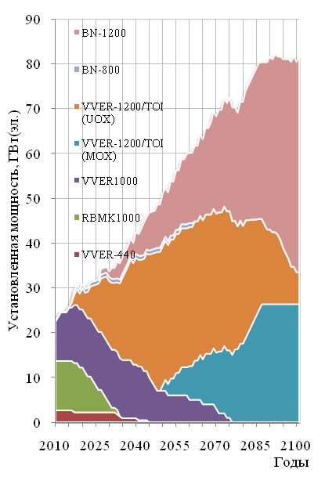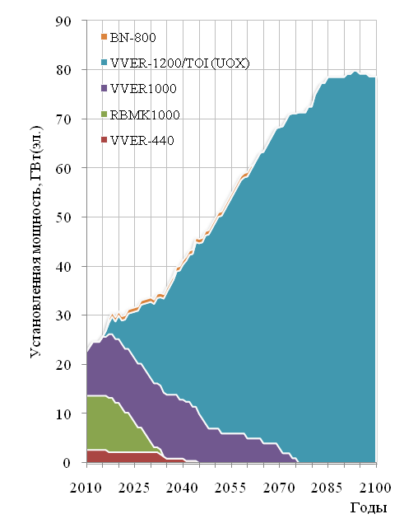
Years
Years
Installed capacity, GW(e)
Installed capacity, GW(e)
Fig. 2. Installed power in two-component (left) and reference (right) scenarios.
Fig. 3 compares natural uranium consumption, integral and specific, in the reference and two-component scenarios. Integral and specific consumption of natural uranium decreases significantly in the two-component scenario compared to the reference scenario. Fig. 4 compares the change over time in the amounts of spent nuclear fuel for this pair of scenarios. In the reference scenario the amount of SNF reaches almost one hundred thousand tons by the end of the century. In the two-component scenario, the amount of SNF decreases to zero. Studies of changes in the amount of plutonium for the two scenarios have shown that for the open cycle the amount of plutonium becomes just over 1,000 tons by the end of the century. In the two-component scenario, the amount of plutonium reaches about 25 t by the end of the century. Thus, a two-component nuclear energy system has an advantage over a single-component nuclear energy system already in the mid-term period.
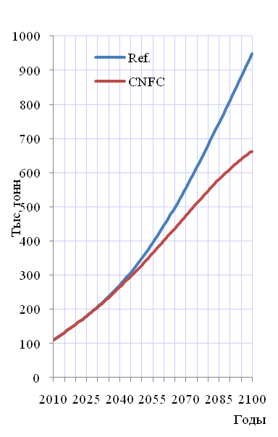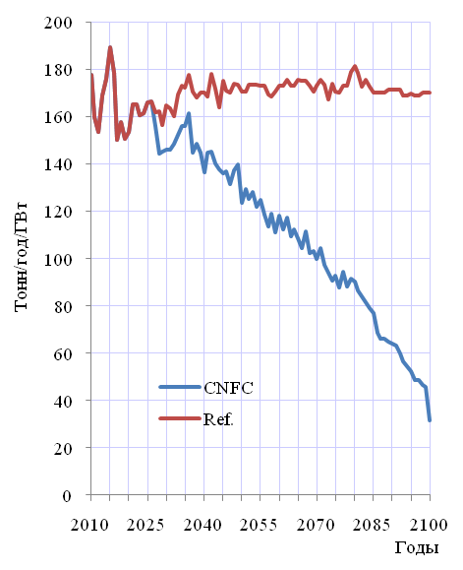
Years
Years
kilotonnes
Tonnes/year/GW
Fig. 3. Integral (left) and specific uranium consumption (right) in the two-component and reference scenarios.
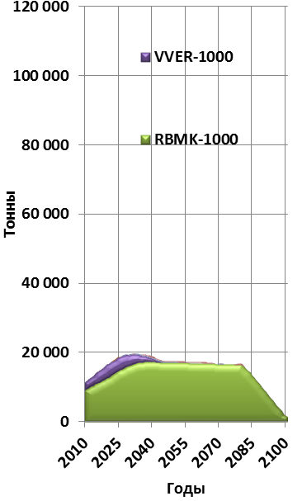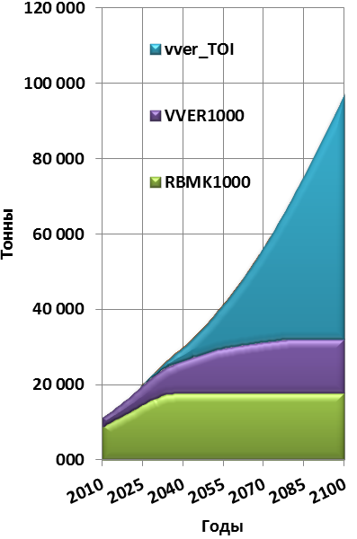
Years
Years
Tonnes
Tonnes
Fig. 4. Comparison of SNF accumulation rates in the reference (right) and two-component (left) scenarios.
In the framework of the second cycle of calculation studies the formation, adaptation and testing on a representative model problem of a comprehensive mechanism for multi-criteria assessment of options for the development of the nuclear energy system were carried out.
In accordance with the MCDA methodology, a computational and analytical assessment was performed for six options of the Russian nuclear energy system development in the scenario where the integrated nuclear capacity of Russia will grow up to 70 GW of installed capacity by 2100. A detailed description of the options is given in the computational and analytical substantiation of the Russian Nuclear Industry Development Strategy-2018 till 2050 and up to 2100:
- option 0 - scenario of the development of Russian nuclear industry based on existing technologies;
- option 1 - scenario of the forming Russian nuclear industry based on the evolutionary development of VVER technology in an open NFC environment (evolutionary development of VVER technology with spectral control of reactivity and low natural uranium consumption);
- option 2 - development scenario with SNF reprocessing, partial closure of the nuclear fuel cycle and recycling of recovered NM in thermal reactors (the possibility of 100% loading of the VVER-S core with MOX fuel is considered);
- option 3 - scenario of the development of RBN (fast neutron reactor) technology on MOX fuel (large-scale implementation of RBN technologies with sodium coolant and moderate indicators of expanded fuel breeding after 2035);
- option 4 - the development scenario with the commissioning of fast reactors with higher breeding ratio using MNUP fuel (large-scale implementation of RBN technologies and high ratio expanded fuel breeding after 2035);
- option 5 - a development scenario with the commissioning of fast reactors with breeding ratio of approximately 1 using MNUP fuel (large-scale implementation of RBN technologies with lead coolant).
Based on the computational and analytical studies of the scenarios under consideration, a set of criteria was formed with their distribution into five assessment areas (Fig. 5, 6):
- manufactured products (maximum total capacity, electricity output up to 2100);
- fuel resources (Total volume of natural U used in nuclear energy system, total volume of stored SNF by 2100, encumbrance under obligations for SNF (without discount) by 2100, total volume of stored Pu by 2100, volume of recovered U used in the nuclear energy system);
- fuel production (volume of recovered U used in the nuclear energy system, average volume of natural U mining, average capacity of U fuel fabrication, average capacity of U-Pu fuel fabrication, average capacity of SNF reprocessing during the period);
- economy (SLCOE);
- export potential.
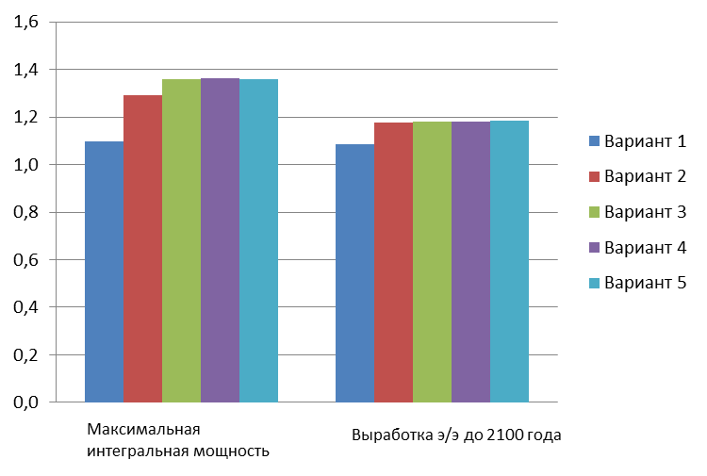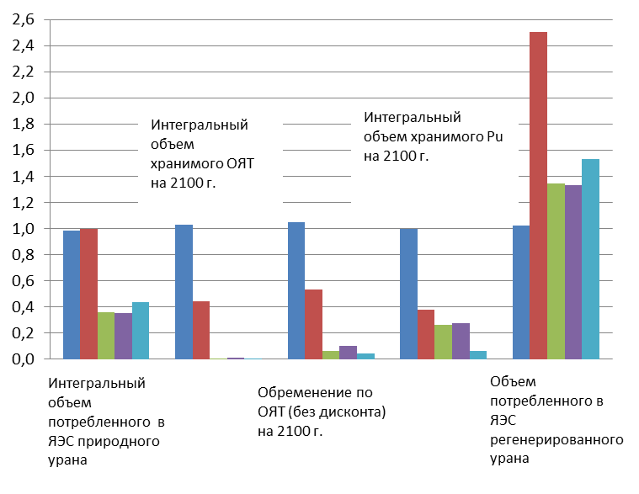
Electricity output up to 2100
Maximum total capacity
Total volume
of stored Pu
by 2100
Total volume
of stored SNF
by 2100
Total volume
of natural U
used in nuclear energy system
Encumbrance under obligations for SNF (without discount)
by 2100
Volume of recovered U used in the nuclear energy system
option 1
option 2
option 3
option 4
option 5
Average volume of enriched fuel fabrication
Average capacity of U-Pu fuel fabrication
a) Production b) Fuel resources
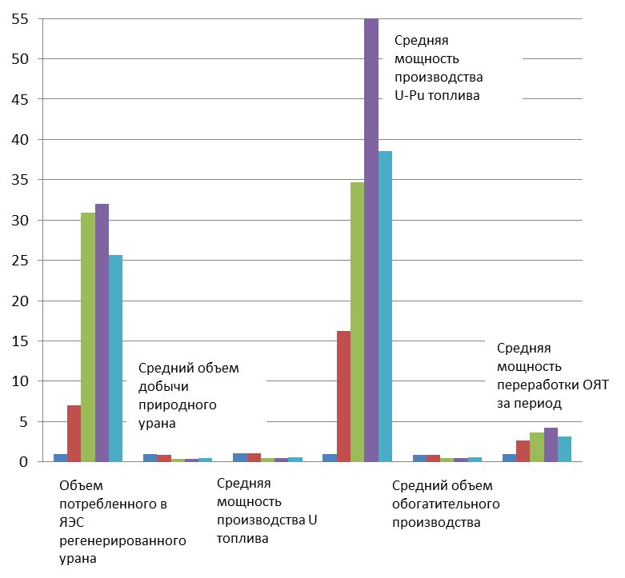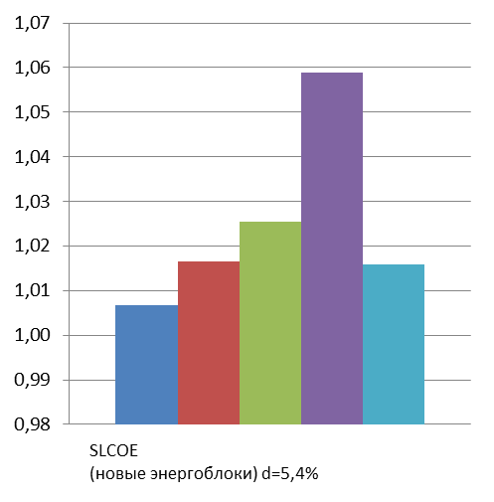
(new power units)
Average capacity of SNF reprocessing during the period
Volume of recovered U used in the nuclear energy system
Average capacity of U fuel fabrication
Average volume of natural U mining
c) Fuel fabrication d) Economy
Fig. 5. Values of the criteria for the selected options relative to option 0, in relative units.

In addition, the assessment area of technological and production readiness levels was introduced. Using the improved approaches to prioritizing the criteria based on expert assessments, the calculations of aggregate indicators for the analyzed options were carried out taking into account the simulated dynamics of priorities determined by the Decision-makers for the short-, mid- and long-term periods (Fig. 6 and 7). In this paper Lp is the metric value for each option used for comparisons (the higher this value, the better is option).
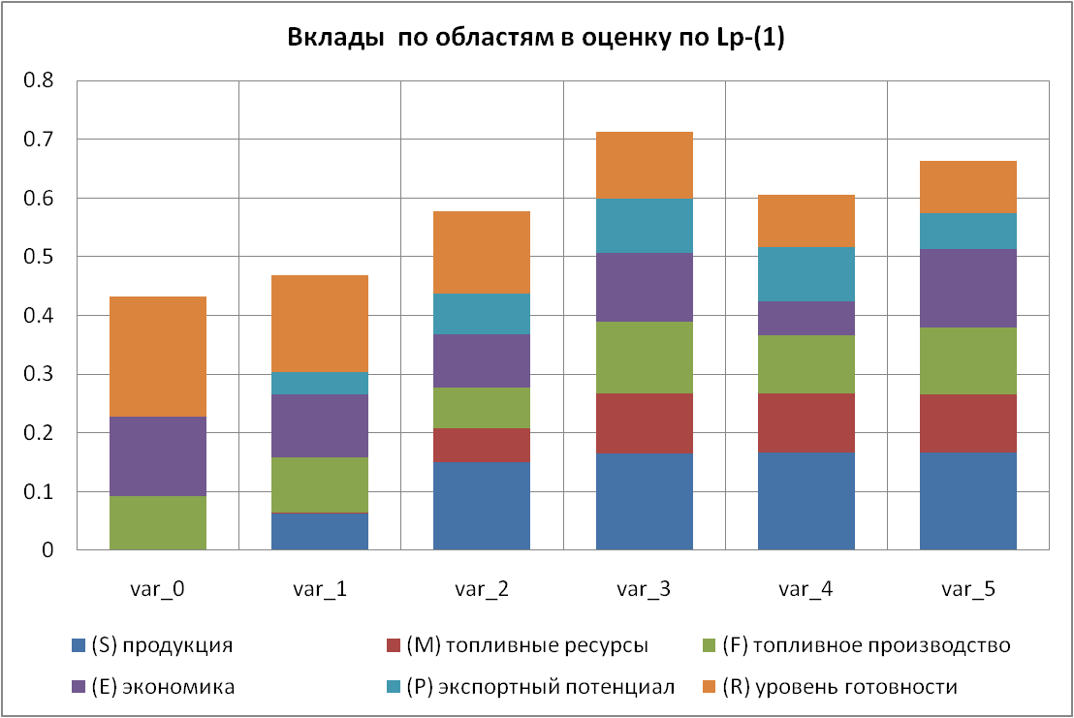
fuel fabrication
fuel resources
Inputs per areas into Lp- (1) assessment
production
economy
export potential
level of readiness
Fig. 6. Aggregated indicators by assessment areas for the basic sets of values of the criteria and weights.
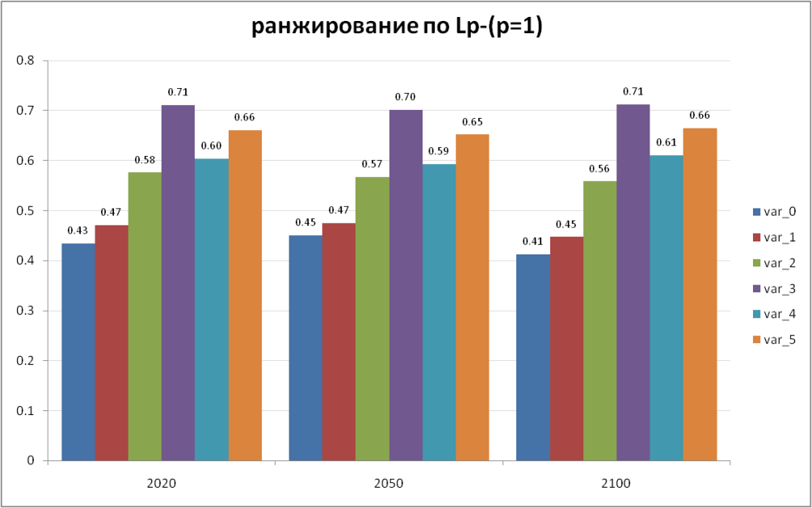
Ranking as per Lp - (p=1)
Fig. 7. Variation Dynamics of Aggregated Indicators on
Short-, Mid-, and Long-Term Horizons.
SLCOE indicator which characterizes the Specific Levelized Cost of Electricity for new power units to be put into operation after 2018 (a ratio of the reduced costs during the entire life cycle of a nuclear energy system to the electric power generation) is considered as the main economic indicator.
In developing the scenarios a limit on natural uranium reserves for the NPP fleet in Russia was taken into account. For options 1–3 of the open and partially closed fuel cycle, the limit on natural uranium reserves leads to restrictions on the growth of the integral installed capacity of the NPP fleet after 2050, which in turn affects other integral indicators.
Comparative analysis of integral characteristics showed:
As for the maximum integral capacity criterion only those options which use fast reactors for power generation (options 3, 4, 5) meet the requirements for the power industry development up to the level of 70 GW.
Transition to VVER-S technology provides a way to reduce natural uranium consumption by 10%. The closed NFC in thermal reactors provided by the use of reprocessed uranium and MOX-fuel in VVER-S reactors offers the possibility to save 10% of natural resources, which facilitates the increase in integrated capacity of NPPs up to 2090.
The options of building only thermal reactors have high risks of decreasing competitiveness with the growth of natural uranium prices.
The spent nuclear fuel issues can be completely resolved only within the scenarios which involve fast reactors in the development of power generation (options 3, 4 and 5).
Scenario calculations are based on the indicators declared for advanced reactor designs with thermal and fast spectrum neutrons. The level of technological readiness of the projects for evolutionary development in the area of VVER and BN (SFR) reactors is higher than that of the RBN reactors with lead coolant. For the RBN technologies there are time risks of achieving the declared indicators both in terms of technical and economic indicators of the power unit, and in terms of fuel characteristics.
Introduction of the RBN technology with lead coolant and sodium coolant removes the limitation on the resource potential across the entire depth of considerations for nuclear industry development scenarios. Nevertheless, the issues related to plutonium stockpile management and development of uranium-plutonium fuel fabrication technologies become relevant for fast reactors with closed NFC. The existing structure of nuclear industry with thermal reactors and the volume of spent nuclear fuel accumulated during their operation, including RBMK spent nuclear fuel, are the drivers of the transition stage aimed at shaping the structure of the two-component nuclear industry with thermal and fast reactors. The characteristics of nuclear fuel breeding and the capabilities to use enriched uranium also have a significant impact on the RBN fuel balance management.
The closed NFC and reduced consumption of natural uranium in Russia will support uranium export to foreign markets, as well as enhance the capabilities in rendering services at the back-end stage of the NFC concerning SNF and RAW management. Reprocessing of spent nuclear fuel obtained from foreign customers without returning plutonium as part of uranium-plutonium fuel contributes to the increase in the volume/rate of nuclear power generation growth in the Russian Federation.
Using IDEAL and SUSA we obtained estimates of the uncertainty in the results caused by the global uncertainty in the values of the weights, understood in the sense that it is assumed that each of the weights can take a uniformly random value in the interval [0, 1]. In addition, the change in the aggregate estimates of the options and their relationships for given values of the maximum possible relative deviations of all criteria from their nominal values were investigated.
The results of these studies have shown the attractiveness of implementing scenarios involving RBN, i.e., implementing two-component nuclear industry with a guaranteed solution to the problems of fuel supply and SNF management.
Fig. 8 shows the change in aggregate TOPSIS estimates for all six options considered. One can see that when taking into account criteria uncertainties within the considered limits and even assuming global uncertainty of weights, the ranking of the options on average does not change, although the estimates are converging and there is a non-zero probability of changing the ranks of alternatives.
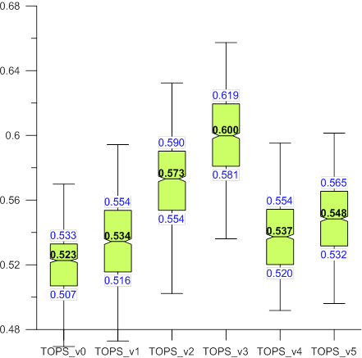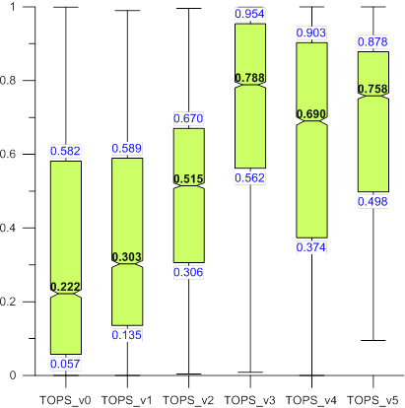
a) b)
Fig. 8. Average values of aggregate estimates and their scatter in the interval [25...75%] for the cases
(a) 10% uncertainty of all the criteria values in the basic set of weights;
(b) global uncertainty of weights for the basic set of criterion values.

CONCLUSION
There is a high level of readiness to implement a two-component nuclear energy system in Russia at the moment, which is due to the VVER and BN reactor technologies, taking into account the experience of building and operating power units BN-350, BN-600 and BN-800, the design development and validation of a high power BN (SFR), as well as the availability of the operating facilities for spent nuclear fuel reprocessing.
The advantage of a two-component nuclear energy system is that it will provide the economic systemic efficiency of nuclear industry in the market due to:
- the unlimited potential of waste and natural uranium used for fuel cycle makeup in BN and VVER reactors, with the imminent shortage of uranium and the increased cost of uranium in a single-component nuclear energy system;
- elimination of stockpiles of accumulated plutonium;
- reduction in the volume of accumulated SNF as a result of its reprocessing and recycling of nuclear materials; leading to reduced costs associated with spent nuclear fuel management obligations of Rosenergoatom, JSC;
- reduction in RAW activity and their volume by burning the long-lived RAW (minor actinides) in BN reactors;
- use of mixed uranium-plutonium fuel in the VVER and BN reactors;
- expanded breeding of plutonium in BN and its use for adjustment of plutonium isotopic composition in MOX fuel for VVER.
Besides, nuclear energy system will provide new opportunities for the State Corporation Rosatom on the foreign market by means of:
- export of VVER together with "leasing" of nuclear fuel;
- commercial and scientific and technical cooperation on BN technologies;
- additional set of services on reprocessing of SNF of foreign NPPs, use of reprocessed materials and further use of separated nuclear materials in BN.
Multicriteria comparative analysis of single-component and two-component system development scenarios showed that using a set of key criteria the rating of the two-component scenario with closed NFC is significantly higher than the single-component scenario with open NFC. Studies of the sensitivity and uncertainty of the values of the selected criteria and their weights showed that the high value of the rating of the two-component system proved to be quite stable to changes in the values of weights and criteria.
LIST OF REFERENCES
- Alekseev P.N., Gagarinsky A.Yu., Kalugin M.A. et al. Toward a Strategy for the Development of Nuclear Power in Russia, Journal of Atomic Energy, vol. 126, edition 4, pp. 183-187, 2019.
- Alekseev P.N., Alekseev S.V., Andrianova E.A. et al. Two-component Nuclear Energy System with Thermal and Fast Reactors in a Closed Nuclear Fuel Cycle, ed. N.N. Ponomarev-Stepnoy, Moscow; Technosphere, 160 p., 2016.
- Petrov A.Y., Shutikov A.V., Ponomarev-Stepnoy N.N. et al. Prospects for a Two-Component Nuclear Energy System - a View of the Russian Customer, Journal "Izvestiya Vuzov. Nuclear Power Engineering", No. 2, pp. 5-15, 2019.
- Forecast of the Development of the Energy World and Russia 2019, ed. Makarov A.A., Mitrova T.A., Kulagin V.A., INEI RAS, Energy Center of Moscow School of Management SKOLKOVO - Moscow, 2019.
- Uranium 2016: Resources, Production and Demand, A Joint Report by the Nuclear Energy Agency and the International Atomic Energy Agency, NEA No. 7301, OECD 2016.
- Status and Trends in Spent Fuel and Radioactive Waste Management, IAEA Nuclear Energy Series No. NW-T-1.14, 2018.
- Spent Fuel Reprocessing Options, IAEA-TECDOC-1587, 2008.
- Solov'eva A.P., Ulyanin U.A., Kharitonov V.V., Yurshina D.Yu. On the Value of SNF as a Raw Material for Heat Neutron Reactor Fuel, Izvestiya Vuzov. Nuclear Power Engineering, No. 2, pp. 140-152, 2019.
- Asmolov V.G.. Requirements for Nuclear Power with Regard to Global Trends and Challenges, Neutronics 2017, 2017.
- Alekseev P.N., Blandinsky V.Yu., Balanin A.L. et al. Assessing the Effectiveness of Nuclear Power Development Scenarios in Russia Using Multicriteria Analysis, Journal of Atomic Energy, vol. 128, no. 1, pp. 3-6, 2020.
- Andrianova E.A., Tsibulsky V.F., Davidenko V.D.. DESAE Program for System Studies of Nuclear Power Development Prospects. Atomic Energy, Vol. 105, edition 6, pp. 303-306, 2008.
- Andrianov A.A., Gurin A.V., Rodionova E.V. et al. Software Complexes for Technical and Economic Modelling of Nuclear Energy Systems: Current State and Prospects of Development. Atomic Energy, vol. 128, edition 6, pp. 344-352, 2020.
- Kalashnikov A.G., Moseyev A.L., Dekusar V.M. et al. Development of the CYCLE Program Complex for the System Analysis of the Nuclear Fuel Cycle // Izvestia vysshee obrazovaniye. Yadernaya Energetika 2016. No. 1. pp. 91-99
- Andrianov A.A., Kuptsov I.S., Utyanskaya T.V. Application of Optimization Methods for Nuclear Energy Systems Efficiency Assessment Problems Using the MESSAGE Environment // Proceedings of Higher Education Institutions. Yadernaya Energetika (News of Higher Educational Institutions/ Nuclear Power Industry). 2016. No. 1. pp. 70-80
- SUSA Version 4.0. User’s Guide and Tutorial. GRS-P-5, Rev.1. January 2015
- Alekseev P.N., Balanin A.L., Dekusar V.M. et al. Development of Physical and Technical Solutions for the BN-1200 Project in the Context of the BN Technology Competitiveness Improvement / Voprosy Atomnoy Nauk i Tekhniki. Series: Nuclear-Reactor Constants, 2018, No. 2, pp. 71-83 // https://vant.ippe.ru/year2018/2/neutron-constants/1482-8.html
- Alekseev P.N., Blandinsky V.Yu., Balanin A.L. et al. Multifactor Assessment of the Competitiveness of a Commercial BN-type Power Unit in the Russian Energy System / Seminar "Neutron-Physical Problems of Nuclear Power Engineering", Obninsk, 2018
- Alekseev P.N., Gagarinsky A.Yu., Kalugin M.A. et al. Toward a Strategy for the Development of Nuclear Power in Russia / Atomic Energy, vol. 126, edition 4, 2019, pp.183-187
- Hwang, C.L.; Yoon, K. (1981). Multiple Attribute Decision Making: Methods and Applications. New York: Springer-Verlag.

