Comparative multi-criteria analysis of scenarios of the Russian nuclear energy development in the context of uncertainty knowledge about the future

V.V. Korobeinikov
State Scientific Centre of the Russian Federation – Leypunsky Institute for Physics and Power Engineering, Joint-Stock Company (IPPE JSC)
Obninsk, Russian Federation

A.L. Moseev
IPPE JSC
Obninsk, Russian Federation

A.F. Egorov
IPPE JSC
Obninsk, Russian Federation
E-mail: afegorov@ippe.ru

V.M. Dekusar
IPPE JSC
Obninsk, Russian Federation

Abstract

Multi-criteria analysis is used in many research areas where comparison of several alternatives under a selected set of criteria is required. The use of this method for comparative assessment of the effectiveness for the scenarios of innovative nuclear energy systems development is of particular interest.
The paper offers an approach to the calculation-based justification of the phased transition of nuclear power industry in Russia to the regime of a two-component nuclear energy system (NES) with a centralized closed nuclear fuel cycle (CNFC), based on the use of the multi-criteria analysis method. At the same time, consideration is given to the options of nuclear energy development in the light of uncertainty of the future. This study distinguishes three groups of evolution scenarios in order to take account of various trends of nuclear energy development. The first group refers to the growing scenarios where the number of units and their total installed capacity are increasing with time. The second group of scenarios suggests that after some time of installed capacity growth the steady-state level will be reached, with no power variation in time. The third group of scenarios models the decrease of installed capacities in the country’s nuclear power industry following their certain growth.
In order to select the most preferable ways of the technological development and NES effectiveness assessment, the use is made of a restricted set of systemic selection criteria and performance indicators that covers the economy, export potential, competitiveness, effective management of spent nuclear fuel (SNF) and radioactive waste (RAW), natural uranium consumption, as well as innovative potential of development. A vital part of this study was represented by a detailed analysis of the uncertainties of weights and input data used to obtain the criteria.

introduction
The nuclear energy system development is a long-term and multi-stage process. The complexity of this process depends on the need to take into account the factors significant not only to date and in the near future, but also the uncertainty of future conditions for the general energy system development and the time period needed to gain the maturity of reactor and NFC technologies. Nuclear energy represents a system with a deep structure of division of labor and many participants, often with diverging interests, are involved in the decision-making process for the development of the system. The relevance, importance and interest of the state and business in the mastery and implementation of fast neutron reactor technologies is determined by the fact that in case of successful deployment of these technologies, it will be possible to solve the accumulated problems of the existing nuclear power industry, to expand the existing markets and create new ones.
The nuclear industry’s task to mature the fast reactor and closed fuel cycle technologies is extremely difficult and has more than 60 years of world history that is not very successful. The results of the studies [1–7] of various nuclear energy development scenarios have demonstrated that the BN (sodium cooled fast reactor) technology is the backbone technology for the closed fuel cycle of the two-component nuclear energy system, with ensured SNF and RAW volume reduction.
The creation of the two-component nuclear energy system based on VVER and fast neutron reactors is defined as a key area in the adopted Russian Strategy of the Nuclear Energy Development until 2050 and its prospects for the period up to 2100.
This study is aimed at conducting a comparative multi-criteria assessment of the effectiveness of two-component nuclear energy systems with thermal and fast neutron reactors (BN-1200 type) with a closed NFC and reference systems of thermal neutron reactors with a once-through NFC, under conditions of uncertainty of knowledge about the future. To achieve this goal, a set of key criteria is used, which cover the economy, export potential, safe management of spent nuclear fuel and radioactive waste, consumption of natural uranium, as well as the technological innovative development potential. LCOE is used to represent the economy criterion. In addition, the alternatives involve combinations of options: the NES development with an increase in nuclear capacities, a steady-state level and a decrease of the nuclear energy systems’ capacities over time.

PROBLEM STATEMENT
No one knows exactly how nuclear energy development will proceed in the country; however, it is expected to be long-term and capable of solving the problem of power supply for a long period of time. Such an energy system should be safe, economically feasible, it hould minimize nuclear waste, excess plutonium, and facilitate export of Russian technologies to global markets. The system should imply the possibility of its improvement (innovation potential). The energy system should “digest” what has been done in the nuclear energy area in the past, which includes the solution of accumulated (postponed) problems, etc. In view of the set requirements, currently the two-component system is assumed to be most suitable for these purposes. In addition, the system must be resistant to demand “fluctuations”. It means that it must cope with diversity in its development rates. That is to say, the system must be manageable (flexible and stable).
Over the past decades, the requirements for nuclear energy have been formulated many times and they agree in many parameters. The prospects of nuclear energy development are often exaggerated, which can be adequately explained by its developers’ optimism. The requirements for nuclear energy are formulated as follows:
- consumer appeal:
- assured safety,
- cost effectiveness;
- scale of production in the electricity market:
- at least 30% by the middle of the century;
- energy production structure:
- should provide multipurpose use in various fields of application, that is, marketing development and complexity, as a factor of flexibility and potential risk tolerance;
- raw material resources base within the Russian Federation:
- should have no restrictions for the historically significant period of time (hundreds of years);
- waste management:
- must ensure safe final isolation of radioactive waste.

This article proposes an analysis of not only optimistic directions in nuclear energy development in Russia, but also quite pessimistic ones. The need for such a review is related to the justification of what should be done “tomorrow” in order to be ready for providing a solution to every challenge arising “the day after tomorrow”. That, in our opinion, is vitally important from the standpoint of a strategically rational allocation of resources in such a slowly developing and financially costly area as nuclear energy.
So, the main features of such tasks include their systemic and “dynamic” nature. When they are addressed, the entire nuclear energy system is considered (with more or less detail), moreover, for a certain long-term (estimated) time interval.

- THE CHOICE OF MODEL SCENARIOS OF NUCLEAR ENERGY SYSTEM DEVELOPMENT IN RUSSIA IN THE CONTEXT OF UNCERTAINTY OF KNOWLEDGE ABOUT THE FUTURE, AND THEIR ANALYSIS
Nowadays, due to a great number of facts, both objective and subjective, it is impossible to provide any definite and confident long-term predictions pertaining to the direction of the future nuclear energy development in Russia; however, it is possible to consider its potential trends. Under these conditions, it seems useful to perform studies on comparison of a number of model scenarios for nuclear power development in Russia, which model a broad spectrum of potential trends in its development. Conventionally, three groups of scenarios can be distinguished. The scenarios were built with the use of the CYCLE code [8].
The first group is the so-called growing scenarios, in which the number of power units and their total capacity grow over time. Presently, there is no way to predict the rate with which the power capacity will grow, and to say if the derivative of the capacity variation in time will be positive over the entire period under consideration. However, for the sake of simplicity, it will be assumed positive. The reference scenario with thermal neutron reactors in the once-through fuel cycle will be considered and compared with two-component scenarios with different time points for the onset of commissioning of a series of fast neutron reactors. In the first case, in the two-component scenario, the option of “timely” commissioning of fast neutron reactors will be modeled, and in the second option a certain “delay” in the time of fast reactor commissioning will be implemented. Hereinafter, the scenario of timely commissioning of fast neutron reactors will be called the “base” one. Thus, in the group of Russian nuclear power growing scenarios, three scenarios will be considered: reference (Ref), two-component with thermal and fast reactors (Base) and two-component with a 35-year delay in commissioning of fast reactors (Delay). Hereinafter, the scenarios of this group are called “growing” scenarios.
The second group of scenarios assumes that after a certain period of capacity growth, a steady-state level will be reached, at which the value of the total installed capacity of the system will not vary in time. This group will also cover three scenarios with the similar variation of the installed power. The first is the reference one, with thermal neutron reactors. Two others are two-component, by analogy to the previous group with timely and delayed commissioning of fast reactors. Designations in graphs and tables: RefS, BaseS and DelayS, respectively. Hereinafter, the scenarios of this group are referred to as “steady-state” scenarios.
The third group of scenarios models reduction in the installed capacities of the nuclear power industry in the country after 2025. The group is also assumed to cover three scenarios with the same logic as in the previous two groups. Hereinafter, the scenarios of this group are referred to as “falling” scenarios. Designation are: RefL, BaseL and DelayL, respectively.
Figure 1 demonstrates variations in the installed capacity levels for the model scenarios under study in this paper.

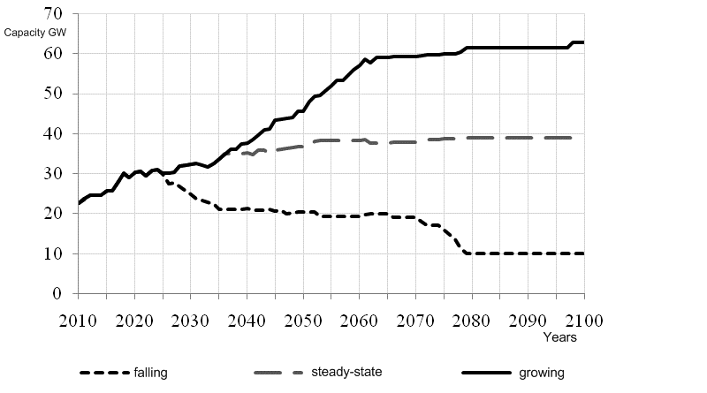
FIG.1. Variations in the installed capacity levels for the groups of scenarios under study

Each line in Figure 1 indicates the level of installed capacity reached by the NES in the specific group of scenarios, with the use of a set of related reactor technologies, fuel production, reprocessing, and storage facilities.
The following conditions were assumed to build the scenarios under this study:
- NES modeling horizon – up to 2100;
- maximum possible recycling of SNF inventories in the two-component (the base scenario) system by the year of 2100;
- the inventory of available natural uranium, which must ensure the thermal reactor fleet operation, are limited to 500 thousand tons and are not broken down in terms of the cost groups;
- plutonium from spent fuel reprocessing is stored and then consumed for the fuel supply; annual reprocessing of spent nuclear fuel is carried out according to the demand for plutonium, the balance of the separated plutonium in the system should not exceed 100 tons; thus, the excess separated plutonium is not accumulated in the system;
- the recovered uranium is not recycled;
- the structure of the reactor fleet and the ratio between the numbers of reactors of various types are selected proceeding from the requirement to achieve the installed capacities (IC) preset in the scenarios by the end of the period under consideration. In this study, the target values of NES IC are 62 GW, 39 GW and 11 GW for “growing”, “stead-state” and “falling” scenarios, respectively.

3.1. A set of key criteria for multi-criteria analysis
In the course of multi-criteria analysis (MCA), a set of key criteria was used, it is given in Table 1. It complies with the scenario elaboration requirements for nuclear energy development in Russia, providing for minimization of SNF amounts, natural uranium saving and separated plutonium storage cost reduction. At a qualitative level, the table gives uncertainties of the values of respective indicators.

Table 1. A set of key criteria

Criteria | Uncertainty
Economy | High
SNF and RAW management | Low
Natural uranium consumption | Low
Plutonium production | Low
Export potential | Moderate

At the first stage of the MCA, it was assumed that all the five criteria had the same importance. In other words, all the criteria had the same weight of 20%. The assessment of the assumption “violation” effect on the MCA results will be given in Section 3 of the paper.

3.2 Comparative multi-criteria analysis of different groups of scenarios
The multi-criteria analysis was performed for three time periods: up to the years of 2050, 2070 and 2100. For these periods, tables 2—4 indicate the SNF amounts and the amounts of natural uranium consumed and plutonium accumulated for all the groups of scenarios. The NES rating for these characteristics was produced with the use of the information given in the tables.

Table 2. The amounts of SNF, natural uranium consumed and plutonium accumulated in the system for the group of growing scenarios
Scenario | By 2050 |  |  | By 2070 |  |  | By 2100
 | ^{nat}U, t | Accumulated Pu, t | SNF amount, t | ^{nat}U, t | Accumulated Pu, t | SNF amount, t | ^{nat}U, t | Accumulated Pu, t | SNF amount, t
Ref | 211 387 | 546 | 47 413 | 384 709 | 966 | 68 545 | 636 451 | 1 451 | 99 997
Base | 188 332 | 507 | 36 331 | 296 092 | 730 | 34 603 | 394 102 | 970 | 326
Delay | 211 387 | 458 | 46 352 | 379 545 | 695 | 62 185 | 547 837 | 1 264 | 47 233
Table 3. The amounts of SNF, natural uranium consumed and plutonium accumulated in the system for the group of steady-state scenarios

Scenario | By 2050 |  |  | By 2070 |  |  | By 2100
 | ^{nat}U, t | Accumulated Pu, t | SNF amount, t | ^{nat}U, t | Accumulated Pu, t | SNF amount, t | ^{nat}U, t | Accumulated Pu, t | SNF amount, t
RefS | 195 618 | 791 | 46 300 | 310 450 | 1 355 | 61 334 | 476 396 | 1 867 | 81 853
BaseS | 181 883 | 441 | 34 369 | 264 038 | 481 | 28 668 | 327 888 | 210 | 0
DelayS | 194 507 | 679 | 45 210 | 304 232 | 1 102 | 52 423 | 410 434 | 1 790 | 14 197

Table 4. The amounts of SNF, natural uranium consumed and plutonium accumulated in the system for the group of falling scenarios

Scenario | By 2050 |  |  | By 2070 |  |  | By 2100
 | ^{nat}U, t | Accumulated Pu, t | SNF amount, t | ^{nat}U, t | Accumulated Pu, t | SNF amount, t | ^{nat}U, t | Accumulated Pu, t | SNF amount, t
RefL | 145 615 | 495 | 41 619 | 202 819 | 661 | 50 230 | 248 328 | 934 | 56 930
BaseL | 132 819 | 312 | 24 317 | 162 368 | 347 | 17 414 | 165 609 | 371 | 1 412
DelayL | 145 615 | 455 | 39 069 | 200 446 | 571 | 44 154 | 236 878 | 742 | 35 465

Hereinafter, the plutonium accumulated in the system refers to the plutonium produced by all the reactors, the plutonium contained in SNF and the one separated in the system.
Figures 2 — 4 show the results of NES rating comparison for various groups of scenarios for different time periods.
b)
a)
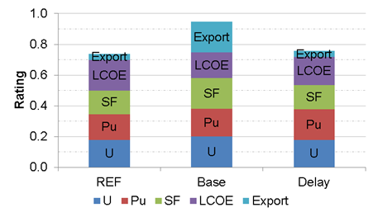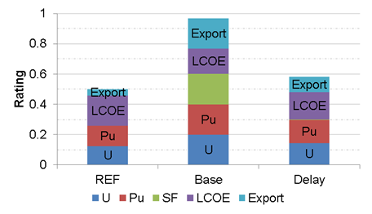

FIG. 2. a) – Alternative NES ratings for 2050, the group of growing scenarios.
b) – Alternative NES ratings for 2100, the group of growing scenarios.

b)
a)
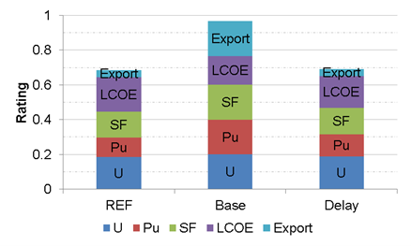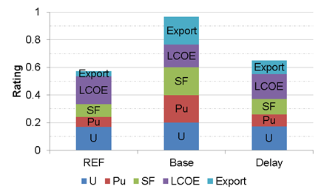

FIG. 3. a) – Alternative NES ratings for 2050, the group of steady-state scenarios.
b) – Alternative NES ratings for 2100, the group of steady-state scenarios.

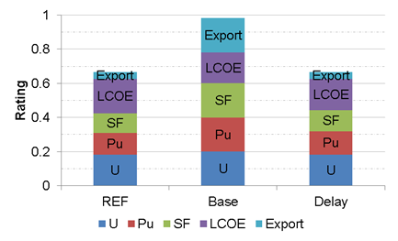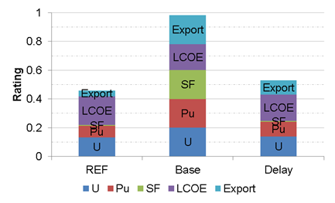
b)
a)

FIG.4. a) – Alternative NES ratings for 2050, the group of falling scenarios.
b) – Alternative NES ratings for 2100, the group of falling scenarios

The results of multi-criteria analysis for all the groups and time intervals have demonstrated a significantly higher rating for the two-component system with timely commissioning of fast reactors. The rating of the option with delayed commissioning of fast reactors is lower among the two-component NESs, but higher in comparison with the reference system.
- sensitivity of MCA results to weights and values of the criteria
Section 3.2 shows a significant advantage of the two-component system compared to the reference one given the equal importance of all the five criteria. It means all the criteria had the same weight of 20%. At the same time, Table 1 shows that the economic criterion for the system of nuclear reactors has the highest uncertainty. Therefore, the task set in the studies was to determine the effect of the weight changes of this criterion on the results of multi-criteria analysis. In the studies the weight of the economic criterion changed upwards, and the weights of the other criteria were “adjusted” to this change so that the sum of all the weights remained equal to unity.
The results show the advantage of the two-component scenario with the timely commissioning of fast reactors over the reference one until the economic criterion reaches a weight of about 0.65. It should be noted that the total weight of the other four criteria becomes equal to 0.35. At the same time, the value of the economic criterion for the two-component system “deteriorated” by 30% compared with the reference scenario. The scenario with delayed commissioning has an advantage over the reference one only at sufficiently low weights of the economic criterion. The advantage of the two-component scenario turned out to be quite stable in the group of falling scenarios.
Figure 5 shows the characteristic curves of the scenarios’ ratings in the group of growing scenarios for 2100, depending on the value of the economic criterion and its weight for two-component scenarios with the timely commissioning of fast reactors. The same graph shows the dependence of the ratings on weight for the reference scenario and the dependence of the economic criterion-sensitivity factor on weight.

Designation: 2KLC– dependences of two-component system rating with different values of the economic criterion
LCOE (1, 0.9, 0.7, 0.5, 0.3, 0.1, 1);
1KLC=1 – dependence of reference system rating with the economic criterion equalling to LCOE=1;
КЧ – dependence of the sensitivity coefficient on economic criterion weight

Fig. 5. Sensitivity of ratings to LCOE criterion changes depending on weight

From the results shown in Figure 5, it follows that with the increase in the economic criterion weight, sensitivity to the economic criterion change increases.

Conclusion
In view of a great number of facts, both objective and subjective, it is impossible to provide any definite and confident long-term predictions pertaining to the direction of the future nuclear energy development in Russia; however, it is possible to consider its potential trends.
To take account of various trends in the nuclear energy development, three groups of scenarios for the nuclear energy development in Russia were distinguished. The first group is the growing scenarios, in which the number of power units and their total capacity grow over time. The second group of scenarios assumes that after a certain period of installed capacity growth, a steady-state level will be reached, at which the value of the capacity will not vary in time. The third group of scenarios models reduction in the installed capacities of the nuclear power industry in the country after some growth. Within each group, three types of scenarios were assumed with the same capacity variation. The first is the reference one, only with thermal neutron reactors. The other two are two-component: with “timely” commissioning of fast neutron reactors (base scenario) and delayed commissioning of fast reactors.
The results of multi-criteria analysis for all the variants of the scenario groups showed the greatest potential for the two-component system. The rating of the option with delayed commissioning of fast reactors is lower among two-component NESs, but higher in comparison with the reference one-component system. That is, the inclusion of fast reactors in the nuclear energy system for all the development options considered will allow its systemic problems to be solved, including the most critical ones, such as reducing the amount of waste in the traditional nuclear power industry, saving natural resources, and other issues mentioned above.
An important stage of this study was a detailed analysis of the uncertainties of the source data used to obtain the criteria and their weights.
The study results showed the stability of two-component systems’ ratings for various groups of scenarios in case of sufficiently significant changes (deteriorations) in the values of the economic criterion and its weight.
The results of the analysis of the two-component scenario with timely commissioning of fast neutron reactors showed the highest rating in comparison with the reference scenario and the scenario with delayed commissioning of fast neutron reactors for all the groups of scenarios, including, to be stressed, the group of falling scenarios. This means that the best way to solve the accumulated problems of nuclear energy, such as reducing the amount of spent nuclear fuel, saving natural uranium, improving export potential, and reducing plutonium accumulation, is to change over to the two-component system with fast and thermal reactors. Moreover, timely commissioning of fast reactors shows the best results in all the scenario groups.

REFERENCES

- Alekseev P.N., Alekseev S.V., Andrianova E.A., et al. Two-component nuclear energy system with thermal and fast reactors in a closed nuclear fuel cycle // Edited by RAS academician N.N. Ponomarev-Stepnoi. — Moscow: Technosphera, 2016. (In Russian)
- Egorov A.F., Korobeinikov V.V.. Assessment of the sensitivity of the nuclear energy development scenarios in Russia to possible changes of selected economic parameters: IPPE preprint-3269 – Obninsk: SSC RF – IPPE, 2016. P. 17. (In Russian)
- Egorov A.F., Korobeinikov V.V.. Application of the multi-criteria analysis for the comparison of innovative nuclear energy systems // VANT. Series: Nuclear reactor constants. — 2017. — Issue 2. — p. 5—13. (In Russian)
- Alekseev P.N., Balanin A.L., Dekusar V.M., Egorov A.F., Klinov D.A., Korobeinikov V.V., Marova E.V., Maslov A.M., Nevinitsa V.A., Staroverov A.I.,. Fomichenko P.A, Shepelev S.F., Shirokov A.V. Development of the BN-1200 physical and technical design in the context of increasing the BN technology competitiveness // VANT. Series: Nuclear reactor constants. — 2018. — Issue 2. (In Russian)
- Alekseev P.N., Blandinskii V.Yu., Balanin A.L., Grol’ A.V., Gulevich A.V., Dekusar V.M., Egorov A.F., Korobeinikov V.V., Marova E.V., Maslov A.M., Moseev A.L, Nevinitsa V.A., Teplov P.S., Farakshin M.R.. Multifactor assessment of the competitiveness of the BN-type commercial power unit in the Russian energy system // VANT. Series: Nuclear reactor constants. — 2019. — Issue 3 — p. 45—61. (In Russian)
- Egorov A.F., Klinov D.A., Korobeinikov V.V., Moseev A.L., Marova E.V., SHEPELEV S.F.. The results of multi-criteria analysis of nuclear energy development in the light of the power industry structure in Russia // VANT. Series: Nuclear reactor constants. — 2017. — Issue 4. — p. 4—7. (In Russian)
- Alekseev P.N., Blandinskii V.Yu., Balanin A.L., Grol’ A.V., Nevinitsa V.A., Teplov P.S., Fomichenko P.A., Gulevich A.V., Dekusar V.M., Egorov A.F., Korobeinikov V.V., Moseev A.L., Marova E.V., Maslov A.M., Farakshin M.R., Shepelev S.F., Shirokov A.V. Effectiveness assessment of the nuclear energy development scenarios in Russia with the use of multi-criteria analysis // Atomnaya energiya. — 2020. — No. 1. — p. 3—6. (In Russian)
- Kalashnikov A.G., Moseev A.L., Dekusar V.M., Korobeinikov V.V., Moseev P.A.. Evolution of the CYCLE code for the systematic analysis of the nuclear fuel cycle // Izvestiya vuzov. Yadernaya Energetika. — 2016. —No. 1. — p. 91—99. (In Russian)

