PHENIX CONTROL ROD WITHDRAWAL TEST ANALYSIS USING A MULTIPHYSICS METHODOLOGY

B. FORNO, V. PASCAL, M. JEANNIN, T. KOOYMAN
CEA, DES, IRESNE, DER, Cadarache, F-13108 Saint-Paul-lez-Durance, France
Email: barbara.forno@cea.fr

Abstract

Before the definitive shutdown of the Phénix reactor, a series of end of life tests were performed in 2009 and 2010, by CEA (Commissariat à l’Energie Atomique et aux Energies Alternatives), EDF (Électricité de France) and AREVA. The main objectives were to enlarge experimental database for the research and design of Sodium cooled Fast Reactors (SFR). Due to this important opportunity, the IAEA (International Atomic Energy Agency) decided to establish a Coordinate Research Project from 2007 to 2011 to stimulate computational codes validation among different countries involved in fast reactors development. In this context, a benchmark was established on the “static Control Rod Withdrawal Test” (CRW) with the objective of the investigation on the flux and power local deformations related to different control rod insertions in the core. Such valuable experimental data are useful to improve calculation schemes used to analyze control rod withdrawal transient, which could potentially trigger a core melting accident in a SFR. The objective of the current study was to perform multi-physics simulation based on a loosely coupled approach to take into account local Doppler feedback effect on power deformations. The probabilistic particle transport code Serpent 2 (VTT Technical Research Centre of Finland, Ltd), associated with the JEFF-3.1 nuclear library, was chosen as reference neutron calculation code and was coupled to an in-house static thermal-hydraulic solver. Firstly, purely neutron transport calculations were done in order to build-up and check the overall core model. The uncoupled results were compared to benchmark results already published and show a correct accordance with experimental and calculated results providing that a heterogeneous description of control rods was used. A convergence study to estimate the required precision level of neutron calculations with respect to multiplication factors and power estimations was also performed. Secondly, coupling between neutron and thermal-hydraulics solvers were done through the Serpent 2 multi-physics interface with a regular exchange of the main coupled parameters such as fuel temperatures and neutron deposited powers for each axial node of each subassemblies of the fissile core. The coupled results on the power deviation are globally slightly nearer to the experimental ones than uncoupled results but are affected by probabilistic uncertainties and batch-to-batch inter correlation problems responsible for light power oscillations with respect to the number of simulated neutrons instead of a straight convergence.

INTRODUCTION
The international research and development effort on Sodium cooled Fast Reactors is currently concentrated on improving safety features, implementing innovative possibilities and optimizing operation in terms of economic criteria [1]. In 2009 - 2010 several tests were performed before the definitive shut down of the Phénix sodium cooled fast reactor in order to enlarge knowledge on SFR. Thanks to the large data base provided by these tests, in 2007, IAEA (International Atomic Energy Agency) decided to set up an international Coordinate Research Project in order to enhance computational codes validation among different countries involved in fast reactors development. A specific benchmark was dedicated to the investigation of the “static Control Rod Withdrawal Test” [2]. These set of experiments had the objective to investigate on flux and power local deformations due to different control rod configurations. This experimental program was related to the study of inadvertent control rod withdrawals which can be a possible initiating event of core meltdown.
The participants to the Coordinate Research Project developed models with different neutronics computational tools. The results on the power deformation in the various test configurations allowed a comparison between each model and the experimental results [3, 4]. The benchmark conclusions proposed various experimental and numerical causes of the observed discrepancies between measured and calculated power deviations. One of the proposed explanation concerns the reactivity feedback effects due to the local temperature variations inside subassemblies located near shifted control rods which were not taken into account. The objective of the present work is to analyse the impact of local Doppler effects on power deviations. The Doppler effect is considered as a first step before taking into account other feedback effects (as sodium density feedback and fuel expansion feedback, …), as it is the main neutron feedback effect which opposes to any reactivity insertion.

PHénix reactor and test set up
Phénix is a pool-type sodium cooled fast reactor. It went into commercial operation in 1974 and was shut down in 2010. Between 1974 and 2003 the reactor worked at 563 MW(th) and 250 MW(e); while, after a period of safety upgrade and renovation of the reactor, in 2003 it was turned on again with the power reduced to 2/3 of the previous one [5].
Phénix core is composed by hexagonal subassemblies (S/As). Among them, 217 assemblies are designed for fuel, mix of uranium and plutonium oxide, with different enrichments in different zones of the core. The subassemblies are loaded in the core lattice following a particular loading map as represented in Fig. 1. In the center, a fissile zone is present (yellow and orange in the figure), which is surrounded by a fertile zone (white), while in the external part of the core a reflector material (red) is present together with neutron shields (grey). Six control rods (blue), for normal operation, and one safety shut down rod (purple) are also present.

The CRW (Control Rod Withdrawal) test was performed with the reactor at a power of 335.4 MW(th). The objective was the investigation of power redistribution and local power deformation due to control rods different insertion positions. During the test, three distinct configurations were explored with different control rods position. The global power was kept constant during the whole experiment. The objective was to measure the local power deviation in the core with respect to the state corresponding to the six control rods on rod bank, which corresponds to the normal operation state. During the first step of the experiment, the control rod number 4 was inserted while all the others were extracted on rod bank. During the second configuration the control rod 4 was inserted while the control rod number 1 was kept extracted and the others rod on rod bank. In the last configuration, only the control rod number 4 was extracted. The overview of the test is shown in Fig. 2.
During the whole test, the total power produced by fission was maintained constant, so as the total sodium flowrate (primary pump speeds were not modified). The temperature at the core inlet was measured using thermocouples located in the three primary pumps, while subassembly outlet temperatures were measured using thermocouples located above each subassemblies (~10 cm above). Sodium density variations were considered to be negligible on individual subassembly flowrates, which were assumed constant during the test. Individual power in each subassembly was then computed considering the following energy conservation equation in steady-state conditions:
$$P_{i}={\dot{m}}_{i} {c_{p}}_{Na}\left(T_{out_{i}}-T_{in}\right),$$ | (1)
where: $P_{i}$ is the total power in each subassembly [W]; ${\dot{m}}_{i}$is the sodium mass flow rate in each S/A [kg/s]; ${c_{p}}_{Na}$is the specific heat capacity of sodium [J/kg/K]; $T_{out_{i}} and T_{in}$are respectively the outlet sodium temperature of each subassembly and inlet sodium temperature in the core [K].

The additional assumptions were the negligibility of heat transfer between subassemblies and the negligible impact on specific heat capacity of sodium temperature variations. With these considerations it can be deducted that the power local deviation was obtained just from the deviation of the difference between inlet and outlet sodium temperature. We can write the following balance equation:

$$δ_{rel}P_{i}=\frac{{\dot{m}}_{i}c_{pi} (∆T_{i}-∆T_{i}^{initial})}{{\dot{m}}_{i}c_{pi} ∆T_{i}^{initial}}\sim \frac{(∆T_{i}-∆T_{i}^{initial})}{∆T_{i}^{initial}},$$ | (2)

where: $δ_{rel}P_{i}$ is the relative power deviation of the subassembly i, between the considered configuration of the test and the reference state [-]; $∆T_{i}^{initial}$ is the temperature difference between outlet and inlet of the subassembly i, in the reference state of the test [°C]; $∆T_{i}$ is the temperature difference between outlet and inlet of the subassembly i, in the considered configuration of the test [°C].
The power deviation of each phase of the test could be obtained measuring only the outlet sodium temperature, through thermocouples. Uncertainties on power deviations can easily be inferred from the equation (2) knowing uncertainties on measured sodium temperature variations.
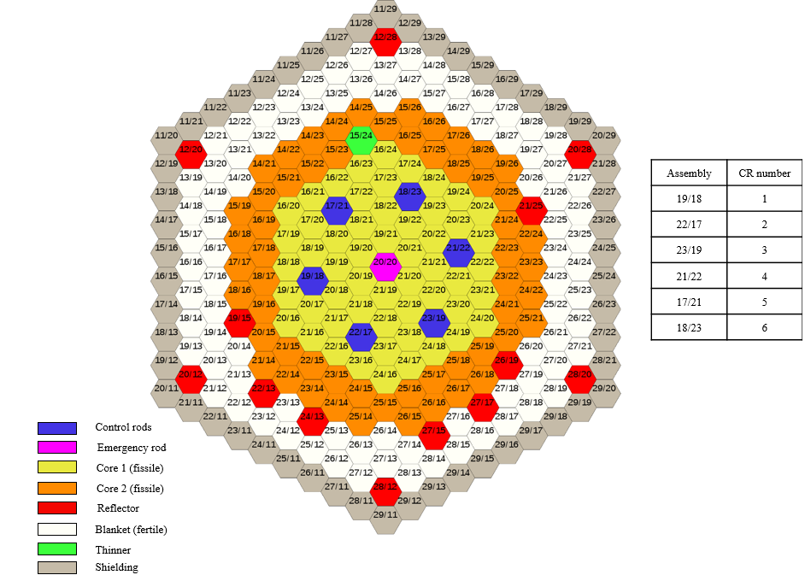
FIG. 1. Phénix core loading map.

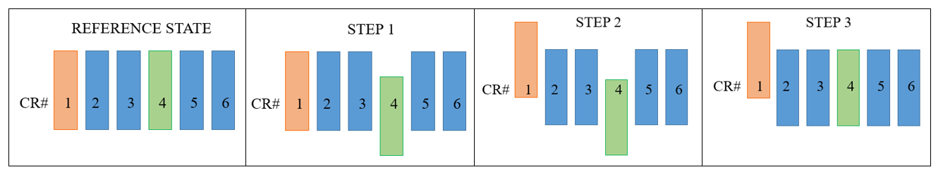
FIG. 2. Overview of the control rod withdrawal test phases.

proposed coupled model
To take into account Doppler effect on the fissile material, a coupled model is proposed. The Doppler Effect is considered as a first step before taking into account other feedback effect (sodium density feedback, fuel expansion feedback …), as it is the main neutron feedback effect which opposes to any reactivity insertion. A neutronic flux solver and a steady-state thermal-hydraulic solver are coupled together using a specific iteration process between the two, to insure convergence. In particular the neutronic model proposed uses Serpent 2, a Monte Carlo neutron transport code elaborated at VTT Technical Research Centre of Finland [7, 8]. JEFF-3.1.1 was used as nuclear data library to obtain punctual cross sections values [10]. In the coupling process the on-the-fly Doppler broadening procedure has been used, available in the multi-physics Serpent procedure. The photon transport was not included in these calculations and we made the assumption that photon energy is locally deposed. This assumption has a weak impact on core assembly powers but could have a more pronounced impact for blanket assemblies (this has not been assessed).
On the other hand, the thermal-hydraulic model is a Python [9] self-developed script considering the heat exchange between the sodium and the fuel inside the core in a steady state condition.
The coupling is represented in Fig. 3. In particular, the data exchanged are the power produced from fission, and the fuel and sodium temperature in each subassembly at each axial node of the core. The fission power is the output of the neutronic calculations and it is used as input in the thermal-hydraulic solver. Vice-versa, from the thermal-hydraulic side, the fuel and sodium temperature is recomputed at each iteration and updated in the neutronic model. As first approach, the coupling process takes into account only the Doppler Effect on the fissile material as thermal feedbacks.

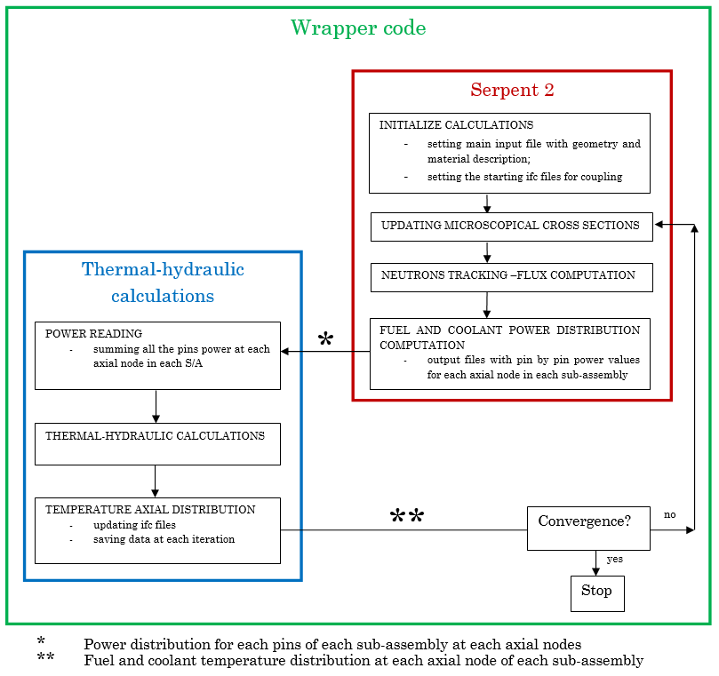
FIG. 3. Coupling scheme of the proposed model.

NEUtronic and thermal-hydraulic model description

As first calculation, a comparison between a homogeneous and a heterogeneous model of the core was made. Heterogeneous description is a realistic description of control rods and fissile subassemblies while homogeneous description accounts for a simple homogeneous media representative in terms of material proportions. The control rods worths, obtained through the Serpent simulation, show that the heterogeneous description represents better the experimental situation, as shown in table 1.

TABLE 1. COMPUTED CONTROL ROD WORTHS IN HOMOGENEOUS AND HETEROGENEOUS MODEL

Control rod number | Computed worth [$] | Experimental result [$] | Discrepancy from experimental results
CR 1 (homogeneous) | 4.48 ± 0.03 | 3.9 | 15%
CR 1 (heterogeneous) | 4.12 ± 0.03 | 3.9 | 6%
CR 4 (homogeneous) | 4.28 ± 0.03 | 3.8 | 12%
CR 4 (heterogeneous) | 3.92 ± 0.03 | 3.8 | 3%

This is mainly due to control rod heterogeneous description. Indeed in a control rod there are strong spatial and energetic flux variations, so a precise model has to be used to correctly take into account these phenomena. This effect has already been observed on CRP benchmark results and a conclusion of the CRP report was the necessity to use a heterogeneous description of control rod [6, 11]. Therefore, for the rest of the work, Phénix core is modelled with a heterogeneous description of fissile, fertile and control rods subassemblies. This best effort core model is presented in Fig. 4.

The thermal-hydraulic model was developed with Python. The heat exchange at each axial node between the fuel and the coolant was modelled. As input data for the thermal-hydraulic calculations the following parameters have been used: the core inlet sodium temperature in each sub-channel, the S/As flow rate that is considered fixed, both set from the benchmark data, and the fission power produced at each axial node of each channel, obtained as neutronic output. The thermal equations taken into account consider [12, 13]:

- the conduction process inside the fuel pellet (in steady state for angular symmetry and infinite cylinder on z axis):
$$\frac{1}{r}\frac{d}{dr}\left(rk\frac{dT}{dr}\right)+Q=0,$$ | (3)
where r is the fuel pellet radial coordinate [m]; T is the fuel temperature [K]; k is the fuel thermal conductivity [W/m/K] and Q is the heat source [W/m³].
In this work, a constant thermal conductivity of 2 W/m/K has been considered, to approach a simplified model. Some specific correlations could be used to improve the model like the Philipponneau correlations adapted for MOX fuels for FR [14];

- convection inside the gap (considering the thermal resistance of a closed fuel gap as in the end of life):
$$q^{'}=h_{gap} 2πR_{f}\left(T_{s}-T_{ci}\right),$$ | (4)
in the expression $h_{gap}$is the gap conductance [W/m²/K]; $R_{f}$is the fuel pin radius [m]; $T_{s}$ is the external fuel pin temperature [K]; $T_{ci}$ is the cladding temperature corresponding to the inner cladding radius [K].
A constant thermal conductance of 5000 W/m²/K was taken, representative of a closed gap [15]. No benchmark values were proposed for this gap conductance, so it was made the assumption of a constant value. In order to evaluate more precisely this parameter (which depends on fuel burn-up and fuel temperature), fuel performance calculations could be done for each fuel pins of the core, taking into account their individual power history. For example, the GERMINAL V2.2 CEA fuel performance code could be used for that purpose [16]. However the goal of the present study was to determine if local Doppler effect due to fuel temperature variations could improve calculated results. As power deviations during the test are slight (<less than 15%), gap conductance variations can be neglected;

- conduction inside the cladding (in steady state condition for linear heat flux):
$$q^{''}=-k dT/dr,$$ | (5)
where $k$ is the cladding thermal conductivity [W/m/K]; $T$ and $r$ are respectively the cladding temperature and radial coordinate [K] and [m].
The cladding thermal conductivity has been assumed constant with the value of 26 W/m/K, representative of the steel used in fast reactor cladding;

- convection between cladding and sodium (in steady state condition, for 1D-vertically sodium heat transfer, incompressible fluid, neglecting gravitational contribution and irradiation heat transfer mechanism):
$$h\left(T_{co}-T_{b}\right)2πR_{co} Δz=\dot{m} c_{p} \left(T_{out}-T_{in}\right),$$ | (6)
where $h$ is the heat transfer coefficient [W/m²/K]; $T_{co}$is the cladding temperature corresponding to the outer radius [K]; $T_{b}$is the coolant bulk temperature [K]; z is the axial coordinate [m]; $ṁ$ is the coolant mass flow rate [kg/s]; $c_{p }$is the sodium specific heat [W/kg/K]; $T_{out}$ is the control volume sodium outlet temperature [K] and $T_{in}$ is the control volume sodium inlet temperature [K]. As the sodium channel has been divided into equally spaced axial nodes, the control volumes refers to the mesh volumes.

Heat transfer between sodium and cladding has been extensively tested and various correlations have been derived. In this work the Seban and Shimazaki correlation for the sodium convection inside a channel was used to determine the Nusselt number [17]:
$$Nu=5+0.025 Pe^{0.8},$$ | (7)
where Pe is the dimensionless Peclet number.
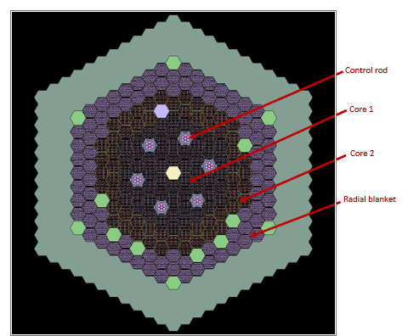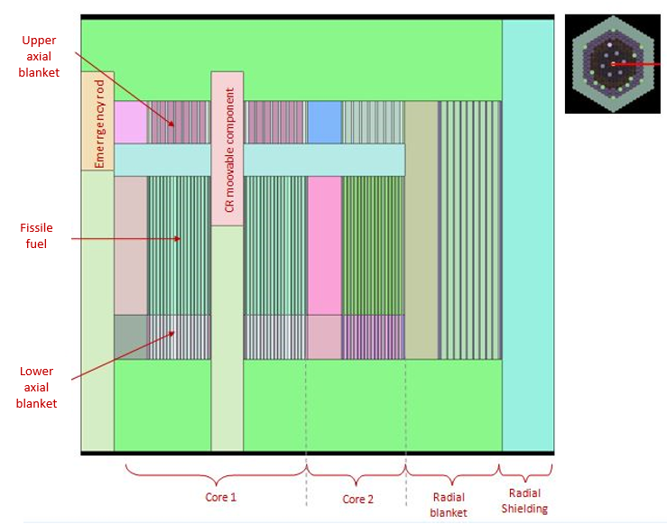

FIG. 4. Radial cross section (on the left) and axial cross section (on the right) of the adopted heterogeneous model.

results

5.1 Neutronic results
First of all, pure neutron calculations were performed without thermal-hydraulic coupling, in order to check the accuracy of the neutron model of the core.
A convergence study on multiplication factor was made in order to optimize simulation parameters. The convergence target on multiplication factor was 3 pcm. The Fig. 5 shows this convergence study for two different cases (5000 and 20000 neutrons by active cycle). As expected, the core reactivity value converges and the uncertainty decreases for increasing simulation parameters. Note that core reactivity of the reference state converge toward -2370 pcm and not zero. This is explained by the averaged model used in terms of isotopic concentrations of fuel assemblies. Indeed, each subassembly was not described individually in terms of isotopic concentrations. The report [4] shows that this assumption does not have great influences on control rod worths or power deviations (but it impacts notably multiplication factors or subassembly powers).
The simulations that are proposed in the next paragraphs, were launched with the following parameters: 20 000 neutrons by active cycle and 90 000 active cycles. These parameters have been considered sufficient for Phénix core that has a volume of barely 1 m³ and for the objective of investigating the coupling mechanism and not only the neutronic aspects.

Then, the power deviation in the core was computed during the different phases of the test. The Fig. 6 illustrates the computed and measured power deviations of step 2 with respect to reference state. The chosen S/As belongs to the diagonal represented on the right side of the image.
It can be noticed that the power deviation is overestimated (in its absolute value) in both the left and right sides of the graph. Note that this overestimation remains included inside experimental uncertainties. These observed phenomena are coherent with the main conclusions of the IAEA CRP benchmark [2]. Proposed explanations in [2] and [4] can be summarized as follows:
- bias bounded to the measurement of the sodium temperatures at the outlet of the subassembly. This aspect is connected to the thermal-hydraulic phenomenon of sodium flowing nearby the thermocouples (sodium mixing, heat transfer between S/As, thermocouple uncertainties);
- bias bounded to the measure of control rod position in the core;
- bias bounded to the calculation model (reactivity feedback effects, nuclear data, S/A isotopic concentrations especially blanket S/As).
Furthermore, in the last subassembly, belonging to the radial blanket, an unexpected power deviation value is observed and this value could require further investigations on the model.

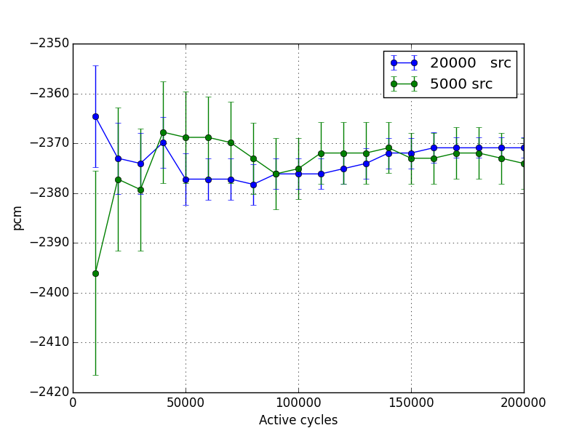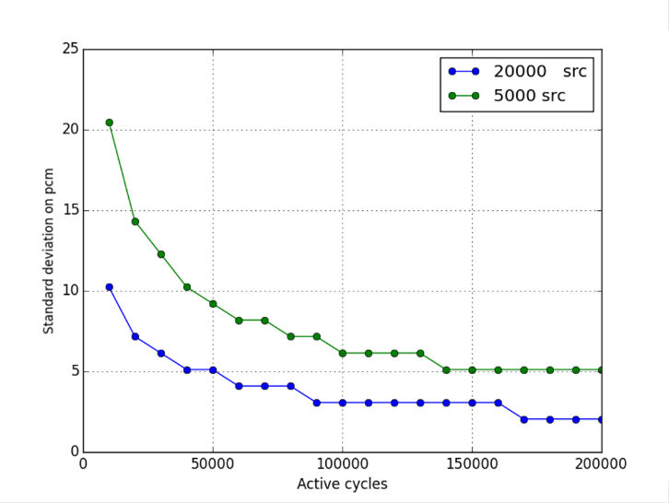
FIG. 5. Reactivity convergence study (on the left) and its related standard deviation (on the right).
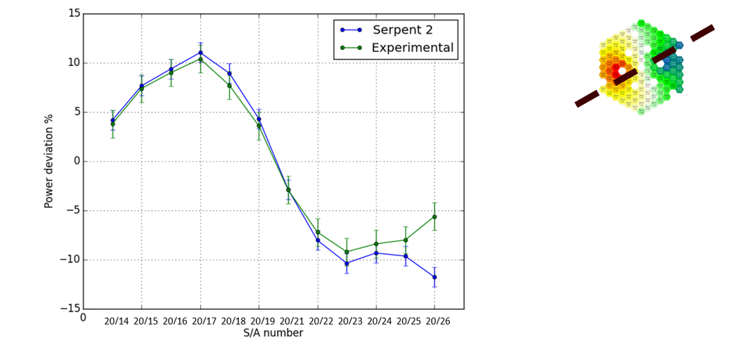
FIG.6. Power deviation of the step 2 of the test with respect to reference state.

5.2 Thermal-hydraulic results
The Fig. 7 shows the nominal temperature axial profiles for two subassemblies (20/21 and 19/26), belonging respectively to core 1 and core 2. The total power of the reference state is equal to 334 MW(th) and the individual power of the two subassemblies are respectively 3.64 MW and 1.95 MW. The temperature is displayed for each internal component of the fuel pin (sodium, cladding, gap and fuel).
The fuel temperature axial shape is in accordance with the neutron flux axial shape in the core. The maximum fuel temperature in the center of the core 1 zone reaches about 2017 K, while the temperature of 1800 K is reached in the core 2, the order of magnitude are in accordance with [18] and [19]. The temperature difference between sodium outlet and inlet channel in reference state is of the same order of the experimental one [2].
The blue line in the results represents the effective temperature (Rowland formulation), which is the temperature chosen to be used for the coupling process and Doppler feedback evaluations [20].
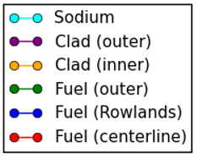
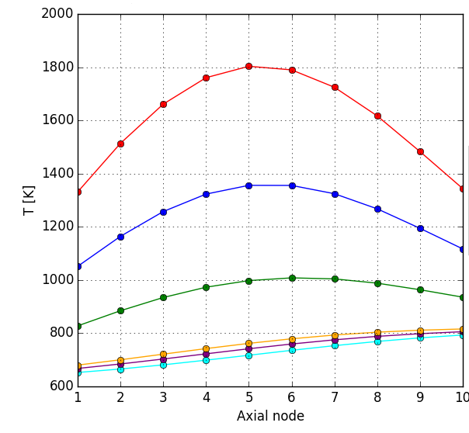
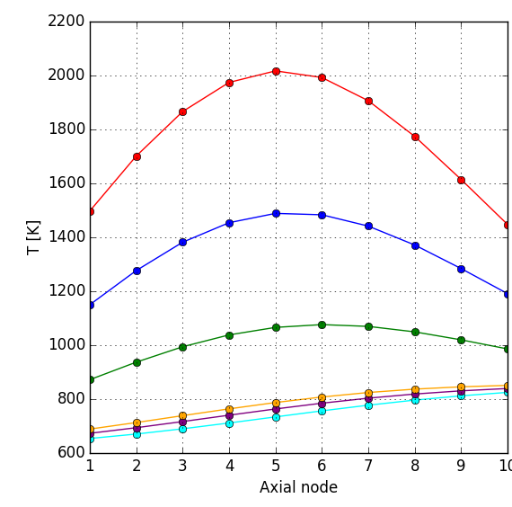
FIG.7. Axial temperature distribution in S/A 20/21, core 1 (on the left) and S/A 19/26, core 2 (on the right).

5.3 Coupled results
The coupled simulation is launched for several numbers of iterations to see the effect on some parameters such as the neutron multiplication factor and the power distribution in the S/A 20/23 (near the control rod n. 4), see Fig. 8. During this coupling, the reactor is considered to be at the reference state with a total power of 334 MW(th). The Serpent 2 parameters were set to 5000 neutrons by cycle and 10 000 active cycles. It is less than the parameters used for pure neutron calculations in order to limit the calculation time (5 days for 16 coupled iteration on a personal scientific computer). Convergence process will be affected as we can see in Fig. 8. However note that the external convergence process between neutronic and thermal-hydraulic calculations partly compensates the decrease in Serpent 2 convergence parameters. Both multiplication factor and power results converge globally but it is observable an oscillatory behavior larger than standard deviation.
From these results it can be noticed that the two parameters, after the first iteration, set up on a small range of values. Oscillations are presents, they reside in the range of 26 pcm for the reactivity parameter, while the power fluctuations are of the order of 0.29% of assembly power. Further investigation could be done in order to understand if this oscillation phenomenon is bounded to neutron clustering effects which can affect flux estimations by Monte Carlo methods (the effect is somehow related to the higher order harmonics of the flux) [21]. No uncertainty propagation has been done in order to assess the impact of power fluctuations due to statistical model on power deviation results and coupling results. The 0.29 % statistical uncertainties on power will for example be transferred on temperature increase inside pellets and then on the pellet mean temperature for Doppler evaluation. The impact is considered to be weak. A simple estimation of combined uncertainties on power deviations have been estimated by assuming the independence of power statistical fluctuations between both power calculations.

At the end, the configuration 2 power deviation from the reference state is represented in Fig. 9. In this calculation the neutronic parameters were set accordingly to the convergence study to 20 000 source neutrons and 90 000 active cycles but with only two external iterations between neutronic and thermal-hydraulic.
A modification of the results is present after the coupling process. Anyway, it has to be taken into account that all these values are affected by Monte Carlo uncertainties, represented in Fig. 9 by the uncertainty bar.

In a future perspective of the work the simulations could be run with the objective of reducing as much as possible the related uncertainties, thus meaning requiring a higher computational effort (the time required for two coupled iteration with the set parameters explained before is of about 7 days on a personal scientific computer). In addition, only the fissile S/As were coupled with the neutronic model, thus bringing to neglect the Doppler effect on the fertile material. Moreover, in the thermal-hydraulic model, the heat transfer coefficients were all defined as constant and the temperature dependence was not considered. All these aspect are considered as future perspectives.
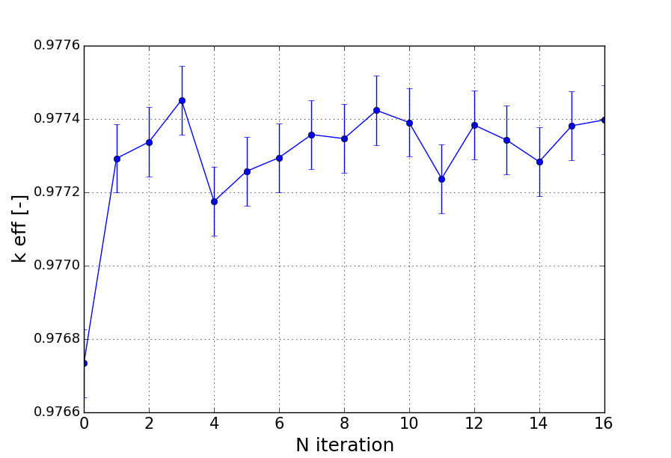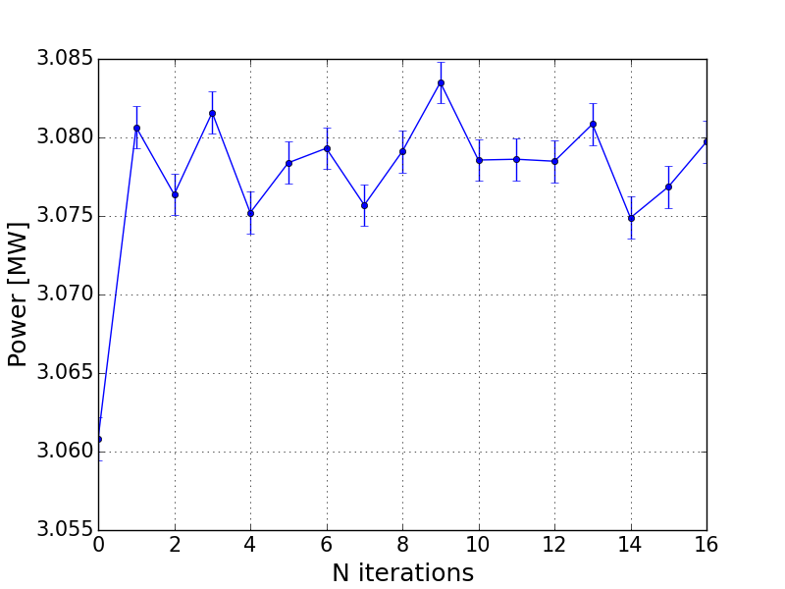
FIG. 8. Convergence study for coupled iteration on core multiplication factor (on the left) and power (on the right) of S/A 20/23.
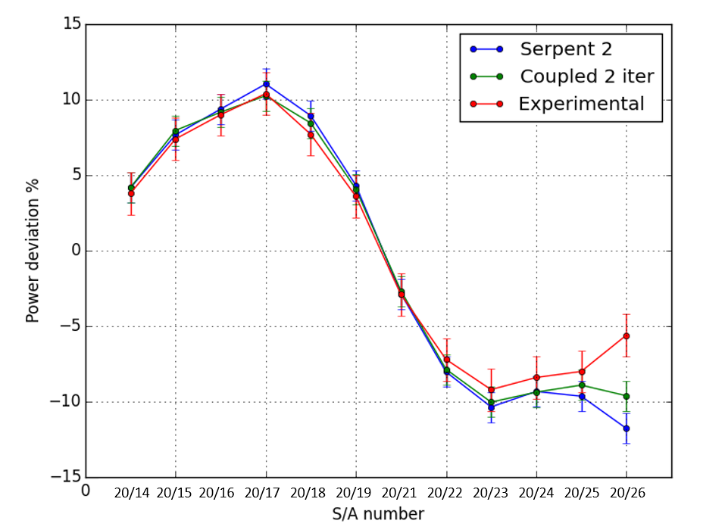
FIG. 9. Power deviations with respect to reference state after coupling process (2 iterations) [%] – step 2 of the test.

6. conclusions
Before the definitive shutdown of Phénix reactor a series of tests were performed to enlarge SFR research database and to validate the main existing fast reactor codes. In particular the Control Rod Withdrawal test was focused on the exploration of the power local deformation due to control rod shift.
In the present work a multi-physics approach is proposed, coupling neutronic model with thermal-hydraulic calculations. The main objective is to explore the contribution of the reactivity Doppler effect feedback on the results of the test simulations, with respect to the pure neutronic calculations.
The neutronic model has been developed using the Monte Carlo code Serpent 2 and coupled to a self-developed thermal-hydraulic model through a wrapper code that allows the iteration between the two.
Firstly, pure neutronic power deviation maps, of the second step of the test with respect to the reference state, were computed. The comparisons with measured values are coherent, except for an unbalance in blanket subassemblies and a weak overestimation of calculated power deviation in fissile, as already stated in in the CRP results [2]. Feedback effects, which were not taken into account, and the neglecting of the gamma transport in blanket assemblies could explain the observed deviations.
To investigate the effect of local feedback effects, a stationary thermal-hydraulic solver was developed and coupled with Serpent 2 thanks to its multi-physics programming interface. Thermal-hydraulic calculations have been carried out to compute fuel and coolant temperature axial distribution in the core by subassemblies and to validate the in-house solver. The multi-physics coupling algorithm produces a convergence of the reactivity and power parameters in the core. The convergence is weakly affected by oscillatory phenomena which are linked to neutron clustering effect. This problem requires more in-depth investigations, but is considered as negligible in the context of the current study.
Finally the power deviation of the second step of the test with respect to the reference state was calculated with the coupled approach. Results obtained are slightly closer to the experimental ones than pure neutronic calculations even if the low statistical uncertainties do not allow to conclude with a large confidence. In the end Doppler feedback effect cannot fully explain observed deviations (of about 0.5% of the power deviation) between measured and calculated parameters and other reasons have to be studied (like neutron feedbacks related to core and materials thermal expansion, technological uncertainties on control rod expansion, gamma transport, tridimensional thermal-hydraulics phenomena which can influence the temperature measurements (sodium mixing)).
It has however to be noted that the global bias is finally low which shows good abilities of the presented calculation schemes (neutron scheme/coupled scheme) to estimate power deviation during the test.

References
- GIF, GIF Annual Report 2019, 2019.
- INTERNATIONAL ATOMIC ENERGY AGENCY, Benchmark analyses on the control rod withdrawal tests performed during the PHÉNIX end-of-life experiments, IAEA-TECDOC-1742, IAEA, Vienna (2014).
- V. PASCAL et al., Benchmark calculations on Control Rod Withdrawal tests performed during Phénix End-Of-Life experiments, ICAPP ’13, Korea, (2013).
- V.PASCAL et al., Interpretation of the Control Rod Withdrawal test in the sodium cooled fast reactor Phénix, Nuclear Science And Engineering (2012) 109-123.
- J.-F. SAUVAGE, Phénix, 30 years of hystory: the heart of a reactor, Valrho: Ellipse, CEA (2004).
- V. PASCAL et al., CEA contribution to the analysis of the control rod withdrawal test performed during Phénix end-of-life experiments (IAEA Common Research Program), PHYSOR 2014 – The Role of Reactor Physics Toward a Sustainable Future, Kyoto (2014).
- J. LEPPANEN et al., Serpent - a Continuous-energy Monte Carlo Reactor physics Burnup Calculation Code (2019), http://montecarlo.vtt.fi/.
- J. LEPPANEN, Serpent - a Continuous-energy Monte Carlo Reactor Physics Burnup Calculation Code, Users manual, VTT Technical research Centre of Finland (2015).
- PYTHON SOFTWARE FOUNDATION, Welcome to Python.org (2013), https://www.python.org/.
- A. SANTAMARINA et al., The JEFF-3.1.1 Nuclear Data Library. Validation Results from JEF-2.2 to JEFF-3.1.1, Nuclear Energy Agency (2009).
- V. PASCAL et al., Main results on Phénix final core physics tests, ICAPP ’12, USA, (2012).
- B.R. MUNSON et al., Fundamentals of Fluid Mechanics, 7th edition, Wiley, (2013).
- F.P. INCROPERA, Fundamentals of Heat and Mass Transfer, 7th edition, Wiley (2011).
- Y. PHILIPPONNEAU, Thermal conductivity of (U,Pu) O2-x mixed oxide fuel, Journal of Nuclear Materials (1992) 194-197.
- A. LAZARO ET AL., Code assessment and modelling for design basis accident analysis of the European sodium fast reactor design. Part I: System description, modelling and benchmarking, Nuclear Engineering and Design, (2014) 1-16.
- M. LAINET et al., GERMINAL, a fuel performance code of the PLEIADES platform to simulate the in-pile behavior of mixed oxide fuel pins for sodium-cooled fast reactors, Journal of Nuclear Materials (2019) 30-53.
- R. A. Seban , T. T. Shimazaki, Heat Transfer to a Fluid Flowing Turbulently in a Smooth Pipe with Walls at Constant Temperature, Trans. ASME, 73, 803 (1951).
- K. Herbreteau, Développement d’un outil physique orienté conception pour la simulation des excursions de puissance non protégée dans un RNR-Na, Université Grenoble Alpes, (2018).
- F. Acosta, Development of a thermal-hydraulics/thermomechanics coupling model for the evaluation of the behavior of SFR fuel assemblies under irradiation, Université Grenoble Alpes, (2019).
- A. CASENAVE, Etude d’un schéma de calcul pour la détermination des sections efficaces d’un Coeur de REP, Ecole Polytechnique de Montréal, Montréal (2012).
- G. BELL, S. GLASSTONE , Nuclear Reactor Theory, Van Nostrand Reinhold Company, New York (1970).

