Validation of SARAX Code for the Transient Analysis of Sodium-cooled Fast Reactor

Jia Xiaoqian¹, Zheng Youqi^{1,*}, Du Xianan¹

¹School of Nuclear Science and Technology, Xi’an Jiaotong University, Xi’an, Shaanxi Province, China

Email contact of corresponding author: yqzheng@mail.xjtu.edu.cn

Abstract

The paper describes the validation work of SARAX code for the transient analysis of sodium-cooled fast reactors (SFR). The Experimental Breeder Reactor II (EBR-II) benchmark released by ANL were modeled and calculated. The reference EBR-II benchmark includes neutronics calculation of the core and SHRT-45R transient (Shutdown Heat Removal Test). The SARAX code is a neutronics analysis package developed by the NECP team at Xi’an Jiaotong University and aiming for the advanced reactor research and development. It consists in a cross-section generation code named TULIP, a steady state neutronics calculation code named LAVENDER and a transient analysis code named DAISY. The simulation of EBR-II SHRT-45R transient showed that SARAX gave comparable results with the reference results, which verified the complete code system for transient calculations of SFR.

INTRODUCTION
Fast reactors have a long history, from the world's first fast reactor in 1946, years of operating experience have been accumulated so far. China Experimental Fast Reactor (CEFR) began in May 2000 at the China Institute of Atomic Energy (CIAE). It reached critical for the first time in July 2010 and combined to the grid in July 2011. During this process, relevant experience in fast reactor construction, experiment and operation has been accumulated. However, the development of Chinese own transient analysis code is still a key task in the design and construction of sodium-cooled fast reactor. In order to accurately simulate the core behaviour in the transient process of sodium cooled fast reactor, the NECP lab. of Xi’an Jiaotong University has developed the SARAX code [1], which is capable of performing calculations required for a fast core design. SARAX code includes a cross section generation code TULIP, a steady state core analysis code LAVENDER and a transient analysis code DAISY.
The cross-section generation program TULIP [2] and the steady state core analysis program LAVENDER [3] have been fully verified and validated. However, for transient analysis process, the steady-state calculation will also have an impact on the final results. This paper will still present the detailed calculation results of TULIP and LAVENDER for the integrity of the results, but will focus on the results of the transient analysis program DAISY. DAISY is developed based on point-kinetics method and integrated thermal-hydraulic feedback model of sodium, lead and LBE [4]. In the previous version of SARAX, the point-kinetics method with a single-channel thermal-hydraulic model was adopted. This coupled method would give the change of average temperature in the core during transient process. Together with lumped reactivity feedback coefficients, several kinds of reactivity feedback could be calculated and then substituted into the point-kinetics equation, including fuel Doppler feedback, coolant density feedback, axial expansion feedback and radial expansion feedback. This method could give approximate changes of power and temperature with a fast speed. But in realistic transient process, each location in the core will have different temperature changes and different deformation amount. It is impractical to use the average temperature and the lumped feedback coefficients to calculate the reactivity feedback. Recently, a spatial-dependent reactivity feedback model was developed in SARAX for reactor transient analysis[5]. In the spatial-dependent model, the results of the detailed reactivity feedback distribution including fuel Doppler feedback, coolant density feedback, axial expansion feedback, grid expansion feedback, and control rod driveline expansion feedback can be modeled. With the spatial-dependent reactivity feedback model developed in recent years , it can more accurately simulate the dilatation and deformation of the core during the transient process.
Since the NECP lab. did not participate in the benchmark analysis work of EBR-II shutdown heat removal test organized by the IAEA, the results presented in this paper can be compared with the results of several participant institutes in the IAEA report. Since EBR-II SHRT-45R test began after a burnup period of Run 138B, the nuclide density is quite different in every fuel assembly and not clear in reference. Then in this paper, the nuclide density of fuel material used in the steady state calculation will be an average nuclide density. It should be noted that the DAISY program currently does not have the function of system analysis, so the changes of inlet core flow rate involved in the transient will use a fitting curve as input instead of the system analysis process. This fitting curve comes from the measured results in the IAEA report [6].
In the process of simulation, TULIP will generate the 33-group cross sections of all materials, of which the fuel material will be modeled using a heterogeneous one-dimensional cylinder geometry and others will be modeled using homogeneous geometry. LAVENDER will give the results of steady state parameters like power distribution, critical control rod position, reactivity coefficients and kinetics parameters. Then, DAISY will simulate the transient progress with a space-dependent point-kinetics model and a parallel multi-channel thermal-hydraulics model. It will also give the results of peaking fuel temperature, cladding temperature, coolant temperature and reactivity feedback variation during the transient.

EBR-II reactor benchmark core and SHRT-45R
Shutdown heat removal tests were conducted on EBR-II by ANL in 1980s, and the experimental data was released in 2012 [6]. The benchmark includes SHRT-17 and SHRT-45R. The former demonstrated the effectiveness of natural circulation in EBR-II [7] and it can be used to confirm the correctness of thermal hydraulic system modeling. The latter, SHRT-45R, was very similar to SHRT-17 but more like a severe unprotected loss-of-flow transient. SHRT-45R test demonstrated the effectiveness of passive feedback in EBR-II and had very complicated reactivity feedback during the process. So this paper chooses the SHRT-45R test to do the validation work of DAISY.
The reference core is the EBR-II Run 138B core and accommodated 637 hexagonal assemblies. There were two types of driver assemblies, MK-II AI and MK-II A, which were processed by different manufacturer and had different fuel element length. Besides, there was another kind of driver assemblies named Half-worth Driver, having the same characteristics with MK-II AI. But half of fuel elements in Half-worth Driver were replaced by dummy elements. U-5 wt% Fs was chosen as fuel to be loaded in the core.
In EBR-II, three types of movable control rods assemblies were used to control reactivity and ensure safety. In addition to control rods assembly and safety rods assembly with fuel segment, high-worth control rods assembly was also designed. High-worth control rods were comprised of a fuel segment and a poison segment while other control rods were only comprised of a fuel segment. Different from the traditional control rods design, the insertion of all the control rods means the fuel segment was placed in the core. As for High-worth control rods, when it was retracted the poison segment was within the core. This design could maximize the reactivity swing.
Many types of experimental assemblies were also loaded in the core, such as XY-16, X302C, X402A, X412 and C2776A. Instrumented assemblies in the core, XX09 and XX10, were similar to a control rods assembly, but was not movable. Out of active core region, there were three rows of reflector assemblies. At the outermost part of the core, blanket assemblies loaded with depleted Uranium.
Considering that some experimental assemblies can be modeled as fuel assembly or dummy assembly, 29 MK-II AI driver assemblies, 44 MK-II A driver assemblies, 13 Half-worth Driver assemblies, 8 dummy assemblies, 2 safety rods assemblies, 1 control rods assembly, 7 High Worth Control Rods assemblies, 200 reflector assemblies, 331 blanket assemblies, 1 XX10 experimental assembly and 1 XX09 experimental assembly were modeled by SARAX. The dimensional parameters of core structures can be detailed in reference [8-9]. Fig.1 shows the core layout of EBR-II in the reference and Fig.2 shows the computing mesh of SARAX at a cross section view at midplane of the core. The results will be compared with that in reference [9]. As mentioned above, since SHRT-45R test sequence includes complex changes in primary coolant circuit and SARAX now does not have the ability to model system devices, it is approximated by a flow curve. The curve could simulate the loss of flow during the transient process as shown in Fig. 3. The initial coolant inlet temperature is set to 617K. Since the flowrate does not have a great change after 500s, the transient process duration is set to 500 seconds and time step is 0.002s.
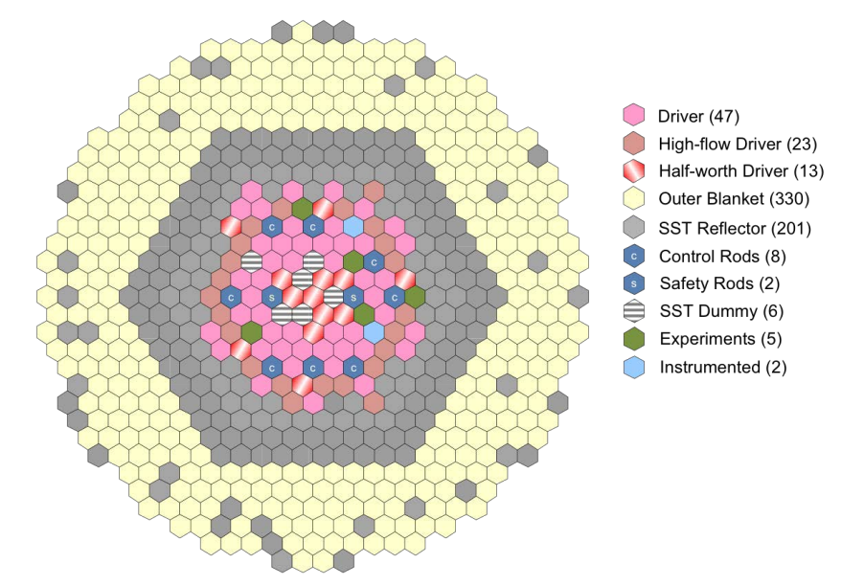
Fig.1 EBR-II Benchmark Core layout in the reference (adapted from [6]).

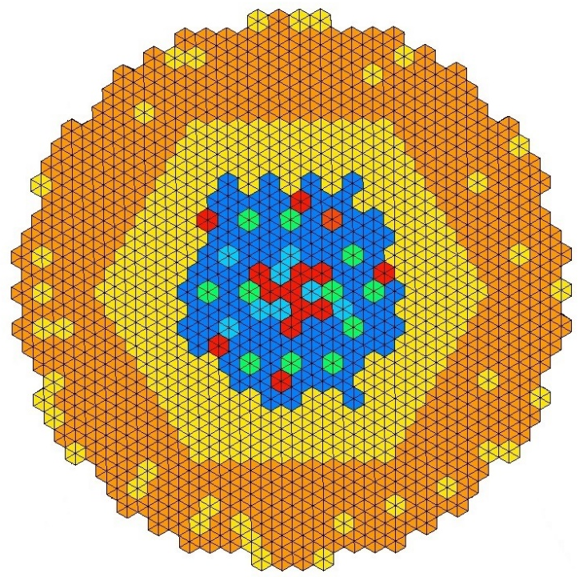
Fig.2 Computing Mesh at midplane of EBR-II Benchmark Core by SARAX.

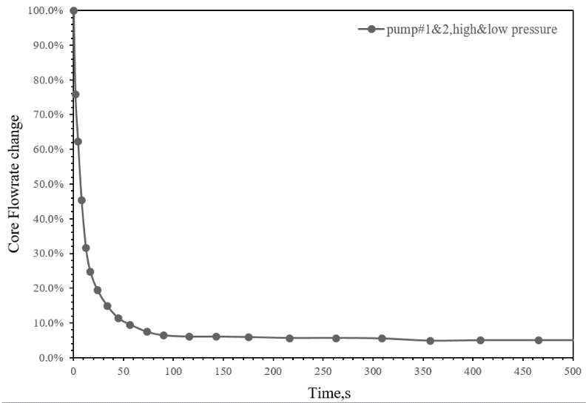
Fig. 3 The variation of inlet flow for EBR-II SHRT-45R.

Neutronic Results of EBR-II by SARAX
The material of the core from different kinds of assembly is modeled by a heterogeneous one-dimensional cylinder geometry. For EBR-II benchmark core, four typical assembly composition is shown in Fig.4. Among them, since the composition of Half-worth Driver is too complex, its equivalent one-dimensional cylinder geometry model is presented in Fig.5. To verify the work of cross section generation, the four kinds of fuel segments are also modeled by Monte-Carlo code, OpenMC. k_{inf} is calculated and set as reference result. As shown in Table 1, the result proves that TULIP has good accuracy in cross section generation even in case of complex geometry like Half-worth Driver and the difference is within 300 pcm. As for the depleted Uranium fuel segment in blanket assembly, the k_{inf} difference with Monte-Carlo code is up to 600 pcm which is acceptable due to the small k_{inf}. The other material segments in the assemblies are modeled by a homogeneous geometry.
Fig. 4 Assembly Composition Views of : (A)Driver, (B) Half-worth Driver, (C)Control assembly and (D)Blanket assembly (adapted from [8]).
Fig. 5 Equivalent one-dimensional cylinder geometry of fuel material in Half-worth Driver

TABLE 1 k_{inf} of materials
Position of fuel material | k_{inf} by TULIP | k_{inf} by Monte Carlo code | Difference/pcm
Driver | 1.98984 | 1.98934±0.00113 | 50
Control assembly | 1.94197 | 1.94214±0.00106 | -17
Half-worth driver | 1.82971 | 1.83253±0.00098 | -282
Blanket assembly | 0.37259 | 0.37856 | -597

With the modeling of the core by LAVENDER composed of 637 assemblies and the cross section generated by TULIP, the steady state physics calculation result by LAVENDER is shown in Table 2 below. The reference results is from technical report [6,9]. The results show that the modeling by SARAX is correct. In order to accurately calculate the value of the control rod and consider the influence of the fuel around it on its value, the absorber cross section in the control rod assembly is generated using the Super-cell model. In Super-cell model of TULIP, a two-ring geometry is defined: the absorber material of interest is located at the center while the external ring is a fissile material used in fuel assembly acting as a neutron supplier. Table 3 gives the worth of three groups of control rods.

TABLE 2 k_{eff} comparison of the EBR-II benchmark core
 | k_{eff}±σ | Difference/pcm
benchmark | 1.00927±0.00458 | -
INL calculated | 1.01169±0.00005 | 237
LAVENDER | 1.00979 | 51
TABLE 3 The worth of three groups of control rods by SARAX
 | k_{eff} | worth/pcm
ARO | 1.00979 | -
CR insert 36 cm | 1.00729 | 243
SR insert 36 cm | 1.00483 | 486
HWCR insert 48.5 cm | 0.95916 | 5224

Before transient analysis kinetics parameters and several reactivity feedback coefficients are calculated. In order to consider the reactivity feedback in different locations more accurately, the spatial-dependent reactivity feedback model is adopted in this calculation. The model is based on first-order perturbation theory and will give reactivity feedback coefficients of every node. The coefficients will be stored in a file generated by LAVENDER, and then will be used by DAISY. For this transient process, the reactivity feedback caused by fuel Doppler effect, coolant density change, axial expansion, radial expansion and control rod drivelines expansion is taken into consideration.
Since it is difficult to show the coefficients of every node in this paper, a series of lumped coefficients of the core are shown in Table 4. The reference is from report [6].

Table 4 Lumped reactivity feedback coefficients of the core
 | SARAX | ANL transport code | Equivalent ΔT used/K
β_{eff}, pcm | 698 | 705 | -
α_{D} , pcm/K | -0.08 | -0.06 | 14.0
α_{axial} , pcm/K | -0.71 | -0.65 | 560.8
α_{C} , pcm/K | -1.71 | -1.49 | 362.9
α_{radial} , pcm/K | -1.56 | -1.67 | 572.5

Transient simulation results of EBR-II shrt-45r by SARAX
It is noticed that in the transient process of SHRT-45R, the reactivity feedback caused by the expansion of control rod driveline (CRD) is significant. During the transient process, the High Worth Control Rods are the only group of control rods being taken into consideration. The other control rods are all like fuel assemblies and always in the core so that there is no issue about their driveline expansion. Parameters of upper plenum full of coolant can be found in report [6].
The transient simulation was performed to verify the spatial-dependent reactivity feedback model and other corresponding models in SARAX. The reference results are selected from the IAEA benchmark report [6] by different participants. Some results from China Institute of Atomic Energy (CIAE), Karlsruhe Institute of Technology (KIT), University of Fukui (UFUKUI), Korea Atomic Energy Research Institute (KAERI), Nuclear Research and Consultancy Group (NRG), and Argonne National Laboratory (ANL) are shown. Fig. 6-10 shows the analysis results of SHRT-45R transient of EBR-II benchmark core by DAISY, and the reference results, including power variation, coolant outlet temperature variation and reactivity feedback variation. The trends of total and fission power by SARAX agree well with the reference. After 350 seconds, the value of power tends to stabilize. It can be seen that the deviation of power results between SARAX and references in the late transient becomes larger. Since the final stabilized power level is closely related to the change of core flow rate, and the total reactivity feedback amount during the whole transient agree with the results of most institutes, the cause of reactivity feedback can be excluded. The deviation may be caused by the fitting flowrate curve. It should be noted that there are several break points in the simulated curves during the transient. It was caused by the slight error from the simplification of numerical fitting of inlet flow, which is ignored in this paper.
In the benchmark report [6], a curve of experimental Z-pipe inlet temperature variation was given as a reference with a lack of 75s to 200s. Due to the lack of data, values of the calculated results cannot be compared with the experimental data. The comparison of results can only focus on the comparison of changing trends. In this paper, the temperature compared was replaced by the mixed-up core outlet temperature by assuming that the temperatures at these two positions are very close. As shown in Fig.8, the trend of Z-pipe inlet temperature calculated by SARAX is in agreement with the results of most institutes, which increases in first 100s due to the loss of flow and then falls down due to the negative reactivity feedback. It can be seen that the calculated temperature rises more rapidly and has higher values, which is reasonable because the calculated temperature is closer to the core outlet.

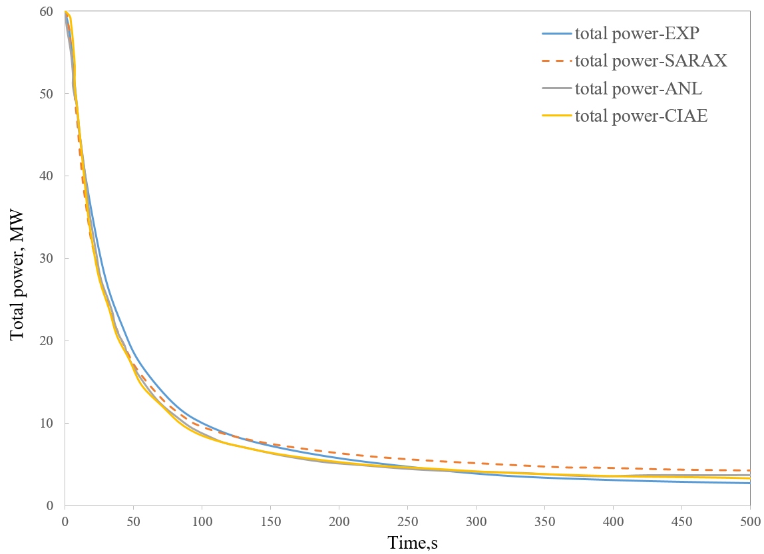
Fig.6 Total power variation results from different institutes
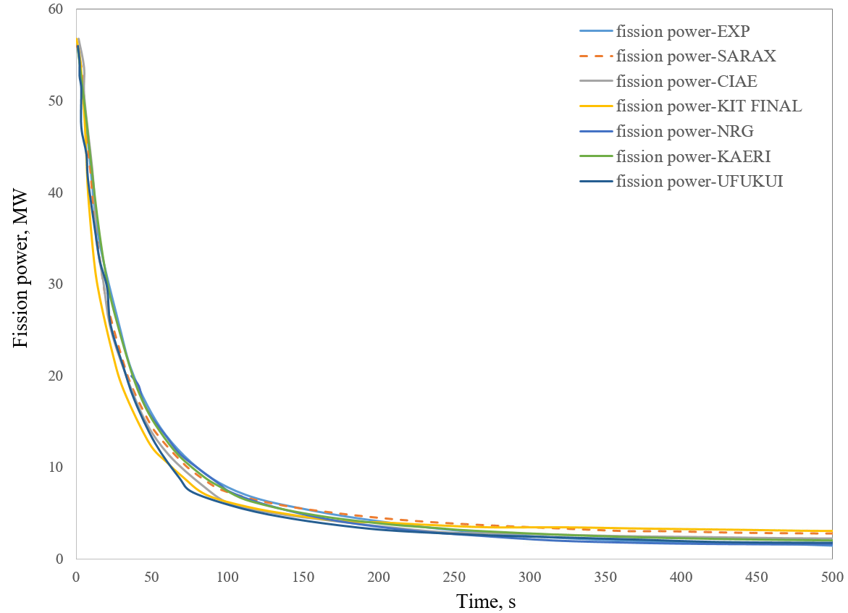
Fig. 7 Fission power variation results from different institutes

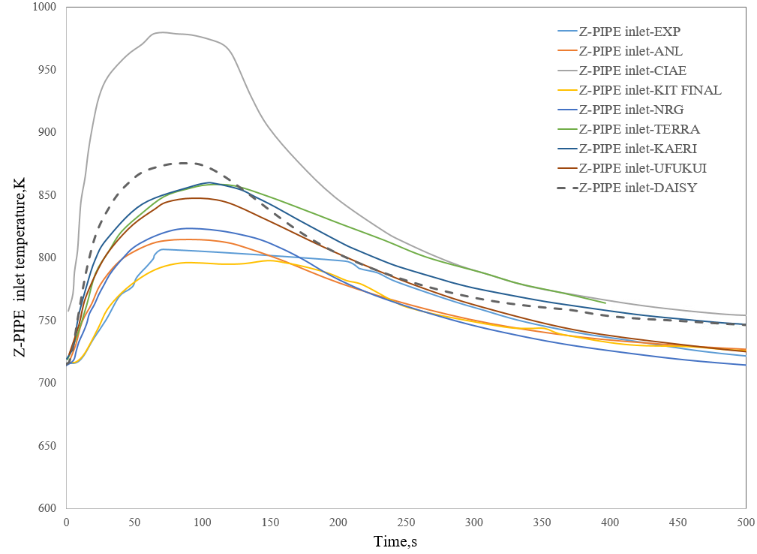
Fig. 8 Z-PIPE inlet temperature variation compared with experiment results and other institutes
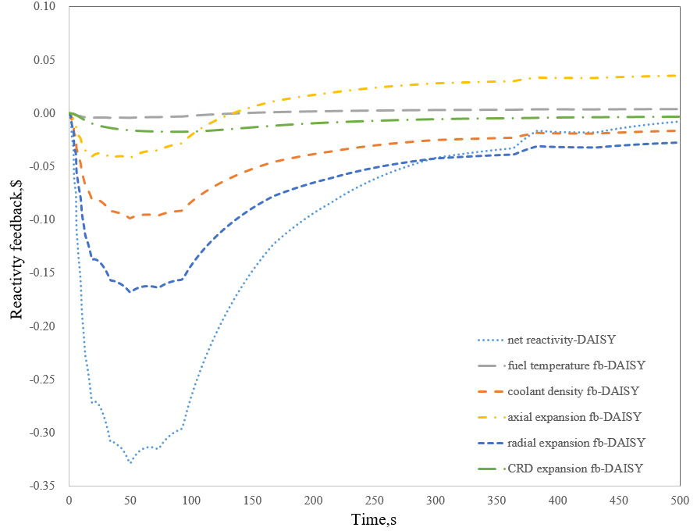
Fig. 9 Reactivity feedback variation by DAISY

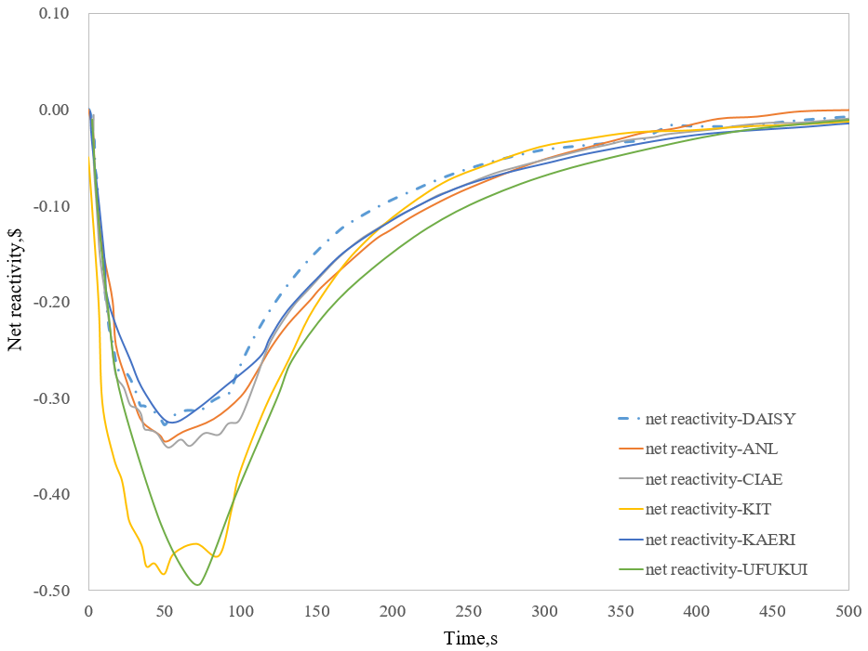
Fig. 10 Net reactivity variation compared with results of other institutes
Fig. 9 shows the variation of different reactivity feedback calculated during the transient. The radial expansion and coolant density feedback are two main aspects contributing to the negative reactivity feedback, which would cause temperature decreasing. Since EBR-II is fueled with metal fuel, the Doppler feedback coefficient is small and the fuel Doppler effect is negligible. The CRD expansion feedback keep small absolute values during the transient, which is not significantly contributive to the whole process. This is because the control rod position during the transient is at a high position, which means the bottom of the absorber is near the top of the active zone. Under this rod position, the differential worth of the control rod is small, so the reactive feedback caused by control rod insertion is relatively small. As for axial expansion, its positive value is directly related to the fuel temperature. In the axial expansion model of SARAX, free expansion is supposed. Without the mechanical coupling between fuel and cladding, the fuel axial expansion is the main source of axial expansion feedback and following the fuel temperature, it becomes positive after about 120s. The axial expansion model of SARAX needs to be improved in the future to consider the interaction between fuel and cladding. And it can be seen in the benchmark report [6] that some other institutes also give positive axial expansion feedback.
Fig.10 shows that net reactivity results compared with reference results. Due to the drop of flowrate and the imbalance between power and flowrate at the early transient, the core temperature rises rapidly. Following the temperature, the increasing negative feedback causes a rapid drop of the core power. Then, with the gradually stable flowrate and the negative feedback, the power level of the core continues to drop, and the temperature of the core begin to decrease. The absolute value of the negative reactivity feedback becomes smaller, gradually reduces to 0. The core power level is finally stable. The minimum value of core net reactivity during the transient also agreed with the results in the report, which ranged from -0.3$ to -0.35$. With the spatial-dependent reactivity feedback model, SARAX could give close values of reactivity feedback. Combined with all the above results, it can be concluded that the spatial-dependent reactivity feedback model in SARAX is correct, and this model could help to simulate the in-core transient and give reliable results of reactivity feedback.

conclusion
In conclusion, SARAX gave comparable results with the benchmark and INL’s results for steady state calculation. As for transient analysis, compared with experimental results and other institutes’ results, SARAX presents good results. However, SARAX does not have the capability of system analysis at present, leading to the need to obtain input parameters for the transient calculation from the references, which makes SARAX not yet capable of independent design of a complete fast reactor. SARAX needs further development and practice.

ACKNOWLEDGEMENTS
This research was carried out under the National Key Research and Development Plan of China (project number: 2018YFB1900604), and the National Science Foundation of China (approved number: 11775170 and 11735011).
References
- Youqi Zheng, Liang Qiao, Zi'an Zhai, et al. 2018. SARAX: A new code for fast reactor analysis part II: Verification, validation and uncertainty quantification [J]. Nuclear Engineering and Design, 331, Pages 41-53.
- Zheng Youqi, Wu Hongchun, et al. “Improvement and verification of the fast reactor neutronics code NECP-SARAX,”[J]. High Power Laser and Particle Beams, Vol. 05. p.116-121,2017
- Zhou Shengcheng, Wu Hongchun, Cao Liangzhi, et al. “LAVENDER: A steady-state core analysis code for design studies of accelerator driven subcritical reactors,”[J]. Nuclear Engineering & Design, Vol. 278.p. 434-444.
- X.N. Du, L.Z. Cao, Y.Q. Zheng, H.C. Wu. “Developments of the Sodium Fast Reactor Analysis code SARAX: methods and verification,”. M&C 2017, Jeju, Korea, April. p.16-20, (2017).
- JIA Xiaoqian, ZHENG Youqi, DU Xianan et al. Application of SARAX Code System in Transient Analysis of Sodium-cooled Fast Reactor[J]. Atomic Energy Science and Technology, 2019, 53(7): 1195-1201.
- Benchmark Analysis of EBR-II Shutdown Heat Removal Tests, IAEA, Vienna, 2017.
- Sumner, Tyler S, Wei, et al. Benchmark specifications and data requirements for EBR-II shutdown heat removal tests SHRT-17 and SHRT-45R. 2012.
- Fei T, Vezzoni B, Marchetti M, et al. Neutronics Benchmark for EBR-II Shutdown Heat Removal Test SHRT-45R. 2016.
- Chad Pope, Experimental Breeder Reactor II Benchmark Evaluation, Idaho State University, the United States, 2017.

