# Simulation of FFTF Individual Reactivity Feedback Tests with SAS4A/SASSYS-1 Code

A. MOISSEYTSEV

Argonne National Laboratory

Argonne, IL, USA

Email: amoissey@anl.gov

D. WOOTAN

Pacific Northwest National Laboratory

Richland, WA, USA

T. SUMNER

Argonne National Laboratory

Argonne, IL, USA

**Abstract**

During the operational history of the 400 MW thermal, oxide-fueled, liquid sodium cooled Fast Flux Test Facility (FFTF), many tests were performed to support the reactor safety demonstration program. In FFTF Cycle 8A, a series of individual reactivity feedback tests were carried out. The primary goal of these tests was to evaluate and confirm the core reactivity feedbacks in a systematic fashion by subjecting the core to various power, flow, and inlet temperature conditions. Each test was designed to simulate and validate specific features and reactivity feedbacks of the FFTF core. The paper presents the results of the application of the fast reactor safety analysis code SAS4A/SASSYS-1 to a selection of FFTF individual reactivity feedback steps, and compares the code predictions with the test data.

## INTRODUCTION

The Fast Flux Test Facility (FFTF) at the Hanford site in Washington [1] was a 400 MW thermal, oxide-fueled, liquid sodium cooled test reactor, built to assist development and testing of advanced fuels and materials for fast breeder reactors. FFTF operated from 1980 until 1992, providing the U.S. Department of Energy (DOE) with the means to test fuels, materials, and other components in a fast neutron flux environment. One of the FFTF passive safety demonstration tests simulating loss-of-flow conditions without scram (LOFWOS) is currently being analyzed by the international community under an IAEA coordinated research project [2].

In preparation for the passive safety demonstration tests in Cycle 8C, a series of individual reactivity feedback tests were performed in FFTF [3]. The primary goal of these tests was to evaluate and confirm the core reactivity feedbacks in a systematic fashion by subjecting the core to various power, flow, and inlet temperature conditions. These tests were carried out during Cycle 8A and consisted of quasi-static steps, where after each change the reactor was held at steady-state conditions for a period of about one hour to adjust to new steady-state conditions. The steps were named in a chronological order (1, 2, …), with some steps were split in two sub-steps (e.g., 36A and 36B). The entire Cycle 8A test campaign consisted of approximately 200 steps. Unlike the integral LOFWOS reactor test, each step in Cycle 8A was designed to simulate and validate specific features and reactivity feedbacks of the FFTF core.

The passive safety tests in Cycle 8A consisted of measurements of control rod positions at selected power and coolant conditions. The reactor power was varied between 10% and 100% while coolant conditions covered a range of 67% to 100% flow and 577°F (303°C) to 680°F (360°C) core inlet temperatures. All reactor plant conditions during the test series remained within existing reactor operational limits. The magnitude of the associated temperature reactivity feedbacks between test states was determined by converting rod movement to reactivity. Additional measurements were conducted before and during the test series to provide accurate rod worth information for post-test conversion of rod movement data to reactivity. In addition, the reactivity change from fuel burnup during the tests was calculated after the tests.

The data from the FFTF individual reactivity feedback tests provides a unique opportunity for validation of reactivity feedback modeling in fast reactor analysis codes. The structure of these tests provides data for code validation in a systematic fashion by separating reactivity feedbacks as much as was practically achievable. The quasi-static nature of these tests also simplifies code validation by eliminating the transient effects.

The FFTF individual reactivity feedback tests have been used to support validation of the reactivity feedback models in the SAS4A/SASSYS-1 [4] safety analysis code that was developed at Argonne National Laboratory for transient simulation of liquid metal-cooled fast reactors. In a standard calculation (without coupling to a kinetics code), SAS4A/SASSYS-1 uses the point-kinetics approximation to calculate the following reactivity feedbacks:

* Fuel Doppler, which is calculated based on the fuel temperature change and a fuel Doppler constant provided from neutronics calculations,
* Core axial expansion, which is calculated based on axial expansion of fuel and cladding and provided reactivity worth of fuel and cladding at each axial location,
* Coolant density (void) effect is calculated from coolant reactivity worth at each axial node,
* Control rod driveline (CRDL) expansion, calculated based on fit parameters for the control rod position in the core (S-curve) and thermal response of the drivelines in the upper internal structure,
* Core radial expansion, which is calculated based on the expansion of structure at the core support plant and the assembly load pads,
* Control reactivity (not used in this simulations), and
* External user-provide reactivity (also not used in this simulation).

The first three feedbacks are the channel-dependent and are calculated for each SAS4A/SASSYS-1 channel (fuel assembly or a group of assemblies). The other feedbacks are calculated for the whole core. The net reactivity is calculated as a sum of all reactivity feedbacks at each time step.

The work described in this paper was carried out to support Argonne’s participation in the IAEA international benchmark project for the LOFWOS test simulation. As such, the primary focus of the work presented in this paper was to improve the prediction of the benchmark test. However, the value of the Cycle 8A individual reactivity feedback tests goes beyond that particular simulation. Reactivity feedbacks such as Doppler, core radial expansion, and more that were simulated for these tests will be present in any sodium-cooled fast reactor. Validating the reactivity feedback models in SAS4A/SASSYS-1 helps ensure accurate transient simulations for future fast reactor analyses.

## CYCLE 8A Test Types

There were seven types of individual reactivity feedback tests in Cycle 8A. These tests, which are described in Table 1, targeted the fuel Doppler and axial expansion feedbacks, the coolant density feedback, and structure reactivity feedbacks such as core radial expansion. Cycle 8A also included integral tests for evaluating the power, flow, and temperature reactivity coefficients. Of the seven test types, tests of the first three types listed in Table 1 are analyzed in this work, as they, on one hand, simulate the most dominant reactivity feedbacks of the FFTF Cycle 8A core and, on the other hand, provide the best opportunity to investigate particular feedbacks. For example, the Type 1 fuel temperature tests were carried out in such a way that only fuel Doppler and axial expansion feedbacks were significant, while all other feedbacks were minimized. The other test types not included in this work, such as flow coefficient tests, provide information important to the reactor operators, but are more complicated for the reactivity validation calculations, since they usually combine several reactivity feedbacks. The international benchmark on the LOFWOS test is designed to capture such integral reactor response.

The measured data for the tests analyzed in this work include statistical averages of power, primary flow and core inlet temperature, as well as reactivity calculated from positions of the six control rods and fuel burnup. The test types for the analyzed steps were determined by comparing the data to the description of the tests in Table 1. All SAS4A/SASSYS-1 calculations began from the conditions of Step 2B, which represented conditions close to the nominal FFTF full power/full flow values.

The core loading for Cycle 8A was similar to that of the Cycle 8C core that is being analyzed in the international benchmark. The most significant difference between the two cycles was the absence of Gas Expansion Modules (GEMs) in Cycle 8A. For Cycle 8C, those modules replaced nine reflector assemblies for the LOFWOS tests, but they were not present in Cycle 8A. The absence of GEMs eliminates a possibility to study GEM reactivity in the systematic fashion available for other reactivity feedbacks. At the same time, the absence of GEMs simplifies comparisons of the reactivity coefficients with the test data, since it eliminates the effect and uncertainties associated with the GEM reactivity feedback.

The other differences between Cycle 8A and Cycle 8C core loadings include several experimental type assemblies in Cycle 8A that were later replaced with regular drivers for integral reactivity tests in Cycle 8C. These assemblies, however, did not have a significant effect on the FFTF core reactivity feedbacks, as was confirmed by comparing the results of neutronics calculations for Cycles 8A and 8C. Nevertheless, a separate set of neutronics analysis and a dedicated SAS4A/SASSYS-1 model were developed to reflect the specifics of the Cycle 8A core loading.

TABLE 1. CYCLE 8A INDIVIDUAL REACTIVITY FEEDBACK TYPES

|  |  |  |
| --- | --- | --- |
| No. | Test Type | Description |
| **1** | **Fuel Temperature** | The core inlet temperature was fixed, the core power and flow rate were varied in a way that the power-to-flow ratio remained constant. As a result, coolant and structure temperatures changed very little, if at all, and the majority of reactivity feedbacks comes from the fuel, including Doppler and axial expansion. |
| **2** | **Structure Effects – Constant Average Temperature** | In these tests, the power was fixed, but the inlet temperature and flow rate were varied in a way that preserves the coolant average temperature in the core. As a result, the average coolant, cladding, and fuel temperatures did not change, but temperatures for core restraint components were affected. |
| **3** | **Structure Effects – Constant Outlet Temperature** | In these tests, the inlet temperature and flow rate were changed, but the core outlet temperature was preserved. The power was selected to preserve average the fuel temperature (as calculated). The dominant reactivity feedbacks are the grid plate expansion as well as coolant and structure density effects. |
| 4 | Temperature Coefficient | The inlet temperature was changed, while both power and flow remained fixed, resulting in a uniform change of all core temperatures. |
| 5 | Flow Coefficient | The inlet temperature and power were fixed, while the coolant flow rate was varied. All temperatures changed, except for core grid plate. |
| 6 | Static  Loss-of-Flow | The inlet temperature was fixed, while the flow rate was decreased. The control rods were not moved in order to allow power to adjust from the reactivity feedbacks only. This test type represents a static simulation of loss-of-flow tests in Cycle 8C. |
| 7 | Power Coefficient | The core inlet temperature and flow rate were fixed, while the power was varied. The effect is similar to Flow Coefficient type tests, but the reactivity feedbacks are dominated by the Doppler and axial expansion in fuel. |

Test types analyzed in this work are highlighted in **bold**

## Analysis of Cycle 8A Tests with SAS4A/SASSYS-1

Several groups of the Cycle 8A steps were simulated in SAS4A/SASSYS-1 with a quasi-static transient, where for each step the first 500 to 1000 seconds of the simulation were devoted to the changes from the previous step and the last 500 to 1000 seconds simulated the hold time to achieve new steady-state conditions. These times are shorter than the actual test durations, but were judged sufficient for this analysis to stabilize all the temperatures in SAS4A/SASSYS-1 results. All SAS4A/SASSYS-1 simulations started from the steady-state conditions corresponding to Step 2B.

The simulation in SAS4A/SASSYS-1 was done using a core-model only, where the input for the core-inlet temperature and normalized flow rate was directly specified in an input table using the measured data. Because such data was directly provided for these tests and also because this analysis is focused on the core reactivity feedbacks, the primary and intermediate loop models developed previously for FFTF were not used for these calculations. Still, this model and the Cycle 8A test data for these loops can be used in future analysis for the model validation outside the reactor core, for example, to characterize the performance of the intermediate heat exchanger under various conditions.

The SAS4A/SASSYS-1 calculations were run in prescribed-power mode, where the power level, normalized to the Step 2B value, was directly specified as an input. Under this approach, SAS4A/SASSYS-1 still calculates and prints out each individual reactivity feedback and the total reactivity, but the point kinetics equations are not used and the effect of reactivity on power is ignored. The net reactivity value at the end of each step is the main output from these calculations and it will be compared in the results presented below with the measured reactivity to judge how accurate the reactivity feedbacks are calculated for each step. The uncertainty of the measured reactivity is evaluated to be 2.1%. Note that this value is too small to be shown in the error bars on the comparison figures presented later in this paper.

### Type 1 Tests - Fuel Feedbacks

The first Cycle 8A steps analyzed in this work were Type 1 tests, aimed at separating the fuel only reactivity feedbacks such as axial expansion and Doppler. In these tests, the core inlet temperature was held approximately constant, while power and flow were changed simultaneously to roughly preserve the power-to-flow ratio. As a result, all temperatures in the core, except for the fuel, were changed little, minimizing the reactivity feedbacks from coolant and structures. The Doppler and axial expansion are important feedbacks for fast reactors, and simulating Type 1 tests provides a unique opportunity to validate those feedbacks in the SAS4A/SASSYS-1 model.

For this work, two series of Type 1 steps are analyzed. In the first series, from Step 2B to Step 10A, both power and flow were gradually reduced from close to full-power full-flow conditions at Step 2B to approximately 65% power and flow by Step 10A. The second series, Steps 56A to 60A, include simultaneous power and flow variation from about 60% power and full flow to approximately 40% power and 70% flow, and is more representative of the conditions encountered during the test analyzed by the IAEA coordinated research project [2].

Both fuel Doppler and axial expansion are calculated in the current analysis by SAS4A/SASSYS-1’s DEFORM-4 oxide fuel performance module. This module simulates fuel pre-irradiation and transient behavior, including fuel restructuring and growth, fission gas release, cladding deformation, and fuel-cladding gap size and thermal conduction. One of the parameters calculated by the DEFORM-4 module that was found to have a significant effect on both the Doppler and axial expansion reactivity feedbacks for FFTF is the fuel-cladding gap thickness and thermal conductivity. The temperature rise across the gap affects the fuel temperatures and thus the fuel temperature change in transients. The DEFORM-4 model for FFTF predicts a gradual closing of the gap with fuel burnup, which could open in some transients in some locations. Depending on when and where the gap closes and opens, significant variations in fuel reactivity feedbacks could result.

As discussed above, each set of SAS4A/SASSYS-1 calculations starts from the base Step 2B, then proceeds in simulating the specific set of steps, for example to Step 56A in the second series of Type 1 tests. Although this approach is sufficient for thermal-hydraulic modeling of the core, there is an unavoidable simplification in this approach for the fuel performance and behavior. Specifically, none of the reactor history between the base and the first modeled step (Steps 3 through 55 in this example) is modeled. Therefore, the fuel conditions at the start of the test series may not be represented accurately. However, the only proper way to achieve such accuracy would be simulating all Cycle 8A steps, which would make SAS4A/SASSYS-1 calculations very complicated. Note that this uncertainty in fuel conditions would increase with the test number in simulations presented in this paper.

The results of initial simulation of the first Type 1 Cycle 8A test series (Steps 6-10) are shown in Fig. 1. In this and the following figures, the first plot compares the change in net reactivity from the reference step (2B in this case) calculated by SAS4A/SASSYS-1 against the measured FFTF result. The SAS4A/SASSYS-1 result is the sum of all reactivity feedbacks, while the FFTF value is calculated from the control rod positions plus the calculated reactivity from fuel burnup, from Step 2B to each step. The second graph in Fig. 1 shows the components of the reactivity feedback calculated by SAS4A/SASSYS-1. There is no similar data from the tests. This plot confirms that the vast majority of the reactivity feedbacks in this series comes from fuel in the form of Doppler and axial expansion. The rest of the feedbacks are negligible, with all the temperatures, other than fuel temperatures, changing very little in these tests.



**Reactivity, $**

FIG. 1. First Results for Cycle 8A Type 1 Tests.

The main conclusion from Fig. 1 is that the SAS4A/SASSYS-1 result for the reactivity prediction is close to the measured data, although there is a slight but consistent overprediction of approximately 10% by SAS4A/SASSYS-1 of the fuel reactivity feedbacks. In addition to the Steps 6-10 values in Fig. 1, Type 1 Steps 56-60 were also analyzed with similar results, although with a larger overprediction of net reactivity. The steps in that series represent the conditions close to the benchmark LOFWOS test with power level around 50%.

In order to identify the reasons for this overprediction, a parametric study was carried out to investigate which modeling options and assumptions can reduce fuel reactivity feedbacks and thus improve agreement with these Cycle 8A tests. The following model variations were tested in an attempt to improve agreement with the test:

* *Refining the fuel property tables in the SAS4A/SASSYS-1 model using more recent correlations for oxide fuel*. Specifically, these new properties include a correction for fuel stoichiometry (ratio of oxide to metal atoms) in fuel thermal conductivity. They also include a correction for the Pu fraction, which varied between 22% and 29% in the FFTF fuel.
* *Modification to the fuel axial expansion model to account for FFTF’s dished fuel pellets*. The DEFORM-4 model in SAS4A/SASSYS-1 does not provide an option to simulate dished pellets. To include this effect, a multiplication factor for axial expansion was *estimated* based on how much fuel centerline temperature needs to increase before the gap is fully closed. That estimate, however, is based on specific assumptions and conditions and may not be applicable to all test conditions analyzed in this work.
* *Increase in fuel radius*. It was found that a very slight increase in fuel pellet radius, by only 0.009 *mm*, which represents less than 50% of tolerance specified for fuel pellets, improves the agreement for the low-power tests.

However, it was found that the last two model variations could improve the agreement for one (Steps 6-10 at high power) or another (Steps 56-60 at low power) set of Cycle 8A steps, *but not both*. Fig. 2 shows the results for what was judged to be an optimal model, which includes all the model corrections listed above. Note that the results for Steps 56-60, as well as for all other step series presented below, are adjusted to compare the reactivity change from the first step in the series, rather than from Step 2B, such that there is no need to simulate the control rod movement and fuel burnup between Step 2B and the beginning of a particular series. Fig. 2 shows that the initial SAS4A/SASSYS-1 overprediction of reactivity for high power Steps 6-10 is now overcompensated. At the same time, almost perfect agreement is achieved for low power Steps 56-60. Since the latter steps are more representative of the LOFWOS conditions, it was decided to maintain all the model modification in the new refined model.



Fig. 2. Results for Cycle 8A Type 1 Tests with Optimized Model.

### Type 3 Tests – Grid Plate Expansion

Step pairs 29-30 and 78-79 are Type 3 tests where the core inlet temperature decreased, by approximately 10°C in each pair of tests, but the coolant flow rate was adjusted to maintain the core outlet temperature, with a fixed power level. Because the core outlet temperature was relatively constant, this type of test minimized reactivity feedbacks from both load pads and control rod driveline (CRDL) expansion. Therefore, these tests were designed to investigate the expansion of the core grid plate with nearly uniform core radial expansion.

Unlike Type 1 tests, Type 3 tests, as well as all other types, are not pure reactivity feedback tests because they could not completely eliminate other reactivity feedbacks. For example, even though the outlet temperature was kept constant during Type 3 tests, the average coolant temperature still changed, such that the reactivity feedback from coolant density could not be eliminated. Likewise, even though the fuel feedbacks were small, they were not completely eliminated in these tests.

The analysis of Steps 29-30 and 78-79 was performed with both the simple and detailed radial expansion models in SAS4A/SASSYS-1. The simple radial expansion model only considers expansion of the grid plate and the above-core load pads and assumes the assembly remain straight (no bending) during core expansion. The detailed radial expansion model in SAS4A/SASSYS-1 also includes top load pads, expansion of the core restraint rings, and does allow for assembly bowing. The detailed core radial expansion is the reference model used in the FFTF LOFWOS benchmark analysis.

For simulation of these Type 3 tests, the reference input for the core radial expansion, both the simple and detailed models, was modified to better reflect test conditions, where the core expansion is dominated by the grid plate and the assemblies would remain vertical when the temperatures are reduced. These model modifications are often implemented for the analysis of loss-of-heat-sink (LOHS) events, where, similar to the Cycle 8A Type 3 tests, core radial expansion is dominated by expansion of the grid plate.

Fig. 3 shows the results of the two pairs of Type 3 tests (Steps 29-30 and 78-79) for both the simple and detailed radial expansion models. In all cases, the SAS4A/SASSYS-1 results for net reactivity are close to the measured values. The results in Fig. 3 also suggest that the simple radial expansion model produces slightly better agreement for these conditions, where the core radial expansion is dominated by the grid plate. Fig. 3 also demonstrates that although the reactivity feedback is dominated by the core radial expansion, other feedbacks are not as small as they were in Type 1 tests (see Fig. 1), although all other feedbacks essentially cancel each other out in these tests.





Fig. 3. Results for Cycle 8A Type 3 Tests with Simple (top) and Detailed (bottom) Core Radial Expansion Models.

### Type 2 Tests – Core Radial and CRDL Expansion

In Type 2 tests, the core inlet temperature was changed and the flow rate was adjusted to maintain the average coolant temperature. Reactor power was also held constant. By maintaining average coolant, cladding, and fuel temperatures, this type of test minimizes reactivity feedbacks from coolant and fuel. At the same time, variation of the core inlet and outlet temperatures induces reactivity feedbacks from core structures, such as grid plate and load pads (i.e. core radial expansion). The changing core outlet temperature also results in control rod driveline expansion. Three series of steps, 17-19, 34-36, and 67-68, were found to satisfy the requirements of Type 2 tests and were simulated in this work. The inlet temperature decreased by roughly 10 °C per step in each sub-series. Power was maintained at approximately 65% in Steps 1-19 and 34-36 and at around 40% in Steps 67-68. The flow rate changed from about 75% by approximately 12% per step

Fig. 4 shows the results of the Type 2 test simulation with both the simple and detailed radial expansion models. The following observations can be made from Fig. 4. For this rather complicated core deformation, the detailed radial expansion model obtained better agreement with the test than the simple radial expansion. For detailed radial expansion results, although the general direction of net negative reactivity is preserved in all tests, there is still a significant difference from the measured data, up to 100% in relative terms, noticeably larger than in all previous results.

Fig. 4 also shows that the reactivity feedbacks from coolant and fuel are small in all tests, confirming that those are good Type 2 tests with fixed core average temperatures. Therefore, the net reactivity is essentially a combination of the core radial expansion and the CRDL expansion feedbacks. Fig. 4 shows that for all three step series, those two feedbacks are opposite in sign and are of comparable magnitude. As a result, the net reactivity is much smaller in magnitude than any of these feedbacks – SAS4A/SASSYS-1 calculates the net reactivity change to be within 4 cents for all these steps.

The difference between the test data and the calculated results in Fig. 4 could be explained by the following observations:

* As discussed above, the magnitude of the net reactivity is small, with competing opposite radial expansion and CRDL expansion feedbacks. Therefore, even a small error in each of these feedbacks can result in a much larger relative difference for the net reactivity. In fact, although the radial expansion and CRDL expansion components *look* similar for the simple and detailed radial expansion model plots in Fig. 4, the small differences in those components can result in negative or positive net reactivity (see for example 67-68 Step with simple radial expansion).
* Accuracy of test data for such a small reactivity change has not been assessed yet for the FFTF data. The experimental net reactivity was calculated after the tests based on the measured control rod position. It also includes the calculated adjustment for the fuel burnup for these multi-hour steps. Even though those calculations are believed to be accurate, as they were calibrated specifically for the FFTF conditions, even a small difference in each calculation can result in a relatively large difference in the net reactivity change for each step.
* In the SAS4A/SASSYS-1 calculations, all steps were initiated from Step 2B conditions. Specifically, the inputs for the CRDL feedback were calculated and fixed at 2B values (rod insertion depth). Different power levels in these steps could require more accurate assessment of the initial position of CRs on their S-curves. Therefore, for more accurate calculation of the CRDL feedback, which is shown to be very important for these particular steps, the CRDL input must be adjusted for each series of tests, possibly for each control rod.

Further investigation of the discrepancy between the SAS4A/SASSYS-1 results and the tests may include analysis of additional measured data. For example, any information on assembly outlet temperatures will be useful in estimating the change in the core outlet temperature, which affects the CRDL expansion feedback.

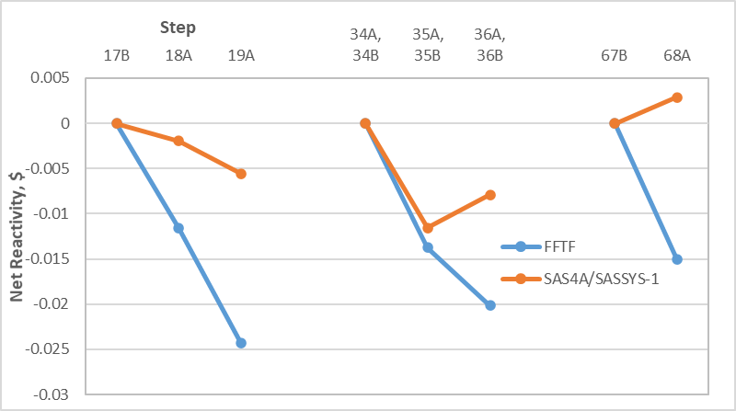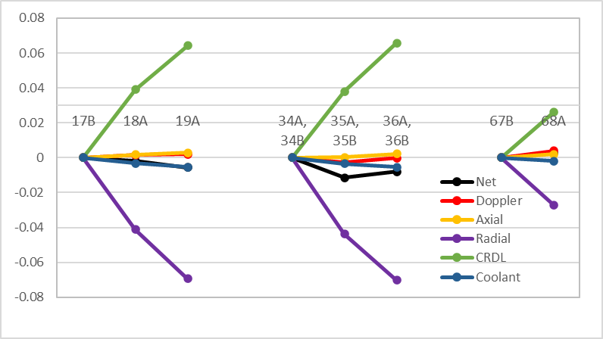

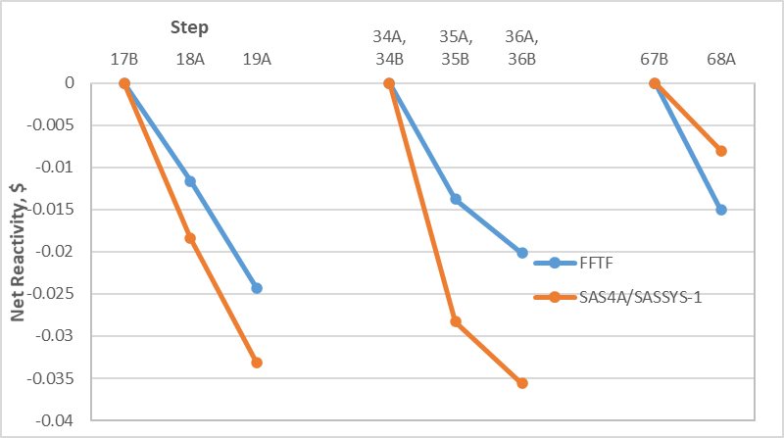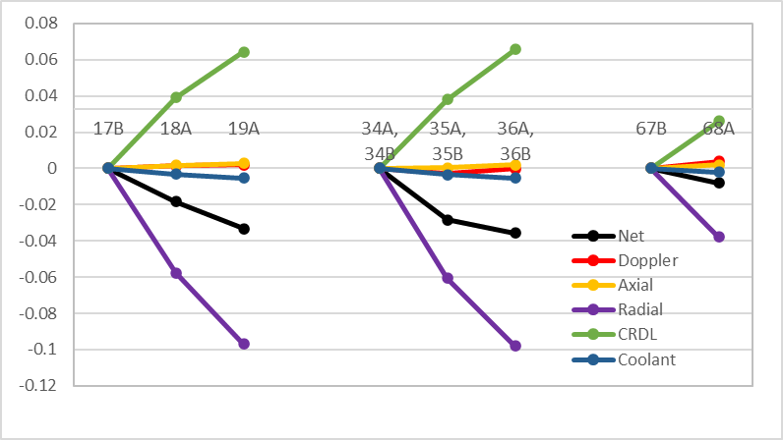

Fig. 4. Results for Cycle 8A Type 2 Tests with Simple (top) and Detailed (bottom) Core Radial Expansion Models.

## SUMMARY and Future Work

The Fast Flux Test Facility passive safety test program included a series of individual reactivity feedback tests. The primary goal of these tests was to check the core reactivity feedbacks in a systematic fashion by subjecting the core to various conditions of power, flow, and inlet temperature. These tests were carried out in Cycle 8A and consisted of quasi-static steps, where after each change the reactor was held at steady-state conditions for a period of about one hour to adjust to new steady-state conditions. The entire Cycle 8A test campaign consisted of about 200 steps. Each step was designed to simulate and validate specific features and reactivity feedbacks of the FFTF core. There were seven types of these individual reactivity feedback tests, targeting fuel reactivity Doppler and axial expansion feedbacks, coolant density feedback, structure reactivity feedbacks such as core radial expansion, as well as integral tests, such as the power reactivity coefficient. The data from the FFTF individual reactivity feedback tests provides a unique opportunity for validation of reactivity feedback modeling in fast reactor analysis codes.

In this work, several Cycle 8A step series were analyzed with the SAS4A/SASSYS-1 code developed at Argonne for transient simulation of liquid metal-cooled fast reactors to validate the code’s reactivity feedback models. The primary goal of this simulation was to compare the net reactivity predicted by SAS4A/SASSYS-1 against the measured value obtained from the recorded control rod movement and fuel burnup.

Type 1 test steps provide experiment data for validation of fuel reactivity feedbacks of Doppler and core axial expansion. A series of Cycle 8A Type 1 tests at nominal and low power were identified and analyzed in this work. The fuel pre-irradiation and transient behavior, including fuel restructuring and growth, fission gas release, cladding deformation, and fuel-cladding gap size and thermal conduction, is modeled using SAS4A/SASSYS-1 DEFORM-4 oxide fuel module. Overall, the SAS4A/SASSYS-1 results for fuel Doppler and axial expansion reactivity feedbacks show good agreement with the tests. Some model refinements were identified and implemented in order to improve the agreement.

Type 3 tests were designed to achieve approximately uniform core radial expansion driven by the core grid plate. Both the simple and detailed radial expansion models in SAS4A/SASSYS-1 were able to predict the results for Type 2 tests, but input adjustments were needed to represent uniform core radial expansion. These adjustments are similar to those used for analyses of loss-of-heat-sink type events to assure that the core radial expansion is dictated by the grid plate.

Type 2 steps simulated the core radial expansion due to temperature changes at both the grid plate and assembly load pads, as well as expansion of the control rod drivelines. The results of SAS4A/SASSYS-1 simulations of these test types showed that cancelation of opposing feedbacks with similar magnitudes resulted in large relative discrepancies for net reactivity. Although the relative net reactivity discrepancies are larger than were observed for other test types, they are considerably smaller than the magnitudes of the positive control rod driveline expansion feedback and the negative feedback from radial core contraction that were observed.

For future work, continued simulation of the FFTF Cycle 8A individual reactivity feedback tests is recommended to provide more insights leading to potential further improvement of the SAS4A/SASSYS-1 models. Although this work covered several test types with a variety of core conditions, only 24 out of approximately 200 steps for which data is available were simulated. In addition, the present work was focused on three of the seven individual reactivity feedback test types from Cycle 8A. The other four types, which target integral reactor behavior such as temperature reactivity coefficient and flow reactivity coefficient, still provide valuable data for validation of fast reactor reactivity models. Lastly, the work presented here was focused exclusively on the core reactivity feedback. Data from Cycle 8A can also be used for validation of models beyond the reactor core, such as for intermediate heat exchangers.

ACKNOWLEDGEMENTS

The submitted manuscript has been created jointly by UChicago Argonne, LLC, Operator of Argonne National Laboratory and Pacific Northwest National Laboratory. Argonne National Laboratory's work is supported by U.S. Department of Energy (DOE) under Contract number DE-AC02-06CH11357. Pacific Northwest National Laboratory work is supported by U.S Department of Energy (DOE) under Contract number DE-AC05-76RL01830. The work described in this paper has been funded by the DOE Advanced Reactor Technologies (ART) program. The authors are thankful to Brian Robinson, the ART Program Manager and Robert N. Hill, the National Technical Director for the ART Program Fast Reactors Campaign. The authors are also grateful to Joseph V. Nelson for processing the FFTF data into a form that could be compared to SAS4A/SASSYS-1 analyses. The authors are also grateful to Nicolas Stauff of Argonne National Laboratory and Paul Lartaud (Argonne intern) for carrying out neutronics calculations necessary to construct the Cycle 8A SAS4A/SASSYS-1 model.

References

1. CABELL, C.P., A Summary Description of the Fast Flux Test Facility, HEDL-400, Westinghouse Hanford Company, Richland, WA, December 1980.
2. KRIVENTSEV, V. et al., “IAEA’s coordinated research project on Benchmark Analysis of Fast Flux Test Facility (FFTF) Loss of Flow Without Scram Test: an overview”, Fast Reactors and Related Fuel Cycles: Sustainable Clean Energy for the Future (FR21) (Proc. Int. Conf. Beijing, 2021), IAEA, Vienna.
3. WOOTAN D.W., and NELSON, J.V., FFTF Cycle 8A Reactivity Feedback Test, PNNL-30811, Richland, WA, Pacific Northwest National Laboratory, 2020.
4. FANNING, T. H., BRUNETT, A. J., SUMNER, T., eds., The SAS4A/SASSYS-1 Safety Analysis Code System, ANL/NE-16/19, Nuclear Engineering Division, Argonne National Laboratory, March 31, 2017.