Experimental Modeling of Oscillations of

a Fuel Element Simulator in a

Coolant Flow

N. PRIBATURIN¹, V. PAVLOV¹, S. LEZHNIN¹, P. LOBANOV², V. MELEDIN², I. SCHEPIKHIN², A. SVETONOSOV²

¹Nuclear Safety Institute of Russian Academy of Science, Novosibirsk Division, Moscow, Russia
²Kutateladze Institute of Thermophysics of the Siberian Branch of the Russian Academy of Sciences, Novosibirsk, Russia

Email contact of corresponding author: pribaturin@itp.nsc.ru

Abstract

The results of experimental study of the oscillations of fuel rod simulators in fuel assembly models with a lead-bismuth eutectic (LBE) coolant flow are represented. Measurements were carried out on a 7 pins model of the fuel assembly. An annular channel with an equivalent diameter equal to the hydraulic diameter of the fuel assembly model was also used for measurements. In addition to the lead-bismuth coolant, a water coolant was also used, which made it possible to compare the results and determine the features of the vibrations of the fuel element simulator in liquids with different densities.

INTRODUCTION
Fluid flow leads to generation of hydrodynamic forces, which can cause vibration of structures. The liquid-solid interaction is an actively developing area of mechanics. Vibration loads can lead to potentially dangerous situations. For example, fretting corrosion of fuel elements or heat exchange tubes in steam generators of power plants [1]. Such loads can lead to damage to the elements of the loop of the reactor plant [2-4].
Currently, there is no generally accepted physical model of vibrations of an assembly of vertical rods in a longitudinal fluid flow and a mathematical description of the process based on it. Calculation of vibrations of the rods requires a joint analysis of their stiffness, method of fastening and positioning relative to each other. Experimental studies are still practically the only detailed way to study the characteristics of the dynamic response of a bundle of rods to the action of a fluid flow. A number of works are devoted to experimental and theoretical studies of vibrations of bodies in streams. Reviews on this topic are given in monographs [5-7].
The purpose of this work is to perform experimental studies of vibrations of fuel rod simulators in 7 rod models of fuel assemblies and an annular channel during the flow of water and lead-bismuth coolants.
Please use these examples to format your paper. Applying the styles saved in this document to your text should format it correctly. Your word processing software may also contain a tool such as a ‘format painter’ that will enable you to copy the formatting from the example text to your own text. Alternatively, the information given in this template should enable to select the correct format for each section.

experimental setup
The scheme of the experimental setup is shown in Figure 1. Two test sections were used. One of them was a 7-rod model of fuel assembly with the cell dimensions corresponding to reactor BREST OD-300. The other one was an annular channel with an equivalent diameter equal to the hydraulic diameter of the fuel assembly model. The test fluids were water at 20°C and lead-bismuth eutectic (LBE) at 170 ° C. The range of change in the flow rate of the coolant was selected to ensure the change of the Reynolds number in the range of 5x10³ - 4x10⁴. The use of a water coolant made it possible to compare the measurement results and to determine the features of the vibrations of the fuel element simulator in liquids with different densities. In addition, for the water coolant, the distribution of the averaged and pulsation component of the fluid velocity was measured both along the axis of a single fuel element simulator and behind its head. For this, the LDV and PIV methods were used.
During the experiments, the following parameters were controlled and measured:
- temperatures of various elements of the setup;
- temperature of the coolant at the inlet and outlet of the test section;
- the flow rate of the coolant at the entrance to the test section;
- profiles of displacements (pulsations) of the fuel element simulator.
In the experiments, the oscillations of the central simulator of the fuel element in the 7-rod model of the fuel assembly and in the annular channel were studied. In both cases, only the console fixing of the lower end of the fuel-element simulator was performed, the upper end remained free. The length of the free part of the fuel element simulator was 800 mm. To carry out measurements directly inside the central pipe in the case of the annular channel or inside the central simulator of a fuel element in the case of a model fuel assembly, a sensor for recording the displacement of the axis of the free end of the tube was inserted. The sensor was stationary relative to the experimental stand and did not touch the inner walls of the pipe or fuel pin simulator.
To determine the distribution of the fluid flow velocity in the case of a water coolant and velocity pulsations in the annular gap between the rod and the cylindrical channel, a laser Doppler velocity meter was used.

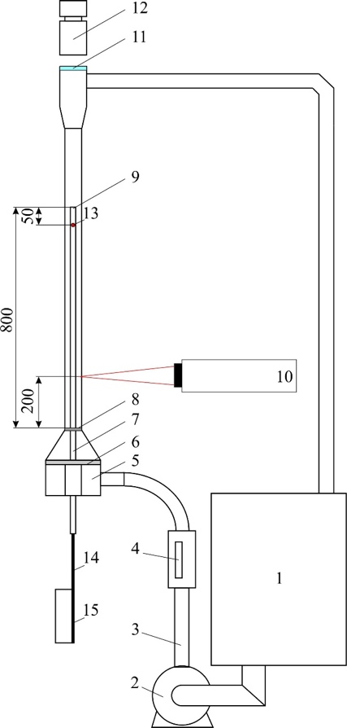

FIG. 1. The scheme of the experimental setup with an annular channel
1 - tank, 2 - pump, 3 - pressure line, 4 - flow meter, 5 - inlet manifold, 6 - honeycomb, 7 - tube - rod, 8 - grid, 9 - rod tip, 10 - LDV system, 11 - optical glass, 12 - speed chamber, 13 - sensor, 14 - rod with a capacitive displacement sensor 15 - electronic equipment
Vibration measurements were performed using the electrical impedance method. With the help of a capacitive sensor installed inside the rod, the deviation of its axis from the vertical position was recorded. The developed capacitive sensor consists of four sensors. They are located on a remote rod, which is inserted into the tube. The principle of operation of the sensor is based on measuring the capacitance between the sensor and the surface of the fuel element simulator, the capacitance depends on the distance between the sensor and the inner wall of the simulator. The sensor includes miniature boards 100x5x1 mm in size. By transforming four containers along the x and y axes into four distances and using triangulation methods, the position of the center of the rod axis relative to the stationary sensors was calculated.

results of experiments
Studies of rod vibrations in an annular channel and a central fuel element simulator in 7 rod model of fuel assemblies were carried out in the range of flow rates Q_{L} = 1.1 - 6 m³/h for a water coolant and at Q_{L} = 0.4 - 1.3 m³/h for lead - bismuth coolant. It was determined that at all liquid flow rates, a complex oscillatory process is observed, in which there is a change of periods with high and low oscillation amplitudes.
Figure 2 shows the typical time dependences of the displacement of the rod axis in the annular channel. The length of the rod was 800 mm, the superficial velocity of the liquid was V_{L} = 0.7 m/s for both coolants. Shown here are the time dependences of the displacement of the bar axis along the x and y coordinates.

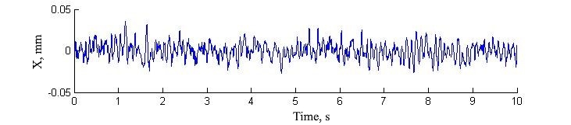
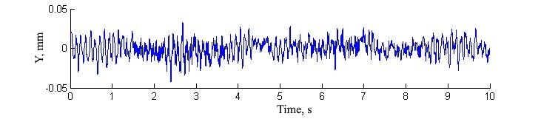
а)
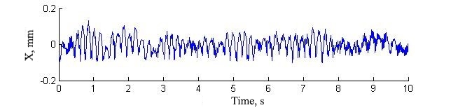
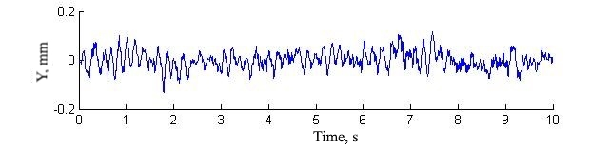
b)
FIG 2. Displacement of the rod axis in the annular channel at V_{L} = 0.7 m/s for water - a) and lead - bismuth coolant - b).

Figure 3 shows the trajectories of the rod axis in the annular channel. The rod axis trajectories for a signal sampling time of 1 second, with a total travel measurement time of 10 seconds are shown. As can be seen, for both coolants, the axis of the rod fluctuates around the vertical axis of the channel, the amplitude of the displacements is the greater, the higher the velocity of the fluid flow.
The amplitude-frequency characteristics of the rod vibration is shown in Figure 4. It can be seen from the figure that the vibration modes with frequencies up to 10 Hz have the maximum amplitude, the spectral characteristics of the signal have a peak in the region of 9-10 Hz. The dependence of the amplitude - frequency characteristics of the rod vibrations on the flow rate in the annular channel clearly indicates an increase in the vibration amplitude with an increase in the coolant flow rate.

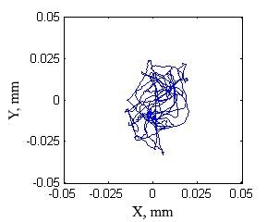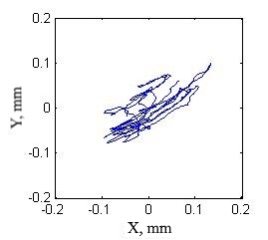
а) b)

FIG 3. The trajectory of the rod axis movement in the annular channel at V_{L} = 0.7 m/s for water - a) and lead - bismuth coolants - b).

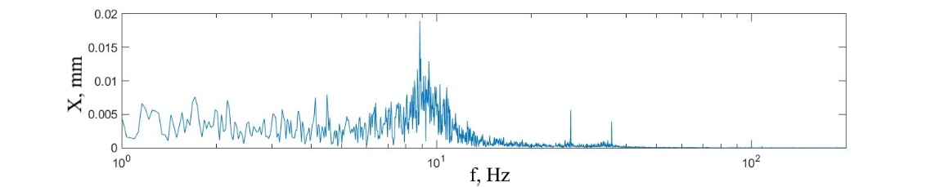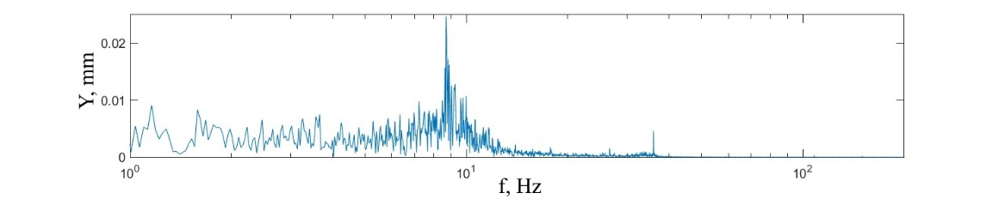
a)
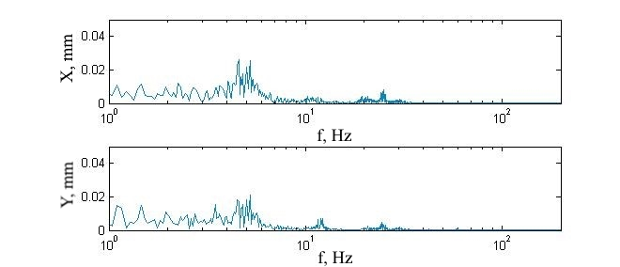
b)
FIG 4. The spectrum and vibrations of the rod along the x and y axes in an annular channel at V_{L} = 0.7 m/s for water - a) and lead - bismuth - b) coolants.

Figure 5 shows the vibration spectrum of the central simulator of a fuel element in a 7-rod model of a fuel assembly with a flow of water and lead-bismuth coolant. Figure 6 shows the amplitude - frequency characteristic of the oscillations depending on the flow rate of the coolant.

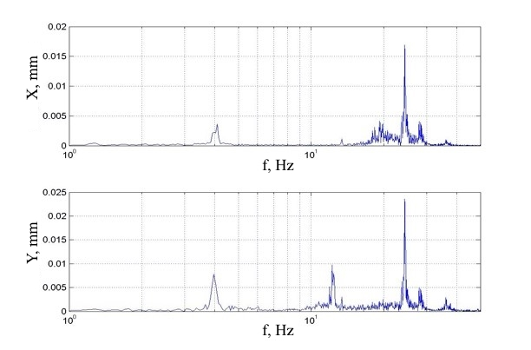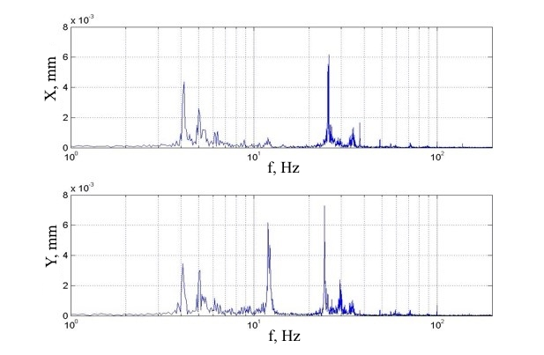
a) b)
FIG 5. Spectral characteristics of sensor signals for oscillation of the central fuel element simulator in the fuel assembly model for water - a) and lead - bismuth - b) coolants

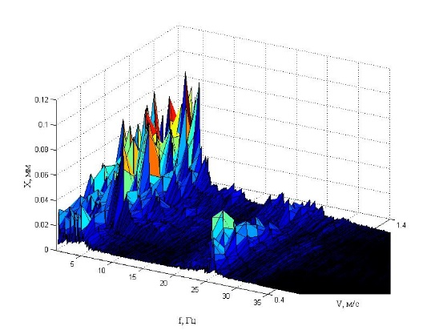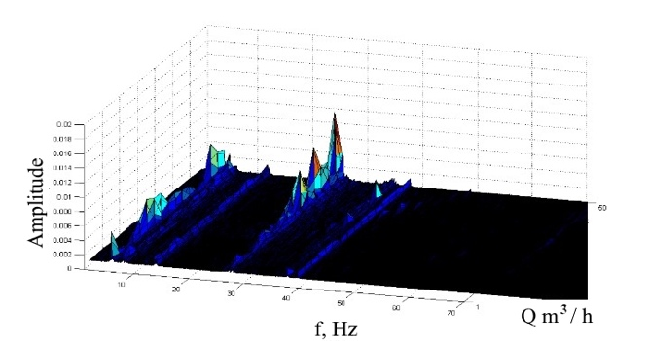
- b)
FIG 6. Dependence of the amplitude-frequency characteristics of the rod vibration in the annular channel - a) and the 7-rod model of fuel assemblies - b) for a lead-bismuth coolant.

An increase in the fluid velocity leads to the appearance of additional noise in the region of low frequencies and to an increase in the maximum vibration amplitude. With a decrease in the fluid velocity, the vibration frequency of the rod approaches the natural frequency of the rod in water.

conclusions
In this work, based on the electrical impedance method, an experimental study of the oscillations of a cantilever-fixed rod - a simulator of a fuel element in an annular channel in a longitudinal ascending flow of a liquid and a central simulator of a fuel element in a 7-rod model of a fuel assembly - was carried out. Comparison of data on characteristics of rod vibrations in fluid flow with different velocities was performed.
ACKNOWLEDGEMENTS
This work was financially supported by AO “Proryv” (contract No. 45) and GK “Rosatom” (contract No. H.4o.241.19.20.1027).

References
- Assessment of CFD Codes for Nuclear Reactor Safety Problems - revision 2, NEA, CSNI, 12 (2014).
- PETTIGREW, M., TAYLOR, C., FISHER, N., et. al., "Flow-induced vibration: recent findings and open questions", Nuclear Engineering and Design, 185, pp. 249-276 (1998).
- SHIN, Y., WAMBSGANSS, M., Flow-induced vibration in LMFBR steam generators: a state-of-the-art review, Nuclear Engineering and Design, 40(2), pp. 235-284 (1977).
- PAIDOUSSIS M., et al, Real-life experiences with flow-induced vibration, Journal of fluids and structures, 22(6), pp. 741–755 (2006).
- KANEKO, S., NAKAMURA, T., INADA, F., et al., Flow-Induced Vibrations Classifications and Lessons from Practical Experiences, Elsevier, Second Edition, 2014.
- PAIDOUSSIS, M., Fluid-structure interactions: slender structure interactions and axial flow. Volume 1, Academic press, 1998.
- PAIDOUSSIS, M., Fluid-structure interactions: slender structure interactions and axial flow. Volume 2, Academic press, 2004.

