Mechanistic Fuel Code BERKUT-U: Self-

Consistent Modeling of FUEL RODS

Thermomechanical Behavior and Processes

in the Fuel of Fast Breeder Reactors

A.P. Dolgodvorov¹, A.V. Boldyrev¹, A.V. Zadorozhnyi¹, I.O. Dolinsky¹, S.Yu. Chernov¹, V.D. Ozrin¹, V.I. Tarasov¹

¹Nuclear Safety Institute of the Russian Academy of Sciences (IBRAE RAN), Moscow, Russian Federation

Email contact of corresponding author: bav@ibrae.ac.ru

Abstract

The paper presents the results of calculations with the engineering and advanced versions of the BERKUT code, comparison of calculated results with the results of post-irradiation examination (PIE). The obtained results allow us to estimate efficiency of applied approaches, as well as the limits of their applicability and the need to account for additional effects. As the data of PIE shows, the experimental results have a fairly large spread even for fuel rods irradiated under similar conditions. The reasons for this spread are related both to the limited resolution of used measuring instruments and/or measurement methods, and due to a number of unaccounted factors, such as overlooked effects on fuel rods during assembly, transportation, overloading, etc. Therefore the results of deterministic calculations with fixed model parameters, as well as fixed input data, do not give a complete picture of the correspondence of the calculated results with the results of PIE. An effective method to mitigate this problem is to perform statistical calculations for the engineering and advanced versions, and then compare the obtained curves with confidence intervals with the results of PIE and each other. To reduce the computaition time, complete statistical calculations were performed only for several EFA.After that based on the obtained results of these calculations, a set of input parameters for statistical calculations was determined. The variation of chosen input parameters has the biggest impact on the calculation results. This allowed us to estimate the spread of deterministic calculations by performing a relatively small number of calculations with different combinations of significant parameters.

INTRODUCTION
Comprehensive program of computational and experimental substantiation (KPREO) for the use of mixed uranium-plutonium nitride (MUPN) fuel in the fast reactors (FR) with a liquid metal coolant (LMC) has been developed and launched in Russia [1]. In accordance with this program, experimental fuel assemblies (EFA) with prototype of the fuel rods with MUPN fuel of the promising BREST-OD-300 and BN-1200M reactors were irradiated in the BOR-60 and BN-600 reactors. Another direction of the KPREO was the creation of the new generation of computer codes that allow modeling the behavior of the reactor core of FR with MUPN fuel and liquid metal coolant in normal operating conditions, its violation and accident conditions. As part of this direction, the fuel performance code BERKUT has been developed at the Nuclear Safety Institute of the Russian Academy of Sciences (IBRAE RAN) for self-consistent computational modeling of evolution of the stress-strain state (SSS) and the temperature distribution in the fuel rod with nitride or oxide fuel, with a gas or liquid metal sublayer during irradiation in FR with liquid metal coolant in stationary and transient conditions of normal operation, as well as its violation up to accidents. Basing on the obtained SSS of a fuel rod, its mechanical state is estimated and its operability is justified.
A 1.5D approach was applied in the development of the BERKUT code, the fuel rod was divided into cells of arbitrary height in the axial direction. Each cell, which generally consists of a fuel column, a fuel-cladding gap, and a cladding, is divided in the radial direction into thin-walled coaxial cylindrical layers. For each cell in the radial direction, the thermal conductivity and the deformation problem of finding SSS are solved for two independent cylindrical structures in the case of an open fuel-cladding gap and for а combined cylindrical structure in the case of pellet-cladding mechanical interaction (PCMI). When solving the deformation problem, the presence of through cracks in the axial cell of the fuel column is taken into account.
At the time of starting work on the code, information about the processes in MUPN fuel under irradiation was limited. Therefore the parametric approach was used to describe the processes in the fuel, when the main processes affecting the temperature distribution and the SSS of the axial cell are described by the relations obtained by processing empirical results. These processes include: production and release to the free volume of gaseous fission products (FP), the swelling of the fuel composition and others.
The version of the code with a parametric description of the main processes in the fuel was called the “engineering” version or BERKUT-I. In parallel with the development of the engineering version, work was carried out to adapt the fuel code MFPR/R, developed for modeling the behavior of oxide fuel in thermal reactors, to the FR conditions. First version for mixed oxide fuel was developed, and then for nitride fuel [2]. This specially developed code was included as a fuel module in the new version of the BERKUT code, which received the postfix “advanced” version, and the code itself was named BERKUT-U [3, 4]. The new fuel module MFPR/R self-consistently models: microstructural changes and fuel swelling, accumulation and radioactive transformations of FP, their intra-grain and inter-grain migration, release to the free volume of gaseous FP, distribution of fission products and fuel components by molecular and phase states, and takes into account the influence of fission products on the thermophysical properties of fuel. The number of molecular compounds under consideration exceeds one hundred, and the number of radionuclides, accumulation and transport of which is modeled by the fuel module, reaches several hundreds.
Any version of the code can be used:

- As a part of the integral code for modeling transient and accident conditions of a reactor with a heavy LMC, for example, with the new generation integrated dynamic code EUCLID;
- As an independent tool for planning and justifying experiments on fuel rod irradiation, analyzing and interpreting the results obtained, and justifying the efficiency of fuel rods of existing and under development fast reactors;
- As an independent tool for carrying out statistical (multivariate) calculations that allows to get a more realistic picture of fuel rod behavior and identify the factors that most strongly affect the uncertainty of the calculated forecast or the model parameters that require the most careful determination.

The paper presents the results of calculations by the engineering and advanced versions of the BERKUT code, comparison of the calculated results with each other and with the results of post-irradiation examination (PIE). The results obtained allow us to estimate efficiency of the approaches used, as well as the limits of their applicability and the need to take into account additional effects. As the data of PIE show, the experimental results have a fairly large spread even for fuel rods irradiated under similar conditions. This is due not only to the limited resolution of the measuring instruments and/or measuring methods used, but also due to a number of factors that have not been accounted for, such as the unaccounted-for impact on fuel rods during assembly, transportation, overloading, etc. In this regard, the results of deterministic calculations with fixed values of the code model parameters, as well as fixed input data, do not give a complete picture of the correspondence of the calculated results with the results of PIE. An effective method to mitigate this problem is to perform statistical calculations for the engineering and advanced versions, and then compare the obtained curves with confidence intervals with the results of PIE and between each other. To reduce significantly the calculations, complete statistical calculations were performed for several EFA, and basing on the results of these calculations, a set of input parameters for statistical calculations was determined. The variation of these parameters most significantly affects the calculation results. This allowed to estimate the spread of deterministic calculations by performing a relatively small number of calculations with different combinations of significant parameters.

Results of statistical calculations
Sensitivity and uncertainty analysis was carried out within the framework of a statistic approach, in which the code input parameters that determine the fuel rod geometry, thermal and physical-mechanical properties of the fuel and cladding material, as well as parameters describing the irradiation regime, were randomly varied within the limits specified in the regulatory documents, or determined by expert assessments.
The uncertainty of each analyzed calculated value (code response) was characterized by a tolerance interval, which was a random interval enclosed between the minimum and maximum sample values obtained in statistical tests. The sample size, which is sufficient for a reliable statistical estimate of this interval was determined by the Wilkes formula [5]. The sensitivity of code responses to the variable parameters was characterized by dimensionless sensitivity coefficients $a_{i}$ [6, 7].
Sensitivity coefficients for the gaseous FP in the free volume of the fuel rod and fuel swelling at the campaign end for fuel rod of the EFA ETVS-5, obtained from statistical calculations according to the version of the BERKUT-U code are shown in Fig. 1.
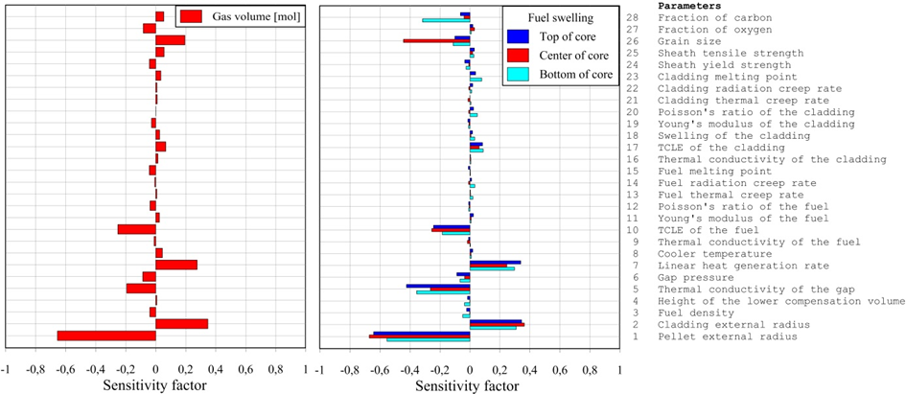
Fig. 1. Sensitivity coefficients for the gaseous FP in the free volume of fuel rod and fuel swelling at the campaign end for fuel rod of the ETVS-5

As shown above, to compare the results of the engineering and advanced versions of the BERKUT code, it is convenient to use the results of deterministic calculations with the maximum and minimum initial fuel-cladding gap.

Calculation results of engineering and advanced versions of the code
The code BERKUT was used for modeling thermomechanical state of the fuel rods with MUPN fuel of the combined EFA (CEFA) KETVS-1, KETVS-6, KETVS-7 and EFA ETVS-5 irradiated in the fast reactor BN-600. Below, the results of calculations with engineering and advanced versions of the BERKUT code and compared with data of PIE [9–12]. The experiments and PIE were performed in the framework of the program KPREO.
Table 1 shows the main characteristics of fuel rods and irradiation conditions of the above EFA.

TABLE 1. MAIN CHARACTERISTICS OF FUEL RODS AND IRRADIATION CONDITIONS OF KETVS-1, 6, 7 AND ETVS-5 [9–12]

Parameter | KETVS-1 | KETVS-6 | KETVS-7 | ETVS-5
Cladding diameter, mm  external  internal | 6.9^{±0.03}  6.1^{±0.03} | 6.9^{±0.03}  6.1^{±0.03} | 6.9^{±0.03}  6.1^{±0.03} | 9.7^{±0.03}  8.7^{±0.03}
Pellet diameter, mm | 5.8^{-0.1} | 5.9^{-0.1} | 5.9^{-0.1} | 8.5^{-0.1}
Gap diameter, micron | 300 | 200 | 200 | 200
Cladding steel | CHS68-ID | CHS68-ID | CHS68-ID | EP823-SH
Fuel type | (U,Pu)N | (U,Pu)N | (U,Pu)N | (U,Pu)N
Duration of campaign, eff. days | 433.0 | 290.2 | 589.2 | 589.2
Maximum linear power, kWt/m | 38.3 | 39.0 | 38.3 | 40.0
Maximum burnup, at.% | 5.5 | 3.9 | 7.5 | 3.8
Maximum damaging dose, dpa | 55.0 | 37.5 | 73.6 | 48.8
There were four fuel rods with MUPN fuel in each of the CEFA, the remaining 123 fuel rods were with pellets made of uranium dioxide. The nitride fuel rods of the CEFA differ, first of all, by the initial size of the fuel-cladding gap, duration of irradiation, final burnup, and damaging dose to the cladding. ETVS-5 contained 61 fuel rods of the type BREST-OD-300 with MUPN fuel, but only four experimental fuel rods were investigated, as for all KETVS. The fuel rods cladding was a cylindrical tube with a diameter of 9.7 mm and a wall thickness of 0.5 mm. The internal cavity of the all fuel rods was filled with helium.
Fig. 2 shows a comparison of the calculated minimum and maximum gas volume in the free volume of fuel rod for the engineering and advanced versions of the BERKUT code with the PIE for four experimental fuel rods of KETVS-1, 6 and ETVS-5. From the comparison with the results of PIE, it is clear that, for all cases, the advanced version describes significantly better the total FP releases. It should also be noted that the majority of the results of PIE lie between the calculated values obtained for the CT and NM variants, which corresponds to the maximum and nominal value of the fuel-cladding gap.
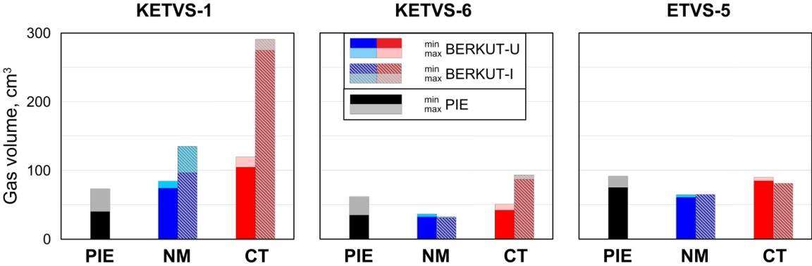
Fig. 2. Comparison of PIE data and the calculation results for FP releases to the fuel-cladding gap obtained by BERKUT-I and BERKUT-U versions of the code

Note that for the engineering version, the results of PIE also lie mostly between the CT and NM variants, but the spread between the calculated values of the CT and NM variants for the engineering version is several times greater than the spread for the advanced version. Although these observations are valid only for the standard size of the BN-600 reactor, i.e. all EFA, for the standard size of the BREST-OD-300 reactor, i.e. in the case of ETVS-5, the opposite picture is observed: the spread for CT and NM variants is maximum for the advanced version, and this is what allows suggest about the better correspondence with PIE.
Thus, one can see that for all EFA, the CT variant corresponding to the maximum possible initial fuel-cladding gap size predicts a significant excess of the FP release in comparison with both the results of PIE and the results of calculations by the advanced version. The reason for that behavior can be understood by comparing the calculated temperature evolutions in the center of fuel pellets in the cross section with the maximum heat release (the middle of the height of the fuel column) for the engineering and advanced versions.
Plot of the center of the fuel pellet temperature changes is presented in Fig.3. One can see that after 50 days of reaching power, CT-variant temperature begins to increase that leads to acceleration of FP release to the fuel-cladding gap. This, in turn, results in a further increase in temperature, an growth of FP release, and so on until the temperature reaches the level of ~ 2250 °C. At such temperatures, thermal deformations of the fuel pellets lead to decreasing of fuel-cladding gap, which first slows down the heating that is then replaced by a gradual decrease in temperature due to increased swelling of the fuel composition. This behavior of the calculated temperature is primarily due to the used parametric dependencies of the FP release from fuel pellet and the fuel swelling of the fuel composition. Both of these dependence include the current burnup value of the fuel composition as an input parameter, which is quite natural. And the dependence on the current temperature is present only at the FP release, while the fuel swelling does not depend on the current temperature. It is also clear that these parametric dependences were found based on the results of experiments with a non-zero burnup, whereas in the first 50 days the burnup is still insignificant and various transients are still ongoing.

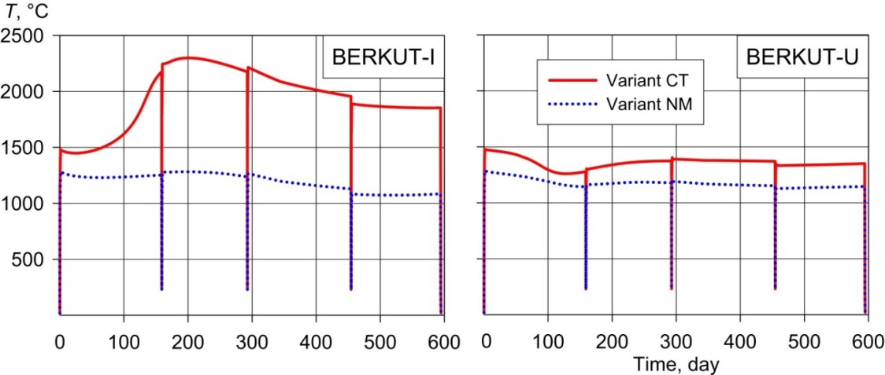
Fig. 3. Evolution of temperature in the center of the fuel pellets at the elevation with maximum heat release of the fuel rod of KETVS-7 calculated by BERKUT-I and BERKUT-U versions of the code

In the advanced version, the self-consistent solution of the temperature, deformation, and fuel processes leads to the fact that up to ~ 150 days there is practically no FP release to the fuel-cladding gap. During this “incubation period” FP generated within the grain reach the grain boundaries and fill intergranular porosity which make the main contribution to the gas component of fuel swelling.
Fig. 4 shows the calculated evolutions of volumetric swelling in the center of the fuel pellet and on the periphery for the advanced version and the average value used by the engineering version. It is seen that the processes of swelling and gas release are as if in antiphase (Fig. 5). The period of increasing swelling of the fuel composition during the first ~ 150 days is accompanied by almost zero FP release. While, after the swelling reaches a certain constant rate, the FP release to the fuel-cladding gap begins to grow, which even leads to a slight rise in the fuel temperature. Note that the fuel temperature predicted by the advanced version does not rise above the level reached immediately after reaching power during the entire duration of irradiation, and there are no sharp fluctuations, and the temperature changes very smoothly throughout. It is also clearly seen from Fig. 3 that the fuel swelling calculated by the advanced version is in good agreement with the results predicted by the parametric dependence for times exceeding 150 days, i.e. after the termination of most transients and the formation of intra-grain and inter-grain porosity.
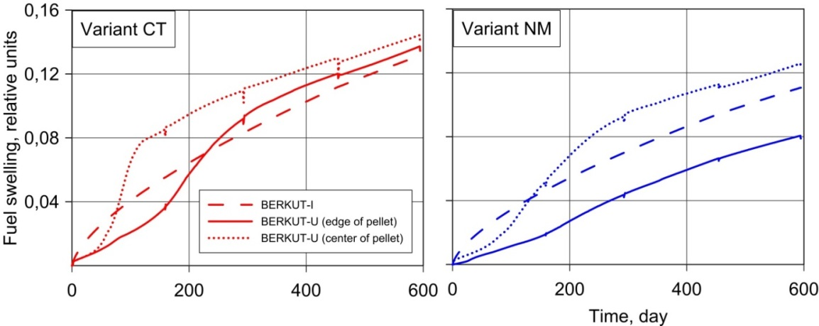
Fig. 4. Evolution of fuel swelling calculated by BERKUT-I and BERKUT-U versions of the code at the elevation with maximum heat release of the fuel rod of KETVS-7
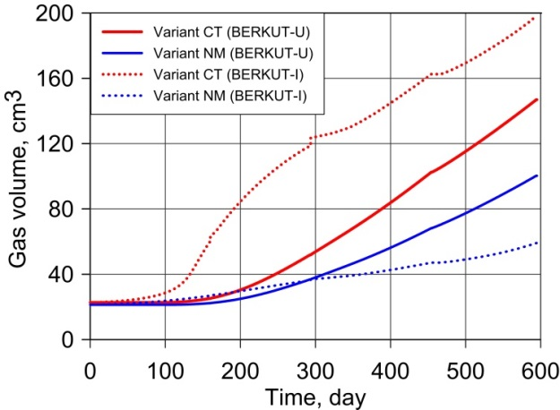
Fig. 5. Calculated evolutions of the release to the free volume of gaseous fission products of the fuel rod of KETVS-7 for the engineering (BERKUT-I) and advanced (BERKUT-U) versions of the BERKUT code

Let us consider the calculated behavior of the prototype fuel rod of the BREST-OD-300 reactor, irradiated in the ETVS-5. The calculated temperature evolution in the center of the fuel pellets at the elevation with the maximum heat release (mid-height of the fuel column) for the engineering and advanced versions of the BERKUT code is shown in Fig. 6. It can be seen that, firstly, after reaching steady-state power, the maximum fuel temperature becomes less than for the CEFA KETVS-7 by ~ 250 and ~125 degree for the CT and NM calculations, respectively, and, secondly, the calculated temperatures behave quite similar for the engineering and advanced versions.
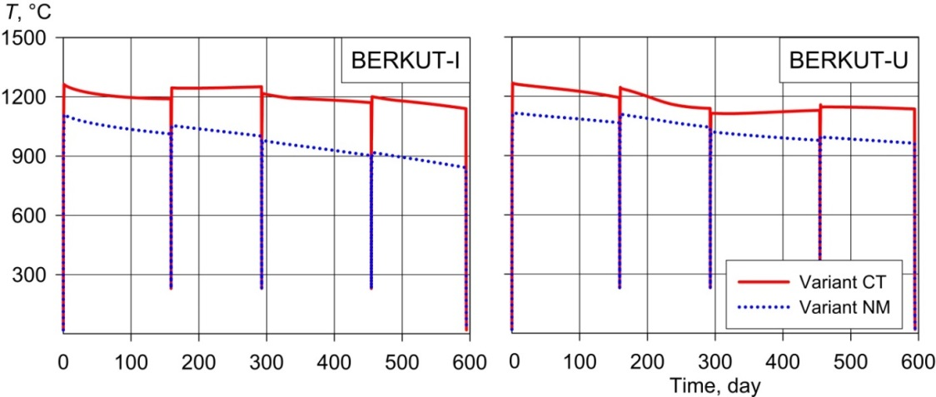
Fig. 6. Evolution of temperature in the center of the fuel pellets at the elevation with maximum heat dissipation of the fuel rod of ETVS-5 calculated by BERKUT-I and BERKUT-U versions of the code

All this can be explained quite simply: the large size of the fuel tablets leads to a decrease in temperature at the same linear heat release. Therefore, the level of swelling should also be lower for the prototype fuel rods of the BREST-OD-300 reactors in comparison with the fuel rods of CEFA, which is confirmed by comparisons with the PIE for four experimental fuel rods shown in Fig. 7.
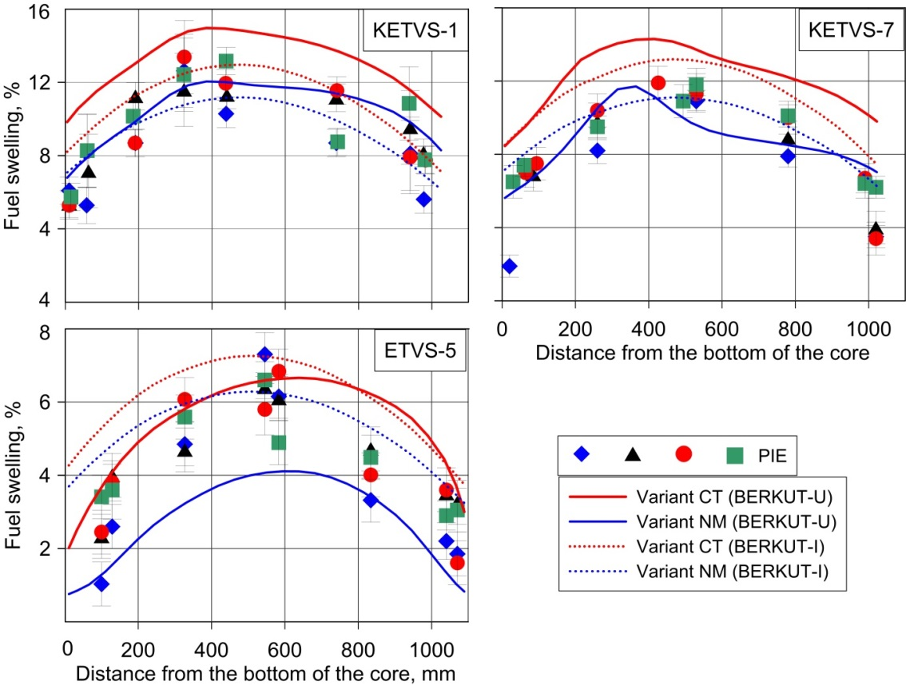
Fig. 7. Comparison of axial profiles of the pellet swelling calculated by BERKUT-I and BERRUT-U versions of the code with the results of PIE

Conclusions
Simulation results of the thermomechanical behavior of prototypes of fuel rods with MNUP fuel of promising Russian fast reactors with a liquid metal coolant, carried out using the fuel performance code BERKUT developed at the IBRAE RAN, implemented as an engineering and advanced version, are presented. The main difference between the versions is the way of describing processes in MNUP fuel: parametric in the engineering version and mechanistic, self-consistent in the advanced one.
To effectively compare the predictive ability of the code versions, a series of statistical (multivariate) calculations of the behavior of fuel rods with MNUP fuel under irradiation in the BN-600 reactor facility were carried out. The analysis of the sensitivity of the obtained calculation results showed that to compare the results of the engineering and advanced versions of the BERKUT code, it is convenient to use the results of deterministic calculations with the maximum and minimum value of initial fuel-cladding gap. This makes it possible to estimate the scatter of the calculation results with the PIE results by performing two deterministic calculations. In this case, the calculation with the maximum initial fuel-cladding gap value corresponds to the maximum values of the fuel temperature, gas release and fuel swelling, and with the minimum one – to the minimum values.
Then, deterministic calculations of the mechanical behavior and state of fuel rods with MNUP fuel in the KETVS-1, -6, -7 and ETVS-5, irradiated in the BN-600 reactor plant and studied within the framework of the KPREO program, were carried out. The fuel rods of the KETVS-1, -6, -7 had the sizes of pellets and claddings used in the BN-600 reactor plant. Fuel rods of the ETVS-5, being a prototype of fuel rods of BREST-OD-300, had increased diameters of pellets and claddings. The results obtained showed that the results on the fission products release obtained by the advanced version are in very good agreement with the PIE results, for the results of the engineering version the agreement is worse and the values obtained for the maximum value of the initial fuel-cladding gap noticeably exceed the PIE results. Another feature of the results of the engineering version for the maximum initial fuel-cladding gap is the increase in fuel temperature sometime after reaching power, which is then replaced by a slow decrease. Such an effect is predicted for all fuel rods with the dimensions of BN-600 fuel rods; for the BREST-OD-300 fuel rod dimensions in ETVS-5, a sharp increase in temperature is not predicted, which is apparently explained by the lower fuel temperature level due to the increased diameter of the pellet with the same initial fuel-cladding gap, which is confirmed by the lower swelling predicted by calculations and PIE results.
For all calculations using the advanced version, sharp spikes in fuel temperature were not predicted; the maximum temperature was reached after reaching power and then gradually decreased. The radius-averaged volumetric fuel swelling calculated by the advanced version is in good agreement with the results predicted by the parametric dependence for the times when most of the major transients in the fuel stopped.
References
- Troyanov V.M. et al. Program and results of reactor tests of mixed nitride fuel in fast reactors, At. Energ. 118 2 (2015) 75–79.
- Veshchunov M.S. et al. Development of mechanistic code MFPR for modelling fission product release from irradiated UO2 fuel, Nucl. Eng. Design 236 (2006) 179–200.
- Boldyrev A.V. et al., “BERKUT – best estimate code for modelling of fast reactor fuel rod behaviour under normal and accidental conditions”, Fast Reactors and Related Fuel Cycles: Next Generation Nuclear Systems for Sustainable Development FR17 (Proc. Int. Conf., Yekaterinburg, 2017), IAEA, Vienna (2018), Paper CN245-363.
- Boldyrev A.V. et al. BERKUT code validation on post-reactor studies of irradiated BN-600 fuel rods with mixed uranium-plutonium nitride fuel, At. Energ. 127 5 (2020) 356–361.
- Wilks S.S. Determination of sample sizes for setting tolerance limits, Ann. Math. Stat. 12 1 (1941) 91–96.
- Ounsy A. A Mathematical Tool for Uncertainty and Sensitivity Analysis of Calculation Codes, Note Technique SEMAR 96/94, IPSN/DRS/SEMAR, France, 1996.
- Ounsy A. SUNSET V0, Rev. 1 – User’s Manual, Note Technique, SEMAR 97/111, IPSN/DRS/SEMAR, France, 1997.
- Temporary guidelines on the use of data on the properties of structural materials and mixed uranium-plutonium nitride fuel to substantiate the performance of experimental fuel rods of the fuel assembly of the BN-600 reactor (3rd edition). Rosatom, Moscow, 2018.
- Zvir E.A. et al. The results of a study of the fuel rods of the combined experimental FA-1 after trial operation in the BN-600 reactor, Collected papers JSC “SSC RIAR” 3 (2017) 76–84.
- Zvir E.A. et al. Results of non-destructive post-reactor studies of the fuel rods of a combined experimental FA-6, Collected papers JSC “SSC RIAR” 4 (2017) 3–8.
- Grachev A.F. et al. Results of studies of BN-600 fuel rods with mixed uranium-plutonium nitride fuel and CHS68-ID c.d. steel cladding, At. Energ. 126 3 (2019) 182–190.
- Grachev A.F. et al. Results of a study of the fuel pins of a BREST-type reactor with mixed uranium-plutonium fuel irradiated in BOR-60 and BN-600, At. Energ. 125 5 (2018) 278–284.

