# First fully adjusted set of parameters for the corrosion product contamination code OSCAR-Na

J.B. GENIN

CEA, DES, IRESNE, DTN

Cadarache, Saint-Paul-Lez-Durance, France

Email: jean-baptiste.genin@cea.fr

L. BRISSONNEAU

CEA, DES, IRESNE, DTN

Cadarache, Saint-Paul-Lez-Durance, France

**Abstract**

The OSCAR-Na code has been developed during the last decade to calculate the mass transfer of corrosion products and related contamination in the primary circuit of sodium fast reactors (SFR). Indeed, even if fuel cladding corrosion appears to be very limited, the contamination of the reactor components plays an important role in defining the design, the maintenance and the decommissioning operations for SFR. The transfer of metallic elements between steel and sodium is mainly due to dissolution and precipitation at the interface, as well as to diffusion in the steel and through the sodium boundary layer. The key parameters of the transfer model are 1) element diffusion in steel, considered to be enhanced under irradiation 2) element diffusion through the sodium boundary layer 3) element equilibrium concentration in the sodium at the interface and 4) oxygen enhanced iron dissolution rate. For the first time, a full set of parameters has been evaluated for each element (Fe, Ni, Cr, Mn, Co) as a function of temperature through comparison of simulations with measurements in sodium loops and in sodium fast reactors. A satisfying validation of the OSCAR-Na code is obtained for the operational domain of a sodium fast reactor. The discrepancy between adjusted and published values for element diffusivity in steel (higher in the code) and element solubility in sodium (lower in the code) is discussed.

## Introduction

In the primary circuit or the primary vessel of sodium fast reactors (SFRs), corrosion of steel materials leads to release into sodium of alloy elements either activated or not. Corrosion products are transported by the sodium and they deposit on the primary surfaces. These phenomena result in a transfer of mass and contamination in the primary circuit which affects the operation of the reactor. Indeed, the contamination of components like Intermediate Heat Exchangers (IHX) and primary pumps has to be addressed during maintenance or dismantling operations.

A model for transfer of metallic elements and radionuclides at the steel/sodium interface has been implemented in the OSCAR-Na code, dedicated to simulation of contamination and mass transfer in a SFR primary circuit. This model is based on equating the diffusion fluxes in the metal and in the sodium with the dissolution/precipitation flux at the interface. Its implementation in the OSCAR-Na code relies on the resolution of the 1D-diffusion equation in the metal by a numerical method for stable and radioactive nuclides, which makes OSCAR-Na unique amongst the corrosion product transport codes for SFR reactors.

The model parameters (mainly element diffusivity in steel and element solubility in sodium) are adjusted by comparison of simulations with measurements in sodium loops and in a sodium fast reactor. The paper presents the parameter values retained in OSCAR-Na. Their discrepancy with previously published values is discussed.

## Corrosion Phenomenology in a SFR

The following observations account for a sodium circuit with low oxygen content (< 5 ppm), for which the corrosion process is mainly due to the dissolution of wall materials. This corresponds to the operational domain of French SFR reactors (~ 1 ppm oxygen). At oxygen contents higher than 5 ppm, ternary oxide compounds can be stable and removed by erosion process.

Two mechanisms are driving steel corrosion in a sodium circuit with low oxygen content [1-5]:

* “General corrosion” or “stoichiometric corrosion” is related to iron dissolution. It leads to surface recession at the steel/sodium interface (as iron accounts for about 2/3rd of the steel mass) and to the release of all alloy elements according to the steel composition. The corresponding mass loss increases linearly with time, given that the operating conditions of the sodium circuit remain constant. The corrosion rate increases with temperature, with sodium velocity (below a limit sodium velocity) and with oxygen content in sodium. The latter correlation is due to the fact that oxygen acts as a catalyst of the iron dissolution process;
* “Preferential corrosion” or “preferential leaching” is related to the dissolution of the main alloy elements (Ni, Cr, Mn), which is faster than iron dissolution. Thus, their diffusion in the steel leads to a depletion of these elements near the surface. The initial evolution of the corresponding contribution to mass loss is parabolic . Then the preferential mass loss tends towards a limit value that is all the greater when the element diffusion in steel is fast and the general corrosion rate is low. Nickel depletion leads to the formation of a ferritic layer near the steel surface, in which metallic element diffusion is faster than in the initial austenitic phase. Some minor elements (Co, Mo) dissolve less rapidly than iron. In this case, an enrichment of these elements is observed in steel near the surface. Lastly, the concentration profile (g/cm3) of iron in steel remains uniform as if iron did not diffuse in steel.

Corrosion occurs at the hot surfaces of a sodium circuit and deposits are observed on the cold surfaces of the circuit. In a SFR reactor, cladding corrosion leads to the release into the sodium of activated corrosion products, which contaminate by diffusion or precipitation all the out-of-flux surfaces: IHX and primary pumps (and cold and hot legs in loop type SFR). The main radiocontaminants (with their radioactive period) are 54Mn (312 d), 60Co (1 925 d) and 58Co (71 d).

## The OSCAR-Na code as a predictive tool

To face the challenges related to contamination transfer in a sodium circuit, a predictive tool is of major interest for SFR conception, operating and dismantling. Empirical laws such as Baqué’s law or Thorley’s law [5] were proposed to assess the global corrosion rate as a function of oxygen content in sodium (and of sodium velocity for Baqué’s law), but they do not deal with the preferential release of the main alloy elements.

According to the assumption that the transfer between steel and sodium is mainly by dissolution and precipitation, Polley and Skyrme [3] proposed a model using mass transfer theory. A complete mass balance is theoretically required around the circuit for each corrosion product, i.e. the concentration in the sodium at all positions in the circuit as a function of time. For release analysis, Polley and Skyrme assumed the element concentration in sodium to be zero. This model has been implemented in the Japanese code PSYCHE [6] and in the Indian code SOLPREC [7] to assess the contamination of a reactor primary circuit. However, these codes deal only with radiocontaminants and do not simulate mass transfer. Moreover, the use of an analytical method to solve the diffusion equation in steel requires the concentration in the sodium to be independent of time. For this reason, the mass balance in the sodium circuit remains simplified, even if it improves the zero concentration assumption of Polley & Skyrme, which overestimates the release of corrosion products.

The Russian code AEROSOL-LM/Na [8] is also dedicated to the transport and behavior of corrosion products in the sodium coolant, as well as fission products and activation products, but it does not deal with the diffusion of metallic elements in the steel.

At the CEA, the OSCAR code [9] has been developed over the past 5 decades to simulate the contamination of the circuits of Pressurized Water Reactors. The OSCAR code is a modular code which can easily integrate new models and calculate mass balances around every circuit. The simulated circuits are discretized into as many nodalization cells or regions as necessary. The OSCAR-Na code corresponds to the adaptation of the OSCAR code to SFR by implementing the Polley and Skyrme’s model. Indeed, it will be shown hereafter that this model can reproduce the above observations for low oxygen content circuits.

The OSCAR-Na code has already been presented in [10,11]. The implementation of the Polley and Skyrme’s model is reminded here. The model is based on equating for each nuclide (stable or radioactive) the mass fluxes  at the steel/sodium interface for diffusion in the steel (eq. 1), for dissolution and precipitation at the steel surface (eq. 2) and for diffusion across the sodium boundary layer (eq. 3):

|  |  |
| --- | --- |
|  | (1) |
|  | (2) |
|  | (3) |

where  is the diffusion coefficient in the steel,  is the general corrosion rate (> 0) or deposition rate (< 0),  and  are the concentration in the steel and bulk sodium, respectively (the subscript  indicating interfacial values at ),  and  are the dissolution and precipitation (absorption) kinetic constants, respectively, and  is the mass transfer coefficient for diffusion through the sodium boundary layer.

Eliminating  from eqs. (2) and (3) yields:

|  |  |
| --- | --- |
|  | (4) |

where  is the effective mass transfer coefficient.

The  ratio that appears in eq. (4) can be seen as a solubility parameter. Indeed, if the dissolution/precipitation reaction is the same for alloy elements in a sodium circuit as for pure elements in pure sodium, then thermodynamics theory links the ratio  to the element solubility  (mass fraction):

|  |  |
| --- | --- |
|  | (5) |

where  is the activity coefficient of the element in steel,  and  are the molar masses of the steel and the element, respectively, and  and  are the sodium density and the steel density, respectively.

In OSCAR-Na, the interface concentration in the steel  is obtained for each nuclide by numerical solving of the general 1D-diffusion equation in the steel:

|  |  |
| --- | --- |
|  | (6) |

where  is the decay constant due to radioactive decay and neutron capture, and  is the rate of production by neutron activation (if appropriate for the element and the surface considered). The steel is assumed to be of infinite thickness and the boundary condition at the interface is derived from equating (1) and (4):

|  |  |
| --- | --- |
|  | (7) |

The mass flux  is calculated from eq. (4) through iterations at each time step between the numerical solving of the diffusion equation in steel for each region, which provides , and a complete mass balance around the sodium circuit (taking account convection, purification on cold traps, neutron activation, radioactive decay), which provides  [10,11]. The mass transfer between metal and sodium, as well as the concentration in the sodium and the concentration profile in the steel, are then calculated for all considered nuclides at all positions in the circuit as a function of time. Moreover, the numerical method implemented in OSCAR-Na allows varying the operating conditions of the circuit: reactor power, temperature, oxygen content, sodium velocity …, as well as taking into account parent depletion for radionuclides creation in steel and enhanced diffusion in the ferrite layer.

The Polley and Skyrme’s model is thus fully implemented in OSCAR-Na. However, additional assumptions are taken into account in order to specify the model parameters:

* Diffusion is enhanced in the ferritic layer that forms near the surface due to the nickel depletion. Austenite is supposed to turn into ferrite when:

|  |  |
| --- | --- |
|  | (8) |

where  and  are the nickel and manganese concentrations in steel respectively,  is the steel density, and  a threshold value;

* In a reactor, metallic element diffusion in the steel is also enhanced under neutron flux due to the defects in the lattice produced by irradiation, according to the following equation [4]:

|  |  |
| --- | --- |
|  | (9) |

where  is the diffusion coefficient under irradiation at the nominal power of the reactor,  is the local power fraction, and  is the diffusion coefficient at equilibrium (out of neutron flux);

* For all elements, the mass transfer coefficient through the sodium boundary layer, , is calculated from the following relationship [12]:

|  |  |
| --- | --- |
|  | (10) |

where  and  represent the Reynolds and Schmidt numbers, respectively,  is the diffusivity of the element in liquid sodium, and  the equivalent hydrodynamic diameter of the flow path;

* For other elements than iron, the precipitation rate  is much greater than the diffusion rate through the sodium boundary layer , and then has no effect on the effective mass transfer coefficient:  (local equilibrium is obtained at the interface for these elements). Consequently, mass transfer is controlled by diffusion through the sodium boundary layer;
* Oxygen is involved in the iron dissolution and precipitation reactions: the kinetic constants  and  increase with the oxygen content  in the sodium like , where  is the apparent order of reaction. Thus, iron transfer at the steel/sodium interface is controlled by the surface reaction when the oxygen content is low and the sodium velocity is high;
* The iron concentration profile in the steel is uniform: iron does not diffuse in the depleted layer. Consequently, the iron flux at the interface is stoichiometric: , and the interfacial velocity (corrosion rate in hot regions or deposition rate in cold regions) is governed by iron behavior (see eqs. (1) and (4)):

|  |  |
| --- | --- |
|  | (11) |

* Elements dissolved in the sodium precipitate on cold traps (the coldest points of the circuit), and can be partially or totally retained in the purification circuit. The latter option is selected for all of them in OSCAR-Na. It can be deduced from eq. (4) that the ensuing lowering of the sodium concentration leads to an increase of the mass transfer.

## Method for EVALUATION OF THE MODEL PARAMETERS

To predict contamination transfer from the above model, the following parameters must be assessed:

* The diffusivity  of metallic elements (except iron) in steel, which is enhanced under neutron flux due to the creation of defects in the lattice (cf. eq. (9));
* The diffusivity  of metallic elements in sodium, which is used for assessing the mass transfer coefficient  (cf. eq. (10));
* The kinetic constant  for the iron precipitation reaction;
* The apparent solubility  of metallic elements in the sodium circuit. The apparent solubility is linked to the  ratio by eq. (5) assuming that :

|  |  |
| --- | --- |
|  | (12) |

Some of these parameters have been calculated (diffusivity in steel of metallic elements under neutron flux [4]) or have been assessed from a literature review (diffusivity in sodium [13]). Other parameters have been evaluated by fitting the model to the experimental database for OSCAR-Na validation.

The considered experimental database consists of:

* Measurements in the PHENIX reactor:
  + - * Axial contamination profiles of radiocontaminants along an intermediate heat exchanger;
      * Total amount of contamination of the IHX, obtained from measured activity in washing and decontamination effluents.
* Sodium loop experiments. The following operating parameters can be varied in the experiments: difference between hot and cold temperatures of the circuit, sodium velocity and Reynolds number in the test section, oxygen content in the sodium, experiment duration, flow rate fraction on cold traps. An increase of each of these parameters enhances the mass transfer. The retained data in the validation database is:
  + - * STCL loop (operated in the 1970’s by HEDL, Westinghouse) [2,14,15]: global and elementary mass loss as well as concentration profiles of metallic elements and radionuclides in SS316 samples exposed to sodium at the hot temperature of the circuit;
      * TIGIBUS loop (operated in the 1970’s by the CEA): global mass loss in SS316 samples exposed to sodium at the hot temperature of the circuit;
      * MASS-BROTHERS loop (operated in the 1980’s by the CEA): global mass loss or gain in SS316 samples exposed to sodium along the circuit.

In this study, the model parameters have been adjusted from PHENIX and STCL data only. Then the calibrated model has been compared to MASS-BROTHERS and TIGIBUS measurements.

## ADJUSTED PARAMETERS in OSCAR-Na

A full set of parameters as a function of temperature has been obtained mainly by fitting the model to the validation database, and is presented in this chapter. Some discrepancies are observed with the published values, due to the specificity of a dynamic sodium circuit, as discussed hereafter.

### Effective diffusivity in steel

The effective diffusivity  for each element in austenite and in ferrite is adjusted from the validation database. Particularly, the concentration profiles obtained from STCL experiments at 604 °C (see § 6.1) provide accurate values for this temperature [11]. The adjusted diffusivities in austenite are higher by one or two orders of magnitude than the recommended values for lattice diffusion of Cr [16], Ni [17], Mn [18], and Co [19] in 316 steel, especially at high temperature (Fig. 1). Brehm [15] provides an explanation for this difference: nickel and chromium depletion would lead to the creation of vacancies, which enhance diffusion in the steel near the surface. This hypothesis is supported by his observation of a higher diffusivity of 54Mn in a sample exposed to sodium at high velocity (showing a deeper depletion in nickel and chromium) than in a sample exposed to sodium at low velocity. This observation also highlights that element depletion is specific to a dynamic sodium circuit, since it increases with sodium velocity.

Diffusivity at equilibrium in the ferrite layer is enhanced by a factor 20 in OSCAR-Na compared to the austenite diffusivity. The threshold value (see eq. (8)) under which austenite turns to ferrite is set to 2.1%.

Lastly, the diffusivity under irradiation  used in OSCAR-Na is also presented in Fig. 1. The same value is considered for all elements, and corresponds to the diffusion under irradiation of iron in stainless steel [4]. As shown in Fig. 1, diffusivity under irradiation is enhanced at a temperature lower than 550 °C but not at a higher temperature (see eq. 9).

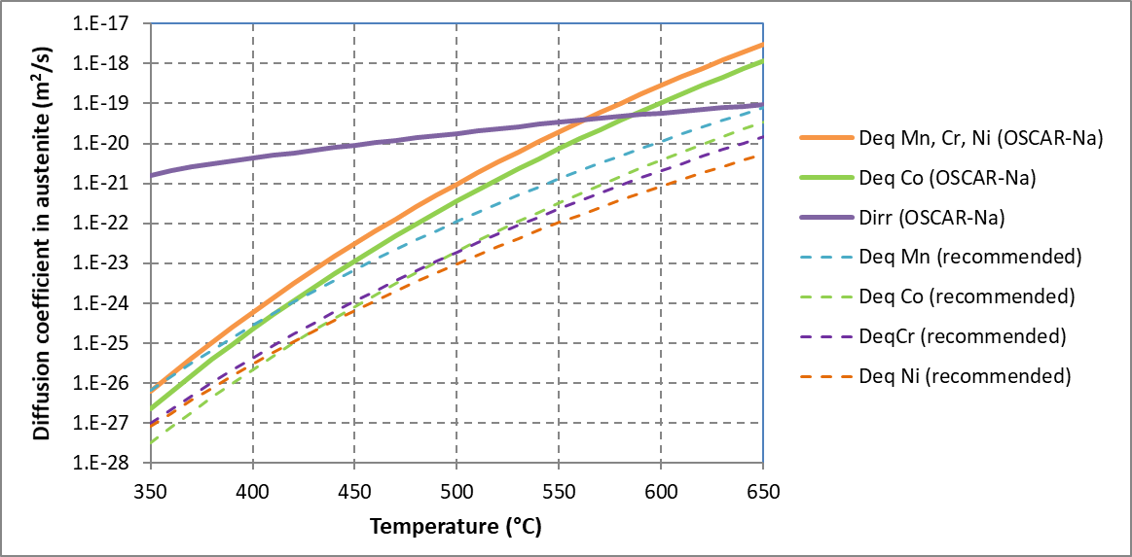

FIG. 1. Element diffusivity in austenite.

### Apparent solubility in sodium

The apparent solubility in sodium of each metallic element is adjusted from the validation database. The adjusted solubilities are much lower than the recommended values [1,20] for pure element solubility in pure sodium (Fig. 2).

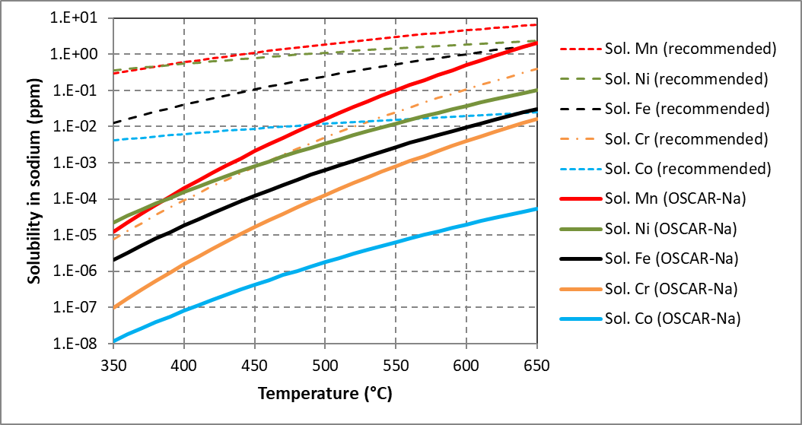

FIG. 2. Element solubility in sodium.

The apparent solubility is obtained from various assumptions, which can explain this discrepancy:

* The formation of a metastable ternary complex with sodium and oxygen is not considered in OSCAR-Na but could occur in a sodium circuit (even with low oxygen content) and could lower the apparent element solubility. Indeed, even if the ternary complex is not thermodynamically stable, it may be involved in the dissolution mechanism and in the diffusion through the sodium boundary layer. This might be the case for chromium and iron. Once again, this behavior is specific to a dynamic sodium circuit, since the formation of a metastable ternary complex has no impact on the element solubility measurement in a crucible with static sodium. The involvement of an oxygenated complex in the dissolution process is consistent with Fleitman and Isaacs measurements [21], according to which the iron solubility could be oxygen dependent down to very low oxygen concentration in sodium, while the recommended values do not vary for oxygen concentrations lower than 0.1 times saturation [1], which means high oxygen content.
* The activity coefficient of each element in steel is supposed to be equal to 1. A lower activity coefficient would correspond to a higher apparent solubility;
* It is assumed that the surface reaction rate does not control the flux at the steel/sodium interface (except for iron). However this assumption may not be valid at low temperature: a lower mass transfer coefficient at low temperature could account for the high temperature dependence of the apparent solubility of other elements than iron;

### Diffusivity in sodium

The diffusivity  for each element in sodium is obtained from the Sutherland-Einstein relationship [13]:

|  |  |
| --- | --- |
|  | (13) |

where  is the Boltzmann constant,  is the absolute temperature of the sodium,  is the sodium viscosity, and  is the radius of the diffusing entity formed with liquid metal and the solute metal. Published values of  in liquid Hg are used in this study (Table 1), although atomic radius would probably be more relevant for diffusion in liquid Na.

TABLE 1. Radii (picometer) of the diffusion particle used for evaluation of element diffusivity in liquid Hg [13]

|  |  |  |  |  |  |
| --- | --- | --- | --- | --- | --- |
| Element | Fe | Mn | Co | Ni | Cr |
| Radius of the diffusing particle (pm) | 116 | 238 | 255 | 330 | 107 |

### Kinetic constants for iron surface reaction

The kinetic constants  and  for iron precipitation and dissolution, respectively, are adjusted from the validation database. They are related to iron apparent solubility by eq. (12):

|  |  |
| --- | --- |
| (m/s)  (m/s) | (14) |

where  is the gas constant (8.314 J.K-1.mol-1),  (Kelvin) is the absolute temperature of the sodium at the interface, and  (ppm) is the oxygen content in the sodium.  is obtained from the Noden solubility law for oxygen in sodium [22]:

|  |  |
| --- | --- |
|  | (15) |

where  (Kelvin) is the absolute temperature of the cold trap.

## COMPARISON of OSCAR-Na simulations with the validation database

The model parameters have been adjusted to best simulate the experimental data. Some of the main results are presented hereafter.

### Concentration profiles in STCL loop at 604 °C

Concentration profiles of elements and radionuclides have been obtained for type 316 fuel cladding specimens in the STCL loop by electropolishing of successive layers and chemical or radiochemical analysis of the polishing solutions. Detailed data have been published for specimens exposed to sodium for 6000 hours ( = 604 °C,  = 154 °C) [2]. The concentration profiles have been recalculated from this data to be comparable to the OSCAR-Na outputs [11]. This detailed data allowed assessing the following model parameters at 604 °C:

* The effective diffusivity in austenite for each element, which governs the depth of the depleted layer;
* The apparent solubility in sodium for each element, which governs the interface concentration;
* The nickel concentration threshold for austenite/ferrite transition;
* The diffusivity ratio between austenite and ferrite.

A very good experiment/simulation agreement is obtained for each element concentration profile (except cobalt) as illustrated in Fig. 3 for nickel and chromium.

54Mn and 60Co normalized concentration profiles have also been published [14] for specimens exposed for 6000 hours to sodium at 604 °C with high oxygen content (*TCT* = 154 °C /  = 3.8 ppm) or low oxygen content (*TCT* = 115 °C /  = 1.0 ppm). The measured profiles at high oxygen concentration were recalculated as mentioned above in order to allow comparison with OSCAR-Na simulations, whereas the profiles at low oxygen content could not be, because of limited data. However, it can be estimated at low oxygen content that the experimental profiles correspond to the simulation, both for 54Mn and 60Co.

A good agreement can be observed between 54Mn experimental and simulated profiles at both low and high oxygen content (Fig. 4, left). The oxygen content has very little effect on 54Mn depletion, which is correctly simulated. On the contrary, a large discrepancy is observed (Fig. 4, right) between 60Co experimental and simulated enrichments at high oxygen content. As already suggested by Brehm [14,15], it can be proposed that cobalt dissolution is oxygen dependent. Indeed, a higher cobalt dissolution rate for high oxygen simulation would lower the enrichment and lead to a better agreement between experiment and simulation. The assumption in OSCAR-Na that cobalt dissolution is controlled by diffusion in the sodium boundary layer should then be revised, by considering a low surface reaction rate controlled by oxygen content in sodium. In this case, the apparent solubility for cobalt would be increased in OSCAR-Na to balance the low surface reaction rate. As for iron, oxygen in sodium would inhibit the cobalt dissolution reaction at low oxygen content.

### Mass losses in STCL loop at 538 °C and 604 °C

Global and elementary mass losses have been measured in the STCL loop for type 316 fuel cladding specimens exposed to sodium for 6000 hours at 604 °C or for 12000 hours at 538 °C [14,15]. The oxygen level in sodium is either low (*TCT* = 115 °C /  = 1.0 ppm) or high (*TCT* = 154 °C /  = 3.8 ppm). Fig. 5 shows for each sodium temperature and each oxygen level: 1) the experimental global mass loss in the form of a linear correlation with time, 2) the simulated global mass loss, and 3) the simulated stoichiometric contribution to global mass loss.

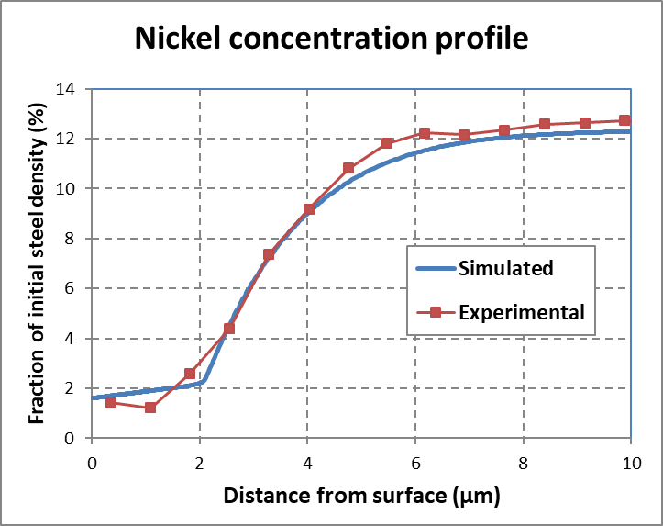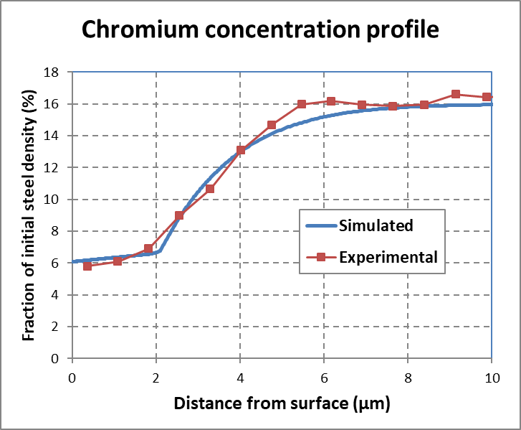

FIG. 3. Experimental and simulated concentration profiles in STCL (TNa = 604 °C, TCT = 154 °C, 6000 hours).

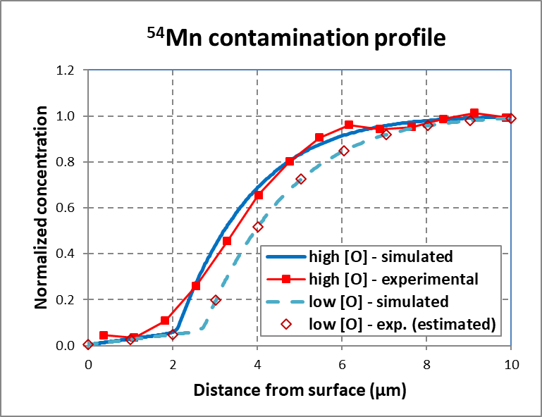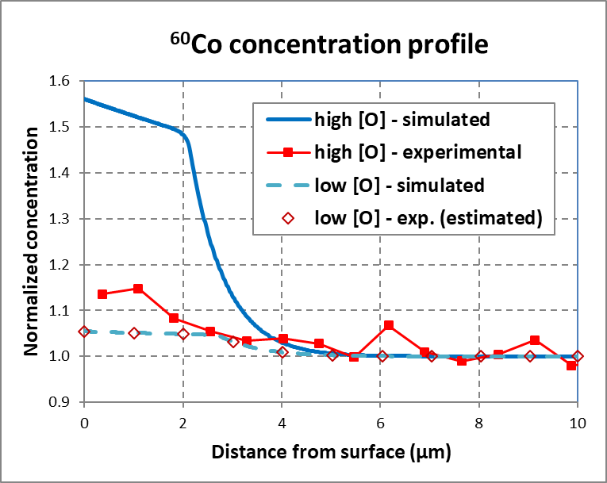

FIG. 4. Exp./sim. concentration profiles in STCL (TNa = 604 °C, 6000 hours) at low and high oxygen contents.

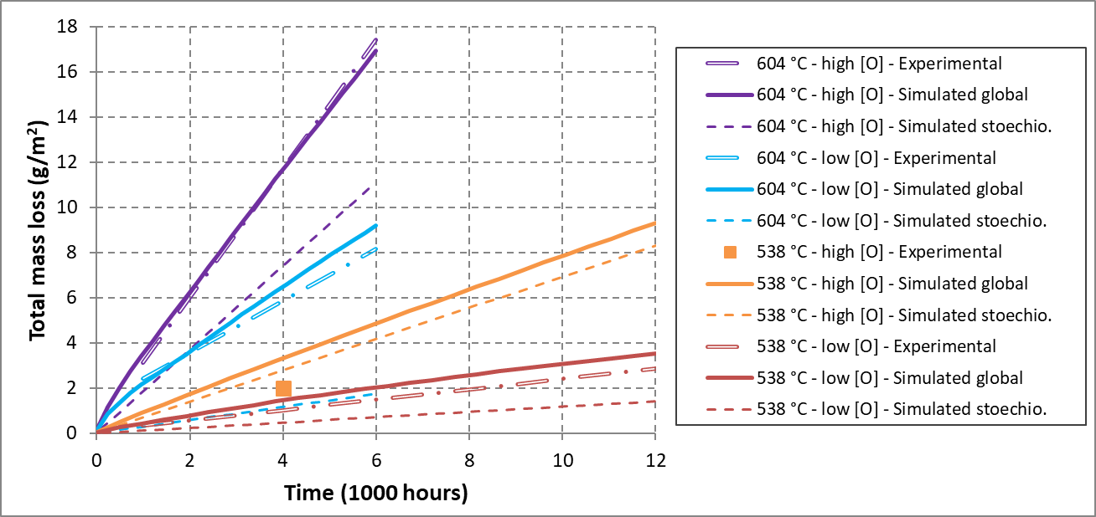

FIG. 5. Experimental and simulated (stoichiometric and global) mass losses in STCL.

The experiment/simulation agreement is good, particularly at 604 °C, at which temperature accurate measured concentration profiles allowed a fine assessment of the model parameters. The agreement is also good for each of the main metal elements: Fe, Ni, Cr, Mn (not presented here). It must be highlighted that the only oxygen dependent parameter in the simulation is the iron dissolution rate: this is sufficient to correctly simulate the mass release of all major elements in metal at both oxygen contents. The stoichiometric contribution to global mass loss increases with oxygen content, according to eq. (14).

### IHX contamination in PHENIX reactor

54Mn, 58Co and 60Co surface contamination along a PHENIX IHX was measured by gamma spectrometry during the removal of the component after about two years of operation. The simulation of the reactor with OSCAR-Na, already performed previously [10], has been updated with the new set of model parameters and is compared to the measured contamination (Fig. 6). The global amount of contamination as well as the contamination profiles and their relative position for the 3 radionuclides are correctly simulated. The 60Co simulated surface contamination, which is too low, could be improved by increasing the Co content in steel or the 59Co 🡪 60Co reaction cross section. Indeed, there is a high uncertainty on these two parameters.

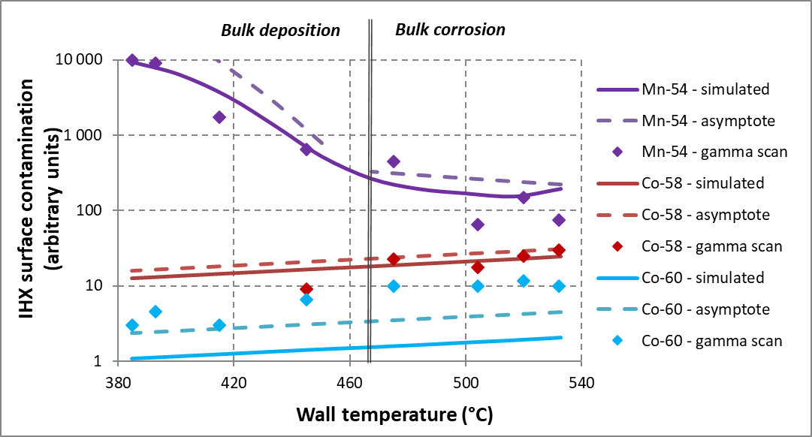

FIG. 6. Experimental and simulated contamination profiles along a PHENIX IHX.

The following asymptotic expressions are plotted in Fig. 6 (dashed lines) and are close to the simulated surface contamination. They were proposed by Polley and Skyrme [3], and highlight the controlling mechanisms for IHX surface contamination ( is the decay constant for the considered radionuclide):

*  for 54Mn on surfaces undergoing bulk corrosion (): control by solid-state diffusion;
*  for 54Mn on surfaces undergoing bulk deposition (): control by bulk deposition;
*  for 58Co on all surfaces: control by diffusion through the sodium boundary layer;
*  for 60Co on all surfaces: control by diffusion through the sodium boundary layer.

The cobalt concentration  in sodium varies like cobalt solubility, and therefore the surface contamination too. Cobalt solubility has then been adjusted in OSCAR-Na in order that the global amount of IHX contamination in 58Co fits the measurement. As seen previously, cobalt dissolution could be oxygen dependent, which is not the case in the current OSCAR-Na version. The oxygen content in PHENIX sodium is  = 1.2 ppm (*TCT* = 120 °C). This observation is consistent with the fact that the 60Co contamination profiles in STCL specimens were well simulated at low oxygen level (1.0 ppm, close to PHENIX value) and not at high oxygen level (3.8 ppm).

### TIGIBUS and MASS-BROTHERS loops

The experimental results obtained with these loops have not been used for adjustment of the model parameters. However an experiment/simulation comparison has been performed and the following observations have been made. Some experiments with close operating conditions have been carried out in STCL and TIGIBUS loops. For example, hot temperature = 604 °C and cold trap temperature = 115 °C ( = 1.0 ppm) for STCL, and hot temperature = 600 °C and cold trap temperature = 110 °C ( = 0.9 ppm) for TIGIBUS. The main differences between the two loops are the temperature difference between hot and cold zones (400 °C for TIGIBUS vs 177 °C for STCL) and the sodium velocity in the test zone (2 m/s in TIGIBUS vs 6,7 m/s in STCL). In both experiments, OSCAR-Na calculates the mass loss at the same level whereas the measured mass loss is 2 to 3 times lower in the TIGIBUS experiment. Both a higher hot/cold temperature difference and a higher velocity favor the mass loss. Thus it seems that in OSCAR-Na simulation, the effect of the temperature difference is too high or the effect of the sodium velocity is too low. The conclusion is similar with the MASS-BROTHERS loop (hot temperature = 690 °C,  = 0.9 ppm, temperature difference = 290 °C, sodium velocity in the boiler = 1 m/s) for which the simulation overestimates the mass loss by a factor 3 to 4. This discrepancy is currently under investigation.

## Conclusion

The dissolution/precipitation model at the steel/sodium interface proposed by Polley and Skyrme [3] has been implemented as precisely as possible in the OSCAR-Na code, using a complete masse balance around the sodium circuit for each element or radionuclide and a numerical method for solving the diffusion equation in steel. Iron mass balance allows calculating the surface recession rate (hot regions) or the deposition rate (cold regions).

The model parameters (mainly effective diffusivity in steel and apparent solubility in sodium for each element) have been assessed by fitting the simulation to an experimental validation database consisting of the PHENIX reactor and sodium loop experiments. The discrepancy observed when comparing assessed parameters to a literature review can be attributed to the specificity of a dynamic sodium circuit. OSCAR-Na simulations are in good agreement with experimental data from PHENIX IHX in terms of contamination as well as with concentration profiles in steel and mass losses obtained in STCL experiments at different oxygen contents in sodium. The oxygen effect is well simulated thanks to an oxygen enhanced iron dissolution rate. However mass losses are overestimated for loop experiments with a lower sodium velocity and a larger temperature difference between hot and cold zones than in STCL loop or PHENIX reactor. This discrepancy is still under investigation. Lastly, some model improvements are proposed: the cobalt transfer at the steel sodium/interface might be controlled by an oxygen dependent surface reaction rate, element diffusivity in steel should be related to the nickel and chromium depletion, iron solubility could be oxygen dependent.

The current OSCAR-Na validation domain corresponds to the operational domain of a SFR:

* Sodium velocity in the core (or regions with increasing temperature): > 4 m/s;
* Cold temperature: > 380°C;
* Hot temperature: < 650 °C;
* Oxygen content in sodium:  < 5 ppm (cold trap temperature < 160 °C).

References

1. J.R. Weeks and H.S. Issacs, “Corrosion and deposition of steels and nickel-base alloys in liquid sodium”, Advances in Corrosion Science and Technology 3 (1973) 1-66.
2. W.F. Brehm et al., “Techniques for Studying Corrosion and Deposition of Radioactive Materials in Sodium Loops”, IAEA Specialists Meeting on Fission and Corrosion Product Behaviour in Primary Systems of LMFBR’s, Dimitrovgrad USSR (1975) 172-186.
3. M.V. Polley and G. Skyrme, “An analysis of radioactive corrosion product transfer in sodium loop systems”, Journal of Nuclear Materials 75 (1978) 226-237.
4. L. Brissonneau, “New considerations on the kinetics of mass transfer in sodium fast reactors: an attempt to consider irradiation effects and low temperature corrosion”, Journal of Nuclear Materials 423 (2012) 67-78.
5. F. Masse and G. Rouviere, “Activation, corrosion and contamination in fast breeder reactors – Validation of models with experimental data”, Material Behavior and Physical Chemistry in Liquid Metal Systems 2, H.U. Borgstedt and G. Frees, Plenum Press, New York (1995) 35-46.
6. K. Iizawa et al., “Calculational model and code for corrosion products transfer in sodium systems”, Proc. International Working Group on Fast Reactors (IWGFR/64), (1987) 191-225.
7. K. Sivasubramanian et al., “SOLPREC - a code for estimating the deposition density of activated corrosion products in the primary circuits of LMFBR: development, validation and application”, 1st National Conference on Nuclear Reactor Safety (Proc. Conf., Mumbai, 2002).
8. M.F. Filippov et al., “AEROSOL-LM/Na Aided Simulation of Fission Product Production and Transport in the First Loop of a Fast Reactor”, Atomic Energy, Vol. 124, n° 4 (2018) 266-271.
9. J.-B. Génin et al., “The OSCAR code package: a unique tool for simulating PWR contamination”, Water Chemistry of Nuclear Reactors Systems NPC (Proc. Int. Conf., Quebec City, 2010).
10. J.-B. Génin et al., “OSCAR-Na V1.3: a new code for simulating corrosion product contamination in SFR”, Metallurgical and Material Transactions E, Vol. 3E, (2016) 291-298.
11. J.-B. Génin, L. Brissonneau., “Validation against sodium loop experiments of corrosion product contamination code OSCAR-Na”, Fast Reactors and Related Fuel Cycles: Next Generation Nuclear Systems for Sustainable Development FR17 (Proc. Int. Conf., Yekaterinburg, 2017), IAEA, Vienna (2018), Paper CN245-380.
12. R.E. Treybal, Mass Transfer Operations, Mc Graw-Hill, New York (1965).
13. C. Guminski, “Diffusion coefficients in liquid metals at high dilution”, Material Behavior and Physical Chemistry in Liquid Metal Systems 2, H.U. Borgstedt and G. Frees, Plenum Press, New York (1995) 345-356.
14. W.F. Brehm, “Effect of Oxygen in Sodium upon Radionuclide Release from Austenitic Stainless Steel”, IAEA Specialists Meeting on Fission and Corrosion Product Behaviour in Primary Systems of LMFBR’s, Dimitrovgrad USSR (1975) 186-195.
15. W.F. Brehm et al., “Corrosion Product Release into Sodium from Austenitic Stainless Steel”, Material Behavior and Physical Chemistry in Liquid Metal Systems, H.U. Borgstedt, Plenum Press, New York (1982) 193-204.
16. R.A. Perkins et al., “Tracer Diffusion of Fe-59 and Cr-51 in Fe-17 Wt Pct Cr-12 Wt Pct Ni Austenitic Alloy”, Metall. Trans. 4 (1973) 2535-2540.
17. R.A. Perkins, “Tracer Diffusion of Ni-63 in Fe-17 Wt Pct Cr-12 Wt Pct Ni”, Metall. Trans. 4 (1973) 1665-1669.
18. A.F. Smith et al., “Diffusion of manganese in type 316 austenitic stainless steel”, Met. Sci. 9 (1975) 181-184.
19. R.V. Patil et al., “Diffusion of 99Mo, 95Zr, and 60Co in 316 stainless steel”,Met. Sci. 14 (1980) 525-528.
20. H.U. Borgstedt, C.K. Mathews, Applied Chemistry of the Alkali Metals, Plenum Press, New York (1987)
21. A.H. Fleitman and H.S. Isaacs, unpublished work reported in ref. [1] (1970)
22. J.D. Noden, “A general equation for the solubility of oxygen in liquid sodium”, Journal of the British Nuclear Energy Society 12 (1973) 57-62