A STATISTICAL Design METHOD FOR SteadY State

Creep APPLIED TO GRADE 91 COMPONENTS
M. C. Messner
Argonne National Laboratory
Lemont, United States of America
Email: messner@anl.gov

Andrea Nicolas
Argonne National Laboratory
Lemont, United States of America

T.-L. Sham
Idaho National Laboratory
Idaho Falls, United States of America

Abstract

Current methods for the design of high temperature fast reactor components are deterministic, often based on deterministic structural analysis compared to factored design material data. These methods often produce very conservative designs and the exact design margin – for example, the probability of premature component failure – often cannot be easily quantified. A statistical design method for high temperature components could better quantify the design margin in current deterministic design methods, provide a basis for tuning the design margin in structural design methods to produce more efficient, but still adequately safe, components, and provide regulators and designers increased confidence in the predicted life of fast reactor structural components. The paper describes a complete statistical design and analysis method for primary load, steady state creep in high temperature reactor components. The method here extends an approach for rapidly evaluating steady-creep stress distributions in structural components using Stokes flow to provide a complete, tractable statistical design approach for steady state creep rupture. The goal of the method is to provide a geometric design that meets a target reliability, assuming creep rupture under steady load as the dominant failure mechanism. The method has two parts: a steady state creep analysis method based on a Stokes flow solution and statistical methods for quantifying the distribution of rupture life and creep rate in Grade 91. Grade 91 is a modified 9Cr-1Mo steel originally developed for sodium fast reactor use in the United States and with potential application to future fast reactors. The Stokes flow analysis greatly reduces the time required to simulate the steady-state stress distribution corresponding to a given set of loading conditions. The statistical creep rate and rupture distributions provide the underlying data for the design analysis. The complete method applies the Monte Carlo approach to sample the creep rate and rupture stress distributions, providing a probabilistic assessment of the life of the component. Here the method is applied to a Grade 91 structural component in the context of a sodium fast reactor. The statistical analysis can be compared to a deterministic design analysis to quantify the design margin in terms of the component reliability.

INTRODUCTION
Design methods for high temperature reactor components, including the main design and fitness for service codes developed and used in the United States[1], France [2], and the United Kingdom [3], are deterministic and do not attempt to directly connect to the probability that the component does not meet its intended function over its intended design life. A statistical high temperature design approach would provide a means to better connect the design margin to the required structural integrity of the component and potentially produce more reliable components in future high temperature reactors. Recent work has made progress towards statistical high temperature design approaches [5-6], but no definitive method has emerged.
This paper describes a statistical approach suitable for the statistical steady state creep design of high temperature reactor components made from Grade 91 steel. Grade 91, a modified 9Cr-1Mo steel, is a likely material for future sodium fast reactors [7] and there is an extensive historical database of material data sufficient to characterize the variation in key material properties. While steady state creep (primary load) design only encompasses one part of the typical design process for high temperature reactor components, it is a key component of a design method. Creep damage will be a critical, limiting failure mechanism in future fast reactors, and design against steady state creep failure (i.e. “primary load design”) is a key step in current high temperature reactor design rules, including the ASME, R5/R6, and RCC-MRx codes.
The approach described here is generally applicable to metallic reactor components operating in the creep regime (above around 370° C for ferritic steels and 420° C for austenitic steels and nickel-based alloys). The particular application here, to Grade 91 steel, details the general approach for a material of particular relevance to fast reactors. Potential high temperature applications of Grade 91 in sodium fast reactors include the primary sodium piping system, the intermediate heat exchanger (IHX), secondary piping systems, and the steam generator.
The design method here is complete in that it provides the design approach and the required statistical material models for Grade 91. Unlike the author’s past work [8], which used statistical methods to evaluate the margin in existing design methods for a fixed component design, the current work presents a method for sizing the component geometry to achieve a target value of reliability. Moreover, the statistical constitutive models for creep deformation and failure represent a significant improvement over the approaches developed and applied in past work on the topic.

Statistical Material Property Models
The first component of a statistical primary load design method is a suitable statistical constitutive model. This section develops probabilistic models for two key material properties for Grade 91 steel: the time to creep rupture and the minimum creep rate.

Creep rupture
Gaussian process (GP) regression provides a robust, statistical method for interpolating and extrapolating data. A standard Gaussian process is a random function $f\left(x\right)$ over a field $x∈R^{n}$ (i.e. a vector of length $n$ real numbers) defined by a mean function $M\left(x\right)=E\left[f\left(x\right)\right]$ and a covariance function $C\left(x_{i},x_{j}\right)=Cov\left[f\left(x_{i}\right),f\left(x_{j}\right)\right]$ such that for any set of inputs $x_{i}$ the corresponding random variables $f\left(x_{i}\right)$ has a multivariate normal distribution with mean $M\left(x\right)$ and covariance $C\left(x_{i},x_{j}\right)$ [9]. Commonly, zero-mean processes are used such that $M\left(x\right)=0$ and the process is defined fully by the covariance function $C\left(x_{i},x_{j}\right)$.
Gaussian processes can be viewed as non-parametric regression over the data points – a method for determining the statistics of a function describing the data without making any explicit decisions on the shape of the function (for example, the order of a polynomial regression). Consider modeling rupture data with a Gaussian process. The goal is to find a random function
$$logσ=f\left(T,t_{R}\right)+ϵ$$ | (1)
where $T$ is absolute temperature (the exposition describes temperatures in Celsius for convenience but these values must be converted to K in the creep model), $t_{R}$ and $σ$ are the time to rupture and the rupture stress, $f$ is a Gaussian process, and $ϵ$ is white noise with variance $σ_{n}^{2}$, that describes the rupture stress statistics as observed in creep rupture tests. In this statistical model $f$ represents the constitutive connection between stress, temperature, and the time to failure and $ϵ$ represents random experimental measurement error. The form of the Gaussian process covariance determines the properties of the model. Here we use the standard squared exponential kernel with covariance
$$C\left(x_{i},x_{j}\right)=σ_{gp}^{2}exp\left[-\frac{1}{2}\left(x_{i}-x_{j}\right)⋅W^{-1}⋅\left(x_{i}-x_{j}\right)\right]$$ | (2)
where $W^{-1}$ is a diagonal matrix containing the feature length scales $l_{k}$. Here $σ_{gp}^{2}$ and $l_{k}$ are hyperparameters, which we determine via an inference process, described below. With these hyperparameters determined, the Gaussian process provides a probabilistic, predictive model giving the probability of a new set of data $x_{new}$ in terms of the available data $x_{old},y_{old}$ as a multivariate normal distribution with mean
$$E\left[y_{new}\right]=Σ_{new,old}⋅Σ_{old,old}^{-1}⋅y_{old}$$ | (3)
and covariance
$$Cov\left[y_{new}\right]=Σ_{new,new}+Σ_{new,old}Σ_{old,old}^{-1}Σ_{old,new}$$ | (4)
where $Σ$ is the total covariance of the random function, including the noise:
$$Σ=C+Iσ_{n}^{2}$$ | (5)
with $I$ the identity tensor and the subscripts indicate blocks of the complete covariance matrix
$$Σ\left(\left[\begin{matrix}x_{old} \\ x_{new}\end{matrix}\right]\right)=\left[\begin{matrix}Σ_{old,old} & Σ_{old,new} \\ Σ_{new,old} & Σ_{new,new}\end{matrix}\right].$$ | (6)
Typically, rather than directly working with time and temperature, models of this type combine time and temperature into a single parameter, often called a time-temperature parameter (TTP). This work uses the Larson-Miller parameter [10]
$$LMP=T\left(C+logt_{R}\right)$$ | (7)
commonly used in the design methods implemented in the ASME Boiler and Pressure Vessel Code. In the context of Gaussian process modeling this changes the random function to
$$\log{σ}=f\left(LMP\right)+ϵ.$$ | (8)
Now the Gaussian process operates over a single, scalar value (the Larson-Miller parameter), simplifying the vector equations described above. Introducing a TTP tends to produce a more predictive model for extrapolating outside the creep rupture database. The author’s past work [8] considers this form of model to predict the statistics of creep rupture where the Larson-Miller parameter is deterministic, calculated using a fixed value of $C$ taken as the best-fit value from a standard polynomial regression.
However, for a statistical rupture model the Larson-Miller $C$ parameter should itself be a random variable, as the Larson-Miller constant often varies between material heats [11]. This work assumes that the Larson-Miller parameter is normally distributed with mean $μ_{C}$ and variance $σ_{C}^{2}$. Making this assumption, the Larson-Miller parameter is then itself a normal random variable with mean $E\left[LMP\right]=T\left(μ_{C}+logt_{R}\right)$ and variance $Var\left[LMP\right]=T^{2}σ_{C}^{2}$.
There is an analytic solution for the statistics of a Gaussian process using the squared exponential kernel with uncertain inputs if the inputs are normally distributed [12,13]. The resulting random function can be viewed as a modified Gaussian process with the covariance function:
$$C\left(x_{i},x_{j}\right)=σ_{gp}^{2}{\left|I+W^{-1}\left(E_{i}+E_{j}\right)\right|}^{-1/2}exp\left[-\frac{1}{2}\left(u_{i}-u_{j}\right)⋅{\left(W+E_{i}+E_{j}\right)}^{-1}⋅\left(u_{i}-u_{j}\right)\right]$$ | (9)
where now $u$ is the mean and $E$ is the covariance of the uncertain inputs. Note that Eq. 9 degenerates to Eq. 2 as the covariance of the input goes to zero.
Specialized to the model in Eq. 8 the total function covariance, including the noise, is:
$$Σ=σ_{gp}^{2}\frac{exp\left[-\frac{1}{2}{\left(T_{i}\left(μ_{C}+logt_{R,i}\right)-T_{j}\left(μ_{C}+logt_{R,j}\right)\right)}^{2}/\left(l+\left(T_{i}^{2}+T_{j}^{2}\right)σ_{C}^{2}\right)\right]}{\sqrt{1+\left(T_{i}^{2}+T_{j}^{2}\right)σ_{C}^{2}/l}}+δ_{ij}σ_{n}^{2}$$ | (10)
This model has five hyperparameters: the GP length scale $l$, the GP variance $σ_{gp}^{2}$, the Larson-Miller parameter mean $μ_{C}$, the Larson-Miller parameter variance $σ_{C}^{2}$, and the white noise variance $σ_{n}^{2}$. We infer these hyperparameters using the Pyro [14] library using the Adam [15] gradient-descent optimizer to maximum the log marginal likelihood over a rupture database for Grade 91 (modified 9Cr-1Mo steel) containing 2045 rupture test results spanning a wide range of temperatures and encompassing many different product forms and heats of material. To regularize the problem the calibration for the GP model divides the temperature by 1000 when forming the Larson-Miller parameter.
Table 1 lists the inferred hyperparameters. Figure 1 compares the GP-based calibration (subfigure a) against a classical Larson-Miller polynomial regression (subfigure b) using a quadratic model. Table2 provides the best-fit value of $C$ and the three polynomial coefficients for the classical Larson-Miller model. Both plots show both the data, the mean/deterministic model prediction on the Larson-Miller diagram, and a 95% prediction interval for the model.
A 10-fold cross-validation study demonstrates the GP model is more robust than the classical approach. This study randomly shuffles the rupture data into 10 groups. Of these, nine groups are included in the model calibration database and both classical and GP models fit following the process described above. The study considers two error metrics for each model, both calculated against the remaining group left out from the calibration database: (1) the mean relative error (against the mean prediction, for the GP model) and (2) the number of validation points inside the 95% prediction interval. The study repeats this process for each of the 10 groups so that each group serves as the validation data once. Table 3 lists the error metrics for each model, averaged over all 10 trials.
The table demonstrates that the GP model is both more predictive on average (has a lower error against the mean) and better captures the statistics of predicted data than the conventional, simple Larson-Miller polynomial regression.
The GP model has several advantages over the classical approach:
- The GP model captures the average trend better, for example capturing small kinks in the average response for large values of the Larson-Miller parameter.
- The prediction interval for the GP model better describes the rupture stress statistics.
- The GP model requires no user-selected hyperparameters, whereas the classical approach requires the user to select the order of the polynomial approximation.
- The GP model considered in this work accounts for heat-to-heat variability in the Larson-Miller $C$ parameter.
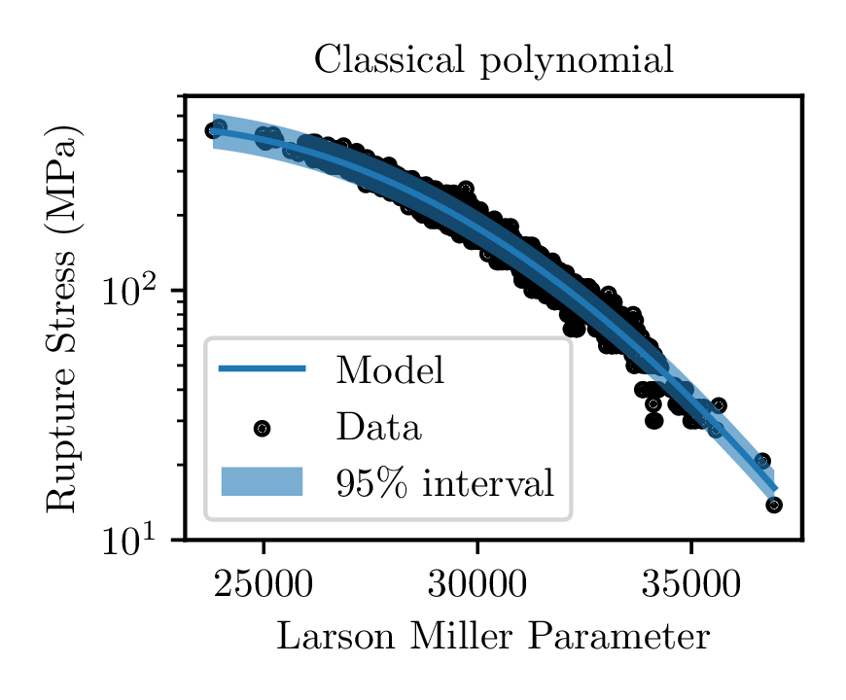  - Results from classical Larson-Miller polynomial regression. | 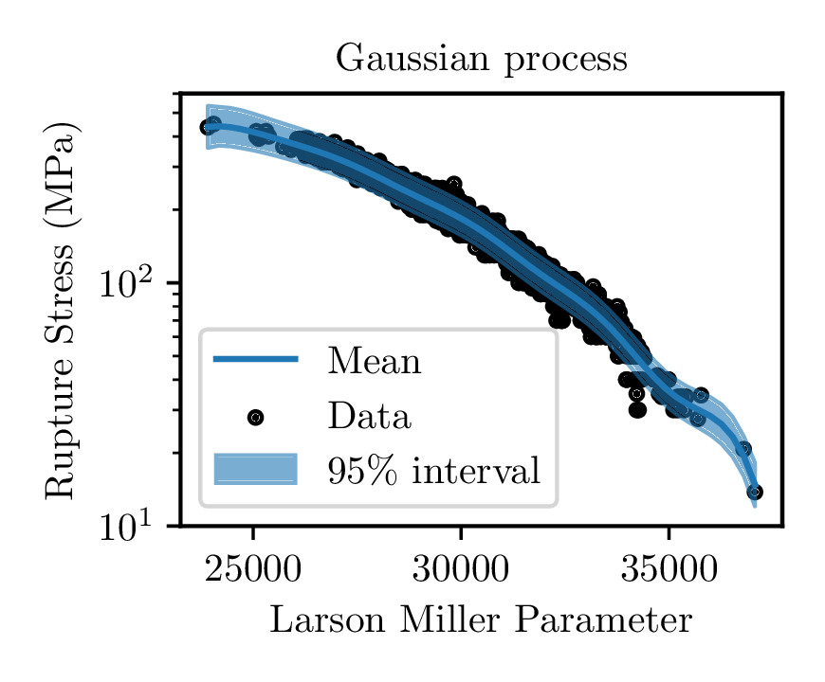  - Results from GP model with uncertain $C$, described in this work.
FIG 1. Comparison between Larson-Miller models using the classical polynomial regression approach (a) and the GP approach described here (b).
Table 1. Inferred parameters from the GP model.
Parameter | Description | Value
$$l$$ | Kernel lengthscale | 5.4575
$$σ_{gp}^{2}$$ | Kernel variance | 2.5020
$$μ_{C}$$ | Mean Larson-Miller parameter | 32.1934
$$σ_{C}^{2}$$ | Larson-Miller parameter variance | 0.0013
$$σ_{n}^{2}$$ | White noise variance | 0.0012

Table 2. Calibrated parameters for the classical polynomial model.
Parameter | Description | Value
$$C$$ | Best-fit Larson-Miller parameter | $$32.065$$
$$a_{0}$$ | Constant term in polynomial | $$-6.1656×{10}^{-1}$$
$$a_{1}$$ | Linear term in polynomial | $$2.9522×{10}^{-4}$$
$$a_{2}$$ | Quadratic term in polynomial | $$-6.6530×{10}^{-9}$$

Table 3. Results of the 10-fold validation study.
 | Classical model | GP model
MRE | 0.08318 | 0.06108
Data inside bounds | 95.80% | 94.91%
More sophisticated versions of the classical model can overcome some of these limitations: the $C$ parameter can be calibrated for each batch and/or a region splitting approach can account for mechanism shifts causing kinks in the Larson-Miller diagram (c.f. [16]). However, region splitting requires additional user intervention to select region split parameters. The GP model will be more robust as it has no user-configurable parameters and can describe an arbitrary functional response over the data.

Creep deformation – steady creep
The design examples here consider only steady creep. Most analytical solutions for the steady creep stress distribution assume a model of the form
$$\dot{ε}=Ae^{cT}σ^{n}$$ | (11)
where $\dot{ε}$ is the steady equivalent creep rate, $σ$ is the steady equivalent stress, $T$ is the absolute temperature, and $A$, $c$, and $n$ are constitutive coefficients. The natural statistical extension of this model is to allow $A$, $c$, and $n$ to be random variables. This model is easier to calibrate in log-space
$$ln\dot{ε}=a+cT+nlnσ$$ | (12)
where $a=lnA$.
We used Bayesian regression [17] to determine a statistical model for the three constitutive parameters. The statistical model is
$$ln\dot{ε}=a+cT+nlnσ+ϵ$$ | (13)
where $ϵ$ is white noise representing experimental error. The model assumes uncorrelated normal priors for $a$, $c$, and $n$. We, again, inferred the mean and variance of the parameters using the Pyro framework and the Adam gradient descent algorithm, now with an evidence lower bound objective function [18]. Table 4 lists the inferred statistical parameters and Figure 2a plots the model for minimum creep rate as a function of both temperature and stress. The figure shows the average model prediction and $2σ$ upper and lower bounds. Figure 2b shows a slice of the full model at $T={600}^{∘}$ C, showing the model mean prediction, $2σ$ bounds, and all the data within ${10}^{∘}$ C of that temperature.

Table 4. Inferred parameters for the minimum creep rate model.
Parameter | Mean | Variance
$$a$$ | $$-1.2970×{10}^{2}$$ | $$5.3525×{10}^{-3}$$
$$c$$ | $$9.1215×{10}^{-2}$$ | $$4.7375×{10}^{-7}$$
$$n$$ | $$7.8983$$ | $$4.1479×{10}^{-3}$$

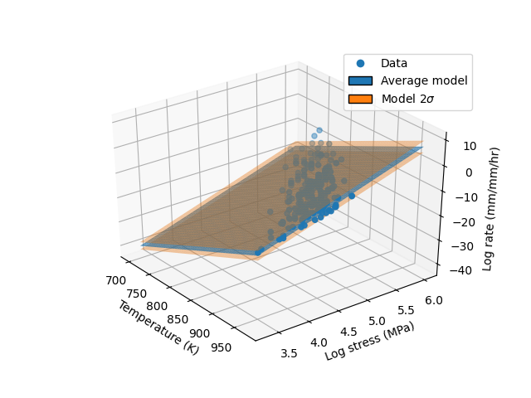  (a) Full 3D view of the minimum creep rate model as a function of stress and temperature. | 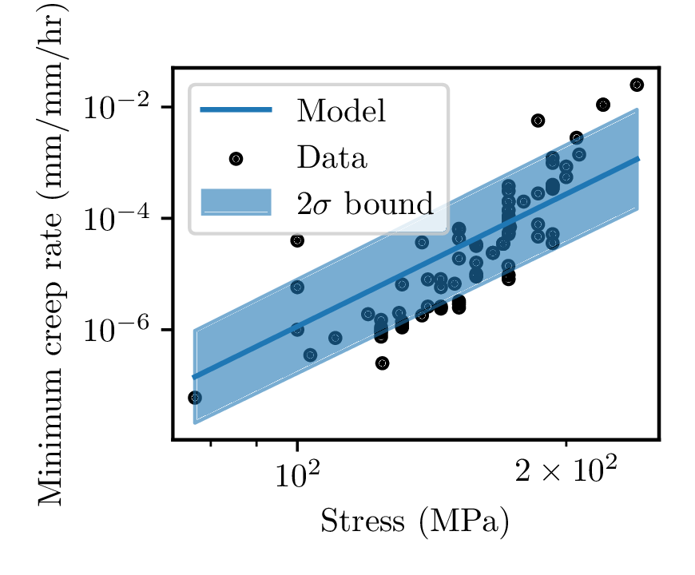(b) Slice of the model at $T=600℃$.
FIG 2. Minimum creep rate model compared to the data. The plot shows the log minimum creep rate data for Grade 91 as a function of temperature and log stress as well as the average and $2σ$ model predictions.
The model adequately captures the effect of temperature and stress on the minimum creep rate and the confidence intervals adequately bound the data. As this is fundamentally a multiple linear regression the process is very robust against overfitting and we did not repeat the 10-fold validation test.

Statistical Design
The design limit considered here is creep rupture under the steady state stress distribution caused by some uncertain loading $L$ on a component made of Grade 91 material. The subsequent analysis uses a deterministic thermal analysis, focusing on the statistical structural analysis. With this assumption, and given a statistical description of the component loading, the probability of a single spatial point in a component failing in a given time $t$ is:
pt=tc=L​σ​ptc|σTpσT|LpLdσdL | (14)
where we use the stress intensity (Tresca stress) as the effective stress measure for creep damage, and so $σ_{T}$ is the random variable representing the Tresca stress at a location in the component. A structural analysis can provide the probabilistic stress distribution in the component using the statistical power law model described above. Section 4 provides two examples on how to obtain this stress distribution: Monte Carlo analysis using analytic solutions or a Stokes flow finite element solution.
In either case, given the fundamental probability distribution in Eq. 14, the cumulative distribution
$$F=\int_{0}^{t_{design}}{p}\left(t\right)dt$$ | (15)
provides the probability of interest: the probability that the component fails before the target design life $t_{design}$. Alternatively, we could define the reliability as $R=1-F$, which is the probability that the component exceeds the design life. As both approaches are equivalent we base the probabilistic design examples in the next section on finding a design meets a target probability of premature failure $F_{target}$. All designs with $F≤F_{target}$ would be acceptable, as they are conservative relative to the target probability. Different values of $F_{target}$ could be specified for different types of components, analogous to Class A and Class B components in Section III, Division 5 of the ASME Code [1]. Selecting $F_{target}$ is beyond the scope of this paper and so the remaining analyses considers the problem of designing a component geometry and loading to achieve a given value of $F$. This type of analysis produces design charts suitable for sizing a component given a value of $F_{target}$.

Example Designs
This section provides two examples of how to determine a probabilistic design curve providing the required component geometry given statistical models for the component loading and the material constitutive response.

Thick walled vessel, temperature gradient
The Tresca stress in a thick walled cylinder (i.e. a cylindrical vessel with a thickness to radius ratio greater than 20) with thickness $τ$ loaded with internal pressure $P$ and a logarithmic thermal gradient
$$T=T_{i}+T_{*}ln\left(1+\frac{x}{r_{i}}\right)$$ | (16)
with $T_{i}$ the inner wall temperature and $T_{*}$ parametrizing the slope of the gradient and where the creep properties depend on temperature as in Eq. 11 is [19]
$$\begin{matrix}2σ_{T} & = & K_{1}K_{2}{\left(\frac{r_{i}+x}{r_{i}+τ}\right)}^{-2K_{1}} \\ K_{1} & = & \frac{1}{n}\left(1+\frac{cT_{*}}{2}\right) \\ K_{2} & = & \frac{2P}{{\left(1+τ/r_{i}\right)}^{2K_{1}}-1}\end{matrix}$$ | (17)
where $x$ is the position through the wall thickness, $x∈\left[0,τ\right]$. Note that
$$T_{inner}=T_{i}$$ | (18)
$$T_{outer}=T_{i}+T_{*}ln\left(1+\frac{τ}{r_{i}}\right)$$ | (19)
so that
$$ΔT=T_{outer}-T_{inner}=T_{*}ln\left(1+\frac{τ}{r_{i}}\right)$$ | (20)
or
$$T_{*}=\frac{ΔT}{ln\left(1+\frac{τ}{r_{i}}\right)}$$ | (21)
We pose the design problem in terms of the wall thickness for a normally distributed pressure load with mean $P=10$ MPa and standard deviation $P=1.5$ MPa. Figure 3 shows design charts giving the thickness required for a given value of $F$ using $T_{i}={525}^{∘}$ C, $r_{i}=25.4$ mm and several combinations of $ΔT$ and design life $t_{design}$. The process to create these curves, for a given $τ$ and $ΔT$, is:
- Divide the thickness into $n_{thick}=50$ discrete points.
- For each point $i$:
  - Calculate the distribution of the Tresca stress using a Monte Carlo analysis of Eqs. 16 to 21 with $n_{stress}=10,000$ random trials, using the minimum creep rate model developed in Section 2.2 and the pressure distribution described above.
  - Based on this distribution of stress, use the rupture time model developed in Section 1 to calculate the probability of premature failure $F_{i}$ for the point.
- Let the probability of premature failure for the vessel be $F=\max_{i}F_{i}$, i.e. the greatest probability of premature failure across the whole vessel thickness.
The analysis is insensitive to the number of points used to evaluate the thickness variation, but a evaluating the stresses through the wall thickness is necessary for $ΔT>0$. The maximum stress is always on the inner diameter of the cylinder. However, the maximum temperature is on the outer diameter. As the creep resistance of the material decreases with temperature, it is not apparent in advance where the worst combination of stress and temperature leading to the highest probability of premature failure will occur. We selected the number of Monte Carlo trials by trying different values separated by an order of magnitude and selecting the smallest number of trials for which the overall distribution of premature failure probabilities did not change between $n$ and $10n$ samples.
The charts in Fig. 3 design lives of 50,000, 100,000, 300,000, and 500,000 hours and temperature gradients of $ΔT=0^{∘},{25}^{∘},{50}^{∘},{75}^{∘}$ and ${100}^{∘}$ C. The general trend matches a deterministic analyses: higher temperature gradients (and hence higher average temperatures) require a thicker wall to maintain the same reliability. Similarly, the thickness required to maintain the same reliability increases as the design life increases.
The figure presents the x-axis values of $F$ on a log scale as we anticipate nuclear design standards would aim for very low premature failure probabilities. Despite the logarithmic scale, the trend is substantially nonlinear. As $F→1$ the required thickness approaches zero, which is intuitive. However, as $F→0$ on the logarithmic scale there is a definite transition from a significant change in the required thickness for each decrease in $F$ to a region of diminishing returns where targeting a lower premature failure probability requires a minimal increase in the wall thickness. For the examples here this region of diminishing returns starts around $F={10}^{-4}$, suggesting there is little practical benefit to setting a $F_{target}<{10}^{-4}$.

More complicated structures: Stokes flow analysis
The preceding example could apply a Monte Carlo analysis relatively easily and at low computational cost because there is an analytic solution available. Analytic solutions will not exist for most types of engineering components (for example IHX and steam generator components), requiring a more general analysis method. Our previous work [8] suggests solving a Stokes flow problem using the finite element method to provide the steady state stress distribution. We demonstrate that the Stokes problem is the steady solution of the standard stress equilibrium equation for a power law creep model. The advantage of the Stokes analysis is that it provides the steady stresses in a single, nonlinear, steady-state analysis step. The standard solid mechanics finite element formulation would need to solve a transient problem over many load steps to approximate the same solution. As such, Stokes finite element analysis makes it more feasible to execute the Monte Carlo analysis required in the design method developed here in a reasonable amount of time.
While a Stokes analysis makes Monte Carlo creep structural analysis more feasible there would still be substantial barriers to implementing the approach, at least for day-to-day engineering design. Our previous work describes a probabilistic analysis of a few, fully-detailed components and compares the failure time statistics from that analysis to the design life for that component following the Section III, Division 5 ASME Boiler and Pressure Vessel Code rules. For this case, where the problem geometry and loading is fixed, the Stokes analysis is feasible. However, in the case of actual design the Monte Carlo analysis needs to be repeated each time the designer alters the component geometry or loading. Section 5 discusses potential alternative design methods that retain a direct connection to the statistical distributions of loading and material properties while avoiding a full Monte Carlo structural analysis.

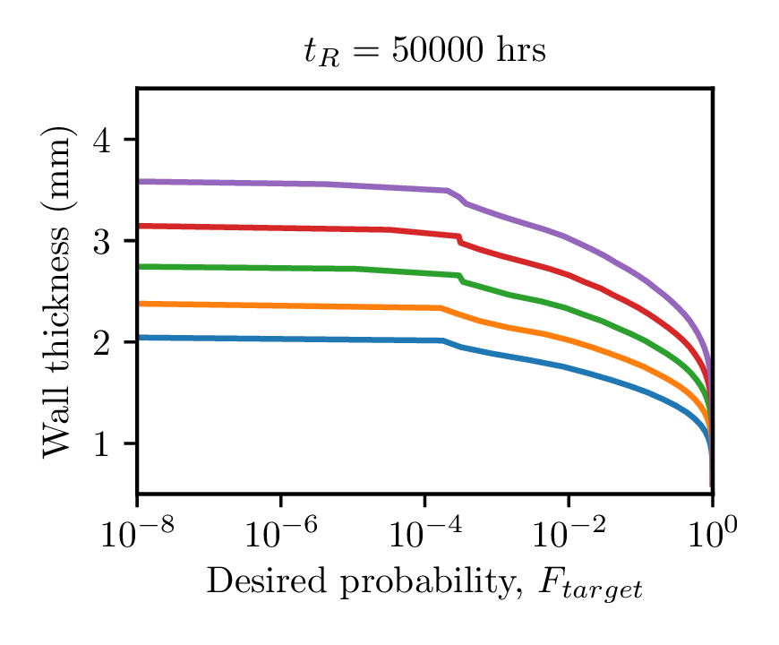  (a) $t_{design}=50,000$ hours | 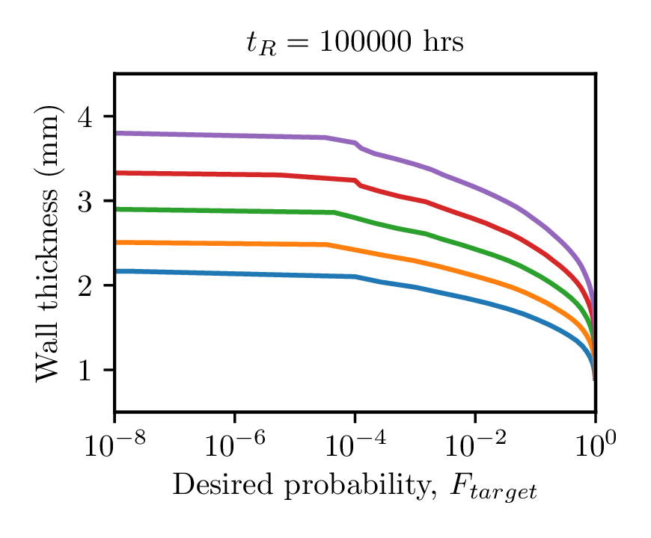  (b) $t_{design}=100,000$ hours
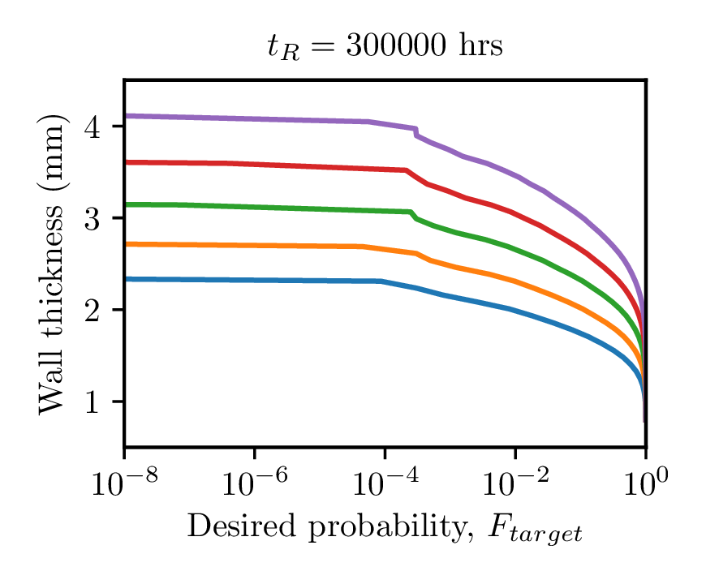  (c) $t_{design}=300,000$ hours | 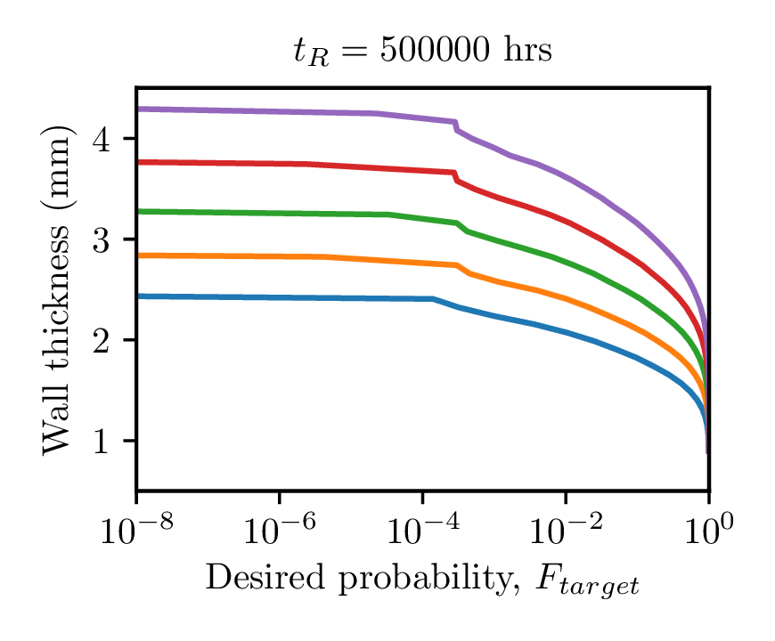  (d) $t_{design}=500,000$ hours
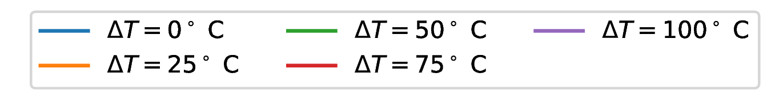
FIG 3. Design charts providing the required wall thickness for a given combination of target premature failure probability, $F$, design life $t_{design}$, and thermal gradient $ΔT$.

Conclusions and Future work
This paper describes a statistical design method suitable for the design of high temperature fast reactor components. The goal of the method is to produce component geometries with a targeted reliability, assuming creep rupture under steady loading as the failure mechanism. The key probability used to evaluate a design is $F$, the probability of premature failure defined as the cumulative probability the component fails at any time less than the design life. The method consists of statistical models for creep deformation and rupture life, a probabilistic description of the component service loads, and a Monte Carlo structural analysis of the component. The approach requires a fast structural analysis, as the Monte Carlo method requires thousands of trials to capture the statistical distribution of stress in the component. We propose two viable analysis techniques to determine the steady state stress distribution: analytic solutions, where available, and a Stokes finite element analysis.
Two statistical constitutive models for Grade 91 steel (a modified 9Cr-1Mo steel with likely future fast reactor applications) provide the rupture stress and steady creep rate data required to complete the structural analysis and life assessment. The rupture model uses Gaussian process regression to capture the statistical relation between stress, temperature, and rupture time. This analysis technique does not require the user to select values of key hyperparameters (for example the order of a polynomial approximation) and we argue it provides a more accurate, robust process for correlating creep rupture data when compared to conventional polynomial regression using a time-temperature parameter. Standard Bayesian regression provides the model for the minimum creep rate. The paper provides a fully-detailed example in the form of design curves for a Grade 91 thick-walled pressure vessel with a through-wall thermal gradient for various temperature gradients and design lives. A Stokes flow finite element analysis could extend this simple example to components with arbitrary geometries and loadings.
The design method proposed here is complete, up to the choice of a target reliability $R=1-F$, as it could be used to evaluate a Grade 91 component with an arbitrary geometry, mechanical loading, and thermal loading. However, the resulting Monte Carlo structural analysis could be too computational expensive to be viable. Developing a simplified approach that does not require Monte Carlo analysis but retains a direct connection to the component reliability should be the focus of future work. One option adopted by the structural engineering community [20] is Load and Resistance Factor Design (LRFD) [21]. This method replaces the statistical analyses of the component loading, stress distribution, and material resistance with factored deterministic analyses with factors calibrated to provide a design with a target reliability. However, LRFD approaches used in structural engineering applications often assume that structural analysis itself is deterministic and linear elastic, leaving only the loading and material resistance as stochastic variables. This simplification is not suitable for creep analysis where heat-to-heat variations in the creep deformation/stress relaxation rates are often significant and, moreover, creep deformation and damage are often correlated. Alternative approaches to avoid or reduce the requirement of a full Monte Carlo analysis include direct methods for propagating uncertainty through finite element analysis, often using a series expansion to represent a distribution in terms its moments [22], or surrogate models interpolating a smaller number of direct analyses [23].
Despite these limitations, the work described here has substantial value in:
- Providing the definition of a reasonable probabilistic metric for high temperature reactor component design: the probability of premature failure over the design life, $F$, and its complement the component reliability, $R=1-F$
- Developing statistical models for Grade 91 for the key material parameters of the creep rupture life and the material deformation rate
- Demonstrating a complete statistical design process for steady creep rupture on a relevant geometry for future fast reactors
- Identifying the critical limitations in the current approach based on a Monte Carlo structural analysis.
ACKNOWLEDGEMENTS
The research was sponsored by the U.S. Department of Energy, under Contract No. DEAC02-06CH11357 with Argonne National Laboratory, managed and operated by UChicago Argonne LLC and Contract No. DE-AC07-05ID14517 with Idaho National Laboratory, managed and operated by Battelle Energy Alliance. Programmatic direction was provided by the Office of Nuclear Reactor Deployment of the Office of Nuclear Energy. The authors gratefully acknowledge the support provided by Sue Lesica, Federal Manager, Advanced Materials, Advanced Reactor Deployment (ARD) Program, Diana Li, Federal Manager, Microreactor Program, and John H. Jackson of Idaho National Laboratory, National Technical Director, Microreactor Program.
Copyright Statement
This manuscript has been co-authored by UChicago ArgonneLLC under Contract No. DE-AC02-06CH11357 with the U.S. Department of Energy. The United States Government retains and the publisher, by accepting the article for publication, acknowledges that the United States Government retains a nonexclusive, paid-up, irrevocable, world-wide license to publish or reproduce the published form of this manuscript, or allow others to do so, for United States Government purposes. The Department of Energy will provide public access to these results of federally sponsored research in accordance with the DOE Public Access Plan: (http://energy.gov/downloads/doe-publicaccessplan).
References
- American Society of Mechanical Engineers. “Section III, Division 5.” In Boiler and Pressure Vessel Code (2019).
- AFCEN. RCC-MRx (2015).
- British Energy. R5: Assessment Procedure for the High Temperature Response of Structures (2015).
- HOLT, P. J., AND R. A.W. BRADFORD. “Application of probabilistic modelling to the lifetime management of nuclear boilers in the creep regime: Part 1.” International Journal of Pressure Vessels and Piping 95. Elsevier Ltd: 48–55 (2012).
- BRADFORD, R. A.W., AND P. J. HOLT. “Application of probabilistic modelling to the lifetime management of nuclear boilers in the creep regime: Part 2.” International Journal of Pressure Vessels and Piping 111-112. Elsevier Ltd: 232–45 (2013).
- N. A. ZENTUTI, ET AL. “A review of probabilistic techniques: towards developing a probabilistic lifetime methodology in the creep regime.” Materials at High Temperatures 34 (5-6): 333–41 (2017)
- J. R. STEFANO ET AL. “Summary of Modified 9Cr-1Mo Development Program: 1975-1985.” Oak Ridge National Laboratory (1986).
- NICOLAS, ANDREA, MARK C. MESSNER, AND T.-L. SHAM. “A method for predicting failure statistics for steady state elevated temperature structural components.” International Journal of Pressure Vessels and Piping (Accepted) (2021).
- RAMUSSEN, CARL EDWARD, AND CHRISTOPHER K. I. WILLIAMS. Gaussian Processes for Machine Learning. Vol. 7. 5. Boston: MIT Press (2006).
- LARSON, F. R., AND J. MILLER. “A time-temperature relationship for rupture and creep stresses.” Transactions of the ASME 74: 765–71 (1952).
- R. W. SWINDEMAN ET AL. “Verification of Allowable Stresses In ASME Section III Subsection NH For Grade 91 Steel & Alloy 800H.” ASME Standards Technology, LLC (2007).
- GIRARD, AGATHE. “Approximate methods for propagation of uncertainty with Gaussian process models.” Doctoral Dissertation, University of Glasgow (2004).
- DALLAIRE, PATRICK, CAMILLE BESSE, AND BRAHIM CHAIB-DRAA. “Learning Gaussian Process Models from Uncertain Data.” In Neural Information Processing, edited by Chi Sing Leung, Minho Lee, and Jonathan H. Chan, 433–40. Bangkok, Thailand: Springer (2009).
- ELI BINGHAM ET AL. “Pyro: Deep Universal Probabilistic Programming.” Journal of Machine Learning Research (2018).
- KINGMA, DIEDERIK P., AND JIMMY LEI BA. 2015. “Adam: A Method of Stochastic Optimization.” In International Conference on Learning Representations 2015, 1–15.
- KIMURA, KAZUHIRO, AND YUKIO TAKAHASHI. “Evaluation of Long-Term Creep Strength of ASME Grades 91, 92, and 122 Type Steels.” In ASME 2012 Pressure Vessels and Piping Conference, 309–16 (2012).
- BISHOP, C. M., AND M. E. TIPPING. “Bayesian Regression and Classification.” In Advances in Learning Theory: Methods, Models and Applications, edited by J. A. K. Suykens, I. Horvath, S. Basu, and C. Micchelli, 267–85. IOS Press (2003).
- BISHOP, CHRISTOPHER M. Pattern Recognition and Machine Learning. New York: Springer Science+Business Media, LLC (2006).
- HETNARSKI, R B, AND M R ESLAMI. Thermal Stresses – Advanced Theory and Applications. Springer Science+Business Media Inc (2009).
- AMERICAN INSTITUTE OF STEEL CONSTRUCTION. Steel Construction Manual. 14th ed (2011).
- GALAMBOS, THEODORE V. “Load and Resistance Factor Design.” Engineering Journal 18 (3): 74–82 (1981)
- KLEIBER MICHAEL AND HIEN, TRAN DUONG. The stochastic finite element method: basic perturbation technique and computer implementation. Wiley (1992).
- SUDRET, BRUNO, STEFANO MARELLI, AND JOE WIART. “Surrogate Models for Uncertainty Quantification: An Overview.” In 11th European Conference on Antennas and Propagation, 193–218 (2017).

