# ALFRED FLOW BLOCKAGE ANALYSIS

R. MARINARI1, I. DI PIAZZA1, M. TARANTINO1, G. GRASSO2, M: FRIGNANI3

1ENEA C.R. Brasimone, Camugnano(Bo), Italy

2ENEA C.R. Bologna, Bologna, Italy

3Ansaldo Nucleare, Genova, Italy

Email contact of corresponding author: ivan.dipiazza@enea.it

**Abstract**

In the context of Lead-cooled Fast Reactor development and safety assessment, the flow blockage in a fuel sub-assembly is considered among the most relevant issues to be addressed. Hence, the event shall be postulated assessing its consequences, also considering that grid-spaced fuel assemblies could partially mitigate the occurrence of sudden blockages with respect to wire-spaced fuel assemblies.

The Advanced Lead-cooled Fast Reactor European Demonstrator (ALFRED) is a 300 MWth pool-type reactor aimed at demonstrating the safe and economic competitiveness of the Generation IV LFR technology. The ALFRED design, currently being developed by ANSALDO NUCLEARE and ENEA in the frame of the FALCON Consortium, is based on prototypical solutions intended to be used to boost the DEMO-LFR development.

Within the scope of FALCON consortium and in the frame of investigating the thermal hydraulics of the average ALFRED FA, a CFD computational model is built looking for the assessment of its thermal field in nominal flow conditions and when affected by a blockage. Starting from the experience in this kind of simulations and in experimental work, the whole model of the ALFRED Fuel Assembly is first presented and calculation of flow and temperature field in nominal conditions is carried out. RANS simulations of idealized blockage scenarios adopting three different spacer grid locations (under the active length, at half active length, above the active length). Results showed that the blockages located upstream the heated length generate a distortion in the temperature field due to the lower mass flow in the assembly and the recirculating vortex downstream of it.

## INTRODUCTION

The flow blockage accident in a Fuel Assembly (FA) of a nuclear reactor consists of a partial or total occlusion of the flow passage area. This leads in general to a degradation of the heat transfer between the FA and the coolant potentially causing a temperature peak in the clad which can eventually lead to the fusion of the clad itself. While a partial blockage at the fuel assembly foot may be dangerous for the integrity of the FA (e.g. Fermi 1 fuel meltdown accident), see [1]and [2], the phenomena can be investigated and assessed by an integral system code in order to devise proper mitigation actions. On the other hand, an internal blockage can be even more dangerous and it is not easy to detect; this kind of blockage can be more effectively modelled and studied by a proper use of a CFD code.

Regarding the sodium fast reactors, they generally adopt wire-spaced bundles, and the accumulation of debris from failed fuel pins or broken wires, generally occurs along the wire. Therefore, in this case, the preferential shape of the blockage is elongated and it follows the helicoid wire [3].

For grid-spaced fuel assemblies, experimental results on blockage growth by particles show that particles with sizes spread around the subchannel dimensions are collected at the spacer grid. A horizontal plate like particle bed with strong radial growth tendency was found [3]. In this paper the attention is focused on the grid-spaced bundles. From these remarks, the most likely internal blockage in a grid-spaced bundle is at the lower spacer grid, and, if the spacer grid is positioned in the active region, a remarkable effect can be evidenced and a possible damage can occur.

In principle, in the latter case, two different effects can be distinguished:

✓ A local effect due to the stagnation-recirculation/wake region downstream of the blockage, with a local minimum of the heat transfer and a clad temperature peak;

✓ A global effect due to the lower mass flow rate in the blocked subchannels; this effect leads to an increase of the bulk fluid temperature with respect to the ‘unblocked’ regions and a consequent peak in the clad temperature at the end of the active region.

In this paper, numerical analysis will be presented of flow blockage event in a fuel assembly of Heavy Liquid Metal (Lead) cooled ALFRED reactor. The Advanced Lead-cooled Fast Reactor European Demonstrator (ALFRED) is a 300 MWth pool-type reactor aimed at demonstrating the safe and economic competitiveness of the Generation IV LFR technology. The ALFRED design, currently being developed by ANSALDO NUCLEARE and ENEA in the frame of the FALCON Consortium, is based on prototypical solutions intended to be used to boost the DEMO-LFR development.

A preliminary work on the ALFRED prototypical geometry was performed in 2014 evidencing the local and global effects [4]. Similar numerical analyses on the ALFRED internal flow blockage were also performed by [5] adopting a reduced resolution RANS approach. The author firstly adopts his approach for the simulation of a blockage test section to preliminary validate his method comparing the numerical results with experimental data. Subsequently, the author simulates different degree of internal blockages inside a real scale ALFRED Fuel Assembly.

Due to the crucial role of the heat transfer in the stagnation-recirculation/wake region in this context, the turbulence in the recirculation region must be carefully assessed. In fact, in the case where the turbulence thermal diffusion overcomes the molecular diffusion, the clad temperature peak downstream the blockage is largely independent of the nature of the fluid, i.e. by the Prandtl number. On the opposite, if the recirculation region is a ‘stagnation’ region with low turbulent heat transfer, the physical nature of the coolant, and in particular the Prandtl number, plays the major role in the establishment of the peak temperature. From the literature, it is not very clear which of the two phenomena is the most important, although some simplified theories assume that the turbulence dominates downstream the blockage and therefore the temperature peak is independent by the Reynolds and the Prandtl number [6]. Probably, a systematic comparison between different coolants has not yet been performed; therefore any preliminary conclusions may not have sufficient basis.

In any case, in References, the specific literature for flow blockage in liquid metal cooled bundles were reported, i.e. sodium and lead, being the flow blockage phenomena in light water reactors a quite different matter because of the unity order of the Prandtl number, see for example [6].

For the heavy liquid metal cooled GEN-IV reactors studied in these years by the scientific community, the flow blockage accident must be considered as one of the reference accidents, and probably the most dangerous for the core integrity. In fact, most of the known accident that have occurred in the LBE cooled fast reactors of the Alpha-class Russian nuclear submarines, were apparently caused by a flow blockage accident, see [7].

An interesting review on flow blockage phenomena in LMFBR fuel assemblies is given in [6]. The paper gives a quite complete review of the investigations on flow blockage in sodium reactors and keeps into account all the technical and scientific development of ‘60s and ‘70s on sodium cooled fast reactors. The review especially refers to experimental and analytical investigations performed in United States and Germany, the authors develop an analytical approach to predict the flow blockage effects.

The blockages at the foot of a fuel assembly may have significant effects in the fuel assembly if coolant mass flow rate is significantly reduced and the blockages would be easily detectable in the case of closed FA. The effect of blockage on reactor safety depends in principle on several factors: size and location of the blockage, nature of the coolant, fuel pin power, and coolant velocity in the assembly. In closed FA, blockages in flow channels will increase the hydraulic resistance and reduce the flow rate.

Experimental data on Clinch River Breeder Reactor (CRBR), the Fast-Flux test facility (FFTF), and the German Sodium-cooled fast Reactor (SNR) are provided in the review. CRBR and FFTF have 217 fuel pins each assembly and are wire-wrapped spaced, while SNR FA consists of 169 pins in a triangular lattice, grid-spaced, and enclosed in a hexagonal wrap. The SNR is particularly interesting for our purposes, because the reference configuration for a Lead Fast Reactor Demonstrator is grid spaced.

With the typical approach of the ‘70s, Kirsch [8] developed a simplified theory to describe the thermo-fluid dynamic phenomena downstream the blockage. The basic assumption is that turbulent diffusion dominates both for momentum and for energy, and thus the molecular heat transfer is negligible. With this hypothesis, the author shows that for sufficiently high Reynolds and Peclet numbers, the dimensionless temperature distribution in the wake is independent of the Reynolds and the Prandtl number, i.e. by the flow and the nature of the fluid. Comparison between experimental results in sodium and water seems to partially confirm these conclusions with a difference between the two fluids of 25%. This difference is probably due to the residual influence of the coolant. Therefore, according to the author, it could be possible to have a ‘universal’ dimensionless temperature profile function of the fraction of the blocked flow area. From this point of view, the main difference between sodium and lead as coolant is the possible onset of boiling in sodium due to the lower boiling temperature (890 °C) with positive reactivity feedback and power excursion. In lead, with a boiling temperature of 1740 °C, this scenario is unlikely in the case of flow blockage.

The only way to numerically investigate (by CFD) the flow blockage in realistic configurations is by the use of turbulence models, being DNS or LES not feasible at Reynolds numbers 105 typical of the fuel assemblies. The controversial point is the ability of the turbulence models to describe the turbulent heat transfer for liquid metals being the turbulent Prandtl number for this fluid not constant and different from 1.

In the last years, due to the growing interest in the developing of GEN-IV prototypes and Demonstrators, the interest in sodium-cooled and lead-cooled bundles is high again. Nevertheless, only a small number of CFD studies appeared in the literature and sometimes these studies adopted simplified models for the bundle (porous media) and the focus was on the whole reactor [9]. Generally, system codes like RELAP are commonly adopted by the safety analysts to compute flow blockage in reactor Fuel Assemblies [10], although the local nature of the involved phenomena does not fully justify this common practice.

Recently experimental study in a dedicated 19-pin test section in heavy liquid metal was published [11]. Data showed that the global effect was not noticed experimentally and the agreement between experimental and numerical analysis was only qualitative by the use of turbulence models. Nevertheless, DNS or LES numerical approaches are not feasible due to the large computational cost and turbulence models were adopter in the present paper.

## MODELS AND METHODS

From the previous arguments, it is clear that the flow and heat transfer in a Fuel Assembly needs CFD analysis to be resolved. The viscous sub-layer was resolved with several points in all the simulations presented here. A value of y+=1 is guaranteed in the whole domain. The grid spacers were included in the model. A model of the whole FA is made to compute the nominal case for the average channel and for the hot channel.

A sinusoidal axial power profile was used in the computations. Temperature-dependent thermo-physical properties were assumed for Lead, according to the correlations in the HLM Handbook [12]. For the clad material (SS 15-15 Ti), constant physical properties were considered at 450°C according to reference [13].

Investigations carried out within the Falcon Consortium showed that the maximum clad temperature to avoid damage in the Ti 15-15 cladding material is 650°C, this value will be the reference for discussing thermal hydraulics in the fuel assembly.

## NUMERICAL METHODS

The general-purpose code ANSYS CFX v.19 was used for all the numerical simulations presented in this paper. The code employs a coupled technique, which simultaneously solves all the transport equations in the whole domain through a false time-step algorithm. The linearized system of equations is preconditioned in order to reduce all the eigenvalues to the same order of magnitude. The multi-grid approach reduces the low frequency error, converting it to a high frequency error at the finest grid level; this results in a great acceleration of convergence. Although, with this method, a single iteration is slower than a single iteration in the classical decoupled (segregated) SIMPLE approach, the number of iterations necessary for a full convergence to a steady state is generally of the order of 102, against typical values of 103 for decoupled algorithms.

The SST (Shear Stress Transport) k-ω model by Menter [14] is extensively used in this paper. It is formulated to solve the viscous sub-layer explicitly and requires several computational grid points inside this latter. The model applies the k-ω model close to the wall, and the k-ε model (in a k- ω formulation) in the core region, with a blending function in between. It was originally designed to provide accurate predictions of flow separation under adverse pressure gradients, but it was applied to a large variety of turbulent flows and is now widely used model in CFX-19 and other CFD codes. Although the model is isotropic, the structural feature of the model to predict in a good way flow separation and recirculation gives a good confidence in applying the model to compute thermal hydraulics in fuel subassemblies. The turbulent Prandtl number in the case of lead was fixed to 1.5, according to the suggestion of the literature [15].

## ALFRED FA CFD MODEL AND TEST MATRIX

The Fuel Assembly of the ALFRED Lead cooled reactor was considered here as the reference configuration to investigate. The fuel assembly is a wrapped hexagonal lattice bundle with 127 rods, grid-spaced, with rod diameter *d*=10.5 *mm*, pitch to diameter ratio *p/d*=1.29 and an active length *L*=0.81 *m*. The total thermal power of the reactor is *Q*~300 *MW*.

A sketch of the fuel assembly seen from the top is shown in Figure 1, while in Table 1 the main geometrical and physical parameters for the ALFRED FA are reported [16]. As shown in Figure 1, the central pin is not active and the total number of active pins in the FA is 126.

Table 1. BASIC GEOMETRICAL AND THERMAL-HYDRAULIC PARAMETERS OF THE DEMO ALFRED CORE

|  |  |
| --- | --- |
| Rod diameter *d* | 10.5 *mm* |
| Pitch to diameter ratio *p/d* | 1.29 |
| Subchannel Equivalent Diameter *Deq* | 8.52 *mm* |
| Number of fuel rods in 1 FA | 127 |
| Clearance between assemblies | 4 *mm* |
| Assembly pitch | 167 *mm* |
| Mean Assembly Power | 2.2 *MW* |
| Active Height *L* | 0.81 *m* |
| Lead Inlet Temperature *Tinlet* | 400*°C* |
| Lead Outlet Temperature *Toutlet* | 520*°C* |
| Lead Bulk Velocity | 1.28 *m/s* |
| Lead flow average FA | 126.2 *kg/s* |
| Bypass flow around the FA | 0.27 *kg/s* |

The CFD analyses presented in this paper are mainly focused on a sensitivity study of upstream flow blockage perturbation on the active fuel bundle temperature field. Three FA operating conditions were considered for the study: the average unblocked Fuel Assembly, an assembly affected by a 30% flow area blockage in a grid upstream the heated length and an assembly affected by a 50% flow area blockage on the same grid position. Value of mass flow rate and power came directly from the FA designers. In the current paper, only central and axial-symmetric blockages were considered with a perfect horizontal shape. Changes in geometry and position of the blockage could lead to different results.

A 3D sketch of the computational domain is shown in Figure 2; the shroud, the funnel and the bypass fluid regions have been included in the CFD model as well as the spacer and the structural grids. The conjugate heat transfer in the spacer grids is not accounted in the model. For symmetry reasons, only 1/6 of the whole FA is modelled for numerical simulation. Flow blockage condition is simulated disabling the fluid-fluid interface across the fluid volumes in the grid holes affected by the hypothetical blockage. Due to symmetry constraint, only central flow blockage is considered in the simulations. This model has been used for all the test cases performed. The spacer grids are positioned 200 mm upstream the active region, at the centre of the active region according to designers’ suggestions. A fluid domain surrounds the funnel to impose proper boundary conditions.

Table 2 shows the reference values adopted for the calculations of the average FA and the blocked FA cases of ALFRED. In the table, the mass flow rate, the inlet temperature, the bypass flow rate, the power, the heat generation due to gamma, are indicated. It must be noticed that the inlet mass flow rate through the assembly decreases due to the increasing flow blockage degree. Inlet mass flow values are set in accordance to [17].

Table 2. REFERENCE VALUES USED FOR THE AVERAGE FUEL ASSEMBLY AND FOR THE BLOCKED FUEL ASSEMBLY: VALUES ARE REFERRED TO 1/6 OF THE FUEL ASSEMBLY

|  |  |  |  |
| --- | --- | --- | --- |
| Parameter | FA ave | 30% blockage | 50 % blockage |
| $\dot{m}$ [kg/s] | **21.04** | **18.93** | **15.78** |
| Tin [°C] | 400 | 400 | 400 |
| $\dot{m}$ bypass [kg/s] | 0.045 | 0.045 | 0.045 |
| Q[kW] | 2206 | 2206 | 2206 |
| $q'''$ wrapper [MW/m3] | 15 | 15 | 15 |
| lead [MW/m3] | 10 | 10 | 10 |

The pin clad has been explicitly modelled; therefore the power generation in the pins has been introduced by imposing a wall heat flux in the internal wall of the pin. The shape axial peaking factor in the active region has been considered according to the designers neutronic suggestions.

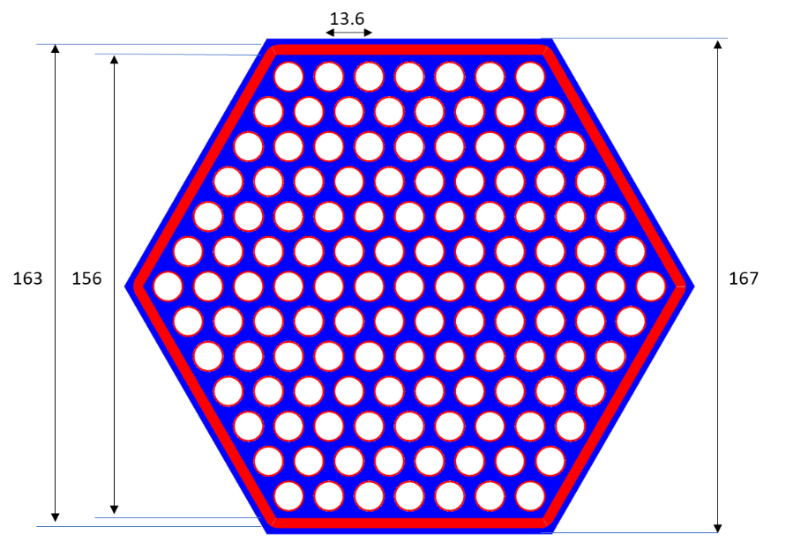

*Figure 1 Sketch of the ALFRED Fuel Assembly: top view*

The boundary conditions are mass flow rate and temperature, at the inlet section and 0 bar opening pressure at the outlet. The computational mesh has 26 millions of elements and it is hexagonal dominant multi-block quasi-structured. The meshing strategy leads to a high-quality mesh and this feature increases the global quality of results. Figure 3 shows a detail of the computational mesh in the pin bundle region where an inflation layer has been applied in all the domain with *y+*=1 at the walls.

All the simulations performed in this paper reached the full convergence both on the RMS of the residuals (RMS< 10-5) and on the monitor points placed in the domain.



*Figure 2 Sketch of the 3D CFD model adopted*

*Figure 3 Computational mesh in the fuel pin bundle active region*

## RESULTS AND DISCUSSION

About the CFD results, average FA results without blockage are first shown and discussed as reference for the blockage simulations. Figure 4 shows the velocity and temperature distributions in a cross section placed 420 mm downstream the beginning of the active region for the average channel. The distributions are regular with the velocity maximum and the temperature minimum at the centre of the subchannels. As far as the temperature field is conceived, the edge effect can be noticed with a strong local minimum in the side subchannels.

|  |  |
| --- | --- |
|  |  |

Figure 4 Temperature(left) and velocity(right) distribution in a cross-section placed 420 mm downstream the beginning of the active region for the average channel.

Figure 5 shows the temperature distribution in the clad in the active region for the average channel. The distribution is linear as expected with a local maximum around 560°C in the corners at the end of the active region. As evident also in Figure 4, the maximum temperature in the generic section is reached in the corner pin. The value of 560°C is well below the value of 650°C considered the limit for the 15-15 Ti clad.

Figure 6 shows the cross-section averaged pressure distribution along the FA for the average channel case. The total pressure drop across the FA is about 47 kPa. The pressure drop in in the bare rods between the grids is around 20.3 kPa/m against 21.15 kPa/m of the Cheng and Todreas correlation [18], while the net pressure drop due to a single grid is around 4.85 kPa.

The pressure recover at the inlet section (from 0 to 300 mm) is due to the flow area expansion at the inlet section.

Figure 5 Temperature contour on the clad for the average assembly condition

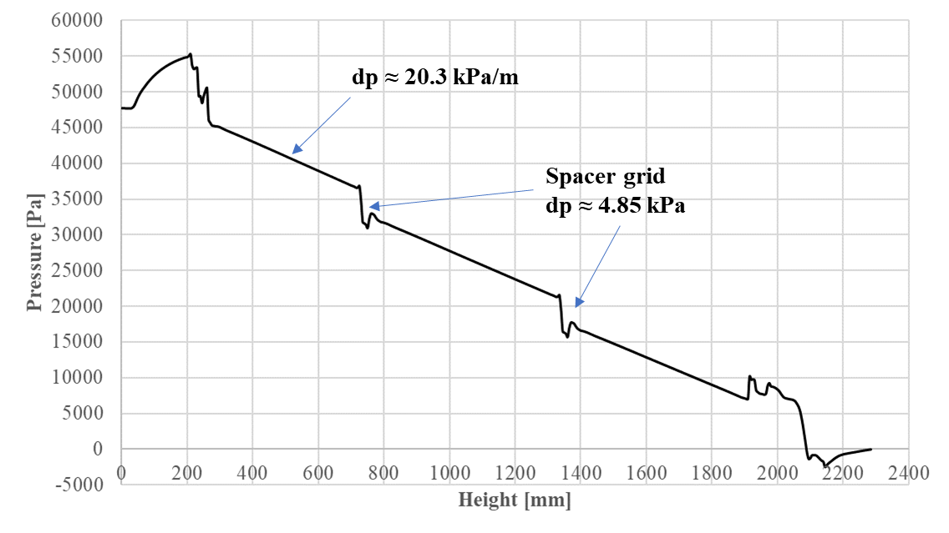

*Figure 6 Axial pressure trend across the CFD model.*

Moving to blockage simulation cases, the 30 % flow area obstruction in the lower spacer grid is simulated. The flow recirculation due to the blockage upstream the active length is found to be remarkable in size (*Figure 7*), more than the distance of 200 mm between the grid and the active length. The recirculating vortex moves cold lead to the active length (highlighted in figure with a blue triangle) and “heated” lead upstream with a sort of mixing.

A second effect of the blockage is the clad overheating in the inner pins, shown in *Figure 8*. This effect has two root causes: the lower mass flow rate in the FA and the flow recirculation generated upstream by the blockage that reduces the mass flow in the inner subchannels corresponding to the blocked areas. The maximum clad temperature is reached in the first rank of pins at the end of the active region (*Figure 9*) and it is evaluated around 639°C, about 80°C higher than the unblocked case but anyway 11°C lower than the 15-15-Ti limit.

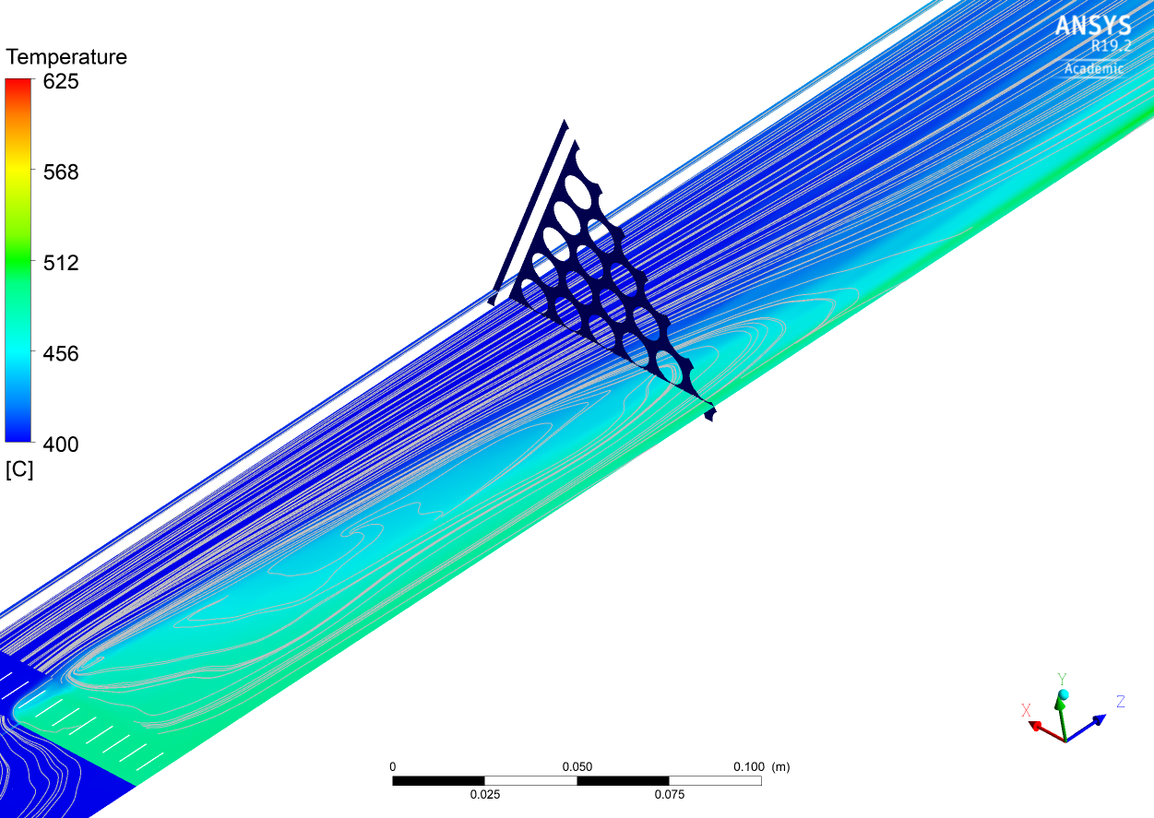

*Figure 7 Temperature and velocity streamlines near the 30% blockage in the lower spacer grid.*

*Figure 8 Temperature contour of the clad affected by a 30% flow blockage in the lower spacer grid, spacer grids and the beginning of the heated length are highlighted in black.*

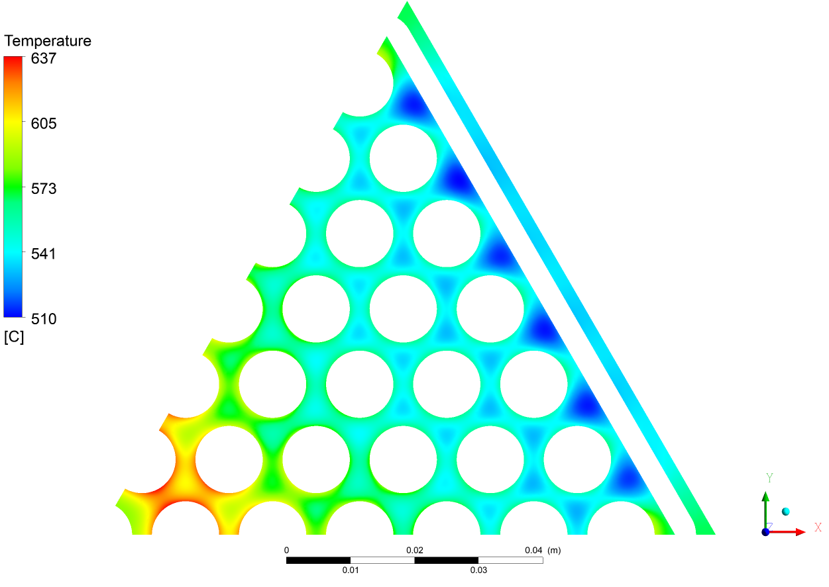

*Figure 9 Temperature contour on a cross section placed at the end of the active length.*

A similar behavior is shown also for the 50 % blockage in the lower spacer grid. Obviously, the magnitude of the previous phenomena is increased both in geometrical dimensions and temperature magnitude.

As shown in *Figure 10*, the recirculating vortex downstream the 50% blockage is far longer than the previous, almost reaching the middle spacer grid. Lead and clad temperature are obviously affected in a similar way. Lead temperature inside the recirculating vortex is increased from 470°C of the 30% blockage to 610°C of the 50% blockage. The maximum temperature is reached, as in the previous case, at the end of the active region and it is higher than 680°C, a value that far exceed the maximum allowable 15-15 Ti temperature fixed by the designers. It must be underlined that these results are obtained with the use of an isotropic turbulence model (SST k-omega) and the application of a RSM second order model could change quantitatively the results. Nevertheless, the present study is a preliminary assessment of the flow blockage in the ALFRED FA.

*Figure 10 Axial temperature contour and velocity streamline downstream the 50% flow area blockage.*

## CONCLUSIONS

This paper described the CFD model and computations of the ALFRED FA in the nominal configuration and different degrees of internal blockages. In particular, the blockage at the first lower spacer grid are studied by CFD RANS simulations.

Preliminary studies were conducted in the past by the same authors on conceptual and realistic ALFRED FA, see for example [4]. Moreover, experimental and numerical studies have been conducted on FPS test section with ALFRED FA features [11]. In this latter case, the comparison between experimental data and CFD numerical simulation was qualitatively good in the prediction of the perturbed region downstream the blockage with an overprediction of the temperature peak. From all these studies, an internal blockage in the active region dramatically affects the temperature clad distribution behind the blockage. Therefore, the presence of a spacer grid in the active region should be avoided and the blockage is fixed in the first lower spacer grid.

First, a CFD model is created to keep into account the main physical phenomena involved. Then the model is applied to predict unblocked nominal configuration and blockage cases in the present study, first of all the unblocked configuration was analysed. Results showed regular distributions with the velocity maximum and the temperature minimum at the centre of the subchannels and a strong local minimum in the side subchannels.

Results for the lower spacer grid blocked showed the presence of the recirculating vortex extended downstream the blockage for both blockage levels (30% and 50%), well inside the active region for the most severe case. This implies the presence of two temperature maxima, one at the beginning of the active region due to the vortex (local effect) and one at the end of the active region due to the lower mass flow rate in the blocked subchannels (global effect). A peak temperature of about 560°C and 680 °C is foreseen at the end of the active region in the 30% and 50% blockage case respectively. For the 50% case, the maximum temperature overcomes the limiting temperature of 650°C fixed by the designers for the 15-15 Ti clad and therefore is not acceptable by design.

ACKNOWLEDGEMENTS

This work was performed in the framework of the FALCON consortium for the design and construction of the ALFRED LFR DEMO.

References

1. NRC "Fermi, Unit 1", NRC Website, 3 February 2011, accessed 17 March 2011.
2. BERTINI, H.W., Description of selected accidents that have occurred at nuclear reactor facilities (1980), ORNL/NSIC-176.
3. SCHULTHEISS, G.F., On local blockage formation in sodium cooled reactors. Nuclear Engineering and Design 100 (1987), 427-433.
4. DI PIAZZA, I., MAGUGLIANI, F., TARANTINO, M., ALEMBERTI, A., A CFD analysis of flow blockage phenomena in ALFRED LFR demo fuel assembly. Nuclear Engineering and Design 276 (2014), 202-215.
5. MATHUR, A., DOOLAARD, H. U., ROELOFS, F., Reduced-resolution RANS approach to grid spacer fuel assemblies, Nuclear Engineering and Design 356 (2020), 110374.
6. HAN, J.T., FONTANA, M.H., Blockages in LMFBR Fuel Assemblies – A Review. Proc. Winter Annual ASME meeting (1977).
7. ZRODNIKOV, A.V., CHITAYKIN, V.I., GROMOV, B.F., GRIGORYV, O.G., DEDOUL, A.V., TOSHINSKI, G.I., DRAGUNOV, Y.G., STEPANOV, V.S., Use of Russian Technology of ship reactors with lead-bismuth coolant in nuclear power. *Russian Federation Report* XA0056274, 2000.
8. KIRSCH, D., Investigation on the Flow Temperature Distribuion Downstream of Local Coolant Blockages in Rod Bundle Subassemblies, Nuclear Engineering and Design 31 (1974), 266-279.
9. MAITY, R.K., VELUSAMY, K., SELVARAJ, P., CHELLAPANDI, P., Computational fluid dynamic investigations of partial blockage detection by core-temperature monitoring system of a sodium cooled fast reactor. Nuclear Engineering and Design 241 (2011), 4994-5008.
10. LU, Q., QIU, S., SU, G.H., Flow Blockage Analysis of a channel in a a typical material test reactor core.Nuclear Engineering and Design 239 (2009), 45-50.
11. MARINARI, R., DI PIAZZA, I., TARANTINO, M., FORGIONE, N., Blockage fuel pin simulator experiments and simulation, Nuclear Engineering and Design 353 (2019), Article 110215.
12. OECD and N. E. Agency, Handbook on Lead-bismuth Eutectic Alloy and Lead Properties, Materials Compatibility, Thermal- hydraulics and Technologies (2015).
13. RCC-MRx, Design and Construction Rules for mechanical components of nuclear installations, ed.AFCEN (2010).
14. MENTER, F.R., Two-Equation Eddy-Viscosity turbulence models for engineering application, AIAA Journal 32(8) (1994), 1598-1605.
15. CHENG, X., TAK, N.I., CFD analysis of thermal-hydraulic behavior of heavy liquid metals in sub-channels, Nuclear Engineering and Design, 236 (2006), 1874-1885.
16. MIKITYUK, K., Heat transfer to liquid metal: Review of data and correlations for tube bundles. Nuclear Engineering and Design 239 (2009), 680–687.
17. BANDINI, G., BUBELIS, E., SCHIKORR, M., STEMPNIEVICZ, M.H., LAZARO, A., TUCEK, K., KUDINOV, P., KÖÖP, K., JELTSOV, M., MANSANI, L., Safety analysis results of representative DEC accidental transients for the ALFRED reactor, IAEA-CN-199/260 (2013)
18. CHEN S. K., Chen Y. M., TODREAS, N. E.,. The upgraded Cheng and Todreas correlation for pressure drop in hexagonal wire-wrapped rod bundles. Nuclear Engineering and Design 335 (2018), 356-373.