Recent thermal hydraulic studies of Gas Fast Reactor

demonstrator ALLEGRO

B. KVIZDA
VUJE a.s.
Trnava, Slovakia
Email: boris.kvizda@vuje.sk
Phone: +421 33 599 1173

G. MAYER
Centre for Energy Research (EK)
Budapest, Hungary
Email: gusztav.mayer@ek-cer.hu

P. VÁCHA
UJV Řež, a.s.,
Řež, Czech Republic

J. MALESA
NCJB
Otwock, Poland

Abstract

ALLEGRO is a helium-cooled high-temperature fast spectrum demonstrator reactor developed in EUROPE to prove the viability of Gas Fast Reactor (GFR) technology. This paper summarises the latest outcomes of the 75 MW ALLEGRO thermal-hydraulic calculations. First, the work done in the EU VINCO project is reviewed, which aims to transfer the GFR technology know-how from the CEA to the V4G4 consortium and establish a platform for the continuation of the ALLEGRO development. It comprises the methods, specific calculations and outcomes of the ALLEGRO thermal-hydraulic benchmark carried out by the V4G4 partners using the CATHARE, RELAP and MELCOR codes. Based on the benchmark, a future experimental program is proposed using helium-cooled experimental facilities, S-ALLEGRO built in Pilsen (Czech Republic) and STU helium loop operating in Trnava (Slovakia). Finally, a summary of recent work is presented, in which the hot duct break scenario is studied for the two and three-loop ALLEGRO versions. The preliminary results of this analysis showed that the three-loop ALLEGRO has better cooling performance in case of a hot duct break.

INTRODUCTION
The helium-cooled high-temperature fast-spectrum reactor (GFR) with a closed fuel cycle is one of the six GEN IV reactors selected by the Generation IV International Forum (GIF) to be developed for the foreseeable future. The European reference concept of the GFR technology is a unit with an envisaged power of 2400 MWth, which is currently in the pre-conceptual design phase. Prior to the building of a full scope facility, the viability of the GFR technology will be proven by means of the ALLEGRO demonstrator with an envisaged thermal power of 75 MWth. The ALLEGRO development is led by the V4G4 Centre of Excellence consortium associating research organizations, companies and laboratories from the Czech Republic (UJV Rez, CVR), France (CEA), Hungary (EK), Poland (NCBJ), Slovakia (VUJE). One of the key tasks of ALLEGRO is to test the new ceramic refractory fuel for the industrial version of GFR2400.
Nuclear energy is a decisive power supply source and plays an irreplaceable role in the 21st century. The limited and constantly decreasing uranium resources and accumulation of highly radioactive nuclear waste from the operation of GEN II, III, III+ Nuclear Power Plants (NPP) encourage engineers to develop brand new technology. The future GEN IV reactors could provide inherently safe, environmentally clean (CO₂ free), proliferation-resistant, long-lasting, and economically competitive energy sources. Fast reactor technologies developed within an international collaborative effort led by GIF are promising to fulfil the above-mentioned objectives. There have been 6 reactor technologies selected by GIF for future research and development, including the Gas-Cooled Fast Reactor, with the ambition to close the fuel cycle and utilize a large amount of U imprisoned in spent fuel assemblies. The GFR uses Sodium Fast Reactors (SFR) knowledge regarding fuel recycling processes and the same reactor technology as used for Very High Temperature Reactors in terms of materials, components, and power conversion systems.

The key advantages of GFR technology using helium (He) as a main coolant are:

- better neutronic safety due to low void reactivity feedback coefficient than in SFR
- minor generation of corrosion products, reducing decommissioning costs;
- optical transparency allowing in-service inspections;
- no phase changes eliminating potential reactivity swings during accidents;
- operation at very high temperatures, high power conversion efficiency;
- beside electricity production GFR technology provides broad spectrum of deployment including cogeneration, process heat, desalination, hydrogen production and others;
- better use of uranium resources than in currently used PWRs;
- proliferation resistance.

In this place, it is good to mention the challenges of GFR technology, which includes:

- heat dissipation at low coolant density and natural convection conditions;
- development of robust and inherently safe Decay Heat Removal system (addressing low thermal inertia of He and higher power density of the core leading to rapid heat-up following a loss of forced cooling);
- diffusion of He through solid materials;
- development of innovative materials (refractory fuel resistant to fast-neutron spectra);
- R&D needs to build and operate dedicated experimental test facilities.

Available TH codes widely used for the safety assessment of NPP were mostly developed and extensively validated for the GEN II, III, III+ Pressurized Water Reactors (PWR) and Boiling Water Reactors (BWR). The majority of the most reliable TH codes (e.g. RELAP, CATHARE, ATHLET etc.) have expanded their field of applicability not only to GFR but to other promising GEN IV technologies too, including Lead-cooled Fast Reactor (LFR), Molten Salt Reactor (MSR), Supercritical Water-cooled Reactor (SCWR), SFR and Very High-Temperature Reactor. The code developers added a new type of fuels, material properties, cooling mediums, updated heat transfer formulas and developed specific modules, e.g. blowers, turbomachinery etc. [4], [10]. Code improvements have been extensively validated in code-to-code benchmarks [6] as well against experimental data [3], [5].
This paper summarises the work in TH code validation performed in the frame of VINCO EU in chapter 3 [1]. Subsequently, the efforts to improve ALLEGRO design in terms of safety, specifically the study investigating benefits of the third primary system loop improving core cooling during hot duct break in chapter 4 [2].

GFR 2400
The reference GFR concept is a 2400 MWth high-temperature helium-cooled fast-spectrum reactor with a closed fuel cycle. The concept is proposed to deliver electricity, hydrogen or process heat with high conversion efficiency. The core is composed of ceramic-cladding carbide fuel pins (SiCf/SiC) placed in a hexagonal wrapper. It operates at a high core coolant exit temperature of 850 °C with an average power density of 100 MW/m³. These conditions are a serious challenge for core designers in terms of construction material properties. The produced heat will be converted into electricity in the indirect combined cycle. The system arrangement consists of 3 independent loops using He in the primary system and He-N₂ mixture in the secondary system. Primary and secondary loops are connected to 3x 800 MWth intermediate heat exchangers. Three turbomachinery modules, turbine and compressor at a single shaft, convert heat to electricity in gas-cycle auxiliary alternators providing 406 MWe in total. A single tertiary loop (H₂O) is equipped with a conventional 2-stage steam turbine connected to a steam-cycle main alternator of 731 MWe. On-site electricity drives 3x primary system helium blowers and a single tertiary system pump. The net efficiency of the cycle is about ~45%, providing a net power grid of 1083 MWe.

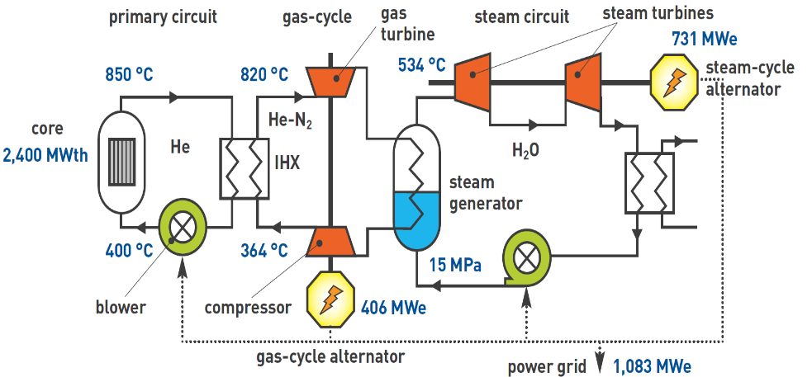

Fig. 1. GFR 2400 primary circuits, secondary circuits, tertiary circuit and power conversion cycle.

ALLEGRO
To demonstrate the viability of the full-scope GFR 2400 technology, the ALLEGRO demonstrator, initially designed by the French Alternative and Atomic Energy Commission (CEA) [15], has been proposed. The demonstrator will be the first of a kind GFR prototype. The current design of ALLEGRO evolved from its predecessor, the Experimental Technology Demonstration Reactor (ETDR 50 MW) [16]. The ALLEGRO project was led by CEA until 2010. The preparations for know-how transfer from CEA to the Visegrád group countries based on the Memorandum of Understanding started in 2010. In 2013 the legal entity “V4G4 Centre of Excellence” (V4G4 CoE) was established. It joins the leading Central European nuclear research organizations and companies from the Czech Republic (UJV Rez), Hungary (EK), Poland (NCBJ), Slovakia (VUJE) and associating members from France (CEA), Czech Republic (CVR). In 2013 the V4G4 CoE launched preparations to design, build and operate an ALLEGRO demonstrator in central Europe [17].
The ambition of a gas-cooled ALLEGRO demonstrator is to be an alternative to the fast reactor technology of sodium-cooled reactors. The demonstrator is aimed to prove the technical feasibility of performance, reliability and inherent nuclear safety. The refractory core proposed for the ALLEGRO will answer the most challenging issues connected with the new innovative materials, particularly the fuel. There are two types of core configuration proposed in R&D Roadmap. The driver core (exit temperature ~530 °C) with MOX (optionally UO₂) fuel and stainless-steel cladding. The driver core includes 6 experimental fuel assembly positions for refractory fuel tests. The outlet temperature in 6 refractory assembly positions will be close to the target outlet temperature of the refractory core (850 °C). Driver core fissile hexagonal sub-assemblies are surrounded by four rings of reflector assemblies and 3 rings of shielding assemblies. The Refractory core will consist of (U,Pu)C pin-type fuel in SiC-SiCf cladding. Power density up to 100 MW/m³ is investigated.
The current V4G4 ALLEGRO design has a 75 MWth MOX driver core (50 MWth, UO₂ option is considered) with a 0.0 MWe output. The core cooling medium is He at 7 MPa. The heat is removed from the primary circuit through the main heat exchangers. The secondary system consists of 2 independent loops with pressurized water at 6.5 MPa. The secondary pressure is lower by 0.5 MPa than the primary system to eliminate water ingress into the core in case of primary to secondary system leaks. Forced convection is maintained by 2 water pumps. The ultimate heat sink is the ambient air, which is envisaged by the operation of 2x water-to-air heat exchangers. The primary system consists of two hot and cold ducts. There is an insulated hot pipe inside the insulated cold pipe connected to the reactor pressure vessel on one side and the main heat exchanger on the other side. Coaxial pipe arrangement limits heat losses, minimizes thermal expansion of structures, decreases the probability of primary system depressurization (LOCA to the Guard vessel from the hot duct), and reduces the Guard vessel's size. The helium coolant in the primary system is circulated by 2 radial blowers driven by 2 main motors (418 kW). Both radial blowers are equipped with other pony motors mounted to the same shaft. This solution enables 20% of the nominal rotational speed of the main blowers in case of scram. The primary system is connected to the secondary systems via two He/H₂O heat exchangers (He/He-N₂ option considered). The following key systems ensure the safety of the ALLEGRO design:

- The Decay Heat Removal system (DHR) for long-term residual heat removal from the core (fully passive mode and/or supercritical CO₂ passive cycle investigated);
- The Emergency Core Cooling System (ECCS) to maintain cool-ability of the core in the most challenging accident conditions (diverse/optimized ECCS solution investigated);
- Reactor shutdown system (diversified fully passive option investigated);
- The Guard vessel structure encompasses the reactor pressure vessel, the primary circuit, the main heat exchangers, including its main blowers, the DHR systems and the ECCSs.

This arrangement prevents the release of radionuclides and keeps elevated pressure in the primary system during depressurized situations.
The DHR system consists of 3 independent loops isolated from the primary system in normal operation. DHR is mainly used for the Design Extension Conditions (DEC) when the core cooling via primary loops is impossible. The secondary side of DHR is cooled by the pressurized water (1.0 MPa) in a natural circulation regime. The tertiary circuits of the DHRs consist of three water pools with heat exchangers placed high above the core. The capacity of the pools is sized to remove residual heat for 24 h by vaporization of its water content.

The ALLEGRO main features are listed in TABLE.1, and the general layout is depicted in FIG. 2.

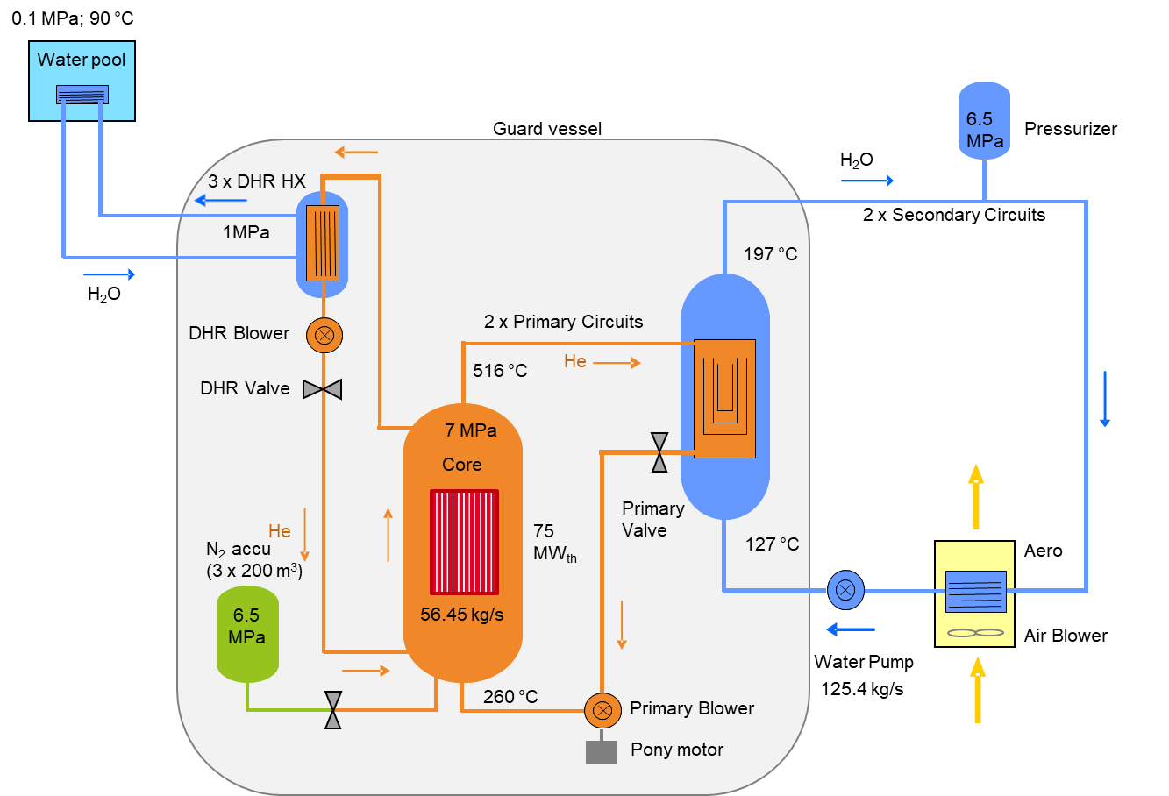

Fig. 2. ALLEGRO primary circuits, secondary circuits, air blower and decay heat removal (DHR) system.

TABLE 1. MAIN DESIGN PARAMETERS

Parameter | Value | Unit
Nominal power (thermal) | 75 | MW
Nominal power (electrical) | 0 | MW
Power density | 100 | MW/m³
Fuel | MOX/  SS cladding
UPuC/
SiCSifC cladding
Type of fuel assembly | Hexagonal wrapper and wired fuel rods
Number of fuel rods per assembly | 169
Number of fuel assemblies | 81
Number of experimental fuel assemblies | 6
Number of control and shutdown rods | 10
Primary circuit coolant | Helium
Secondary circuit coolant | Water
Tertiary circuit coolant | Air
Primary pressure | 70 | Bar
Core inlet/outlet temperatures | 260/516 | °C
Number of primary loops | 2
Secondary pressure | 65 | Bar
Number of secondary loops | 2
Number of DHR loops | 3
DHR circuits coolant | Helium
DHR intermediate circuits coolant | Water
Number of N₂ accumulators | 3
DHR heat sink | Water pool

thermAL hydraulic BENCHMARK
This chapter summarizes the conclusions of the TH benchmark exercise carried out within EU VINCO project. The VINCO aimed to stimulate capacity building for future R&D activities focused on innovative nuclear technologies in central European countries. One of the objectives was to develop TH models of GFR ALLEGRO 75 MW demonstrator for selected TH codes and perform preliminary qualification in the code-to-code benchmark. There have been 4 participants using 3 different TH codes and 5 independent ALLEGRO models. CATHARE2 v25_3 mod6.1 [10] was used in VUJE (Slovakia), EK (Hungary) and NCBJ (Poland), RELAP5-3D [11] ver. 4.3.4 in VUJE (Slovakia) and MELCOR 2.1[12] in UJV Řež (Czech Republic). The benchmark activities have been performed in five consecutive steps.
Phase I – development of ALLEGRO database for TH analyses collecting relevant, at the time available, data necessary to develop valid ALLEGRO models. The source of the data was found in available documentation generated in former projects, including EU FP7 GoFastR, ESNII+ or other relevant GFR oriented projects, e.g. RAPHAEL.
Phase II – specification of the TH benchmark exercise describing, in the smallest details, the type of selected scenarios, measuring points, and the extent of output parameters to be compared. Complex description of initial and boundary conditions, core model specification including hot channel definition, flow distribution, thermal capacity, axial and radial power peaking factors, maximum linear power and reactivity coefficients were made available to all participants
Phase III – development of new ALLEGRO models. The ALLEGRO CATHARE2 model developed within the EU GoFastR project (2009) by CEA France was distributed to all V4G4 participants. At the time, the CEA model was outdated due to previous progress in ALLEGRO development. During VINCO, it was adjusted independently according to the database (Phase I) and the specification (Phase II). Finally, we used 3 independent CATHARE2 models at VUJE, EK and NCBJ. The most significant modifications were done in the DHR system and the core model. In addition, a brand new RELAP5-3D model at VUJE and MELCOR model in UJV Řež was developed.
Phase IV – Steady-state qualification and identification of distortions among models. The aim of Phase IV was to eliminate the user effect. The systematic procedure for qualification of TH models developed at the University of Pisa in Italy [14] was used, providing a powerful tool for identifying the major distortions among the models. The phenomenological effect of each distortion was analyzed and justified. Although the TH benchmark exercise was considered blind, users were free to make their own modifications as a reaction to the steady-state qualification. Participants were prevented from sharing any other information, such as nodalizations or specific model details. There were eight significant distortions identified, and the following of them had the most significant impact: a) the lack of point kinetic model in MELCOR core model (UJV Řež); b) the different types of heat exchange correlations used in water-to-air HX models; c) the core decay heat curve after scram; d) stopped DHR blower flow resistance affecting natural convection efficiency in the core.
Phase V – Transient calculations and code-to-code comparisons. Two different types of transients have been selected. In Exercise No.1- Loss of Coolant Accident (LOCA) was analyzed. The break, 3 in. (76.2 mm), was located on cold duct No.1. In Exercise No.2, Total station blackout (SBO) using 1 DHR loop in natural convection to remove the residual heat was analyzed. A LOCA represents a typical Design Basis Accident (DBA), while total SBO is a typical Design Extension Condition (DEC-A) event. According to [1] the 3 in. LOCA belongs to category 3 with a fuel cladding temperature limit of 735 °C, and a total SBO is a DEC-A event with a fuel cladding limit of 1300 °C. It was intended to check the ability of the models to predict both depressurized and pressurized conditions. The results have been compared and evaluated from qualitative and quantitative perspectives. The distortions and their effect on the course of transient identified in Phase – IV have been utilized to formulate recommendations for further improvements.

3 in. LOCA results (Exercise No.1)
LOCA is a challenging type of transient for GFRs. According to the current design of ALLEGRO, the coolant leaking from the primary system cannot be reinjected back to the primary system as it is common in, e.g. PWR NPPs. For this reason, a leak-tight stainless steel closed-containment (the guard vessel) was designed, which envelops the entire primary system, including the reactor pressure vessel, DHR loops and ECCS. Pre-stressed concrete containment is investigated as an option. The role of the guard vessel is to keep elevated pressure in the primary system after the loss of its tightness and to contain radioactive materials if necessary.
The LOCA process starts with rapid depressurization (Fig.3 – L1) of the primary system. Primary pressure decreases from 7 MPa to 0.35 MPa in less than 5 min. The initial helium leak rate is about 24 kg/s. The guard vessel's initial pressure (0.1 MPa) and temperature (50 °C) rapidly increase. The gas expansion has a positive reactivity effect in the core (Fig.3 – L2). The core power increase is noticeable before the scram. The high value of the power-to-mass ratio actuates the scram signal. The effect of power increase is interrupted by the scram. For unprotected LOCA scenarios, it is good to mention that the total power would be later reduced by the negative Doppler reactivity feedback effect due to fuel temperature increase. It is also worth recalling that other GFR related reactivity coefficients (e.g. fuel expansion, cladding expansion and diagrid expansion) have been neglected due to limitations in point kinetic models. The elevated pressure in primary system is kept by the pressurized guard vessel. A value of 0.35 MPa is enough for long term residual heat removal. The core mass flow rate was reduced by 94% even if the operation of the main blower persisted. Adiabatic expansion of helium gas initially contributes to low gas temperatures inside the primary system. It can be a challenge from a structural integrity point of view.
Based on the identified model distortions, a few discrepancies were justified among the calculations. There was no point kinetic model in MELCOR (UJV Rez), so a power decay profile was substituted instead. Consequently, the void reactivity effect was not predicted by MELCOR. The gas gap conductivity of pin-type fuel in MELCOR was overestimated, providing a 50°C higher initial cladding temperature. The next difference comes from the water-to-air heat exchanger model. CATHARE2 models use modified heat transfer correlation, while RELAP5 - 3D and MELCOR models use build-in heat transfer correlation. Different heat exchange correlations led to substantial differences in the main heat exchanger (MHX) inlet water temperature (Fig. 3 – L4). This affects the core inlet temperature and fuel cladding temperature (Fig. 3 – L3). Most of the evaluated parameters were in reasonable qualitative and quantitative agreement.

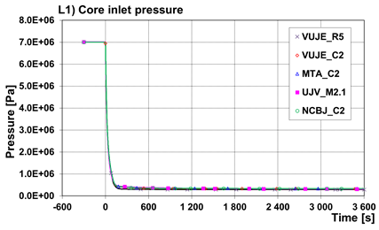 | 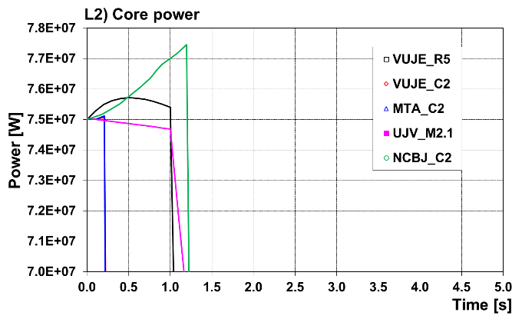
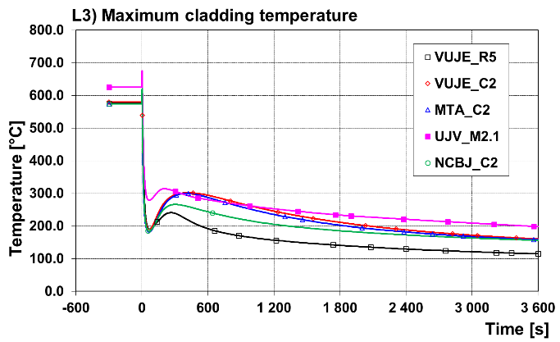 | 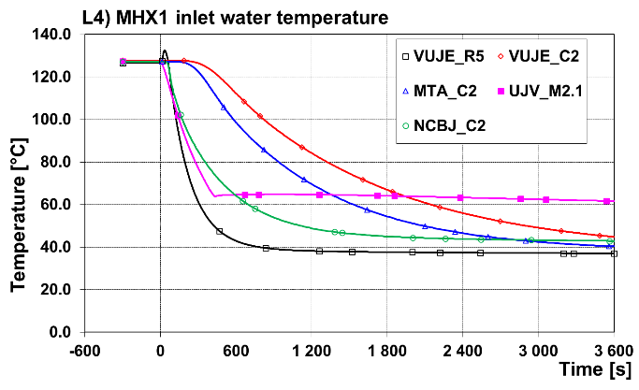

Fig. 3. Exercise No.1 - 3 in. LOCA on cold duct No.1 results.

TABLE 2. Resulting sequence of main events for LOCA 3 in.

 | VUJE | VUJE | UJV | MTA-EK | NCBJ
Parameter | RELAP5-3D | CATHARE2 | MELCOR | CATHARE2 | CATHARE2
LOCA 3 inch at cold duct No.1 | 0.0 s | 0.0 s | 0.0 s | 0.0 s | 0.0 s
Scram signal No. 7 “Power to mass ratio > 130%” | 0.1 s | 0.1 s | 0.4 s | 0.1 s | 0.1 s
Beginning of control rods motion | 1.1 s | 0.1 s | 1.4 s | 0.1 s | 1.1 s
1st maximum of fuel cladding temperature | 1.7 s | 1.1 s | 2.3 s | 2.0 s | 2.7 s
Value | 606.4 °C | 585.0 °C | 675.5 °C | 588.7 °C | 626.8 °C
Lower plenum and guard vessel pressure equal | 215.0 s | 170.0 s | 280.0 s | 220.0 s | 180.0 s
Break flow rate less than 0.05 kg/s | 277.0 s | 317.0 s | 284.0 s | 300.0 s | 291.3 s
Maximum guard vessel pressure reached | 159.0 s | 117.7 s | 128.0 s | 118.5 s | 120.2 s

SBO using 1 DHR results (Exercise No.2)
The station blackout event (SBO) belongs to design extension conditions events analyzed in many NPPs with a relatively low frequency of occurrence. On the other hand, the loss of offsite power is of a rather high frequency of occurrence with relatively moderate consequences. This event is typically managed by activation of scram and start-up of diverse power sources, typically diesel generators or line-up of electricity from other on-site units. If redundant electricity sources are not available, e.g. due to multiple failures, the loss of offsite power can lead to a station blackout event, obviously, with considerably more unfavourable consequences.
SBO in ALLEGRO is characterized by the instant trip of main blowers, secondary side pumps and air coolers. We assumed that power necessary for reactor trip signals, engineered safety features actuation system signals (ESFAS) and isolation devices operation on main and DHR loops are supplied from backup batteries. The pony motors of the main blowers do not startup in this case.
The reduced core flowrate at full power resulted in a barely visible 1st core heat-up (Fig.4 – S4). When the rotation speed of the main blowers is less than 85% of the nominal value, the scram signal is activated. (Fig.4 – S1). The inertia keeps the rotation of main blowers until 65 s (Fig.4 – S2). As the blower rotation speed decreases to less than 5%, the nominal DHR transition sequence is activated. It includes the closing of both main loop isolation valves and opening of the isolation valve in DHR loop no.1. This transition sequence allows to start up DHR blower, which is unavailable due to loss of electricity in this case. Until this point, the core heat is removed through the secondary and tertiary system by MHX and water-to-air HX to the environment. The delay of 10 s between complete isolation of the main loops and the opening of the DHR loop temporarily interrupts the core flowrate. The 2nd core heat-up occurs as a consequence (Fig.4 – S4). As the blower in the DHR loop does not start and it takes a couple of seconds to on-set natural circulation through the core and dedicated DHR loop. The time interval to establish natural circulation through the DHR loop is dependent on the proper conditioning (heat-up) of the DHR loop during normal operation. Another aspect influencing 2nd core heat-up relates to stopped DHR blower flow resistance and partially to the core flow resistance. Both aspects have an impact on natural convection in the core (Fig.4 – S3). The effectivity of DHR is dependent on all the above-mentioned factors, which include a) DHR loop conditioning, b) delay in transition to DHR, and c) total flow resistance of DHR. All mentioned phenomena will be targeted in further studies utilizing the data coming from existing experimental facilities, specifically S-ALLEGRO (built in Pilsen, Czech Republic) and STU helium loop (built in Trnava, Slovakia). From a qualitative point of view, the SBO results were in reasonable agreement, and the observed discrepancies are tightly connected with the above-mentioned phenomena.

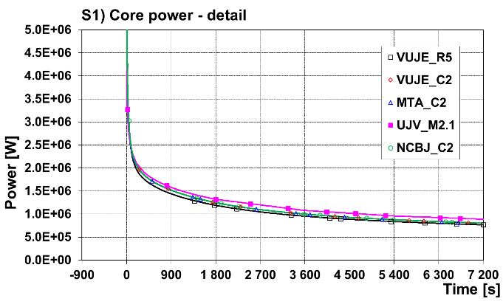 | 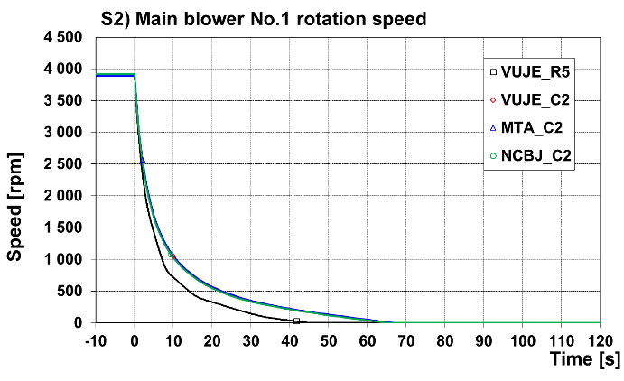
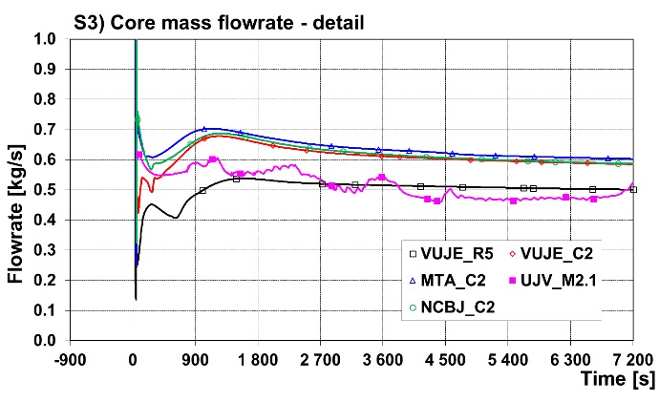 | 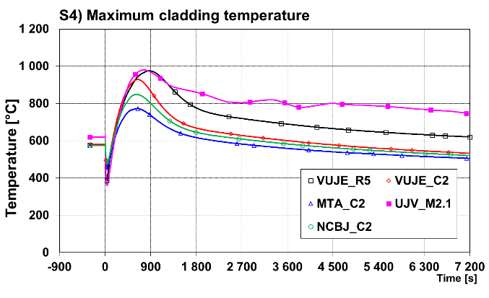
Fig. 4. Exercise No.2 – SBO using DHR No.1 results.

TABLE 3. Resulting sequence of main events for Station blackout
 | VUJE | VUJE | UJV | MTA-EK | NCBJ
Parameter | RELAP5-3D | CATHARE2 | MELCOR | CATHARE2 | CATHARE2
Initiating event „Total station blackout“ | 0.0 s | 0.0 s | 0.0 s | 0.0 s | 0.0 s
Trip of main blowers, secondary system pumps, tertiary circuit air ventilators | 0.0 s | 0.0 s | 0.1 s | 0.0 s | 0.0 s
Scram signal No.35 “Main blower rotation speed in loop No.1 (No.2) ω < 85% ω_{nom}“ | 0.7 s | 0.8 s | 0.7 s | 0.8 s | 0.5 s
Beginning of control rods motion | 1.7 s | 0.8 s | 1.7 s | 0.8 s | 1.5 s
ESFAS Signal No. 45,46 „Rotation speed of main blower in loop No.1 (No.2) < 5% of nominal speed“ | 27.0 s | 42.8 s | 42.0 s | 41.8 s | 41.3 s
MIVs in main loops No.1 and No.2 closed | 37.0 s | 53.6 s | 52.0 s | 43.4 s | 51.5 s
Isolation device in DHR loop No.1 fully opened | 57.0 s | 71.1 s | 64.0 s | 65.3 s | 62.2 s
Maximum cladding temperature | 870.0 s | 644.4 s | 780.1 s | 630.2 s | 620.7 s
Value | 975.1 °C | 928.8 °C | 979.7 °C | 772.3 °C | 848.7 °C

HOT DUCT BREAK
Core bypass transients play a pivotal role in ALLEGRO safety analysis. In these transients, a significant part of the circulated coolant bypasses the core, which may be resulted in the overheating of the fuel and its cladding.
Basically, the core bypass transients can be divided into two major groups. In the first group, there is a sudden valve action, which generates a huge core bypass. A good example of this kind of transient is the inadvertent opening of a DHR valve aggravated by the failure of the start of its blower. In this case, the direction of the flow is backward through the opened DHR loop. In the second group, the core bypass is generated by breaks. A typical example of this kind of scenario is the break of the hot duct. In this chapter, this latter hot duct break transient is investigated in more detail.
The current ALLEGRO reference design has two main primary cooling loops and three DHR loops. The hot duct connects the reactor, and the main heat exchangers - are led inside the cold ducts. For this reason, there is no depressurization of the primary system in case of a hot duct break, but there is a huge core bypass. One of the drawbacks of the two-loop ALLEGRO design is that there is only one blower operating, which is in addition to the broken loop if the other (intact) loop is supposed to be closed by a single failure criterion. To overcome this problem, a three-loop ALLEGRO model was proposed [2]. In a three-loop model, there is an additional blower in the third loop, which is still running even if one intact loop is out of operation.
The French CATHARE thermal-hydraulics code was selected for the comparison of the cooling performance of the two- and three-loop ALLEGRO designs. A new three-loop CATHARE ALLEGRO input deck was developed. The core model was the same in the two- and three-loop models. The heating perimeter of the heat exchangers and the flow areas were decreased to 2/3 of the two-loop model on both the primary and secondary sides of the MHXs. In the three-loop model, the air cooler was modelled by decreasing the number of the heat exchanger pipes to 2/3 of the original number of the two-loop model. The total core mass flow rate was set to be identical in both models. Accordingly, the mass flow rate of the three-loop model was decreased to 2/3 of the three-loop model. The pressure loss coefficients along the loops were identical in the two- and three-loop models.
Figure 5. shows the time evolution of maximum cladding temperature for the two- and three-loop models. The peak cladding temperature is lower by 66 °C in the three-loop case. In this example, the blower inertias - which play a major role - are the same in both models (10 kg*m*m).

Fig. 5. Maximum cladding temperature.

Conclusions
The VINCO EU project was focused on the capacity building of innovative nuclear technologies in Central European Countries. It contributes to the process of transfer of GFR technology know-how from the CEA France to the national scientific institutes and technical support organizations from V4 (Visegrád group) countries. In order to achieve this goal, the V4G4 Centre of Excellence was founded in 2012, joining EK from Hungary, NCBJ from Poland, UJV Řež from the Czech Republic, and VUJE from Slovakia. V4G4 includes two associate members CEA from France and CVR from the Czech Republic.
The presented paper includes a review of the main results of the thermal-hydraulic benchmark exercise performed within the VINCO project and the results of the hot duct break for the 2 and 3 loop ALLEGRO model performed in EK (Hungary).

The thermal-hydraulic code-to-code benchmark exercise carried out during the EU VINCO project presented in this paper focused on developing qualified models of ALLEGRO 75 MW demonstrator using various codes RELAP5-3D, CATHARE2 and MELCOR. A comprehensive database of ALLEGRO 75 MW was established, collecting all relevant data from previous projects and studies performed during ALLEGRO development in CEA France. Participants prepared 5 independent models based on the data, 3 for CATHARE2, one for RELAP5-3D and one for MELCOR code. The models have been assessed qualitatively and quantitatively among each other. Two initiating events were selected for the benchmark exercise to cover both pressurized and depressurized transients: Loss of Coolant Accident with a 3-inch diameter and the total station blackout.
Both steady-state and transient calculations have been compared and assessed. Based on the qualitative and quantitative assessment, the major distortions among the models have been summarized, including their effect on the transient. The heat conductivity of the gas gap between the fuel pellet and the cladding wall influences the initial fuel temperature and the maximum cladding temperature as well. The pressure loss distribution along with the primary system loops, including the core, the main blowers, and the main heat exchanger, affects the flow distribution, affecting the core heat-up in the critical phase of the transient. Water-to-air heat exchanger model in RELAP5-3D and CATHARE2 is different. While RELAP5-3D relies on build-in heat transfer correlation, the CATHARE2 model uses user-defined heat transfer correlation. The effect is clearly visible in MHX inlet water temperature in LOCA 3inch calculation. Different rate of feed water temperature decreasing has an impact on the inlet temperature of helium in the core. The results of the Station blackout transient mostly differ due to the pressure loss differences in DHR and the core model. The most important factors were a) DHR loop conditioning, b) delay in transition to DHR and c) total flow resistance of DHR, and d) the core pressure difference. All these factors contribute to the difference in total core mass flow rate during the critical phase of the accident. The higher the natural circulation flow through the core and DHR loop was calculated, the lower the maximum cladding temperature was observed. Other differences have been identified during the transition sequence when changing from the main heat removal to the DHR. There is a delay between the scram actuation and the physical movement of the CSD and DSD into the core. This delay substantially affect the maximum cladding temperature during LOCA transients.
All participants predicted the key phenomena typical for LOCA and station blackout transients. From the qualitative point of view, the results were comparable. There were quantitative distortions observed. However, the source of distortions was identified and will be eliminated in further studies.
The DHR system of ALLEGRO is primarily designed for design basis transients. The usage of DHR in the case of DBA may contradict the Defence in Depth principle. Nevertheless, the two-loop ALLEGRO design has some drawbacks when one of the main primary loops stops operating for design basis reasons, and at the same time, a single failure is supposed in the other loop. In this case, the cooling could be insufficient, and the DHR system may be needed to start. To improve the system's robustness against single failure, a three-loop ALLEGRO option was proposed [2]. The calculation results for hot duct break bypass transient showed that the three-loop ALLEGRO has better cooling capabilities than the two-loop ALLEGRO.

NOMENCLATURE

CEA - French Alternative Energies and Atomic Energy Commission
DBA – Design Basis Accident
DEC – Design Extension Conditions
DEC-A - Design Extension Conditions without core degradation (melting)
DHR – Decay Heat Removal system
ECCS - Emergency Core Cooling System
EU – European Union
GFR – Gas Fast Reactor (Gas-cooled Fast Reactor)
GIF – Generation IV International Forum
GV – Guard vessel (leak-tight closed containment)
HW – Heat Exchanger
HX – Heat Exchanger
LFR – Lead-cooled Fast Reactor
LOCA – Loss Of Coolant Accident
MHX – Main Heat Exchanger
MOX – Mixed Oxide fuel (U,Pu)O₂
MSR – Molten Salt Reactor
NPP – Nuclear Power Plant
PWR – Pressurized Water Reactor
R&D – Research and Development
SBO – Station Blackout accident
SCWR – Supercritical Water-cooled Reactor
SFR – Sodium Fast Reactor
SS – stainless steel
TH – Thermal Hydraulic
V4G4 – Centre of Excellence set up by ÚJV Řež (Czech Republic) , EK (Hungary), NCBJ (Poland) and VUJE (Slovakia).

ACKNOWLEDGEMENTS
This project has received funding from the Euratom research and training programme 2014-2018 under grant agreement No 945041.

References
- KVIZDA, B. et al. (2019) ‘ALLEGRO Gas-cooled Fast Reactor (GFR) demonstrator thermal hydraulic benchmark’, Nuclear Engineering and Design, 345. doi: 10.1016/j.nucengdes.2019.02.006.
- MAYER, G. (2020) ‘Hot duct break transient with two- and three-loop ALLEGRO models’,Nuclear Engineering and Design, 370. doi: 10.1016/j.nucengdes.2020.110911.
- BENTIVOGLIO, F. et al. (2006) ‘Validation of CATHARE code for gas-cooled reactors: comparison with EVO experimental data on Oberhausen II facility’. Proceedings of the 2006 International Congress on Advances in Nuclear Power Plants, ICAPP’06.
- MAUGER, G. et al. (2018), On the dynamic modeling of Brayton cycle power conversion systems with the CATHARE-3 code, Energy 168 (2019) 1002-1016.
- BENTIVOGLIO, F. et al. (2008). Validation of the CATHARE2 code against experimental data from Bryton-cycle plants., Nuclear Engineering and Design, 238 (2008) 3145-3159.
- BUBELIS, E., et al. (2008). A GFR benchmark: Comparison of transient analysis codes based on the ETDR concept. Prog. Nucl. Energy. https://doi.org/10.1016/j.pnucene.2007.11.090.
- URBAN, F., et al. (2017). Research of natural circulation in the experimental helium loop of STU. AIP Conference Proceedings 1889(1):020047, DOI: 10.1063/1.5004381.
- KNÍŽAT, B., et al. (2015). CFD Simulation of a Natural Circulation Helium Loop, Scientific Proceedings Faculty of Mechanical Engineering 23(1), DOI: 10.1515/stu-2015-0006
- POPE, M., A. (2009). Thermal hydraulic challenges of Gas Cooled Fast Reactors with passive safety features, Nuclear Engineering and Design, 239 840-854, https://doi.org/10.1016/j.nucengdes.2008.10.023.
- Lavialle, G., 2015. CATHARE2 V25_3 mod5.1 code: General description (CATHARE PARTNERS VERSION), EN/DANS/DM2S/STMF/LMES/NT/15-028/A, 23/11/2015, CEA-EDF-AREVA-IRSN.
- RELAP5-3D©, 2015 Code Manual Vol. I., II., III., IV., V.. RELAP5-3D© Code Development Team, Idaho National Laboratory, INL/MIS-15-36723, rev. 4.3.
- MELCOR Computer Code Manuals, 2015. Vol. 1: Primer and Users’ Guide, Version 2.1. 6840, SAND 2015-6691 R, Sandia National Laboratories.
- MELICHAR, T. et al. (2020). Thermal hydraulic experiments at large-scale experimental facility S-Allegro, Proceedings of HTR 2020, Yogyakarta, Indonesia, October 6-8, 2020.
- Petruzzi, A., D’Auria, F., 2008. Thermal-hydraulic system codes in nuclear reactor safety and qualification procedures. Sci. Technol. Nucl. Install UNIPI, Article ID 460795, 16 pages.
- Poette, C., Brun-Magaud, V., Morin, F., Pignatel, J.F., Stainsby, R., Mikityuk, K., 2009. ALLEGRO: the European gas fast reactor demonstrator project. In: Proceedings of the 17th International Conference on Nuclear Engineering ICONE17 July 12-16, 2009, Brussels, Belgium.
- Poette, C., Brun-Magaud, V., Morin, F., Dor, I., Pignatel, J.F., Bertrand, F., Stainsby, R., Pelloni, S., Every, D., Da Cruz, D., 2008. ETDR, The European Union’s Experimental Gas-Cooled Fast Reactor project. In: Proceedings of the PHYSOR 2008 Conference, paper 313, Switzerland.
- VÁCHA, P., et al. (2019). Progress in the ALLEGRO Project ̶ Neutronics and Thermal-Hydraulics, ICAPP 2019 – International Congress on Advances in Nuclear Power Plants France, Juan-les-pins – 2019, May 12 │15

