APPLICATION OF DIGITAL TWIN OF FAST

REACTOR PLANT FOR CONTROL SYSTEM

ALGORITHM TESTING

A.S. USHATIKOV¹, E.V. BOGDANOVA¹, S.A. MALKIN¹, M.V. ZOTOVA¹,
V.A. BOLNOV¹, M.A. BOL’SHUKHIN¹, S.F. SHEPELEV¹
¹JSC “Afrikantov OKBM”, Nizhnyi Novgorod, Russia
Email contact of corresponding author: aushatikov@gmail.com
Digital twins of various plants have been used in designing for over two decades. In the modern sense, this term means that on the basis of design data on the design and parameters of a facility a computer model is created that describes the behavior and reactions of the facility to disturbances in dynamics with a high level of detail. Nevertheless, for technologically sophisticated facilities, which include several hundred separate systems and equipment items, digital twins are created quite rarely.
JSC “Afrikantov OKBM” has accumulated vast experience in numerical modeling of determining physical processes [1,2], including:
- analyzing and validating reactor core physics characteristics, design and composition, the worth of reactivity control elements and systems, neutron instrumentation and instrumentation for monitoring nuclear safety conditions;
- analyzing the thermal hydraulics of reactor plant equipment and systems in static, dynamic and emergency modes; validating design solutions for pump and heat-exchange equipment, for normal operation systems and safety systems;
- analyzing the dynamics of reactor plants in normal operation modes, abnormal operation modes, design-basis and beyond design-basis accidents, including introduction of CFD−calculations;
- validating automatic reactor control algorithms and developing computer mathematical models and virtual power units.
The next stage in the development of calculation technologies is the integration of calculations using individual routines and codes into a single package — the digital twin of a reactor plant that allows reactor plant parameters to be analyzed at all stages of the lifecycle.
This work provides a description of the technology for creating a digital twin of a fast reactor plant (Fig. 1) and its application for analyzing and testing control system algorithms.
The digital twin of a fast rector plant implies three levels of detail:
- a top-level model that allows taking into account the effects of non-isothermal coolant flows, the distribution of power fields in the core, and the propagation of neutron fluxes upstream of the ionization chambers. The model is implemented on the basis of integration of three-dimensional codes into a single calculation problem and allows conducting multiphysics calculations for various modes of reactor plant operation;
- a medium-level model designed for dynamics calculations and taking into account the effects obtained during multiphysics calculations. It is implemented on the basis of the coupled neutron-physical and thermal-hydraulic calculation controlled by the control system model;
- a real-time model designed for debugging and optimization of algorithms of the reactor plant control system. It is implemented on the basis of the data obtained from the developed top-level models.
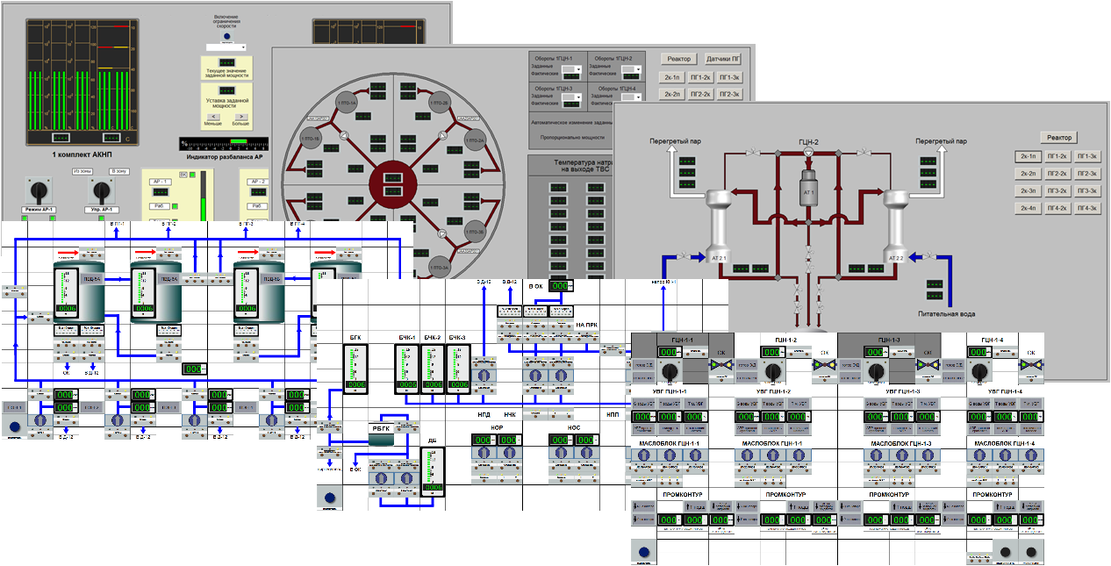
Fig. 1. Models of video frames and mimic panels of a fast reactor plant digital twin.

A cross-verification using the BURAN code was performed for the developed digital twin, which showed results that were close to the verified code. Subsequently, the digital twin was used to test the modes of normal and abnormal reactor plant operation. Based on the results of calculating these modes, discrepancies in the design documentation were identified and the necessary adjustments were made.
The flexibility of the control system models included in the fast reactor plant digital twin has made it possible to assess the competitiveness of the reactor plant in the modes of general primary grid frequency control and maneuvering in comparison with the VVER-type reactor plants [3]. For this purpose, different control approaches were used and the margin of criterion parameters to the operational limits was evaluated. After selection of optimal control algorithms, for these modes, computational studies into performance of fuel rods with different types of fuel were conducted. The results of the studies showed that the selected algorithms provide optimal operating conditions for the main equipment incorporated in the reactor plant in the modes of general primary frequency control, but in some maneuvering modes the fuel and fuel cladding parameters exceed the operational limits. To confirm these results, further development activity is required with placing fuel rods of the selected design in the core of a similar design as part of a fuel assembly and testing in analogous modes.
Another field of application of the digital twin of a fast reactor plant is its application for the development of the appearance, functionality and human engineering of video frames and mimic panels. Due to the easy editing and the large number of templates, it only takes a few minutes to relocate the simulators of switches, buttons and instruments that display the measured values.
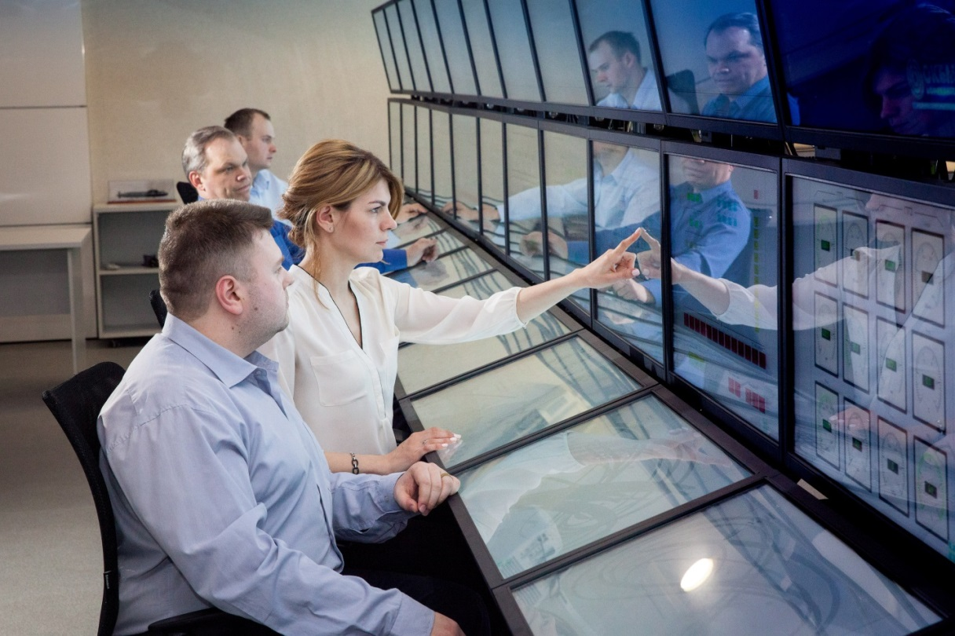
Fig. 2. Appearance of a fast reactor plant digital twin.

The developed technology of creating digital twins of fast neutron reactor plants allowed increasing the rate of development and validating the safety of newly developed designs, reducing the cost of expensive testing and debugging at the stage of startup and adjustment, and cutting down the design time. Currently, JSC “Afrikantov OKBM” extensively uses the fast reactor plant digital twin in a number of R&D activities finding application to meet a number of objectives: reduction of excess conservatism inherent in design, testing of new solutions for algorithm functioning, evaluation of equipment and system life, studying equipment behavior in a wide range of modes, including beyond design-basis ones. Implementation of this technology at early design stages showed its efficiency and allowed us to cut down the time of reactor plant development.
References
- BOL’SHUKHIN M.A., BOLNOV V.A., BUDNIKOV A.V., EREEV M.N., ZOTOVA M.V., ZOTOV I.S., LEPEKHIN A.N., PANOV V.A., PETRUNIN V.V., ROGOZHKIN S.A., ROMANOV R.I., FOMICHEV V.I., Supercomputer twin of a nuclear energy installation: developmental approaches and application experience, Atomic Energy, Vol 129, No. 2, Moscow, Russia, December 2020
- EZEKOV A.G., SKRYABIN YU.V., ZOTOV I.S.,SMIRNOV D.A., Application of a complex mathematical model of a nuclear energy installation for oprimizing the control algorithms KSU TS KOTLIN-220”, 13th Youth Sci. Techn. Conf. A Look into the Future-2015, TsKB MT Rubin, St. Petersburg, Russia, 2015.
- BOLNOV V.A., BOGDANOVA E.V., MALKIN S.A., MAYZUS A.S., USHATIKOV A.S. Virtual power unit application for analysis of a possibility for a fast neutron reactor to participate in daily meneuvoring, V ISTC NIKIET, Moscow, Russia, 2018

