# Models of the integral EUCLID/V2 code

# for numerical modeling of different

# regimes of lead-cooled fast reactor

V.M. Alipchenkov, A.A. Belov, V.P. Bereznev,

A.V. Boldyrev, A.A. Butov, D.P. Veprev,

Ya.V. Grudtsyn, I.N. Drobyshevskaya,

O.Kh. Ilyasova, I.A. Klimonov, D.A. Koltashev,

I.G. Kudashov, N.A. Mosunova, D.A. Nazarov,

V.D. Ozrin, A.V. Palagin, V.F. Strizhov,

A.A. Sorokin, O.V. Tarasov, V.I. Tarasov,

T.V. Sycheva, E.V. Usov, S.V. Tsaun, V.I. Chukhno

Nuclear Safety Institute of the Russian Academy of Sciences

Moscow, Russian Federation

Email: veprev@ibrae.ac.ru

**Abstract**

The EUCLID/V2 integral multiphysics computer code is designed for the safety analysis and justification of the new generation NPPs with liquid metal cooled fast reactors under normal operating conditions, anticipated operational occurrences, design basis accidents and severe accidents. The EUCLID/V2 code includes the system thermohydraulics module (HYDRA-IBRAE/LM), spatial time-dependent neutronics module (DN3D/CORNER), quasi two-dimensional fuel rod module (BERKUT), the module of burnup and decay heat calculations (BPSD), the module of fission, activation and corrosion products transport in primary loop and gas system of a reactor facility (AEROSOL/LM and OXID), the module of fission product source calculation, the fuel rod and core disruption module (SAFR), the modules of mass transfer and fission product transport calculation in the reactor containment compartments (AEROSOL/LM or KUPOL-BR), the module of simulation of radiation situation beyond industrial site of a NPP (ROM). The mentioned modules are multi-purpose, their models do not depend on a coolant or fuel type and may be used to simulate reactor facilities with sodium, lead or lead-bismuth coolant and nitride or oxide fuel. However, some additional special models needed for behavior simulation of reactor facilities with lead coolant have been implemented into the EUCLID/V2 integral computer code. They are the model of solid phase impurities transport in a primary loop of a reactor facility with heavy liquid metal coolant, the models for a steam generator tube rupture simulation of a reactor facility with the lead coolant, the model of fission product source calculation taking into account physicochemical interaction between the nitride fuel and the lead coolant, the nitride fuel dissociation model, the lead melt and concrete interaction model, the lead freezing model. At present, the V&V of the listed above modules and models is being carried out on analytical and numerical tests and experimental results.

## INTRODUCTION

In Russia, within the framework of the subproject “Codes of a new generation” of the “Proryv” project, software is being developed for mathematical modeling of innovative fast reactor facilities with liquid metal coolants and objects of a closed nuclear fuel cycle [1]. One of the key elements of the project “Codes of a new generation” is the development of a universal multiphysics code for the safety analysis and justification of NPPs with fast reactors with liquid metal coolants. This code was named EUCLID and has two versions: the first (EUCLID/V1) and the second (EUCLID/V2). The first version of the code is designed to simulate normal operating conditions, anticipated operational occurrences and the initial stages of accidents. The second version has a broader area of applicability up to modeling of severe accidents with the disruption of the core and release of radioactivity into the environment. Both versions of the code are universal and allow simulating the behavior of reactor facilities with sodium, lead and lead-bismuth coolants and oxide or nitride fuel.

This contribution presents a description of the EUCLID/V2 integrated code additional models, included into the code during last few years, developed to simulate the NPPs with lead-cooled reactors.

## General description of the EUCLID/V2 muptiphysics code

The EUCLID/V2 multiphysics code is intended for the safety analysis and justification of NPPs with fast reactor facilities with liquid metal coolants. The code is modular. Modules are packages of programs unified according to their functional purpose and contents. The integrated code consists of the following modules: the thermohydraulics module (HYDRA-IBRAE/LM), which allows modeling of thermohydraulic processes both in circulation circuits and a reactor containment compartments, the neutronics module (DN3D/CORNER), the fuel rod behavior module (BERKUT), the burnup and decay heat calculation module (BPSD), the module of fission, activation and corrosion products transport in the primary loop and gas system of a reactor facility (AEROSOL/LM and OXID), the module of fission product source calculation taking into account physicochemical interaction between the fuel and the coolant (is a part of the BERKUT module), the fuel rod and core disruption module (SAFR), the module of mass transfer and fission product transport calculation in the reactor containment compartments (there are two options: the AEROSOL/LM module or the KUPOL-BR module), the module of simulation of radiation situation beyond an industrial site of a NPP (ROM). The SMART_LM integrating shell provides coupled, self-consistent calculations with the noticed modules. Furthermore, the code includes the material and coolant properties database (SmartDB) and the module of instrumentation and control systems simulation (CFunc).

To solve a coupled problem, the multiphysics code modules perform the data exchange after each time step. Data exchange is carried out through the shared memory that leads to minimal overheads connected with this operation (with exception of the ROM module, the input data for which is transferred through external exchange files). At the time when the calculation starts each module gets pointers to the necessary exchange structures. The required data is taken from a previous time step.

The modules of the EUCLID/V2 integrated code listed above are multi-purpose, the models implemented in them do not depend on the type of coolant and the type of fuel. Nevertheless, the EUCLID/V2 integrated code also contains special models necessary for modeling the physical and chemical processes typical for a reactor with a lead coolant, in particular, BREST-OD-300. Below is a brief description of them.

## The models of OXID module: solid phase impurities transport in a primary loop

The OXID module is intended for numerical simulation of the processes of oxide film formation on the surface of structural materials, the release of corrosion products into the coolant, the transfer of solid phase particles and their deposition on the surface in a non-isothermal heavy liquid metal coolant (HLMC) flow with the formation of a layer of solid phase deposits. Modeling the behavior of fission products (FPs) and activated impurities in the volume of the lead coolant in the primary circuit is necessary for analyzing and justifying the radiation safety of NPPs under various operating conditions of the reactor facility. The development of an appropriate model is related to the general problem of mass transfer and dynamics of various impurities in a loop with HLMC.

The change in the concentration (*Ci*) of soluble and insoluble impurities including particles of the dispersed phase in the coolant flow is considered in a one-dimensional approximation and is determined by a system of general equations:

,

where  is the carrier medium velocity (coolant flow calculated by a system thermohydraulic code),  is the concentration flux of a given component due to the action of the k-th process,  is the longitudinal coordinate along the channel length.

The change in the thickness of various layers of the oxide film and the deposition layer () is considered in the following approximation

,

where  is the mass flux (kg/(m2s)) of the p-th component into the j-th layer due to diffusion (oxide layer) and deposition of particles or condensation of soluble components on the surface (deposition layer).

At the phase interface, when calculating the corresponding mass fluxes for various components, the fulfillment of the mass conservation law is taken into account. For example, when solid particles are deposited on the surface, the entire mass from the flow passes into the mass of this component in the deposition layer. As a result, a multi-component deposition layer is formed. On the other hand, in the case of crystallization of the components soluble in the coolant on the surface of the channels, only a part of the flow of the component mass to the surface is transferred to the accumulated mass of this component in the deposition layer. This part is determined by the equilibrium concentration of this component above the surface at the current surface temperature of the deposition layer. In its turn, the equilibrium concentration of a component above the surface is determined by the thermodynamics of the phase transition under consideration. Similarly, during the formation of a magnetite layer in an oxide film, the boundary condition at the phase interface is determined by the thermodynamics of magnetite formation. In this case, an excess of oxygen or iron determines, respectively, the flux of oxygen into the steel and, therefore, corrosion, and the excess of iron determines the flux of corrosion products into the flow of the coolant.

In the current version of the module, the following mechanisms are considered: oxidation-reduction of steel and the formation of an oxide film on its surface; erosion of the oxide film and the release of erosion particles into the coolant flow; the release of corrosion products from steel into the coolant; the flow of oxygen dissolved in the coolant to the steel surface; the formation and transfer of solid phase polydisperse particles in the lead melt flow, including the coagulation of particles; deposition of particles on the surface and the formation of a solid phase layer of deposits; change in oxygen activity in a non-isothermal coolant flow taking into account physicochemical transformations; dissolution of lead oxide spheroids in the coolant.

## Some models used to describe the processing occurring during steam generator tube rupture

When modeling a leak in a steam generator with a lead coolant, the key issue is determining the size of dispersed particles (bubbles) or the interfacial surface. This is necessary to correctly describe the processes of heat and mass transfer and interfacial friction, and as a result, the distribution of the gas phase in the circuit of the reactor facility with a liquid metal coolant. To determine the size of bubbles resulting from a leak, correlations were implemented in the code, which were validated using the experiments [2].

To determine the size of bubbles during their movement along the circuit of the reactor, a hierarchy of models with different levels of complexity and description detail has been implemented in the code.

In the simplest case, the size is determined from empirical relations and corresponds to the equilibrium value in accordance with the thermohydraulic parameters averaged in the considered region. This approach assumes instantaneous adjustment of the size of the dispersed phase when the thermohydraulic parameters of the carrier flow change, while the real relaxation zone can be significant. The next more complex approach uses a special equation for determining the volumetric interfacial area, which describes its dynamics over time and, accordingly, the size of the dispersed phase. Although this approach allows to qualitatively and quantitatively improve the description of the dynamics of changes in the size of the dispersed phase, in comparison with the calculation from the empirical ratio, it usually considers the monodisperse approximation. The use of the monodisperse approximation for solving a number of practical problems is insufficient, in particular, it is impossible to correctly describe the separation in the downflow in cases where small bubbles are captured by the coolant flow, and large-diameter bubbles float up.

A more detailed description of the ensemble of interacting particles, taking into account the spectrum of their sizes, can be obtained only in the approach based on the kinetic equation for the particle size distribution function. The method of fractions (groups) is widely used for numerical solution of the kinetic equation. In this method, all particles are divided into groups by size, and for these groups, based on the kinetic equation, a system of equations is written for the concentration of particles in the group (fraction), taking into account various interactions (fragmentation, coagulation, and other processes). This model is also implemented in the code.

Qualitatively, the advantages of the latter approach are shown in Fig. 1. Fig. 1 illustrates the results of modeling steam injection at the height of 3.6 m into a vertical channel with a lead coolant moving downward with the velocity of 0.3 m/s for the cases of monodisperse and bidisperse distribution (with the same initial average size at the channel entrance) of bubbles by size.

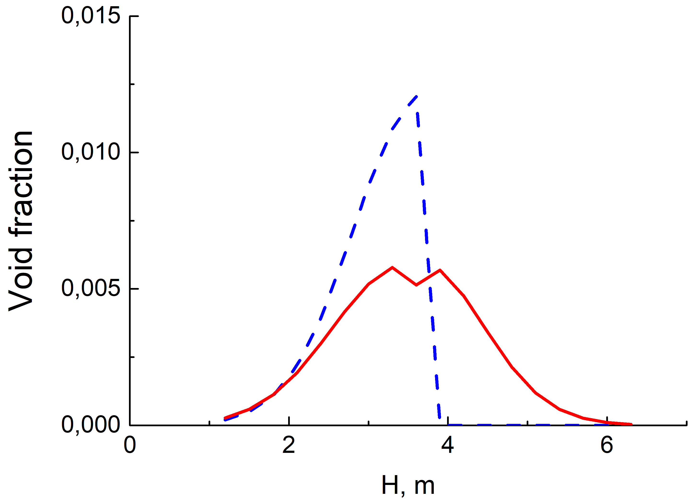

*FIG. 1. Distribution of void fraction over the channel height for the monodisperse case (blue dashed line) and for the calculation using a heterogeneous model (red solid line).*

The figure shows that for the given lead velocity in the case of a monodisperse size distribution, the volume gas fraction distribution is shifted down the coolant flow relative to the injection point, whereas in a bidisperse distribution, the void fraction also extends upstream.

To our knowledge, a model based on the kinetic equation for the bubble size distribution function are available only in some CFD codes.

To take into account the effect of water vapor bubbles on neutron-physical processes in the lead-cooled reactor core, the EUCLID/V2 integrated code uses the procedure for recalculating the cross-sections for the interaction of neutrons with nuclei depending on the lead density, water vapor density and the void fraction of water vapor in the computational cells of neutronics model. The computational model in the neutronics module of the EUCLID/V2 code consists of cells with homogenized materials. Each assembly is divided into axial cells, while the fuel, coolant and structural materials inside each cell are homogenized.

The deterministic simulation with EUCLID/V2 code includes a method based on neutron cross-sections interpolation using preliminarily prepared data. The calculation grids are built on fixed values of thermohydraulic parameters. Nuclear data are prepared using thermohydraulic parameters in the grid nodes. During the simulation, neutron cross-sections for current thermohydraulic characteristics are interpolated using the values in the grid nodes. The set of thermohydraulic parameter grids traditionally includes coolant density and temperature, fuel temperature and construction materials temperature. The grids also include void fraction to take into account steam transport.

## The model of fission product source calculation taking into account physicochemical interaction between the nitride fuel and the lead coolant

The thermochemical model of nitride fuel of the BERKUT module includes a representative set of elements that contains 23 classes of chemical elements: U, Pu, Cs, I, Mo, Ru, Pd, Rh, Tc, Ba, Sr, Zr, La, Ce, Eu, Nd, Nb, Sb, Te, Xe, N, O, C.

In the model, irradiated nitride fuel is considered as a heterogeneous system consisting of the following multi-component phases: solid solution of fission products (FP) and impurity carbon in mixed mononitride (U,Pu)N, five-component metallic phase of Mo, Ru, Rh, Pd and Tc, nitride phase of (Ba,Sr)3N2, phase of Cs and Ba tellurides and intermetallic phase, phase of condensed cesium iodine, U2N3 phase. As follows from ab-initio calculation [3], solid solubility of oxygen in UN is relatively low. Therefore, presence of impurity oxygen in nitride fuel can result in formation of separate oxide phases. Besides, the phases of sesquialteral carbides U2C3 and Pu2C3 with impurities of FPs Zr, Ce and Mo can be precipitated. The gas phase included in the model means noble gases released from fuel grains and FP vapors formed in the intergranular and open porosity. It is supposed that the fuel initial state is the mixed oxycarbonitride phase of uranium and plutonium. Atoms formed by fission of actinides interact with “liberated” nitrogen, oxygen and carbon, diffuse to the grain boundaries. Depending on the boundary conditions, they can enter the intergranular porosity where the secondary condensed phases, precipitates and FP-bearing vapors, are formed. Note that the boundary conditions for the FP diffusion problem are derived from the condition of thermochemical equilibrium at the boundary of the solid solution phase and the subsystem “precipitates–gas phase”. It is also assumed that there is equilibrium with respect to the nitrogen and oxygen exchange between the subsystems. Models of FP transport by intergranular porosity are similar in functional form to the models used to describe the behavior of oxide fuel, which are described in [4, 5].

Studies of interaction between nitride fuel and liquid lead [5] showed that uranium and plutonium do not dissolve in lead, and there is no depletion of nitrogen in the fuel boundary zone. Based on the literature data, it can be concluded that, from the main components of nitride fuel, lead can interact chemically with nitrogen only. However, according to [6], lead nitrides are unstable at operating temperatures of a fast reactor, and therefore their formation can be ignored. Among FPs released from the irradiated fuel, liquid lead can react chemically with iodine, tellurium, and molybdenum to form condensed lead iodides and tellurides, as well as lead molybdate. PbI2 and PbTe compounds, as well as iodides and tellurides of Cs and Ba, are apparently soluble in liquid lead, in contrast to oxides and nitrides of La, Ce, Nd, Ba, Sr and intermetallides (Ru,Rh, Pd)3U.

The problem of calculating the composition of substances entering the gas gap or, in the case of direct contact, the coolant, is formulated as follows.

The initial quantitative composition of the system is formed from condensed components that make up the fuel layer adjacent to the pellet boundary, the liquid lead phase, which is a solution of Pb with impurities of lead oxides, and the gas phase, which consists of gaseous chemical compounds coming out of the pellet, as well as lead vapors and its compounds. The volume of the cylindrical gap layer adjacent to the pellet is considered as the volume of the lead phase. The characteristic of equilibration in the system is defined by diffusion transport along the liquid coolant layer. Since the rate of changes in the system composition is mainly limited by the much slower process of solid-state diffusion, it is assumed that these changes in time steps of ~104–105 s can be ignored. Thus, it is assumed that the system including the fuel layer adjacent to the pellet boundary is in thermochemical equilibrium. In thermodynamic calculations, all condensed phases consisting of more than one component are considered as solid solutions. Thermodynamics of the system is described in the framework of a modified ideal solution model at a given temperature and the gap pressure. The calculation result is the distribution of FP in condensed and gas states. It is assumed that condensed phases are formed on the surface of fuel pellet. In the case of destroyed fuel element cladding, the condensed components with a melting point lower than the coolant temperature pass into the solution, and the rest are washed away by the flow of lead in the form of insoluble solid inclusions.

## The nitride fuel dissociation model

It is known, that at relatively low nitrogen pressures above the surface of uranium nitride, congruent melting of the latter is not observed. There is decomposition into uranium (plutonium) and nitrogen. The most important thing for modeling of the mixed uranium and plutonium nitride (MNUP) fuel dissociation during severe accident is to determine the rate of mass loss due to the release of nitrogen and uranium (plutonium) vapor. Nitrogen and uranium (plutonium) vapor appear as a result of the following reactions:

, ,

where  – molar fraction of the plutonium (Pu); l, g and c mean liquid, gaseous and solid phase, respectively.

The rate of weight loss for a sample with MNUP fuel can be calculated from the following relation:

,

where  is the mass of the fuel pellet,  is the surface area of the fuel pellet, , , are mass fluxes of the uranium, nitrogen and plutonium, correspondingly.

The right side of the equation contains the mass flows of nitrogen, uranium and plutonium atoms. To calculate mass flows of the molecules and atoms, it is proposed to use a model that takes into account the kinetics of evaporation from the fuel surface, as well as the diffusion and convection of molecules in the near-surface layer of gas. More detailed description of the models is presented in [1, 7]. To validate the model of dissociation of MNUP fuel during severe accident, a systematization of model experiments data obtained in JSC “VNIINM” (Russia) has been carried out. Thermogravimetric studies were carried out in an atmosphere of high-purity helium at a sample heating rate of 30°C/min, with a 30-minute exposure. During the experiment, the following parameters were recorded: change in sample weight and rate of change in sample weight. A comparison of simulation results and experimental data is presented in Fig. 2. The average error of calculation is equal to 30%. The differences between theoretical and experimental results are due to the fact that in calculations the assumption of the cylindrical shape of the sample has been used, while in the experiment the samples had irregular shape, which affected the area estimation error for the lateral surface of the samples.

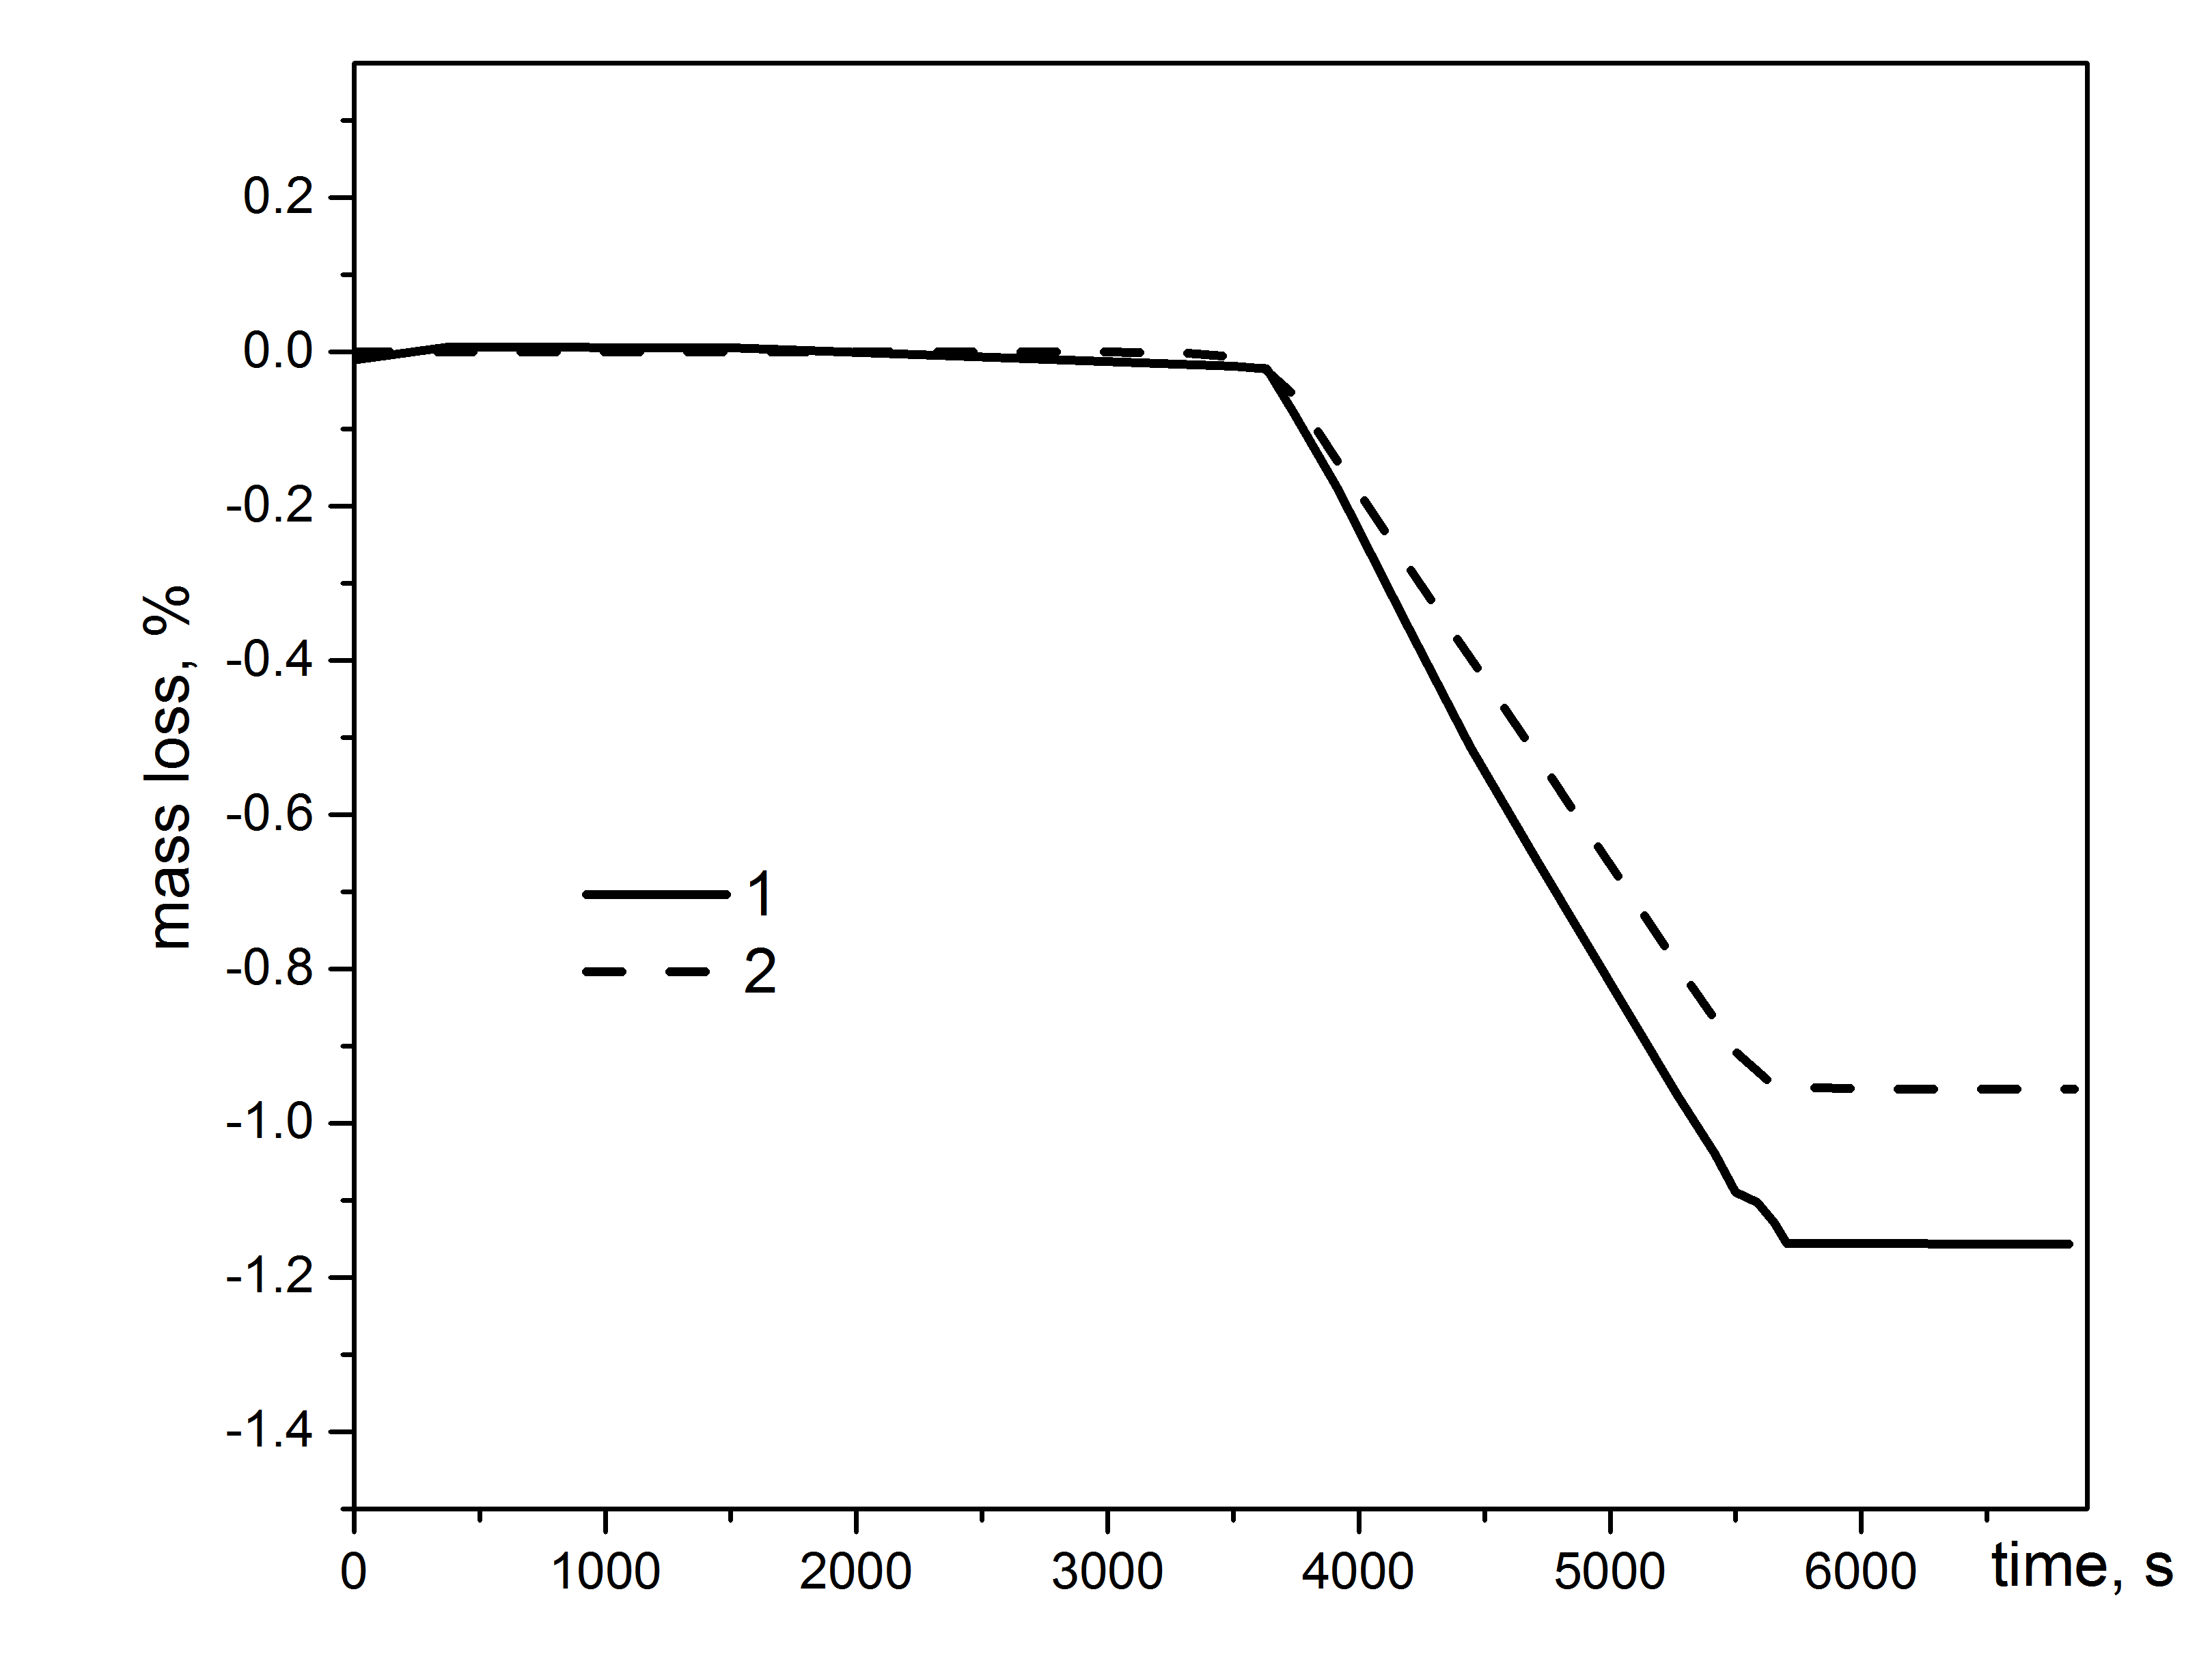

*FIG. 2. Mass loss of the MNUP fuel at 2200 K: 1 – experimental data; 2 – calculation with the EUCLID/V2 code.*

## The lead melt and concrete interaction model

Physical phenomena during interaction of lead melt with concrete are modeled in the CORCONIT module. If the liner of the loop with the lead coolant is violated, lead contacts with the concrete. The basic phenomena are the lead-concrete heat exchange, including lead freezing at low temperatures. Besides lead-concrete heat exchange, when temperature increases the following physicochemical phenomena in the heated concrete are considered:

* thermal decomposition of concrete components, for example, Ca(ОН)2;
* thermal decomposition of dolomite with the release of СО2, etc.

## The lead freezing model

When liquid lead temperature decreases below melting point solidification process begins. A solid lead layer (crust) formed on the channel wall can partially or completely block channel cross-section causing heat transfer drop and increase of hydraulic local resistance. Such a situation can occur in a reactor primary coolant system under emergency cooldown conditions, main circulation pump failure and the associated excessive heat removal by the secondary circuit. When coolant temperature increases, the crust thickness begins to decrease.

The model for the description of lead coolant solidification has been developed and implemented in the EUCLID/V2 code. If the temperature at the liquid lead/solid interface goes down and reaches a value of  = 600.61 K, the temperature decrease stops at this location, and crust begins to form at the interface. According to Stefan condition, a variation of solid lead mass on a time step is given by the difference of heat flux in the crust  and heat flux in the liquid  at the interface:

,

where  is the lead melting heat. Change of crust thickness results in channel cross-section area  change. To take into account the fast variations of  thermohydraulic equations were modified and the new terms with time derivative  were added to the right-hand side:

,

,

,

where  is the enthalpy,  is the density, subscript ‘*l*’ stands for liquid and ‘*s*’ for solid. So, the exact balance of mass of flowing lead at phase transition was ensured. Cross-section area variation affects the hydraulic parameters of the channel; thermal properties of solid layer differ from that of tube material – all these effects are accounted for when heat exchange is considered.

Below a test problem on lead solidification is considered. Lead flows in a steel tube 30/34 mm, length of the tube is 50 cm. Tube outer surface temperature is constant,  = 570 K. Lead inlet temperature is (Fig. 3), mass flow rate is 5 kg/s. One has to calculate the crust thickness. A comparison of the EUCLID/V2 code calculation results and the analytical solution of the problem is shown in Fig. 4. The good agreement is observed.

|  |  |
| --- | --- |
|  |  |
| *FIG. 3. Liquid lead inlet temperature* | *FIG. 4. Time dependence of crust thickness at z = 25 cm* |

## Conclusion

Additional modules and models designed to simulate physical and chemical processes characteristic of a lead-cooled reactor facility, namely, the model of solid phase impurities transport in a primary loop of a reactor facility, the models for a steam generator tube rupture, the model of fission product source calculation taking into account physicochemical interaction between the nitride fuel and the lead coolant, the nitride fuel dissociation model, the lead melt and lead-concrete interaction model, the lead freezing model have been developed and implemented in the EUCLID/V2 multiphysics code. At present, they are being verified and validated. The listed models together with previously realized will make it possible to simulate the behavior of a reactor facility with a lead coolant both in normal operation conditions and anticipated operational occurrences.

ACKNOWLEDGEMENTS

The EUCLID/V2 code has been developed within the “Codes of a new generation” subproject of the “Proryv” project.

References

1. BOLSHOV, L., Strizhov, V., Mosunova, N., Codes of new generation for safety justification of power units with a closed nuclear fuel cycle developed for the “PRORYV” project, NUCET **6** 3 (2020) 203–214.
2. LOBANOV, P., Usov, E., Butov, A., et al., Experimental investigation of the impulse gas injection into liquid and the use of experimental data for verification of the HYDRA-IBRAE/LM thermohydraulic code, Therm. Eng. **64** 10 (2017) 770–776.
3. VESHCHUNOV, M., Boldyrev, A., Kuznetsov, A., et al., Development of the advanced mechanistic fuel performance and safety code using the multi-scale approach, Nucl. Eng. Design **295** (2015) 116–126.
4. VESHCHUNOV, M., Ozrin, V., Shestak, V., et al., Development of mechanistic code MFPR for modelling fission product release from irradiated UO2 fuel, Nucl. Eng. Design **236** (2006) 179–200.
5. Rogozkin, B., Stepennova, N., Fedorov, Yu., et al., “Mononitride U–Pu mixed fuel and its electrochemical reprocessing in molten salts”, Power Reactors and Sub-Critical Blanket Systems with Lead and Lead–Bismuth as Coolant and/or Target Material, IAEA-TECDOC-1348, IAEA, Vienna (2003).
6. Lyakishev, N., Diagrams of the State of Binary Metal Systems. Mashinostroenie, Moscow (1996).
7. USOV, E., Chukhno, V., Kudashov, I., Sycheva, T., Model for the calculation of the dissociation rate of nitride fuel at high temperatures, High Temp **58** 2 (2020) 222–226.