SOCRAT-BN INTEGRAL CODE: DEVELOPMENT, VALIDATION AND CURRENT STATUS
Chalyy R.V.¹, Tarasov A.E.¹, Fokin A.L. ¹, Ryzhov N.I. ¹, Tsaun S.V. ¹, Filippov M.F. ¹, Semenov V.N. ¹, Gusev М.V ¹, Kechkov А.А. ¹, Butov A.A. ², Kudashov I.G. ², Usov E.V. ², Pribaturin N.A. ²

¹Nuclear Safety Institute of the Russian Academy of Sciences, Moscow
²Novosibirsk Branch of Nuclear Safety Institute of the Russian Academy of Sciences, Novosibirsk

E-mail contact of main author: chalyy@ibrae.ac.ru

Abstract

The computer programs SOCRAT-BN (integral computer codes) was developed in two stages in the frame of the Federal Target Program «New-Generation Nuclear Power Technologies for the Period 2010–2015 and up to 2020». A version of the SOCRAT-BN/V1 code was developed at the first stage for safety justification of NPPs with sodium-cooled reactors in design basis and beyond design-basis accidents and was limited by materials melting. The next version SOCRAT-BN/V2 extended the scope of the code to cover severe accidents with core melting. At present, both versions of the code have been validated and certified by “Scientific and Engineering Centre for Nuclear and Radiation Safety” (SEC NRS) and are used by JSC «Afrikantov OKBM» to justify the safety of existing and developed reactors with sodium coolant. Based on the results of using the code, a number of user and model improvements were made. Methodological approaches are being developed in terms of the analysis of uncertainties and the assessment of the sensitivity of the results of validation and computational modeling. The paper provides information on the current status of the SOCRAT-BN code.

Key Words: Safety, Severe Accidents, Integral Code, Sodium Coolant, Uncertainty Analysis.

- INTRODUCTION

In Russia there are two power units with a fast neutron reactors with a sodium coolant [1]: BN-600 (commissioned in 1980) and BN-800 (commissioned in 2015). A power unit with a 1200 MWe reactor - BN-1200 is at the design stage. To justify the safety of these power units, including the task of extending the operation life of the BN-600 reactor until 2040, certified programs are required. As of March 2021, the SOCRAT-BN/V2 computer program is the only certified integral code covering the modeling area from deviation from normal operation to severe accidents with core melting. Brief information on the SOCRAT-BN/V2 code was presented in 2017 at the FR-17 conference in Yekaterinburg [2]. In 2019, Rostechnadzor issued a certificate number 472 for the SOСRAT-BN/V2 code with a validity period from 20.11.19 to 20.11.29. In the process of code certification, a several works were done to improve some models and code interfaces.

- CURRENT STATUS

A brief description of the main program modules of the SOСRAT-BN code is presented in [2]. Fig. 1 shows the general structure of the code. The overall structure is in line with the 2017 structure. As of 2021, the improvement of the thermohydraulic and radiation modules have been performed.

- IMPROVEMENT OF THE THERMOHYDRAULIC MODULE

The improvement of the thermohydraulic module is carried out in terms of the post-CHF heat transfer model. In the previously implemented model of heat transfer, the crisis of heat transfer occurred during the drying of the liquid film on the wall. Drying of the film began when void fraction α in the cell exceeded the value α_{dryout}=0,957, and complete drying at α_{trans}=0,999. The experience of calculating emergency processes at the sodium fast reactor (SFR) with core melting showed that when molten steel moves down, a situation can arise when the temperature of the liquid in the cell is below the saturation temperature, i.e. no bulk boiling is observed, and the wall temperature is significantly higher than the saturation temperature, as a result of the dragging of molten steel. In such situations, the overestimated heat flux led to a sharp heating and thermal expansion of sodium in the cell, which in turn led to a rapid increase of pressure in this cell. To solve this problem, a calculation of the heat transfer crisis was introduced at low values of steam content and high values of wall temperature.
The improvement was based on the calculation of the critical heat flux using the Kottowski correlation [3], which was developed to calculate the critical heat flux in the flow of liquid alkali metals in round tubes and bundles. The critical heat flux $q_{CHF}$, [W/m²], is calculated by the formula:

$q_{CHF}=A∙G^{B}∙\left(1-2∙x_{i}\right)∙{\left(\frac{L}{d_{h}}\right)}^{-0,8}∙h_{fg}$,
where G is the specific mass flow rate of the coolant, [kg / m²s]; L - heated length, [m]; d_{h} - hydraulic diameter, [m]; h_{fg} - phase transition enthalpy, [J / kg], x_{i} - relative flow enthalpy. For round pipes, the constants A and B are 0.216 and 0.807, respectively. For wire wound rod bundles, A = 0.224 and B = 0.766.
The measured values of the critical heat flux for sodium flow in the experiments of Kottovsky [3] varied in the range from 1 to 7.4 MW/m².
When liquid alkali metals boil in a large volume without directional flow, the critical heat flux is calculated using the Kirillov model [4]
$q_{CHF}=3.12∙{10}^{5}∙k_{f}^{0.6}∙{\left(\frac{p}{p_{crit}}\right)}^{\frac{1}{6}}$,
where k_{f} is the thermal conductivity of the liquid phase, [W/m K]; p - pressure [Pa]; p_{crit} is the critical sodium pressure [Pa].
The model implemented in SOCRAT-BN uses the maximum value among the two possible.
The critical heat flux q_{CHF} corresponds to the maximum heat flux q_{f} from the wall on the boiling curve in the bubble flow regime, q_{CHF} = q_{f}. Therefore, at this point, the equality holds:
$q_{CHF}=h_{wf}∙\left(T_{crit}-T_{s}\right)$,
where h_{wf} is the nucleate boiling heat transfer coefficient, [W/m²K]; T_{s} - saturation temperature, [K]. From the equality, it is possible to calculate the critical wall temperature T_{crit}, above which the heat transfer will be supercritical. The condition for the transition to the supercritical heat transfer regime in SOСRAT-BN/V2 is the fulfillment of the inequality
$T_{w}>T_{crit}$.

FIG. 1. Structure of the code SOCRAT-BN/V2

- IMPROVEMENT OF THE FISSION PRODUCT MODULES

The fission product block consists of a program module for calculating the production of fission products BONUS-BN and a module for transferring fission products (FP) in the loop of the TRANS-FP reactor. In the initial version of the code, the BONUS-BN module worked until the fuel rods were depressurized. Further, the TRANS-FP module transported fission products without taking into account radiation decay from the moment of depressurization until the moment the fission products were ejected from the reactor circuit. At present, at the moment of fission products exit from the circuit, a call of the BONUS-BN module is organized to calculate radiation decays taking into account the transport time of fission products.
An additional improvement of the radiation module is the implementation into the TRANS-FP module of a model for the evaporation of volatile fission products from the surface of a molten pool, based on finding the thermodynamic equilibrium of chemical compounds into which FPs are combined. The new model makes it possible to reduce the uncertainties of the basic model based on the use of empirical volatility coefficients. Since the empirical coefficients were obtained in a narrow temperature range, their extrapolation to higher temperatures gives additional uncertainties. The model is based on the representation of the evaporation process of fission products as a sequence of quasi-stationary states between the surface layers of liquid sodium and a protective gas of the pressure compensation system. For each equilibrium state, the source of fission products is determined:
,
where is the rate of loss of fission products from the surface layer of the sodium volume (kg / m³ / s), is the surface area of the sodium-gas system, is the volume of sodium coolant (which is considered to be ideally mixed within the approximations of the model), is the diffusion coefficient of the vapor of the chemical compound FP, in the form of which this is predominantly present in the shielding gas, is the concentration of the chemical element FP in the shielding gas at the surface of the melt, is the average concentration of the chemical element FP in the volume of the shielding gas, is the thickness of the boundary layer.
The equilibrium value is determined by the values of the equilibrium vapor pressures of chemical compounds of a given element of the FP, determined in the course of solving the thermodynamic problem. The equilibrium state is defined as the equality of the Gibbs energy of the entire system to zero - dG = 0.

- UNCERTAINTY ANALYSIS IN VALIDATION

For the purpose of the code validation, the ASME V&V20 method [5] was adapted to estimate the modelling error. The main idea in the used method is to use the analogy between a computer program and a measurement device, the result of calculation and measurement. As a consequence, the basic metrological terms "true value", "measurement error" and "measurement uncertainty" apply to the area of calculations. The purpose of code validation is to assess the component of the calculation error associated with simplifications and approximations of physical and mathematical models implemented in the computer i.e., modelling error. A graphical representation of the terms used is shown in Fig. 2 [6].

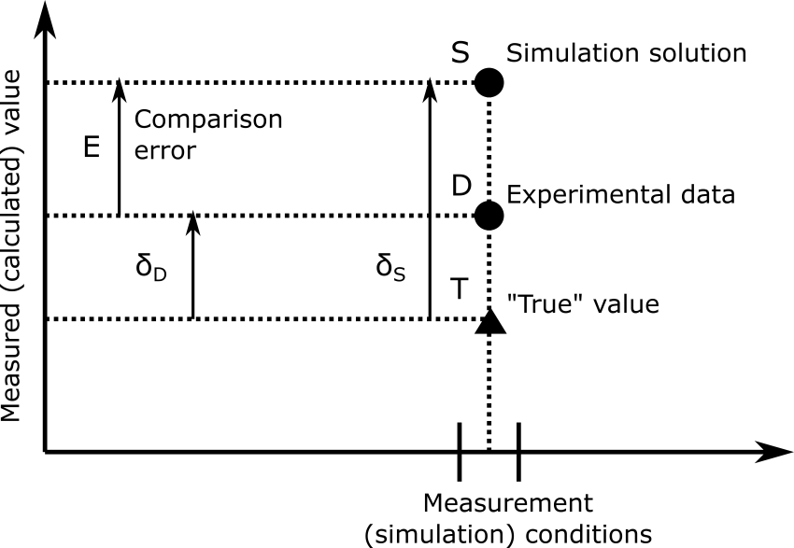
Fig. 2. Graphic illustration of the concepts used in the validation of the code
A central part of the method is the analysis of the uncertainties of the validation calculations. The uncertainty analysis algorithm is based on Monte Carlo method. At the first stage, the input parameters of the calculation are determined, which will participate in the uncertainty analysis, and their probability distribution functions (PDF) are estimated. At the second stage, samples of input parameters are generated using a pseudo-random number generator from a given PDFs to perform Monte Carlo calculations. After the calculations are completed, the average comparison error of the calculations with the measurements and the standard deviation of the calculation results are estimated.
Validation uncertainty includes three components:
- u_{D} is the standard measurement uncertainty of the compared (measured) value;
- u_{input} is the standard uncertainty of the calculation results due to the incompleteness of information about the input parameters (initial and boundary conditions, properties, etc.) - estimated on the results of Monte Carlo runs;
- u_{num} is the standard uncertainty due to the numerical solution of the equations (choice of the time integration step, cell sizes).
As a result of calculations by the Monte Carlo method, we obtain the value of the average comparison error E:
$E_{n,\%}=\frac{1}{N_{calc}}\sum_{k=1}^{N_{calc}}{\frac{\left(S_{n}^{k}-{\overline{D}}_{n}\right)}{{\overline{D}}_{n}}}=\frac{{\overline{S}}_{n}-{\overline{D}}_{n}}{{\overline{D}}_{n}}$;
and the standard uncertainty u_{input} by the formula:
$$u_{input,n,\%}^{2}=\frac{1}{N_{calc}-1}\sum_{k=1}^{N_{calc}}{\frac{{\left(S_{n}^{k}-{\overline{S}}_{n}\right)}^{2}}{{\overline{S}}_{n}^{2}}}$$
where ${\overline{D}}_{n}$, ${\overline{S}}_{n}$ – average values of measurement and calculation, respectively; k is the number of the Monte Carlorun, N_{calc} is the number of runs. The resulting validation uncertainty is calculated using the formula:
$$u_{val, n,\%}=\sqrt{u_{input,n,\%}^{2}∙{{\overline{S}}_{n}^{2}}/{{\overline{D}}_{n}^{2}}+u_{num,n,\%}^{2}∙{{\overline{S}}_{n}^{2}}/{{\overline{D}}_{n}^{2}}+u_{D,n,\%}^{2}}$$
The n (experiment number) symbol in expressions indicates that the current evaluation was performed for one experiment. Validation results for individual experiments are averaged over similar experiments and the values ${\overline{E}}_{\%} and u_{val,\%}^{tot}$ are obtained. The result of validation is the interval in which the modelling error is located:
$δ_{model}∈({\overline{E}}_{\%}{-u}_{val,\%}^{tot}; {\overline{E}}_{\%}{+u}_{val,\%}^{tot})$.
This error is recorded in the code certificate.
To apply the results of validation to the results of the accident calculation, the same approach is used (Fig. 2) as in the validation. The distinctive feature is the lack of measurement results at the reactor plant under the conditions of a simulated accident. Uncertainty in the result of calculating an accident at a reactor consists of 3 components:
$u_{S}^{2}={u_{model}^{2}+u}_{input}^{2}+u_{num}^{2}$,
where $u_{model}$ means the value $u_{val,\%}^{tot}$, that is, $u_{model}≡u_{val,\%}^{tot}$, $u_{model}$ и $u_{num}$ are the uncertainties associated with the uncertainties in the input data and the choice of the grid and the time integration step (similar to validation) ...
Then the estimate of the true value T of the calculated parameter is calculated as:
$$T∈\left(\overline{S}-\overline{E}-u_{S}; \overline{S}-\overline{E}+u_{S}\right).$$
where $\overline{S}$ is the averaged result of accident calculations by the Monte Carlo method, and $\overline{E}$ is the systematic error of the model (validation results). Note that the transfer of modelling error is possible only for the case when the modelling error is estimated under conditions close to the conditions that arise during an accident calculation.

- DEVELOPMENT OF THE INTERFACES

Since 2018, active development of user interfaces for the SOСRAT-BN code has been underway. At the first stage, a postprocessor was developed [7]-[8] using the Qt 4 programming library, which provides the ability to visualize and analyze the results of calculations with the SOCRAT-BN code for:
1) time dependences of the design parameters of the thermohydraulic design module;
2) spatial distributions of the calculated parameters of the thermohydraulic and severe emergency modules.
An example of a post processor interface is shown in Fig. 3.
At the second stage, a preprocessor is being developed for the interactive preparation of computational schemes. The preprocessor is implemented using the C ++ cross-platform language and the free Qt 5.15 library [9]. At the same time, the freely distributed components QtnProperty [10] and nodeeditor [11] are used to implement the graphical interface.
An example of a preprocessor interface is shown in Fig. 4.
The preprocessor allows one to graphically create hydraulic design schemes, adjust the parameters of the circuit elements and additional modules. The preprocessor provides control over the correctness of the entered values and their sufficiency, start and control of the calculation progress.
The preprocessor has the ability to fully configure the parameters without additional programming. This provides an opportunity to accompany changes in the structure of the input deck of the SOСRAT-BN/V2 code without involving the developers of the preprocessor. Provides the ability to add support for additional calculation modules, add / remove parameters, set ranges and format of parameter values, set links between parameters.
For this purpose, a special configuration file with a json structure has been created.

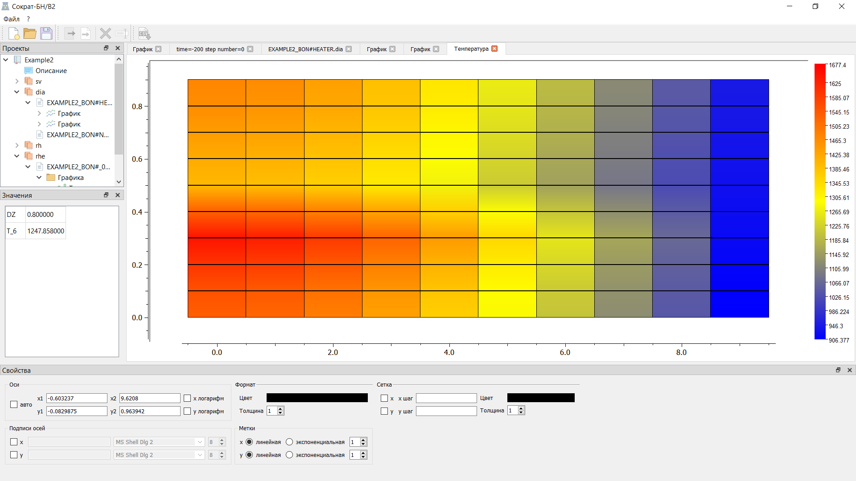

Fig. 3. Postprocessor interface

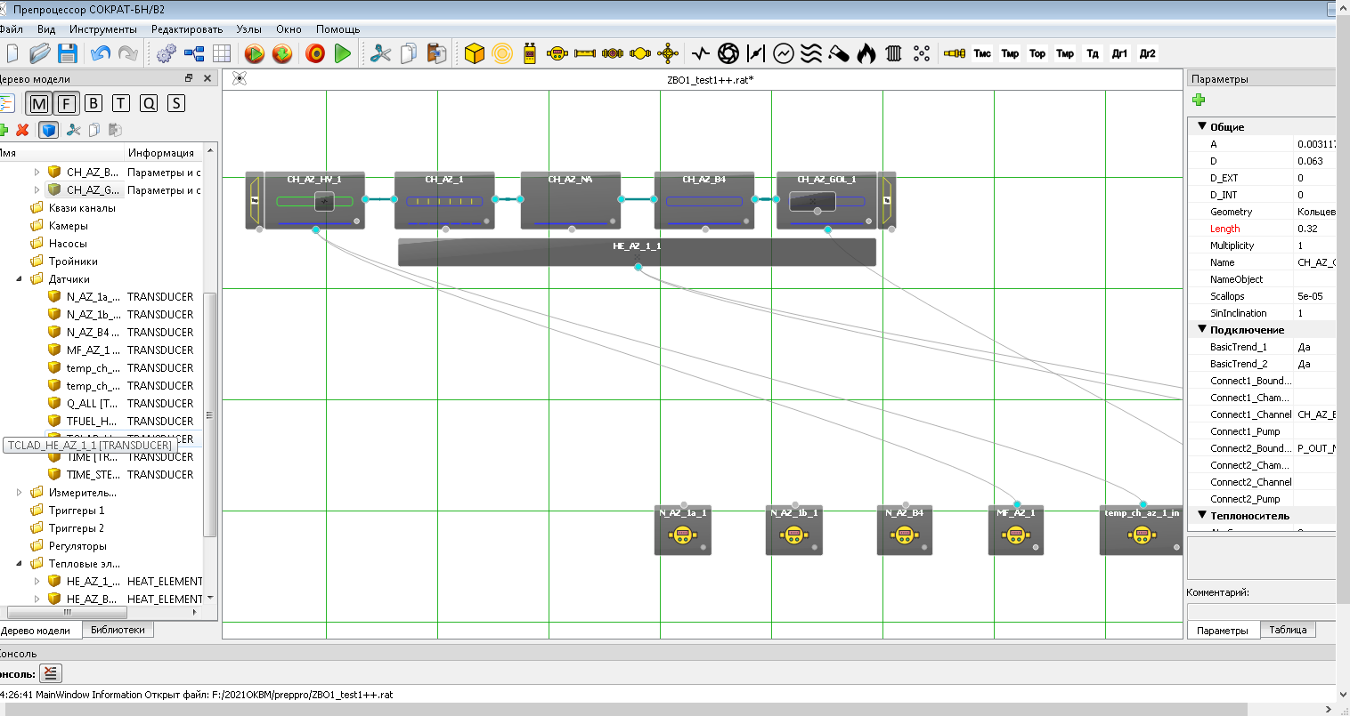
Fig. 4. Preprocessor interface

- CONCLUSION

At present, the development of the SOCRAT-BN code has been fully completed. The code is certified by Rostekhnadzor and nowadays code is used to justify the safety of sodium-cooled fast breeder reactor plants in the area of violations of normal operation, design basis and beyond design basis accidents. The code makes it possible to simulate an accident from the initial event to the formation of the source of fission products into the environment. IBRAE RAN specialists provide technical support to users in terms of improving code models, diagnostic systems and user interfaces. User training is carried out within the framework of seminars.

8 REFERENCES

[1] http://www.okbm.nnov.ru/business-directions/bystrye-reaktory-s-natrievym-teplonositelem/
[2] Chalyy R.V., et al. “SOCRAT-BN integral code for safety analyses of NPP with sodium cooled fast reactors:development and plant applications”, International Conference on Fast Reactors and Related Fuel Cycles: Next Generation Nuclear Systems for Sustainable Development (FR17), (Proc. Int. Conf., Yekaterinburg, 2017), IAEA, Vienna (2018), Paper CN245_281
[3] H.M. Kottowski, C. Savatteri and W. Hufschmidt, A new critical heat flux correlation for boiling liquid metals, Nucl. Sci. and Eng., V. 108(4), pp. 396-413, 1991.
[4] Kaeri/AR-553/99. Reviev of the critical Heat Flux Correlation for liquid Metalls. 1999. 20 p..
[5] Standard for verification and validation in computational fluid dynamics and heat transfer. ASME V&V20–2009. New York: ASME, 2009. 88 p.
[6] Dolganov K.S., et all. EVALUATION OF SOKRAT CODE POSSIBILITY TO MODEL URANIUM-DIOXIDE FUEL DISSOLUTION BY MOLTEN ZIRCONIUM. Atomic Energy. 2018. Т. 125. № 2. С. 82-90
[7] S. Sumarokov., et al. «Integral computational code SOCRAT-BN for modeling serious accidents at NPP: analysis and visualization of results». Information technologies of CAD/CAM/CAE, №2, 2019, pp. 12-15.
[8] Sumarokov S. V., et al. "Analysis and visualization of the calculation results of the integrated heavy-accident calculation code SOCRAT-BN", Information technology in design and production, No. 2, 2019, pp. 12-15.
[9] URL: https://www.qt.io.
[10] http://github.com/qtinuum/QtnProperty.
[11] https://github.com/paceholder/nodeeditor.

