Models of the integral EUCLID/V2 code for numerical simulation of severe accidents in a sodium-cooled fast reactor with MOX and MNUP fuels

V.M. Alipchenkov¹, A.A. Belov¹, V.P. Bereznev¹, A.V. Boldyrev¹, A.A. Butov¹, D.P. Veprev¹, I.N. Drobyshevskaya¹, O.Kh. Ilyasova¹, I.A. Klimonov¹, D.A. Koltashev¹, I.G. Kudashov¹, N.A. Mosunova¹, D.A. Nazarov¹, V.D. Ozrin¹, A.V. Palagin¹, V.F. Strizhov¹, A.A. Sorokin¹, O.V. Tarasov¹, V.I. Tarasov¹, T.V. Sycheva¹, E.V. Usov¹, S.V. Tsaun¹, V.I. Chukhno¹

¹ Nuclear Safety Institute of the Russian Academy of Sciences (IBRAE RAN), Moscow, Russia

E-mail: usovev@ibrae.ac.ru

Abstract. For the modeling of severe accidents in a sodium-cooled fast reactor coupled multiphysics EUCLID/V2 code is being developed in Russian Federation in Codes of New Generation subproject of “Proryv” project. Multiphysics code allow calculating all relevant processes occurring during severe accident: reactor power change, coolant boiling and dryout, cladding and fuel melting (for MOX fuel), as well as fuel dissociation (for MNUP fuel), movement and solidification of the resulting melt, reactor power change due to boiling and melting, the formation of a pool of melt, the release and transport of fission products in the reactor and beyond and others.
To simulate thermohydraulic processes HYDRA-IBRAE/LM module is used in the EUCLID/V2 code. This module simulates processes in one- and two-phase coolant flow. For fuel rod behavior modeling the BERKUT module is used. The processes of core damage are represented by the severe accident module SAFR. Also EUCLID/V2 code contains the DN3D neutronics module and the AEROSOL-LM module for calculation of the FP transport in the reactor facility and in the containment compartments. MCU-FR module based on Monte-Carlo method is used to estimate the secondary criticality of the core configuration during severe accident.
In the contribution the brief description of each module is given as well as the algorithms used to make the computational grids of all modules to be consistent and for modules coupling. Some results of the V&V calculations are also presented..

Key Words: EUCLID/V2 integral computer code, safety analysis and justification, sodium coolant, core disruptive accidents, melting, fuel pin, fission products.

Introduction
To calculate severe accidents in a sodium-cooled reactor in the Russian Federation, within the framework of the private project “New Generation Codes” of the “Proryv” project, an integrated code EUCLID/V2 has been developed [1]. The integral code will make it possible to calculate the main processes accompanying severe accidents in a reactor plant with a sodium coolant: a change in the reactor power, boiling of the coolant and a boiling crisis, melting of the cladding and fuel (for MOX), as well as fuel dissociation (for MNUP), relocation and solidification of the resulting melt , change in reactor power due to boiling and melting, formation of melt pool, release and transfer of fission products in the reactor and beyond.
The second version differs from the first by the presence of modules that allow calculating the processes that accompany the destruction of fuel rods, fuel assemblies and the core: severe accident module SAFR [2], thermohydraulic module HYDRA-IBRAE/LM [3] with a multicomponent model, three-dimensional neutron physical modules (DN3D and MCU-FR) [4], AEROSOL/LM [5] module that uses to simulate release and transfer of fission products in the reactor circuits and beyond, and module ROM that uses to describe the processes of fission products transfer in the environment. The thermomechanical processes in a fuel rod are calculated, and the accumulation of fission products and their release to under the claddingare modeled using the BERKUT code [7] (see FIG. 1).
Coupled calculations are provided by the SMART_LM integrating shell. Furthermore, the integrated code includes the material and coolant properties database (SmartDB) and the module of instrumentation and control systems simulation (CFunc)
The EUCLID/V2 code is currently being verified and validated on the basis of analytical tests and experimental data. A brief description of these modules and the results of the verification and validation of the EUCLID/V2 code will be presented below.

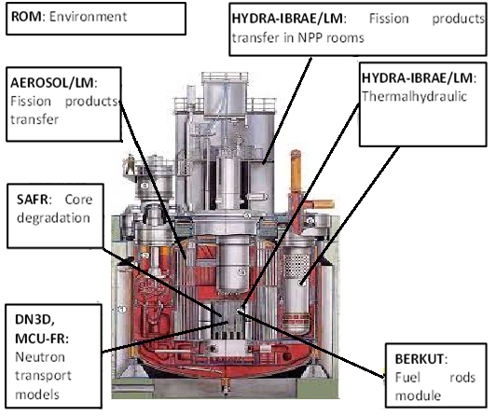
FIG. 1. Structure of the EUCLID/V2 code

Severe accident module SAFR
The SAFR [2] (Severe Accidents in Fast Reactors) is a module to calculate severe accidents with core degradation in fast reactors with liquid metal coolant. It can simulate:
- the melting of the cladding and mixed oxide fuel (MOX), solidification of the formed melt;
- dissociation of the mixed nitride uranium-plutonium fuel (MNUP);
- the relocation of the melt along the surface of the fuel rods under the influence of gravitational force and friction with fuel pin surface and coolant flow;
- the blockage of the cross sectional area of the fuel pin bundle due to solidification of the melt on the surface of fuel pins;
- the entrainment of the melt into the coolant flow and deposition of the melt on the fuel pin surface;
- the formation of the melt pool;
- the fission products release from the melt pool.
The SAFR code consists of four different modules. The first one solves heat transfer problem in solid and liquid state of materials. There are three kinds of boundary conditions. The first one is defined temperature, the second one is defined heat flux, and the third is heat transfer with coolant. Also there is an additional kind of boundary condition. This type of condition allows adding radiation heat transfer from the surface of fuel pin. To solve heat transfer equation in solids, to determine the mass of the melt, and to simulate fuel assembly wrapper tube melting, the enthalpy formulation of heat transfer problem is used.
The second module solves the problem of the melt relocation. Models that are based on the results of experimental studies give the best prediction in the simulation of the fuel rod melting. Relocation of the melt depends on the balance of the gravitational forces, friction forces between melt and surface of the fuel pins, and friction between melt and coolant. To simulate melt relocation, the system of mass, energy, and momentum conservation are solved.
The third module solves the problem of the nitride fuel dissociation. It is known that, at relatively low nitrogen pressures above the surface of uranium nitride, congruent melting of the latter is not observed. There is decomposition into uranium (plutonium) and nitrogen. To determine the rate of dissociation of MNUP fuel during an accident in a reactor facility, it is proposed to use a model that takes into account the kinetics of evaporation from the fuel surface, as well as the diffusion and convection of molecules in the near-surface layer of gas. More detailed description is presented in [7].
The fourth module calculates the processes in the melt pool: the formation of the pool and the fission products release from the pool. To simulate fission products release from melt pool, two type of fission products are considered: volatile and non-volatile fission products (FP). The mechanism of release of volatile and non-volatile FP is different. Volatile FP are gases and leave the melt in the form of bubbles. The release of the non-volatile FP from the melt pool is determined by convective transport and mass transfer from the melt surface to the environment.

Thermohydraulic module HYDRA-IBRAE/LM
Thermohydraulic module HYDRA-IBRAE/LM [3] allows performing calculation of non-stationary thermohydraulics applied to reactor loops and experimental facilities with liquid metal coolants, including a capability to describe the behavior of the water circuit and heat exchange equipment important for the safety of the Nuclear Power Plant. Computation of the thermal-hydraulic processes in HYDRA-IBRAE/LM is based on the non-equilibrium nonhomogeneous two- or three-fluid model.
The HYDRA-IBRAE/LM/V1 code uses a map with seven sodium flow regimes [8]. Two of these regimes correspond to a single-phase flow of gas and liquid with the remaining five regimes describing two-phase flows, including a bubbly flow, two transition flows, dispersed-annular flow, and dispersed flow. The regime boundaries are determined by the gas phase void fraction. Sodium boiling is calculated in the HYDRA-IBRAE/LM code using a simplified flow regime map where a slug flow is not considered due to the complexity of its description in the two-fluid model. It is assumed that there is a direct transition from bubbly flow to dispersed annular flow, which is most typical for liquid alkali metal flow boiling according to the experimental results.
The interphase friction is determined by the two-phase flow regime. The processes of friction between spherical gas bubbles and liquid in the bubble mode and liquid drops in the dispersed and dispersed-annular modes can be described by the “standard curve” for the coefficient of friction of spheres. It should be noted that the features of the bubble motion in liquid metals do not differ from the features obtained for ordinary liquids, and therefore the approaches developed for usual coolants can be used for the calculations.
Liquid metals feature high conductivity and, hence, low Prandtl number. Although mechanisms of water and liquid metal flows are similar due to close viscosity values, the mechanisms responsible for heat transfer differ considerably, thereby affecting both wall heat transfer and interfacial heat transfer. Interphase heat transfer in the presence of a phase transition at the interface can be divided into two stages: heat input via liquid to the interfacial boundary and heat transfer as a result of the phase transition.
For the coupled calculation of the HYDRA-IBRAE/LM thermohydraulic module and the SAFR severe accidents calculation module as part of the EUKLID/V2 integral code, interface classes for data exchange are implemented in both modules. The main exchange class SAFR_Hydra_Exchange contains an array of heatElemLink exchange structures of the HeatElementLink class for each heat elements. In this case, each heat elements of the HYDRA-IBRAE/LM module through the input file must be associated with the thermal element of the SAFR module.

Three-dimensional neutron physical modules DN3D and MCU-FR
The heat release that takes place in the core during fuel rod destruction is calculated in the module DN3D (Diffusion Neutron 3D) in the quasi static approximation just as it is done under other operating conditions of the nuclear power facility. Changing of neutron field parameters over time due to core degradation is simulates in diffusion approximation.
The main specific feature relating to the calculation of the neutron power during the core destruction is the transfer of fuel and structural materials within the computational domain. This phenomenon is taken into account by recalculating the constants with taking into account the change in the concentration of radionuclides transferred within the computational cell boundaries. Thus, for solving this problem, the block for computing the constants for the specified temperature and concentration of fuel, structural materials, and coolant has been extended for the possibility to process additional parameters, namely, the density of structural materials and fuel arriving from other areas. To speed up the computations, the following assumptions are taken: the fuel and structural materials move as a unit; that is, individual radio nuclides are transferred only with the fuel or structural material, and there is no radial transfer of materials. The change of radionuclide concentration in computational cells caused by transfer of molten fuel and structural materials is calculated in the SAFR module and transmitted to the DN3D module.
MCU-FR module based on Monte-Carlo method is used to estimate the secondary criticality of the core configuration during severe accident. The main task solved by the module is calculation the effective neutron multiplication factor for the melt pool. The Monte Carlo method eliminates the problem of the forming of nuclear physics data libraries, because such methods allow using these libraries in a pointwise representation. Coupled calculations are provided by the SMART_LM integrating shell through an exchange structure. The SAFR module transmits the melt pool parameters to the SECRIT module. Then the SERCIT module generates input files for the MCU-FR code. After completion of the calculation, the SECRIT module also reads the effective neutron multiplication factor from the MCU-FR and sends it to the SAFR module (see FIG. 2).
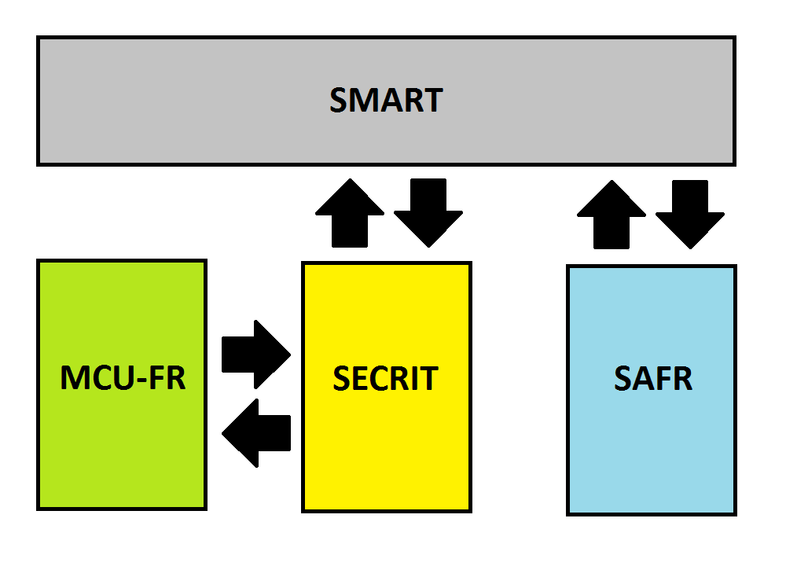
FIG. 2. Structure of the modules connections

Transport of fission products in the coolant and in the NPP rooms. The AEROSOL/LM module
The mathematical model used in the AEROSOL/LM software module [5] contains a system of differential equations for modeling the transport of fission products and the physicochemical processes that undergo in a liquid coolant and in the vapor–gas medium contained in the cover gas space, and for modeling the change in the surface concentration of fission products precipitated on the walls from sodium and from the cover gas.
The aerosol module allows simulating the following processes:
- the coagulation of multicomponent polydisperse aerosol particles;
- the condensation of various (multicomponent) vapors on particles;
- the condensation and sorption of vapors on surfaces;
- the deposition of aerosols on surfaces due to different mechanisms; the formation of multicomponent deposits on surfaces;
- the transfer of aerosols and various vapors through the compartments.
The method for calculating processes in polydispersed is based on the approximation of monodispersed fractions. This method has been modified for taking into account the multicomponent composition of aerosols as well as condensation or vaporization of different vapors on particles. In calculating the formation of the radioactive deposits on the room surfaces, their multicomponent composition is taken into account. A detailed description is given in [5].
A distinctive feature of the radionuclide transfer model of the EUCLID/V2 integrated code is the ability to simulate the dynamics of various components in the liquid metal circuit, taking into account their individual properties, i.e. without combining radionuclides into a small number of groups with some identical properties for all components in a group. It makes possible to model the evolution in the loop of each radionuclide that is significant for radiation safety.

BERKUT fuel rod module
The BERKUT fuel rod module [6] of the EUCLID/V2 code is used to model the processes occurring in fuel rods of fast reactors with nitride, mixed nitride, dioxide and mixed oxide uranium–plutonium fuel and claddings made of austenitic or ferrite-martensite steels.
The BERKUT fuel rod module allows simulating following processes:
- temperature distribution in a fuel rod;
- stress-strain state of the fuel rod with the open gap and in the case of the pellet-cladding mechanical interaction (PCMI);
- cladding integrity analysis according to the performance criteria (margins for melting, ultimate strength, long-term strength, etc.);
- fission gas release (FGR) under the cladding;
- degradation of the gas gap conductivity due to FGR.
Dependencies of thermophysical and mechanical material properties and irradiation conditions are taken into account during simulation.
The thermal problem at the initial stage of severe accidents is calculated by the BERKUT fuel rod module. However, the simulation with help of this module is stopped if melting (or dissociation) points of structural materials or fuel have been reached. So the further calculation of the fuel rod behaviour is transferred to the SAFR module.

Some results of the validation and verification of the EUCLID/V2 code
One of the main stages of the coupled code development is validation and verification. To validate coupled code EUCLID/V2, validation matrix has been made. This matrix contains more than 15 analytical tests and data that have been obtained in 16 different experimental facilities.
To validate EUCLID/V2 code, we selected the experiments with sodium boiling and dryout, cladding melting and fuel melting (dissociation), solidification of the melt and melt relocations. For example, we use the experiments that was carried out in TREAT reactor (Idaho National Laboratory and the Argonne National Laboratory, United States) [9], and in the impulse graphite reactor (IGR) [10] (Republic of Kazakhstan), on the HRR facility at the Sandia National Laboratory [11] (United States), on the DEH experimental facility at the Argonne National Laboratory [12] (United States), on the facility at the Nizhny Novgorod State Technical University [13] (Russia), the series of experiments on the oxide fuel solidification that was carried out on GEYSER facilities [14] (France), experiments of nitride fuel dissociation at the Moscow Engineering Physics Institute (Russia) [15] and the fission products release from melt pool at the Oak Ridge National Laboratory (USA) [16].
As an example, results of calculating the experiment on simulation of the ULOF accident, performed at the Argon National Laboratory in the TREAT reactor are shown in FIG. 3 and 4. In the experiment the pressure, temperature, vapour boundary and flow rate evolution in a seven-rod assembly cooled by sodium were studied with a decrease in the coolant flow rate (ULOF accident). Oscillatory behaviour of the vapor volume has physical reasons and isn't connected with stability problem. It is caused by sodium vapor condensation in cold region.
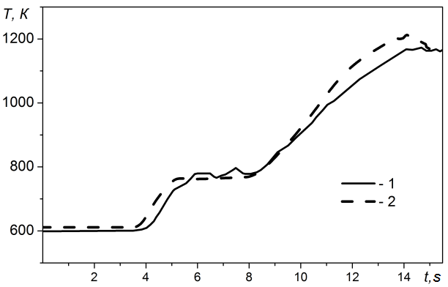
FIG. 3. FA duct temperature as a function of time in the experiment on the ULOF accident simulation (TREAT): 1 – experimental data; 2 – calculation with the EUCLID/V2 code
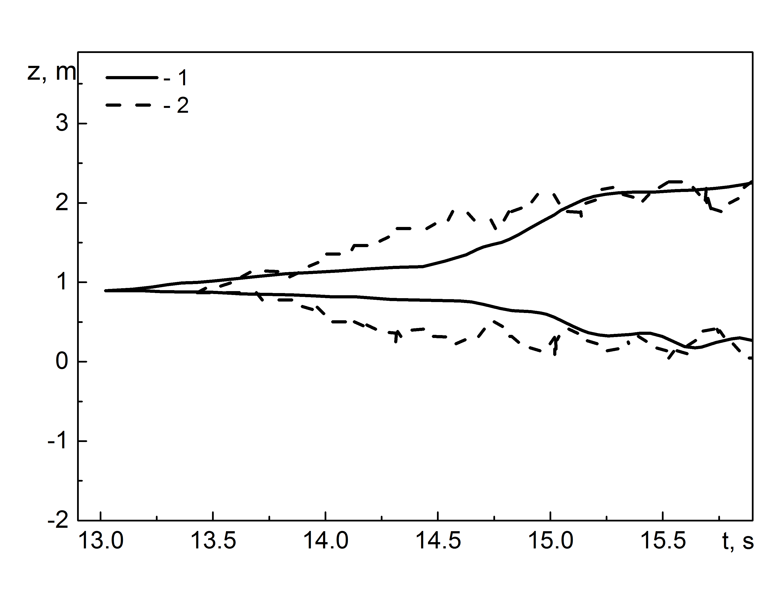
FIG. 4. Vapor boundary as a function of time in the experiment on the ULOF accident simulation (TREAT): 1 – experimental data; 2 – calculation with the EUCLID/V2 code

As it is obvious from the figure, the calculated and experimental results are in good agreement. The mean absolute error of the fuel assembly (FA) duct temperature determination is equal to 25 К.
The data of the uranium dioxide melting during the experiments with sharp power increase (UTOP accidents) was received on the the DEH experimental facility at the Argonne National Laboratory [12]. In these experiments, the volume fraction of molten uranium dioxide in the fuel pellets was measured. Comparison of the simulation results and experimental data is shown in FIG. 5. The average error of the simulation is equal to 6%.
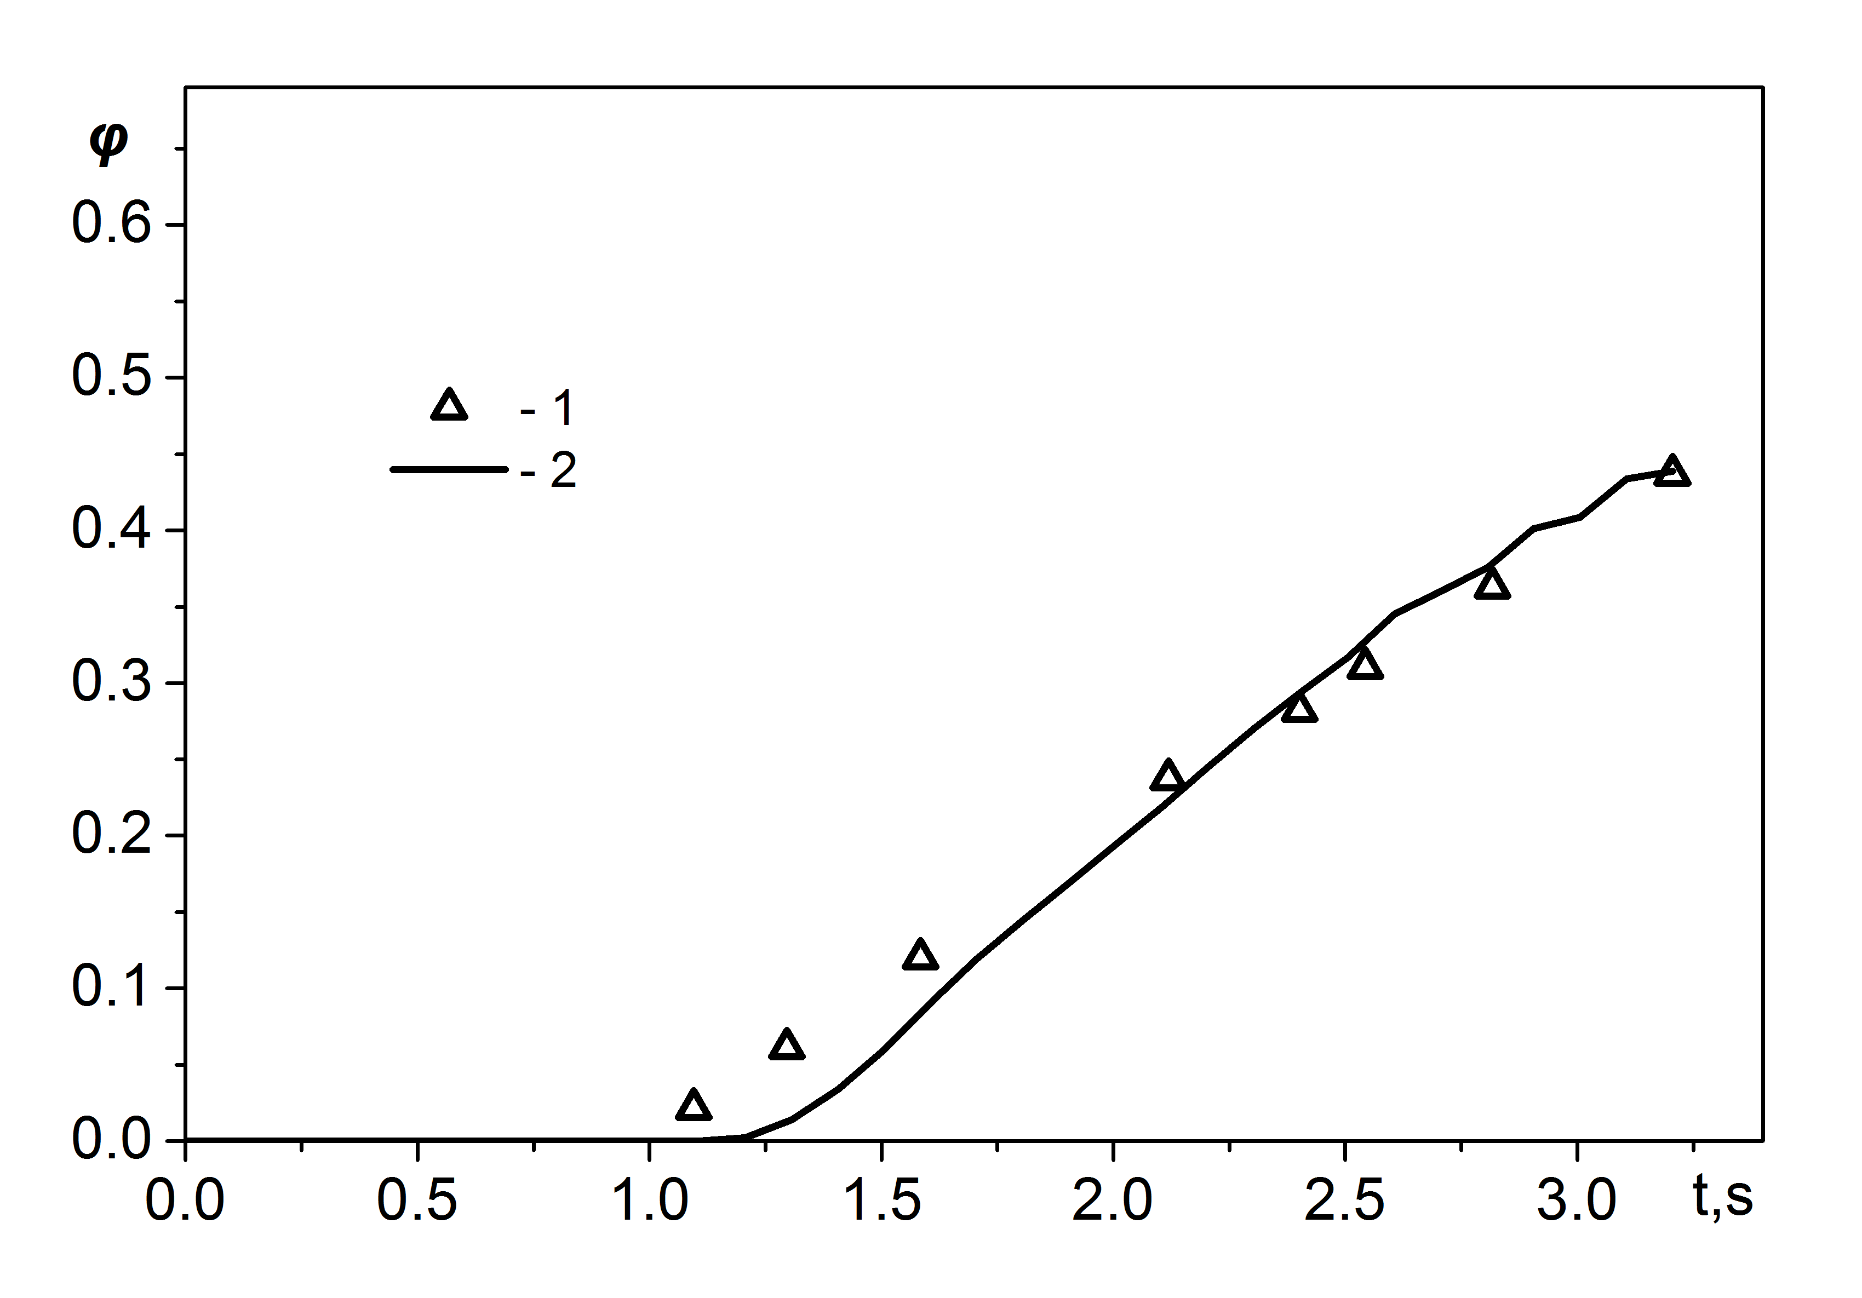
FIG. 5. Volume fraction of the melt (DEH experiments) : 1 – experimental data; 2 – calculation with the EUCLID/V2 code

The experiments on the dissociation of uranium nitride were carried out at at the Moscow Engineering Physics Institute (MEPhI) [15]. The dissociation of UN at different temperatures was studied in the experiments with inert gas (helium) atmosphere. The sample was placed in a tungsten crucible, heated to a certain temperature, which was maintained for 2173 K and 2373 K for 2 hours, and for 2573 K for half an hour. A comparison between simulation results and experimental data are presented in FIG 6.
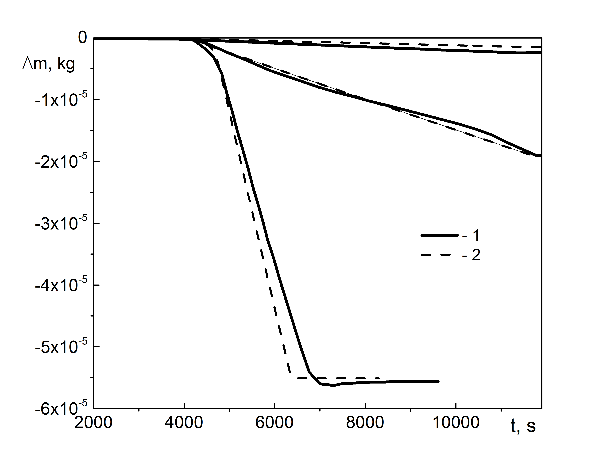
FIG. 6. Mass loss of the uranium nitride fuel for different temperatures (from bottom to top: 2573 K, 2373 K, 2173 K) : 1 – experimental data; 2 – calculation with the EUCLID/V2 code
As we can see, the results of simulation are in good agreement with experimental data. The maximum relative error is equal to 20%.

Conclusions
The description of the modules and models of the coupled code EUCLID/V2, that used to simulate severe accidents in sodium cooled fast reactors with oxide and nitride fuels, are presented in the paper. Presented modules are used to simulate:
- melting of the cladding and melting or dissociation of the fuels in the fuel rods;
- sodium flow and its boiling in fuel assemblies;
- neutron transport in core during its damage and forming of the melt pool;
- fission products transport in loops of a fast reactor facility and fission product transport calculation in the reactor containment building.
Some results of the code EUCLID/V2 validation on the base of experimnets with immitation of the severe accidents are presented too. It has been shown that results of the simulation are in a good agreement with experimental data.

Acknowledgements
The EUCLID/V2 code has been developed within the "Codes of a new generation" subproject of the "PRORYV" (or "Breakthrough") project at the expense of the Federal targeted program "Nuclear power technologies of a new generation for 2010 – 2015 and for the future till 2020".

References

[1] | A. A. BUTOV, V. S. Zhdanov, I. A. Klimonov, I. G. Kudashov, A. E. Kutlimetov, N. A. Mosunova, A. A. Sorokin, V. F. Strizhov, S.A. Frolov, E. V. Usov and V. I. Chukhno. The EUCLID/V2 Code Physical Models for Calculating Fuel Rod and Core Failures in a Liquid Metal Cooled Reactor // Thermal Engineering, 2019. Vol. 66. #5. P. 293–301.
[2] | E. V. USOV, A. A. Butov, V. I. Chukhno, I. A. Klimonov, I. G. Kudashov, V. S. Zhdanov, N. A. Pribaturin, N. A. Mosunova, V. F. Strizhov. Fuel Pin Melting in a Fast Reactor and Melt Solidification: Simulation Using the SAFR/V1 Module of the EVKLID/V2 Integral Code // Atomic Energy, 2018. Vol.124. #3. P. 147–153.
[3] | ALIPCHENKOV V.M., Zeigarnik Y.A., Mosunova N.A., Strizhov V.F., Usov E.V., Anfimov A.M., Gorbunov V.S., Osipov S.L., Afremov D.A., Kudryavtsev A.V. Fundamentals, Current State of the Development of, and Prospects for Further Improvement of the New Generation Thermal Hydraulic Computational HYDRA-IBRAE/LM Code for Simulation of Fast Reactor Systems // Thermal Engineering, 2016. Vol. 63. #2. P. 130–139.
[4] | D. A. KOLTASHEV, A. A. Stakhanova. Neutronic calculationof fast reactors by the EUCLID/V1 integratedcod // J. Phys.: Conf. Ser.,2017. Vol 781. #012003..
[5] | FILIPPOV M.F., Kolobaeva P.V., Sorokin A.A., Mosunova N.A. The modeling of the formation and transport of fission product aerosols in the first circuit of fast reactors in the AEROSOL/LM/Na module // Atomic Energy, 2018. Vol.124. #4. P. 266–271
[6] | D. P. VEPREV, A. V. Boldyrev, S. Y. Chernov, N. A. Mosunova Development and validation of the BERKUT fuel rod module of the EUCLID/V1 integrated computer code // Ann. Nucl. Energy, 2018. Vol. 113. P. 237–245.
[7] | USOV E.V., Chukhno V.I., Kudashov I.G., Sycheva T.V. Model for the calculation of the dissociation rate of nitride fuel at high temperatures // High Temperature, 2020. Vol. 58. #2. P. 222-226.
[8] | USOV E.V., Butov A.A., Dugarov G.A., Kudashov I.G., Lezhnin S.I., Mosunova N.A., Pribaturin N.A., 2017. System of closing relations of a two-fluid model for the HYDRA-IBRAE/LM/V1 code for calculation of sodium boiling in channels of power equipment // Thermal Engineering, 2017. Vol. 64. #7. P. 48–55.
[9] | B. W. SPENCER. Final Report on TREAT Tests R4 and R5; Seven-pin, Loss-of-flow Tests with Full-length, Unirradiated FFTF-type Fuel Pins // Argonne national Laboratory. ANL/RAS 79-8. 1979. 219 p.
[10] | K. KONISHI, J. Toyooka, K. Kamiyama, et al. The result of a wall failure in-pile experiment under the EAGLE project // Nuclear Engineering and Design, 2007. Vol. 237. P. 2165–2174.
[11] | S.A. WRIGHT, D. H. Worledge, G. L. Cano, P. K. Mast, F Briscoe. Fuel-Disruption Experiments Under High-Ramp-Rate Heating Conditions // NUREG/CR-3662. SAND81-0413. October 1983. 88 p.
[12] | B.J.WRONA, T.M.Galvin, and D.Stahl. Out-of-reactor experimental study of fuel-pin failure phenomena. // International Meeting on Fast Reactor Safety and Related Physics Chicago, II. October 6-8, 1976.
[13] | G. B. USYNIN, Yu. I. Anoshkin, and M. A. Semenychev. Investigating fuel element melt in simulators with fuel compositions // At. Energy,1991. Vol. 70. P. 136–138.
[14] | BERTHOUD G., Duret, B. The freezing of molten fuel: reflections and new results // Proceedings Fourth International Topical Meeting on Nuclear Reactor Thermal-Hydraulics (NURETH-4). Karlsrue. Germany (October 10-13) 1989. Vo1. P 675 – 681.
[15] | BARANOV V.G., Tenishev A.V., Kuzmin R.S., et. all. Thermal stability investigation technique for uranium nitride // Ann. Nucl. Energy, 2014. Vol. 87. #2. P. 784–793.
[16] | BROWNING W.E., Miller C.E., Shields R.P., Roberts B.F. Release of fission products during in-pile melting of UO2 // Nucl. Sci. Eng, 1964. Vol. 18. P. 151–162.

