# DEVELOPMENT OF COOLANT VOIDING MODEL

# FOR FAST REACTOR CORE

DHRUMIL GANATRA, VIKRAM GOVINDARAJAN, RAJENDRAKUMAR M., NATESAN K., RAGHUPATHY S.

Indira Gandhi Centre for Atomic Research,

Kalpakkam, India

Email contact of corresponding author: dhrumil@igcar.gov.in

**Abstract**

Understanding the mechanics of sodium boiling in case of severe accidents is of critical importance for LMFBR safety. Sodium boiling in the core can result in either positive or negative reactivity feedback, depending on the location and extent of the vapour void. Therefore, an accurate description of the voiding process with respect to space and time is necessary. To address this, a code has been developed for predicting the boiling behaviour of liquid sodium in channels of a reactor core. In this code, subassemblies having identical power and flow characteristics are modelled by an equivalent subassembly or channel. The entire reactor core can be represented with several such equivalent channels for different zones and clubbing together. It employs a multi bubble slug ejection model for simulating sodium boiling within a channel of an LMFBR. Once the coolant temperature reaches a specified superheat, a switch to slug flow model is made and a bubble of zero height at coolant temperature is considered to form at the respective node. The growth of these vapour bubbles is governed by heat transfer through the liquid-vapour interface and cladding surface. This paper describes the details of the multi bubble slug ejection model and of numerical studies carried out for validating the model against experimental as well as numerical data available in the literature.

## INTRODUCTION

Unlike thermal reactors, the LMFBR core is not in the most reactive configuration. Any undesirable event may raise the reactivity in the core and can increase reactor power. Liquid metals used in LMFBRs have high boiling points and there is a considerable margin between normal operating temperatures and their boiling points. By design, liquid metals used as coolant are not expected to boil under any normal operating conditions of the reactor. However, in case of loss of flow accidents along with the failure of reactor shutdown systems, boiling of the coolant in the reactor core is possible. Such accidents are termed Unprotected Loss of Flow (ULOF) accidents. The boiling of coolant in the reactor core can also be caused by an uncontrolled increase in power. Such accidents are termed Unprotected Transient Overpower (UTOP) accidents. Improved understanding of the mechanics of sodium voiding in the case of ULOF or UTOP is of critical importance for LMFBR safety. Sodium boiling in the core can result in either positive or negative reactivity feedback, depending on the location and extent of the vapour void. Therefore, an accurate description of the voiding process with respect to space and time is necessary.

NaBOIL, which stands for Natrium Boiling Onset Influence in LMFBRs, is an in-house code developed in IGCAR, Kalpakkam for predicting the boiling behaviour of liquid metals in a reactor core. It calculates the heat transfer from the fuel pin to the coolant until the coolant reaches a specified superheat. At this point, the onset of boiling occurs. The stages of bubble growth are approximated by a thin bubble assumed to occupy the entire coolant channel area, except for the liquid film remaining at the clad wall. This approach is similar to that followed in SAS4A [1][2]. The coupled solution of the energy and hydrodynamic equations of the coolant and the heat transfer equations of the fuel pin are then continuously solved during the voiding process. The main purpose of this model is to predict the extent and rate of voiding that can be used for voiding reactivity calculations and to predict the heat removal from the cladding surface after the onset of boiling, for fuel and cladding temperature calculations.

## NUMERICAL MODELLING

Reactor core comprises of various kinds of subassemblies, viz., fuel, blanket, shielding etc. Based on the thermal power generated within the subassemblies and the coolant flow rate through them, they are divided into various neutronic and flow zones. In this code, subassemblies having identical power and flow characteristics are modelled by an equivalent subassembly or channel. The entire reactor core can be represented with several such equivalent channels for different zones and clubbing together. Geometrical discretization for the single equivalent channel is shown in Fig. 1.

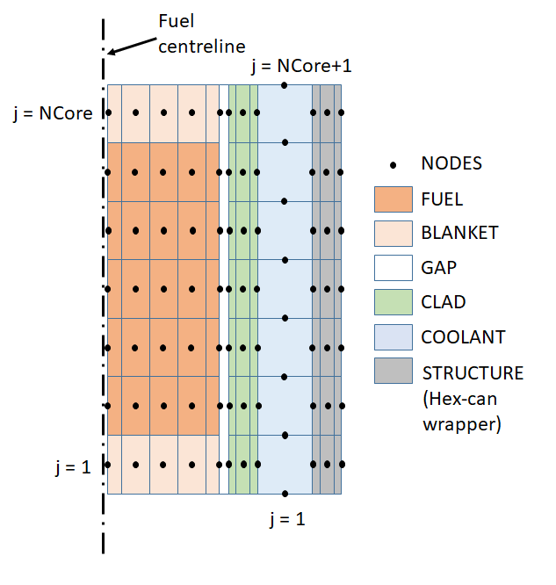

FIG. 1. Axial and radial discretization of an equivalent subassembly

A channel is divided into several axial segments, the heat generation within each segment being constant. A radial heat flow model is employed for fuel pins neglecting axial heat flow. Each segment is radially divided into annular elements for evaluation of temperature variation across the thickness of fuel pins as well as clad (Fig. 1). The coolant nodes, defined at the axial boundaries of clad and fuel elements are staggered w.r.t fuel and cladding nodes. The thermophysical properties of the fuel, clad, hex-can and coolant are taken as a function of temperature. Gap conductance is taken as constant throughout the length of the channel.

## SOLUTION METHODOLOGY

### Single-phase model

The steady-state equations are solved by first calculating coolant temperatures at the coolant nodes from the thermal power generated by each axial fuel segment. The temperature of clad and fuel radial nodes are evaluated from cell averaged coolant temperatures starting from cladding outer node to the fuel centreline by adding temperature drops due to resistance of the respective elements. A null transient is performed to ensure temperatures at all nodes in the channel have converged under steady-state conditions. A transient is initiated by reducing the pressure at the inlet simulating a ULOF. Fig. 2 shows the flowchart of the solution procedure followed in NaBOIL code.

|  |  |
| --- | --- |
| code2flow_9sjM0u (2) | code2flow_9sjM0u (2) |

FIG. 2. Flow chart of NaBOIL code

The transient calculation starts by solving the momentum equation (Eq. 1) to evaluate the advanced time step coolant mass flow rate in the channel. From advanced time step mass flow rate, temperature of coolant, clad, fuel and structure are evaluated by simultaneously solving equations formulated for solids (Eq. 2) and coolant (Eq. 3) in each axial segment. Transient calculations march from one axial segment to other in the direction of flow. Finite differencing scheme is used in both space and time for discretizing the differential equations.

|  |  |
| --- | --- |
| $$\frac{1}{A_{c}}\frac{∂w}{∂t}+\frac{1}{ρ{A_{c}}^{2}}\frac{∂w^{2}}{∂z}=-\left(\frac{∂P}{∂z}\right)-ρg$$ | (1) |
| $$mC\frac{∂T_{s}}{∂t}=kA_{s}\frac{∂T_{s}}{∂r}+ {\dot{Q}}_{gen}$$ | (2) |
| $$ρV_{cv}C\frac{∂T_{c}}{∂t}={\dot{Q}}_{cv}+ ∆(wCT_{c})$$ | (3) |

Where,

|  |  |
| --- | --- |
| w = mass flow rate | *C* = specific heat |
| t = time | Ts = temperature of clad or hex-can |
| Ac = area for sodium flow through channel | r = radial coordinate |
| $ρ$ = density of sodium | k = thermal conductivity |
| z = elevation | Tc = temperature of coolant |
| P = pressure | ${\dot{Q}}_{gen}$ = heat generated at a node |
| g = acceleration due to gravity | *Vcv* = volume of control volume (Axial node height x Ac) |
| m = mass of node | ${\dot{Q}}_{cv}$ = net heat transfer to sodium through clad and hex-can |

Heat transfer to sodium through clad and hex-can (${\dot{Q}}_{cv}$) in Eq. (3) is computed using the thermal resistance model for heat flow from clad and hex-can. Once iteration for all the axial nodes in the channel is performed, core temperatures at the end of the time step are obtained. After evaluating core temperatures, iteration is performed to check if the temperature at any coolant node has exceeded the saturation temperature (defined by pressure at that point) plus the pre-defined superheat. When this condition is satisfied at any coolant node, a switch to multi-bubble slug ejection model is made.

### Multi-bubble slug ejection model for boiling sodium

Once the coolant temperature reaches a specified superheat (input parameter, taken as 10 °C [1]), a switch to slug flow model is made and a bubble of zero height at coolant temperature is considered to form at the respective node. Bubbles are assumed to fill the whole cross-section of the coolant channel, except for a liquid film left on the cladding and structure. The vapour bubble pressure is assumed always equal to the saturation pressure corresponding to its temperature. Thus, the formation of a vapour bubble with a nonzero amount of superheat leads to an immediate jump in pressure at the bubble location.

The initial bubble growth is mainly due to two effects:

1. The initial jump in pressure corresponding to the superheat drives the liquid slugs apart, forming a larger bubble.
2. Heat flow through the liquid-vapour interface produces vapour to fill the bubble and sustain the pressure

Vapour pressure and temperature are assumed spatially uniform within the vapour bubble in this model. The initial stage of the bubble growth is governed by the heat transfer through the liquid interface and after a bubble of sufficient height is formed, heat from the cladding becomes a dominant factor.

Fig. 3a shows the schematic of the multi-bubble slug ejection model. Liquid slugs separated by large vapour bubbles are considered to be formed during the boiling of liquid metals in the subassembly channels. In the multi-bubble slug ejection model, Eq. (1) and (3) are used for evaluating coolant temperature only in liquid slugs instead of for the entire channel in single-phase flow.

For vapour bubbles, heat transferred from the liquid-vapour interface (approach adapted from [2]) is equated with the change in enthalpy of the vapour bubble to evaluate advanced time step vapour temperature. Fig. 3b. shows the control volume (CV) consisting entire vapour bubble plus a tiny fraction of liquid film present on the clad surface. The liquid film taken within the control volume is the mass of liquid film that will vaporize or condense in the time interval $∆t$. Heat exchange with liquid-vapour interface and cladding (hex-can) is accounted for through an enthalpy approach for evaluating the temperature (vapour pressure) of the vapour bubble at the end of time interval [1]. From the enthalpy approach similar to that used in [1], the change in enthalpy within the vapour bubble can be evaluated from Eq. (4).

|  |  |
| --- | --- |
|  | (4) |

Where,

|  |  |
| --- | --- |
| $∆E$ = change in enthalpy of vapour bubble within a time step | *P* = bubble pressure |
| $∆t$ = time step size | *V* = volume of vapour bubble |
| $m_{l}$ = mass of liquid sodium evaporated (condensed) in $∆t$ | $∆V$*=* change in volume of vapour bubble in $∆t$ |
| *C* = specific heat of liquid sodium | $ρ^{(P,T)}$ = density of vapour |
| *T =* temperature of vapour bubble | $λ^{(T)}$ = latent heat of vaporisation |
| $ΔT$ = change in temperature of vapour bubble in $∆t$ |  |

In Eq. (4), the only unknown to evaluate enthalpy change is the change in temperature of vapour bubble $∆T$. Similarly, as explained in detail in [1], net heat transfer to vapour bubble from the liquid-vapour interface and clad (and hex-can) surface is also solely a function of change in temperature of vapour bubble $∆T$. Equating them gives the change in temperature of vapour bubble $∆T$ and hence the temperature of vapour bubble at the end of the time step. Once the temperature is known, it is used to calculate the vapour pressure, since the saturation conditions have been assumed. The vapour pressure is the driving force for the motion of the liquid slugs, so finding the vapour pressures in all bubbles provides the link between conditions in the liquid slugs and conditions in the bubbles and therefore leads to a complete description of conditions throughout the channel.

|  |  |
| --- | --- |
| \\fileserver\profiles$\igc34369\Desktop\Data\Official\Conference papers\IAEA-FR22-2022\fig1.bmp | \\fileserver\profiles$\igc34369\Desktop\Data\Official\Conference papers\IAEA-FR22-2022\fig2.bmp |
| (a) | (b) |

FIG. 3. (a) Schematic of multi-bubble slug ejection model of boiling Liquid Metals and (b) Energy balance in Vapour bubble due to heat addition from Clad and Liquid-Vapour interface

Coolant temperatures in liquid slugs formed are evaluated separately from the extrapolated cladding temperatures (using a modified form of Eq. (3) adapted for liquid slugs). The heat flux to the coolant is then supplied as an input for temperature calculations of clad and fuel to ensure a complete energy balance (using Eq. (2)). Vaporization from the liquid film attached to the clad surface governs bubble growth except during the initial stages of bubble growth after its formation.

The liquid film provides vapour to sustain vapour pressure within the bubble. Film thickness is evaluated at every axial node using Eq. (5) as it determines the value of resistance for heat transfer to vapour from clad. In this model, the film is assumed to be static and the rate of vaporization of the liquid film is a function of heat transfer to vapour from the cladding.

|  |  |  |
| --- | --- | --- |
|  | $$L_{f}\left(z,t+∆t\right)=L_{f}\left(z,t\right)+\frac{∆t}{R\left(z,t\right)ρ_{Na}\left(z\right)}\frac{T_{vap}\left(z,t\right)-T_{c}\left(z,t\right)}{{ C}_{Na}(z)+λ\left(z\right)}$$ | (5) |

Where,

|  |
| --- |
| $L_{f}\left(z,t+∆t\right)$ = film thickness at the end of time step at node z |
| $L_{f}\left(z,t\right)$ = film thickness at the beginning of time step at node z |
| $ρ_{Na}(z)$ = density of liquid sodium temperature at node z |
| $C_{Na}(z)$ = specific heat of liquid sodium at node z |
| $R(z,t)$ = resistance offered by clad (hex-can) and liquid film on it for heat transfer to bubble at node z |
| $Δt$*=* time step size |
| $T_{vap}\left(z,t\right)$ = temperature of vapour bubble at node z and time t |
| $T_{c}\left(z,t\right)$ = temperature of clad (hex-can) at node z and time t |
| $λ\left(z\right)$ = latent heat of vaporization of liquid sodium at node z |

It may be noted that at the initiation of voiding at a particular node, a pre-defined film thickness for the liquid film is considered. Once the liquid film thickness reaches a minimum specified value, dryout is considered to have occurred at that particular node. Dryout may or may not be permanent depending on the movement of liquid slugs in the channel. Solution of the coupled equations (hydrodynamics and energy) of the coolant, and the heat transfer equations of fuel, cladding and structure (hex-can) are carried out to estimate the temperature evolution in all the nodes throughout the transient.

## VALIDATION

For validating NaBOIL code, L22 reference test of Kompakter Natriumsiede-Kreislauf (KNS) facility (a sodium loop) in Germany that simulates the fuel subassembly located at the periphery of SNR-300 core at full power conditions is selected [4]. KNS L22 test is selected particularly because its geometrical and transient description is documented in the literature in a detailed manner. In addition, the L22 test acted as a reference for validating different codes developed in a joint worldwide effort under the Liquid Metal Boiling Working Group. BACCHUS-3D, CAFCA-NA2, SABENA-3D, SABRE-3C, TRACE, SIMMER etc. are some of the notable codes that are validated against the KNS L22 test [3].

### Description of KNS loop

The KNS loop at Karlsruhe, Germany is presented schematically in Fig. 4a [4]. This facility was designed for carrying out sodium boiling tests with heated pin bundle geometry under different thermal-hydraulic conditions. The experiments carried out simulated the flow run-down characteristics of SNR-300 using 37-pin bundle geometry [4].

|  |  |
| --- | --- |
| \\fileserver\profiles$\igc34369\Desktop\Sketch 4a 4b Model (2).png | \\fileserver\profiles$\igc34369\Desktop\Sketch 4a 4b Model (2).png |
| (a) | (b) |

FIG. 4. (a) Schematic of KNS loop and (b) Schematic of KNS 37-pin bundle [4]

The KNS 37-pin bundle is shown schematically in Fig. 4b [4]. It represents the main features of an SNR 300 fuel subassembly. The pins of 6 mm outer diameter lie on a 7.9 mm pitch and are surrounded by a hexagonal wrapper. They are supported by spacer grids at regular intervals. Geometrical data of the KNS 37 pin bundle are given in Table 1 [4]. The resistance heater pins result in the chopped cosine heat flux profile [4] which is approximated as,

|  |  |  |
| --- | --- | --- |
|  | $$\frac{X}{X_{max}}=0.38+0.62sin\frac{π(z+25)}{900}$$ | (5) |

Where, z is the distance (in mm) from the bottom of the heated section

*X* is the power density in an axial segment at elevation z from the bottom of the heated section

*Xmax* is the peak power density

TABLE 1. GEOMETRICAL DETAILS OF KNS 37-PIN BUNDLE [4]

|  |  |
| --- | --- |
| Parameter | Value |
| Number of pins | 37 |
| Pin outer diameter / pitch | 6 mm / 7.9 mm |
| Heated length | 900 mm |
| Unheated length at inlet / outlet | 200 mm / 450 mm |
| Width of the hex-can tube (flat to flat) | 50.6 mm |
| Wall thickness of hex-can | 2.7 mm |
| Flow area | 1171 mm2 |

### Description of the L22 reference test

Under steady-state, the inlet mass flow rate in the test section was measured 3.41 kg/s, the inlet velocity 3.38 m/s, and the average coolant temperature at the test section inlet and outlet were measured 380 ℃ and 539.3 ℃ respectively. Steady-state parameters of the L22 test are given in Table 2 [3][4]. Boiling of coolant in the test section was initiated by tripping pump and keeping heater power constant.

TABLE 2. STEADY-STATE PARAMETERS OF L22 TEST [3][4]

|  |  |
| --- | --- |
| Parameter | Value |
| Mass flow rate through the test section | 3.41 kg/s |
| Average flow velocity at inlet | 3.38 m/s |
| Inlet temperature | 380 °C |
| Average pin power | 215.4 W/cm |
| Total bundle power | 717.4 kW |
| Average outlet temperature | 539.3 °C |
| Static pressure at P 711 / P 712 | 5.16 bar / 2.32 bar |
| Static pressure at P 716 / P 512 | 1.07 bar / 1.0 bar |

L22 reference test is described elaborately elsewhere [4] and its crux is discussed here for brevity. Fig. 5 shows the normalized inlet mass flow rate measured in the experiment, time t = 0 represents the start of flow rundown. The first crucial event after the start of transient is the onset of boiling at 6.11 s at the normalized mass flow rate of 25.2 %. Coolant begins to boil at the upper end of the heated section from the centre of the pin bundle since the coolant temperature is highest at the centre. The initial boiling phase viz. nucleate boiling is identified by tiny fluctuations in flow and static pressure signals. The boiling front subsequently propagates radially from the centre of the pin bundle to its periphery, where coolant temperature reduces adjacent to the relatively colder hex-can wrapper. In the axial direction, the boiling front propagates primarily downwards in the heated section. During this phase, the pressure and mass flowrate are more or less similar to those before boiling. Once the boiling front has reached the relatively cold coolant flow adjacent to the wall of the test section, the tiny fluctuations of pressure and mass flowrate changes to oscillations (at 6.91 s). In this regime, static pressure does not increase drastically with the development of two-phase flow. The increase in pressure due to axial two-phase pressure losses in the boiling region is compensated by pressure drop due to buoyancy due to boiling as well as decrease single-phase pressure drop due to drop in mass flow rate through the test section. During this phase, the vapour has significant radial motion. Once the boiling front reaches the wall of the test section, the direction of the vapour flow expansion changes from primarily radial to axial. The vapour bubble blocks the entire test section flow area. This significantly increases the two-phase pressure drop and hence the flow through the test section drops sharply. This phase is classified as the pre-dryout period and begins with the onset of boiling in the region adjacent to the hex-can wall, at t = 8.31 s. The last phase starts with the onset of dryout at t = 9.25 s when the mass flow rate is reduced to 3.8 %. At dryout onset, there is a sharp temperature rise in the heater rod due to a sharp drop in heat transfer rate to the coolant once it is vaporised. The heater power is switched off at t = 9.45 s, and the static pressure stops rising due to a drop in vapour generation. Once the heater power is switched off, the vapour starts condensing and, at t = 12.3 s, the flow again becomes single-phase.

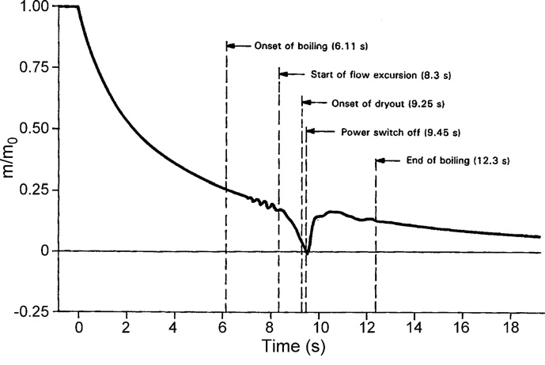

FIG. 5. Normalized inlet mass flowrate through test section in L22 test [4]

### NaBOIL predicted results and comparison with L22 experimental data

L22 test is simulated with NaBOIL code using 5 mm axial mesh for test section with a time step of 1E-4 second. The transient signals of pressure sensors P 711 and P 716 (Fig. 4a) are used as the boundary conditions in this simulation [5]. Pressure losses at the inlet side which comprise of the valves V1 and V2 and the tube between the pressure transducer P 711 and the inlet of the test section is calculated based on pressures measured by P 711 and P 712 under initial steady-state flow conditions. Due to the lack of details regarding geometrical features of the loop external to the test section in the available literature, the hydraulic resistance in the inlet and exit of the pipe is tuned to match the experimentally recorded values at the steady-state conditions. Table 2 shows the steady-state parameters of the L22 test which are matched before the start of a transient. The irreversible pressure loss across the flow mixer has been calculated from empirical correlations derived from the results of experimental tests [3].

Single-phase calculations carried out before simulating boiling provided a crucial check on the modelling of the KNS test section as well as on the applied boundary conditions. Also, the accurate estimation of the single-phase temperature profile prevailing at the onset of boiling is very critical as it influences the dynamics of vapour bubble expansion in heated as well as unheated sections of the pin bundle. The axial temperature profiles, measured in the L22 test and calculated by NaBOIL code at steady-state and at the onset of boiling are shown in Fig. 6. At the onset of boiling, temperature rises quickly along the heated length and decreases sharply in the upper unheated section. It can be observed from Fig. 6 that the measured steady-state and transient axial temperature profiles are very well reproduced. The difference in the results of NaBOIL code from that of the experiment in Fig. 6 is partly because the temperatures measured in the experiment are of sensors located at the centre of the pin bundle and temperatures calculated by NaBOIL are the pin bundle averaged temperatures. Table 3 shows the comparison of NaBOIL results at the onset of boiling with experimental results of L22 [4] and of simulation by BACCHUS [4], TRACE [6] and SIMMER [6] codes.

TABLE 3. COMPARISON OF NaBOIL WITH OTHER CODES AT THE ONSET OF BOILING

|  |  |  |
| --- | --- | --- |
| Results | Time at the onset of boiling (s) | Coolant velocity at boiling inception (m/s) |
| Experiment | 6.11 | 0.87 |
| BACCHUS | 6.28 | 0.86 |
| TRACE | 6.17 | 0.9 |
| SIMMER | 7.3 | 0.74 |
| NaBOIL | 6.21 | 0.86 |

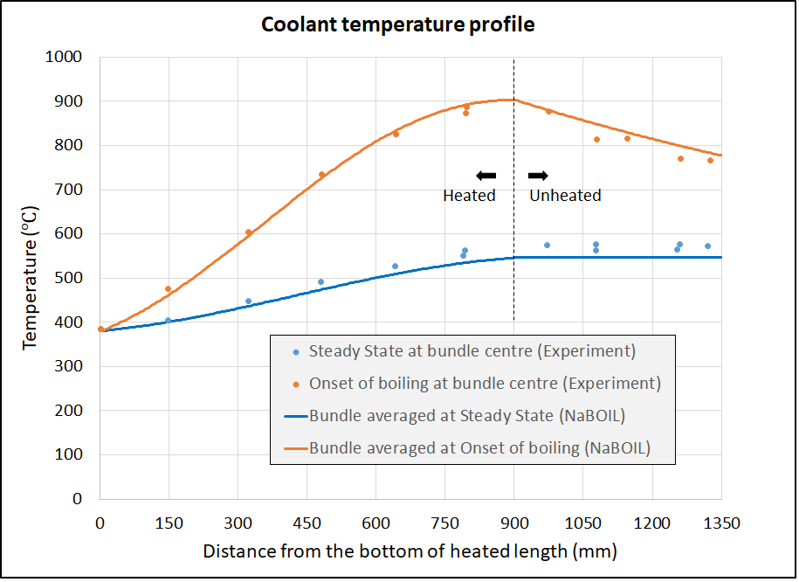

FIG. 6. Axial temperature profiles in coolant at Steady State and Onset of boiling

The comparison of experimental [4] and calculated results from NaBOIL code is shown in Fig. 7. In addition to NaBOIL code, predictions by TRACE [6], SIMMER [6] and SABENA [5] codes are also presented. These codes are extensively validated against numerous experiments. Results described in this section are from 1-D models of TRACE and SIMMER codes. In Fig. 7, z is the elevation of sensor location from the bottom of the heated section.

|  |  |
| --- | --- |
| \\fileserver\profiles$\igc34369\Desktop\Data\Official\Completed works\MTech Sodium Voiding Model\Code\KNS L22 14.08.19\Plot\MassFlow.png | \\fileserver\profiles$\igc34369\Desktop\Data\Official\Completed works\MTech Sodium Voiding Model\Code\KNS L22 14.08.19\Plot\Void.png |
| \\fileserver\profiles$\igc34369\Desktop\Data\Official\Completed works\MTech Sodium Voiding Model\Code\KNS L22 14.08.19\Plot\Coolant-Temp.png | \\fileserver\profiles$\igc34369\Desktop\Data\Official\Completed works\MTech Sodium Voiding Model\Code\KNS L22 14.08.19\Plot\Clad-Temp.png |

FIG. 7. Validation of NaBOIL code with KNS L22 experimental results

Once the boiling starts, a difference is observed in the experimental and calculated results. The calculated inlet mass flow rate falls more rapidly as compared to experimentally measured values. The differences in the calculated results with that of the experiment are due to the one-dimensional nature of the multi-bubble slug ejection model used in NaBOIL. This deviation from the experiment is observed in the predicted 1-D model of TRACE. In the experiment, initially, after the onset of boiling the vapour expands radially and condenses in the subcooled liquid zone in the vicinity of hex-can; there is no possibility to simulate this phenomenon with the 1-D model. In 1-D models, the vapour blocks the entire cross-section of the test section as soon as the boiling starts. This corresponds to an increase in two-phase pressure drop, causing a sharp reduction in flow from the very onset of boiling. Thus, the initial phase of sodium boiling which corresponds to radial expansion of boiling from the centre cannot be simulated and vapour expansion is primarily in the axial direction right from the onset of boiling. NaBOIL predicts flow reversal at 6.96 s (7.1 s by TRACE). Shortly after flow reversal, permanent dryout is observed and power is shut down at 7.2 s as per test criteria.

Heat transfer coefficient for heat exchange between clad and vapour bubbles is high as long as the thin liquid film is adhering to the surface of clad. Due to the high heat transfer coefficient in vapour bubble regions, the heat removal from the surface of clad is faster as compared to the removal rate in liquid slug regions. Therefore, once boiling initiates, the temperature of clad as well as coolant stops rising and remains close to saturation temperature. It is seen that the results are similar to the prediction made by TRACE, SIMMER and SABENA codes as well as experimentally measured values. Geometrical details of the loop external to the pin bundle govern the transient behaviour beyond 7 s as vapour bubbles start escaping the fuel bundle region. Due to the non-availability of this information in the literature, NaBOIL simulation is stopped at 7.2 s.

## CONCLUSIONS

A numerical model to simulate coolant boiling in a typical LMFBR subassembly has been developed based on the formulation of SAS4A code. A multi-bubble slug ejection model is incorporated to simulate liquid metal boiling due to the high liquid superheat and thermal conductivity of liquid metals. KNS L22 reference test is simulated to validate the NaBOIL code. NaBOIL results are compared with the results predicted by TRACE and SIMMER codes also. NaBOIL results agree very well with the predictions made by TRACE one-dimensional model. It is observed by comparison with TRACE and SIMMER codes as well as experimental results that these one-dimensional models were able to capture the phenomenological trend qualitatively but are inadequate to predict quantitatively and accurately the boiling behaviour of liquid metals accurately. However, it has to be noted that the KNS bundle comprises of 37 pins only where flow through the wall sub-channels is much higher than that in actual reactor subassembly. In addition, with a smaller number of pins, wrapper thickness also affects the boiling behaviour due to its relatively higher thermal inertia. In commercial reactor subassembly, the number of pins is higher and most of the coolant flow is through inner sub-channels. With a large number of pins, the number of rows increases and the effect of a relatively colder wrapper is limited to a short distance from its surface. As the effect of the wrapper is limited to the outer few rows, radial expansion of vapour is accelerated and shortly after the onset of boiling it expands primarily in the axial direction as predicted by one-dimensional models. Hence, with the increasing number of pins (increasing inner sub-channels), the boiling behaviour of liquid metals can be more accurately simulated by one-dimensional models.

References

1. CHAPTER 12 - F. E. DUNN, “Sodium voiding model”, The SAS4A/SASSYS-1 Safety Analysis Code System, Argonne National Laboratory, USA, 2017.
2. A. W. CRONENBERG, H. K. FAUSKE, S. G. BANKOFF AND D. T. EGGEN, A single-bubble model for sodium expulsion from a heated channel, Nucl. Eng. and Des., 16 3 (1971) 285-293.
3. H. M. KOTTOWSKI-DUMENIL, Liquid Metal Thermal-Hydraulics, INFORUM Verlag, Germany (1994).
4. MAURIZIO BOTTONI, BURKHARDT DORR, CHRISTOPH HOMANN, FRANZ HUBER, KARL, F. W. PEPPLER, DANKWARD STRUWE, Experimental and Numerical Investigations of Sodium Boiling Experiments in Pin Bundle Geometry, Nucl. Technol., **89** 1 (1989) 56-82.
5. H. NINOKATA, Analysis of low-heat-flux sodium boiling test in a 37-pin bundle by the two-fluid model computer code SABENA, Nucl. Eng. and Des.*,***97** 2 (1986) 233-246.
6. A. CHENU, K. MIKITYUK, R. CHAWLA, TRACE simulation of sodium boiling in pin bundle experiments under loss-of-flow conditions, Nucl. Eng. and Des.*,* **239** 11 (2009) 2417-2429.