Development of Multi-level Simulation System for Core Thermal-hydraulics Coupled with Plant Dynamics Analysis

– Prediction of transient temperature distribution in a subassembly

under inter-subassembly heat transfer effect –

N. DODA
Japan Atomic Energy Agency
Ibaraki/Oarai, Japan
Email: doda.norihiro@jaea.go.jp

E. HAMASE
Japan Atomic Energy Agency
Ibaraki/Oarai, Japan

N. KIKUCHI
Japan Atomic Energy Agency
Ibaraki/Oarai, Japan

M. TANAKA
Japan Atomic Energy Agency
Ibaraki/Oarai, Japan

Abstract

In design study of sodium-cooled fast reactors, various activities by numerical simulations from sensitivity analysis on plant dynamics using simple models to detailed analysis on local phenomena of interest are performed. In conventional way, they are performed individually and the mutual interaction between them is considered through the boundary conditions settings with conservativeness for each individual analysis. Thus, the final result through the analyses may contain excessive conservativeness. Japan Atomic Energy Agency, therefore, has begun to develop the multi-level simulation system in which detailed analysis codes for local phenomena of interest are coupled with a plant dynamics analysis code in order to obtain evaluation results considering the mutual interaction by successively updating the boundary conditions without excessive conservativeness in coupling process. In the development of the multi-level simulation system, focusing on core transient thermal-hydraulics phenomena, the coupled analysis method using a plant dynamics analysis code named Super-COPD and a subchannel analysis code named ASFRE has been developed to evaluate temperature distribution in a subassembly taking account of inter-subassembly heat transfer in radial direction of the core during the plant transient from forced circulation to natural circulation conditions. The numerical analysis on a test in the Experimental Breeder Reactor-II was performed to validate the coupled analysis in which two models in different level of detail for the specific subassemblies were used; one was the subchannel model of ASFRE and another one was the channel model included in the whole core model of Super-COPD. Through the comparison of the numerical results and the measurement data, it was confirmed that the coupled analysis could predict transient temperature distribution in a subassembly and the multi-level simulation by changing the level of detail of the analysis model could be performed for the core thermal-hydraulics in transient.

INTRODUCTION
In design study of sodium-cooled fast reactors (SFRs), various analyses by numerical simulations from the sensitivity analysis on whole plant dynamics using simple models to the detailed analysis on local phenomena of interest are performed. In conventional way of design, the analyses on whole plant dynamics and local phenomena are performed individually and the mutual interaction between them is considered with reflecting conservativeness of the uncertainty through the settings of boundary conditions of each individual analysis. Thus, the final result through the individual analyses may contain excessive conservativeness.
Japan Atomic Energy Agency (JAEA), therefore, has begun to develop the multi-level simulation system in which detailed analysis codes for local phenomena of interest are coupled with a plant dynamics analysis code in order to obtain evaluation results considering the mutual interaction with reasonable conservativeness by updating the boundary conditions successively [1, 2]. For the multi-level simulation system to simulate plant behavior within design basis events before occurrence of core damage, the plant dynamics analysis code is used as a base module that can perform efficient calculations to support the plant design. The detailed analysis codes in the fields of neutronics, thermal-hydraulics, and structural mechanics are used as modules that can be coupled with the base module under the appropriate resolution and the reasonable calculation time for each evaluation purpose. In the core thermal-hydraulics design process, once the reactor power distribution condition is given by the core neutronics design, the core flow distribution condition must be decided so that the maximum temperature in each subassembly is lower than the design criteria. In order to predict the maximum temperature in the subassembly of evaluation interest for integrity evaluation during the plant transition from forced circulation to natural circulation, the detailed thermal-hydraulics in the subassembly needs to be simulated taking account of inter-subassembly heat transfer in radial direction of the core.
In this study, the coupled analysis method of a plant dynamics analysis code and a subchannel analysis code has been developed to obtain detailed temperature distribution in the subassembly taking account of the inter-subassembly heat transfer during the plant transient. In the coupled analysis, the whole core thermal-hydraulics is analysed by using the plant dynamics analysis code named Super-COPD and the thermal-hydraulics in subassembly to be evaluated is analysed by using the subchannel analysis code named ASFRE. Both codes are coupled with the concept of multi-level simulation approach. The numerical analyses on a test for decay heat removal capability in the Experimental Breeder Reactor-II (EBR-II) [3] was applied for the validation of the coupled analysis. The numerical results of the temperature distributions in the instrumented subassemblies obtained by the two models are compared with the measured data in the test.

CORE THERMAL-HYDRAULICS ANALYSIS MODELS of ebr-II

EBR-II SHRT-45R test
The EBR-II is a sodium-cooled fast reactor designed and operated by Argonne National Laboratory. Shutdown Heat Removal Test (SHRT) -45R was conducted to simulate an unprotected loss-of-flow event in 1986 [3]. The purpose of the test was to illustrate the natural circulation could remove the decay heat without any problems. Figure 1 shows overview of the EBR-II plant including the reactor, the intermediate heat exchanger, Z-shaped pipe (Z-pipe) and two primary pumps. All the major primary system components are submerged in the primary tank. Two primary pumps provide the sodium from the primary tank to the inlet plenum of the core. The sodium entering the inlet plenum goes upward through the core subassemblies. The sodium flows from upper plenum into the intermediate heat exchanger through the Z-pipe. In SHRT-45R test, the plant was operated at full reactor power as an initial condition, and a simultaneous trip of both primary pumps and intermediate loop pump was happen without the control rod scram.
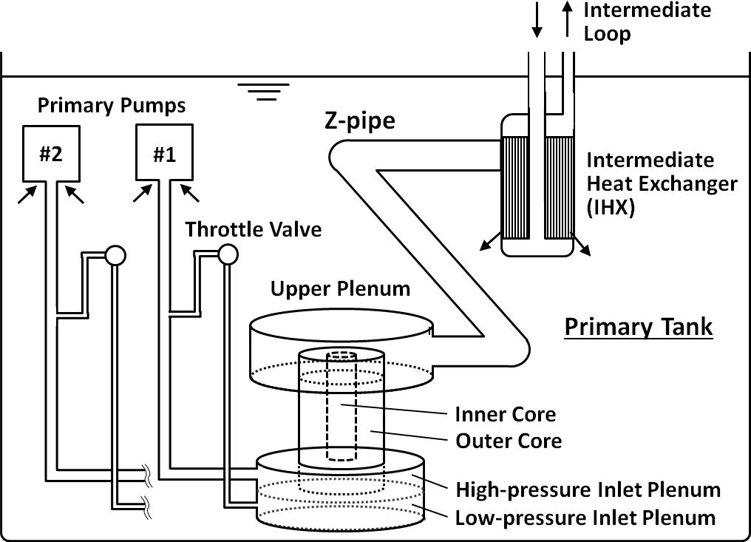
FIG. 1. EBR-II Plant Overview
Focusing on thermal-hydraulics in the core, two instrumented subassemblies were installed in the core as shown in Fig. 2, in which temperature distribution and flow rate in the subassemblies were measured. One is XX09 subassembly with 61 fuel pins and another one is XX10 subassembly with 19 stainless-steel pins.

Plant dynamics analysis model
Figures 3 (a), (b), and (c) show the core flow model, radial heat transport model, and inter-wrapper gap flow model, respectively, for a plant dynamics analysis of EBR-II. An in-house single-phase one-dimensional plant dynamics analysis code for sodium-cooled fast reactors named Super-COPD [4, 5] is used. It has been developed from 1988 and its validity has been confirmed using test data including the experimental fast reactor JOYO and the prototype FBR of MONJU [6, 7, 8]. In the flow network model as shown in Fig.3(a), all subassemblies in the core are modelled with the independent flow channels to calculate the flow re-distribution caused by the buoyancy force under natural circulation conditions in each subassembly. The inlet plena separated into the high-pressure and the low-pressure plena respectively for the inner and the outer core region was modeled in the analysis as shown in Fig.1. The total flow rates through the inner core and the outer core are calculated by using the inner core pressure difference ΔP_{I} and the outer core pressure difference ΔP_{O}, respectively. As it is assumed that the differential total pressure between the inlet and the outlet of each subassembly is uniform, flow rate W in each subassembly is calculated depending on pressure drop and buoyancy. Chang and Todreas's Correlation [9] is used for the estimation of total pressure drop in fuel pin bundle. As for the model of fuel pin bundle in the core model, 7 regions are assumed for the bundle in subassembly as shown Fig.3 (b) on the basis of subchannel analysis model. Heat transfer between the wrapper tube and the sodium in the inter-wrapper gap is calculated using the temperatures calculated in the peripheral region and in the wrapper tube to estimate heat transfer coefficient between them. The flow through the inter-wrapper gap is simulated by three-dimensional network model in the core as shown in Fig. 3 (c).
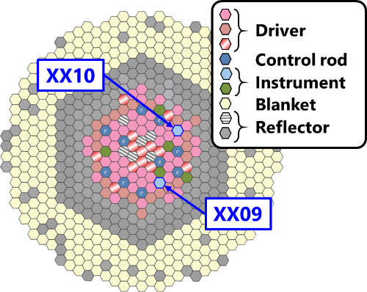
(a) Core loading pattern
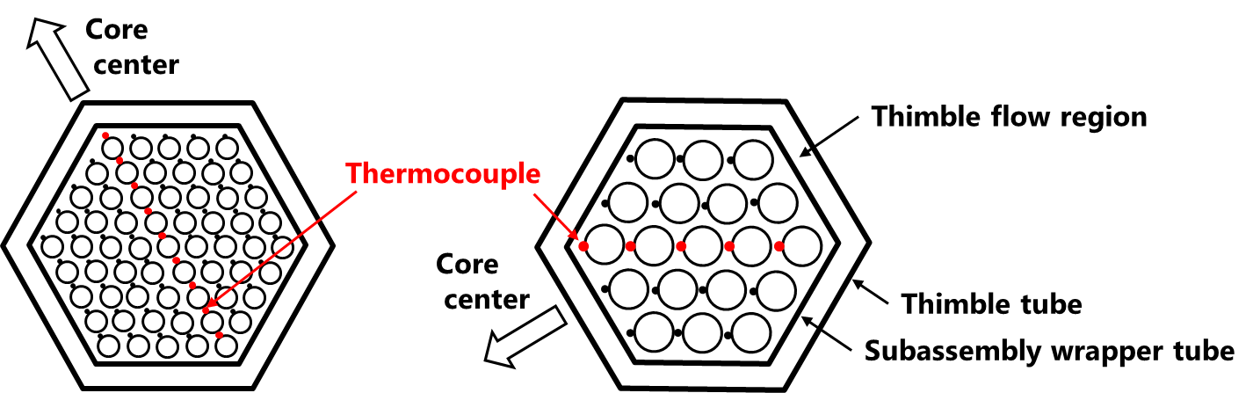
(b) XX09 subassembly (c) XX10 subassembly
FIG. 2. EBR-II Core

Subassembly thermal-hydraulics model
Figure 4 shows subchannel analysis model for thermal-hydraulics in the fuel subassembly. An in-house subchannel analysis code named ASFRE [10] for single-phase thermal-hydraulics analysis in the SFR subassembly is used. Its validity has been confirmed using full-scale mockup water test data on the pressure loss in the subassembly and sodium experiment data on the temperature field in the subassembly [11, 12, 13]. Figure 4 shows the arrangement of the cells for each subchannels in the subassembly for the ASFRE. In the model, the triangular cells surrounded by three fuel rods are defined as center subchannels, the rectangular cells surrounded by two fuel rods and a side surface of the wrapper tube are defined as edge subchannels, and the quadrilateral cells surrounded by one fuel rod and a corner surface of the wrapper tube are defined as corner subchannels.
In the coupled analysis, flow rate through each subchannel is calculated depending on pressure drop and buoyancy so that the differential total pressure of each subchannel is uniform in a subassembly. The same pressure drop correlation is used as that in plant dynamics analysis. Pressure drop in subchannel and energy exchange between adjacent subchannels are described by Chang and Todreas’s Correlation [9]. The wrapper tube area are circumferentially divided to the size of the adjacent subchannel and the heat transfer between the subchannel and the inter-wrapper gap through wrapper tube are solved. The inlet coolant temperature and flow rate, the axial power distribution for each fuel pin, the inter-wrapper gap sodium temperature and the heat transfer coefficient are given as boundary conditions given by the plant dynamics analysis in the coupled analysis.
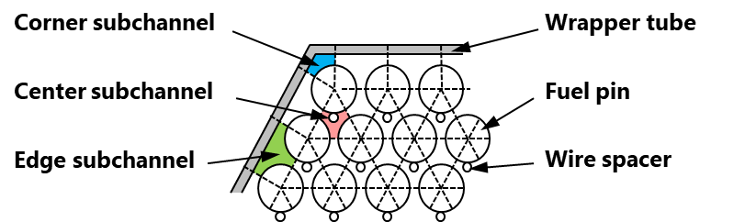
FIG. 4. Subchannel analysis model for subassembly thermal-hydraulics
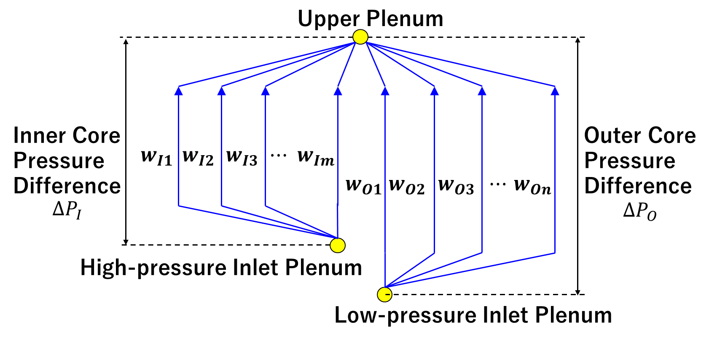
(a) core flow model
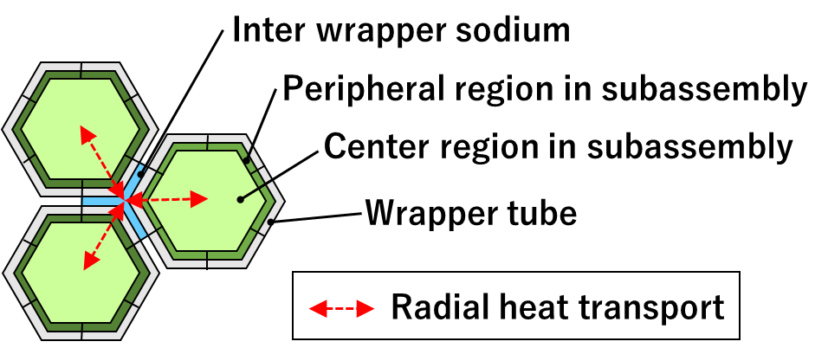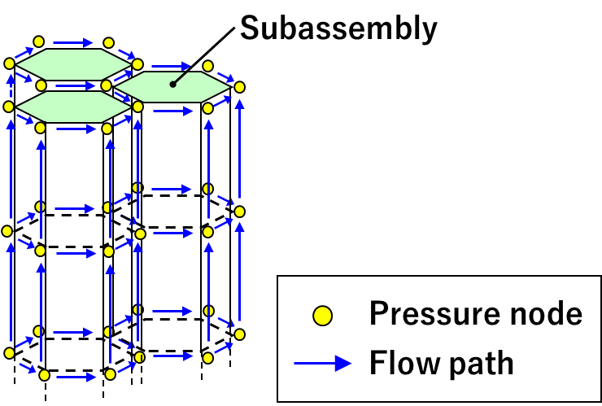
(b) Radial heat transport model (c) Inter-wrapper gap flow model
FIG. 3. Whole core thermal-hydraulics model

Coupling analysis method
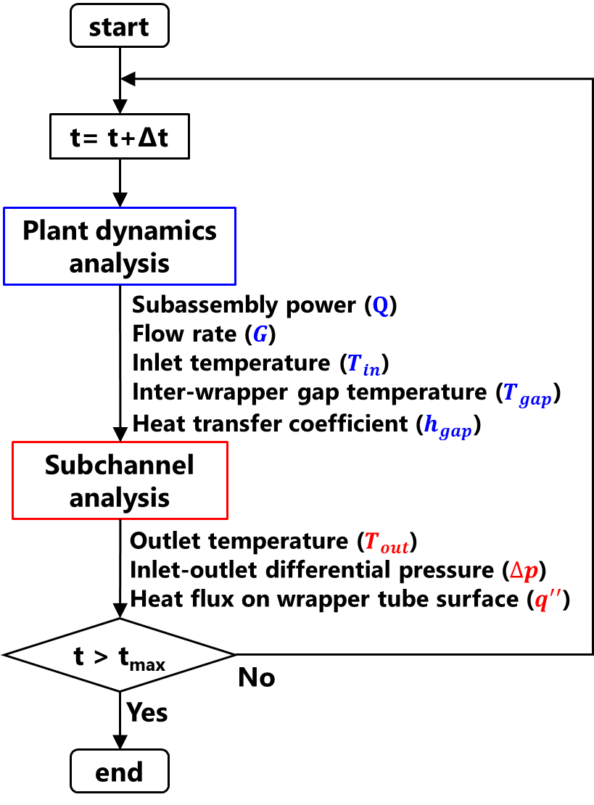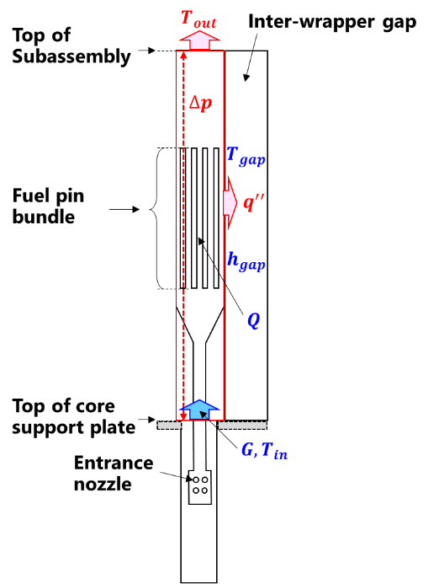
(a) Coupling analysis procedure (b) Variables at interface
FIG. 5. Coupling analysis method
Figure 5 shows the coupling method using plant dynamics analysis model calculated by the Super-COPD and the subassembly thermal-hydraulics model calculated by the ASFRE. Sequential two-way coupling methodology [14] is used to couple the codes as base technique in this coupled analysis. In the coupling procedure as shown in Fig.5(a), the Super-COPD is firstly conducted with the boundary conditions given by the results of the ASFRE calculated in the previous time step, and then the ASFRE calculates with the boundary conditions given by the Super-COPD in the same time step. The boundaries at the top of subassembly and the top of core support plate of the ASFRE are respectively connected to the core upper plenum and the core lower plenum of the Super-COPD. The boundary at the outer surface of wrapper tube in the ASFRE is also connected to the inter-wrapper gap region of the Super-COPD. The variables at each boundary between the two codes are shown in Fig.5(b). Data transfer for these boundary conditions was performed using the Programmable Synchronization Script by Python (PSSP) module which was developed. The PSSP controls the execution of each analysis code and communicates with each analysis code to pass the boundary condition data from one analysis code to another analysis code, according to the coupling analysis procedure. Message Passing Interface (MPI) was used for data communication.

Analytical models and conditions
Figure 6 illustrates the one-dimensional flow network model of the Super-COPD for primary heat transport system of the EBR-II. In this model, the core subassemblies were modelled with the independent flow channels as shown in Fig.3(a). Figure 7 shows the simulation model of the subassemblies of XX09 and XX10 for the subchannel analysis by ASFRE. Since XX09 and XX10 were inserted into a thimble tube in the core as illustrated in Fig.2 (b), and (c), respectively, the thimble tube, the subassembly wrapper tube, and the sodium layer between them were treated with their respective thermophysical properties in the corresponding mesh of the ASFRE. Figure 8 shows the axial mesh geometry of EBR-II core model. Since the axial mesh sizes of the Super-COPD and the ASFRE were different, each boundary condition given by the other code was linearly interpolated. The time step of the Super-COPD and the ASFRE was set to 0.001 s in common, which was calculated based on the Courant-Friedrichs–Lewy (CFL) condition in the ASFRE.
(a) Coupling analysis procedure (b) Variables at interface
FIG. 5. Coupling analysis method

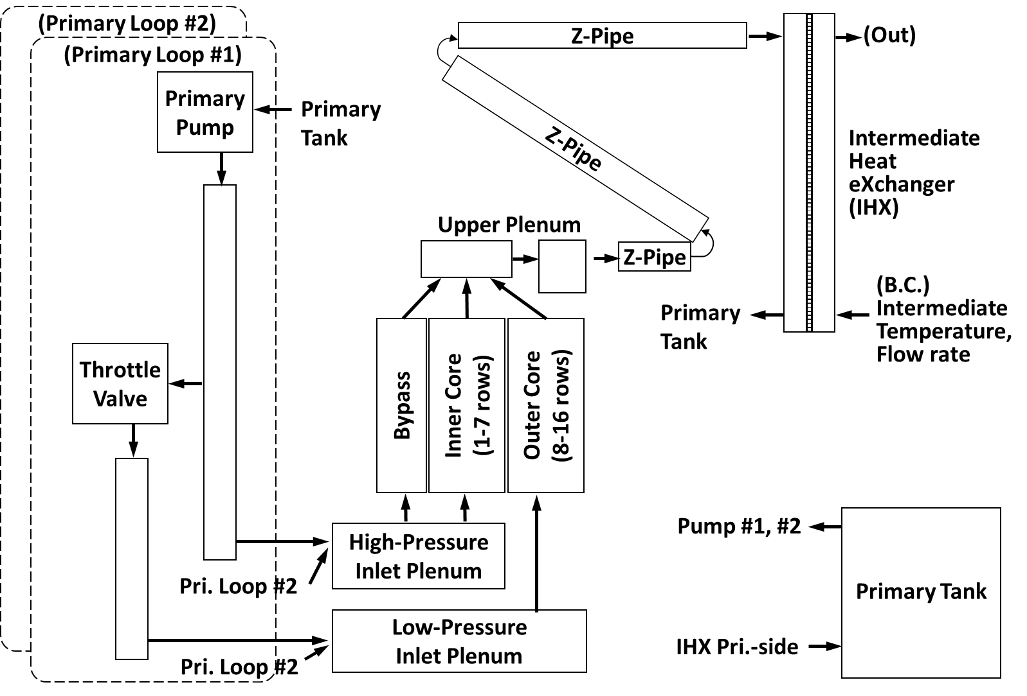
FIG. 6. Model for primary heat transport system of EBR-II
Boundary and initial conditions were basically given from the benchmark specification [3]. The decay heat curve, the rotational speeds of the primary pumps, and the sodium inlet temperature and the sodium flow rate of the intermediate heat exchanger in the secondary loop side were given as the boundary conditions. The power distribution in the core, the sodium flow rates, the pressure differences between the core outlet and the discharge of pumps, and the sodium outlet temperature of intermediate heat exchanger in the secondary loop side were given as the initial conditions. The initial steady state condition was obtained by running transient calculations of the Super-COPD and the ASFER independently and additional run of transient calculation in the coupled analysis with both codes was performed at fixed boundary condition.
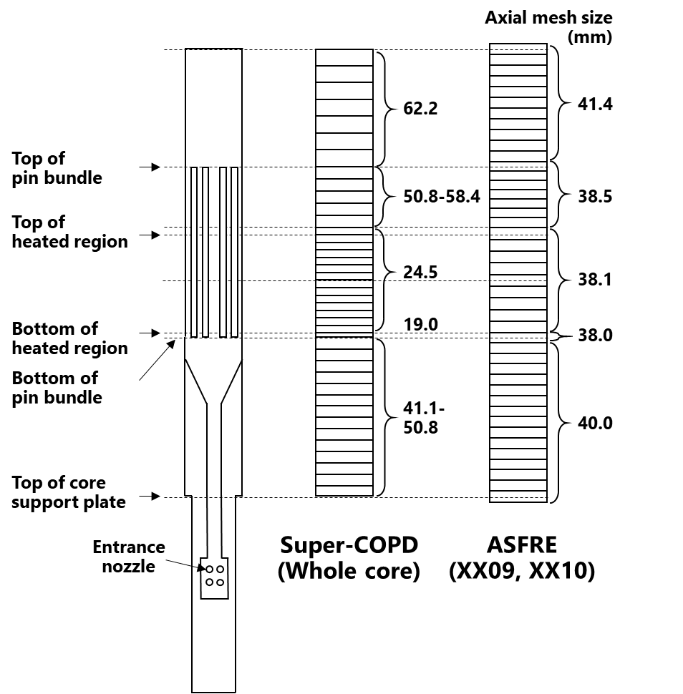
FIG. 8. Axial mesh geometry of EBR-II core
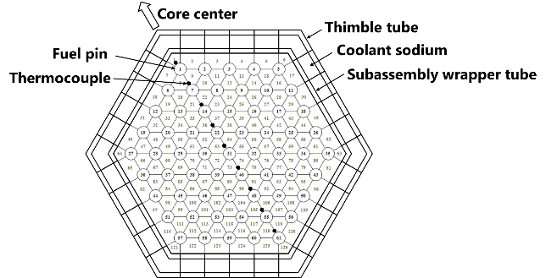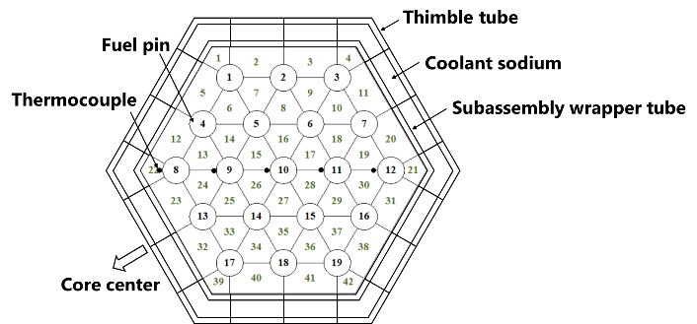
(a)XX09 (b) XX10
FIG. 7. Models of instrumented subassemblies of EBR-II

NUMERICAL RESULTS AND DISCUSSION

Flow rates
The numerical analyses on the SHRT-45R test were performed with two models of different level of detail for the instrumented subassemblies of XX09 and XX10; one was the subchannel model of ASFRE in the coupling method and another one was included in the core model of Super-COPD. Figure 9 shows that the flow rate through the pump No. 2. In the experiment, the flow rate coasted down during the initial 90 s after a simultaneous trip of the two primary pumps at 0 s and then recovered to about 6 percent of the initial flow rate due to natural circulation. The numerical results of the flow rate using the coupled code were almost the same as the Super-COPD standalone results in 300 s. Both the two models could predict the flow rate through the pump No. 2. Figure 10 and 11 show that the flow rates of the instrumented subassemblies of XX09 and XX10, respectively. The numerical analysis models could predict the same flow responses in XX09 and XX10 as the measurement. There is, however, a discrepancy in XX09 at low flow rates by a factor of 1.5. A plausible explanation is that the flowmeter offset setting has a wider uncertainty at low flows. The simulated XX09 flow rate may fall within this uncertainty range.

Temperature distribution in subassembly
Figure 12 shows that the temperature distribution in and around the instrumented subassembly XX09 at the top of heated region at 50 s. From this figure, it can be seen that the temperature field around XX09 was not uniform. XX09 was adjacent to a subassembly which has stainless-steel pins on the core center side. The temperature on the core center side of the double-wall wrapper tube region which are thimble tube, subassembly wrapper tube, and the sodium layer between them was lower than that on the other side. Figure 13 shows the transient horizontal temperature distribution inside XX09 at the top of heated region. In this figure, the horizontal axis is the distance from the center of subassembly standardized by fuel pin pitch. The inter-wrapper gap temperature of numerical result is also plotted in this figure. As can be seen, the horizontal temperature distribution inside the subassembly could be predicted in more detail by increasing the level of detail of the subassembly model. The inter-wrapper gap temperature on the core center side was lower than the double-wall wrapper tube temperature of XX09 on the same side, hence the temperature distribution in XX09 was also slightly lower on the core center side than on the other side. From the viewpoint of peak temperature evaluation, the maximum temperature in the subassembly during 300 s was compared. The result by the subchannel analysis was 989 K at 39 s and its difference was about 12 K from the measured value of 977 K at 49 s. This difference was less than 3 percent of the temperature rise from the core inlet temperature.
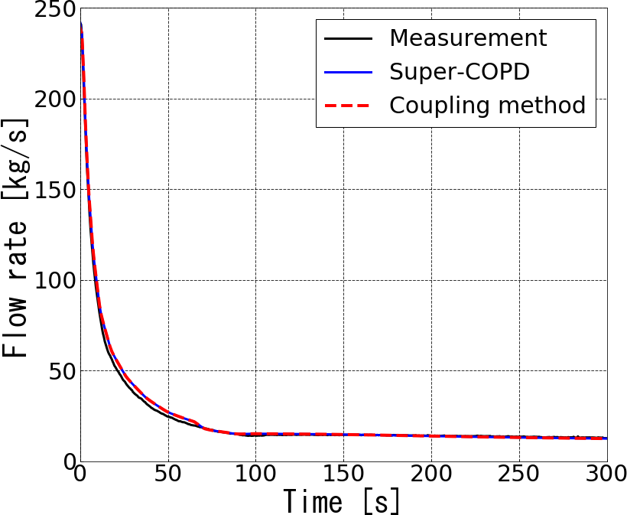
FIG.9 Flow rate through pump No.2
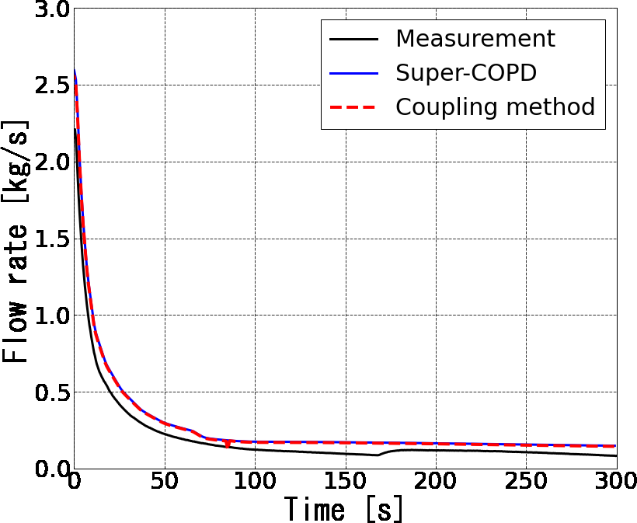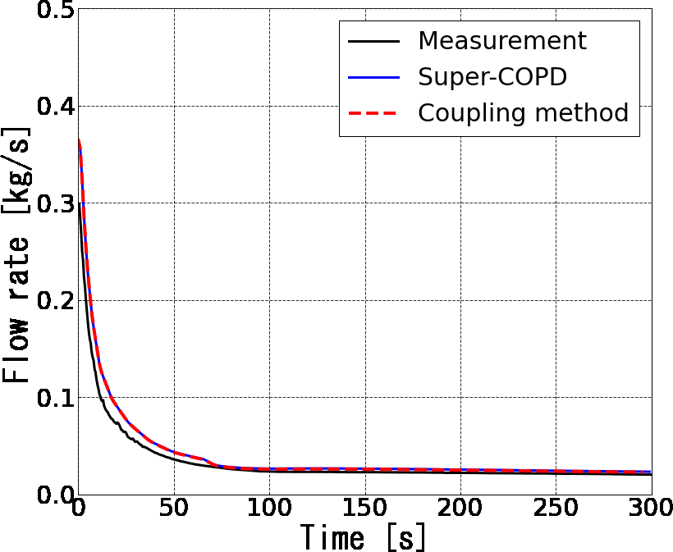
FIG.10. Flow rate of XX09 FIG.11. Flow rate of XX10
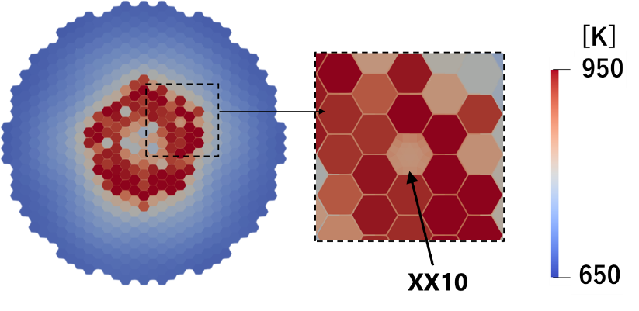
FIG. 14. Coupled analysis result of temperature distribution in and around XX10
at the top of heated region at 85 s
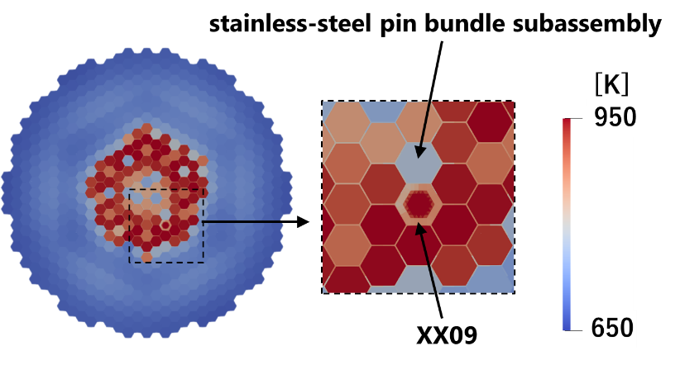
FIG. 12. Coupled analysis result of temperature distribution in and around XX09
at the top of heated region at 50 s
Figure 14 shows that the temperature distribution in and around the instrumented subassembly XX10 at the top of heated region at 85 s. From this figure, it can be seen that the temperature of XX10 was lower than that of the adjacent driver subassemblies and the temperature of the driver subassemblies on the core center side was slightly lower than that on the other side. Figure 15 shows that the transient horizontal temperature distribution in XX10 at the same elevation of the top of the heated region of the driver subassembly. The gap temperature between adjacent subassembly wrapper tubes is also plotted in this figure. From this figure, it can be seen that in the experiment, XX10 was heated from the adjacent subassemblies through inter-wrapper gap and the temperature distribution had a parabolic shape with a minimum value at the center. In addition, since the inter-wrap gap temperature on the core center side is lower than that on the other side, the temperature distribution inside the XX10 is slightly lower on the core center side. As can be seen, the horizontal temperature distribution in the subassembly can be predicted in more detail by increasing the level of detail of the subassembly model. The maximum temperature in the subassembly during 300 s was compared between the coupled analysis and the measurement. The result by the subchannel analysis was 813 K at 86 s and its difference was about 7 K from the measured value of 820 K at 84 s. This difference was about 4 percent of the temperature rise from the core inlet temperature.
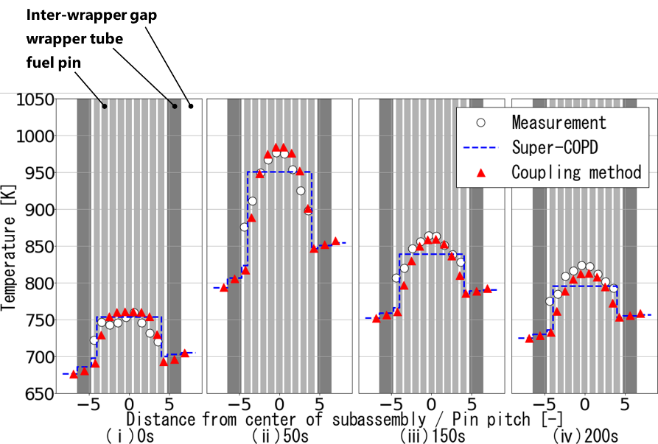
FIG. 13. Transient temperature distribution at the top of heated region in XX09
The comparison of the temperature distributions among the only Super-COPD analysis result, the coupling analysis result, and the measurement in XX09 and XX10 shows that the coupled analysis could predict detailed temperature distribution in a subassembly and the average temperature of subassembly cross-section was consistent with the only Super-COPD analysis result. As a result of the demonstration, it was indicated that the multi-level simulation by changing the level of detail of the analysis model between the method with the plant dynamics code and the coupling method could be performed.
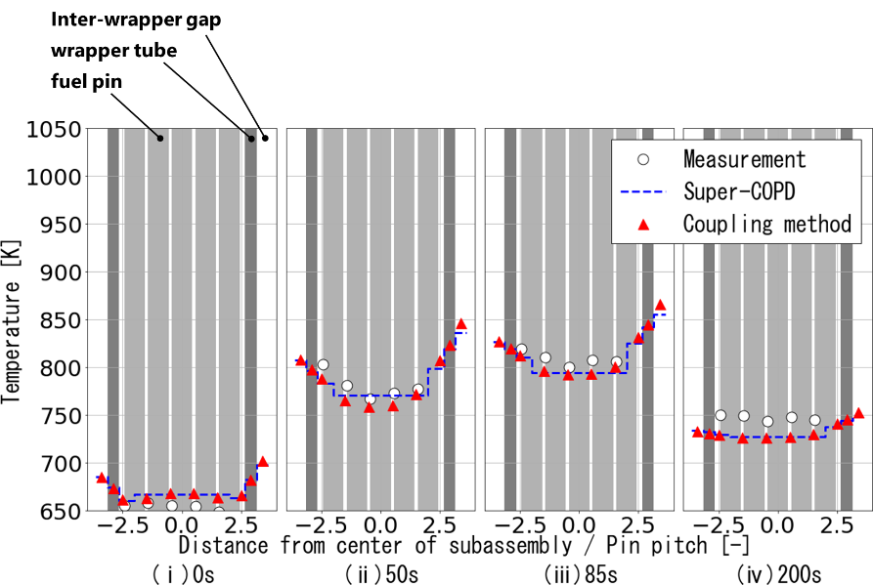
FIG. 15. Transient temperature distribution at the top of heated region in XX10

CONCLUSIONs
JAEA has begun to develop the multi-level simulation system in which detailed analysis codes for local phenomena of interest are coupled with a plant dynamics analysis code in order to obtain evaluation results considering the mutual interaction with reasonable conservativeness. Focusing on core thermal-hydraulics, the coupling analysis method using the plant dynamics analysis code Super-COPD and the subchannel analysis code ASFRE to evaluate temperature distribution in a subassembly has developed as a part of multi-level simulation system.
For demonstration purpose, the numerical analyses on test in the EBR-II were performed. Two models of different level of detail for the instrumented subassemblies with thermocouples were used to compare the transient temperature distributions in a subassembly with the measurement. The comparison of the temperature distributions in the instrumented subassemblies among the only Super-COPD analysis result, the coupling analysis result, and the measurement shows that the coupled analysis could predict detailed temperature distribution in a subassembly taking account of inter-subassembly heat transfer and the average temperature of subassembly cross-section was consistent with the only Super-COPD analysis result. As a result of the demonstration, it was indicated that the multi-level simulation by changing the level of detail of the analysis model could be performed. In future work, the analysis on the sodium tests under various inter-subassemblies radial heat transfer conditions using PLANDTL test facility at JAEA, which simulates thermal-hydraulics in the core, is planned to be carried out as validation purpose of the coupled analysis method.

ACKNOWLEDGEMENTS
This work was partially supported by a study of “Research and Development of Multi-level and Multi-scenario Plant Simulation System Technology in Innovative Sodium-cooled Fast Reactor” entrusted to “Japan Atomic Energy Agency (JAEA)” by the Ministry of Education, Culture, Sports, Science and Technology of Japan (MEXT). Analysis code runs were technically supported by Mr. T. Iwasaki of ENO Corporation and Mr. Y. Nakamine of NDD Corporation. Programming of code coupling tool was technically supported by Mr. D. Horie and Mr. P. Till of Smart Solutions Corporation.

References
[1] DODA, N. et al., “Development of platform for design optimization in fast reactor based on coupling analysis codes”, Proc. of the Conference on Computational Engineering and Science 24, 4p, 2019-05 (2019) (in Japanese).
[2] DODA, N. et al., “Development of Neutronics and Thermal-hydraulics Coupled Analysis Method on Platform for Design Optimization in Fast Reactor”, Proc. of the Conference on Computational Engineering and Science 25, 4p, 2020-06 (2020) (in Japanese).
[3] INTERNATIONAL ATOMIC ENERGY AGENCY, Benchmark analysis of EBR II shutdown heat removal, IAEA-TECDOC-1819, IAEA, Vienna (2017).
[4] NAKAI, S. et al., “Super-COPD module integrated plant dynamics analysis code; Code system description (Programmer's manual)”, PNC-TN9520 88-019 (1988) (in Japanese).
[5] YAMADA, F. et al., “Development of natural circulation analytical model in Super-COPD code and evaluation of core cooling capability in Monju during a station blackout”, Nucl. Technol., 188(3) (2014) pp.292-321.
[6] NABESHIMA, K. et al., “Analysis of natural circulation tests in the experimental fast reactor JOYO”, Proc. of the 16th International Topical Meeting on Nuclear Reactor Thermal Hydraulics (NURETH-16), Chicago, IL, August 30 - September 4, 2015 (2015) pp.1041-1049.
[7] DODA, N. et al., “Benchmark analysis of EBR-II shutdown heat removal test-17 using of plant dynamics analysis code and subchannel analysis code”, Proceedings of 2016 International Congress on Advances in Nuclear Power Plants (ICAPP 2016), San Francisco, CA, April 17–20 (2016).
[8] HAMASE, E. et al., “Study on applicability of fast reactor plant dynamics analysis code to core thermal hydraulics under natural circulation decay heat removal conditions”, Transactions of the JSME, Vol. 83, No.848 (2017) 16-00431 (in Japanese).
[9] CHENG, S, K et al., “Hydrodynamic models and correlations for bare and wire-wrapped hexagonal rod bundles - Bundle friction factors, subchannel friction factors and mixing parameters”, Nucl. Eng. Des., 92 (1986) pp.227-251.
[10] NINOKATA, H. et. al., “Distributed resistance modeling of wire-wrapped rod bundles”, Nucl. Eng. Des., 104 (1987) pp. 93-102.
[11] OTAKA, M. et al., “Validation of single-phase subchannel analysis code ASFRE-III”, PNC-TN9410 96-212 (1996) (in Japanese).
[12] NARITA, H. et al., “Improvement of Single-phase Subchannel Analysis Code ASFRE-III –Verification Analysis of Fuel Pin Heat Transfer Model and Pressure Loss Model”, PNC TN9410 97-104 (1997) (in Japanese).
[13] KIKUCHI, N. et al., “Thermal-Hydraulic Analysis of Fuel Assembly with Inner Duct Structure of an Advanced Loop-Type Sodium-Cooled Fast Reactor Using ASFRE Code”, Proc. of the 25th International Conference on Nuclear Engineering (ICONE-25), ICONE-67870. American Society of Mechanical Engineers (2017).
[14] HU, R. et al., “Development of SFR primary system simulation capability for advanced system codes”, ANL/NE-13/11, Argonne National Laboratory (2014).

