# Codes of new generation – sustainable platform for numerical modeling of installations in the Proryv project

L.A. BOLSHOV

Nuclear Safety Institute of the Russian Academy of Sciences (IBRAE RAN)

Moscow, Russia

V.F. STRIZOV

Nuclear Safety Institute of the Russian Academy of Sciences (IBRAE RAN)

Moscow, Russia

N.A. MOSUNOVA

Nuclear Safety Institute of the Russian Academy of Sciences (IBRAE RAN)

Moscow, Russia

E-mail contact of main author: nam@ibrae.ac.ru

**Abstract**

Since 2010, software required for design decision making and safety assessment of nuclear power plants with fast reactors has been developed in the Russian Federation within the subproject “Codes of New Generation” of the “Proryv” project. Up to date, the task to develop 24 software products has been successfully solved in various areas, from neutron physics to the final stage of fuel cycle - SNF reprocessing and radioactive waste disposal. The state-of-the-art mathematical models and effective numerical algorithms that are aimed at using of personal computers and high-performance computing systems are implemented into the codes of new generation. The codes have been developed within the cooperation of leading Russian research centers and scientific institutes. The success of the project in development, verification and validation of codes is mainly related to application of modern approaches to collective software development and to using automated systems that is the shell for codes integration, automated testing systems, platforms for optimization calculations, etc., most of which have been developed within the project "Codes of New Generation". The experimental data from operating reactor facilities (BOR-60, BN-600, BN-800) and from studies of separate processes and phenomena, including the small-scale experiments performed in the Russian Federation recently are used for validation of the codes. The codes of new generation are used for safety assessment of nuclear facilities, to train students at universities, to model benchmarks in IAEA coordinated research projects, and are considered in other industries of the Russian Federation as promising software to solve operation tasks. The contribution addresses the basics of the codes of new generation development, the current state, the progress in their verification and validation, as well as plans for the further.

Key words: safety, codes of new generation, nuclear power plant, liquid metal coolant, project “Proryv”.

## INTRODUCTION

Development of the new generation nuclear reactors with liquid metal coolant (lead in BREST-OD-300 and sodium in BN-1200) and closed nuclear fuel cycle is actively implemented in the Russian Federation within the “Proryv” project [1]. Creation of the domestic system of codes of new generation (CNG) for assessment of design solutions and safety cases for facilities under construction has been separated as a specific direction [2], [3]. The term "Codes of New Generation" means alienable commercialized software based on the modern level of theoretical knowledge on physical phenomena and experimental data, in combination with effective numerical algorithms that fit the modern computations and have the advanced interfaces with the end user, including automated conversion of the design data.

The basic principles of development and a brief description of the current state of work, verification and validation of the codes of new generation, as well as plans for future are discussed in the contribution.

Since the previous presentation on development of the codes of new generation was delivered at the FR17 conference [4], the results and achievements obtained in the period 2018 through 2020 are in the focus of the present contribution.

## LIST AND DEVELOPMENT STATUS OF the CNG As on THE BEGINNING OF 2021

By the beginning of 2021, the task to develop 24 software products was successfully solved for various aspects of safety cases, from neutronics to the final stage of the fuel cycle – SNF reprocessing and radioactive waste disposal.

The main functionality of the major part of the codes of new generation was developed by 2017. Thus, the special attention was paid to their validation, certification[1] and development of advanced models in the period 2018 through 2020. The number of certified codes increased significantly during this period: as of mid-2017 there were only 3 certified codes, while by the end of 2018 there were already 7 of them, by the end of 2019 – 12, and on the beginning of 2021 – 17.

The current development status of the codes of new generation is shown in Table 1.

TABLE 1: DEVELOPMENT STATUS FOR THE CODES OF NEW GENERATION AS ON BEGINNING OF 2021

| Code name / Developer/ Reference | Code Assignment | Development, Validation and Certification Status |
| --- | --- | --- |
| CRISS 5.3 / JSC  "Afrikantov OKB Mechanical Engineering"/ [5] | Calculations utilizing the probabilistic safety analysis of nuclear installations and other nuclear facilities. The code calculates the reliability indicators of safety systems and the probabilistic characteristics of the facility safety. It is used for development of logical models of safety systems and the facility, as well as for preparation of data for databases on the probabilistic characteristics of the equipment reliability. Assessment of the reliability of systems and calculation of probabilistic safety indicators are carried out using methods of fault trees and event trees analyses. | Validated Certified |
| BERKUT-I / IBRAE RAN / [6] | Modeling of stress-strain states (SSS) and temperature distribution in the fast reactor (FR) fuel rod. The calculations also give the amount of gas released from the fuel, gas gap pressure and fuel swelling. The 1.5D approach is used. The fuel rod is divided into cells of arbitrary height in the axial direction. Each cell is divided into thin wall coaxial cylindrical layers in the radial direction. A heat conduction equation and a problem of SSS finding for two independent cylinders are solved for each cell in the radial direction for an open gap and a structure of two nested cylinders for the case of fuel-cladding mechanical interaction (FCMI). Through-the-thickness cracks are taken into account for the fuel pellets. | Validated Certified |
| BERKUT-U / IBRAE RAN / [7], [8] | Modeling of SSS and temperature distribution in fuel rod, production and radioactive transmutation and migration of fission products (FP) in fuel, intragrain and intergranular transport of radioactive FP, thermochemical transformations in fuel, including distribution of FP over molecular and phase states, porosity formation, evolution of fuel microstructure and its swelling, both gaseous and solid, release and distribution of radioactive FP in the gap of fuel rod with nitride or oxide fuel with gas or liquid metal sublayer during irradiation in FR with liquid metal coolant. | Validated Certification is in progress |
| **Neutronics codes** | | |
| MCU-FR / NRC “Kurchatov Institute” / [9], [10] | Simulation of neutrons, photons and electrons transport, using analog and weight Monte-Carlo methods based on estimated nuclear data in the systems with three-dimensional geometry. This includes calculations of the following characteristics: effective neutron multiplication factor; efficiency of control rods; coefficients and effects of reactivity; distribution of the neutron flux density in the core; distribution of nuclear reaction rates in the core; distribution of energy release in the core; equivalent dose rate from neutron and gamma radiation on the external surface of transport casks, etc. | Validated Certified |
| ODETTA / IBRAE RAN / [11] | Calculation of functionals of the spatial-energy distribution of the neutron flux density for defined radiation sources: flux densities with energies exceeding 0.1 MeV, 0.5 MeV and 1.1 MeV; full flux density; specific reaction rates determining the activation of structural materials. The stationary multi-group equation of neutron transport is solved in the approximation of the method of discrete ordinates by the discontinuous linear finite element method on unstructured tetrahedral grids. Anisotropic scattering is represented by expansion into a series of associated Legendre functions up to the 5th order. | Validated Certified |
| CORNER / IBRAE RAN / [12] | Calculation of the following neutronic characteristics of FR installation: effective multiplication factor; efficiency of groups and single control rods; power distribution (averaged over fuel assemblies); void effect of reactivity; temperature coefficient of reactivity; Doppler reactivity coefficient; effective fraction of delayed neutrons, etc. The energy dependence is represented by the multi-group approximation. The angular dependence is considered in the SNPM approximation. The spatial grid consists of straight prisms with a hexagonal base and can contain nested cells (parallelepipeds). | Validated Certified |
| DOLCE VITA / IBRAE RAN | Calculation of the following neutronic characteristics of fast reactor installation (diffusion approximation): effective multiplication factor; power of fuel assemblies; efficiency of groups and single control rods; void effect of reactivity; temperature coefficient of reactivity, etc. The energy dependence is represented by the multi-group approximation. The spatial grid consists of straight prisms with a hexagonal or pentagonal base. Finite difference schemes are used for the spatial approximation. | Validated Certified |
| BPSD / IBRAE RAN / [13] | Solution of the following problems: changes in nuclides concentrations; fuel burnup; residual heat generation; accumulation and activity of fission products; activation of structural materials; etc. An iteration method is used to solve the equations of nuclide kinetics. | Validated Certified |
| COMPLEX / IBRAE RAN, JSC “Proryv”, NRC “Kurchatov Institute”/ [14] | The code is used for radiation safety cases of fast reactors and fuel cycle facilities. The code includes the following basic modules with consistent input and output data: CORNER, DOLCE VITA, ODETTA, BPSD, MCU-FR, RASTAS_M. The RASTAS_M module is designed to define a radiation source. The rest of the modules are briefly described above. | Partially validated |
| **Thermohydraulic Codes** | | |
| HYDRA-IBRAE/LM / IBRAE RAN / [15], [16] | Computational modeling of non-stationary thermohydraulic processes in sodium, lead, lead-bismuth, water, air circuits of nuclear power plants and test facilities. Modeling of thermohydraulic processes is performed by solving a system of equations based on laws of conservation of mass, energy and momentum (thermally nonequilibrium heterogeneous two- or three-fluid model with equal pressure of phases), which is closed by thermodynamic relations of the coolant state and relations describing interphase interactions and interactions of phases with channel walls, i.e., by closing relations. | Validated Certified |
| LOGOS / FSUE “RFNC-VNIIEF” / [17] | CFD code based on RANS and LES approximations. Calculation of parameters of laminar and turbulent steady and unsteady coolant flows taking into account a heat exchange with solid-state equipment elements. | Validated |
| CONV-3D / IBRAE RAN / [18] | CFD code based on LES approximation and DNS. Calculation of parameters of laminar and turbulent steady and unsteady coolant flows taking into account a heat exchange with solid-state elements of a reactor installation at forced and/or free convection caused by temperature inhomogeneity and/or volumetric heat release, including mixed coolant flows with different temperatures. | Validated Certified |
| CONV-3D/TwoPhase / IBRAE RAN / [19] | CFD code for calculation of thermodynamics and hydrodynamics in a two-phase medium. | Under  development |
| KUPOL-BR / JSC “SSC RF-IPPE” / [20] | Calculating the medium parameters and modeling the behavior of fission products in the NPP compartments. The code calculates the following basic values: time variation of pressure in each room and the pressure drops between the rooms; time variation of temperature in each room; time variation of concentrations of the gaseous medium components (nitrogen, oxygen, steam, hydrogen, carbon monoxide, carbon dioxide, argon and an arbitrary inert gas) in each room; sodium combustion parameters etc. | Validated Certified |
| **Codes for the analysis of fission product transport in the environment** | | |
| ROM / IBRAE RAN / [21] | Calculation of parameters of radioactive releases in aerosol and gaseous form into the atmosphere: instantaneous values of surface volumetric activity of radionuclides in aerosol and/or gaseous form; time integrals of volumetric activity; surface activity of a radionuclide in aerosol form on the surface; dose rates and exposure doses from each radionuclide etc. | Validated Certified |
| ROUZ / IBRAE RAN / [22] | Assessment of a radiation situation under releases of radioactive substances into the atmospheric air and their impact taking into account the industrial or urban environment (3D geometry). The code calculates the following parameters: three-dimensional wind-velocity fields, taking into account a specific industrial or urban environment; three-dimensional fields of turbulence intensity (three-dimensional coefficients of turbulent exchange); concentration of radionuclides in atmospheric air; values of surface concentrations of radionuclides; dose rates and radiation exposure doses for people outside buildings etc. | Validated Certified |
| SIBILLA / IBRAE RAN / [23] | Calculation of the following radiation situation parameters formed in surface freshwater bodies under impact of nuclear facilities: specific (volumetric) activity of radioactive substances in water; effective dose for the population due to water use (consumption of drinking water, fish, agricultural products) and inhalation of tritium vapor from the surface of water bodies; the effective dose of external exposure forming from staying on the shore, from an irrigated area, a contaminated floodplain, from being in water and on boats etc. | Validated Certified |
| GeRa / IBRAE RAN, INM RAS / [24], [25] | 3D modelling groundwater flow in confined, unconfined and variably saturated conditions; transport of radionuclides and various chemical substances in geological media; dynamics of radioactive and chemical contamination plumes resulting from surface and subsurface sources of pollution. The following parameters can be calculated: hydraulic head (groundwater level in unconfined conditions), groundwater fluxes, concentrations of chemical species or radionuclides’ specific activities, temperature etc. | Validated Certified |
| **Integral Codes** | | |
| SOCRAT-BN/V1 / IBRAE RAN, JSC "SSC RF TRINITY" / [26] | Modeling of thermohydraulic, thermomechanical processes, radionuclides transport in sodium-cooled FR during abnormal operation, design basis and beyond design basis accidents. The code calculates the main parameters of a reactor installation, considering the operation of equipment in the primary and secondary circuits, the steam generator of the 3rd circuit (water/steam) and the emergency heat removal system (EHRS) (with air). | Validated Certified |
| SOCRAT-BN /V2/ IBRAE RAN JSC "SSC RF TRINITY" / [26] | Numerical modeling of neutronics, thermohydraulic, thermomechanical processes, accumulation of FP, radionuclide transport in FR with sodium coolant during abnormal operation, design basis and beyond design basis accidents, including accidents with fuel melting. The code has interface to provide input data to the KUPOL-BR code and the NOSTRADAMUS code (release of FP to NPP compartments and environment). The code calculates the main parameters of a reactor installation, considering the operation of equipment in the primary and secondary circuits, the steam generator of the 3rd circuit (water/steam) and the emergency heat removal system (EHRS) (with air). | Validated Certified |
| EUCLID/V1 / IBRAE RAN / [27], [28] | Multiphysics modeling of FR installations with liquid metal coolants during normal and abnormal operation, including the initial stages of accidents prior to cladding failure and release of radionuclides. The coupled neutronic, thermomechanical and thermohydraulic calculations are performed. The code includes the following codes as modules: HYDRA-IBRAE/LM, BERKUT-U (I), CORNER, DOLCE VITA and BPSD described above. | Validated Certified |
| EUCLID/V2 / IBRAE RAN, NRC “Kurchatov Institute”, NRNU MEPhI, JSC "NIKIET"/ [29], [30], [31] | Multiphysics modeling of fast reactor installations with liquid metal coolants during normal and abnormal operation, including severe accidents. The integral code EUCLID/V2 includes the following modules that calculate the various physical processes in reactor installation with a liquid metal coolant: HYDRA-IBRAE/LM, AEROSOL/LM, OXID, TRITIUM, DOLCE VITA, CORNER, BPSD, BERKUT-U (I), CELSIST, APMod, SAFR, SECRIT, CORCONIT, ROM, HEFEST-FR (the description will be given below in this contribution). | Partially validated |
| **Codes for Simulation of Closed Nuclear Fuel Cycle Processes** | | |
| VIZART / FSUE Akademician Zababakhin "VNIITF"/ [32] | The code simulates the material balance and nuclide fluxes in the closed nuclear fuel cycle. | Partially validated |
| CODE TP / TPU / [33] | The code simulates the technological schemes operation. | Partially validated |
| Computational models of closed nuclear fuel cycle / FSUE “VNIITF”, JSC “VNIINM”, IBRAE RAN | Computational models of closed nuclear fuel cycle facilities that allow optimizing the technological processes, performing calculations for nuclear and radiation safety cases. | Under development |

Description of some advanced models and results of their verification and validation over the past 3 years is given below.

## NEUTRONics

Development and validation of standalone versions of neutronic codes that allow calculating the neutronic characteristics of fast reactors in various approximations were basically completed by 2017. Thus, the main efforts in 2018–2020 were applied to creation of COMPLEX code system for radiation safety cases of reactor installations and fuel cycle facilities [34]. The objects modelled by the code are storage and transportation units for fresh and spent assemblies, core, reactor installations, NPP equipment and rooms, closed nuclear fuel cycle facilities. The modules (codes) in the COMPLEX code system are integrated by exchange data files and a pre- and post-processing system. The code includes the following modules:

- modules for calculating a reactor core using a diffusion approximation (DOLCE VITA) and SN-approximation (CORNER);

- nuclide kinetics module (BPSD);

- module for calculating radiation sources (RASTAS_M);

- module for calculating the radiation protection based on the finite element method (ODETTA);

- module for calculating a reactor core and radiation protection using the Monte-Carlo methods (MCU-FR);

- nuclear data (CONSYST/BNAB-RF).

Figure 1 shows the functional diagram of the code.

The first version of the integrated pre- and post-processing system was created in 2018–2020, and the cross-verification and validation of the COMPLEX code system were performed. Table 2 demonstrates (as an example) the results of the equivalent dose rate calculations for the TUK model shown in the Figure 2 using the COMPLEX code system in comparison with the reference results obtained by the SCALE code system.

The plans for the COMPLEX code system development include:

- code validation and certification;

- parallelization of separate modules using OpenMP and MPI technologies;

- improvement of pre- and post-processing systems.



*FIG. 1 - Functional diagram of the COMPLEX code system*

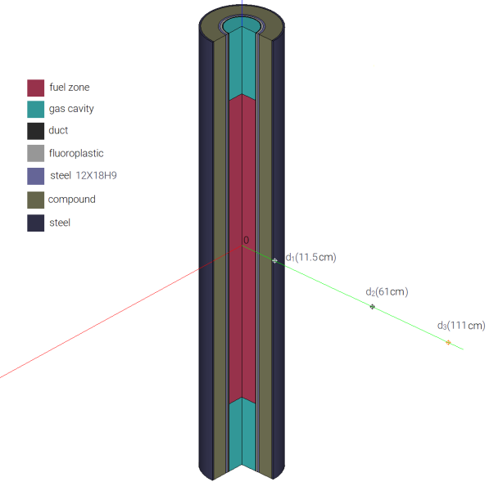

*FIG. 2 - TUK computational model*

TABLE 2 - EQUIVALENT DOSE RATE OF PHOTON RADIATION FROM TUK, µSv/h

|  |  |  |  |  |  |
| --- | --- | --- | --- | --- | --- |
| Fuel type | Detector position, cm | SCALE | | COMPLEX | |
| Value | Standard deviation, % | Value | Relative deviation from SCALE, % |
| MOX fuel fabricated from low background plutonium | 11.5 | 4.71E+01 | 0.28 | 4.76E+01 | 1.0 |
| 61 | 6.01E+00 | 0.23 | 6.01E+00 | 0.0 |
| 111 | 2.16E+00 | 0.26 | 2.17E+00 | 0.6 |

## THERMOHYDRAULICS

In recent years, the system code HYDRA-IBRAE/LM has been developed in the following directions:

- development of the turbine model;

- inclusion of new models into the code for determining the size of the dispersed phase (bubbles);

- improvement of the free-level model;

- using of the transport equation to determine the size of the dispersed phase.

A more detailed description of the models is presented in [35]. This contribution gives only a brief description – a notice of some models with a demonstration of the influence of one of new models on the calculation results.

The more accurate the size of the dispersed phase is determined, the better modeling of its spatial distribution and interfacial heat exchange is achieved. The most detailed description of an ensemble of interacting particles is based upon the approach based on the kinetic equation for the particle size distribution function. The method of fractions (groups) is commonly used for the numerical solution of the kinetic equation. A multispeed multigroup model based on the above method is implemented in the code. The approach using the interfacial area transport equation is simpler than the one described above, but it also gives much better results than the traditional approach using empirical correlations for the particle (bubble) size, when simulating processes with a dispersed phase presence. The interfacial area transport equation realized in HYDRA-IBRAE/LM code has the following form [36]:

,

where  – interfacial area concentration;  – void fraction;  – velocity of the gas phase;  – change of the interface due to bubble coagulation;  – change of the interface caused by fragmentation process;  – change of the interface due to the presence of a source of mass. Figure 3 demonstrates a comparison of the simulation results and the data of experiments on vapor injection into liquid lead, performed at the IT SB RAN (Russia) in 2018. There are two sets of simulation results for two approaches used: a traditional one based on the use of correlation to determine the size of the dispersed phase [37], and the interfacial area transport equation. When calculated using the correlation approach, the time-average diameter of the bubbles is smaller than the diameter calculated using the transport equation. Accordingly, the interfacial area concentration and the interfacial heat flux will be higher. This leads to increased cooling of the lead that is shown in Figure 3. One can see that the transport equation gives more realistic calculation results.

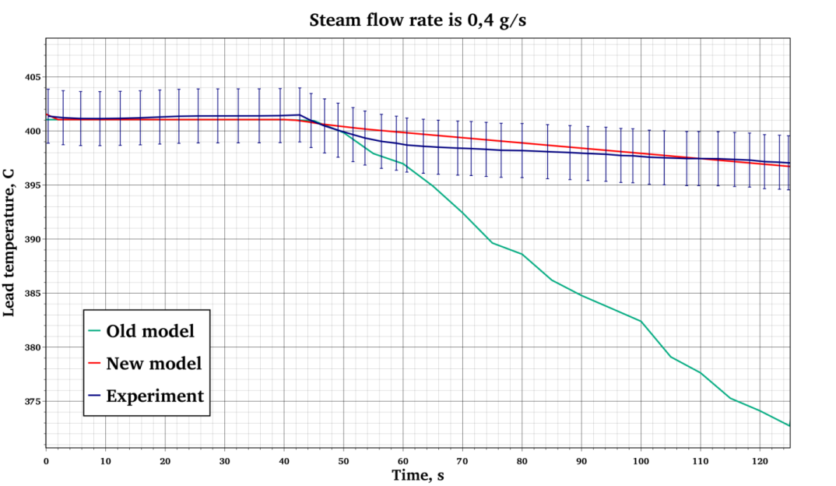

*Old model - empirical correlations, New model - transport equation for the interface area density*

*FIG. 3 – Time dependence of lead temperature*

The main direction of the DNS code CONV-3D development is related to development of a two-phase three-dimensional CFD module for direct numerical modeling of thermo- and hydrodynamics in a two-phase medium, considering the interphase heat and mass transfer and using an equation of state of the stiffened type for condensed gas without a map of flow regimes [38]. Development of two-phase process models in a three-dimensional approximation is a worldwide trend, since this approach will allow simulating the individual elements of reactor installations in the future with significantly non-uniform flow characteristics, including emergencies when the second phase appears. The software module utilizes the technique for modeling of heat and mass transfer processes in a two-phase environment using the HLLC (Harten-Lax-van Leer-Contact) solver and a two-step predictor-corrector of the MUSCL algorithm (Monotonic Upwind Scheme for Conservation Laws is a monotonic scheme with directed differences for solving the conservation laws). The first version of the two-phase module has been developed on the basis of a multidimensional technique using the stiffened equation of state to solve problems of liquid-gas interaction with an interface separation. The technique was verified by solving a number of test problems: rupture decay and cavitation, dodecane. An experiment on heat and mass transfer in a vertical channel during sodium boiling was simulated to validate the module [39] (Figure 4). A satisfactory agreement of numerical predictions with experimental data has been demonstrated.

Further development of the code is aimed at validation and increase of the computational efficiency, which includes computing systems with a hybrid architecture (CPU and GPU).

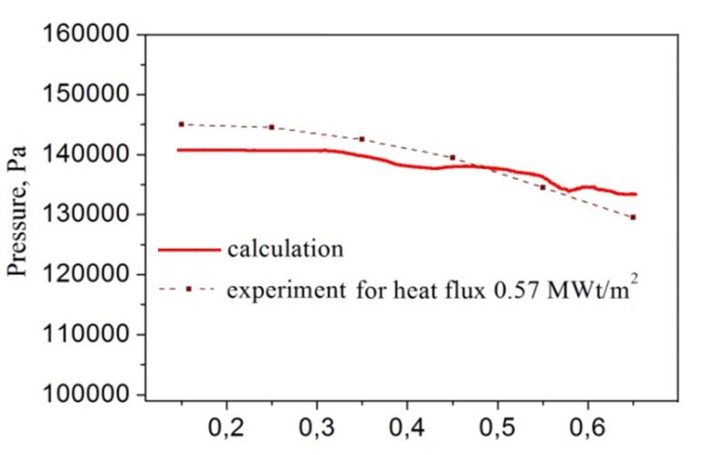

*FIG. 4 - Pressure drop along the channel axis*

## Fuel ROD CODE

The development and evolution of the mechanistic fuel rod code BERKUT-U were aimed at self-consistent modeling of microstructural changes and swelling of nitride fuel, production (initial inventory) and radioactive transmutations of FP, their intragrain and intergranular migration, release of gaseous FP in the gap, distribution of FP and fuel components by molecular and phase states. The simulation results show that the mechanistic (advanced) version of the BERKUT-U code allows predicting the behavior of nitride and oxide fuel under irradiation in FR. Comparison of the calculated and experimental axial profiles of the volumetric swelling of the nitride fuel of the experimental KETVS-1 fuel elements is given in Figure 5 [7], [40].

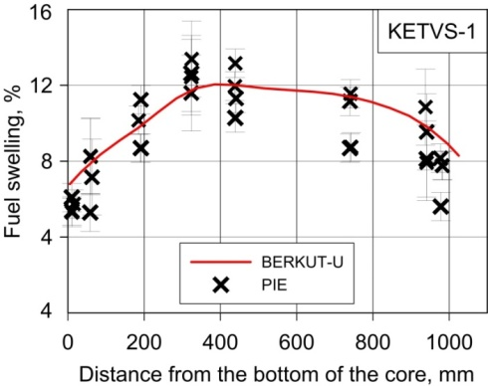

*FIG. 5 - Calculated axial profile of volumetric swelling of fuel pellets*

At present, the BERKUT-U code is being further developed. The models describing the change of mechanical properties of the cladding material under fast neutron irradiation are developed and implemented in the code. The models are based on the state-of-the-art knowledge level of the most important physicochemical processes in the cladding material under fast neutron irradiation for different reactor operation modes. A model based on the approach proposed in [41] is used to model the changes in the elemental composition of the cladding as a result of nuclear reactions under neutron irradiation. Development of the corresponding software module allowed not only achieving the autonomy of the BERKUT-U code in relation to assessing the damaging dose in the cladding material, but also calculating the rate of impurity element production. In particular, this module is used to calculate the source  of helium transmutation in the developed model of nucleation and growth of gas-filled porosity in the cladding. The approach proposed in [42] is used in this model as the first approximation. This approach is interpreted in the terms of a bimodal approximation for applications of the BERKUT-U code. Namely, the concentration of helium , gas-filled bubbles , and the average number of helium atoms  in a bubble are described by the system of equations:



where the processes of bubble nucleation, capture of helium atoms from the matrix, helium flow to grain boundaries, dislocations and dislocation loops, and thermal re-dissolution of helium from bubbles are taken into account in the right part of the equation. Further development of the model assumes its generalization to describe an evolution of the defect structure of the cladding material within the mean-field approximation, similar to the used one in the fuel module of the BERKUT-U code.

In parallel, a model of radiation-induced segregation in ferritic-martensitic and austenitic steels is being developed. The model of the three-component system Fe – Ni – Cr is based on the approach proposed in [42], [43]. This model calculates the concentration profiles of alloy components depending on temperature at a given rate of defect formation and an accumulated dose (see Figure 6), as well as diffusion models of carburization and nitriding in the fuel element cladding material, where the sources are nitrogen and carbon released from the fuel into the gas gap and “knocked out” as a result of the knock-out effect.

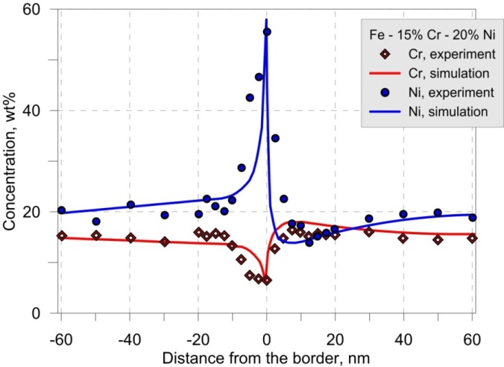

*FIG. 6 - Profiles of Ni and Cr concentrations in the Fe – 15.2Cr – 20.1Ni alloy near a moving boundary at doses of 14.4 dpa, dose accumulation rate of 4 × 10–3 dpa/s and T = 623 K. Displacement of the grain boundary over irradiation time is 20 nm*

## INTEGRAL CODE EUCLID/V2

EUCLID/V2 is a multiphysics universal code for safety analysis of NPP with fast reactor installations with liquid metal coolant (sodium, lead, lead-bismuth) intended for modeling of normal and abnormal operation modes, emergency conditions, including severe accidents. The modular structure of the code is given in Figure 7.

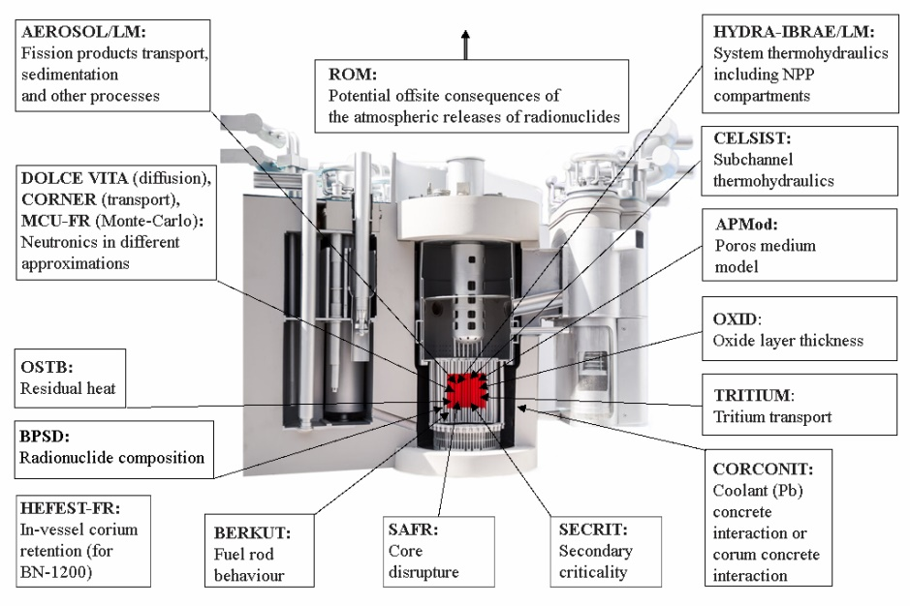

*FIG. 7 - Modular structure of the EUCLID/V2 code*

The EUCLID/V2 multiphysics code includes the following modules (each of them is used for modeling of various physical processes): non-stationary thermohydraulic module HYDRA-IBRAE/LM with a two or three-fluid model of two-phase flow and a model of liquid lead with steam-water mixture flow; module of transport and behavior of FP, mass transfer and distribution of FP and sodium combustion in NPP compartments (AEROSOL/LM); module of transport of solid-phase impurities in the primary circuit of a reactor installation with a heavy liquid-metal coolant (OXID); module of tritium transport (TRITIUM); neutronics module (DN3D) that has the diffusion (DOLCE VITA) and kinetic (CORNER) options; burnup (BPSD) and residual heat (OSTB, the part of BPSD) modules; fuel rod module (BERKUT-I and BERKUT-U) with models for calculating the release of FP in the core in the event of fuel rod failure; subchannel module (CELSIST) that has been designed for quasi-three-dimensional thermohydraulic calculations of stationary and non-stationary processes of fuel assemblies with a liquid metal coolant cooling; module for the modeling of thermohydraulic processes in the core cooled by a single-phase liquid-metal coolant, in the approximation of an anisotropic porous body (module APMod); module for calculating of core degradation, including calculations of the nitride fuel dissociation and pool scrubbing model (SAFR); module for estimation of the possibility of secondary criticality in case of a severe accident (SECRIT) that includes a Monte-Carlo module (MCU-FR); module of melt (corium or lead) interaction with concrete (CORCONIT); module for calculating the radiation situation in mesoscales (outside the industrial site of a nuclear facility) (ROM); module for two-dimensional calculation of retention and cooling of the melt in the reactor vessel taking into account heat exchange with the in-vessel structures (HEFEST-FR).

Also, the multiphysics code includes auxiliary software modules to simulate the operation of computerized process control system (CFunc) and to calculate and store the data on material and coolant properties used in the fast reactor installations (SmartDB). SMART_LM is an integrating shell that controls the consistent calculations by modules.

One of the main directions in the development of the EUCLID/V2 code at the present relates to taking into account the spatial effects when simulating the processes of the core degradation. In particular, the code integrates the approaches that are used for simulation of fuel element destruction, transfer of components of a destroyed fuel element, as well as retention and cooling of the melt in 2D and 3D approximations. Figure 8 gives an example of comparison of the calculation results using the EUCLID/V2 code and the experimental results for the temperature distribution along the radius of the assembly at a distance of 80 mm from the blockage for the experiment on partial blockage of the flow section in a 169-rod assembly at the KNS facility (Germany) [44].

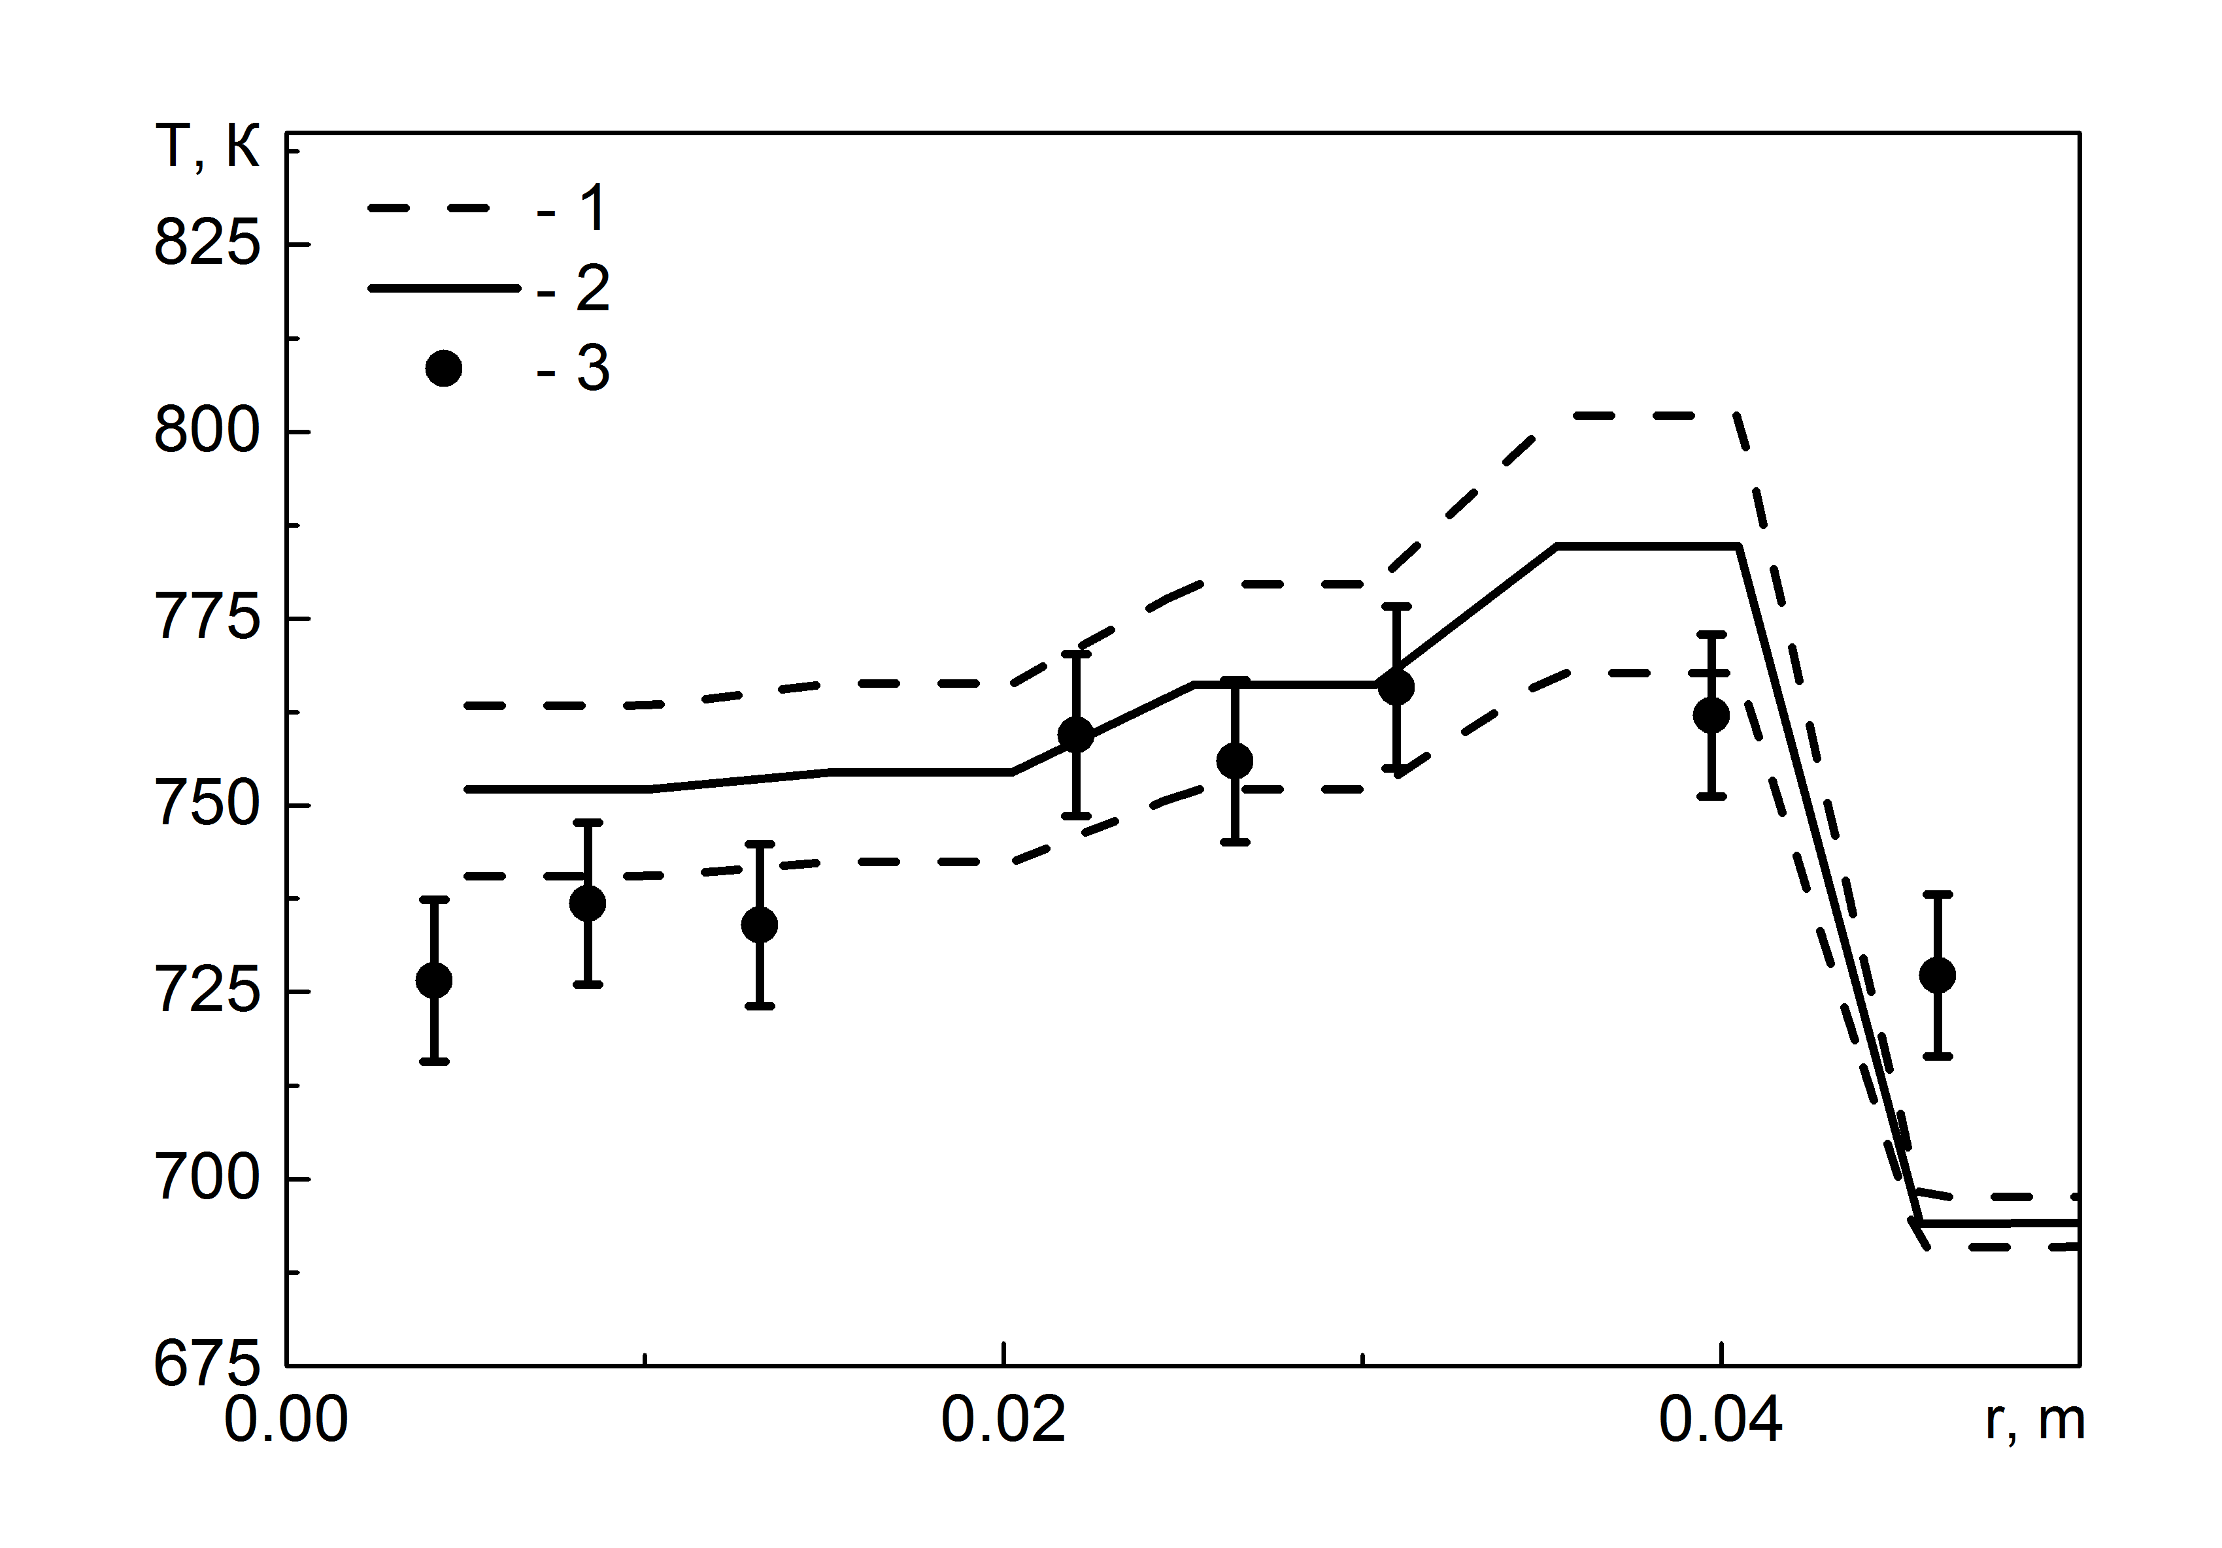

*FIG. 8 - Distribution of temperature along the radius of the assembly: 1, 2 - minimum and maximum calculated values, 3 - experimental data*

More detailed information on the implemented approaches, calculation results and directions of development for the multiphysics code EUCLID/V2 can be found in [45], [46]. Further development of the code is associated with validation, increase of the computational efficiency and specific facilities safety assessment using the code.

## BASIC PRINCIPLES FOR DEVELOPING CODES OF NEW GENERATION

To ensure the efficiency of the project team “Codes of New Generation” and the ability to manage the progress of the project, a managing system has been created and implemented. The system controls the life cycle processes of the calculation codes. Development of similar systems begins with identification of life cycle processes for a code. Figure 9 shows a V-shaped model of the software life cycle, reflecting the specifics of the software development aimed at safety cases for nuclear facilities, i.e. the Rosteсhnadzor’s requirement for certification of the codes. Formalization of the corresponding stages led to streamline the development process and significantly improve the quality of the results obtained. The average duration of the code life cycle, starting from assessment of need and concluding by obtaining of certification passport is equal to from 5 to 7 years depending on code complexity. The duration may be more for complex multiphysics codes, that consist of more than 10 modules. As one can see in Figure 9 the iterations may occur between different stages of code life cycle. For example, the results of verification and validation may lead to necessity of models improvement.

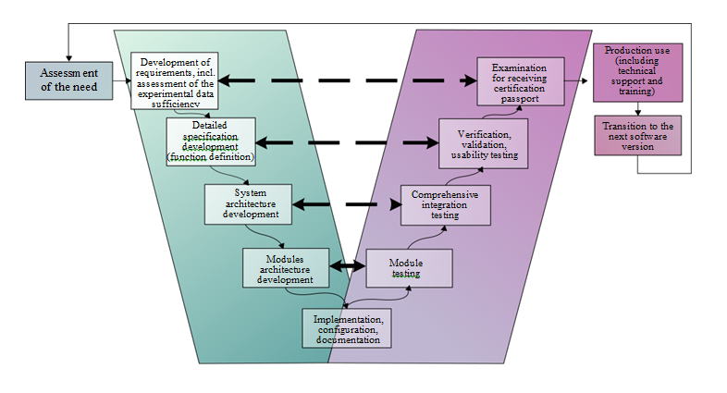

*FIG. 9 – The main stages of the life cycle of a code*

The automated control system for the calculation code life cycle is designed for:

* planning and control of operations and resource loading;
* storage of documents, source codes, input data files and other project documentation with support of version management and provision of an authorized access;
* management of requirements;
* management of linkage of executable modules;
* test management;
* software configuration management;
* management of changes;
* administration of communications between project participants.

Almost all tasks listed above are typical for development of application software. However, the system components in the project “Codes of New Generation” created to automate the solutions of the above tasks are focused on the specifics of developing software products to simulate nuclear facilities. In particular, the automated testing system allows not only comparing the calculation results with the reference values to prove their full compliance, but also intelligently processes them, comparing the calculation results with experimental values in various metrics. This is necessary for generation of final reports with the code validation and verification results. Such reports are generated over a period of several years, and the code version develops significantly during this period, so the developers have the information about the influence of the code changes on the results of validation calculations.

The recommendations developed for the efficient use of automated systems describe step by step the actions of software developers.

## EXPERIMENTS to VALIDATe the CODES of new GENERATION

[Statement of basic requirements](https://www.multitran.com/m.exe?s=statement+of+basic+requirements&l1=1&l2=2) and planning of experimental studies that are needed for the validation of codes is an essential part of software development. A program of computational and experimental studies of the processes that occur at hypothetical accidents with a core disrupture in a lead-cooled reactor was developed in 2019 within the project "Codes of New Generation". The program defines the studies of interaction of the nitride fuel and cladding with lead coolant at high temperatures up to the lead boiling point. The program includes studies of fission product releases into the gas cavity, studies of the interaction of coolant, fuel cladding, steel vessel and fuel debris with the reactor shaft concrete, and studies of thermohydraulic processes at melting of fuel assemblies and fuel rods in the lead coolant.

In 2019 – 2020, at FSUE NITI, a series of BR-experiments was carried out using the experimental facility “Rasplav-3” based on the technique of induction melting in a cold crucible. Interaction of the nitride fuel with coolant, release of gases and aerosols from the melt in the inert and oxidizing atmosphere were studied. The main component of aerosols is lead or its oxide. The steel melt is located above the lead melt. It was demonstrated that there was no interaction of the fuel with the coolant up to the lead boiling point.

The obtained experimental data allowed developing and validating models of the multiphysics EUCLID/V2 code for modeling various operating modes of NPP with FR. Also, unique experimental studies of the thermohydraulic and vibration parameters of fuel assemblies placed in a heavy liquid metal coolant, processes occurring in case of a steam-water mixture ingress into the lead coolant, and a number of other experiments have been carried out within the project "Codes of New Generation" (see, for example, [47], [48]).

## CONCLUSION

In conclusion, one can see that within the framework of the subproject “Codes of New Generation” within the “Proryv” project, 24 high-technology scientific software products have been developed: engineering-level, high-precision and multiphysics codes. By the beginning of 2021, Rostechnadzor issued certification passports for 17 codes. More than half of the developed products are applied for safety cases of innovative designs of reactor installations, such as BREST-OD-300 and BN-1200, as well as for other nuclear facilities. Thus, a unified system of calculation codes has been created in the Russian FR nuclear industry. The system is in demand justification of design solutions and the safety cases of unique facilities being developed within the “Proryv” project.

For the past 10 years, the team of the project “Codes of New Generation” managed to develop a large number of modern mathematical models and effective computational techniques, analyze, generalize and evaluate foreign and domestic experimental data obtained over many years on liquid metal coolants and fast reactors. These models and data are a sustainable platform for the further development of the computational code system.

Application of collective software development technology with automated quality assurance procedures allowed organizing and ensuring an excellent coordination of the code developers from more than twenty scientific and research institutes. The developed codes have been installed at dozens of enterprises and universities; four user workshops have been conducted for more than several hundred people.

Further development of the created system of computational codes is related to the improvement and development of new models, and to application of precision codes in computational research.

ACKNOWLEDGEMENTS

The research was conducted in frame of Proryv project and funded by government contracts ##Н.4х.44.90.13.1084, Н.4х.44.9Б.14.1037, Н.4х.241.9Б.17.1018, Н.4х.241.9Б.18.1012, Н.4х.241.9Б.19.1017, H.4о.241.19.20.1027 (government customer – ROSATOM State Atomic Energy Corporation).

References

1. Adamov, E.O., et al., Conceptual framework of a strategy for the development of nuclear power in Russia to 2100, Atomic Energy 112 6 (2012) 391–403.
2. Bol’shov, L.A., et al., [Next generation design codes for a new technological platform for nuclear power](https://elibrary.ru/item.asp?id=29485804), [Atomic Energy](https://elibrary.ru/contents.asp?issueid=1688905) 120 6 (2016) 369–379.
3. Bolshov, L.A., et al., Codes of new generation for safety justification of power units with a closed nuclear fuel cycle developed for the “PRORYV” project, Nuclear Energy and Technology 6(3) (2020) 203–214.
4. Strizhov, V.F., et al., “|Codes of new generation developed for BREAKTHROUGH project”, International Conference on Fast Reactors and Related Fuel Cycles: Next Generation Nuclear Systems for Sustainable Development (FR17), (Proc. Int. Conf., Yekaterinburg, 2017), IAEA, Vienna (2018), Paper CN245-561.
5. Abramov, L. V., et al., Development and verification of a software system for probabilistic safety analysis of nuclear installations project direction "PRORYV", Izvestiya Wysshikh Uchebnykh Zawedeniy, Yadernaya Energetika 1 (2016) 5–12 (in Russian).
6. Veprev. D.P., et al. Development and validation of the BERKUT fuel rod module of the EUCLID/V1 integrated computer code, Annals of Nuclear Energy 113 (2018) 237–245.
7. Boldyrev, A.V., et al. BERKUT code validation on post-reactor studies of irradiated BN-600 fuel rods with mixed uranium-plutonium nitride fuel, Atomic Energy 127 6 (2020) 356–361.
8. BOLDYREV A.V., et al. “BERKUT – Best Estimate Code for Modelling of Fast Reactor Fuel Rod Behaviour under Normal and Accidental Conditions”, International Conference on Fast Reactors and Related Fuel Cycles: Next Generation Nuclear Systems for Sustainable Development (FR17), (Proc. Int. Conf., Yekaterinburg, 2017), IAEA, Vienna (2018), Paper CN245-363.

1. [Gurevich, M.I.](https://elibrary.ru/author_items.asp?authorid=172429" \o "Список публикаций этого автора), et al., Features of MCU-FR, Problems of Atomic Science and Technology. Series: Physics of nuclear reactors 5 (2016) 17–21. (in Russian)

1. [Kalugin M.A.](https://www.scopus.com/authid/detail.uri?authorId=6602432772&amp;eid=2-s2.0-85027921483" \o "Показать сведения об авторе), et al., Overview of the MCU Monte Carlo software package, Annals of nuclear energy 82 (2015) 54–62.
2. Belousov, V.I., et al., Some results of verification of code ODETTA for shielding calculations, Problems of Atomic Science and Technology. Series: Nuclear Reactor Physics 3 (2018) 46–53. (in Russian)
3. Bereznev, V.P., Chernova, I.S. Nonstationary version of the neutronic code CORNER, Problems of Atomic Science and Technology. Series: Nuclear Reactor Physics 3 (2018) 40–45. (in Russian)
4. Seleznev, E.F., et al., BPSD code upgrade for solving the nuclear kinetics problem, Proceedings of Higher Educational Institutions. Nuclear Power Engineering 4 (2018) 115–127. (in Russian)
5. Belov, A.A., et al., Program COMPLEX for radiation safety calculation, Problems of Atomic Science and Technology. Series: Nuclear and Reactor Constants 2 (2019) 243–255 (in Russian)
6. Usov, E.V., et al., System of closing relations of a two-fluid model for the HYDRA-IBRAE/LM/V1 code for calculation of sodium boiling in channels of power equipment, Thermal Engineering 64 7 (2017) 504–510.
7. Mosunova, N.A., et al., Lead coolant modeling in system thermal-hydraulic code HYDRA-IBRAE/LM and some validation results, Nuclear Engineering and Design, 359 (2020) № 1104631.
8. Kozelkov, A. S., et al., Investigation of Supercomputer Capabilities for the Scalable Numerical Simulation of Computational Fluid Dynamics Problems in Industrial Applications, Computational Mathematics and Mathematical Physics 56 8 (2016) 1506–1516.
9. Chudanov, V. V., et al., Adaptation of CONV-3D Single-Phase Module for Modeling Turbulent Flow in Reactors in the LES Approximation, Atomic Energy 128 (2020) 340–342.
10. Chudanov, V.V., et al., Method of solving problems of two-phase heat- and hydrodynamics with sodium coolant, Atomic Energy 125 4  (2019) 224–230.
11. Vitushkina, N.M., et al., [Simulating spatial effects during condensation of steam in a model containment using the KUPOL-3D computer code](https://elibrary.ru/item.asp?id=20746503). [Thermal Engineering](https://elibrary.ru/contents.asp?id=33321846) 53 9 (2006) 749–754.
12. DZama, D.V., et al., Methods for estimation of radiation situation through emergency release from NPP with use of real meteorological data Problemy bezopasnosti i chrezvychajnyh situacij 3 (2019) 36–44. (in Russian)
13. Dzama, D.V., Sorokovikova O.S. Verification of a mathematical model for calculating the effective irradiation dose rate from contaminated soil and building walls taking screening into account, Atomic Energy 126 6 (2019) 388–392.
14. Krylov A.L., et al., [Verification of the multi-chamber model of radioactivity migration in reservoirs](https://elibrary.ru/item.asp?id=27140263), [Russian Meteorology and Hydrology](https://elibrary.ru/contents.asp?id=34326406) 41 [5](https://elibrary.ru/contents.asp?id=34326406&selid=27140263) (2016) 344–350.
15. Novikov, K., Kapyrin, I. Coupled surface–subsurface flow modelling using the GeRa software, Lobachevskii Journal of Mathematics 41 4 (2020) 538–551.
16. Kapyrin, I., et al., Modeling groundwater flow in unconfined conditions of variable density solutions in dual-porosity media using the GeRa code, Communications in Computer and Information Science 965 (2019) 266–278.
17. Usov E.V., et al., “Coupled code SOCRAT-BN development for safety analysis of sodium-cooled fast reactors”. In: International Conference on Nuclear Engineering, Proceedings, ICONE, 2: 1: (2012) 361–366.
18. Mosunova, N.A. The EUCLID/V1 Integrated Code for Safety Assessment of Liquid Metal Cooled Fast Reactors. Part 1: Basic Models, Thermal Engineering 65 5 (2018) 304–316.
19. Alipchenkov, V.M., et al., The EUCLID/V1 Integrated Code for Safety Assessment of Liquid Metal Cooled Fast Reactors. Part 2: Validation and Verification, Thermal Engineering 65 9 (2018) 627–640.
20. Lobanov, P.D., et al., Verification of the EUCLID/V2 code based on experiments involving destruction of a liquid metal cooled reactor’s core components, Thermal Engineering 66 5 (2019) 302–309.
21. Butov, A.A., et al., The EUCLID/V2 code physical models for calculating fuel rod and core failures in a liquid metal cooled reactor, Thermal Engineering 66 5 (2019) 293–301.
22. Usov, E. V., et al., Experiment-based verification of the SAFR/V1 module of the EVKLID/V2 integral code for thermal breakdown of fuel pins in a fast reactor, Atomic Energy 124 5 (2018) 287–291.
23. Shmidt, O.V., et al., Vizart software for balance calculations of material flows in closed nuclear fuel cycle technologies, Atomic Energy 122 2 (2017) 106–111.
24. Goryunov, A.G., et al., Optimization and diagnostics code for technological processes: radiochemical production simulator, Atomic Energy 124 5 (2018) 321–325.
25. Belov A.A., et al., “Integral code COMPLEX for radiation safety assessment of reactor and nuclear fuel cycle facilities”, International Conference on Fast Reactors and Related Fuel Cycles: Sustainable Clean Energy for the Future (FR22), (Proc. Int. Conf., Beijing, China, 2022), Paper.
26. Alipchenkov, V.M. et al., “Progress in system thermohydraulic code HYDRA-IBRAE/LM models development for fast reactor simulation”, International Conference on Fast Reactors and Related Fuel Cycles: Sustainable Clean Energy for the Future (FR22) (Proc. Int. Conf., Beijing, China, 2022), IAEA, Vienna (2022), Paper CN291-91.
27. Yao W., Morel, C., Volumetric interfacial area prediction in upward bubbly two-phase flow, International Journal of Heat and Mass Transfer 47 (2004) 307–328.
28. Hibiki, T., Ishii, M. Interfacial area concentration of bubbly flow systems, Chemical Engineering Science 57 (2002) 3967–3977.
29. Chudanov, V.V., et al., “Current status of development of 3D DNS CONV-3D code: one- and two-phase flow models”, International Conference on Fast Reactors and Related Fuel Cycles: Sustainable Clean Energy for the Future (FR22) (Proc. Int. Conf., Beijing, China, 2022), IAEA, Vienna (2022), Paper CN-291-118.
30. Zeygarnik, Yu.A., Litvinov, V.D., Investigation of hydraulic resistance for sodium boiling in the round tube, High Temperature 5 (1977) 1116–1118.
31. Boldyrev, A.V., et al., “Mechanistic fuel code BERKUT-U: self-consistent modeling of thermomechanical behavior of fuel elements and processes in the fuel of fast breeder reactors”, International Conference on Fast Reactors and Related Fuel Cycles: Sustainable Clean Energy for the Future (FR22) (Proc. Int. Conf., Beijing, China, 2022), IAEA, Vienna (2022), Paper.
32. Gilbert, M. R., et al., An integrated model for materials in a fusion power plant: transmutation, gas production, and helium embrittlement under neutron irradiation, Nucl.Fus. 52 (2012) 083019.
33. Pechenkin V.A., Stepanov I.A., «Modeling the Radiation-Induced Segregation of Undersized Solutes Near Grain Boundaries». Mater. Sci. Forum 294–296 (1999) 771.
34. Stepanov, I.A., et al., Modeling of radiation-induced segregation at grain boundaries in Fe–Cr–Ni alloys, J. Nucl. Mater 1214 (2004) 329–333.
35. Huber, F., Peppler, W., Summary and implications of out-of-pile investigations of local cooling distributions in LMFBR subassembly geometry under single-phase and boiling conditions. Kfk 3927, Kernforschungszentrum Karlsruhe (1985).
36. Alipchenkov, V.M., et al., “Models of the integral EUCLID/V2 code for numerical simulation of severe accidents in a sodium-cooled fast reactor with MOX and MNUP fuels”, International Conference on Fast Reactors and Related Fuel Cycles: Sustainable Clean Energy for the Future (FR22) (Proc. Int. Conf., Beijing, China, 2022), IAEA, Vienna (2022), Paper CN291-113.
37. Alipchenkov, V.M., et al. “Models of the integral EUCLID/V2 code for numerical modeling of different regimes of lead-cooled fast reactor”, International Conference on Fast Reactors and Related Fuel Cycles: Sustainable Clean Energy for the Future (FR22) (Proc. Int. Conf., Beijing, China, 2022), IAEA, Vienna (2022), Paper CN291-114.
38. Lobanov P.D., et al., Experimental investigation of the impulse gas injection into liquid and the use of experimental data for verification of the HYDRA-IBRAE/LM thermohydraulic code, Thermal Engineering 64 10 (2017) 770–776.
39. Butov, A.A., et al., Verification of THE EUCLID/V2 code based on experiments involving destruction of a liquid metal cooled reactor’s core components, Thermal Engineering, 66 5 (2019) 302–309.

1. According to the Russian legislation, the developed codes can be used for safety cases of nuclear power facilities only after certification by Rosteсhnadzor (that is Federal, Environmental, Industrial and Nuclear Supervision Service of Russia).