REALISATION OF AN ADJUSTED NUCLEAR DATA

LIBRARY BASED ON ENDF/B-VIII.0 NUCLEAR

DATA EVALUATIONS FOR THE ALFRED CORE

D.M. CASTELLUCCIO, F. LODI, G. GRASSO, V. PELUSO, M. SAROTTO
Italian National Agency for New Technologies, Energy and Sustainable Economic Development (ENEA)
Bologna, Italy
Email: giacomo.grasso@enea.it

Abstract

During the last decades, the importance in quantifying nuclear uncertainties and the need for additional efforts to reduce them was well established. To accomplish this task, the heritage supplied by tens of systems which were built and operated in the past, provides a considerable database which can be leveraged to avoid performing new experiments through the nuclear data adjustment technique. In the European context, Italy holds a key role for what concerns LFR systems, in particular, ENEA, through the participation to the FALCON Consortium, is pursuing all activities required to support the construction of ALFRED – the European demonstrator of the LFR technology – in Romania, notably to what concerns the core design. In this context, in order to refine target accuracies for complying with the ambitious safety goals and/or setting new optimized safety margins for the ALFRED reactor, an extended version of the old, proprietary AMARA code, which was devised for adjustment purposes, has been developed. This new version, named AMARA+, uses covariances opportunely generated from the most updated nuclear data evaluations, and extends the capabilities of the old code by flexibly allowing any user-defined selection of integral experiments conducted on systems/facilities representative of the system of interest. Furthermore, a Chi squared-type test has been added for better substantiating the statistical soundness of the procedure. In the present case, the reference nuclear data are taken from the ENDF/B-VIII.0 library, while a number of integral experiments, taken from the OECD/NEA’s IRPhE database, were used for performing a preliminary adjustment for the ALFRED reactor. A comprehensive description of AMARA+ is presented in this work, stressing the aspects related to the adjustment algorithm, together with the preliminary results obtained using the restricted set of integral experiments chosen.

INTRODUCTION
When looking at integral core parameters, resulting from neutronic calculations, thanks to the latest improvements in the analytical tools, it appears that nuclear data are the main source of uncertainty, and their refinement should therefore be the target of priority actions. The typical approach requires performing new differential measurements that extend the database used in evaluating cross-sections individually, however, a complementary one, for which the possibility of performing an adjustment on the data library in use by leveraging on the heritage provided by hundreds of systems which were built and operated in the past was also considered. For the latter, integral measurements provide an invaluable database for achieving the uncertainties’ reduction through the so-called nuclear data adjustment methodology, which was already proposed in the past and already successfully applied in fast reactor research [1]. In this way, experiments performed on facilities which can be considered as representative of a target reactor, can be used for obtaining, starting from evaluated nuclear data files, an adjusted library, calibrated so that computations (C) vs. experiments (E) discrepancies can be opportunely reduced.
In the paper, for what pertains the adjustment process, the reference application gravitates around the safety-relevant neutronic parameters of the ALFRED demonstration reactor [2], whose project is currently being carried on by the Fostering ALFRED Construction (FALCON) international consortium [3]. For the ALFRED core, analyses were carried out by the deterministic European Reactor Analysis Optimized System code (ERANOS) [4]. With the aim of performing the best library adjustment for the given problem, the most recent ENDF/B-VIII.0 library was selected for generating, by dedicated processes, both a new library in a format suitable for ERANOS (the so called ECCOLIB) and its associate covariance matrix which were used to feed the adjustment algorithm.

Generation processes for ECCOLIB LIBRARIES AND associated COVARIANCES
The latest release of the ERANOS code is still provided with neutron cross-section libraries derived from the old JEFF-3.1 evaluated nuclear data files, released years ago. This is in contrast with the need of using state-of-the-art nuclear data and the associated covariance matrix. In the paper, two dedicated processes able to generate both the libraries and their covariances in ECCOLIB format were used to overcome the limitations of the ERANOS official release. An 80 groups energy structure was used to optimize energy discretization covering the most populated region of the ALFRED spectrum, thus increasing the confidence in the reliability of results [5].

ECCOLIB library generation
The process used for generating libraries in ECCOLIB format (which is summarily described in [6] and illustrated in Fig.1) starts from the original libraries in the ENDF-6 format and invokes different codes which are used for processing data. Official ECCOLIB libraries released with the latest ERANOS version (based on JEFF-3.1 evaluations) were produced using the NJOY-99.90 [7] and CALENDF-2005 [8] versions of the processing codes. NJOY is used to reconstruct cross-sections in the resonance region, and performing their Doppler broadening at given temperatures, while CALENDF converts resolved and unresolved resonances into temperature-dependent point-wise data and subsequently forms group-averaged cross-sections (in alternative to NJOY), putting them in a probability tables representation [9]. In the unresolved resonance range, it generates statistical ladders of resonances [8], since resonances can be statistically described when not explicitly reconstructed. The MERGE-3.8 [8] and GECCO [8] interface tools combine the data generated by the two processing codes, finally producing ECCOLIB-formatted files. The process just described, which retains in the final output libraries a very detailed representation of the cross-section behaviour with energy, can be used to produce libraries at 1968 energy groups for the isotopes deemed fundamental for accurately simulating the system of interest (e.g., ²³⁸U, ²³⁹Pu, etc.), and at 172 energy groups for the remaining ones by a simplified calculation chain in which only NJOY and GECCO codes are invoked.
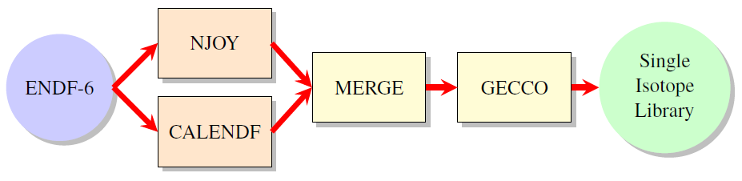
FIG. 1. ECCOLIB single isotope step processing scheme.

Treatment of errors and inconsistencies
The process for generating ECCOLIB-formatted libraries was fully automated, but considerations on single isotopes cannot be completely avoided. In fact, on rare occasions, inconsistencies or non-physical results can occur, mainly due to the questionable content of some evaluations (for example ⁴⁶Ti in the JEFF 3.1 evaluation has negative elastic cross-section at high energy already in the tape) or for the presence of very sharp resonance dips leading to negative cross-sections, as near an abrupt change of sign in the cross-section derivative. In these cases, different CALENDF options can be used for solving the problem, or negative partial cross-sections can be forced to a default (very small) positive value. For settling and better grasping the nature of the error or inconsistency, the Java-based nuclear information software (JANIS) [10] was extensively used for accessing the chosen nuclear database, identifying the nuclide of interest, and displaying (graphically) its properties.

ENDF/B-VIII.0 based library generation
The correctness of the described process was initially tested by application to the JEFF-3.1 evaluations, and the resulting library used for performing cell and core calculations whose results were compared with those obtained with the same library, as distributed with the official ERANOS release. The optimal agreement found between them provided the aimed evidence for a verification claim.
Once checked, the library generation process was thus applied to the ENDF/B-VIII.0 library, so to build a new reference ECCOLIB library using state-of-the-art evaluations. In this case, the NJOY-99.90 version used for verification purposes, was substituted by the latest NJOY-2016 one, which has also more advanced covariance treatment capabilities. Initially, 446 isotopes were treated at 172 energy groups, and processed at three (293.6 K, 573.6 K, 973.6 K) different temperatures, while other 110 isotopes, treated at 1968 groups, were processed also at 1473.6 K, and 2973.6 K. The Legendre expansion orders for the scattering terms were P3 and P1 for the 172 and 1968 groups, respectively. Running the process, some isotopes, namely ⁴⁰Ca, ⁵⁴Fe, ⁵⁷Fe, ⁶³Cu, ⁶⁵Cu, ¹⁸²W, ¹⁸³W, ¹⁸⁴W and ¹⁸⁶W appeared to be not treatable at 1968 groups due to some limitations in CALENDF capabilities in treating the resolved resonance region by the general R-matrix formalism, and then were treated at 172 energy groups, making the 1968 groups list reduced to 101 elements.
Other inconsistencies, due to negative cross sections found in some energy groups, arose for ²³⁹Np, ⁴²Ca, ⁵⁶Fe, ⁵⁸Ni, ²⁴⁴Cm, ⁴⁶Ca, and ²³²U: they were solved modifying some parameters of the CALENDF code, as the reconstruction precision, or neglecting CALENDF evaluations from the latter, preferring instead the NJOY ones. After solving these issues, 33, 172 and 1968 groups libraries were successfully generated in the format suitable for ERANOS.

Covariance matrix generation
In order to build multigroup (using the same 80 groups energy structure introduced in Section 2) covariance matrices, data must be extracted from the original tapes, and then appropriately converted for all the available isotopes and reactions in a format useful for ERANOS, the so-called AMARA format (from the name of the ENEA’s code for library adjustment, see Section 4). The procedure used for generating such matrices is illustrated in Fig. 2, from which it clearly appears the two-steps nature of the process: the first step tackling the conversion from the detailed description contained in the ENDF-6 tapes to the required group-wise one (performed by the ERRORR and COVR modules of the NJOY code [11]), the second one based on a dedicated Python script which post-processes the information on uncertainties reformatting them in the right ERANOS-usable format.

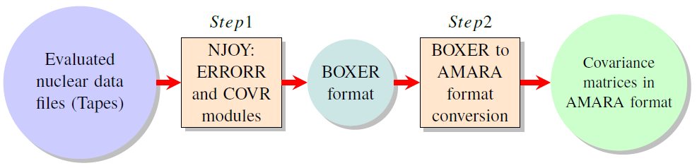
FIG. 2. Basic scheme of the process used for generating covariance matrices in AMARA format starting from nuclear data evaluations.

ENDF/B-VIII.0 based covariance generation
The process described in the previous section was applied for generating a covariance matrix from the ENDF/B-VIII.0 evaluation [12] used in the paper in all the uncertainty analyses performed for adjustment purposes. In line with the process already described, file 31 (MF=31) and file 33 (MF=33) of the original tapes, containing covariances for reaction cross-sections and $\overline{ν}$, respectively, were processed by NJOY at a temperature of 293.6 K. The process was applied only to isotopes most relevant from the neutronic point of view. In calculating covariances, some isotopes needed a special treatment: in particular, the isotopes not having covariances for reaction cross-sections (more than thirty, such as ⁶³Cu, ⁶⁴Cu, ⁵⁴Cr) were excluded, and those, as ²³⁴U, which showed covariances only for MT=456 (prompt fission neutrons), but not for MT=452 (total number of fission neutrons), included by assuming prompt neutron covariances as representative of the total ones.

SELECTION OF ISOTOPES FOR THE ADJUSTMENT PROCESS
The ENDF/B-VIII.0-based library and its associated covariance matrix obtained in the format useful for ERANOS by the processes described in the previous sections, were used for performing a complete S/U analysis of the main safety-relevant parameters of the ALFRED reactor. The effective multiplication factor, the coolant density and the fuel Doppler effects, the protection system worth and the effective delayed neutrons fraction were evaluated and the associated S/U results collected [5] to outline what are the most important isotope-reaction couples, with the aim of reducing the number of isotopes to handle, which could be particularly high for the most recent libraries containing more than 500 isotopes. Isotope-reaction contributions to sensitivity, as obtained by the performed S/U analysis, were sorted in descending order of magnitude, and contributions lower than an arbitrary value of 0.01 were excluded, while uncertainty-wise, only contributions higher than 1/100 of the maximum were taken into consideration in the final list of isotopes. In addition, the isotopes deemed fundamental for the set of experiments representative of ALFRED (see below) were considered; the example of Sodium is emblematic in this sense. From all the above, a final list of 37 isotopes, reported in Table 1, was considered for the adjustment algorithm, as explained hereafter.

TABLE 1. ISOTOPES SELECTED FOR LIBRARY ADJUSTMENT

¹⁰B | ¹¹B | ¹²C | ¹⁶O | ²³Na | ²⁷Al | ²⁸Si | ⁵⁰Cr | ⁵²Cr | ⁵³Cr
⁵⁵Mn | ⁵⁶Fe | ⁵⁸Ni | ⁶⁰Ni | ⁹⁰Zr | ⁹¹Zr | ⁹²Zr | ⁹²Mo | ⁹⁴Zr | ⁹⁴Mo
⁹⁵Mo | ⁹⁶Mo | ⁹⁷Mo | ⁹⁸Mo | ¹⁰⁰Mo | ²⁰⁴Pb | ²⁰⁶Pb | ²⁰⁷Pb | ²⁰⁸Pb | ²³⁵U
²³⁸Pu | ²³⁸U | ²³⁹Pu | ²⁴⁰Pu | ²⁴¹Pu | ²⁴¹Am | ²⁴²Pu | - | - | -

SELECTION OF THE DATABASE OF FACILITIES
Experiments representative of the ALFRED core, in terms of spectrum and core characteristics, are required by the adjustment algorithm to improve calculation accuracy. Their selection started considering existing real case experiments from critical facilities operated in the past, which are included in the IRPhE database [13]. Initially, to avoid the huge modelling effort required for evaluating the representativeness of each configuration, a preliminary selection among them was performed by means of a sort of heuristic (qualitative), but physically driven, approach comparing the characteristics (e.g., the presence of symmetries, or moderating or fertile materials, the spectrum profile, etc.) of the facilities and using them as guiding criteria for the screening. The need to spread out measurements so to avoid as much as possible correlation between experiments (not currently handled by the adjustment algorithm) was another criterion of the selection process.
Table 2 summarizes the selected database of facilities specifying, for each of them, what are the integral observables considered in the adjustment process. After the completion of the heuristic screening, 20 facilities were selected and, for each of them, a detailed ERANOS model was therefore set up in the 2D cylindrical approximation and a further sensitivity and uncertainty analysis carried out. For the selected facilities, the so-called representativeness coefficient was used to quantify the content of shared information with the reference reactor. In practice, the coefficient takes values ranging from zero (no correlation) to one (maximum correlation): so, a minimum value of around 0.5 is typically deemed necessary for claiming representativeness [14]. In theory, representativeness analysis should be performed for every integral parameter for each facility, to have a representativeness coefficient matching every observable. However, in the paper, the representativeness coefficient was evaluated only in relation to the effective multiplication factor (k_{eff}). Almost all the facilities have high values of the representativeness coefficient, as high as 9.45∙10⁻¹ or 8.89∙10⁻¹ for the ZPPR-005(10B) and ZPPR-010(12) facilities, respectively. The worst value of the representativeness coefficient (1.27∙10⁻¹) was found for the BFS-73-1 reactor configuration; nevertheless, it is still included in the selected database since it acts to strengthen the adjustment by performing a sort of further internal consistency check, when the adjustment algorithm is recursively applied.

TABLE 2. RESULTS OF THE PRELIMINARY DATABASE SELECTION

Facilities | $$k_{eff}$$ | spectral index | reaction rate | isotopic worth | $$β_{eff}$$ | FA worth | CR worth | temp. coeff. | void coeff.
BFS-73-1 |  | ü |  | ü | ü
BFS-61-0 | ü | ü | ü
BFS-61-1 |  | ü
BFS-61-2 |  |  | ü
BFS-62-3A |  | ü |  |  |  |  | ü
FFTF | ü |  |  |  |  |  | ü | ü
JOYO-64-FA | ü |  |  |  |  | ü |  | ü
JOYO-70-FA | ü |  |  |  |  | ü |  | ü
SNEAK(7B) | ü | ü | ü | ü | ü
ZEBRA-001(25) | ü |  |  |  |  |  |  |  | ü
ZPPR-001(10A) | ü |  | ü |  |  |  | ü |  | ü
ZPPR002(9) |  |  |  |  |  |  |  | ü
ZPPR-005(10B) | ü | ü |  |  |  |  | ü |  | ü
ZPPR-006(10C) |  |  |  |  |  |  | ü
ZPPR-010(12) | ü |  |  |  |  |  |  |  | ü
ZPPR-011(2) | ü |  |  |  |  |  |  |  | ü
ZPR-001(6a7_1) |  | ü | ü |  |  |  |  |  | ü
ZPR-002(6a7_2) | ü |  | ü |  |  |  | ü |  | ü
ZPR-003(3a48B) | ü
ZPR-004(3a56B) | ü

the AMARA+ CODE
The results obtained performing the S/U analysis on the selected database of facilities were used for ENDF/B-VIII.0 library adjustment. The so-called analytical approach was followed, tailoring the cross-sections set via Bayesian methods and the generalized least square technique which must be applied to a Gaussian distributed likelihood function targeted for the combined set of differential and integral data [15]. The latter assumes the following form:
$χ^{2}={\left(T-T_{0}\right)}^{T}C_{T}^{-1}\left(T-T_{0}\right)+{\left(R_{E}-R_{C}\right)}^{T}V_{R}^{-1}\left(R_{E}-R_{C}\right)$ ,
where $T_{0}$ and $T$ are the original and to be optimized multi-group cross-sections sets, $R_{E}$ and $R_{C}$ the measured and calculated values of the considered integral experiments and $C_{T}$ and $V_{R}$ the covariance matrices of $T_{0}$ and of the (E-C) discrepancy, respectively, the latter thus including modelling covariance information when appropriate. In this work, this contribution due to correlations among experiments which are scarcely found in the experiments reports and must be eventually estimated from the experimental information available, were supposed to be null. Furthermore, the minimization problem is constrained by the requirement of small variations of $T$ from the initial cross-sections set ($T_{0}$) so to enforce physical and statistical soundness on the solution.
The analytical approach just described is implemented in the algorithm of the adjustment code named AMARA [16]. Based on this, an updated and extended version of the code, named AMARA+, came to light. AMARA+ introduces some innovations with respect to the old code since it can use libraries and covariances generated from any nuclear data evaluation and implements a statistical test for checking the validity and consistency of the performed adjustment. The statistical coherence of the set of data used was improved disregarding any element of the original set which would scatter, and not focus, the physical information required for an optimized adjustment. The objective function to minimize, is no other than the classical $χ^{2}$ variable, which obeys the so-called Chi-squared distribution Under the null hypothesis of consistency (i.e., all posterior C/E equalling unity), a sound adjustment should target, with a $3σ$ confidence interval, a $χ^{2}$ around the M (i.e., the number of degrees of freedom in the adjustment) meanIf this condition is not respected, an in-depth analysis is opportune to identify the (major) contributors to possible deviations from unity of ${χ^{2}}/M$. When this is the case, for obtaining a more effective adjustment, it should be noted that the objective function can be thought as the sum of three different contributions:
$χ^{2}=χ_{mac}^{2}+χ_{mic}^{2}+E$, | (1)
where $χ_{mac}^{2}$ and $χ_{mic}^{2}$ are the contributions from the integral parameter’s predictions, and microscopic cross-sections adjustment, respectively, while $E$ is the complementary part of the first two terms, regarding all contributions due to correlations among experiments. The $χ^{2}$ can then be re-evaluated, eliminating the integral experiment which determines the greatest value, aiming at optimizing the Chi-squared response. The elimination process can therefore be recursively applied to determine the best set of data for Chi-squared optimization. However, to further ensure adjustment consistency, satisfying the distribution condition alone is not sufficient for claiming statistical soundness, so that a check on the effect of the process on the cross-sections contribution must also be added. This further check aims at ensuring that a stable set of adjusted cross-sections is identified, meaning that when adding (or removing) a particular experiment to it, the predicted corrections show minimal changes, further increasing the confidence in the consistency among experiments. In this case, an iteration accuracy must be given; and in this work it was taken as 5%.
AMARA+ also implements enhanced input capabilities to manage all quantities requested for any generic problem (e.g., sensitivities and uncertainties), flexibly allowing any user-defined selection of integral experiments to include in the representative database.

ANALYSIS OF THE ENDF/B-VIII.0 ADJUSTMENT
All the data used as input by the AMARA+ code initially included 20 facilities and 73 different experiments for different integral quantities such as the effective multiplication factor, a number of spectral indices as f28/f25, f49/f25, etc., taken from the IRPhE database, with the aim of calculating relative corrections for the initial nuclear data evaluations having the ALFRED core as reference. The code was iteratively launched until the stability condition of the Chi-squared test was satisfied, finally obtaining an optimized and coherent set of integral parameters and adjusted cross-sections for the selected 37 isotopes after 16 iterations. shows the Chi-squared evolution as a function of the number of experiments (M), along with the evolution of the contribution of nuclear data ($χ_{r, mic}^{2}$). All the quantities are normalized to M.

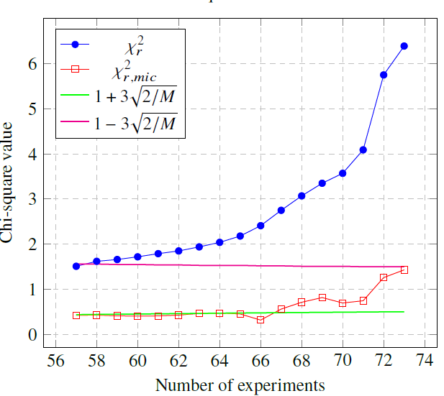
FIG. 3. Evolution of the Chi-squares as a function of the number of retained experiments.

Among the rejected experiments, f40/f49, f48/f49, and c28/f25 spectral indices for BFS-61-1, which had one of the highest values of the representativeness coefficient, were found. This probably stems from the too large adjustments which would have been necessary to reduce the C/E within the small experimental uncertainty. Concerning the c28/f25 index, incoherence with information coming from other experiments was supposed to be the principal cause of the rejection. Information about the denominators however were not completely lost, since they could be retrieved anyway from other different experiments. As another example, the rejected experiments at the BFS-73-1 facility can be measured also in other facilities (e.g., SNEAK7B, BFS-62-3A and ZPPR-005(10B)), so their rejection has a minor impact on the adjustment strength. On the contrary, when some experiments (as for f48/f49 of BFS-61-1) have been measured only in a certain facility, an impact on the adjustment must be expected since the information coming from those experiments cannot be included in a different way.
Measurements of the Sodium void worth were also rejected for ZPPR-010(12), ZPPR-011(2) and ZPR-001(6a-7_2), so reducing the adjustment contribution due to this type of measurement. However, their impact is marginal given the several other $Δρ\left(Na\right)$ measurements still present in the database. It is also worth noticing that, for both the configurations (64FA, and 70FA) of the JOYO facility (which is one of the few power reactors present in the database), $k_{eff}$ values were also rejected by the adjustment algorithm. The motivation is again believed to be linked to the high initial discrepancy (greater than 1.350∙10⁻²) in relation to AMARA+ possibilities of adjustment (a nuclear data-related uncertainty of about 6.80∙10⁻³) and to some degree of incoherence of information.
The final set of retained facilities reduced ${χ^{2}}/M$ from its prior (to the adjustment process) value of 2.93∙10¹ to 1.51∙10⁰, clearly showing the significant improvement in the predictive capabilities of the cross-sections set brought about by the adjustment process in tandem with the Chi-squared test. Comparing the C/E values for each integral parameter before (prior) and after (posterior) adjustment, it is satisfactorily seen that, after adjustment, C/E values stay close to unity within two standard deviations of the experimental uncertainty, as shown in Fig. 4.

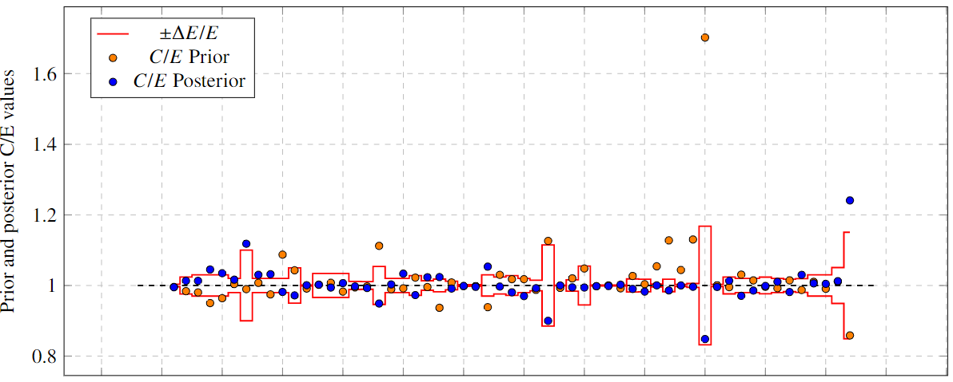
FIG. 4. Prior and posterior C/E values.

Global considerations
AMARA+ uses the selected database of facilities to predict corrections which need to be applied to the original library for obtaining the corresponding adjusted one. A first verification of the adequateness of the corrections was performed, confirming that the majority of isotopes have corrections below 1$σ$, and significant corrections (within two standard deviations) are obtained only for the capture and elastic reactions of ²³⁸U (in the energy range 50-500 keV). Lower magnitude (1.5$σ$) corrections are found for elastic, capture cross sections and $ν$ of ²⁴⁰Pu. Minor corrections also occur for other isotopes and are found to be in the range 1.1-1.2$σ$ for the fission and inelastic reactions of ²³⁸U, and the inelastic reactions of ⁵⁶Fe.
The results were compared, wherever possible, with some recent experimental determinations performed at the CERN n_TOF facility [17]. In particular, data for capture reaction of ²⁴²Pu and fission of ²³⁵U were used to provide an additional support to the adjustment hints obtained in the work.

Single isotopes considerations
AMARA+ allowed to point out all the isotope-reaction couples and the energy intervals for which major corrections are needed to minimize discrepancies on the C/E values. It is worth mentioning that, in the ensuing sections, a brief summary of the results for the most relevant isotopes for ALFRED is presented.

Uranium isotopes
Among the most remarkable results, as shown in Fig. 5, the relative correction for ²³⁸U fission gravitates around -1.5∙10⁻² in the energy range above the threshold (i.e., around 1 MeV). Regarding capture for the same isotope, the relative corrections are significant, especially in the above-resonance region, suggesting that ²³⁸U capture needs further evaluations. In the case of the average secondary fission neutrons corrections are extremely small, suggesting that no significant deviations are therefore predicted for this parameter.

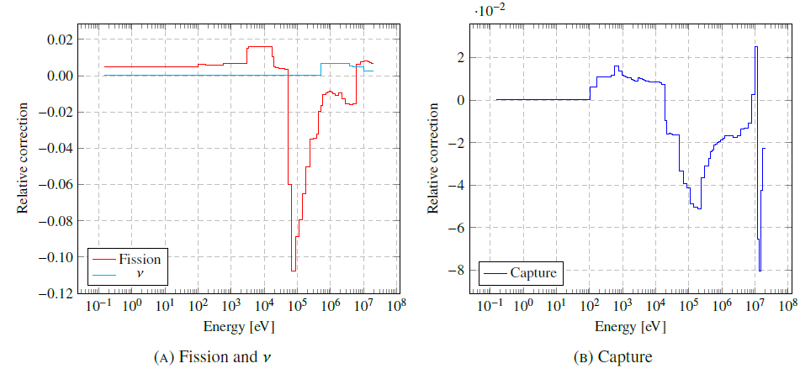
FIG. 5. Relative corrections predicted for ²³⁸U.

For ²³⁵U instead (see Fig. 6), the relative correction to the fission cross-section shows a plateau where values are quite constant, which is followed, just at the beginning of the unresolved resonance region, by a drop towards negative values, between 1 keV and about 20 keV, to then show a sudden increase up to about 1.3∙10⁻². The correction is positive over the full energy range, suggesting that the reference nuclear data are underestimated. In this case AMARA+ predictions are quite in agreement with the n_TOF findings, even if further investigations will be anyway needed to strengthen the adjustment grounds relative to the state-of-art differential measurements.
Regarding capture, the relative correction values are very close to zero up to 2 keV; then, at the beginning of the unresolved resonance region, they become negative. The correction for $ν$ is positive over the full energy range, suggesting that the original evaluation is systematically underestimated, and with major values found to be 1.5∙10⁻¹ in the region between 1 keV and 10 keV.
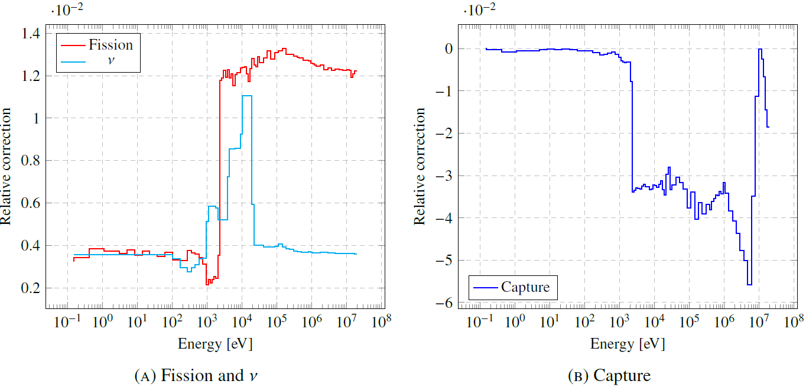
FIG. 6. Relative corrections predicted for ²³⁵U.

Plutonium isotopes
Corrections for ²³⁸Pu are always positive over the full energy range and extremely small, the highest value occurring around 1 MeV as expected, given the considerations relative to the exclusion, via the Chi-squared test, of the f48/f49 spectral index. Regarding capture, the correction profile sinks towards negative values, with a minimum positioned around 3-6 MeV. Moreover, $ν$ corrections are predicted to be always positive, albeit extremely small, with a maximum placed, similarly to the capture cross-sections, around 3-6 MeV.
²³⁹Pu fission (see Fig. 7) shows relative corrections ranging from values close to zero up to ~-5∙10⁻³ from thermal energies up to about 1 keV while, just after the resolved resonance region, a change in sign occurs and the relative corrections become positive, rising to about ~5∙10⁻³. Significant positive (about 10%) corrections occur for the capture reaction of ²³⁹Pu, mainly in the energy window between 5 and 10 keV. In this case, $ν$ corrections are slightly positive again over the full energy range, suggesting that $ν$ is always underestimated in the original nuclear data evaluation.
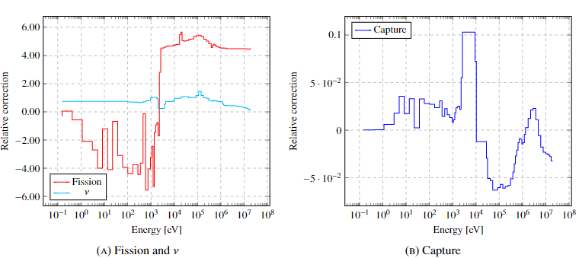
FIG. 7. Relative corrections predicted for ²³⁹Pu.

Lead isotopes
Lead isotopes show very similar profiles in their relative corrections both for the elastic and inelastic reactions (see Fig. 8). In the first case, the relative corrections profile is close to zero in the lower part of the energy range while, at higher energy, it sinks attaining not negligible negative values (~ 3- 4%). For inelastic reactions, the predicted corrections are always positive, suggesting a systematic underestimation in the ENDF/B-VIII.0, and of the order of few percent, in the upper part of the energy range.

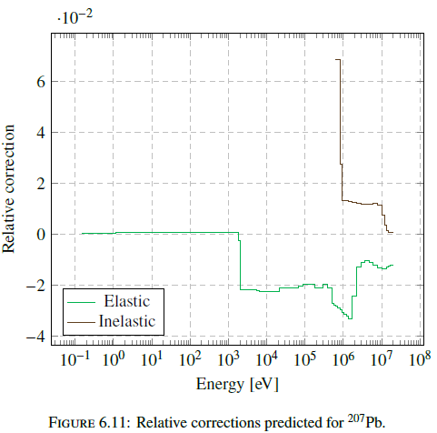
FIG. 8. Relative corrections predicted for ²⁰⁷Pb.

CONCLUSIONs
All the validation activities, inherently performed throughout the adjustment process, can be used to retrieve relevant information for the certification of the uncertainties affecting every calculated integral parameter of the ALFRED core, so strengthening the confidence in their estimates when verifying the compliance with the requirements imposed by the safety authority. Moreover, these results are also essential for leading the evaluation experts in updating the High Priority Request List (HPRL) of isotopes to draw the most appropriate strategy for planning new differential measurements, nuclear model refinements and data evaluation programs, ensuring the best possible accuracy, according to a policy more focused on safety and sustainability. This is also one of the main tasks of the Sub-group 46 of the OECD’s Nuclear Energy Agency [18], within whose scope part of this work directly falls. A further improvement of the AMARA+ code is underway, to allow a more refined adjustment that will be subsequently extensively tested for its validation by application to additional integral experiments not used in the adjustment. At the conclusion, it will be possible to obtain a nuclear data library by using a deconvolution algorithm spreading the relative corrections over the 1968 groups grid requested by ERANOS, for practical use for the ALFRED reactor.
References
- PALMIOTTI, G., SALVATORES, M., The role of experiments and of sensitivity analysis in simulation validation strategies with emphasis on reactor physics, Ann. Nucl. Energy 52 (2013) 10–21.
- GRASSO, G. et al., “An improved design for the ALFRED core”, International Congress on Advances in Nuclear Power Plants ICAPP 2019 (Proc. Int. Conf., Juan-les-pins, 2019) .
- FALCON,
http://www.alfred-reactor.eu/index.php/falcon-2/
- RIMPAULT, G. et al., “The ERANOS code and data system for fast reactor neutronics analyses”, International Conference on the New Frontiers of Nuclear Technology: Reactor Physics, Safety and High-Performance Computing PHYSOR 2002 (Proc. Int. Conf., Seoul, 2002).
- CASTELLUCCIO, D.M. et al., “ENDF/B-VIII.0 nuclear data sensitivity and uncertainty analysis (S/U) of key safety-relevant reactivity coefficients for the ALFRED core”, INTERNATIONAL CONFERENCE ON FAST REACTORS AND RELATED FUEL CYCLES: SUSTAINABLE CLEAN ENERGY FOR THE FUTURE FR22 (Proc. Int. Conf., Beijing, 2022), IAEA, Vienna (2022), Poster CN291-421.
- SUBLET, J.C. et al., ECCOLIB-JEFF3.1 LIBRARIES. Rapport, CEA, Paris, 2006.
- MACFARLANE, R.E., BOICOURT, R.M., NJOY: a neutron and photon processing system, Trans. Am. Nucl. Soc. 22, 720 (1975).
- SUBLET, J.C. et al., CALENDF-2010: User Manual, internal report, CEA, Paris, 2011.
- LEVITT L.B., THE PROBABILITY TABLE METHOD FOR TREATING UNRESOLVED NEUTRON RESONANCES IN MONTE CARLO CALCULATIONS, Technical Report, Nuclear Science and Engineering, Vol. 49, Issue 4, (1972).
- SOPPERA N., BOSSANT M., DUPONT E., JANIS 4: An Improved Version of the NEA Java-based Nuclear Data Information System, Nucl. Data Sheets 120 (2014) 294–296.
- OSTI.GOV-THE NJOY NUCLEAR DATA PROCESSING SYSTEM, VERSION 2016,
https://www.osti.gov/biblio/1338791
- ENDF/B-VIII.0 EVALUATED NUCLEAR DATA LIBRARY
https://www.nndc.bnl.gov/endf/b8.0/
- OECD/NEA, INTERNATIONAL REACTOR PHYSICS EXPERIMENTS DATABASE PROJECT (IRPHE), International Handbook of Evaluated Reactor Physics Benchmark Experiments, (2004).
- B. RATNER. The correlation coefficient: Its values range between +1/−1, or do they? J. target. meas. anal. mark. 17, pages139-142 (2009).
- OECD/NEA, Methods and Issues for the Combined Use of Integral Experiments and Covariance Data. OECD NEA/WPEC-33 report, Paris, (2013).
- GANDINI A., PETILLI M. AMARA: A CODE USING THE LAGRANGE MULTIPLIERS METHODS OF NUCLEAR DATA ADJUSTMENT, Rapporto Tecnico, RT/FI (73)39, CNEN, Rome, 1973.
- N_TOF, The neutron time-of-flight facility (n_TOF) studies neutron-nucleus interactions for neutron energies ranging from a few meV to several GeV,
https://home.cern/science/experiments/ntof .
- EFFICIENT AND EFFECTIVE USE OF INTEGRAL EXPERIMENTS FOR NUCLEAR DATA VALIDATION WPEC SUBGROUP 46 (SG46),
https://www.oecd-nea.org/download/wpec/sg46/

For completeness, other modules like RECONR and BROADR have been used, but since their presence and purpose is common to almost any standard utilization of NJOY, their detailed description is omitted in this context.

