# COMPUTATIONAL studies of ADVANTAGES OF LEAD-COOLED FAST REACTOR CORE

A.V. MOISEEV, A.P. ZHIRNOV, V.K. DAVYDOV, A.V. BALOVNEV,

K.M. KALUGINA, A.N. IVANYUTA, E.O. SOLDATOV

JSC NIKIET, Moscow, Russian Federation

Email contact of corresponding author: a.moiseev@nikiet.ru

**Abstract**

Concept of the BREST reactor with lead coolant and dense heat-conductive nitride fuel envisages the development of an equilibrium core with complete breeding of fissionable nuclides in the core (core breeding ratio of ~ 1) without a blanket compensating for reactivity reduction due to fuel burnup and fission-product buildup. This makes it possible to operate the reactor in the period between two regular refuelings with low reactivity margin (< βeff). At the same time, efficient utilization of uranium is provided by means of conversion of 238U to 239Pu in the fast reactor spectrum and a possibility of transmutation of the produced minor actinides during the reactor operation in the closed nuclear fuel cycle mode.

To carry out computational studies of the BREST reactor core, a design code system is used, which includes the FACT-BR diffusion software system, the MCU-BR software tool based on the Monte-Carlo method, and the IVIS-BR thermophysical module.

During the computational analysis, impact of technological tolerances on Keff and reactivity margin was evaluated. Maximum deviation of each manufacturing parameter was conservatively considered, including the most significant ones: plutonium mass fraction, fuel mass, nitrogen content. Feasibility of low reactivity margin during rated reactor operation   
(~ 0.54 βeff) was demonstrated even for the initial period of operation given the compensation of methodology, constant and manufacturing uncertainties by technical measures taken at the first criticality stage. Fuel and absorber burn-up, power distribution in the core, reactivity effects were calculated. CPS working member shutdown systems are sufficiently worth to ensure reactor transition into a subcritical state and to keep it subcritical in accordance with the regulatory requirements.

The developed and validated design code system, the results obtained in computational studies may be used to support design solutions for the BREST-OD-300 reactor and commercial lead-cooled fast reactors.

## INTRODUCTION

Presently, a project is being implemented in Russia to create the BREST-OD-300 reactor as an experimental demonstration prototype of basic commercial reactor plants of nuclear power industry in the future. One of the main tasks of the project is to demonstrate not only the expected physical and operational characteristics, the intrinsic safety of the BREST reactor [1], but also its ability to operate in a closed nuclear fuel cycle mode with an equilibrium core and a fuel breeding ratio close to 1. The power unit is supposed to be operated as part of the Pilot-Demonstration Energy Complex (PDEC) with an on-site closed nuclear fuel cycle arrangement. Plutonium separated from VVER SNF is proposed for initial fuel. After the initial period of operation, the BREST-OD-300 core operates in a steady-state mode with partial refuelings between micro campaigns under the conditions of a closed nuclear fuel cycle (CNFC). The proposed fuel for reloaded fuel assemblies is the regenerated fuel mix nitride (U-Pu-MA)N with the addition of depleted uranium and without feeding with external plutonium. Between refuelings, the core operates with a low reactivity margin (<βeff). For the most efficient power generation, the BREST reactor must demonstrate high operational performance without exceeding the limit values for the temperature of core components, fuel burnup, and damaging radiation dose. The neutronic characteristics shall meet the regulatory requirements established for operating NPPs.

To solve such a complex new task, specialized computational tools are necessary. For this purpose, a design code system [2-3] was developed that includes the FACT-BR diffusion software system, the MCU-BR high-precision software tool based on the Monte-Carlo method, and the IVIS-BR thermophysics module. This paper describes the design code system and presents some results of computational studies carried out using this system.

## SOFTWARE TOOLS FOR NEUTRONIC CALCULATIONS

The FACT-BR software system is designed to calculate neutronics of fast reactors using diffusion approximation. To calculate a three-dimensional neutron-flux density field and power distribution, 26-group diffusion approximation is used in the program. Diffusion equations are solved either by the finite-difference method or by the nodal Askew-Takeda method. As a neutron data set, the CONSYST neutron cross-section preparation system with the BNAB-93 library is used. During calculations, changes in the nuclide composition of materials during the reactor campaign are taken into account.

When calculating core life using the FACT-BR software system, there are multiple possibilities for simulating the reactor fuel cycle. When simulating the operation of the reactor, refueling is carried out in batches of individual fuel assemblies. The software system implements the possibility of rearranging fuel assemblies in the core, unloading them into the in-vessel storage (IVS), unloading them to a storage facility after the hold time in IVS and loading new fuel assemblies with fresh fuel or fuel that has passed the refabrication stage. Three main fuel assembly unloading modes are provided:

* According to a specified refueling scheme;
* Upon reaching the specified maximum fuel burnup of FAs;
* Manual selection of FAs to be reloaded.

In the basic scenario, when simulating the fuel cycle of a lead-cooled fast reactor, it is assumed that the fuel is unloaded at the end of the micro campaign according to the maximum burnup. At the beginning of the micro campaign, the maximum burnup in all fuel assemblies in the core is estimated. Next, linear interpolation of the maximum burnup during the current micro campaign is carried out using the rate of reaching maximum burnup in the considered fuel assembly obtained in the previous micro campaign. If the maximum burnup in a fuel assembly exceeds the specified value, this fuel assembly is unloaded into IVS.

When estimating maximum fuel assembly burnup, fuel element-wise distribution is considered. Restoration of fuel element-wise burnup is carried out based on seven node points in the selected FA and six points in adjacent FAs using quadratic interpolation. To improve the accuracy of restoration of fuel element-wise power density and description of local FA characteristics such as frame tubes and CPS control member shroud, detailed calculation of typical FAs by means of the Monte-Carlo-based MCU-BR is used as a shape function.

The IVIS-BR thermal physics module is designed for numerical simulation of steady-state and transient modes in the primary circuit of a liquid metal-cooled reactor in normal operation conditions and in the event of their violation. The module calculates coolant flow, pressure and temperature in the analytic model elements. The reactor core is simulated as a system of parallel channels, each of which represents an FA with a shroud of zero thickness and width across flats equal to FA pitch. In the first approximation, the flow is distributed across the FA in proportion to the flow area. Then, during the iteration process, values of coolant flow through the FA are calculated from the condition of pressure drop equality. For the themophysical calculation, pre-calculated coolant flow through the cell and thermal power of the calculated section are used as input parameters. After determination of the average linear thermal load of the equivalent fuel element in this section, the calculation of the required temperatures for the average power of the fuel element is carried out. Then a similar calculation is carried out taking into account the power peaking factors and flow rate using the assembly cross-section. In this case, thermal expansion and radiation swelling of materials are considered. Thus, the maximum temperatures in the assembly in this section are estimated.

Neutronics core calculations and nuclear safety justification are carried out using the MCU-BR high-precision software system based on the Monte-Carlo method. The Russian software MCU-BR (developed by RSC Kurchatov Institute) is in many respects analogous to the MCNP software, which is used extensively all over the world. Analytical models of the MCU-BR code provide the most precise description of the geometry and composition of a core, reflectors and other components affecting neutronic characteristics of a reactor. In the calculations, the MDBBR50 cross-section library is used. In the process of the library preparation, the following files for estimated nuclear data were used: JENDL-4.0 (for 239Pu, 240Pu, 241Pu and lead isotopes), ENDF/B-VII.1 (for 235U, 238U, 56Fe), ROSFOND for other nuclides.

The MCU-BR software tool features the following capabilities:

* Simulation of steady-state reactor operation at different power levels;
* Simulation of reactor operation during nuclear fuel burnup;
* Description of neutron field behavior;
* Simulation of reactor operation in a partial refueling mode;
* Analytical simulation of a closed nuclear fuel cycle (CNFC));
* Calculation of isotopic composition change during burnup;
* Acquisition of fuel element-wise distribution of power density and burnup;
* Calculation of CPS control member efficiency and reactivity effects;
* Estimation of spatial distribution of neutron fluence and levels of radiation damage of structural materials during burnup;
* Simulation of photon transport using analog and non-analog (weighing) Monte-Carlo methods;
* Kinetics parameters (βeff, prompt-neutron lifetime).

The MCU-BR and FACT-BR software systems have been certified for calculations of a lead-cooled reactor with nitride fuel. Experimental results obtained with the BN-350, BN-600, JOYO reactors were used for validation. To verify neutronic characteristics of the lead-cooled reactor, extensive series of experiments with lead was carried out at the BFS test facility; at various times, assemblies 61, 64, 77, 85, 87, 95, 113 were created [4]. The last assembly of this series, BFS-113 (2015) with nitride, was a benchmark model of the BREST-OD-300 reactor core with a central insert, composition and spectral characteristics of which were close to those of the simulated reactor. At the moment, full-scale simulation of the BREST-OD-300 core using the BFS-2 large critical assembly is arranged. The analysis of earlier experiments using BFS [5] showed high accuracy of criticality calculation; the maximum discrepancy was 0.31 %. Besides MCU-BR validation using all of the available experiments, comparative calculations using various international libraries of constants were carried out, as well as cross-verification calculation tests (Table 1). Among them, calculations of international benchmark model of the RBEC-M reactor with uranium-plutonium nitride fuel and lead-bismuth alloy coolant were carried out. Currently, the estimated accuracy of the BREST reactor criticality calculation does not exceed 0.7 % Δk/k, however the calculation accuracy will be improved based on the results of validation of BREST-OD-300 itself during first criticality and power startup. Several reactor features can be measured and verified only with the use of the reactor facility itself (such as temperature and power coefficients of reactivity, neptunium reactivity effect, core breeding ratio).

TABLE 1. ESTIMATION OF BFS ASSEMBLY CALCULATION ERROR

|  |  |  |  |  |  |  |  |
| --- | --- | --- | --- | --- | --- | --- | --- |
| **Assembly** | **Experiment** | **C-E/E, %** | | | | | |
| **ROSFOND** | **ENDF/B-7.1** | **JEFF-3.2** | **JENDL-4.0** | **CENDL-3.1** | **MDBBR50** |
| **61-0 (Pu)** | 1.0003 | -0.14 | -0.30 | -0.35 | 0.31 | 0.28 | 0.23 |
| **61-1 (Pu)** | 1.0004 | -0.42 | -0.56 | -0.65 | 0.04 | -0.03 | -0.04 |
| **61-2 (Pu)** | 1.0004 | -0.43 | -0.50 | -0.56 | 0.03 | 0.00 | -0.08 |
| **77-1 (U-Pu)** | 1.0004 | 0.12 | -0.02 | 0.15 | -0.20 | 0.22 | 0.10 |
| **77-1a (U-Pu)** | 1.001 | 0.09 | -0.05 | 0.12 | -0.25 | 0.19 | 0.07 |
| **85-1 (U)** | 1.0007 | -0.18 | 0.00 | 0.47 | -0.34 | -0.66 | -0.24 |
| **85-2 (U)** | 1.0021 | -0.10 | 0.02 | 0.49 | -0.29 | -0.53 | -0.17 |
| **95-1 (U-Pu)** | 1.0004 | 0.25 | 0.02 | 0.12 | 0.09 | 0.38 | 0.31 |
| **95-2 (U-Pu)** | 1.0004 | 0.13 | -0.08 | -0.01 | 0.00 | 0.30 | 0.21 |
| **113-1A (U-Pu)** | 1.0006 | 0.16 | -0.11 | 0.03 | -0.03 | 0.24 | 0.19 |
| **113-1B (U-Pu)** | 1.0011 | 0.12 | -0.18 | -0.04 | -0.08 | 0.16 | 0.14 |
| **64-0** | 1.00040 | 0.16 | 0.18 | 0.01 | 0.05 | 0.04 | -0.07 |
| **64-1** | 1.00110 | 0.11 | 0.12 | 0.07 | 0.005 | 0.10 | 0.002 |
| **σ, %** |  | 0.23 | 0.25 | 0.34 | 0.19 | 0.32 | 0.18 |
| **max (C/E-1), %** |  | -0.43 | -0.56 | -0.65 | -0.34 | -0.66 | 0.31 |

IVIS-BR was validated based on the experiments in terms of reactor tests of mixed nitride fuel (MNUP) in the BN-600 reactor [6], as well as during joint calculations using the BERKUT code. Simulation of the experiments on the irradiation of the fuel elements with MNUP fuel as part of KETVS -1,2,3,6 in the BN-600 reactor was conducted to a maximum burnup of 5,46 % h.a. and a damaging dose of 62 dpa. The values of volumetric swelling of the MNUP fuel, the outer diameter of the fuel column, the fuel-cladding gap and the outer diameter of the fuel elements are obtained. Good agreement between calculation results and experiment was obtained. Maximum deviation of fuel diameter does not exceed 1 % for all experiments. Maximum deviation of the estimated fuel diameter change due to swelling does not exceed 9 %. Estimated systematic error of fuel cladding and fuel temperature distribution calculation is 1 K, coolant temperature – 8 %.

## simulation of brest initial loading

The core of the BREST-type lead-cooled fast reactor consists of hexagonal shroudless FAs and has two radial zones – a central zone (CZ) and a peripheral zone (PZ) (Fig. 1). Spacing and fastening of fuel rods in an FA is ensured by grids. Fuel composition, fuel element number and pitch in all FAs are the same. Flattening of power density, fuel peak temperatures and coolant heating across all FAs is ensured by radial shaping of fuel loading and lead flow rate by using smaller diameter fuel elements in CZ FAs and larger diameter fuel elements in PZ FAs. Stability of flattened distributions throughout the campaign is ensured by using the fuel of the same composition in all FAs under the condition of complete breeding of fissile nuclides in the core (core breeding ratio ~ 1). For the manufacture of uranium-plutonium nitride fuel for the initial loading, reactor-grade plutonium obtained from VVER SNF and held for 20-25 years to ensure decay of 241Pu to 241Am was selected. This composition was chosen due to its closeness to the composition of the equilibrium plutonium, which the reactor can reach in a closed nuclear fuel cycle. When the reactor operates in the closed nuclear fuel cycle, the process of fuel reprocessing will consist in separating the fission products and replacing them with an equivalent amount of depleted uranium.

|  |  |
| --- | --- |
| D:\Конференции\FR22\Картограмма.png  *FIG. 1. Constant reactivity compensators (CRC) arrangement on the core map  in the analytical model.* | *FIG. 2. Formation of the starting loading. The graph shows the possible region of reaching the first criticality.* |

In the initial loading fuel fabrication, deviations in geometric and mass characteristics of the fuel elements are possible within the specified tolerances. In the course of computational studies, the impact of manufacturing tolerances on Keff and reactivity margin was evaluated. The maximum deviation of each manufacturing parameter was conservatively assumed, including the most significant ones such as height and mass of the fuel column, plutonium mass fraction, nitrogen content, deviations of isotopic compositions, and the fuel element cladding tolerance. The estimation of the total error in determining Keff and the reactivity margin was 1.36%, including the calculation and the manufacturing components.

During analytical simulation, the fuel composition for the initial core loading was selected with compensation of excess reactivity of 1.36 % Δk/k taking into account possible manufacturing and calculation uncertainties. In the initial period of operation, the uncertainties are compensated by the fixed, immobilized constant reactivity compensators (CRC), which can only be removed when the reactor is shut down. A core layout with 9 CRCs was defined taking into account the requirement for power density field flattening across the core. The actual decision on the place and number of installed CRC will be made upon the first formation of the critical core loading taking into account the moment of achieving the first criticality (Fig. 2).

As a result, we can have the following outcome shown in Fig. 3, i.e. operation with low reactivity margin even in the initial period of operation. About 5 years later, after the core transition to the steady-state partial refueling mode, CRCs can be removed from the core. Further adjustment of the core criticality parameters and breeding ratio will be carried out by updating the fuel density and the mass fraction of plutonium in the reloaded FAs.

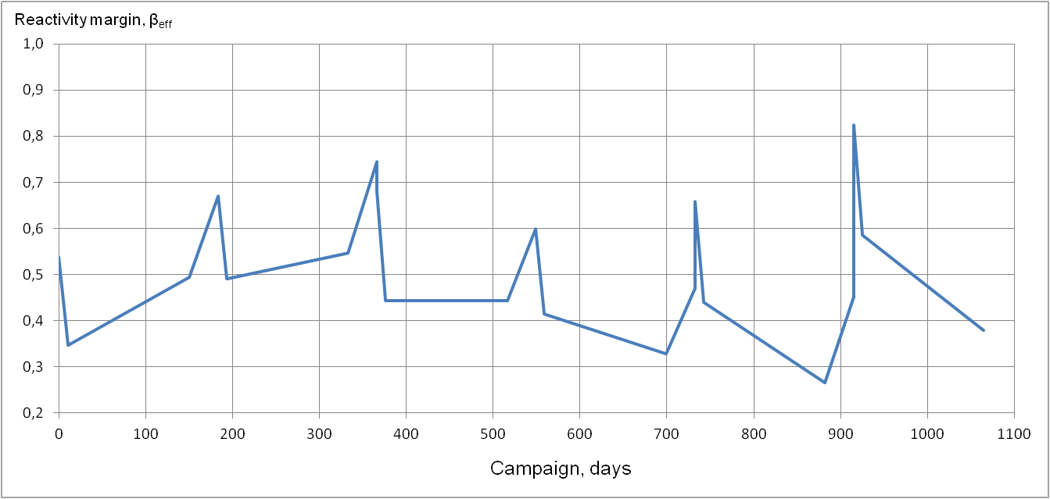

*FIG. 3. Reactivity margin of BREST-OD-300 when operated at rated power*

*(initial period of operation).*

It should be noted that the existing experience in calculating the criticality and the reactivity margin for the operating BN-600 reactor makes it possible to ensure the required accuracy at a level of 0.2 % Δk/k, and in many cases even 0.1% Δk/k [7]. But of course, this is only possible when the results of operational measurements performed at the reactor itself are taken into account, when considering the actual production characteristics of the manufactured fuel and absorber materials and using modern validated calculation codes, methods and databases.

## SIMULATION OF THE INITIAL OPERATION PERIOD AND TRANSITION TO STEADY-STATE OPERATION UNDER cnfc CONDITIONS

The selected level of electric and thermal power of 300 and 700 MW is close to the minimum, at which the characteristics of the BREST-OD-300 reactor core meet the condition of complete breeding of plutonium in the core (core breeding ratio ~ 1) and operation in an equilibrium mode with a low reactivity margin. The main operating mode of the core is the basic one (maintaining the specified reactor power); it also provides for operation at power levels in the range of 30 - 100% Nnom. When operating a core with a "zero" reactivity margin for fuel burnup during a micro campaign, all reactivity compensation (RC) control members and emergency protection (EP) control members are removed from the core. Only two pairs of automatic control (AC) members remain partially inserted, compensating for the neptunium effect of reactivity ~0.08 % Δk/k and small reactivity swings when isotopic composition of fuel in the core changes (Fig. 3). There is no need for the group consisting of all RC control members to participate in compensation of reactivity loss during fuel burnup, as it was required in the traditional fast reactors. In the BREST equilibrium reactor core, the function of RC control members is to compensate the temperature and power effect of reactivity; they are partially inserted into the core in the cold state at a minimum power. Also RC control members form the basis of the reactor shutdown system (EPR, emergency power reduction), which should independently from the other shutdown system (EP) ensure reactor transition into a subcritical state and keep it subcritical. The EPR and EP systems are sufficiently worth to perform this function taking into account the conservative superposition of computed uncertainties in accordance with the current safety standards.

Full duration of the first campaign is 900 effective days; it is separated into 6 micro campaigns of 150 effective days with shutdowns for 33 days. During the first six semiannual cycles after the startup, the reactor operates without partial refuelings but with shutdowns; then it operates with partial refuelings in 150 effective days. Reactor operation at rated power during the initial period takes into account limited maximum fuel burnup of 6 % h.a., later on, the justified phased transition will be made to reach the target design level of maximum mixed nitride fuel burnup of 10 % h.a. and a micro campaign of 300 effective days with a single shutdown for 65 days per year.

TABLE 2. ESTIMATED CHARACTERISTICS OF THE INITIAL PERIOD OF OPERATION

|  |  |
| --- | --- |
| Core characteristics | Value |
| Reactivity margin, βeff (with Np effect) | 0.54 |
| Core breeding ratio | 1.078 |
| Maximum FA power (CZ/PZ), MW | 6.04/4.38 |
| Maximum linear heat rate, W/cm (CZ/PZ FAs) | 406/341 |
| Worth of EP system, % Δk/k | 2.52 |
| Worth of the EPR shutdown system, % Δk/k | 4.47 |
| Temperature and power effect of reactivity, % Δk/k | - 0.576 |
| Effective fraction of delayed neutrons, % Δk/k | 0.357 |

The equilibrium BREST reactor core features unique stability of power density fields over a campaign – FA power changes slightly during the campaign regardless of fuel life and burnup (Fig. 4). This feature makes it possible to use radial-annular refueling pattern instead of the uniform ones, which have traditionally been used for fast reactors. The radial-annular refueling pattern provides maximum power generation for each FA. After each micro campaign, batch of FAs with approximately the same fuel burnup is unloaded from the core.

|  |  |
| --- | --- |
|  |  |
| 1. *FA power in the first micro campaign, MW* | 1. *FA power in the fourth micro campaign, MW* |
| *FIG. 4. Stability of neutron field and power density fields in the equilibrium core,*  *there is minor FA power change over a campaign.* | |

Refuelings are carried out as the fuel burnup gets close to the limiting value in each refueling batch. The spent FAs unloaded from the core are placed into IVS for decay heat drop for one micro campaign of 150 eff. days, after which the spent FAs are unloaded from the reactor. The further period of postreactor decay, SNF reprocessing and regenerated fuel fabrication is set equal to 3 years. During refabrication, fission products and curium are completely removed from the fuel. Americium and neptunium isotopes are retained in the fuel. To obtain the plutonium fraction specified based on the calculation results, depleted uranium is added to the purified fuel. The SNF reprocessing technology does not allow the extraction of fissile isotopes, which contributes to nonproliferation regime enhancement.

In contrast to reactor cores of the operating reactors, the BREST-OD-300 core does not require involvement of enriched uranium in the fuel cycle. The use of plutonium extracted from VVER SNF is required only for the initial loading and first feedings of the core operating in the uranium-plutonium-actinide closed nuclear cycle in the partial refueling mode. Involvement of reactor-grade plutonium in the fuel cycle ensures its utilization and reduces its storage costs. Slight excess of plutonium generation (average core breeding ratio ~1.05) makes up for neutron absorption by fission; in the BREST-OD-300 fuel cycle, U-238, which is the starter material for plutonium breeding, is virtually the only isotope to be burnt. The schematic diagram of the BREST’s closed nuclear fuel cycle (CNFC) is shown in Fig. 5.

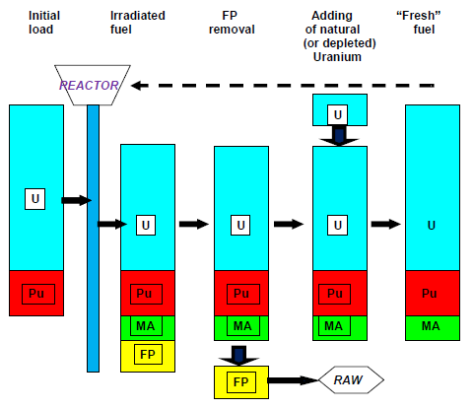

*FIG. 5. Schematic diagram of the BREST reactor closed nuclear fuel cycle.*

Using the system of design codes, the BREST-OD-300 reactor campaign was simulated for the entire service life of 30 years. The total campaign duration is 9000 effective days and it is broken down into 36 micro campaigns. The duration of micro campaigns ranges from 150 to 300 effective days with shutdowns for 33 to 65 days for refueling. Partial refuelings are carried out either with fresh fuel from the initial loading or with reprocessed fuel obtained by reprocessing the spent fuel unloaded from the reactor. During the reactor shutdown, the change in the isotopic composition of the fuel is taken into account [8]. The initial parameters of the core starting loading are given in Table 3.

TABLE 3. Initial parameters of the initial loading during core life simulation

|  |  |
| --- | --- |
| Parameter | Value |
| Fuel density, g/cm3 (20 ˚С) | 12.3 |
| Plutonium content in the mixture of uranium and plutonium isotopes, wt% | 13.6 |
| Full reactor loading, t | 20.8 |
| Uranium mass, t | 17.04 |
| Plutonium mass, t | 2.67 |

The reactor campaign during rated power operation is simulated taking into account the following restrictions:

* Maximum reactivity margin during rated power operation not exceeding 1 βeff;
* Maximum fuel burnup not exceeding 10 % h.a.;
* Maximum 10В absorber burnup in absorbers of RC/EP control members and CRC not exceeding 22 %;
* Maximum damaging dose in fuel claddings of 140 dpa.

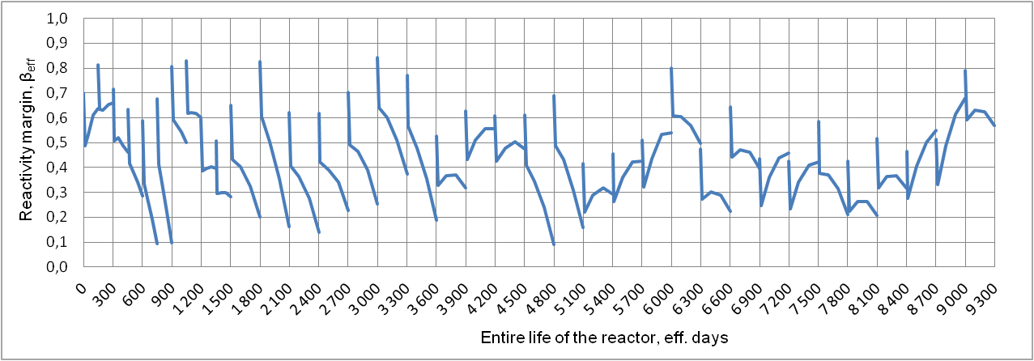

*FIG. 6. Reactivity margin change over the BREST-OD-300 campaign*

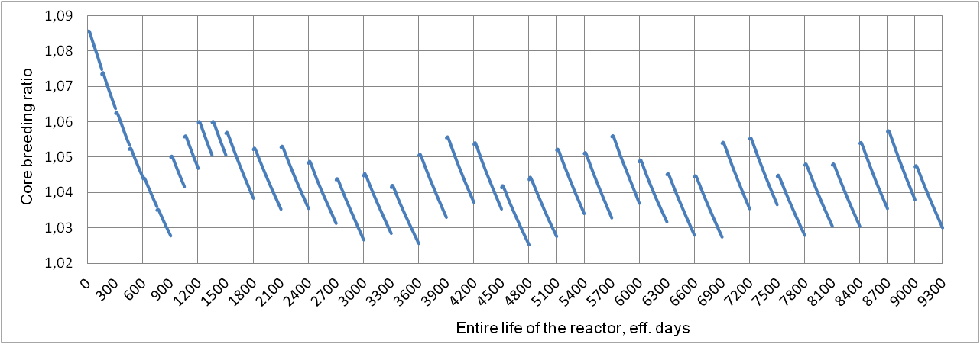

*FIG. 7. Core breeding ratio change over the BREST-OD-300 campaign.*

The reactivity margin change throughout life is adjusted by the number of reloaded FAs and characteristics of fresh loaded fuel. After each micro campaign, 18 to 36 FAs with a fuel density of 12.3-12.5 g/cm3 and plutonium mass fraction of 13.0-13.6 % are reloaded. At the initial stage preceding the closure of the nuclear fuel cycle, reactor-grade plutonium extracted from VVER SNF is used for fuel fabrication. Then, starting from the 10th micro campaign, the reactor’s own reprocessed fuel (after reprocessing the fuel from the first refueling) is used. Starting from the 12th micro campaign, the percentage of the loaded reprocessed fuel approaches 100%. The effective fraction of delayed neutrons is 0.00373. The maximum change in reactivity over all micro campaigns is about 0.6 βeff (Fig. 6), the core breeding ratio over a campaign ranges from 1.02 to 1.06 (Fig. 7). Thus, it has been shown that throughout the entire BREST-OD-300 service life (30 years), the core can be operated with a low reactivity margin and a breeding ratio slightly exceeding 1.

## capabilities of COMPUTATIONAL simulation of large commercial lead-cooled fast reactors

The developed and validated design code system, the experience of carrying out computational studies in support of the BREST-OD-300 design solutions make it possible to proceed to simulation of the commercial BREST-type lead-cooled fast reactors with an electric power of 1200 MW. When simulating the BR-1200 reactor, the same approaches are used, but there are also some peculiarities. Calculations of a large core with a significantly larger number of FAs (397 instead of 169) and higher fuel column (150 cm instead of 110 cm) are performed while ensuring as detailed as possible description of core components. A commercial reactor is characterized by a higher fuel burnup, a longer FA service life (damaging dose), a longer reactor service life, and, accordingly, the entire fuel life (60 years instead of 30); a higher neutron flux (5.7∙1015 1/(cm2∙s) instead of 3.5∙1015 1/(cm2∙s)) in the core. In a geometrically large extended core, it is necessary to pay more attention to flattening the power density fields and non-exceedance of the limiting temperatures of fuel claddings taking into account the shroudless design of FAs and the coolant flow control by fuel element diameters.

The core of BR-1200 uses shroudless FAs, the result of which is the fuel cladding peak temperature depending not only on the power output, but also on FA thermohydraulic parameters. Thus, the assessment of fuel peak cladding temperatures is a complex task and consists of coordinated neutronics and thermophysics calculations. However, the capabilities of the design code system make it possible to overcome these difficulties and perform calculations for the BREST-type commercial reactors. Here, it is possible to carry out both variable, engineering, search calculations, and high-precision calculations with the highest possible accuracy.

In BR-1200, the power density and coolant flow flattening along the core radius is achieved by dividing the FAs into three radial subzones – the central one (CZ), the middle one (MZ) and the peripheral one (PZ). Shaping is done based on fuel diameter variation. In the central part, the smaller diameter fuel element is used, whereas in MZ FAs and PZ FAs, the larger diameter fuel elements are used, with the fuel composition and density being the same in all FAs in the core. In this task, it is impossible to determine which zone has the highest peak temperatures without a complex calculation. The power density distribution was calculated using a diffusion neutronics module based on normalization of the total heat generation to rated thermal power in consideration for interactions of neutrons and photons with the reactor materials calculated using the MCU-BR software system (Fig. 8). According to the MCU-BR calculation, the power density in the core is ~ 98.3%.

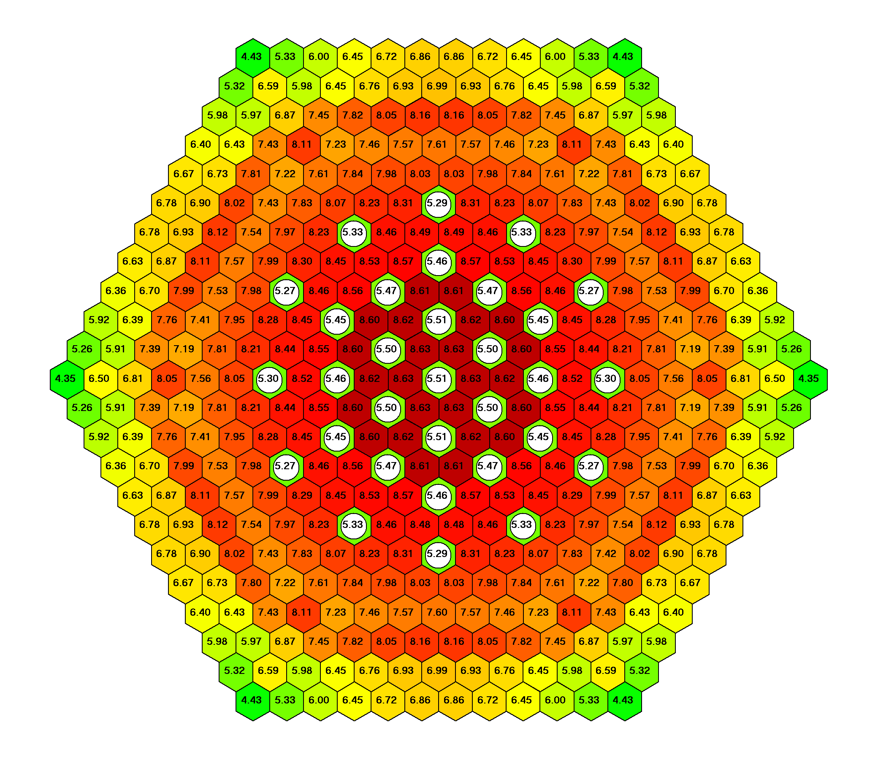

*FIG. 8. FA power distribution (calculated using FACT-BR), MW.*

Three-dimensional FA power distribution is transferred from the neutronics module to the thermophysics module to calculate thermal and physical characteristics. To adjust the power peaking factors in FAs during thermophysics calculations, the function of recovery of fuel element-wise power density implemented in FACT-BR is used. In contrast to BREST-OD-300, the presence of three shaping areas results in increasing fuel element-wise power peaking irregularity in FAs. The maximum fuel element-wise power irregularity (1.15) is seen in PZ FAs. The adjustment of fuel element-wise power peaking factor in FAs increases the accuracy of the fuel cladding peak temperature calculation.

During fuel burnup and refuelings, power density field redistributes to the central part of the core resulting in increasing fuel cladding peak temperatures. Flattening of power density shape at the moment of initial loading ensures cladding temperature margin that is sufficient for safe reactor operation during campaign.

## CONCLUSIONS

This paper presents the system of design codes used to carry out calculation studies of the BREST reactor core, which includes the FACT-BR diffusion software system, the MCU-BR software tool based on the Monte-Carlo method, and the IVIS-BR thermophysics module. The design codes have been validated and certified for calculations of the BREST-OD-300 reactor with lead coolant and nitride fuel.

The purpose of this work is to demonstrate some of the main design features of the BREST-OD-300 reactor plant, competitive indicators and positive aspects such as equilibrium core with complete breeding of fissionable nuclides without blanket, low reactivity margin, neutron field stability, transmutation of minor actinides, on-site CNFC. In computational studies, initial loading of the BREST reactor, initial period of operation, steady-state reactor operation in the closed nuclear fuel cycle conditions were simulated. It was demonstrated that the reactor operation with a low reactivity margin (< βeff) is possible at all operation stages including the initial operation stage in consideration for all manufacturing and calculation uncertainties. Fuel and absorber burn-up, power distribution in the core, reactivity effects were calculated. Features of an equilibrium core were demonstrated, as well as complete plutonium breeding with a core breeding ratio ~1, and stability of power density fields. CPS working member shutdown systems proved to be sufficiently worth to ensure reactor transition into a subcritical state and to keep it subcritical in accordance with the regulatory requirements for operating NPPs.

The developed and validated design code system, the experience of carrying out computational studies in support of the BREST-OD-300 reactor design solutions make it possible to proceed to simulation of the BREST-type commercial lead-cooled fast reactors.

References

1. ADAMOV YE.О., KAPLIENKO A.V., ORLOV V.V., SMIRNOV V.S., LOPATKIN A.V., LEMEKHOV V.V., MOISEEV A.V., “The BREST fast lead-cooled reactor: from concept to technology implementation”, Atomic energy (Atomnaya energiya). 2020. Vol. 129. Issue 4. P. 185-194. (in Russian).
2. BALOVNEV A.V., DAVIDOV V.K., ZHIRNOV A.P., et al., “System of codes for physical design of the lead-cooled fast reactor”, Problems of Atomic Science and Technology. Series: Nuclear and Reactor Constants. 2020, no 3, pp 30-38 (in Russian).
3. BALOVNEV A.V., DAVIDOV V.K., ZHIRNOV A.P. MOISEEV A.V., SOLDATOV E.O. “Simulating the fuel cycle of a lead-cooled fast reactor”, Nuclear energy and technology. 2022, no 8, pp 71-76.
4. DAVYDOV V.K., ZHIRNOV A.P., BUKOLOV S.N., KALUGINA K.M., YUFEREVA V.A. “Methodical uncertainty of precise criticality calculation for a lead-cooled fast reactor”, International Conference on Fast Reactors and Related Fuel Cycles: Next Generation Nuclear Systems for Sustainable Development (FR17) Yekaterinburg, Russian Federation 26 – 29 June 2017.
5. BOROVSKAYA ZH.V., ZHIRNOV A.P., KALUGINA K.M., MOISEEV A.V., ROZHDESTVENSKIY I.M., YUFEREVA V.A., “Verification of the MCU-BR software system based on the results of critical experiments using the BFS-2 facility”, Atomic energy (Atomnaya energiya). 2021. Vol. 130. No. 5, P. 243—249. (in Russian).
6. GRACHEV A.F., ZABUDKO L.M., ZVIR E.A., ZOZULYA D.V., IVANOV YU.A., KRYUKOV F.N., MOCHALOV YU.S., SKUPOV M.V. “Development of innovative fast reactor nitride fuel in Russian Federation: state-of-art”, International Conference on Fast Reactors and Related Fuel Cycles: Next Generation Nuclear Systems for Sustainable Development (FR17) Yekaterinburg, Russian Federation 26 – 29 June 2017.
7. MOISEEV A.V., KHOMYAKOV YU.S., SUROV S.V., “Experimental and calculating substantiation of reactivity balance and energy-release distribution in BN-600 core”, FR-13, Paris, France, March 4-7, 2013.
8. VASYUKHNO V.P., KOLMOGORTSEV A.V., MOISEEV A.V., et al., “Characteristics of the recycled fuel of the BREST-OD-300 reactor under various scenarios of closed nuclear fuel cycle”, Problems of Atomic Science and Technology. Series: Ensuring NPP Safety, 2016, no 36. pp. 22- 29 (in Russian).