# CFD Simulations on a hexagonal 61-pin

# wire-wrapped fuel bundle with

# STAR-CCM+ and comparison with

# experimental data

OCTAVIO BOVATI

Thermal Hydraulics Research Lab, Texas A&M University

College Station, Texas, United States of America

Email: octavio.bovati@tamu.edu

MUSTAFA ALPER YILDIZ

Thermal Hydraulics Research Lab, Texas A&M University

College Station, Texas, United States of America

YASSIN HASSAN

Thermal Hydraulics Research Lab, Texas A&M University

College Station, Texas, United States of America

RODOLFO VAGHETTO

Thermal Hydraulics Research Lab, Texas A&M University

College Station, Texas, United States of America

**Abstract**

One of the fuel assembly designs considered for the sodium-cooled fast reactor utilizes wires helically wrapped around each fuel rod as spacers. The wire keeps the fuel pins separated, enhancing the turbulent mixing and the heat transfer, but also affecting the pressure drop. A wire-wrapped fuel assembly replica with 61-pins has been in operation at the Thermal-Hydraulic Research Laboratory of Texas A&M University, and has produced high-fidelity experimental measurements of axial and transverse pressure drop at different flow regimes. The purpose of the present paper is to optimize computational fluid dynamics and compare the code predictions of pressure drops with the experimental data and available correlations. The friction factor is of paramount importance in determining reactor features such as pump specification and safety limits. The Reynolds-Averaged Navier-Stokes (RANS) equations with the $k-ω$ SST model were solved using the commercial software STAR-CCM+. Overall, the simulations were capable of reproducing the experimental and the correlation results within their uncertainty interval. This indicates that the SST model can be used to accurately predict the flow characteristics on wire-wrapped fuel bundles. The pressure distribution on the bundle cross-section was also analyzed, indicating the presence of cross flow produced by the wire shaped.

## INTRODUCTION

The nuclear facility that motivates the paper is the wire-wrapped fuel bundle, commonly found in generation-IV sodium-cooled fast reactors. A typical bundle contains fuel rods organized in a triangular lattice, enclosed by a hexagonal tube. For the spacers, some designs use a wire wrapped around the fuel rods to keep a suitable distance between them. These wires increase heat transfer due to an increase in turbulent mixing, but they also increase the pressure drop. Increasing interest in new-generation nuclear reactors and the challenging geometrical characteristics of the wire-wrapped fuel assembly have inspired research in the study of their thermal-hydraulics, focusing on experimental measurements and subsequent empirical correlations, such the one of Chen and Todreas [1], recently updated in 2018 [2]. In addition, experimental measurements of axial and transverse pressure drop were performed by Dajun Fan et al. [3], Vaghetto et al. [4], and Chills et al. [5]. Due to experimental restrictions and the cost of generating further detailed pressure data inside the wire-wrapped fuel assembly, computational fluid dynamics (CFD) techniques have become more popular as computing capabilities have improved in the recent time.

Among the existing computational methods, Reynolds-Averaged Navier-Stokes (RANS) equations is a convenient tool for the simulation of turbulent flows at a relatively low computational cost. A number of researchers have performed RANS simulations for different wire-wrapped bundles. Zhao et al. [6] used the open-source code OpenFOAM to simulate a 7-pin geometry with the $k-ω$ SST model for different Reynolds numbers, rod pitch, rod diameter and helix pitch. Yoon and Heidet [7] used STAR-CCM+ with the $k-ω$ SST model and the Spalding wall function to evaluate the accuracy of empirical correlations for friction factors in a 217-pin bundle. Brockmeyer et al. [8] used RANS $k-ϵ$ with elliptic blending and $k-ω$ SST to compare with LES calculations to determine the minimum representative size that captures the physics of a commercial wire-wrapped bundle, finding the 61-pin assembly to be the one that best represented the physics of larger bundles. Pointer et al. [9] simulated a 217-pin wire-wrapped assembly using RANS, investigating the advantages of using polyhedral-based meshing over trimmed cell meshing. Ahmad et al. [10] simulated a 37-pin bundle with the shear stress transport RANS model using the code CFX to characterize the velocity distributing on the bundle cross-section and the vorticity. Gajapathy et al. [11] used the $k-ϵ$ model to simulate a 7-pin assembly to assess the effect of transverse flow in promoting flow and temperature uniformity. A recent validation study of RANS models for this kind of fuel assemblies was performed by Bieder et al. [12] using wall functions. Another RANS validation study for different number of pins was done by Dovizio et al. [13].

The purpose of the paper is to analyze the capability and accuracy of the RANS $k-ω$ SST turbulence model to predict the fluid-flow characteristics of a 61-pin wire-wrapped fuel assembly. This was accomplished by comparing the RANS predictions with the experimental data of axial and transverse pressure drop provided by the Thermal-hydraulics Research Laboratory of Texas A&M University, and predictions of an existing friction factor correlation.

## experimental facility

The CFD calculations presented in the paper are based on empirical measurements conducted on the 61-pin wire-wrapped test bundle at the Thermal-Hydraulic Research Laboratory of Texas A&M University [14]. The experimental facility is a scaled model of a typical sodium-fast reactor assembly, characterized by a triangular arrangement of wire-wrapped rods enclosed in a hexagonal channel, as shown in FIG 1. Faces of the duct are named with letters A to F. Pressure transducers were placed at the center of faces A, F, E and D and for the axial locations denoted as PT5, PT6 and PT7. The axial pressure drop was measured between PT5 and PT7, because they were separated by a distance equal to 1 helix pitch. The wire position repeats itself after one helical pitch. The transverse pressure drop distribution was obtained by combining the pressure signals at faces A, F, E and D for the axial positions corresponding to PT5 and PT6. The values of the dimensions of the geometrical parameters are listed on TABLE I. The test section was located at the fully developed region.

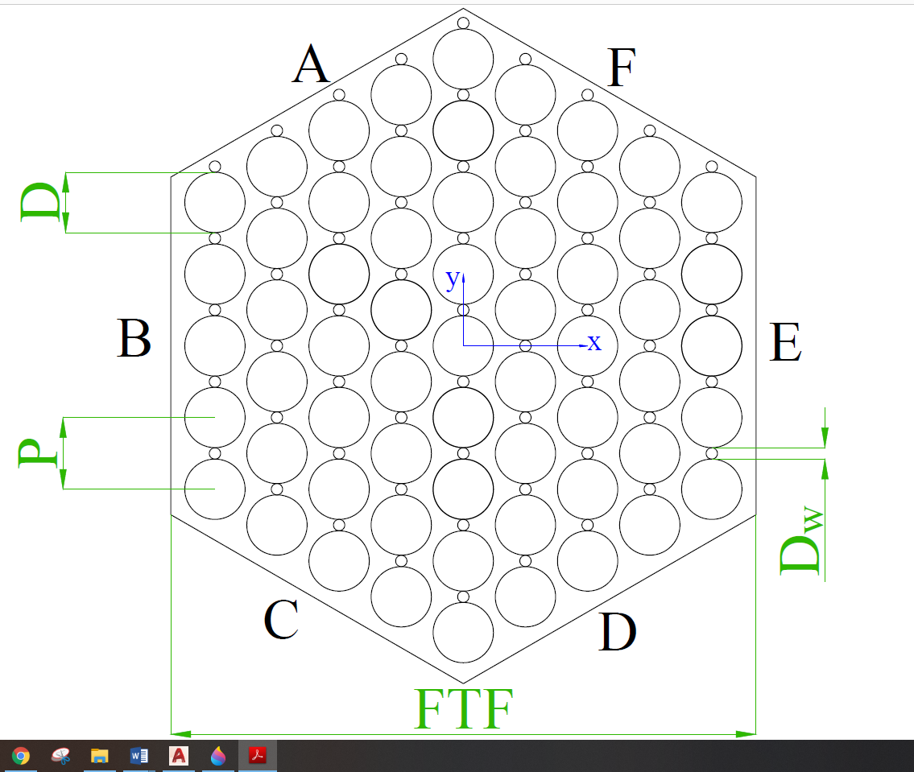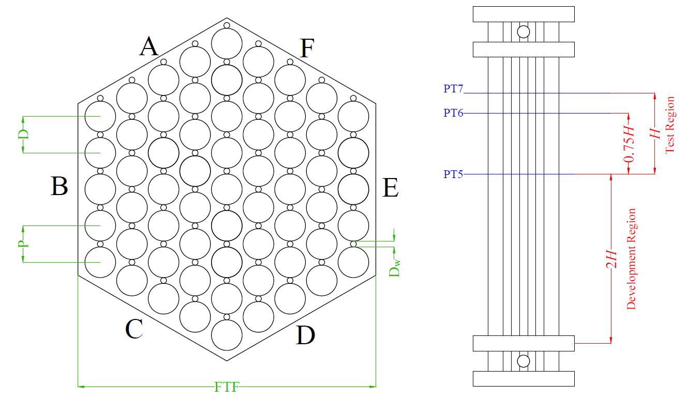

FIG 1. 61-rod hexagonal fuel bundle cross-section (left) and axial position of pressure transducers (right)

TABLE I. GEOMETRY DIMENSIONS

|  |  |  |
| --- | --- | --- |
| Variable | Symbol | Value |
| Flat to flat distance [mm] | $$FTF$$ | 154.00 |
| Rod diameter [mm] | $$D$$ | 15.88 |
| Wire diameter [mm] | $$D_{w}$$ | 3.00 |
| Rod Pitch [mm] | $$P$$ | 18.88 |
| Helix Pitch [mm] | $$H$$ | 476.25 |
| Hydraulic Diameter [mm] | $$D_{h}$$ | 7.756 |

The dimensions listed on TABLE I were used to compute the wetted perimeter and the cross-sectional flow area of the hexagonal duct, equal to m and m2, respectively. The hydraulic diameter was determined using Eq. 1.

$$\begin{aligned}D_{h}=\frac{4A_{f}}{P_{w}}\#\left(1\right)\end{aligned}$$

The length of the rod bundle was selected to guarantee fully developed flow conditions within the measurement region of the test section. A detailed description is available in others published researches conducted by Vaghetto et al. [4] and by Childs et al. [5].

The bundle-averaged axial friction factor, $f_{b}$, is defined as

$$\begin{aligned}f_{b}=\frac{D_{h}}{\frac{1}{2}ρ{\overline{U}}^{2}}\frac{ΔP}{H}\#\left(2\right)\end{aligned}$$

where $ΔP$ is the pressure drop between inlet and outlet, $\overline{U}$ is the bulk velocity, $ρ$ is the fluid density and $H$ is the wire helical pitch.

The experimental data of axial friction factor was available for the range of Reynolds numbers $439<Re<13767$ (Vaghetto et al. [4]). The transverse pressure difference data used for the benchmark was obtained by Childs et al. [5] from the same experimental facility, for Reynolds numbers in the range $3144<Re<17552$.

The axial friction factor results were also compared with the predictions of the Upgraded Chen and Todreas Detailed (UCTD) correlation [2]. This correlation was selected because it is applicable to the wideset range of Reynolds number and it was largely validated.

## methodology

The computational fluid dynamics (CFD) simulations in this study were executed using STAR-CCM+ software, Version 14.04.013. The velocity and pressure fields in the wire-wrapped fuel bundle were solved using incompressible and steady Reynolds-Averaged Navier-Stokes (RANS) equations. The $k-ω$ Shear Stress Transport (SST) turbulence model, with a nonlinear (cubic) constitutive equation for the estimation of the Reynolds Stress Tensor, was selected for giving closure to the RANS equations. This turbulence model was proposed by Menter [17] in order to provide a solution to the problem of sensitivity to free-stream/inlet conditions of the standard $k-ω$ model by using a blending function that included a cross-diffusion term far from the walls, but not near the walls. This approach effectively blends a $k-ϵ$ model in the far-field with a $k-ω$ model near the wall. In addition, a nonlinear (cubic) constitutive model was utilized to estimate the Reynolds stress tensor. Constitutive relations describe the relation between the stress tensor and the mean strain rate used in the Boussinesq approximation. By default, the Boussinesq approximation implies a linear constitutive relation. Non-linear constitutive relations [18] account for anisotropy of turbulence by adding non-linear functions of the strain and rotation tensors. This is of particular importance in wire-wrapped bundle flows where the turbulence is expected to be anisotropic. This turbulence model with the cubic constitutive relation was found suitable for predictions of pressure drop and velocity in wire-wrapped bundles, as it was reported by Bovati et al. [19].

The model axial length was one helix pitch, $H$. The inlet and outlet surfaces were connected through a periodic fully-developed interface. This let to simulate a fully developed flow, as it was the case of the experiment. The remaining surfaces had a no-slip boundary condition. The mass flow was forced at the inlet with a value that varied depending on the desired $Re$.

A particular approach was used to model the contact surface between the rod and the wire. According to Merzari et al. [16], the approach adopted to model the contact between the fuel rod and the wire spacer may significantly impact the simulation results. The wire-pin contact model adopted for this study was to overlap the wire boundary within the rod boundary to avoid the singularity at the tangential contact point. Then, contact angles were smoothed out using circular fillets, to reduce the required number of mesh cells, which is desirable for a faster RANS calculation. FIG 2 shows the final CAD model of the wire-wrapped assembly with a view of the wire-rod contact geometry simulated

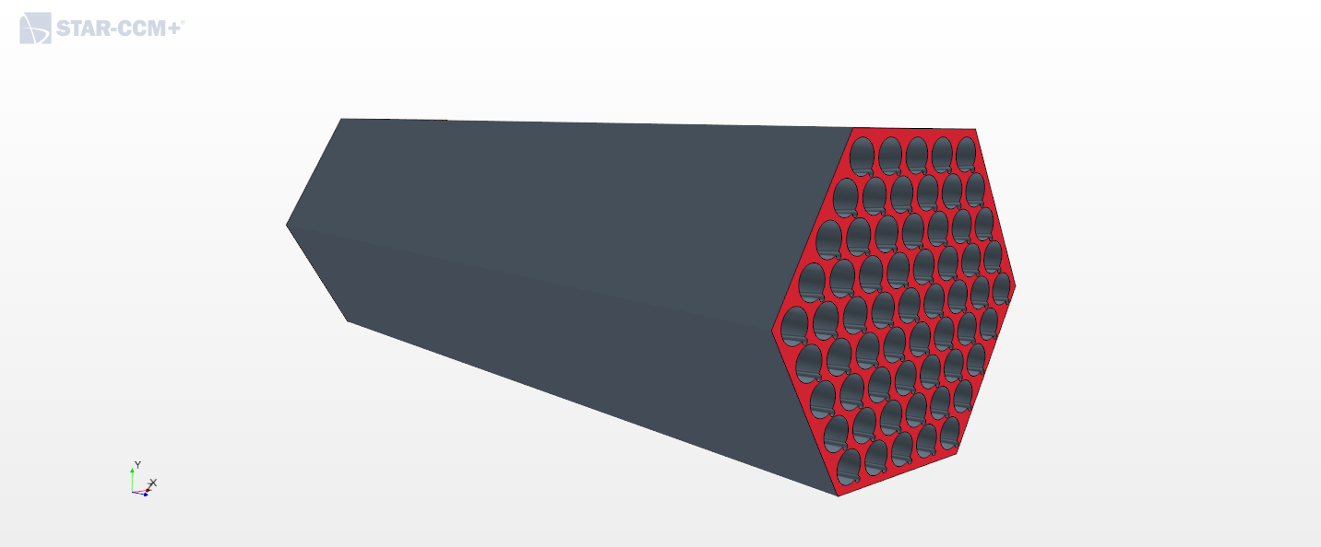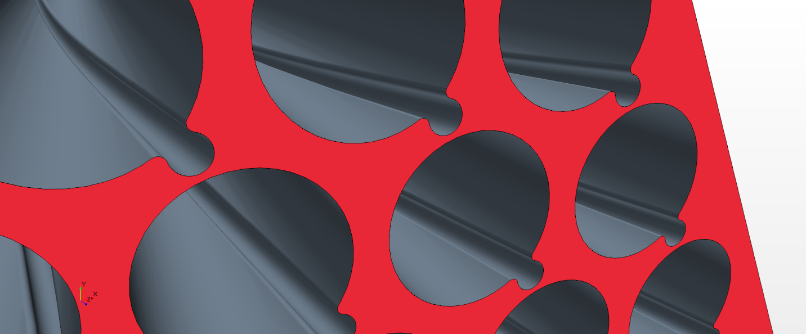

FIG 2. Visualization of the final CAD model for the CFD calculation (left) and detailed of the contact model between the fuel rod and the wire spacer (right)

The mesh was created using STAR-CCM+ with the Polyhedral Mesher, Prism Layer Mesher, and Surface Remesher models. A mesh sensitivity analysis was achieved to identify the most appropriate number of mesh cells. Simulations for mesh sensitivity were set at $Re=50,000$, because it was the highest Reynolds number analyzed. A converged mesh for this Reynolds number is appropriate for simulations with lower Reynolds numbers. The figure of merit to determine mesh convergence was the friction factor. Four different meshes with different number of cells were tested and their features are indicated on TABLE II.

TABLE II. PARAMETER VALUES FOR THE ANALYZED MESHES

|  |  |  |  |  |
| --- | --- | --- | --- | --- |
| Mesh Number | 1 | 2 | 3 | 4 |
| Number of Cells | 79,266,451 | 93,003,107 | 124,003,072 | 156,536,939 |
| Base Size (BS) [m] | 0.0035 | 0.003 | 0.003 | 0.00275 |
| BS/Dh | 0.4512 | 0.3868 | 0.3868 | 0.3545 |
| Number of Prism Layers | 7 | 7 | 9 | 10 |
| Prism Layer Thickness [m] | 7.00E-04 | 7.33E-04 | 6.04E-04 | 6.04E-04 |
| 20% of BS | 24.42% of BS | 20% of BS | 21.96% of BS |
| Thickness of Near  Wall Prism Layer | 4.64E-05 | 5.77E-06 | 7.89E-07 | 7.89E-07 |

The calculated friction factor is presented on TABLE III for each mesh analyzed. It is observed that the relative difference between two consecutive meshes decreases as the mesh becomes finer. This was also the case for the relative error with respect to the UCTD correlation. The friction factor predicted by the UCTD correlation at $Re=50,000$ is 0.02339. Because the relative difference between the friction factors calculated with meshes 3 and 4 was relatively low (~3.5%), mesh 3 is considered to be the converged mesh and it was used to performed the simulations for all the Reynolds numbers considered. The averaged-wall $Y^{+}$ is also indicated. Mesh 3 had an average wall- $Y^{+}$ of 0.397, which means that the viscous sub-layer was calculated with the low $Y^{+}$ wall treatment of STAR-CCM+.

TABLE III. FRICTION FACTOR AND AVERAGE $Y^{+}$ OBTAINED WITH THE FOUR MESHES ANALYZED

|  |  |  |  |  |  |
| --- | --- | --- | --- | --- | --- |
| Mesh Number | Cells | Friction Factor (CFD) | Relative difference w. r. t. previous mesh | Relative error w. r. t UCTD | Average Wall – $Y^{+}$ |
| 1 | 79,266,451 | 0.027139 | - | 16.04 % | 8.065 |
| 2 | 93,003,107 | 0.020001 | 26.30 % | 14.48 % | 0.995 |
| 3 | 124,003,072 | 0.022592 | 12.96 % | 3.40 % | 0.397 |
| 4 | 156,536,939 | 0.023385 | 3.51 % | 0.02 % | 0.395 |

## results

Simulations using the RANS $k-ω$ SST model were performed for 16 different Reynolds numbers, covering the transition regime ($1,270≤Re≤13,175$) and the turbulent regime $\left(17,552≤Re≤50,000\right)$. The comparison of the friction factor simulation results with the experimental measurements and the UCTD correlation predictions are shown in FIG 3. The friction factor presented a decreasing value with the Reynolds number, as expected. The turbulence model predictions were in excellent agreement with the experimental measurements, being always within the experimental uncertainty interval. The UCTD correlation slightly underpredicted the empirical and the simulation results, being the maximum relative difference with the simulation to be 7.33%, recorded for the transition regime. The matching between the simulation and the correlation improved at the turbulent regime, with the biggest relative error found to be 3.24%. Overall, the $k-ω$ predictions of the friction factor indicates that this model is suitable to be used for axial pressure drop calculations in 61-pin wire-wrapped rod bundles.



FIG 3. Friction factor results obtained with RANS $k-ω$ SST and comparison with experimental measurements and UCTD correlation. The correlation confidence interval of ±14.8% is also indicated

In order to better understand the flow physics in wire wrapped fuel bundles, transverse pressure difference was investigated between adjacent faces. Differential pressure between two faces was quantified with respect to the wire wrapping angle, θ, which represents the position of the wire relative to the corner between two adjacent faces. In the study, pressure difference between faces A and F was recorded along the full length of the bundle. Results of the transverse differential pressure in the assembly were compared with the experimental data of Childs et al. [5] for the validation. The differential pressure was normalized according to Equation 3,

$$\begin{aligned}Δp^{*}=\frac{P_{A}-P_{F}}{ρ{\overline{U}}^{2}}\#\left(3\right)\end{aligned}$$

where $P_{A}$ and $P_{F}$ are the pressure at the center of faces A and F, respectively (see FIG 1), $ρ$ is the fluid density and $\overline{U}$ is the bulk velocity.

FIG 4 and FIG 5 shows the comparison of the normalized transverse differential pressure between the simulation and the experimental data as a function of the wire angular position. The comparison is shown for four different Reynolds numbers $Re=17552; 9395$ (FIG 4) and $Re=6263; 5637$ (FIG 5). The experimental measurements were available for six different angular positions as can be seen from the figure. In all four */cases, the simulation results showed a continuous differential pressure profile. The differential pressure profile along the bundle presented a bell curved shape, where the maximum differential pressure was recorded when the wire faces the corner between the adjacent faces at $θ=0°$. The minimum differential pressure was recorded at $θ=-90°$ when the wire was directed to the face E. The experimental measurements for the lowest Reynolds numbers (FIG 5) showed a different trend than the simulation in proximity to the wire angle of $θ=0°$. Experimental measurements presented a local minimum where the wire was directed to the corner between the faces A-F, which was not the case in higher Reynolds numbers. In higher Reynolds number, especially in the turbulent regime ($Re=17552$), experimental measurements show good agreement with the simulation results.

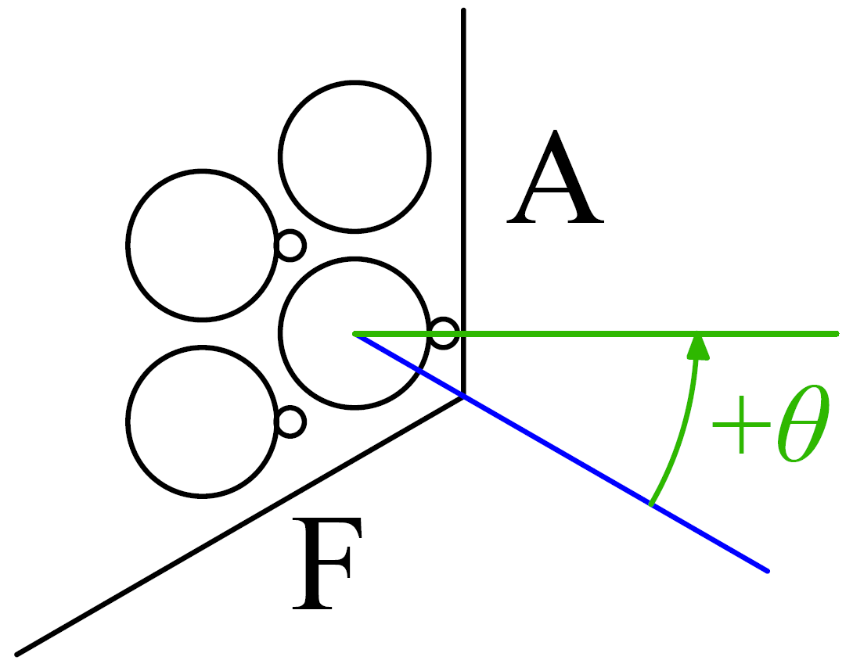

FIG 4. Transverse pressure difference between faces A and F as a function of the wire orientation angle for Re=17552 and Re=9395

. 

FIG 5. Transverse pressure difference between faces A and F as a function of the wire orientation angle for Re=6262 and Re=5637.

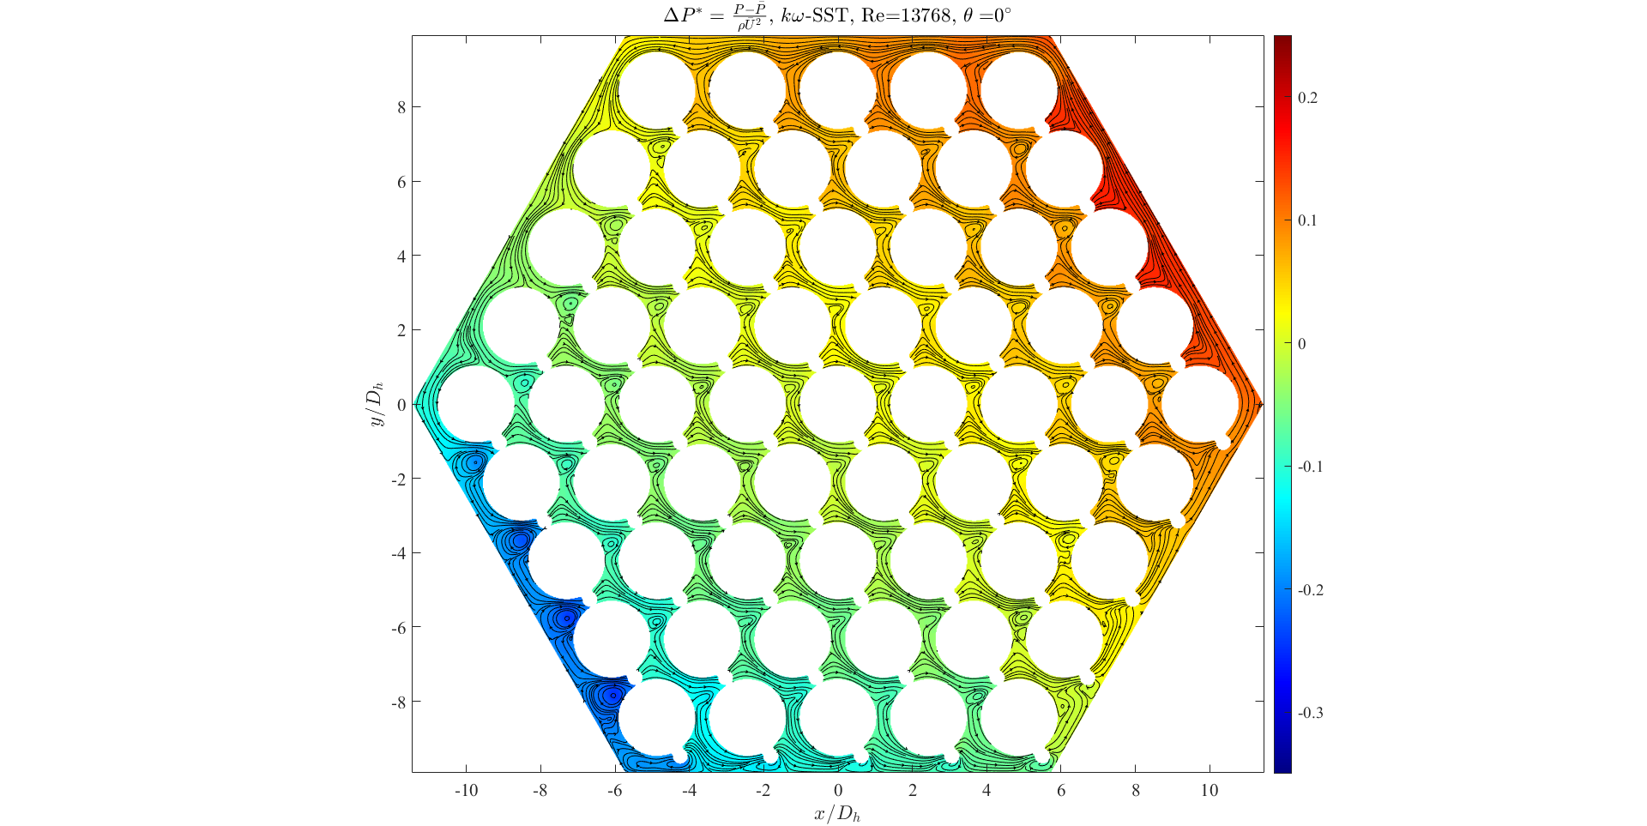

FIG 6. Normalized pressure and velocity streamlines over the wire-wrapped fuel assembly cross-section at Re=13K.

The observed variation of the transverse pressure difference with the wire orientation indicates the presence of a change in the pressure relative values along the bundle length. To better visualize this distribution, a normalized pressure over the assembly cross-section is shown in FIG 6 for a wire position facing directly the corner between two adjacent faces at a Reynolds number of thirteen thousand. Velocity streamlines were also plotted over the cross-section to visualize the cross flow. The maximum pressure was located at the position where the flow tended to travel perpendicular to the wire. Because of this obstruction, the flow had to move around the pin in the direction of decreasing pressure, creating the observed cross-flow pattern. The presence of vortexes was also observed, with a diameter that was bigger in the region of the lowest pressure. This swirl flow is a direct consequence of the wire shape, and it is the responsible of the higher mixing in this kind of fuel assemblies.

## conclusion

CFD calculations were performed using the RANS approach with the $k-ω$ SST to simulate an incompressible flow through a wire-wrapped fuel assembly using STAR-CCM+. The analyzed results focused mainly on the axial and transverse pressure drops for a wide range of Reynolds numbers covering the transition and turbulent regimes. The results were compared with available experimental data provided by the Texas A&M experimental facility, and with the UCTD correlation. It was found that this RANS model was able to predict the experimental and correlation friction factor values with a low relative error, since all the model predictions were within the experimental uncertainty interval.

With respect to the transverse pressure drop, the bigger discrepancy occurred at low Reynolds number where the wire faced directly to the corner formed by faces A and F. All the remaining angular positions were in satisfactory agreement with the model predictions. Due to the wire shape, the pressure distribution on the wire cross-section was not uniform, producing regions of high and low pressure and the presence of cross-flow.

It can be concluded that the $k-ω$ SST turbulence model can be used to predict pressure drop, both axial and transversal, for 61-pin fuel assemblies that use helical wire-wrapped as spacers. This allows to get reasonably accurate pressure drop results with a considerably less computational effort when compared to more sophisticated numerical tools. The results presented in the paper might let the nuclear industry to use RANS CFD models with more confidence and reliability in the calculation of wire-wrapped fuel bundles. However, this RANS turbulence model should be used carefully to predict the transverse pressure drop at low Reynolds numbers because a higher relative error with respect to experiments was observed at these Reynolds numbers.

References

1. SHIH-KUEI CHENG & NEIL E. TODREAS; “Hydrodynamic models and correlations for bare and wire-wrapped hexagonal rod bundles - bundle friction factors, subchannel friction factors and mixing parameters”; *Nuclear Engineering and Design*, **92**; 1986; 227-251.
2. S.K. CHEN, Y.M. CHEN, N.E. TODREAS; “The upgraded Cheng and Todreas correlation for pressure drop in hexagonal wire-wrapped rod bundles”; *Nuclear Engineering and Design*; **335**; 2018; pages 356–373.
3. DAJUN FAN, TIANJI PENG, YANZE TANG & OTHERS; “Periodicity and transversal pressure distribution in a Wire-wrapped 19-Pin fuel assembly”; *International Journal of Energy Research*; September 2020;1–14.
4. RODOLFO VAGHETTO ET.AL.; “Pressure Measurements in a Wire-Wrapped 61-Pin Hexagonal Fuel Bundle; Journal of Fluids Engineering”; *Fluids Engineering Division of ASME*; MARCH 2018; **Vol. 140**.
5. MASON CHILDS, RODOLFO VAGHETTO, PHILIP JONES, NOLAN GOTH, YASSIN HASSAN; “Experimental Determination and Analysis of the Transverse Pressure Difference in a Wire-Wrapped Rod Bundle”; *International Journal of Heat and Mass Transfer*; January 7, 2021.
6. PINGHUI ZHAO, JIAMING LIU, ZHIHAO GE, XI WANG, XU CHENG; “CFD analysis of transverse flow in a wire-wrapped hexagonal seven-pin bundle”; *Nuclear Engineering and Design*; **317**; 2017; 146–157.
7. SU-JONG YOON & FLORENT HEIDET; “Evaluation of Pressure Drop Correlations for the Wire-wrapped Rod Bundles”; *Transactions of the American Nuclear Society*, **Vol. 122**, Virtual Conference, June 8–11, 2020.
8. LANDON BROCKMEYER, LANE B. CARASIK, ELIA MERZARI, YASSIN HASSAN; “Numerical simulations for determination of minimum representative bundle size in wire wrapped tube bundles”; *Nuclear Engineering and Design; Nuclear Engineering and Design*; **322**; 2017; 557–590.
9. POINTER, W. D., THOMAS, J., FANNING, T., FISCHER, P., SIEGEL, A., SMITH, J., & TOKUHIRO, A. (2009). “RANS-based CFD simulations of sodium fast reactor wire-wrapped pin bundles”. In American Nuclear Society - International Conference on Mathematics, Computational Methods and Reactor Physics 2009, M and C 2009 (pp. 2212-2224). (American Nuclear Society - International Conference on Mathematics, Computational Methods and Reactor Physics 2009, M and C 2009; Vol. 4).
10. AHMAD, IMTEYAZ & KIM, KWANG-YONG. “Three-Dimensional Analysis of Flow and Heat Transfer in A Wire-Wrapped Fuel Assembly”. Proceedings of the American Nuclear Society - International Congress on Advances in Nuclear Power Plants 2005, ICAPP'05. 1.
11. GAJAPATHY, R., VELUSAMY, K., SELVARAJ, P., CHELLAPANDI, P., CHETAL, S.C., 2007. “CFD investigation of helical wire-wrapped 7-pin fuel bundle and the challenges in modeling full scale 217 pin bundle; *Nuclear. Engineering. Des.*; **237**, 2332–2342.
12. U. BIEDER, H. UITSLAG-DOOLAARD, B. MIKUZ; “Investigation of pressure loss and velocity distribution in fuel assemblies with wire-wrapped rods by using RANS and LES with wall functions”; *Annals of Nuclear Energy*, <https://doi.org/10.1016/j.anucene.2020.108025>
13. DANIELE DOVIZIO, BLAŽ MIKUŽ, AFAQUE SHAMS, FERRY ROELOFS; “Validating RANS to predict the flow behavior in wire-wrapped fuel assemblies”; *Nuclear Engineering and Design*; **356** (2020) 110376.
14. Texas A&M University-Thermal-Hydraulic Research Laboratory. (2021, February 24). Wire Wrapped Fuel Assembly <https://thrlab.tamu.edu/wire-wrapped-fuel-assembly/>
15. N.E. GOTH, “Design and PIV Measurements on a Wire-Wrapped 61-Rod Hexagonal Fuel Assembly Experimental Facility”, Texas A&M University, 2017 MS thesis.
16. E. MERZARI, W.D. POINTER, J.G. SMITH, A. TENTNER, P. FISCHER; “Numerical simulation of the flow in wire-wrapped pin bundles: Effect of pin-wire contact modeling”; *Nuclear Engineering and Design*; **253**; 2012; pages 374-386.
17. Menter, F.R. 1994; “Two-equation eddy-viscosity turbulence modeling for engineering applications”, *American Institute of Aeronautics and Astronautics Journal*, **32**(8), pp. 1598-1605.
18. Lien, F.S., Chen, W.L., and Leschziner, M.A. 1996. “Low-Reynolds number eddy-viscosity modelling based on non-linear stress-strain/vorticity relations”, Proc. 3rd Symp. on Engineering Turbulence Modelling and Measurements, 27-29 May, Crete, Greece.
19. O. Bovati, M. A. Yildiz, Y. Hassan, and R. Vaghetto, “RANS simulations for transition and turbulent flow regimes in wire-wrapped rod bundles,” *International Journal of Heat and Fluid Flow*, **90** (2021)