# CURRENT STATUS OF DEVELOPMENT OF 3d DNS CONV-3d CODE: ONE- AND TWO-PHASE FLOW MODELS

V.V. CHUDANOV

Nuclear Safety Institute of the Russian Academy of Sciences (IBRAE RAN)

Moscow, Russia

E-mail contact of main author: chud@ibrae.ac.ru

A.E. AKSENOVA

Nuclear Safety Institute of the Russian Academy of Sciences (IBRAE RAN)

Moscow, Russia

A.A. LEONOV

Nuclear Safety Institute of the Russian Academy of Sciences (IBRAE RAN)

Moscow, Russia

A.A. MAKAREVICH

Nuclear Safety Institute of the Russian Academy of Sciences (IBRAE RAN)

Moscow, Russia

V.A. PERVICHKO

Nuclear Safety Institute of the Russian Academy of Sciences (IBRAE RAN)

Moscow, Russia

**Abstract**

In IBRAE RAN in “Codes of New Generation” subproject of “Proryv” project one- and two-phase models are being developed to simulate heat and mass transfer processes in the separate elements of nuclear reactor. Those models are realized in the LES and DNS CONV-3D code. The one-phase models are based on the algorithms with small numerical diffusion, for which the discrete approximations are constructed with use of finite-volume methods and fully staggered grids. For solving convection problem the regularized nonlinear monotonic operator-splitting scheme has been developed. The Richardson iterative method with FFT solver for Laplace’s operator as preconditioner is applied for solving pressure equation. Such approach to the elliptical equations with variable coefficients gives multiple acceleration in comparison with the usual conjugate gradients method. For modeling of 3D turbulent flows both quasi-DNS and LES approaches are used. The one-phase module of CONV-3D code is fully parallelized and has perfect scalability, thus it is effective on high-performance computers such as “Lomonosov” (MSU, Russian Federation). The one-phase module has been validated against data of well-known and just got experimental data for various liquids, including lead and sodium used as coolants, in a wide range of Rayleigh numbers between 106 and 1016, and Reynolds numbers in the range of 103– 105. The two-phase models take into account interphase heat and mass transfer, stratification of the two-phase flow and separation of the gas component through the interface using equations of state such as condensed gas and the Noble-Able. The two-phase module in CONV-3D code is fully parallelized and has perfect scalability on a CPU and GPU systems. The algorithm of two-phase module is based on the use of HLL (Harten-Lax-van Leer) and HLLC (Harten-Lax-van Leer-Contac) solvers and two-step MUSCL (Monotonic Upstream-centered Scheme for Conservation Laws) predictor-corrector. The validation base includes experiments in which the heat and mass transfer and sodium boiling in the pipes were investigated. This contribution presents several examples of code application for solving such problems as flow in fuel assemblies, tubes and ring channels, as well as natural convective flows in the elements of reactor. The results of two-phase flows modeling on the series of tests, including the problem of sodium boiling in a round pipe, are also shown. In all cases the good agreement of numerical predictions with experimental data has been found, that specifies the applicability of the developed CONV-3D code to solve CFD problems for designing and operating NPPs.

Key words: safety, CONV-3D codes, one- and two-phase flow models, liquid metal coolant, project “Proryv”.

## INTRODUCTION

The CONV-3D precision scalable eddy-resolving CFD code is designed for calculating laminar and turbulent stationary and non-stationary coolant flows and heat exchange with solid-state elements of reactor plant equipment under forced and/or free convection caused by temperature inhomogeneity and/or volumetric heat release, including flows when mixing different-temperature flows [1]. The scope of application of the code for the type of object of use of atomic energy includes reactors with water or liquid metal coolant. This article presents the current state of development of CONV-3D code and examples of its application for calculating practical problems. The CONV-3D DNS CFD code developed at IBRAE is intended for modeling heat and mass transfer processes in RF elements, and currently includes models for modeling single-phase and two-phase processes.

## State of the art of the one-phase flow models in CONV-3D code

The one-phase models are based on the algorithms with small numerical diffusion, for which the discrete approximations are constructed with use of finite-volume methods and fully staggered grids. For solving convection problem the regularized nonlinear monotonic operator-splitting scheme has been developed. The Richardson iterative method with FFT solver for Laplace’s operator as preconditioner is applied for solving pressure equation. Such approach to the elliptical equations with variable coefficients gives multiple acceleration in comparison with the usual conjugate gradients method. For modeling of 3D turbulent flows both quasi-DNS and LES approaches are used. The one-phase module of CONV-3D code is fully parallelized and has perfect scalability, thus it is effective on high-performance computers such as “Lomonosov” (MSU, Russian Federation). The one-phase module has been validated against data of well-known and just got experimental data for various liquids, including lead and sodium used as coolants, in a wide range of Rayleigh numbers between 106 and 1016, and Reynolds numbers in the range of 103– 105.

For example, flows of incompressible fluid in laminar, transition and turbulent flow regime in a circular pipe. It is known that the Reynolds number at which the transition from laminar to turbulent mode is observed in the pipe is largely due to the flow at the pipe entrance. Such a transition usually does not occur suddenly; there is a finite range of Reynolds numbers in which the flow is neither laminar nor turbulent. To study such phenomena, an experimental setup with different types of injectors was developed [2] (Figure 1). Calculated by CONV-3D code friction factor in comparison with experiment for two types of inlet nozzles of different diameters shown in Figure 2, where there is satisfactory coincidence of calculation and experiment [2]. The pipe resistance coefficient λ, depending on the Reynolds number , is calculated from the measured difference, time-averaged static pressure *p*2 and *p*1, in positions II and I. Other symbols:  – distance between measurement points,  – nozzle diameter,  – speed,  – air density in the pipe.

|  |  |
| --- | --- |
|  | fig4 |
| *FIG. 1 - Experimental setup for studying the flow in the region of the critical Reynolds number with injectors* | | *FIG. 2 - Calculated by the CONV-3D code of the coefficient of friction (*─●─*) in comparison with [2] for the injectors Nr1 (*─ ⯀ ─*), Nr3 (─ ▼ ─) and (⎯) Poiseuille formula* |

Another example is the calculation of the parameters of the coolant flow in the experiment of the Novosibirsk branch of IBRAE RAS [3] with fuel assembly of 7 fuel rods 400 mm long. The main results were obtained for the fuel rod diameter of 9 and 10 mm and the distance between the fuel rods with respect to the diameter (s/d) equal of 1,4. Distilled water and a ferrocyanide electrochemical solution based on distilled water, whose physical properties coincide at room temperature, were used as a model liquid in the experiments. Calculations were performed on a sequence of fine grids in laminar, transient, and turbulent modes at Reynolds number using a convective operator that provides energy neutrality (the circuit viscosity is negligible).

Figure 3 shows the results of calculating the friction coefficient at the Reynolds numbers 2500 and 5000 along the longitudinal coordinate at a distance from the spacing grid of 5-160 mm in comparison with the measured one [3]. We can see a satisfactory agreement between the results of the numerical calculation and the experiment: the relative deviation in the pointwise  norm does not exceed 15%.

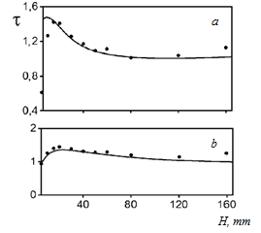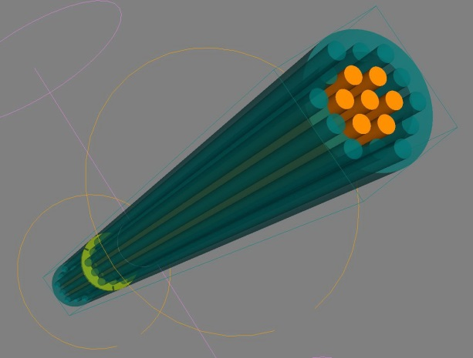 *c*

*FIG. 3 - Calculated (****⎯****) and experimental friction coefficient (*●*) along the horizontal coordinate for the Reynolds number 2500 and s/d=1.2 (a); 5000 and s/d=1.4 (b); scheme of the calculated geometry (c)*

Another illustrative example, to verify the CONV-3D code adapted for modeling in the LES approximation, calculations of the coolant flow in a round pipe were performed using the large eddy simulation (LES) method in comparison with the Blasius formula [4]. The coefficients of hydraulic resistance of the turbulent flow of the coolant in a round pipe at different Reynolds numbers, calculated using the LES approximation and the Blasius formula [4], are consistent with an error of no more than 5% (see table 1).

TABLE 1: COEFFICIENT OF HYDRAULIC RESISTANCE FOR TURBULENT FLOW OF A HEAT CARRIER IN A ROUND PIPE, CALCULATED USING THE LES APPROXIMATION

|  |  |  |
| --- | --- | --- |
| Re, 1000 | Blasius formula [4] | LES calculation |
|  | 0,039 | 0,038 |
|  | 0,033 | 0,035 |
|  | 0,030 | 0,029 |
|  | 0,026 | 0,027 |
|  | 0,022 | 0,023 |
|  | 0,018 | 0,017 |
|  | 0,015 | 0,014 |
|  | 0,012 | 0,012 |

Figure 4 shows that the calculations by both methods are qualitatively the same, but to achieve the result by the method of large eddy simulation a four-times less detailed grid is required than for direct numerical simulation. This makes it much easier and faster to get results on available computing resources.The method of large eddy simulation allows you to obtain both qualitative and quantitative results that are comparable to calculations using direct numerical simulation, but on coarser grids, and speed up the calculations by a number of times proportional to . On rough computational grids with a characteristic cell size , qualitative and quantitative results can be obtained using a convective operator with minimal circuit viscosity, for example, using the skew-symmetric operator. The results showed that the CONV-3D code can be used to calculate flow parameters in the LES approximation.

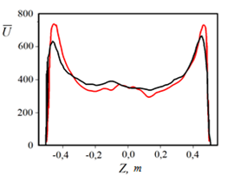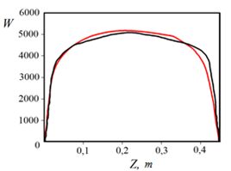

*a) b)*

*FIG. 4 – Dimensionless average longitudinal velocity  (a) and standard deviation of the average longitudinal velocity as a function of the coordinate (b), calculated by DNS (****—****) and LES approach (****—)***

## Application of single-phase CFD CONV-3D code for calculating reactor applications

Research on heavy liquid metals such as lead-bismuth eutectic (LBE) is of particular interest for industrial activities related to fast neutron reactors and high-energy accelerators, especially in terms of the hydraulic resistance coefficient. The results of modeling the flow of bismuth+lead alloy in a 19-fuel element assembly with three grid spacers from [5] are presented below using the CONV-3D code. An example of geometry and grid spacer is shown in figure 5. For Prandtl number significantly less than one, the physical mechanisms that determine heat transfer are balanced differently than for liquids with a Prandtl number of the order of one, such as water or air. In the case of liquid metals, the molecular thermal conductivity plays an even greater role, even at high Reynolds numbers. Therefore, specific examples are needed to develop models that accurately reproduce the thermohydraulic behavior of liquid metal flows.

|  |  |  |  |
| --- | --- | --- | --- |
|  | |  | |
| *a) grid spacer* | | *b) fuel rods with three grid spacers* | |
| *FIG. 5 -* *19-fuel rods with three grid spacers* | |

Evolution of the friction factor based on simulation results for the entire geometry using the relations $∆P=λ\frac{L_{1}}{d_{г}^{1}}\frac{ρV^{2}}{2}$; $f=\frac{∆P}{ρ}\frac{d_{г}^{1}}{L_{1}}\frac{2}{V^{2}}$ and input data $d_{г}^{1}=7.7*{10}^{-3}m$; ${\overline{\left(\frac{P}{ρ}\right)}}_{\begin{aligned}z=-0.9 \\ k=111\end{aligned}}=42,23*{10}^{6}\frac{{mm}^{2}}{c^{2}}$; (the line at the top indicates the average value by cross section) ; ${\overline{\left(\frac{P}{ρ}\right)}}_{\begin{aligned}z=1288.15 \\ k=847\end{aligned}}=14,38*{10}^{6}\frac{{mm}^{2}}{c^{2}}$; $\frac{ΔP}{ρ}=27,85*{10}^{6}\frac{{mm}^{2}}{c^{2}}$; $V=3,61*{10}^{3} mm/c$; $Re=\frac{V_{input}d_{г}^{1}}{ν}=8,84*{10}^{4}$; $L_{1}=1290 mm=1,29 m$ based on the results of the simulation, it gives the value $f=0,026$, and in the experiment $f=0,021$ [5].

For the coefficient of hydraulic resistance on the grid spacer closer to the output using the ratios

$∆P=K_{sp}\frac{ρV^{2}}{2}$; $K_{sp}=\frac{2∆P}{ρV^{2}}$ and data ${\overline{\left(\frac{P}{ρ}\right)}}_{\begin{aligned}z=960 \\ k=660\end{aligned}}=18,31*{10}^{6}\frac{{mm}^{2}}{c^{2}}$; ${\overline{\left(\frac{P}{ρ}\right)}}_{\begin{aligned}z=933,68 \\ k=644\end{aligned}}=32,18*{10}^{6}\frac{{mm}^{2}}{c^{2}}$; $\frac{ΔP}{ρ}=13,87*{10}^{7}\frac{{mm}^{2}}{c^{2}}$; $V=5,11*{10}^{3} mm/c$ we have based on the results of modeling $K_{sp}=1,1$, and in the experiment $K_{sp}=1,2$. Thus, there is a good agreement between the simulation results and the experimental data.

Another example of using the CONV-3D code for calculating reactor applications is the simulation of experiments on convective sodium flow in a pipeline section with an aspect ratio of l/d=20 at the OKBM facility [6]. A straight cylindrical tube with a diameter of 0,096 m and a length of 1,972 m is filled with liquid sodium. At one end of the pipe there is a heater consisting of a copper array and three simultaneously operating ring electric heaters, at the other end of the pipe there is a sodium-air heat exchanger. Adjacent to the surface of the heat exchanger is a copper plate with rods that are not included in the design model, but intensify heat transfer to the cooling air. To compensate for the temperature expansion of sodium, an electrically heated expansion tank is connected to the pipe using a small tube, which is not included in the calculation model. The pipe is completely insulated with mineral wool. When the heater and heat exchanger operate simultaneously in a closed pipe cavity, free sodium convection occurs under the influence of a density difference. It was necessary to solve the problem of conjugate heat exchange taking into account the free convection of sodium for three positions of the pipe. Figure 6 shows the results of calculating the sodium temperature along the upper pipeline generatrix for two positions in comparison with experimental data. There is a good agreement between the calculated data and the experiment.

|  |  |
| --- | --- |
|  |  |
| *a) vertical position* | |
|  |  |
| *b) inclined position* | |
| *FIG. 6 - Sodium temperature along the line of thermocouples for two pipeline positions* | *FIG. 7 - Power spectrum of the sodium temperature at the corresponding monitoring point* |

Figure 7 shows the power spectra of the sodium temperature at the monitoring points corresponding to the thermocouple readings. The results are grouped for two positions of the pipeline from top to bottom vertically and diagonally. As can be seen from the figures, the coincidence of spectral characteristics with the experiment is good.

## State of the art of the two-phase flow models in CONV-3D code

The two-phase models take into account interphase heat and mass transfer, stratification of the two-phase flow and separation of the gas component through the interface using equations of state such as condensed gas and the Noble-Able. The two-phase module in CONV-3D code is fully parallelized and has perfect scalability on a CPU and GPU systems. The algorithm of two-phase module is based on the use of HLL (Harten-Lax-van Leer) and HLLC (Harten-Lax-van Leer-Contac) solvers and two-step MUSCL (Monotonic Upstream-centered Scheme for Conservation Laws) predictor-corrector. The validation base includes experiments in which the heat and mass transfer and sodium boiling in the pipes were investigated.

Below are the results of calculating the Soda problem (Figure 8) or otherwise the problem of breakup in a two-component medium [7].

|  |  |  |  |
| --- | --- | --- | --- |
|  |  | |  |
| *a) volume fraction of liquid* | *b) liquid density* | | *c) gas density* |
|  |  | |  |
| *d) liquid velocity* | *e) gas velocity* | | *f) liquid pressure* |
|  |  | |  |
|  |  | |  |
|  | *g) gas pressure* | |  |
| *FIG. 8 - Task Soda in a two-component environment* | | | |
|  | |  | |

The Soda problem allows us to check the absence of non-physical oscillations of the solution in the calculations of moving shock waves and contact discontinuity, as well as the correctness of the density profile reproduction. At the initial moment of time, a one-dimensional horizontal pipe 1 m long is filled with a stationary mixture of gas and liquid. The volume fraction of the liquid in the left part of the pipe () is equal to 0,8 ; and in the right part of the pipe ( ) – 0,3. The liquid density values in the left and right parts of the pipe are equal to 1 kg/m3. The gas density values in the left and right parts of the pipe are 0,2 and 1 kg/m3, respectively. The liquid pressure values in the left and right parts of the pipe are the same and equal to 1 Pa. The gas pressure values in the left and right parts of the pipe are 0,3 and 1 Pa, respectively. Each component of the mixture has its own speed and pressure. The borders on the left and right of the calculation area are free. Under these initial conditions, following the collapse of gaps is formed by the shock wave, contact discontinuity and rarefaction wave. Gas and liquid are described by the equation of state of an ideal gas. The calculation was performed according to the method [6] with the value of the interface velocity equal to the fluid velocity. At Fig. 8 shows the results of the calculation on the grids 200 (red line), 400 (green line) and 800 (blue line) nodes for a time of 0,2 second in all figures, the exact solution is shown in the magenta color. Small oscillations in the fluid density and velocity profiles are associated with initial discontinuities. For gas, the behavior of the profiles is in good agreement with the exact solution. Small deviations of the liquid profiles from the exact solution are typical for most of the computational schemes proposed for this problem [6].

The next example of using the two-phase CFD code CONV-3D is modeling the separation problem in a three-component environment [8].

At the initial moment of time, a one-dimensional vertical pipe 7,5 m long is filled with a mixture of gas and liquid at rest. The volume fractions of each component of the mixture are equal to 0,5. The gas density is 1 kg / m3, and the liquid density is 1000 kg / m3. The pressure in the entire pipe is 105 Pa. Solid walls are located at the top and bottom of the pipe. Under the influence of a gravitational field () directed along the X-axis, the liquid begins to move down, and the gas-up. Gas and liquid are described by the equation of state of an ideal gas.

In the three-component model, a gas consists of two components. Each has a density of 1 kg/m3 and a volume fraction of 0,25. The calculation is performed on a grid of 400 nodes, taking into account the pressure relaxation of all three components of the mixture. Each component has its own speed. First, the volume fractions of each of the three components were calculated for the separation problem with the same densities of gas components for a time of 1,4 s (Figure 9 a-c). The volume fractions of the first and second gas components, as well as the liquid, are shown. It can be seen that the gas and liquid components are completely separated by the gravitational field.

Then the calculation was performed for different densities of gas components (Figure 10 a-c). The density of the first gas component is 1 kg/m3. The density of the second gas component is 30 kg/m3. The results of calculating the volume fractions of each of the three components are presented for time 1,4 s.

The volume fractions of the first and second gas components, as well as the liquid, are shown. It can be seen that all three components of the mixture are separated by the gravitational field. The results are the same c [8].

|  |  |
| --- | --- |
|  |  |
|  |  |
|  |  |
| *FIG. 9 - Separation problem for identical densities of gas components* | *FIG. 10 – Separation problem for different densities of gas components* |

## Application of two-phase CFD CONV-3D code for calculating reactor applications

An example of modeling heat and mass transfer in a vertical channel with boiling sodium under the condition of forced lifting is presented. The vertical size of the working area of a flat channel with a cross dimension of 5 mm is 70 cm. The heat flow through the side walls was assumed to be ~ 0,57 mW/m2. The initial volume fraction of sodium vapor in the entire pipe is 10-5, and the initial temperature of the two-phase sodium mixture was assumed to be 1153 K everywhere, which is 3 K less than the boiling point at atmospheric pressure. The initial vertical velocity distribution corresponds to a mass flow rate of 166 kg/m2/s. At the lower bound, constant values of temperature and volume fraction equal to the initial values are maintained. A constant mass flow is also maintained at the lower bound. Atmospheric pressure was recorded at the upper boundary. The calculation was performed using a “Stiffened” EOS with the parameters shown in table 2.

TABLE 2: “STIFFENED” EOS COEFFICIENT FOR SODIUM

|  |  |  |  |  |  |
| --- | --- | --- | --- | --- | --- |
| Phase | γ | π, Pa | q, J/kg | q', J/kg/K | CV, J/kg/K |
| Liquid | .48 | 3.67×108 | -265030 | 0 | 864 |
| Gas | .49 | 0 | 2086460 | -4149 | 1690 |

A vertical profile of the pressure averaged over the cross section at time instant 0.22 s is shown if Figure 11. The points correspond to the experimental values of the pressure for two different values of the heat fluxes [9]. The dashed curve corresponds to the interpolation of the experimental values for the heat flux of 0,57 MW/m2 assuming a linear dependence of the pressure values on the heat flux. A good qualitative agreement of the calculated and experimental values is obtained. The difference in the magnitude of the pressure difference over the working region of the pipe can be related to the "flat" approximation of the model calculation, which leads to different values of the ratio of the transverse length of the heating section to the enclosed area.

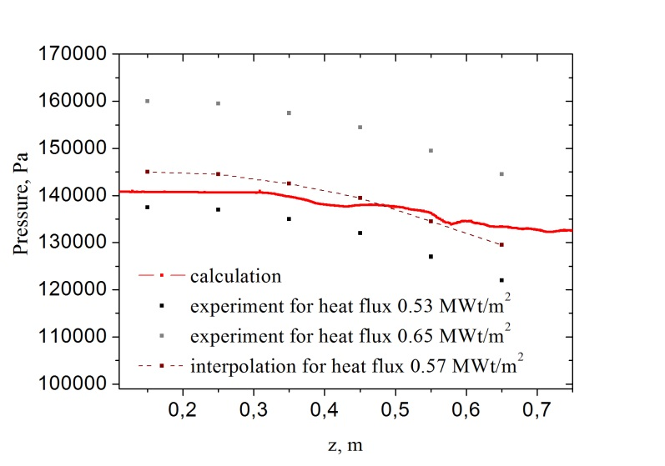

*FIG. 11 – Pressure distribution along the channel*

## CONCLUSION

This article shows the results of modeling experiments with single-phase sodium and lead--bismuth heat carriers on such problems as flow flows in fuel assemblies, tubes and ring channels and naturally convective flows in the elements of the RU and presents the results of comparing of the calculated data with the experiment. The results of modeling two-phase flows on a series of tests, including the problem of sodium boiling in a round tube, are also shown. In all cases, a good agreement was reached between the numerical forecasts and experimental data, which indicate the possibility of using the developed CONV-3D code for predicting CFD flows in the design and operation of nuclear power plants.

## References

1. Chudanov, V.V., Aksenova A.E., et al., Application of the CFD-code CONV-3D in reactor applications, Atomic Energy 121 3 (2017) 179–184.
2. Rotta, J., Experimenteller Beitrag zur Entstehung turbulenter Strömung im Rohr, Applied Mechanics 24 4 (1956) 258–281.
3. Budnikov, A.B., et al., Measurement of hydrodynamic and vibration characteristics for validation of numerical calculations of structure excitation by a fluid flow, Devices and measurement methods, 10 3 (2019) 223–232.
4. Blasius, H., Grenzschichten in Flüssigkeiten mit kleiner Reibung, Zeit. für Math. und Phys, 56 (1908) 1–37.
5. Pacio, M., et al., Heavy-liquid metal heat transfer experiment in a 19-rod bundle with grid spacers, Nuclear Engineering and Design, 273 (2014) 33–46.
6. Kolesnichenko, I.V., et al, Experimental study on free convection of sodium in a long cylinder, Therm. Eng., 62 6 (2015) 414–422.
7. Ambroso A., et al., A Godunov-type method for the seven-equation model of compressible two-phase flow, Computers & Fluids, 54 (2012) 67–91.
8. Coquel, F., et al., A numerical method using upwind schemes for the resolution of two-phase flows, Journal of computational physics, 136 (1997) 272–288.
9. Zeigarnik, Yu., Litvinov, V., High Temp., 5 (1977) 1116–1118.