Objectives and status of neutronics sub-exercises of the oecd/nea Benchmark for Uncertainty Analysis in Modelling for Design, Operation and Safety Analysis of SFRs

F. BOSTELMANN
Oak Ridge National Laboratory, Oak Ridge, TN, USA
bostelmannf@ornl.gov

L. BUIRON
French Alternative and Atomic Energy Commission (CEA), Saint-Paul-lez-Durance, France

A. AURES, N. BERNER, K. VELKOV, W. ZWERMANN
Gesellschaft für Anlagen- und Reaktorsicherheit (GRS) gGmbH, Garching, Germany

I. TRIVEDI, K. ZENG, J. HOU, K. IVANOV
North Carolina State University (NCSU), Raleigh, NC, USA

N. STAUFF
Argonne National Laboratory (ANL), Lemont, IL, USA

Y. JO, X. DU, D. LEE
Ulsan National Institute of Science and Technology (UNIST), Ulsan, South Korea

Q. LIANG, Y. ZHENG, C. WAN
NECP at Xi'an Jiaotong University, Xi’an, China

E. FRIDMAN
Helmholtz-Zentrum Dresden-Rossendorf (HZDR), Dresden, Germany

A. PAUTZ
École Polytechnique Fédérale de Lausanne (EPFL), Lausanne, Switzerland

I. HILL
OECD Nuclear Energy Agency (NEA), Boulogne-Billancourt, France

Abstract

The OECD/NEA Benchmark for Uncertainty Analysis in Modelling (UAM) for Design, Operation and Safety Analysis of Sodium-cooled Fast Reactors (SFRs) was launched in 2015 to study reactivity feedback coefficients and their uncertainties for a medium-sized 1,000 MWth metallic core and a large 3,600 MWth oxide core. In addition to investigations of full core models, stand-alone multi-scale neutronics analyses of several sub-exercises on the fuel pin and assembly levels were identified to be relevant for a systematic assessment of the influence of nuclear data in fast reactor simulations. When studying simple models, comparisons between computational results using different methods, models, and applied nuclear data libraries can reveal the major drivers of observed differences and calculated uncertainties. For the fuel pin and assembly levels, calculation of nominal values and corresponding uncertainties of the multiplication factor, reactivity effects, and collapsed cross sections are requested. Up to now, 18 contributions to these sub-exercises have been received from 9 international institutions. The preliminary results for nominal metrics values from calculations that were based on the same nuclear data library show good agreement. A similar conclusion was drawn for the comparison of submitted uncertainties: differences in the applied covariance data dominate the cause of differences between results that were obtained using different methods for the neutron transport calculation and uncertainty quantification. This paper provides an overview of the objective and describes the status of the sub-exercises of the standalone neutronics phase for the UAM SFR benchmark. Preliminary comparisons between results submitted by participants are presented and discussed.

INTRODUCTION
The Organisation for Economic Co-operation and Development (OECD) / Nuclear Energy Agency (NEA) Benchmark for Uncertainty Analysis in Modelling (UAM) for Design, Operation and Safety Analysis of Sodium-cooled Fast Reactors (SFRs) was launched in 2015 to study reactivity feedback coefficients and their uncertainties for a medium-sized 1,000 MWth metallic core and a large 3,600 MWth oxide core [1]. In addition to investigations at the full core level, stand-alone multi-scale neutronics analyses of several sub-exercises on the fuel pin and assembly levels were identified to be relevant for a systematic assessment of the influence of uncertainties in fast reactor simulations. When studying simple models, comparisons between computational results using different methods, models, and applied nuclear data libraries can reveal the major drivers of observed differences and obtained uncertainties. The original benchmark specifications for each of the two reactor designs [1] were therefore amended by neutronics sub-exercise specifications covering a fuel pin cell, a fuel assembly, and a super cell that is a small lattice of assemblies with a central absorber assembly surrounded by fuel assemblies.
Although input uncertainties can arise from multiple sources—such as manufacturing uncertainties and uncertainties associated with methods and modeling approximations utilized—the focus of these sub-exercises is the analysis of the impact of nuclear data uncertainties. Uncertainty analyses are requested for several output quantities of these models using different methods, models, and nuclear data libraries. For some of the requested quantities, the identification of input parameters that contribute most to the observed output uncertainty, i.e. a sensitivity analysis, is requested.
Up to now, 9 international institutions have contributed 18 sets of sub-exercise results based on a wide range of methods and nuclear data libraries. This paper provides a brief description of the sub-exercise specifications, lists the details of the participating institutions, and presents preliminary comparisons between submitted results.

BENCHMARK Description
The models defined in the sub-exercises are derived from the medium-sized metallic core (MET1000) and the large oxide core (MOX3600) of the UAM SFR specifications, both of which contain fuel at the end of equilibrium cycle [1]. The sub-exercises follow the lines of Phase I of the OECD/NEA UAM Light Water Reactor (LWR) benchmark [2]. Each exercise is defined for both the metallic and the oxide core types. Figures 1–3 show the MOX3600 models.

Exercise I-1: Fuel pin cell
Exercise I-1 describes an infinite lattice of two-dimensional hexagonal fuel pin cells composed of fuel cylinders surrounded by cladding and cooled by sodium (Figure 1). As leakage effects are not accounted for through this very simple model, the identification of the sources of differences between calculations are not hidden by the interference of various effects as might occur for a complicated geometry, so in this case, identification is more straightforward. Output quantities of interest are the uncertainties of the eigenvalue k_{eff}, several 1-group microscopic cross sections (²³Na elastic scattering in the coolant, ⁵⁶Fe elastic scattering in the structural material, ²³⁸U inelastic scattering in fuel, and fission and neutron capture (n,γ) of ²³⁸U and several plutonium isotopes in fuel), and 1-group homogenized macroscopic fuel and absorption cross section of the fuel region.

Exercise I-2: Fuel assembly
Exercise I-2 describes an infinite lattice of two-dimensional fuel assemblies that contain 271 fuel pin cells enclosed in a duct composed of structural material (Figure 2). The analysis at the assembly level is especially important because these models are often used to generate lattice physics parameters for full-core simulations. Output quantities of interest are the uncertainties of the eigenvalue k_{eff}, the Doppler constant K_{D}, and the sodium void coefficient Δρ_{Na}. For the Doppler constant, the fuel temperature for the perturbed state is doubled compared to its nominal value, as commonly used for such calculations for SFRs; for the sodium void worth calculation, all sodium is removed from the model to simulate a loss of coolant. Furthermore, the uncertainties of the following homogenized macroscopic 4-group cross sections are requested (see Table 4 for the group structure): total cross section Σ_{tot}, absorption cross section Σ_{abs}, the fission cross section multiplied by the number of neutrons released per fission event νΣ_{fis}, and the total scattering cross section Σ_{s} (i.e., the total scattering from an individual energy group to all other groups).

Exercise I-3: Supercell
Exercise I-3 describes an infinite lattice of a two-dimensional hexagonal primary control assembly surrounded by fuel assemblies (Figure 3). Such a supercell model is sometimes used to generate the lattice’s physics parameters for non-multiplying assemblies in which fuel assemblies provide a representative neutron flux spectrum. The control assembly includes an outer and an interior duct. The absorber rods are included in the interior duct, and they consist of tubes made of structural materials that contain boron carbide pellets. Output quantities of interest are the uncertainties of the eigenvalue, as well as the control rod worth Δρ_{CR} in the form of the reactivity difference between the nominal model and a model in which the primary control assembly is removed. Uncertainties of homogenized macroscopic 4-group cross sections are requested similar to that of the fuel assembly level.

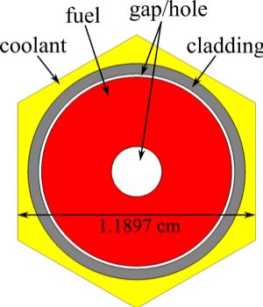  FIG. 1. MOX3600 pin cell [1]. | 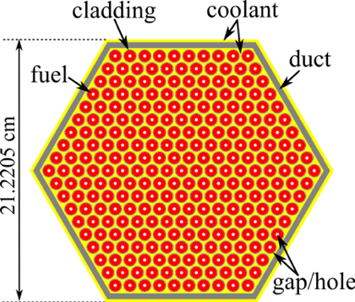  FIG. 2. MOX3600 assembly [1]. | 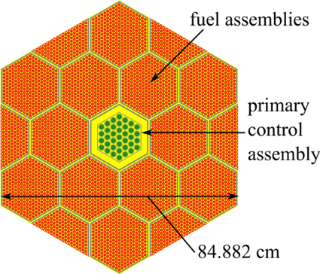  FIG. 3. MOX3600 super cell [1].

Calculation methodologies
Nine participating institutions have provided results for at least one of the exercises or one of the reactor designs, and additional participants might contribute in the future. A wide variety of calculation methods were used, as summarized in Table 1. Most of the participants used the ENDF/B-VII.1 cross section library [3]. Other applied libraries were JEFF 3.1 [4], JEFF 3.2 [5], JEFF 3.3 [6], ENDF/B-VII.0 [7] and ENDF/B-VIII.0 [8]. Nuclear data uncertainty and correlation data were mostly from SCALE’s ENDF/B-VII.1-based covariance library [9] and the COMMARA 2.0 library, which is a predecessor of ENDF/B-VII.1 [10]. Other applied covariance libraries were COMAC 1.0, COMAC 2.0 [11], ENDF/B-VII.1 [3], and SCALE’s ENDF/B-VIII.0–based library [8]. Both deterministic and Monte Carlo methods were used for the neutron transport calculations. For uncertainty and sensitivity analyses, participants used a variety of methods based on perturbation theory and random sampling.

TABLE 1. Overview of participating institutions and applied codes and methodologies.
Institution | Neutron transport code and method | Uncertainty analysis code and method
CEA | ERANOS [12], S_{N} BISTRO (S8) | ERANOS [12], sensitivity calculation (exact perturbation) + sandwich formula
NCSU | Serpent [13], CE-Monte Carlo | Serpent [13], perturbation theory (sandwich rule)
ANL/  NCSU | ARC codes through Workbench/PyARC (MC²-3 [14], DIF3D/VARIANT [15]) | PERSENT [16], generalized perturbation theory/ direct perturbation
HZDR | Serpent [13], Monte Carlo | Serpent [13], perturbation theory (sandwich rule)
NECP | SARAX [17], UFG-collision probability method + 3D Nodal S_{N} method | UNICORN [18], DNPM + sandwich rule
UNIST | MCS [19], Monte Carlo | MCS [19], generalized perturbation theory
GRS/  ORNL/  EPFL | SCALE/NEWT [9], 2D deterministic S_{N} | SCALE/TSUNAMI [20], perturbation theory (sandwich rule)
 |  | XSUSA [21], random sampling
 |  | SCALE/Sampler [22], random sampling
GRS | MCNP [23], CE-Monte Carlo | –
 | SCALE/NEWT [9], 2D deterministic S_{N} | XSUSA-LR [24], random sampling
ORNL | SCALE/NEWT [9], 2D deterministic S_{N} | SCALE/TSUNAMI [20], perturbation theory (sandwich rule)
 |  | SCALE/Sampler [22], random sampling

Preliminary results
The major differences between participants’ results were caused by the application of different nuclear data libraries. Therefore, the presented results here are distinguished according to the applied cross section library for the nominal values and the applied covariance library for the uncertainty results. The uncertainty results labelled ENDF/B-VII.1+ refer to SCALE’s ENDF/B-VII.1–based covariance library This library is mainly based on ENDF/B-VII.1 data, but it also contains additional data to fill in gaps such as missing fission spectrum uncertainties [9]; furthermore, data for ¹H, ²³⁵U and ²³⁹Pu were taken from a pre-release of ENDF/B-VIII.0. Correspondingly, ENDF/B-VIII.0+ refers to SCALE’s ENDF/B-VIII.0–based covariance library that contains the same additional data as the ENDF/B-VII.1–based library to fill in missing data.
Tables 1–3 provide the average nominal values and average uncertainties (arithmetic mean) determined from all contributed results. In the calculation of the average nominal results, multiple results with the same transport code based on the same library were only considered once. Many contributed results were based on transport codes, uncertainty analysis codes, and libraries of SCALE, so the average results are biased to some extent. Given the page limit, detailed results are only provided for the MOX3600 models (see figures provided in the Appendix).

Exercise I-1: Fuel pin cell
Table 1 presents the average results for both the MET1000 and the MOX3600 fuel pins. The eigenvalue uncertainties of 1.40 and 1.53% are clearly above the typical LWR eigenvalue uncertainties of ~0.5% [25]. While one of the major contributors of LWR eigenvalue uncertainty is the neutron multiplicity of ²³⁵U, the uncertainty of the fast-spectrum SFR system is mostly driven by inelastic scattering of ²³⁸U, which shows a large uncertainty in the fast energy range. The differences in the uncertainty of this cross section for the different covariance libraries result in different eigenvalue uncertainties as shown in Figure 5. Since the major driver of the investigated 1-group microscopic cross section uncertainties is in most cases the reaction itself and a major contribution originates from ²³⁸U inelastic scattering (for example, the major contributors to the 1-group microscopic ⁵⁶Fe elastic scattering reaction are ⁵⁶Fe elastic scattering and ²³⁸U inelastic scattering), differences in the uncertainties between the covariance libraries for the particular reaction and ²³⁸U inelastic scattering dominate the observed output uncertainty differences. The large uncertainty of the 1-group microscopic cross section of the ²⁴¹Pu capture reaction is mainly caused by the uncertainty of this reaction itself in the fast energy range. While the COMMARA and ENDF/B-VII.1 results are in good agreement as expected since much of the covariance data between the two libraries is consistent, the COMAC and ENDF/B-VIII.0 results show clear differences. As an example, the ²³⁸U inelastic scattering uncertainty is compared between the different covariance libraries in Figure 4.

TABLE 1. Average fuel pin cell results: Nominal values and uncertainties due to nuclear data. Microscopic cross sections are provided in barn, macroscopic cross sections in cm⁻¹.
 |  | MET1000 |  | MOX3600
 | Output | Nominal | Uncertainty | Nominal | Uncertainty
k_{eff} | Eigenvalue | 1.36293 | 1.40% | 1.19293 | 1.53%
1-group microscopic cross section | Coolant, Na23 el. | 4.01E+00 | 5.66% | 4.81E+00 | 4.82%
 | Cladding, ⁵⁶Fe el. | 3.52E+00 | 5.90% | 4.19E+00 | 5.53%
 | Fuel, ²³⁸U inel. | 1.05E+00 | 5.70% | 9.28E-01 | 5.76%
 | Fuel, ²³⁸U fission | 3.40E-02 | 7.07% | 4.21E-02 | 7.13%
 | Fuel, ²³⁹Pu fission | 1.62E+00 | 0.59% | 1.75E+00 | 0.60%
 | Fuel, ²⁴⁰Pu fission | 3.48E-01 | 3.90% | 3.58E-01 | 3.98%
 | Fuel, ²⁴¹Pu fission | 2.10E+00 | 1.02% | 2.47E+00 | 1.07%
 | Fuel, ²⁴²Pu fission | 2.45E-01 | 5.15% | 2.50E-01 | 5.26%
 | Fuel, ²³⁸U n,γ | 2.08E-01 | 1.81% | 2.78E-01 | 1.70%
 | Fuel, ²³⁹Pu n,γ | 2.95E-01 | 6.61% | 4.77E-01 | 5.77%
 | Fuel, ²⁴⁰Pu n,γ | 3.62E-01 | 4.24% | 4.95E-01 | 3.55%
 | Fuel, ²⁴¹Pu n,γ | 3.22E-01 | 17.89% | 4.39E-01 | 12.56%
 | Fuel, ²⁴²Pu n,γ | 2.98E-01 | 4.38% | 4.34E-01 | 4.48%
1-group macroscopic cross section | Fuel, fission | 5.31E-03 | 1.47% | 5.22E-03 | 1.47%
 | Fuel, absorption | 1.12E-02 | 0.95% | 1.26E-02 | 0.86%

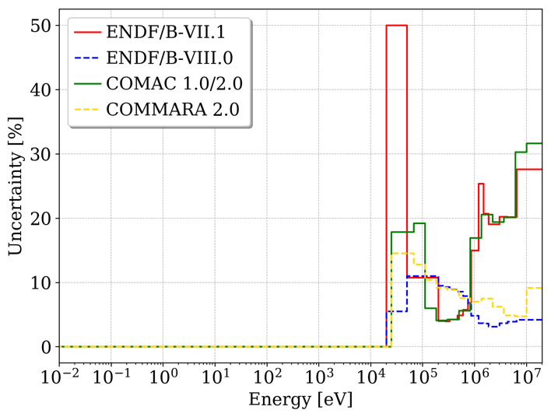
FIG. 4. Uncertainty of ²³⁸U inelastic scattering compared between different covariance libraries.

Exercise I-2: Fuel assembly
Table 2 presents the average results for the MET1000 and MOX3600 fuel assemblies. The same observations were made regarding the eigenvalue uncertainty and the different output uncertainties when using different covariance libraries that were made for the fuel pins. For the macroscopic absorption cross sections, the uncertainty of neutron capture in ²³⁸U and in several Pu isotopes plays an increased role; for the macroscopic fission cross sections, naturally the uncertainty of ²³⁹Pu provides a major contribution to the output uncertainty, and for the scattering cross sections, elastic scattering in ²³Na (coolant), ⁵⁶Fe (structure), and ²³⁸U play an import role. The Doppler constant uncertainty is driven by ²³⁸U inelastic scattering and not by ²³⁸U neutron capture, as in thermal spectrum systems. The uncertainty of the sodium void coefficient is naturally driven by scattering on ²³Na.

TABLE 2. Average fuel assembly results: Nominal values and uncertainties due to nuclear data. Reactivity coefficients are provided in pcm, macroscopic cross sections in cm⁻¹.  MET1000 MOX3600  Output Nominal Uncertainty Nominal Uncertainty  k_{eff} 1.2825 1.30% 1.1455 1.39%  Σ_{tot}, 1 1.73E-01 1.46% 1.99E-01 1.12%  Σ_{tot}, 2 2.17E-01 1.97% 2.68E-01 1.32%  Σ_{tot}, 3 2.79E-01 2.05% 3.26E-01 1.57%  Σ_{tot}, 4 3.98E-01 1.76% 4.42E-01 1.21%  Σ_{abs}, 1 5.83E-03 0.70% 6.50E-03 0.74%  Σ_{abs}, 2 3.14E-03 0.94% 3.29E-03 0.94%  Σ_{abs}, 3 5.40E-03 0.95% 5.85E-03 0.96%  Σ_{abs}, 4 1.24E-02 1.29% 1.49E-02 1.14%  νΣ_{fis}, 1 1.50E-02 1.05% 1.66E-02 1.00%  νΣ_{fis}, 2 4.82E-03 0.61% 5.11E-03 0.57%  νΣ_{fis}, 3 4.70E-03 0.61% 5.00E-03 0.59%  νΣ_{fis}, 4 7.75E-03 1.19% 9.33E-03 1.02%  Σ_{s}, 1 1.67E-01 1.59% 1.94E-01 1.26%  Σ_{s}, 2 2.17E-01 1.99% 2.68E-01 1.33%  Σ_{s}, 3 2.80E-01 2.09% 3.26E-01 1.60%  Σ_{s}, 4 3.98E-01 1.62% 4.37E-01 1.11%  K_{D} -339 5.81% -772 4.94%  Δρ_{Na} 5953 4.44% 3017 5.00% | TABLE 3. 4-group structure.  Group Upper Energy (eV)  1 20 MeV  2 820 keV  3 110 keV  4 15 keV

Exercise I-3: Supercell
Table 4 presents the average results for the MET1000 and MOX3600 supercells. Similar observations were made for the fuel assembly. The uncertainty of the control rod worth is driven by ²³⁸U inelastic scattering, not as may have been expected by the reactions of the absorber material. Other relevant reactions for this uncertainty are the scattering in ⁵⁶Fe and ²³Na.

TABLE 4. Average supercell results: Nominal values and uncertainties due to nuclear data. Reactivity coefficients are provided in pcm, macroscopic cross sections in cm⁻¹.
 | MET1000 |  | MOX3600
Output | Nominal | Uncertainty | Nominal | Uncertainty
k_{eff} | 1.0871 | 1.44% | 1.0768 | 1.47%
Σ_{tot}, 1 | 1.46E-01 | 1.66% | 1.53E-01 | 1.72%
Σ_{tot}, 2 | 2.02E-01 | 1.98% | 2.12E-01 | 1.92%
Σ_{tot}, 3 | 2.70E-01 | 1.85% | 2.85E-01 | 1.83%
Σ_{tot}, 4 | 4.08E-01 | 1.55% | 3.75E-01 | 1.45%
Σ_{abs}, 1 | 1.54E-03 | 1.10% | 1.89E-03 | 1.05%
Σ_{abs}, 2 | 4.97E-03 | 0.70% | 5.72E-03 | 0.69%
Σ_{abs}, 3 | 1.30E-02 | 0.31% | 1.48E-02 | 0.33%
Σ_{abs}, 4 | 3.45E-02 | 0.36% | 3.70E-02 | 0.36%
Σ_{s}, 1 | 1.45E-01 | 1.67% | 1.45E-01 | 1.74%
Σ_{s}, 2 | 1.97E-01 | 2.03% | 1.99E-01 | 1.97%
Σ_{s}, 3 | 2.57E-01 | 1.94% | 2.56E-01 | 1.93%
Σ_{s}, 4 | 3.74E-01 | 1.69% | 3.64E-01 | 1.61%
Δρ_{CR} | 12,429 | 2.57% | 4,995 | 2.40%

Summary and PRELIMINARY Conclusions
An overview of the objective and the specifications from the sub-exercises for the standalone neutronics phase of the UAM SFR benchmark were provided. The sub-exercises include fuel pin and assembly level exercises to allow for a straightforward identification of the drivers causing the differences between results obtained using different methods, models, and applied nuclear data libraries. The analysis covers nominal values and corresponding uncertainties of the eigenvalue, reactivity coefficients, and collapsed cross sections on the different levels of modelling.
Based on the 18 contributions to these sub-exercises from 9 international institutions, the results were discussed, and preliminary conclusions were drawn. Good agreement was found in the calculated nominal results for calculations based on the same nuclear data library. A similar conclusion was drawn for the comparison of submitted uncertainties: differences in the applied covariance data dominate the cause of differences between results obtained using different methods for the neutron transport calculation and uncertainty quantification. In particular, the uncertainties in ²³⁸U inelastic scattering were driving the uncertainties of many of the investigated output quantities. Other relevant reactions were ²³⁹Pu fission and the scattering reactions of ⁵⁶Fe in the structure and ²³Na in the coolant, originating in the combination of a significant sensitivity of the output quantities and a significant uncertainty of these reactions.
Particular differences between results were observed when using the COMAC or ENDF/B-VIII.0 covariance library compared to COMMARA and ENDF/B-VII.1 libraries. The uncertainties were in good agreement in many cases, but the ranking of the top contributors to the uncertainties showed significant differences in some cases. A more in-depth study with respect to the approach for the calculation of top contributors, as well as uncertainty comparisons between the library, are needed to improve the understanding of these differences.
ACKNOWLEDGMENTS
The Oak Ridge National Laboratory (ORNL) portion of this work was sponsored by the US Nuclear Regulatory Commission. The GRS contribution was supported by the German Federal Ministry for Economic Affairs and Energy. Argonne National Laboratory’s work was supported by the US Department of Energy (DOE) under Contract number DE-AC02-06CH11357.
References
- L. Buiron et al., Benchmark for Uncertainty Analysis in Modelling (UAM) for Design, Operation and Safety Analysis of SFRs, Core Definitions, Version 1.6. OECD/NEA (2019). Available to benchmark participants.
- K. Ivanov et al., Benchmark for Uncertainty Analysis in Modelling (UAM) for Design, Operation and Safety Analysis of LWRs, Volume I: Specification and Support Data for the Neutronics Cases (Phase I). NEA/NSC/DOC(2013)7 (2016). Available to benchmark participants.
- M. Chadwick et al., “ENDF/B-VII.1 Nuclear Data for Science and Technology: Cross Sections, Covariances, Fission Product Yields and Decay Data,” Nucl. Data Sheets, 112(12), pp. 2887–2996 (2011).
- A. Koning et al., “The JEFF-3.1 Nuclear Data Library,” Nuclear Energy Agency Data Bank, OECD, JEFF Report 21, NEA N° 6190 (2006).
- JEFF-3.2 evaluated data library (2021). https://www.oecd-nea.org/dbforms/data/eva/evatapes/jeff_32/.
- A. J. M. Plompen et al., The joint evaluated fission and fusion nuclear data library, JEFF-3.3. EPJ. A, 56, pp. 1–108 (2020).
- M. B. Chadwick, et al., “ENDF/B-VII.0: Next Generation Evaluated Nuclear Data Library for Nuclear Science and Technology,” Nucl. Data Sheets, 107(12), pp. 2931–3060 (2006).
- D. Brown et al., “ENDF/B-VIII.0: The 8th Major Release of the Nuclear Reaction Data Library with CIELO-project Cross Sections, New Standards and Thermal Scattering Data,” Nucl. Data Sheets, 148, pp. 1–142 (2018).
- W. A. Wieselquist, R. A. Lefebvre, and M. A. Jessee, Eds, SCALE Code System, ORNL/TM-2005/39, Version 6.2.4, Oak Ridge National Laboratory, Oak Ridge, Tennessee (2020). Available from Radiation Safety Information Computational Center as CCC-834. https://www.ornl.gov/file/scale-62-manual/display
- M. Herman et al., “COMMARA-2.0 Neutron Cross Section Covariance Library,” BNL-94830-2011 (2011).
- P. Archier et al., “COMAC: Nuclear Data Covariance Matrices Library for Reactor Applications,” Proceedings of PHYSOR 2014, Kyoto, Japan (2014).
- G. Rimpault et al., “The ERANOS Code and Data System for Fast Reactor Neutronic Analyses,” Proc. Int. Conf. PHYSOR 2002, Seoul, Korea, October 7–10 (2002).
- J. Leppanen, “Serpent: a Continuous-energy Monte Carlo Reactor Physics Burnup Calculation Code,” User’s Manual, VTT Technical Research Centre of Finland, Espoo, Finland (2012).
- C. Lee, and W. S. Yang. “MC²-3: Multigroup Cross Section Generation Code for Fast Reactor Analysis,” Nucl. Sci. Eng., 187(3):268–290 (2017).
- M. A. Smith, W. S. Yang, A. Mohamed, E. E. Lewis, “Perturbation and Sensitivity Tool Based on the VARIANT Option of DIF3D,” American Nuclear Society Transactions 107, San Diego, CA, Nov. 11–15 (2012).
- G. Aliberti and M. Smith, “PERSENT: Need of a Deterministic Code for Sensitivity Analysis in 3D Geometry and Transport Theory,” Proceedings of PHYSOR2014, Kyoto, Japan (2014).
- Youqi Zheng, Liang Qiao, Zi’an Zhai, Xianan Du, Zhitao Xu, “SARAX: A New Code for Fast Reactor Analysis Part II: Verification, Validation and Uncertainty Quantification,” Nucl. Eng. Des., 331, pp. 41–53 (2018).
- C. Wan et al., “Code Development for Eigenvalue Total Sensitivity Analysis and Total Uncertainty Analysis,” Ann. Nucl. Energy 85, pp. 788–797 (2015).
- H. Lee et al., “MCS – A Monte Carlo Particle Transport Code for Large-Scale Power Reactor Analysis,” EPJ A, 139, 107276 (2020).
- B. L. Broadhead et al., “Sensitivity- and Uncertainty-Based Criticality Safety Validation Techniques,” Nucl. Sci. Eng. 146, pp. 340–366 (2004).
- F. Bostelmann et al. “Sampling-Based Nuclear Data Uncertainty Analysis in Criticality and Depletion Calculations,” Proc. of ANS MC2015, Nashville, TN, April 19–23 (2015).
- M. L. Williams, et al., “A Statistical Sampling Method for Uncertainty Analysis with SCALE and XSUSA,” Nucl Technol., 183, pp. 515–526 (2013).
- T. Goorley et al., “Initial MCNP6 Release Overview,” Nucl. Technol., 180, pp. 298-315 (2012).
- W. Zwermann, N. Berner, A. Aures, K. Velkov, “Sensitivity and Uncertainty Analysis for the UAM-SFR Sub-Exercises with Linear Regression from Random Sampling,” Ann. Nucl. Energy, 149, 107832 (2020).
- D. Rochman et al., “Nuclear Data Uncertainties for Typical LWR Fuel Assemblies and a Simple Reactor Core,” Nucl. Data Sheets, 139, pp. 1–76 (2017).

APPENDIX
Besides the eigenvalue k_{eff}, the Doppler constant, sodium void worth and control rod worth, results are compared for collapsed 1-group microscopic or macroscopic cross sections. The labels of these cross sections specify material (if not averaged over the geometry), type (microscopic “mic” or macroscopic “mac”), reaction, nuclide (for microscopic cross sections).

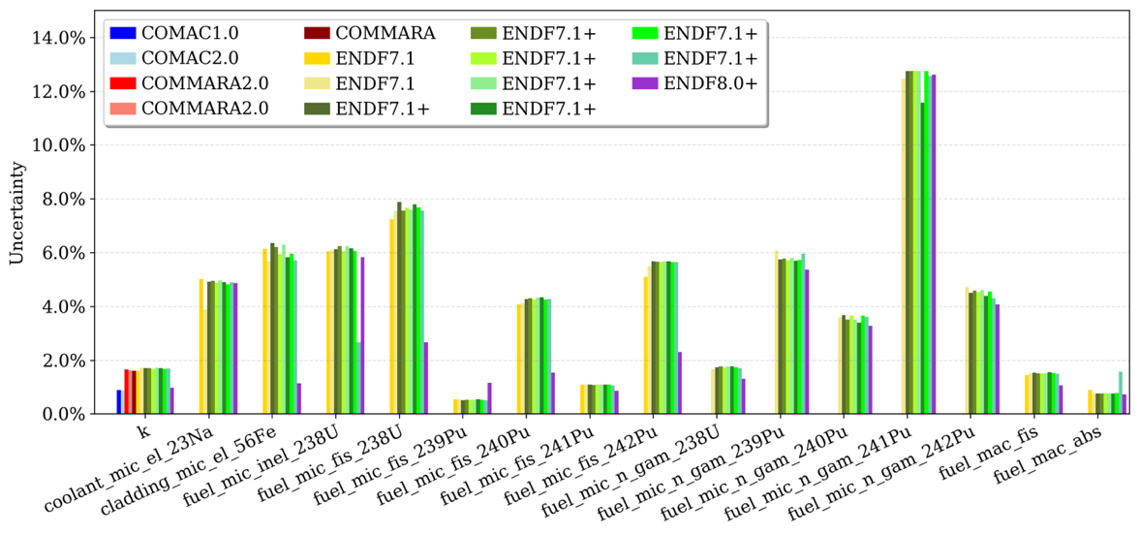
FIG. 5. MOX3600 pin cell: Uncertainty analysis results.
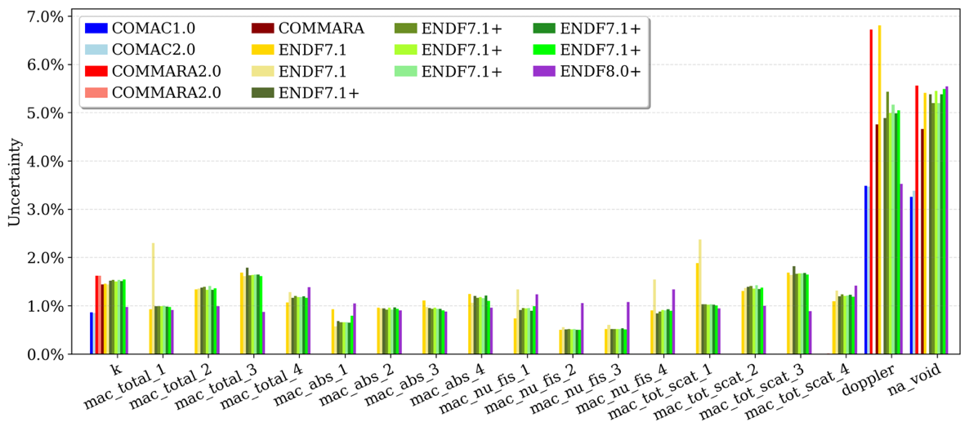
FIG. 6. MOX3600 fuel assembly: Uncertainty analysis results.
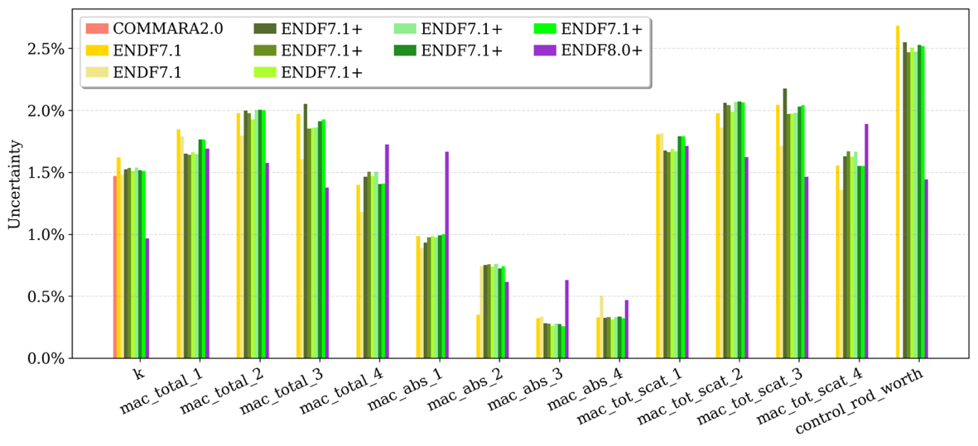
FIG. 7. MOX3600 supercell: Uncertainty analysis results.
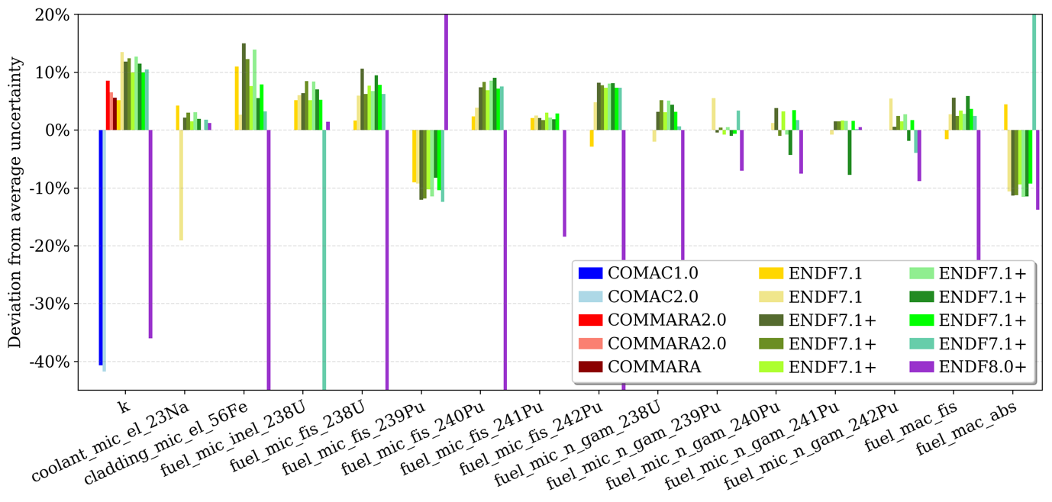
FIG. 8. MOX3600 pin cell: Relative difference of individual uncertainty results to corresponding mean value.
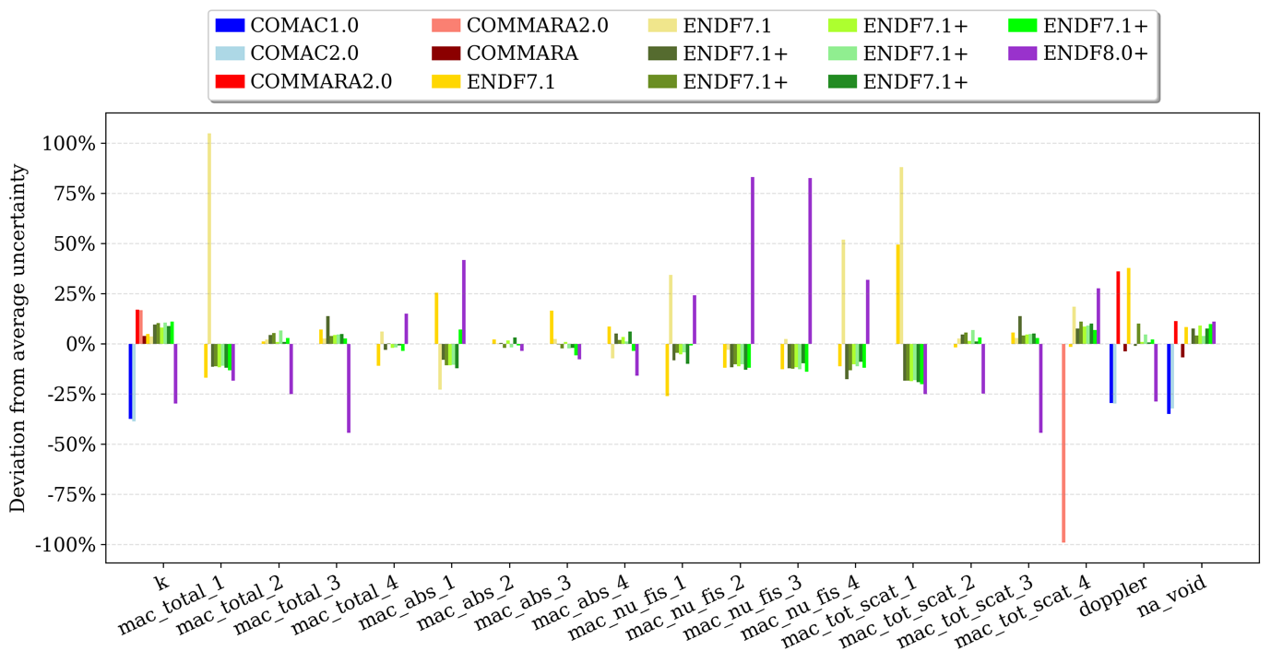
FIG. 9. MOX3600 fuel assembly: Relative difference of individual uncertainty results to corresponding mean value.
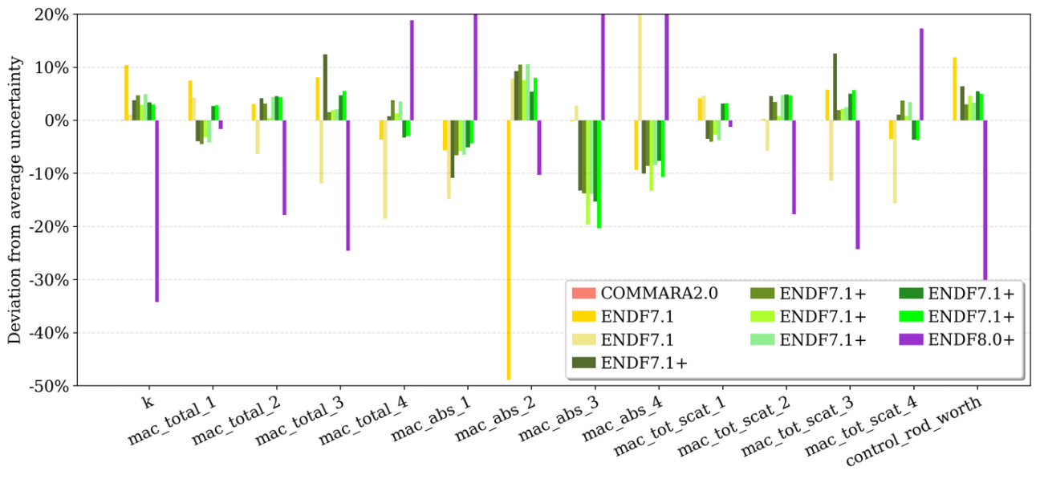
FIG. 10. MOX3600 supercell: Relative difference of individual uncertainty results to corresponding mean value.

This manuscript has been authored by UT-Battelle, LLC, under contract DE-AC05-00OR22725 with the US Department of Energy (DOE). The US government retains and the publisher, by accepting the article for publication, acknowledges that the US government retains a nonexclusive, paid-up, irrevocable, worldwide license to publish or reproduce the published form of this manuscript, or allow others to do so, for US government purposes. DOE will provide public access to these results of federally sponsored research in accordance with the DOE Public Access Plan (http://energy.gov/downloads/doe-public-access-plan).
See author affiliations for details on institutions.

