DISTINCTIVE FEATURES OF THE BN-800 CORE IN THE COURSE OF
TRANSITION TO COMPLETE MOX-FUEL LOADING

S.B. BELOV
JSC “Afrikantov ОКBM”
Nizhny Novgorod, Russia
Email: belovsb@okbm.nnov.ru

B.A. VASILYEV M.R. FARAKSHIN A.E. KUZNETSOV E.A. MUMRENKOV
JSC “Afrikantov OKBM”
Nizhny Novgorod, Russia

Abstract

To solve problems of the BN-800 transition from a hybrid core consisting of fuel subassemblies (FSAs) with pellet-type uranium oxide fuel and FSAs with pellet-type and vibro-packed MOX fuel to a core completely loaded with pellet-type MOX fuel (full MOX-fuel core), it is necessary to develop and implement a proper core design.
In the developed design it is provided that the transition is performed by replacement of hybrid core spent FSAs with fresh FSAs with pellet-type MOX-fuel. The FSAs shall be replaced during three sequential refuelings (eighth, ninth, and tenth refuelings of the core).
The paper compares configurations of the hybrid core and the full MOX-fuel core and shows change of the core composition at transition to complete loading with MOX-fuel.
The transition period is characterized by step-wise increase of neutron flux density in the core caused by nuclear distinctive features of plutonium relative to uranium-235. Nevertheless, corresponding increase of linear power of fuel pins of hybrid core FSAs operated in the transition period is compensated by fissile isotope content decrease in the course of fuel burnup.
The transition period has also some distinctive features concerning hydraulic characteristics. Change of ratio of quantities of FSAs of different types with different hydraulic resistance leads to correspondent re-distribution of sodium flowrates through them and to change of the total hydraulic resistance of the core.
The paper presents data on sodium pressure drop over the core and on the temperature state of FSAs during transition period. The paper shows that FSAs operation parameters do not exceed the justified values. No reactor power limitation is required during reactor operation in the transition period.

INTRODUCTION
The BN-800 reactor is the first Russian reactor designed to use mixed uranium and plutonium dioxide (MOX) fuel, including highly radioactive plutonium-based fuel. As a starting reactor loading, a hybrid core was created which is composed of enriched uranium FSAs (the most part of the core) and MOX FSAs fabricated at pilot production lines. The hybrid core has operated since 2016 during the first eight operation cycles, half a year each in duration.
Transition to a full MOX fuel core started in 2021 upon completion of fine-tuning of the pellet-type MOX fuel industrial production technology at FSUE “Mining and Chemical Combine” [1] and production of the first batch of FSAs for reactor refueling. A full set of MOX FSAs core (93% of the total quantity of FSAs in the core, with account of spare uranium FSAs utilization) is attainable after three reactor refuelings.

COMPARISON OF A HYBRID CORE AND A FULL MOX FUEL CORE CONFIGURATIONS
The start-up hybrid core was formed of uranium oxide FSAs and partially (16% of the total quantity) of FSAs with MOX fuel of two types: pellet-type and vibro-packed [2]. A pellet-type MOX FSA is designed like a full MOX core FSA with an upper sodium plenum. The rest of FSAs have a conventional design with an upper axial blanket (Figure 1). The height of a fuel column in all hybrid core FSAs is identical (900 mm) and matches the height of a full MOX fuel core.
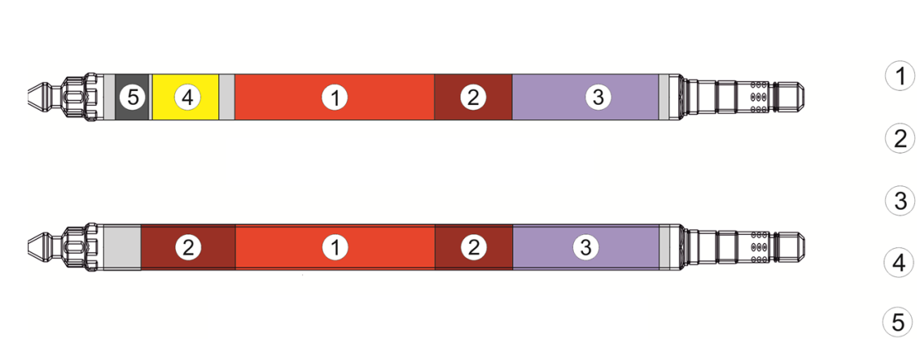
FSA with vibro-packed MOX fuel and FSA with UO₂ fuel
- core
- axial blanket
- gas plenum
- sodium plenum
- boron shield
Pellet-type MOX fuel FSA
Figure 1 FSA chematic

When the hybrid core operated, its composition changed as compared with the start-up core [2] subject to the volume of deliveries of MOX FSAs. Data regarding the quantity of various type FSAs in the hybrid core during its operation are given in Table 1.

Table 1. Hybrid core composition

Reactor operation cycle | Number of FSAs, pcs.
 | UO₂ | MOX  pellet-type | MOX  vibro-packed
1 | 468 (204/156/108)* | 54 | 36
2 | 474 (210/156/108) | 54 | 36
3 | 447 (210/156/ 81) | 54 | 63
4 | 441 (210/156/ 75) | 54 | 69
5 | 494 (210/200/ 84) | 10 | 60
6 | 546 (210/210/126) | - | 18
7 | 538 (210/192/136) | 18 | 8
8 | 538 (210/192/136) | 18 | 8
* Low Enrichment Zone (LEZ)/ Middle Enrichment Zone (MEZ) / High Enrichment Zone (HEZ)

Installation of permanent reactivity compensator SAs (similar in design to boron shielding SAs) instead of six LEZ FSAs in order to compensate excess reactivity is a specific feature of the start-up core loading [2]. They are replaced with FSAs after the first operation cycle.
All MOX FSAs are located within the boundaries of a high enrichment zone. The number of FSAs in different enrichment zones within 1-4 operation cycles matches a full MOX fuel core. After the forth and fifth operation cycles MEZ FSAs were installed into the core instead of spent pellet-type MOX FSAs.
The hybrid core layout in the eighth operation cycle - before starting transition to a full MOX fuel core and a full MOX fuel core layout [3] are given in Figure 1.

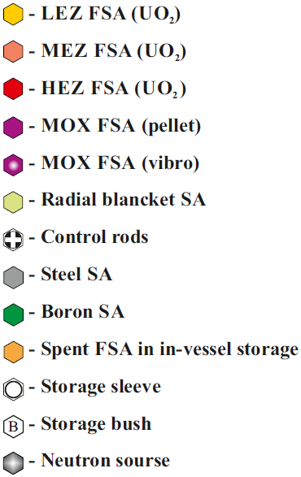

a) the hybrid core (Operation cycle 8)

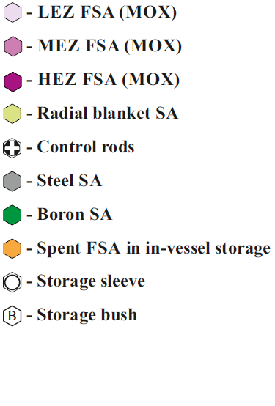

b) the full MOX-fuel core

Figure 2 Layout of the core before and after transition to a full MOX fuel core

The boundaries of the hybrid core fuel enrichment zones in the eighth operation cycle and of the full MOX fuel core are almost similar. The difference consists in a somewhat bigger (by 36 fuel assemblies) MEZ dimension.
In the hybrid and the transition core a ²⁵²Cf-based neutron source is applied to monitor refueling as part of a steel SA installed into the central core cell. A neutron source is not used in a full MOX fuel core since the proper MOX fuel neutron source is sufficient to monitor refueling.

PROCEDURE FOR FORMING A FULL MOX-FUEL CORE
The assigned lifetime of the hybrid core FSAs is accepted the same as for the full MOX fuel core:
- 465 equivalent full power days (three operation cycles of 155 efpd length) for the main array of fuel assemblies;
- 620 efpd (four operation cycles) for the peripheral FSAs, except for the FSAs with vibro-packed MOX fuel whose lifetime is limited to three operation cycles under the operation conditions.
During operation of the hybrid core, three refueling batches were formed for the main array of fuel assemblies and four groups for the peripheral fuel assemblies. Transition from the hybrid core to a full MOX fuel core shall be done in three subsequent refuelings, during which spent FSAs of the hybrid core are replaced with standard FSAs with industrially produced pellet-type MOX fuel. Apart from standard pellet-type MOX FSAs, single assemblies developed to be used in the hybrid core from among the spare FSAs, are installed into the transition core.
A scheme of FA refueling during operation of the transition core is given in Table 2.

Table 2. Scheme of FSAs refueling during operation of the transition core
(FSAs run time is presented in the number of operation cycles)

Reactor operation cycle No. | State | Main array FSAs  (480 pcs.) |  |  | Peripheral fuel FSAs  (84 pcs.)
 |  | Batch 1 | Batch 2 | Batch 3 | Batch 1 | Batch 2 | Batch 3 | Batch 4
8 | End | 3 | 3 2 | 1 | 3 | 1 | 4 | 2
9 | Beginning  End | 0  1 | 2 2  3 3 3 | 1  2 | 3  4 | 1  2 | 0  1 | 2  3 3
10 | Beginning  End | 1  2 | 0  1 | 2  3 | 0  1 | 2  3 | 1  2 | 3 3  4 4
Legend:
- unloading into in-vessel storage with subsequent unloading from the reactor
- reshuffling in the core

The following is used to minimize loss of fuel utilization performance by incomplete fuel burnup and to form equilibrium scattered batch distribution of FSAs during operation of the transition core:
- return of the incompletely irradiated FSAs from in-vessel storage to the core after the eighth operation cycle (loading six MEZ UO₂ FSAs with the run time of two operation cycles instead of spent MEZ UO₂ FSAs of the second batch of the main array);
- installation after the ninth operation cycle of HEZ UO₂ FSAs (from the second batch of the main array FSAs) with the lowest accumulation of radiation damage with the run time of three operation cycles, instead of eight spent peripheral FSAs with vibro-packed MOX fuel of the fourth group.
Changes in the core composition during transition to a full MOX fuel core are given in Table 3.

Table 3. Changes in the core composition during transition to a full MOX fuel core
Reactor operation cycle No. | Composition of the core |  |  |  |  |  |  | Note
 | LEZ |  | MEZ |  | HEZ
 | UO₂ | MOX  pellet-type | UO₂ | MOX  pellet-type | UO₂ | MOX  pellet-type | MOX  vibro-packed
8 | 210 | - | 192 | - | 136 | 18 | 8 | A hybrid core, ~5 % FSAs with MOX fuel
9 | 144 | 66 | 135 | 43 | 95 | 63 | 18 | Start of transition (~34 % FSAs with MOX fuel)
10 | 71 | 139 | 77 | 95 | 70 | 102 | 10 | ~61 % FSAs with MOX fuel
11 | 3 | 207 | 10 | 147 | 25 | 152 | 20 | ~93 % FSAs with MOX fuel

SPECIFICS OF OPERATION CONDITIONS FOR FSAS DURING TRANSITION TO A FULL MOX FUEL CORE
The neutron flux level in a full MOX fuel core is by ∼ 19% higher than in the hybrid core, which is due to nuclear physical properties of plutonium versus uranium-235. The transition period is characterized by step-wise increase in the neutron flux density in the core. Nevertheless, there is no increase in linear power of fuel pins of the hybrid core FSAs operated during the transition period since the content of fissionable isotopes decreases as the fuel burns up. The values of peak linear power of uranium fuel pins and MOX fuel pins during transition to a full MOX fuel core are given in Table 4.

Table 4. Change in the peak neutron flux density and linear power of fuel pins during transition
to a full MOX fuel core
Characteristic | Value for operation cycle
 | Hybrid core | Transition core |  | Full MOX fuel core
 | 8 | 9 | 10 | 11 | 12 and on
MOX FSAs fraction, % | 5 | 34 | 61 | 93 | 100
Peak neutron flux density, cm⁻²⋅с⁻¹ ·10¹⁵ | 6.9 | 7.4 | 7.7 | 8.1 | 8.2
Peak fuel pin linear power  for UO₂ FSA, kW/m | 48.0 | 48.0 | 47.0 | 46.4* | -
Peak fuel pin linear power  for MOX FSA, kW/m | 36.6 | 41.5 | 45.4 | 46.8 | 47.3
* - for UO₂ FSAs from among spare set.

Before starting transition to a full MOX-fuel core, the composition of the hybrid core differs from the initial one (for the first four operation cycles) due to the replacement of a significant part of MOX FSAs with UO₂ FSAs having a lower hydraulic resistance. To maintain the overall sodium flow rate through the core, a sodium pressure drop over the core in the eighth operation cycle shall be lower versus the nominal one (770 kPa).
During transition to a full MOX fuel core, resistance of the core will increase due to the replacement of UO₂ FSAs with MOX FSAs. The required sodium pressure drop over the core to maintain the nominal overall sodium flow rate through the core will be ensured by adjusting the primary sodium pump operation mode. Data on a sodium pressure drop over the core and the fuel pin cladding temperature during transition from a hybrid core to a full MOX fuel core are given in Table 5.

Table 5. Change in sodium pressure drop over the core and fuel pins temperature
Characteristic | Value for operation cycle
 | Hybrid core | Transition core |  | Full MOX fuel core
 | 8 | 9 | 10 | 11 | 12 and on
MOX FSAs fraction, % | 5 | 34 | 61 | 93 | 100
Sodium pressure drop over the core, kPa | 725 | 745 | 750 | 770 | 770
Peak fuel pin cladding temperature, °C | 702 | 708 | 704 | 706 | 691

Taking into account the actual (lower than the nominal) sodium pressure drop over the core and sodium flow rate values respectively, the peak fuel pin cladding temperature during reactor operation at nominal power is not over 708 °C, which does not exceed the maximum value of 710 °C justified in the fuel pins designs. Hence, it is not required to limit reactor power during the transition core operation period.

- CONCLUSION
Transition to a full MOX fuel core shall be done by subsequently replacing spent FSAs of the hybrid core with standard MOX fuel FSAs in three reactor refuelings. Fuel pins linear power for the hybrid core FSAs during the transition period, characterized by a step-wise growth of a neutron flux, is within the allowable design limits.
Sodium flow rate through the core, when its overall hydraulic resistance changes during the transition period, is maintained by adjusting the primary sodium pump operation mode.
The peak fuel pins cladding temperature during transition to a full MOX fuel core does not exceed the value justified in the fuel pins designs (710 °C).
In view of the above, it is not required to limit reactor power during operation of the transition core.

REFERENCES
- P.M. Gavrilov, I.A. Merkulov, I.A. Kravchenko, D.V. Druz “Creating MOX fuel production at FSUE Mining and Chemical Combine”. NTK-2014 “The next generation nuclear fuel for nuclear power plants”. Compilation of scientific conference paper abstracts. Moscow, 2014, 59 pages.
- Selecting the layout for the hybrid core of the BN-800 reactor / A.E. Kuznetsov, B.A. Vasiliev, M.R. Farakshin, A.N..Krukov, S.B. Belov, // Proc. of International Conference on Fast Reactors and related Fuel Cycles: next generation nuclear systems for sustainable development. – Vienna. – Austria. – 2018
- The BN-800 Core with MOX Fuel / A.E. Kuznetsov, B.A. Vasiliev, M.R. Farakshin, S.B. Belov, V.S. Sheryakov // Proc. of International Conference on Fast Reactors and related Fuel Cycles: next generation nuclear systems for sustainable development. – Vienna. – Austria. – 2018

