Comparison of calculation methods for
lead cooled fast reactor reactivity effects

Z.I. BÖRÖCZKI
Budapest University of Technology and Economics
Budapest, Hungary
Email: boroczki@reak.bme.hu

Á. ARANYOSY
Budapest University of Technology and Economics
Budapest, Hungary

M. SZIEBERTH
Budapest University of Technology and Economics
Budapest, Hungary

Email contact of corresponding author: boroczki@reak.bme.hu

Abstract

The application of Generation IV reactors offers improved sustainability of nuclear energy production and extends the current reserves while it helps to reduce the amount of nuclear waste. In fast reactors, due to its characteristic spectra and the reactor design, the effect of the leakage is much higher, which suggest the need of transport approximations with higher angular expansion for various analysis, such as sensitivity and uncertainty analysis. In this study three different reactivity feedback coefficients of the Advanced Lead-cooled Fast Reactor Demonstrator (ALFRED) reactor is analysed: the coolant temperature coefficient, the cladding expansion coefficient, and the fuel temperature coefficient. During the evaluations, the central difference direct perturbation method (DPM) and the linear perturbation theory (LPT) were applied to determine the feedback coefficients and their uncertainties. Multiple codes with fundamentally different calculation methods were employed during our investigations. The continuous energy SERPENT Monte Carlo code, the multigroup TSUNAMI-3D sequence of the SCALE program package, and PARTISN discrete ordinate neutron transport code coupled with SEnTRi developed by the authors was applied and the properties of these fundamentally different calculations are presented. Furthermore, uncertainty calculations were performed to estimate the uncertainty of the reactivity feedback coefficients due to cross-section data. In order to confirm the validity of the applied tools and methodologies, lead void coefficient calculations were performed for the Comet critical assembly and the results were compared with the published experimental data. The results confirm that good agreement can be reached between the different methods and with the measurement results with properly chosen calculation parameters. Besides the high-level transport approximation, the appropriate spatial resolution has outstanding importance to describe the high flux gradient. While Monte Carlo solutions may use more accurate geometry modelling deterministic solutions may be superior in respect to the uncertainty analysis of reactivity coefficients where small differences need to be determined.

INTRODUCTION
The Generation IV reactors are under extensive research in order to facilitate their commercial deployment as well as their introduction to the nuclear fuel cycle in the future. The use of these reactors offers an improved sustainability of nuclear energy production, the extension of current reserves, while they also help to reduce the amount of nuclear waste. On the Gen. IV International Forum in 2000 [1], six concepts were selected for further development, including the Lead-cooled Fast Reactor (LFR) design. Within the 7th European Framework Program (FP7), the objective of the Lead-cooled European Advanced Demonstration Reactor (LEADER) project was to design the Advanced Lead-cooled Fast Reactor Demonstrator (ALFRED) [2]. The construction and successful operation of ALFRED would be a milestone in the process of developing the LFR concept. Due to the limited experience with fast reactors, the design heavily relies on the results of numerical simulations. In particular, sensitivity and uncertainty analysis has huge importance to identify the fundamental physical processes and critical points of the system.
Sensitivity and uncertainty calculations have been performed for the gas-cooled fast reactor concepts in [3] and [4] with the direct and linear perturbation theory. Furthermore, in [5] the PORK code is presented to determine the explicit sensitivity coefficients and performs calculations like the SEnTRi code, which will be presented later in this study. In [6], the collision history approach was implemented to the SERPENT code and was used to study the coolant density reactivity feedback for the ALFRED and an SFR reactor design. Our earlier calculations on this topic were presented in [8], which indicated the importance of the leakage therefore the full core calculations in the reactivity effects. More extensive research is introduced in [9] for the reactivity effects of the ALFRED reactor core with direct perturbation theory and nuclear data uncertainty analysis, which is extended in [10] with the uncertainties from material properties. The effect of these uncertainties on safety margins is assessed in [11]. As the scope of the research extends to transient simulations, a deeper understanding of the physical processes behind the feedbacks became necessary [7]. In some cases, experimental data also support the results of calculations: a series of measurements were performed at the Los Alamos National Laboratory on a modified setup of the Comet Critical Assembly, in order to determine the void coefficient of lead in a fast neutron spectrum [12].
This paper presents sensitivity and uncertainty calculations for the Comet Critical Assembly and for the ALFRED reactor core. Reactivity coefficients and their uncertainties originating from the nuclear data were determined using several different codes and methods and the results were compared. To obtain reactivity coefficients, direct perturbation calculations were performed with the SERPENT [13] continuous energy (CE) Monte Carlo transport code, with the KENO multigroup Monte Carlo code from the SCALE [14] package, as well as with the PARTISN [15] multigroup discrete-ordinates neutron transport code. Sensitivity coefficients were computed with the iterated fission probability (IFP) [16] based method implemented in SERPENT and using linear perturbation theory implemented in TSUNAMI [17] (the sensitivity and uncertainty analysis sequence of SCALE). Additionally, they were calculated with the SEnTRi code developed recently by the present authors, being based on the linear perturbation theory, this code requires the calculation of the forward and adjoint flux moments, which were obtained using the PARTISN deterministic transport code. A more extensive description of the applied methods can be found in [22], with a detailed discussion of the nuclear data uncertainties with the most significant contributors.
The remainder of the paper is structured as follows. Section 2 describes the theory of the computational methods used in the calculations. Section 3 presents results of the lead void coefficient obtained for the benchmark experiment of the Comet Critical Assembly. In Section 4, three reactivity coefficients (the coolant temperature coefficient, the cladding expansion coefficient, and the fuel temperature coefficient) of the ALFRED reactor are analysed. Finally, a short conclusion is given in Section 5.

Methods and theory
Reactivity feedback coefficients describe the sensitivity of the multiplication factor $k$ for a change in one of the parameters $C$ of the system. Two methods to determine these parameters will be described: the central difference direct perturbation method (DPM) and the linear perturbation theory (LPT).

The direct perturbation method
When applying the DPM method, two eigenvalue calculations are performed by applying a positive and a negative change to one of the system parameters around its reference value. The reactivity feedback coefficient $α$ is then obtained by subtracting the reactivity $ρ$ from the two calculations and dividing the change in the system parameter $ΔC$:
$$α_{C}=\frac{∂ρ}{∂C}=\frac{ρ_{C_{0}+ΔC}-ρ_{C_{0}-ΔC}}{2ΔC}$$ | (1)
This method requires separate calculations for all parameters and may produce results with large relative errors, but it does not use any approximations, and all processes which stem from the change will be taken into consideration. Therefore, it represents a global reactivity effect and does not give an insight into the details of the physical phenomenon.

The linear perturbation theory
In the course of LPT calculations [18], the so-called sensitivity coefficients are determined, which quantify the relative change in the effective multiplication factor due to a small perturbation in the macroscopic cross-section.
$$S_{x}^{i}=\frac{Σ_{x}^{i}\left(\vec{r}\right)}{k}\frac{∂k}{∂Σ_{x}^{i}\left(\vec{r}\right)}=-\frac{Σ_{x}^{i}\left(\vec{r}\right)}{k}\frac{\left\langle ϕ^{†}\left(\vec{ξ}\right)\left(\frac{∂D}{∂Σ_{x}^{i}\left(\vec{r}\right)}-\frac{1}{k}\frac{∂F}{∂Σ_{x}^{i}\left(\vec{r}\right)}\right)ϕ\left(\vec{ξ}\right)\right\rangle }{\left\langle ϕ^{†}\left(\vec{ξ}\right)\frac{1}{k^{2}}Fϕ\left(\vec{ξ}\right)\right\rangle }$$ | (2)
In Eq. 2, $D$ stand for destruction operator in the Boltzmann transport equation, $F$ represents the fission source term, $Σ_{x}^{i}\left(\vec{r}\right)$ is the cross-section of the reaction in interest, and $ϕ$ and $ϕ^{†}$ denote the forward and adjoint flux, respectively. The $k$ is the effective multiplicity factor, $ξ$ represents the space vector, and $<,>$ denotes the integration on the full phase-space.
The greatest advantage of the use of the LPT, that these sensitivity coefficients can be computed for any energy group $g$, material $i$, reaction $x$, and geometrical region $z$ and therefore more details can be acquired about the system. However, the application is limited to problems where the higher-order terms of the perturbation and the perturbation of the flux are negligible. The reactivity feedback coefficient can be determined by the sensitivity parameters for those physical processes which affect the cross-section data, and it can be expressed with Eq. 3.
$$α_{C}=\frac{∂ρ}{∂C}=\frac{1}{k}\sum_{i=1}^{I}{\sum_{x=1}^{R}{\sum_{z=1}^{Z}{\sum_{g=1}^{G}{\left(S_{x,g,z}^{i}\frac{1}{Σ_{x,g,z}^{i}}\frac{∂Σ_{x,g,z}^{i}}{∂C}\right)}}}}$$ | (3)

Uncertainty analysis
With the use of the sensitivity coefficients one can calculate the uncertainty of the multiplication factor or any reactivity effect originating from the uncertainty of the nuclear data. In particular, the variance of the effective multiplication factor due to the uncertainty of a cross-section data of any isotopes and reaction can be written as:
$$σ_{k_{x,y}^{i,j}}^{2}=S_{x}^{i}C_{α_{x}^{i}α_{y}^{j}}S_{y}^{j}$$ | (4)
where $S_{x}^{i}$ denotes the region-integrated sensitivities and $C_{α_{x}^{i}α_{y}^{j}}$ represents the covariance matrix. The calculation of the variance of the reactivity effect goes in a similar way, but $S_{x}^{i}$ are replaced by the so-called reactivity response sensitivities defined as:
$$S_{ρ,x}^{i}=\frac{\frac{1}{k_{2}}S_{2,x}^{i}-\frac{1}{k_{1}}S_{1,x}^{i}}{\left|\frac{1}{k_{2}}-\frac{1}{k_{1}}\right|}$$ | (5)
To obtain $S_{ρ,x}^{i}$, the sensitivity coefficients and the effective multiplication factor need to be calculated for both the reference and the perturbed state, which means that the perturbation of the flux is taken into account for the reactivity effect and for its uncertainty.

The applied codes
The computation of the integral in Eq. (2) can be done with several methods. In order to assess the performances of these techniques for fast reactor applications, we used three codes that implement three different approaches to calculate the integrals. The SERPENT continuous-energy Monte Carlo code, the TSUNAMI sequence of the SCALE program package, which uses the KENO multi-group Monte Carlo program, and the PARTISN discrete ordinate neutron transport solver coupled with the SEnTRi code were used during our research.
In the SERPENT continuous-energy Monte Carlo code, the adjoint-weighting is performed by the implementation of the IFP method, while the perturbation of the operators is modelled by the perturbation of particle weights [19].
The method used by the latest version of multi-group TSUNAMI [17] requires less computational effort. First, a forward calculation is performed, and the angular moments of the flux are determined in a given spatial discretization. Then the moments of the adjoint flux are calculated in a similar manner during the adjoint calculation, and finally the integral in Eq. 2. is calculated for every cell by using the cell-wise flux values.
The PARTISN [15] is a discrete ordinates neutron transport code, which was developed at Los Alamos National Laboratory (LANL), was coupled with SEnTRi code (Sensitivity and Transient investigator), under development by the authors, was also used during the investigation as a deterministic approach to determine the sensitivity coefficients. To calculate these coefficients from the angular flux distributions generated by the PARTISN the same technique applied by the TSUNAMI [14] sequence was implemented into the code. Similar approaches have already existed, like the SUS3D code [20].
The TSAR module of the SCALE program package offers the opportunity to perform the uncertainty calculation although it is limited for the sensitivity coefficients calculated by TSUNAMI. In order to perform the analysis with the sensitivities determined by other codes, a new calculational tool was developed in the NTI. The reactivity response sensitivities are determined in the same way as it is done in the TSAR module, however, the error calculation was modified to take into account the variance of the effective multiplicity factor, as well. This results in higher deviations of the uncertainties when the reactivity differences are smaller.

Calculations for the COMET critical assembly and the validationof the applied methods
Lead void coefficient measurements [12] were performed during a collaboration between the Japan Atomic Energy Agency and Los Alamos National Laboratory on the Comet critical assembly. The Zeus series of critical experiments were performed on the Comet assembly, over the years between 1998 and 2004. The geometry, which contained highly enriched uranium (HEU) plates and various interstitial materials, was changed later, and recently it was used for the investigation of lead-void reactivity coefficient with added lead plates.
The Comet Critical Assembly is a zero-power reactor with many possible configurations. In this section, only one configuration, namely the Low-enrichment Uranium/Lead (LEU/Pb)[12], is introduced, which was used for our investigations and can be seen in Fig. 1. The core itself has a cylindrical shape, vertically split into two parts by a metal plate named the diaphragm and surrounded by slabs of a copper reflector. In this particular configuration, the units of which the core is built consist of thick natural uranium (NU) and thinner highly enriched uranium and lead plates stacked upon each other. During the experiments lead units were replaced with aluminium spacers in the center of the core right below the diaphragm, which is referred to as the test region. Various configurations were measured, beginning with the reference case, which contained no removed plates, followed by a series of void cases. In these cases, a different number of lead plates were removed from the center, namely two (2V), three (3V), and four (4V).
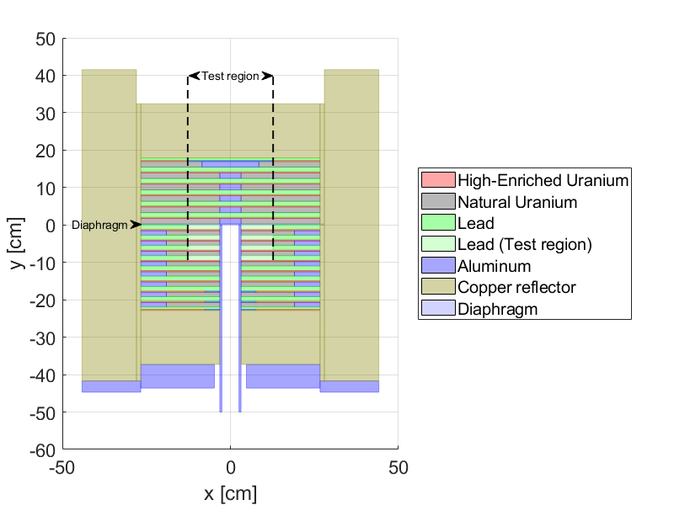
Fig. 1. The Comet critical assembly
In the Monte Carlo codes, the exact geometry description was applied for each cell, therefore the SCALE and SERPENT models are identical in every aspect. On the other hand to create the model for the PARTISN code some homogenization of the geometry was necessary and the lead plates sandwiched between two sheets of aluminium were mixed together. A sensitivity study was done for different quadrature sets in PARTISN and as a result, the built-in $S_{12}$ triangular Gauss-Chebyshev quadrature set was applied. The sensitivity coefficients were computed in the SCALE 252-group structure with all three codes and the uncertainty analysis was done with the same structure with the SCALE and the SEnTRi codes. However, due to the prohibitive computation effort required to reach proper statistics, in the SERPENT uncertainty calculation the SCALE 56-group structure was applied. Based on Eq. 3. the following formula was applied to determine the reactivity worth of the lead plates with LPT:
$$∂ρ=\frac{1}{k}\sum_{i=1}^{I}{\sum_{x=1}^{R}{\sum_{z=1}^{Z}{\sum_{g=1}^{G}{\left(S_{x,g,z}^{i}\frac{∂Σ_{x,g,z}^{i}}{Σ_{x,g,z}^{i}}\right)}}}}=\frac{1}{k}\sum_{i}^{Pb}{\sum_{x=1}^{R}{\sum_{z}^{Test}{\sum_{g=1}^{G}{\left(S_{x,g,z}^{i}\frac{-n}{n_{0}}\right)}}}}$$ | (6)
where summation for index $i$ and $z$ goes for the Pb isotopes and the volumes of the test region, respectively, $n/n_{0}$ denotes the number of lead plates exchanged in the system and divided up with the total number of plates in the test regions.

Sensitivity and uncertainty calculations for the Comet Critical Assembly
In order to compare the different methods produced by the three different codes and to achieve a better understanding of the system and the effects of the different options in the codes numerous analyses were performed. The final results from these calculations are summarized in Fig. 2, which indicates that all codes were able to produce adequate results compared to the measured data.
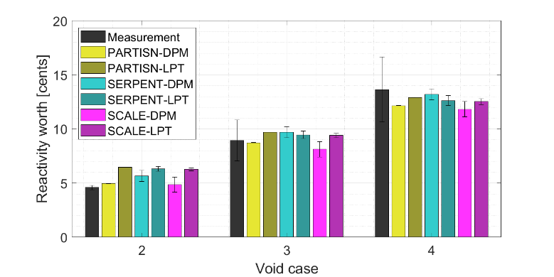
Fig. 2. Void reactivity worth calculated by the three codes and with the two method for the three cases
The energy-dependent contributions of the different reactions can be calculated from the sensitivity coefficients and compared in Fig. 3. The contributions for the reactivity worth were divided into 3 main reactions: elastic, non-elastic scattering, and capture reactions. One can observe that the positive lead void effect can be associated to the lead inelastic scattering above 1 MeV since that produce low energy neutrons with less importance in a core with fast neutron spectrum. This is partially compensated by the negative effect of the elastic scattering which is due to higher leakage probability in the absence of the scattering on lead. The low absorption cross-section of lead produces a minor positive effect. Even though the group-wise contributions of the elastic scattering and the capture reaction agree well for all cases, a small deviation can be observed for the elastic scattering, which is strongly related to the leakage and therefore the angular and spatial distribution of the flux. The estimation of the TSUNAMI sequence gives a higher negative contribution for the lower energy groups, however, it does not cause a significant difference in the global estimation.
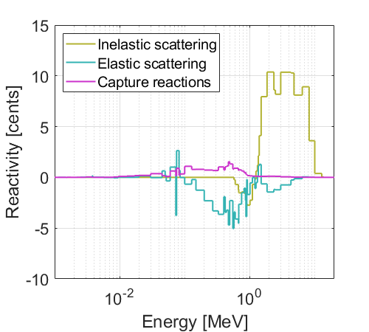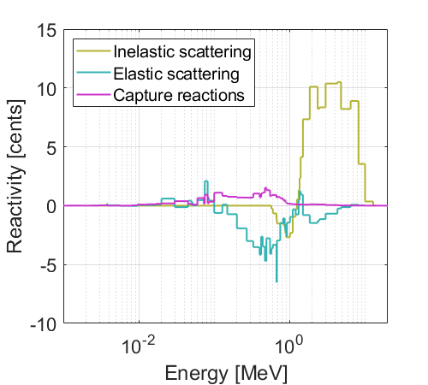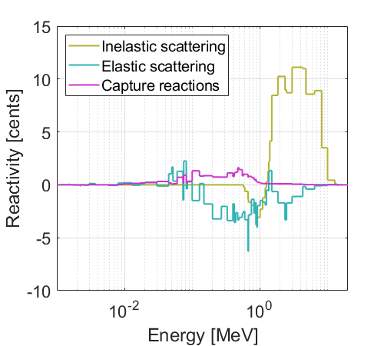
Fig. 3. The group wise contribution of the three main reaction type to the void reactivity worth for the V4 case divided by the unit lethargy calculated by three codes (SCALE, SEnTRi, SERPENT)
The relative uncertainty of reactivity worth was calculated with sensitivity coefficients from the TSUNAMI sequence and the SEnTRi code using the 252-group covariance library of the SCALE code system. The uncertainty analysis was also performed with sensitivity coefficients calculated by the SERPENT code in 56-group with the 56-group covariance library. The total uncertainties estimated by the three codes are listed in Table. 1 and the results are in good agreement with each other.

TABLE 1. Comparison of the nuclear data uncertainties of the lead void coefficient and their standard deviations.

 | SEnTRi |  | SCALE |  | SERPENT
Uncertanity [%] | 26.025 | ±0.012 | 22.641 | ±0.729 | 24.140 | ±0.784

Calculations for the ALFRED reactor
A detailed description of the ALFRED reactor core can be found in Ref. [21] and the layout of the core is shown in Fig. 4. ALFRED has a pool-type configuration and is going to utilize MOX fuel in two different enrichments. The core can be divided into three concentric regions. The inner fuel region contains 57 hexagonal, and 4 safety assembly. The outer fuel region is made up of 114 fuel assemblies and contains 12 control assemblies. In addition, the core is surrounded by 110 dummy assemblies, which serve as reflector for the core. This layout and different enrichments result in more uniform power distribution in the core. Each fuel assembly contains 127 fuel pins arranged in hexagonal lattice and have total height of $139 \text{cm}$ with the active length of $60 \text{cm}$. ALFRED is designed to generate $300 \text{MW}$ thermal power at nominal conditions which is converted to approximately $125 \text{MW}$ electric power in the secondary cycle and supplied to the grid. All calculations were performed for the Beginning Of Life (BOL) state and material composition.
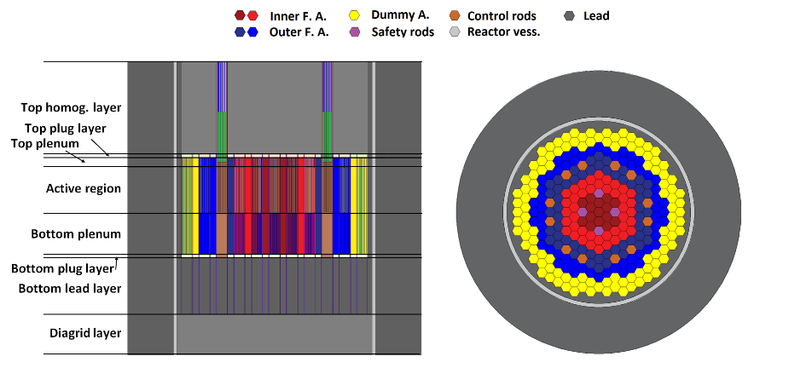
Fig. 4. The ALFRED reactor core design [8]

Approximations and model description
The SCALE and SERPENT detailed geometry models were constructed based on Ref. [21] applying all the suggested approximations. However, to perform the calculations with the PARTISN code, a cylindrical approximation of the geometry, and employment of the homogenized cross-section libraries was necessary.
The main aim of our investigations was to determine three reactivity feedback coefficients for the ALFRED reactor and the uncertainty originating from the nuclear data with different codes and methods. The coolant temperature coefficient (CTC), the cladding expansion coefficient (CEC), and the fuel temperature coefficient (FTC, Doppler) were investigated in these calculations. In order to perform the calculations with LPT, the sensitivity coefficients were calculated for the reference and with some assumptions in Eq. 3 the Eq. 8, 9 and 10 can be derived.
$$α_{T_{Cl}}=\frac{1}{k}\sum_{i=1}^{I}{\sum_{x=1}^{R}{\sum_{z=1}^{Z}{\sum_{g=1}^{G}{\left(S_{x,g,z}^{i}\frac{1}{V}\frac{∂V_{Pb}}{∂R_{Cl}}R_{Cl}ν\left(T_{Cl}\right)\right)}}}}$$ | (7)
$$α_{T_{Co}}=\frac{1}{k}\sum_{i=1}^{I}{\sum_{x=1}^{R}{\sum_{z=1}^{Z}{\sum_{g=1}^{G}{\left(S_{x,g,z}^{i}\frac{1}{γ\left(T_{Co}\right)}\frac{∂γ\left(T_{Co}\right)}{∂T_{Co}}\right)}}}}$$ | (8)
$$α_{T_{D}}=\frac{1}{k}\sum_{i=1}^{I}{\sum_{x=1}^{R}{\sum_{z=1}^{Z}{\sum_{g=1}^{G}{\left(S_{x,g,z}^{i}\frac{ΔΣ_{x,g,z}^{i}}{ΔT_{f}}\right)}}}}$$ | (9)
In all three cases of the DPM calculation, a roughly 200 °C temperature difference was targeted to achieve sufficiently high reactivity differences and remain close to the linear range of the perturbation. The assumption that the expansion of the cladding only influences the quantity of the coolant in the unit cell was used in the LPT calculation of the cladding expansion coefficient $α_{T_{Cl}}$. A $0.00152 \text{cm}$ increase in the claddings outer diameter$R_{Cl}$ was applied in DPM which corresponds to roughly $150 °C$ change in its temperature. In Eq. 8 $γ\left(T_{Co}\right)$, the temperature-dependent density of the coolant was altered by $209 °C$ to perform the calculations for the coolant temperature coefficient $α_{T_{Co}}$. Therefore, the density was changed in the DPM calculation by $0.25{\text{g}\text{/}\text{cm}}^{3}$ in the active region and the top reflector region since these are the domains which would be affected first by a presumed change in heating power. For the Doppler coefficient $α_{T_{D}}$ resonance-corrected cross-sections were calculated with the CSASI module of the SCALE code package for an $200 °C$ increased temperature to perform the LPT calculations and in the DPM calculations, the fuel temperature was increased accordingly.

Sensitivity and uncertainty calculations for the ALFRED reactor
The three reactivity feedback coefficients (the coolant temperature coefficient, the cladding expansion coefficient, and the fuel temperature coefficient) was determined with the three codes and with the direct perturbation method and the linear perturbation theory, and are compared in Fig. 5, Fig. 8, and Fig. 9.
In the LPT calculations the coefficients can also be divided according to contributing regions. For the CTC calculations two domains were separated: an active and an upper region, which were chosen with the consideration that the increasing power would change the temperature in these parts of the reactor first. In Fig. 6, and Fig. 7 the results from the different codes are compared by the reaction and energy dependent contributions for the given domains. The inelastic scattering and the capture reactions give a positive contribution, primary in the active region, for this coefficient. As the number density of the lead decreases, the loss rate of neutrons decreases due to the capture reactions and the efficiency of thermalization is also reduced due to the inelastic scattering. These effects will result a spectrum hardening and a positive feedback in fast reactor design. The energy dependence of the average number of emitted neutrons per fission is greater over higher energies and consequentially, high-energy neutrons have a higher importance. However, the elastic scattering can compensate these effects since the decreasing quantity of lead in the core also leads to a higher leakage. This effect gives a high negative contribution in both regions. The reaction and energy dependent values are in an outstanding agreement for the capture and inelastic scattering, however small differences can be observed for the elastic scattering. In Fig. 5 the cumulated coefficients estimated with LPT are compared for the two regions and the total coefficients are also compared to the DPM results. The opposing effects results smaller contribution in the active region, while the increasing leakage in the upper reflector is more relevant.
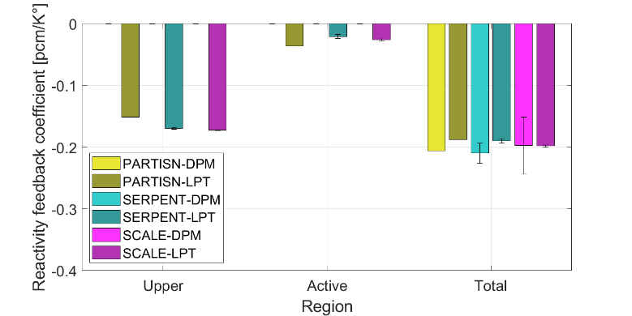
Fig. 5. Coolant temperature coefficient calculated by the three codes and with the two method. In the case of LPT calculations, the contributions of the effected regions are also presented.
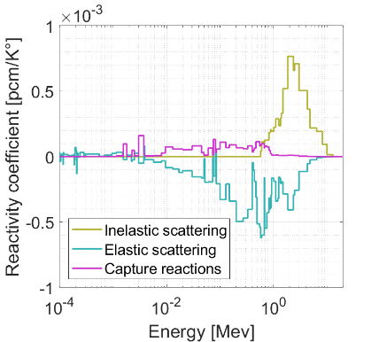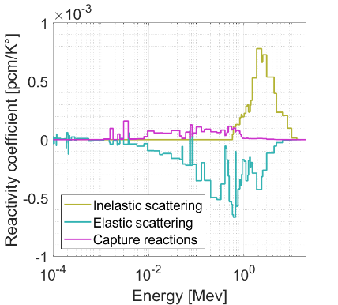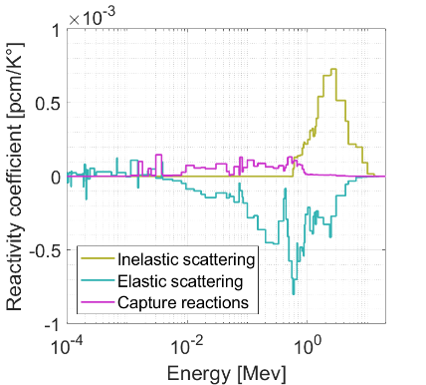
Fig. 6. The group wise contribution of the three main reaction type to the coolant temperature reactivity coefficient divided by the unit lethargy calculated by three codes for the active region. (SCALE, SEnTRi, SERPENT)
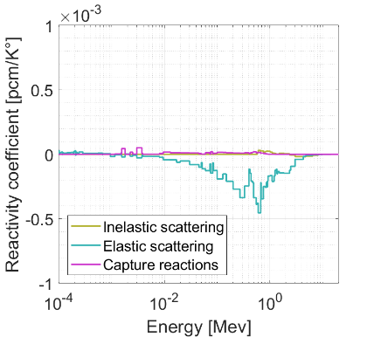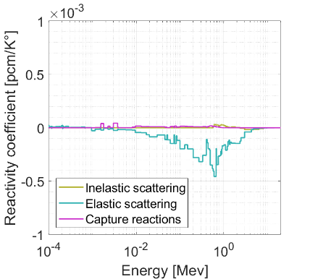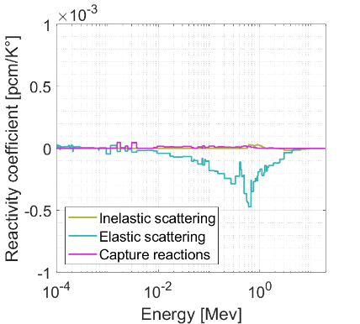
Fig. 7. The group wise contribution of the three main reaction type to the coolant temperature reactivity coefficient divided by the unit lethargy calculated by three codes for the upper region. (SCALE, SEnTRi, SERPENT)
It was shown in [8] that the expansion of the cladding is analogous to the decreased density of the lead, which allows the assumption in Eq. 9. Therefore, similar results are obtained along the same earlier presented considerations, however the expansion of the cladding effects the lead above and below the active region. In this case the feedback coefficient was divided up to three components and are compared to each other and DPM results in Fig. Fig. 8. Even though the DPM results of the Monte Carlo codes has a high uncertainty, as $0.00152 \text{cm}$ change in the radius equals to $\sim 10 \text{pcm}$ reactivity change, the results from the different codes and methodologies are in a good agreement.
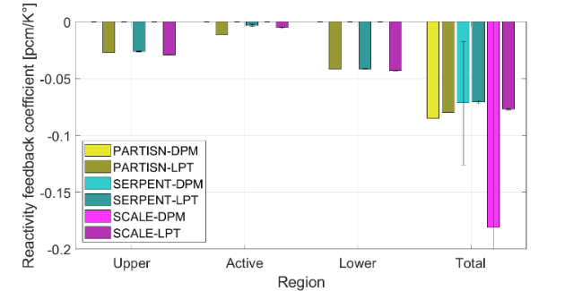
Fig. 8. Cladding expansion coefficient calculated by the three codes and with the two method. In the case of LPT calculations, the contributions of the effected regions are also presented.
It is visible, on Fig. Fig. 9, that the values of Doppler coefficients from different methods and codes are very close to each other. The sign of the coefficients is negative in all cases, and due to the larger fertile isotope ratio in the fuel composition of the inner fuel assemblies have stronger feedback.
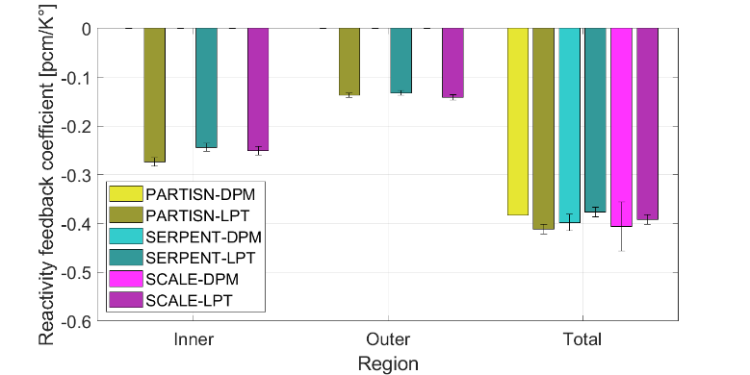
Fig. 9. The fuel temperature coefficient (Doppler) calculated by the three codes and with the two method. In the case of LPT calculations, the contributions of the effected regions are also presented.
The nuclear data uncertainty of the reactivity coefficients was determined from sensitivity coefficients calculated by the TSUNAMI sequence and SEnTRi code. The same 252-group covariance library of the SCALE code system were applied in these estimations, and the final uncertainties are shown in Table 2. The calculations from sensitivity coefficients of the SCALE code have fairly high errors compared to the deterministic method, however the total uncertainty agrees quite well. In these cases, especially for the cladding expansion coefficient, reactivity response sensitivities suffer from high errors due to the small difference between effective multiplicity factors of the two states. This error causes a significant standard deviation for the final uncertainness. This effect becomes more significant as the reactivity difference decreases and the error of the effective multiplicity factor becomes more relevant, which can be observed for the calculations of the Cladding expansion.
In [9] the 44-groups covariance matrix of SCALE6.1 was used and larger differences were taken in to account during the calculation of the perturbed states, which resulted in a higher reactivity effect and a better standard deviation in the final uncertainties. As the calculations were performed for different perturbed states and the Beginning of Cycle fuel composition (BoC) the results are quite hard to compare, however, the contributors appear in similar order and magnitude.

TABLE 2. Comparison of the nuclear data uncertainties of the three reactivity feedback coefficients and their standard deviations.

Uncertainty [%] | PARTISN |  | SCALE
Fuel temperature coefficient | 3.932 | ±0.015 | 6.696 | ±1.448
Coolant temperature coefficient | 10.799 | ±0.109 | 10.359 | ±8.514
Cladding expansion coefficient | 8.988 | ±0.371 | 8.342 | ±45.08

Conclusion
In this paper, reactivity feedbacks were studied by direct and linear perturbation theory in order to analyse the efficiency and accuracy of fundamentally different calculation methods. The continuous energy SERPENT Monte Carlo code, the multigroup TSUNAMI-3D sequence of the SCALE program package, and the PARTISN discrete ordinate neutron transport code coupled with the newly developed SEnTRi was used.
In order to verify these computational methods, a benchmark experiment carried out on the COMET Critical Assembly was modelled with the different codes and the lead void coefficient and its uncertainty were determined. The elastic scattering gave large negative contribution to the final void coefficient, however, the contribution of the inelastic scattering and capture reactions determine the positive feedback. The uncertainty of the reactivity worth of the lead due to the uncertainty of nuclear data was estimated by using the sensitivity coefficient determined by the three codes, with good agreement. The high uncertainties imply that cross-section databases should be improved further to be fit for fast-reactor simulations.
Following this validation exercise and based on the gained experiences three reactivity feedback coefficients of the ALFRED reactor were determined with the two methods and three codes: the coolant temperature coefficient, the cladding expansion coefficient, and the fuel temperature coefficient. Similar effects were observed during the energy and reaction dependent analysis on the feedback coefficients, which confirmed the conclusions on the previous calculations on the COMET critical system. The uncertainties of the feedback coefficients were determined from the sensitivities generated by the SEnTRi code and the TSUNAMI sequence. The match between the results was satisfactory, however, the calculations with the SEnTRi code provides smaller variance due to its deterministic background. A more detailed discussion is available in [22] about the applied methods and a detailed study on the most significant contributors to the nuclear data uncertainties.
ACKNOWLEDGEMENTS
The research reported in this paper and carried out at the Budapest University of Technology and Economics was supported by the “TKP2020, National Challenges Program” of the National Research Development and Innovation Office (BME NC TKP2020).

References
- U. S. Department of Energy, A technology roadmap for generation IV nuclear energy systems, Nuclear Energy Research Advisory Committee and the Generation IV International Forum (2002).
- A. Alemberti, M. Frogheri and L. Mansani, The Lead Fast Reactor: Demonstrator ALFRED and ELFR Design, International Conference on Fast Reactors and Related Fuel Cycles, Paris, France 1 (2013) 233–247.
- Z. Perko, S. Pelloni, K. Mikityuk, J. Krepel, M. Szieberth, G. Gaetan, B. Vrban, J. Luley, S. Cerba, M. Halasz, S. Feher, T. Reiss, J. L. Kloosterman, R. Stainsby, and C. Poette, Core neutronics characterization of the GFR2400 Gas Cooled Fast Reactor, Progress in Nuclear Energy 83 (2015) 460–481.
- J. Lüley, B. Vrban, S. Cerba, J. Hascik, V. Necas, S Pelloni, Sensitivity and Uncertainty Analysis of the GFR MOX Fuel Subassembly. Nuclear Data Sheets 118 (2014): 545-547.
- F. Osuský, S. Cerba, J. Lüley, B. Vrban, J. Hascík, V Necas, On gas-cooled fast reactor designs–Nuclear data processing with sensitivity, uncertainty and similarity analyses. Progress in Nuclear Energy 128 (2020): 103450.
- M. Aufiero, M. Martin, M. Fratoni, E. Fridman, and S. Lorenzi, Analysis of the coolant density reactivity coefficient in LFRs and SFRs via Monte Carlo perturbation/sensitivity, in: Proceedings of The Physics of Reactors Conference, Sun Valley, Idaho, U. S., 2016, pp. 3493–3504.
- A. D. Perez-Valseca, G. Espinosa-Paredes, J. L. Francois, A. Vazquez-Rodriguez, and C. Martin-del-Campo, Stand-alone core sensitivity and uncertainty analysis of ALFRED from Monte Carlo simulations, Annals of Nuclear Energy 108 (2017) 113–125.
- P. German, Á. Aranyosy, Z. Böröczki, and M. Szieberth, Sensitivity and uncertainty studies for the ALFRED lead cooled reactor core, PHYSOR, Cancun, Mexico (2018).
- G. Grasso, F. Lodi, P. Romojaro, N. Garcia-Herranz, F. Alvarez-Velarde, D. Lopez, E. Bubelis, G. Bandini, Stress-testing the ALFRED design – Part I: Impact of nuclear data uncertainties on Design Extension Conditions transients, Progress in Nuclear Energy 106 (2018) 372–386.
- F. Lodi, G. Grasso, F. Alvarez-Velarde, D. Lopez, E. Corsetti, D. Gugiu, Stress-testing the ALFRED design-Part II: Quantification of uncertainties on the fuel assembly temperature field, Progress in Nuclear Energy 105 (2018) 301–308.
- F. Lodi, G. Grasso, Stress-testing the ALFRED design-Part III: Safety margins evaluation, Progress in Nuclear Energy 106 (2018) 433–439.
- M. Fukushima, J. Goda, J. Bounds, T. Cutler, T. Grove, J. Hutchinson, M. James, G. McKenzie, R. Sanchez, A. Oizumi, H. Iwamoto, and K. Tsujimotoa, Lead Void Reactivity Worth in Two Critical Assembly Cores with Differing Uranium Enrichments, Nuclear Science and Engineering 189 (2018) 93–99.
- J. Leppänen, M. Pusa, T. Viitanen, V. Valtavirta, T. Kaltiaisenaho, The Serpent Monte Carlo code: Status, development and applications in 2013, Annals of Nuclear Energy 82 (2015) 142–150.
- B. T. Rearden and M. A. Jessee, SCALE code system, Tech. rep., Oak Ridge National Laboratory (ORNL) (2018).
- R. E. Alcouffe, R. S. Baker, J. A. Dahl, S. A. Turner, and R. C.Ward, PARTISN: A Time-Dependent, Parallel Neutral Particle Transport Code System, Tech. rep., LA-UR-08-7258, Los Alamos National Laboratory (2008).
- Y. Nauchi, T. Kameyama, Development of calculation technique for Iterated Fission Probability and reactor kinetic parameters using continuous energy Monte Carlo method, Journal of nuclear science and technology 47 (11) (2010) 977–990.
- B. T. Rearden, M. L. Williams, M. A. Jessee, D. E. Mueller, and D. A. Wiarda, Sensitivity and uncertainty analysis capabilities and data in SCALE, Nuclear Technology 174 (2) (2011) 236–288.
- C. R. Weisbin, E. M. Oblow, J. H. Marable, R. W. Peelle, and L. J. Lucius, Application of Sensitivity and Uncertainty Methodology to Fast Reactor Integral Experiment Analysis, Nuclear Science and Engineering 66 (3) (1978) 307–333.
- M. Aufiero, A. Bidaud, M. Hursin, J. Leppänen, G. Palmiotti, S. Pelloni, P. Rubiolo, A collision history-based approach to sensitivity/perturbation calculations in the continuous energy Monte Carlo code SERPENT, Annals of Nuclear Energy 85 (2015) 245–258.
- I. Kodeli, Multidimensional Deterministic Nuclear Data Sensitivity and Uncertainty Code System: Method and Application, Nuclear Science and Engineering 138 (1) (2001) 45–66.
- G. Grasso and L. Mansani, ALFRED core and plant specifications, ESNII+ report D6.1.1-3, UTFISSM-PD21-001 (2014).
- Z. I. Böröczki, Á. Aranyosy, M. Szieberth. "Comparison of calculation methods for lead fast reactor reactivity effects". Annals of Nuclear Energy, 171 (2022) 109042.

