THERMO-HYDRAULIC TESTS IN JUSTIFICATION
OF DESIGN CHARACTERISTICS
OF THE BREST-OD-300 RP STEAM GENERATOR

V.A. GRABEZHNAYA
State Scientific Centre of the Russian Federation –
Leypunsky Institute for Physics and Power Engineering,
Joint-Stock Company (IPPE JSC)
Obninsk, Russian Federation
Email: gva@ippe.ru

A.S. MIKHEYEV, Yu.A. KUZINA
State Scientific Centre of the Russian Federation –
Leypunsky Institute for Physics and Power Engineering,
Joint-Stock Company (IPPE JSC)
Obninsk, Russian Federation

Abstract

In order to substantiate the design characteristics of the steam generator of the BREST-OD-300 reactor plant developed at NIKIET JSC, the IPPE JSC carried out thermo-hydraulic tests of various models of the lead-heated steam generator. Initially, a model of a helically coiled steam generator was tested. It consisted of two three-tube modules with a longitudinal lead flow around a bundle of heat-transfer tubes. The influence of operating parameters on thermo-hydraulic characteristics and hydrodynamic stability is shown in the case of operation of one module, as well as in the joint operation of two models in the investigated range of operating parameters. At the second stage, the standard steam generator model of the BREST-OD-300 RP was tested with lead flowing around 18 heat-transfer coiled tubes. The model consisted of two collectors, each of them included a bundle of nine heat-transfer tubes. The boundary of thermo-hydraulic stability has been experimentally confirmed. The tests were carried out in a wide range of changes in operating parameters. During the tests, there were no noises inherent in unstable operating modes of the circuit. There were no pulsations of water and steam temperature at the collectors’ inlet and outlet, respectively. At high lead temperatures, the superheated steam temperature was always close to the lead inlet temperature. The tests carried out showed the absence of thermo-hydraulic instability, both in the case of longitudinal and transverse flowing of a liquid-metal coolant around the steam-generating tubes in the investigated range of lead and water parameters. A series of works devoted to the study of heat transfer from the lead coolant with a transverse flow around a bundle of heat-transfer tubes has been completed. A model with a transverse lead flow around the steam-generating tubes has been created. It was used to study the effect of the oxygen concentration in lead on heat transfer in normal heat transfer conditions.

INTRODUCTION
The concept for developing the nuclear power industry in Russia involves, among other things, application of the closed nuclear fuel cycle technology, which can be implemented only on the basis of fast-neutron reactors [1]. The BREST-OD-300 reactor plant (RP), which is under development at the Dollezhal Research and Development Institute of Power Engineering (NIKIET), is one of possible versions of a fast-neutron reactor plant, for which lead has been selected as reactor coolant [2]. The steam generator (SG) version adopted for this plant uses helical tubes arranged in coils.
The advantages of steam generators made in the form of helically coiled tubes in comparison with the straight tubes are obvious. These advantages are compactness, reduced metal consumption, solution of the problem of temperature expansion. Coiled tubes are used in heat-exchange equipment not only to increase the heat exchange surface and to solve the problem of thermal expansion, but also to increase the coefficient of heat transfer to the liquid flowing inside the tubes. A steam generator with coiled tubes was tested at the BOR-60 unit (USSR); the micro-modular steam generators of the Phoenix NPP were in the form of flat S-shaped coils and the Super-Phenix NPP (France) and Enrico Fermi NPP (USA) also had coil-type steam generators.
To substantiate operability of any steam generator (SG), it is necessary to prove its design characteristics. It can be performed by calculation, if there are convincing experimental data that prove the correlations used in the calculation codes. If there are no provided correlations, it is necessary to perform experimental study at the models of a standard SG. The latter is true for the case of the BREST-OD-300 RP steam generator. Another aspect that requires experimental studies is hydrodynamic stability of the steam generating channel in a wide range of variations of the operating parameters, i.e. from start-up conditions to the normal operation of the steam generator.
To perform the tests to substantiate a full-scale steam generator, the steam generator model (version 2000) was developed in the OKB “GIDROPRESS”. This model consists of two identical three-tube sections (modules) with longitudinal coolant flow, although in the real steam generator design the heating coolant has a down-flow configuration. However, it is difficult to arrange similar flow in the model with a small number of steam-generating tubes. In terms of its design characteristics (elevation marks, media motion: the downcomer section is a straight tube, the riser section is a coiled tube), the SG model is as close to the design of the BREST-OD-300 RU steam generator of those years as possible.
The test program of the SG model was aimed at studying heat transfer and thermal-hydraulic stability of the steam generating tubes during operation of one module, as well as at identifying flow pulsations in the secondary circuit due to parallel (joint) operation of two modules with the parameters of partial and startup modes.
However, the insufficient number of heat-transfer tubes in the module (only three) does not allow us to make a conclusion about the ensured complete hydrodynamic stability for the SG of the BREST-OD-300 RP in the entire possible range of operating modes. On the other hand, in the real SG design, the heating coolant has the downflow close to the transverse flow. The geometric characteristics of the helically coiled steam generator of the version of the year 2000 differ from those laid down in the current design of the steam generator of this RP (different dimensions of the heat-transfer tube, other pitches of the in-line arrangement of these tubes, a different inclination angle of the tubes relative to the horizon). Insufficient argumentation for transferring the results obtained in the experiments with a model with a longitudinal flow of coolants to a full-scale SG served as the basis for the need to conduct tests with a multi-tube model of a standard SG, the design of which was carried out in Podolsk.

EXPERIMENTAL MODELS AND test FACILITY LOOP
2.1. Lead loop of the test facility
To carry out tests for the steam generator of the BREST-OD-300 RP, a lead loop was arranged for the first time in the world at the SPRUT test facility, which makes it possible to perform tests and experiments with various models of steam generators heated by any liquid metal coolant. The main characteristics of the SPRUT test facility are shown in Table 1.
TABLE 1. CHARACTERISTICS OF THE SPRUT TEST FACILITY
Parameter | Value
Inlet coolant temperature of the models, °С | up to 550
Feed water temperature, °С | above 180
Outlet water vapor temperature of the models, °С | up to 550
Water pressure, MPa | up to 30
Maximum coolant flow rate, m³/h | 40
Maximum water flow rate, m³/h | 8
Power (electric), MWt | up to 1.0
The schematic diagram of the lead loop of the test facility is shown in Fig. 1. The diagram indicates the location of loop thermocouples, valves and some other equipment.
Either a two-section model with longitudinal flow of coolants, or an 18-tube fragment model, or a model with transverse flow of lead was arranged as a model of the steam generator.

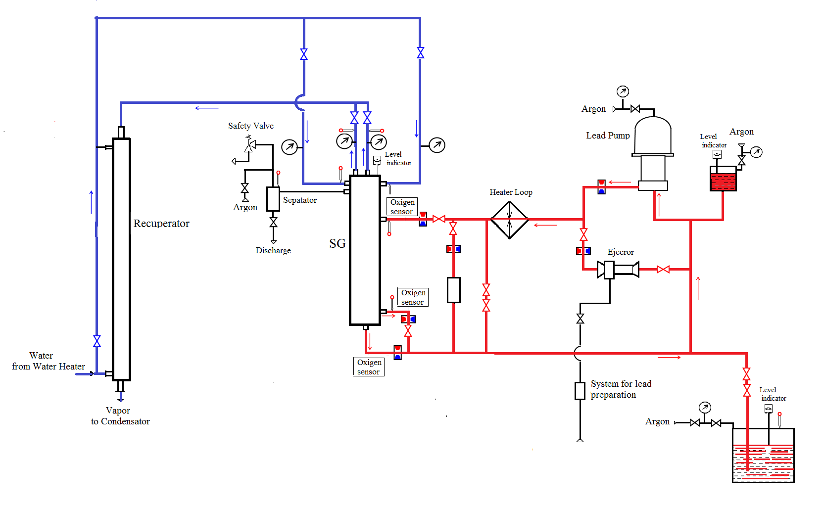
FIG. 1. Schematic diagram of the lead loop of the SPRUT test facility with a steam generator model.

For lead purification from oxygen, there is a coolant technology system in the circuit. Lead is purified by ejecting an argon-hydrogen mixture of a given composition into lead in the course of its circulation in the loop. Lead purity is controlled by means of oxygen thermodynamic activity (OAS) sensors installed at the inlet and outlet of the model.
Lead flow rate is measured by a magnetic flow meter and a volumetric method with the use of a measuring tank. The liquid metal lead circuit has an expansion tank and a loading tank.

2.2. Steam generator models

The first SG model with longitudinal flow of coolants consisted of two identical three-tube modules (Fig. 2a). The coil average diameter of the heat-transfer tubes of the full-size steam generator of the BREST-OD-300 RF (1600 mm) is chosen as a diameter of the coil of the three-tube bundle. Collector elevation marks correspond to the full-size steam generator, the material of the heat-transfer tubes corresponds to the material of the full-size steam-generating tubes used in the BREST-OD-300 RP (design of the year 2000.). Each module consists of a downcomer section, through which up to 5% of the total lead flow is pumped, and a helical riser section where the main lead flow is pumped. There are 15 spacers located at 750 mm from each other along the helical tube.
To measure the temperature of the shell, the model is equipped with thermocouples located with a variable pitch.
The flow of coolants in the coiled section was parallel, i.e. lead moved downwards along the annular gap formed by the model shell and the heat-transfer tube, and water moved upwards inside the tube.
The purpose of testing the two-section model of a steam generator was to confirm the design characteristics of the secondary circuit, and to identify possible pulsation modes of operation of the secondary circuit in the entire range of operating parameters, especially in the conditions of operation of two modules (sections).
The multi-tube (fragment) thermo-hydraulic model of the RP BREST-OD-300 steam generator consists of 18 helically coiled steam generating tubes located on one conditional diameter (a spiral with 18 turns), Fig. 2b. To simulate coil winding, the coiled tubes were divided into two groups, nine tubes in each group, and the design of the model allowed tests with both 18 and 9 tubes.

Vapor outlet  Lead inlet  Water inlet  A – A  A  A  Lead  inlet  Lead outlet  а | Vapor outlet  б  A – A  A  A  Lead outlet  Lead outlet  Lead inlet
FIG. 2. Steam generator models.
The steam generator model was developed in Podolsk. The total height of tube bundle is less than the real one due to shortening of the tubes above the maximum level of lead in SG, where the temperature of feed water is almost constant. Simulation of hydraulic resistance of the missing part of the tubes is carried out by means of throttle devices located immediately after the feed water collector at each downcomer inlet.
Depending on the model test conditions, a different number of tubes are involved: 9 tubes at the parameters of nominal operating conditions, 18 tubes under the conditions of partial modes. Spacing of heat-transfer tubes in the helical riser section is carried out by means of spacer grids uniformly arranged along the perimeter.
Medium motion: direct flow in the straight downcomer section of the heat-transfer tubes (for water) and counter flow in the helical riser section (for steam-water mixture and steam). The steam is collected in one or two collectors (depending on the operation modes – 100% or 50% of nominal power) and through the outlet nozzles vapor is supplied to the condensers and coolers of the SPRUT test facility.
b
The main purpose of the fragment model testing was to study hydrodynamic stability of steam-generating tubes and the entire model under the conditions of simultaneous operation of nine or eighteen steam generating channels.

RESuLTS OF STEAM GENERATOR MODELS’ TESTING
Experimental investigation of three-tube SG module operation was aimed at confirming the design characteristics of the steam generator in different modes of its operation. With constant lead coolant operating parameters, at constant pressure in the water circuit (~ 18 MPa) and constant inlet water temperature in the model (340 °C), the SG behavior was investigated at different water flow rates: 80%, 100% and 120% of the nominal value.
As an example, Fig. 3a shows the distribution of the three-tube module shell temperature at the inlet water pressure of 18 MPa and temperature of 340 °C for one of the design modes. At the same mode parameters, the tests were carried out at supercritical pressure (SCP) of 25 MPa (see Fig. 3b).
From the shell temperature distribution at water pressure of 18 MPa, it is clearly seen that there is a steam superheating region with a low heat transfer coefficient that covers the most part of the riser section. At the SCP values, the module shell and, thus, the heat-transfer tubes are less loaded (in terms of temperature) than at subcritical pressure.

а | b
●– inlet/outlet of lead; ▲ – inlet/outlet of water/steam; ○ , △ – shell temperature
FIG. 3. Distribution of adiabatic wall temperature along the model length at a pressure of 18 (a), 25 MPa (b), [3].

The tests which were carried out at the parameters corresponding to the nominal operating mode showed that outlet vapor temperature values were in line with its design value under different levels of feed water pressure.
The purpose of testing the three-tube module at low water flow rates was to identify possible pulsation modes of the secondary circuit operation, to determine the origination boundary for such modes. It should be noted that throttling devices were not installed at the feed water inlet in the steam generating tubes in this model. No fluctuation of feed water pressure and flow rate related to hydraulic instability of steam-generating tubes were observed during testing in the entire variation range of operating parameters, both in the partial-load (water flow rate variation from 20% to 80% of the nominal value) and startup (water flow rate variation from 30% to 4% of the nominal value) modes of operation [4]. Figure 4 shows the time variation of water flow rate in one of the startup modes.

0
FIG. 4. Fragment of time recording of water flow rate for the three-tube module.

The aim of testing the SG model with join operation of two three-tube modules was to reveal pulsations in the secondary coolant circuit due to joint operation of the modules. The joint operation of the modules was studied at the parameters of startup modes, with a given imbalance in the lead or water flow through the modules.
Figure 5 shows a fragment of the recording of water flow through the modules when they work together in one of the startup modes.

Module No.1
Module No.2
FIG. 5. Fragment of time recording of water flow rate for modules No. 1 and No. 2.

The tests carried out showed that the magnitude of water flow rate pulsation in the course of joint operation of two modules was less than the magnitude of its pulsation during the tests of one module [5]. The main reason for it consists in the fact that, due to the need to measure water flow rate in each module, pressure sensors were installed in a set with throttling orifices in each module. This led to throttling of the feed water flow at the inlet to the modules. No pulsation modes that could cause circulation reversal in the secondary coolant circuit were revealed. Feed water flow rate fluctuation that was observed at the SG module inlet was due to the operating conditions of the module and the entire lead test facility as a whole.
The results of testing the SG model with longitudinal flow of coolants gave the extensive information about heat transfer in different zones of the steam generating tube under various operating conditions. However, the insufficient number of heat-transfer tubes in the module (only three) did not allow us to make the conclusion that the complete hydrodynamic stability is ensured for the BREST SG in the entire possible range of operation modes. Insufficient argumentation for transferring the heat transfer processes obtained in tests [3, 4] to the full-scale SG served as the basis for conducting tests with the multi-tube model of a standard steam generator.
The advantages of this or that way of heat removal by steam generating tubes can be estimated by comparing the integral characteristics, i.e. to compare the vapor temperature at the outlet of each model, with all other conditions being equal. Two regimes relating to the parameters of startup modes were selected, in which the flow rates of water and lead per one steam-generating tube were almost identical (Fig. 6).

FIG. 6. Temperature distribution on the shell of helically coiled (a) and fragment (b) models (see Fig. 3.).

The inlet values of lead temperature as well as the initial temperatures of feed water were insignificantly different. Figure 6a (from [6]) shows the temperature distribution on the shell of coiled model, and Figure 6b (from [7]) shows the temperature distribution along the height of fragment model.
From the temperature distributions shown in Figure 6, it can be seen how efficient heat transfer is at low feed water flow rates in the case of transverse (oblique) flow over heat-transfer tubes in comparison with longitudinal flow. With oblique flow around the steam generating tubes, the temperature values of superheated vapor is closer to the inlet temperature value of lead. The difference between these temperatures is 13 °C, and vapor superheat is 76 °C. In the case of longitudinal flow over the heat-transfer tubes, the difference between the lead inlet temperature and vapor outlet temperature is 46 °C, and vapor superheat is only 28 °C.
Throttling devices were installed at the inlet of each steam generating tube of the fragment model. Therefore, it can be said that the conditions for the hydrodynamic tests of the fragment model were significantly less stressed compared to the two-section model of the steam generator. Figures 7 and 8 show how the water circuit characteristics vary in time (feed water flow rate through the model and feed water pressure at the inlet to the collectors) when two collectors (18 steam generating tubes) operate together.

FIG. 7. Fragment of time recording of water flow rate.

а | b
FIG. 8. Fragment of time recording of water pressure in collectors No. 1 (a) and No. 2 (b).

Despite the fact that the water inlet temperature of the collectors differed from the saturation temperature by less than 5 °C at a given pressure, i.е. boiling took place in the downcomer leg of the steam generating tube, no pulsation of the water flow rate at the collector inlet that could indicate thermal-hydraulic instability, to say nothing of circulation reversal, was found. Inlet water flow ripple was less than 1%. Apparently, these pulsations are due to the pump operation. Water pressure pulsations at the inlet of the collectors correlated with each other and with water flow rate pulsations. The double amplitude of water pressure pulsations did not exceed 0.045 MPa.
The conducted thermos-hydraulic tests of the steam generator model in the steam generation mode at various power levels showed that neither instability nor pulsation modes associated with it were found.
Besides, the fragment model was tested. The tests were aimed at determining hydraulic losses in the heat-transfer tubes in the modes of cold and hot flushing. In the course of hot flushing, no noticeable effect of feed water temperature on the hydraulic characteristics of the steam generating tube was found within the temperature range from 100 to 200 °С. As an example, Figure 9 shows the hydrodynamic characteristic of throttle No. 3 at different water temperatures.

0.25 0.5 0.75 1.0
T, °C
● – 25
■ – 100
▲ – 140
FIG. 9. The hydrodynamic characteristic of throttle No. 3.

- HEAT TRANSFER IN TRANSVERSE LEAD FLOW AROUND STEAM GENERATING TUBES
To verify the thermo-hydraulic codes describing the operability of a steam generator in all modes of its operation, it is required to know the data on heat transfer in the lead coolant when steam generating tubes are flown around.
The first data were obtained with the models consisting of bundles of six rows of tubes, five of which are heat-transfer tubes [9]. The experiments were carried out in the model with the length of heat-transfer tubes of 250 mm and without any spacer grids. To flatten the velocity profile of the coolant at the inlet, a special grid was installed, the design of which (diameter, number, and relative arrangement of the openings) was chosen on the basis of optimization calculations by means of the TURBOFLOW software [10]. Subsequently, after the effect of this grid on the hydraulic characteristics had been evaluated, a decision was made to significantly increase, by 700 mm, the entry section, i.e. the extent of the zone from the entry grid to the first row of tubes. Instead of lead, a eutectic lead-bismuth alloy was chosen as a heating coolant, which made it possible to carry out experiments with a single-phase flow of water with a water pressure of 1.4 MPa. Since the experimental data obtained covered mainly the region of transitional, and not developed, turbulent flow (the Reynolds number varied from 4.1⋅10³ to 1.54⋅10⁴) and as a coolant, not lead, but a lead-bismuth alloy was used, the decision was made to carry out the experiments on a new model with a lead coolant.
The experimental model consists of six vertical and four horizontal rows of tubes connected by a common collector; five of these tubes are heat-transfer ones (Fig. 10a). The shell of the experimental model is designed for a pressure up to 2.5 MPa at temperatures up to 550 °С.
In order to increase the mass flow rate of water in rows 2, 5 and 6 (Fig. 10b), the heat-transfer tubes were plugged. The third and fourth rows of tubes remained operating to study heat transfer.
The main modes of SG operation are nominal, startup and operation at partial parameters. Lead solidification modes refer to violations of the normal operation of nuclear power plant equipment. Verification of the design codes requires the data on heat transfer in such modes as well. Most of the experiments were dedicated to the study of heat transfer under normal operating conditions.

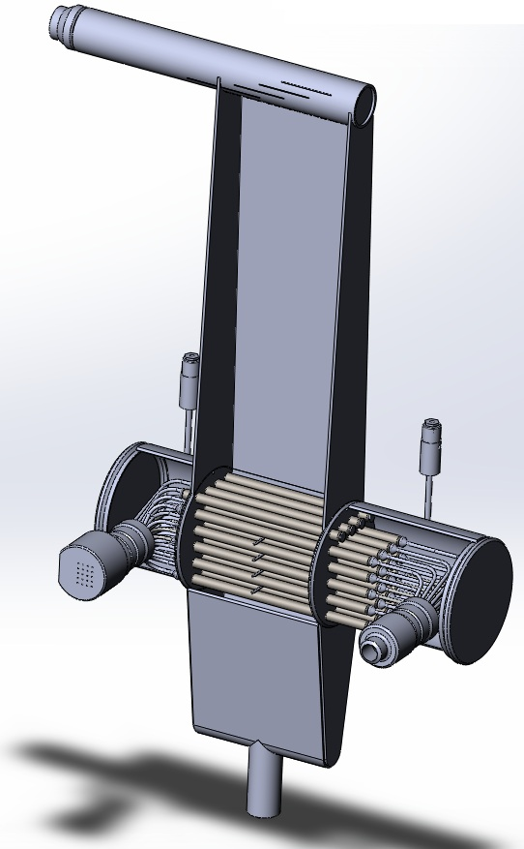 | 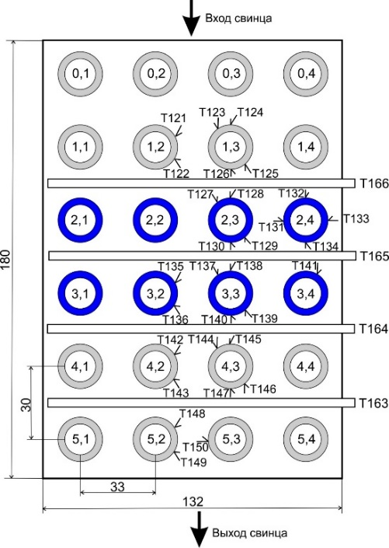  Lead outlet  Lead inlet
a b

FIG. 10. View of assembly model (a) and arrangement of thermocouples (b).
(The first figure in the two-figure number in the center of tubes stands for the row number,
the second one means the tube number in a row.)

Experiments with a coolant in the oxygen saturation line
The experiments were carried out at different lead velocities in the Reynolds numbers range of 5⋅10³ – 5⋅10⁴. Water parameters were determined proceeding from the condition of no water boiling and lead solidification.
Figure 11 shows time recording of tube wall temperatures in the horizontal heat exchange rows. Low-frequency temperature fluctuations are noted on the surface of the heat-transfer tubes with a frequency of no more than 0.15 Hz.

36 °С  а  Т133  Т127  Т131  Т132  Т128 | 26 °С  b  Т141  Т137  Т139  Т135

FIG. 11. Fragments of time recording of tube wall temperatures in the first (a) and second (b) horizontal rows,
Re_{Pb} = 5.1⋅10³.

Low-frequency oscillations are due to the peculiarities of the flow of the lead coolant in an assembly with an in-line arrangement of tubes under conditions of heat transfer between lead and water flowing in these tubes. In both the first and the second heat exchange rows, the maximum temperature fluctuations are noted by thermocouples installed in the aft part of the tubes.
During the tests, the thermodynamic activity of oxygen varied from 0.77 to 1. With time, in the course of the test facility operation, the concentration of oxygen impurities increased, both in the lead flow and on the heat exchange surface. The dependence of the linear heat transfer coefficient on the lead coolant purity was found (Fig. 12).

0 0.2 0.4 0.6

FIG. 12. Overall heat transfer coefficient as a function of duration of lead circuit operation:
start of operation on 24 Jul. (▲); 25 Jul. (▲); 2 Aug. ( , ).
  - Basic oxygen regime
Before the experiments, the coolant was purified by means of an argon-hydrogen mixture. As a result, the oxygen concentration in the lead decreased to a value, which corresponds to the basic oxygen operating mode of the lead loop.
The data of one of the experiments with the minimum lead flow rate are shown in Figure 13. The thermocouple number is indicated next to the temperature curve (see Fig. 10b).

a  11 °C  Temperature drop  Time, s | 9 °C  Temperature drop  b  Time, s
FIG. 13. Fragments of time recording of tube wall temperatures in the first (a) and second (b) horizontal row,
Re_{Pb} = 1.3⋅10⁴.

Low-frequency temperature fluctuations with a frequency of less than 0.25 Hz occur on the surface of the heat-transfer tubes. The largest amplitude of the temperature pulsations corresponds to thermocouple T129, which is located in the aft part of the tube.
On the one hand, over 3.5-time increase in the lead flow rate resulted in an appreciable reduction of the amplitude of temperature pulsations; on the other hand, in an increase in the temperature maldistribution between the coolant layers, which are in contact with the heat exchange surface of the tube and the central flow of lead flowing in the intertube space.
Based on the results obtained, the lead heat transfer coefficient in the basic oxygen regime can be calculated by the formula previously determined at the IPPE JSC [12]:

Nu = 5.5 + 0.025·Pe^{0.8}. (1)

The value of the data approximation reliability is R² = 0.9963. Similar results were obtained earlier by A.V. Beznosov and others [13].
However, the most reliable is the overall heat transfer coefficient k, since to determine it, it is not required to know water heat transfer coefficient, and deviation of the water temperature of 0.5 °С at the level of 45 °С (temperature difference in water) gives an error of only 1%. The dependence of the linear heat transfer coefficient on the lead velocity in the experiments with subcritical and supercritical water pressure is shown in Figure 14.

0 0.2 0.4 0.6 0.8 1.0
FIG. 14. Linear overall heat transfer coefficient as a function of lead velocity in the basic oxygen regime.

A comparison of the Nusselt number dependence on the Peclet number for lead in the basic oxygen regime, and lead on the saturation line with an excess in oxygen in the lead coolant are shown in Figure 15. The data presented are related only to the experiments with supercritical water parameters. A decrease in the lead heat transfer coefficient was found out in case of severe lead contamination with oxygen to the Nusselt number equal to 2.0.

1 – Eq. (1)
1
FIG. 15. The Nusselt number as a function of the Peclet number for lead in the basic oxygen regime (■)
and for lead on the oxygen saturation line (▲, ○, ●).

After lead purification to the basic oxygen conditions, heat transfer coefficients are reset and increased 1.5 – 4 times pertaining to lead on the oxygen saturation line.
- CONCLUSION
At the State Scientific Centre of the Russian Federation – Leypunsky Institute for Physics and Power Engineering, Joint-Stock Company (IPPE JSC), a large scope of work was carried out to justify the BREST-OD-300 RP steam generator, which is under development at NIKIET JSC. The tests carried out with various models of the steam generator showed the following:
- under the nominal operating conditions, the design steam superheating is provided at the outlet of the steam-generating tube;
- in all the operating modes (nominal, startup, partial parameters), steady-state operation of the steam-generating channel is ensured up to a water flow rate of 4% of the nominal value.
The dependence of lead coolant heat transfer on the oxygen concentration in the lead has been experimentally confirmed. Under basic oxygen conditions, it is recommended to calculate lead heat transfer by the formula Nu = 5.5 + 0.025⋅Pe^{0.8}.
For lead with oxygen concentration on the saturation line, the lower limit of Nu = 2 is set in the range of Peclet numbers from 80 to 600. The dependence of the heat transfer coefficient on the lead velocity in a narrow cross section was not found, which agrees with the data of other authors.
It was found out that after transition from lead on the saturation line to the basic oxygen regime, the values of the heat transfer coefficient come back to the values characteristic of this regime.
References
- ADAMOV, E., DZHALAVYAN, A., LOPATKIN, A., et al., Conceptual state of the strategy for the development of nuclear energy in Russia in the future until 2100, Atomic Energy, 112, 6 (2012), 319–330, https://j-atomicenergy.ru/index.php/ae/article/view/1336 (in Russian).
- GABARAEV, B., FILIN, A., “Development of a BREST-OD-300 NPP with an on-site fuel cycle for the Beloyarsk NPP implementation of the initiative by Russian President V.V. Putin”, ICONE-11, (Proc. 11th Intern. Conf., Tokyo, Japan, April 20-23, 2003), Paper ICONE11-36410 (CD).
- GRABEZHNAYA, V., MIKHEYEV, A., STEIN, YU., SEMCHENKOV, A., Numerical and experimental investigation of the model steam generator reactor facility BREST-OD-300, Proceedings of Universities. Nuclear Energy, 1 (2013), 101–109, DOI: https://doi.org/10.26583npe.2013.1.13 (in Russian).
- GRABEZHNAYA, V., MIKHEYEV, A., KRYUKOV, А., “Tests of the BREST steam generator model when operating in partial and startup modes”, Results of Scientific and Technical Activities of the Institute of Nuclear Reactors and Thermal Physics for 2012, SSC RF – IPPE Publ., Obninsk, (2013), 139–152 (in Russian).
- GRABEZHNAYA, V., KRYUKOV, А., MIKHEYEV, A., STEIN, YU., “Some research results on the model of the helically coiled steam-generator heated by liquid lead”, 4th Conf. Heavy Liquid Metal Coolants in Nuclear Technology (HLMC-2013) (Proc. Conf. Obninsk, SSC RF – IPPE, September 23-26, 2013), Obninsk, SSC RF – IPPE, Publ., (2013), 1, 139–152 (in Russian).
- GRABEZHNAYA, V., MIKHEYEV, A., BEREZIN, A., “The pressure effect on the model of the helically coiled steam generator heated by heavy metal”, 6th Russian National Heat Transfer Conference (RNHTC-6), (Proc. Conf., Moscow, Russia, October 27-31, 2014), Public House MEI, Moscow, (2014), Paper № 224, (CD) (in Russian).
- GRABEZHNAYA, V., MIKHEYEV, A., Thermal-hydraulic tests of multi-tube model steam generator in partial parameters, Questions of Atomic Science and Technology. Series: Nuclear-Reactor Constants, 3, (2017), 177–186, https://vant.ippe.ru/year2017/3/thermal-physics-hydrodynamics/1384-15.html (in Russian).
- GRABEZHNAYA, V., MIKHEYEV, A., Experimental study of thermal hydraulics on the model of helically coiled steam generator heated by liquid lead with longitudinal and transverse flow, Questions of Atomic Science and Technology. Series: Nuclear-Reactor Constants, 1, (2019), 133–143, https://vant.ippe.ru/year2019/1/thermal-physics-hydrodynamics/1667-11.html (in Russian).
- KALYAKIN, S., GRABEZHNAYA, V., “Experimental study of heat transfer in a liquid metal with a transverse flow around a tube bundle to substantiate a steam generator of the BREST-OD-300 reactor plant”, 4th Russian National Heat Transfer Conference (RNHTC4) (Proc. Conf., Moscow, Russia, October 23-27, 2006), Public House MEI, Moscow, (2006), 2, 128–131 (in Russian).
- SHCHERBAKOV, S., “Numerical simulation of nonsteady-state multiphase flow. The 2D TURBO-FLOW computer code used to perform express analysis of designs”, NURETH-11 (Proc. 11th Int. Conf., Avignon, France, October 2-6, 2005), Paper No. 238 (CD).
- GRABEZHNAYA, V., MIKHEYEV, A., Effect of oxygen content on heat transfer in steam-generating tubes in transverse flow of heavy liquid-metal coolant, Atomic energy, 127, 4, (2020), 207–215, DOI: https://doi.org/10.1007/s10512-00612-8.
- PARFENOV, A., MIKHEYEV, A., GRABEZHNAYA, V., SHCHERBAKOV, S., “Experimental study of heat transfer in a transverse flow of lead around a bundle of steam-generating tubes”, Thermophysics of Fast Neutron reactors “Theplophyzika-2013” (Proc. Sci.-Tech. Conf., Obninsk, SSC RF – IPPE, October 30 – November 1, 2013), SSC RF – IPPE Publ., Obninsk, (2014), 1, 294–299, (in Russian).
- BEZNOSOV, A., NOVOZHILOVA, O., SAVINOV, S., MOLODTSOV, A., “Experimental studies of the characteristics of heat transfer on "hot" and "cold" surfaces simultaneously with the introduction of impurities into the lead coolant circuit and cleaning from them”, Heat and mass transfer and properties of liquid metals “Theplophyzika-2007” (Proc. Sci.-Tech. Conf., Obninsk, SSC RF – IPPE, October 30 – November 1, 2007), SSC RF – IPPE Publ., Obninsk, (2008), 275–285, (in Russian).

