Investigation on natural circulation for decay heat removal in reactor vessel of sodium-cooled fast reactor

K. Aizawa¹, M. Tsuji¹, J. Kobayashi¹, A. Kurihara¹, Y.Miyake², S. Nakane³, K. Ishida⁴

¹Japan Atomic Energy Agency
Ibaraki, Japan
Email: aizawa.kosuke@jaea.go.jp

²NDD Corporation
Ibaraki, Japan

³NESI Incorporation
Ibaraki, Japan

⁴ASCEND Co., Ltd
Ibaraki, Japan

Abstract

In sodium-cooled fast reactors (SFRs), optimizing the design and operate decay heat removal systems (DHRSs) is important for safety enhancement against severe accidents that could lead to core melting. The natural circulation phenomena in a reactor vessel during operating a DHRS were clarified by conducting water experiments using a 1:10 scale experimental facility (PHEASANT) simulating the reactor vessel of loop-type SFRs. The dipped-type direct reactor heat exchanger (DHX), the penetrated-type DHX, and reactor vessel auxiliary cooling system (RVACS) are mounted in PHEASANT. Moreover, electric heaters are installed to simulate the core and fuel debris accumulated on the core catcher and upper plenum. Therefore, PHEASANT can simulate natural circulation phenomena under various conditions for decay heat sources and DHRS operation. In this study, we investigated the natural circulation phenomena under conditions of operating the dipped-type DHX and RVACS using the results of temperature and particle image velocimetry (PIV) measurements, respectively. Furthermore, the effects of temperature fluctuation on the PIV measurement were quantitatively evaluated.

INTRODUCTION
In sodium-cooled fast reactors (SFRs), evaluating the safety and developing countermeasures against severe accidents that might lead to core melting is necessary. During a core melting event under an unprotected loss-of-flow accident in the advanced loop-type SFR, the molten core accumulates on the upper plenum, core catcher, and core [1]. The efficient and long-term heat removal of molten fuel dispersed in the reactor vessel is essential for avoiding thermal damage to the reactor vessel. Therefore, establishing a robust cooling system using a decay heat removal system (DHRS) is anticipated. SFRs have various types of DHRSs depending on the reactor type or design concept. For example, the advanced loop-type SFR has a direct reactor auxiliary cooling system (DRACS) set in the upper plenum of the reactor vessel, and a primary reactor auxiliary cooling system located in the inlet plenum of the primary side of the intermediate heat exchanger [2]. ASTRID, the pool-type reactor, has several types of DRACS installed in a cold pool and hot pool [3]. Furthermore, ex-vessel heat exchangers are planned to be installed around the safety vessel in the reactor pit to cool the reactor vessel. Thus, various types of DHRSs are designed as countermeasures against predicted incidents and accidents for each type of reactor.
Some water experiments were conducted to investigate the thermal-hydraulics in SFRs during DHRS operation. Water experiments were conducted using a 1:10 scale experimental apparatus to clarify the thermal–hydraulic phenomena in a reactor vessel including plant transient dynamics in loops [4]; the experimental apparatus comprised a reactor vessel and two primary cooling loops including intermediate heat exchangers. Murakami et al. [4] evaluated the potential for cooling using DHRSs via natural circulation. Mente et al. [5] conducted 1:4 scale water experiments on PFBR which is a pool-type SFR. They demonstrated heat removal via natural circulation and confirmed the inter-wrapper flow effect on heat removal. Hoffmann et al. [6] conducted water experiments on a 1:20 scale of SNR-2, which is a pool-type SFR and observed heat removal behavior under symmetric and nonsymmetric conditions.
In this study, to develop a robust DHRS for establishing long-term heat removal via natural circulation inside the reactor vessel, water experiments using a scale model were conducted to investigate the thermal-hydraulic phenomena in the reactor vessel. In particular, the natural circulation phenomena were investigated using the results of temperature and particle image velocimetry (PIV) measurements under the conditions of operating the dipped-type direct reactor heat exchanger (DHX) and reactor vessel auxiliary cooling system (RVACS), respectively. Furthermore, the effects of temperature fluctuation on the PIV measurement were quantitatively evaluated.

EXPERIMENTAL METHOD

Experimental apparatus
Figure 1 shows the schematic of the water experimental apparatus named PHEASANT, which is a 1:10 scale model based on the reactor vessel of an advanced loop-type SFR [7]. The vessel’s inner diameter and height are 1.2 and 25.1 m, respectively. It is made of acrylic resin enabling PIV measurements in the vessel. PHEASANT has three types of heat exchangers simulating a DHRS, i.e., the dipped-type DHX in the upper plenum, the penetrated-type DHX, and RVACS. Moreover, PHEASANT has microheaters simulating the decay heat generated by the reactor core and the fuel debris on the bottom of the upper plenum and core catcher. The simulated core is divided into three regions to represent the inner core named Region I, the outer core named Region II, and the blanket region named Region III. Regions I and II generate heat at 18 and 12 kW maximum, respectively. Region III is a blanket region that does not generate heat. The maximum heater output at the bottom of the upper plenum is 5 kW and that on the core catcher of the lower plenum is 25 kW. The pressure loss coefficient is an important parameter to coincide the Richardson and Euler numbers between the reactor and the experimental apparatus, as described further. Two baffle plates are set at the top and bottom of the simulated core to adjust the pressure loss coefficient. In addition, thermocouples are installed at various areas inside the reactor vessel and multipoint thermocouple trees are installed in the upper and lower plenums. The thermocouples are φ0.5 mm in diameter, with a pitch of 5 mm. The multipoint thermocouple tree in the lower plenum has 100 thermocouples and that in the upper plenum has 61 thermocouples. The multipoint thermocouple trees can be rotated circumferentially and moved vertically. The three-dimensional temperature distribution can be measured in the reactor vessel using these thermocouple trees.

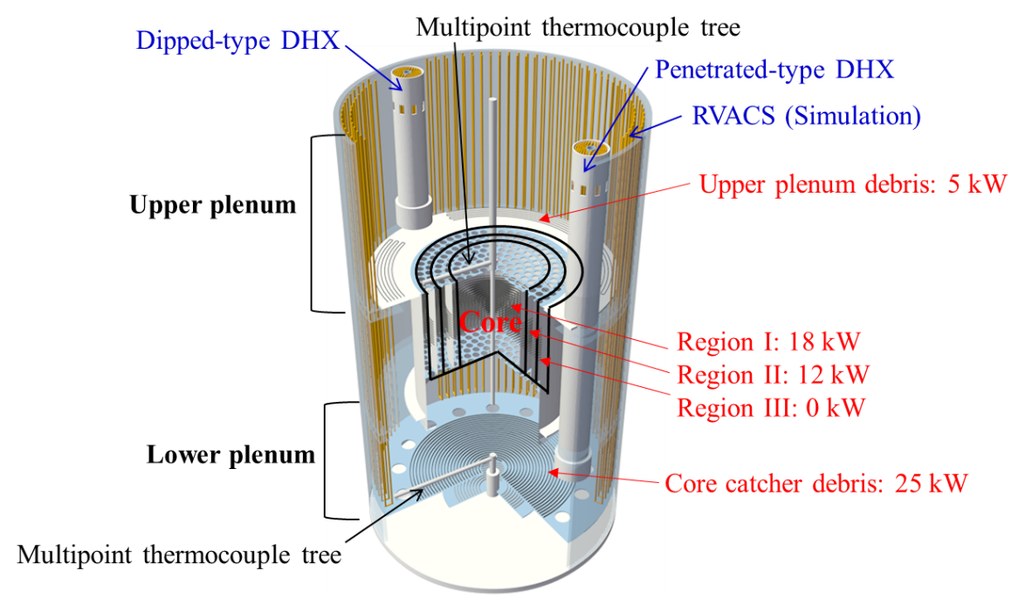

Fig. 1. Schematic of PHEASANT

Similarity between model and reactor
In the scaled model experiments, nondimensional numbers between the model and reactor must be identical to simulate the thermal-hydraulic phenomena. Considering the thermal-hydraulic phenomena for natural circulation driven by the temperature difference, the Richardson number (Ri), Euler number (Eu), Reynolds number (Re), and Peclet number (Pe) are important. These nondimensional numbers are defined as

, (1)
, (2)
, (3)
, (4)

where β is the thermal expansion coefficient, ΔT is the temperature difference, g is the gravitational acceleration, L is the characteristic length, u is the characteristic velocity, ρ is the fluid density, ΔP is the pressure difference, ξ is the pressure loss coefficient, ν is the kinematic viscosity and α is the temperature conductivity. From the balance between the buoyancy force and momentum under steady-state condition

, (5)
, (6)

Equation (6) indicates that an identical Ri can be obtained by matching the pressure loss coefficient between the model to the reactor. However, the scale considerably affects Re and Pe. Figure 2 shows the relation between the scale ratio of the water experiment model and the ratio of nondimensional number between the water experiment and reactor. By closing the scale ratio to unity, (Re) is close to unity, whereas (Pe) is away from unity. Pe is prioritized in PHEASANT because it is the temperature field is considered to be important to consider the large-scale thermal-hydraulic phenomena driven by buoyancy. When the scale ratio of the experiment model is made too small, the spatial measurement accuracy decreases. Because of Pe and the spatial measurement accuracy are considered, the scale ratio of PHEASANT is set to 1:10.

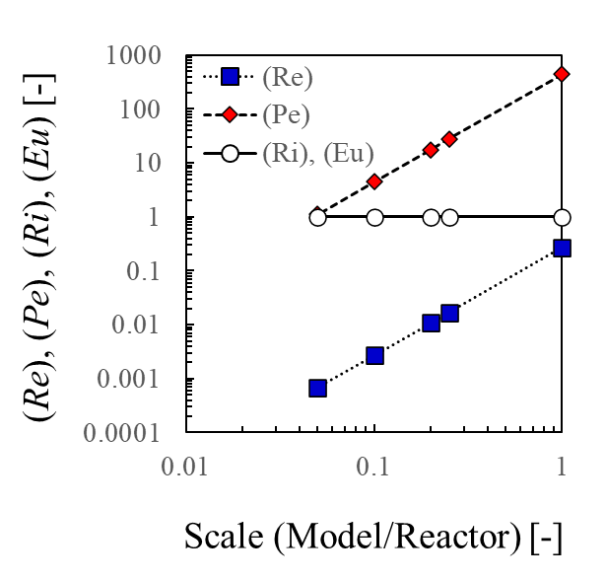
FIG. 2 Dependency of nondimensional numbers on the scale model

RESULTS AND DISCUSSION
3.1 Dipped-type DHX operation

3.1.1 Natural circulation flow field
PIV and temperature measurements were conducted while operating the dipped-type DHX. Figure 3 shows the schematic view of the PIV measurement position and the coordinates (x, y, z). The horizontal origin position, x = 0, corresponds to the center of the experimental apparatus, and the vertical origin position, z = 0, corresponds to the bottom surface of the lower plenum. The dipped-type DHX was installed on the negative side in the x-direction. The image sizes of the high-speed camera were approximately 155 × 155 mm² (1,024 × 1,024 pixels) in the upper plenum and approximately 133 × 133 mm² (1,024 × 1,024 pixels) in the lower plenum. The laser sheet’s irradiation position was shifted 25 mm from the center of PHEASANT to avoid the thermocouple tree at the center of the plenum. A neodymium-doped yttrium lithium fluoride pulse laser was used as a light source for the laser sheet. A high-speed camera was used to capture particle images in the upper and lower plenums. A fluorescing tracer particle and optical sharp-edged band-cut filter were used in the PIV measurement to cut the reflection lights from the structure. The high-speed camera frequency was set to 100 Hz. The recording time for each section was set to 60 s or more. Cross-correlation methods with subpixel accuracy were used for PIV data analysis. The correlation’s spatial error was nearly 0.2 pixel using the subpixel method [8]. The estimated velocity measurement errors were less than 0.6 mm/s. Furthermore, temperature measurements were conducted using the thermocouples installed at various areas inside the reactor vessel and multipoint thermocouple trees. The temperature measurement frequency was set to 500 Hz. The recording time for temperature measurements was set to 260 s. Table 1 shows the heater power conditions. This condition simulates that 20% of the core fuel fell to the lower plenum and accumulated on the core catcher. PIV and temperature measurements were conducted under stable conditions operating the dipped-type DHX and heaters as shown in Table 1.
Figure 4 shows the distributions of the time-averaged velocity in the upper and lower plenums. Figure 4-(a) shows the flow indicated by (1) at the center of the core ascended in an upward direction. The flows indicated by (2) and (3) from the vessel wall side flowed toward the center at the bottom of the upper plenum. The downward flow along the vessel wall is indicated by (4). Figure 4-(b) shows that the flow indicated by (5) descended through core Region III where the DHX is located. The flows indicated by (6) and (7) flowed toward the center at the bottom of the lower plenum. The upward flow in the center is indicated by (8). Figure 5 shows the time-averaged temperature distributions in x–y cross section. The temperature was almost constant at the height of the intake port of the dipped-type DHX, as shown in Fig. 5-(a). The flow was considered to have formed from the dipped-type DHX outlet toward the center of the plenum because the coolant’s temperature decreased between the dipped-type DHX and the center of the core (Fig. 5-(b)). Figure 5-(c) indicates that the fluid temperature decreased at the outer circumferential part in the lower plenum because of the cold coolant from the dipped-type DHX flowing through core Region III. Furthermore, in Fig. 5-(d), because the temperature is low at the outer circumferential part and high at the center, the coolant flows from the outer circumferential part toward the center and rises at the center to the core. From PIV and temperature measurement results, the cold flow from the dipped-type DHX flowed through Region III around the core to the lower plenum to cool fuel debris on the core catcher. Then, the flow flowed into the core from the core catcher, and the upward flow heated by the core flowed to the intake port of the dipped-type DHX. Hence, the large-scale flow path driven by the density difference of fluid was observed.

TABLE 1. HEATER POWER CONDITIONS UNDER OPERATION OF DIPPED-TYPE DHX

Heater | Core Region I | Core Region II | Core Region III | Core catcher | Upper plenum debris
Heater power [kw] | 2.0 | 2.0 | 0.0 | 1.0 | 0.0

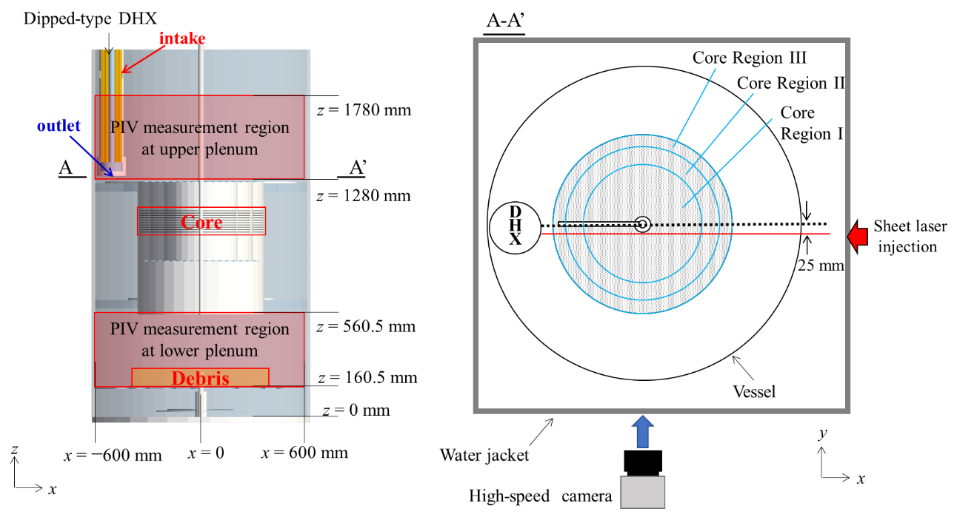
FIG. 3 Schematic view of PIV measurement position

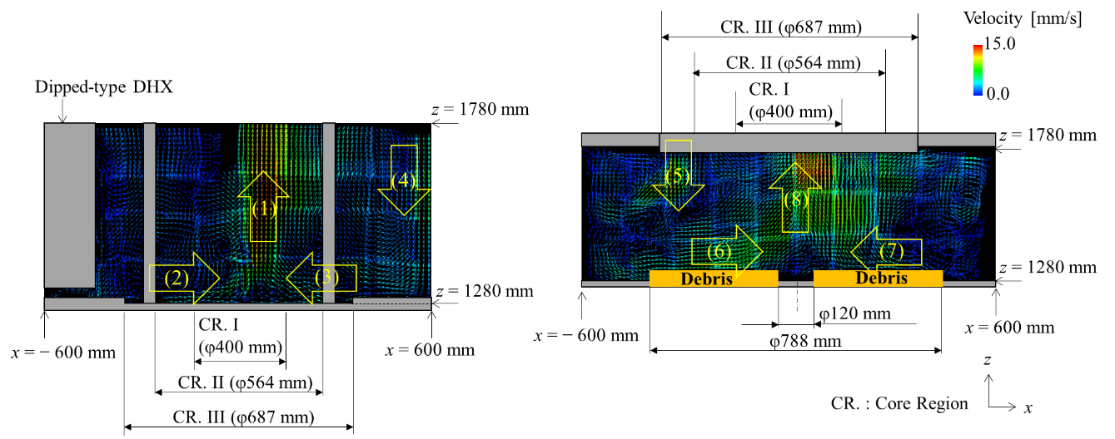
(a) Upper plenum (b) Lower plenum

Fig. 4 Time-averaged velocity fields in the upper and lower plenums

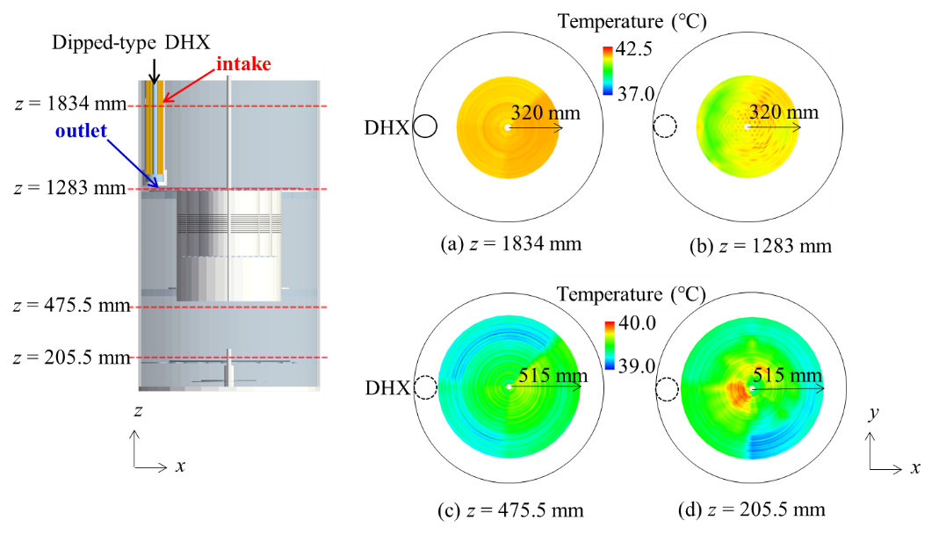
Fig. 5 Time-averaged temperature distributions in the upper and lower plenums

3.1.2 Effect of temperature fluctuation on PIV measurement
PIV was measured to quantitatively evaluate the natural circulation flow field in PHEASANT. However, because of the temperature gradient, the distortion of the photographic image occurred in the flow field when the refractive index changed. This distortion is an uncertainty factor for PIV measurement. Therefore, the uncertainty caused by the photographic image’s distortion owing to the temperature fluctuation was evaluated in the PIV measurement in the natural circulation flow field.
Figure 6 shows the distorted grid pattern and the reference image for the cross-correlation process. When a grid board is installed in a position with a temperature gradient, the grid pattern distorts due to the change in the refractive index. The P_{i}(r, c) position varies at any time as shown in Fig. 6-(a). The fluctuation range ΔP(r, c) of P_{i}(r, c) can be established from the standard deviation of the grid point position as

, (7)

where n denotes the total number of grid images and $\overline{P}$ denotes the mean of P_{i}(r, c). The position of the grid point photographed in the grid image is calculated using the correlation coefficient between the reference image shown in Fig. 6-(b) and the photographed grid image. Figure 7 shows the vertical (z direction) fluctuation distribution of the grid point evaluated using Eq. (7) and temperature fluctuation under the same conditions as the PIV measurement. The heights of z = 1283 mm and z = 1305 mm are at the bottom of the upper plenum near the core exit, and the height of z = 1580 mm is in the middle of the upper plenum. The basing point on the horizontal axis (x axis) is the center of the reactor core, and the dipped-type passive DHX is installed on the negative side of the x axis. The grid points are displaced by approximately 0.4 pixel on the negative side of the x axis and 0.15 pixel on the positive side of the x axis at z = 1305 mm, as shown in Fig. 7-(a). However, the grid points are distorted by about 0.1 pixel at z = 1580 mm. The temperature fluctuation results show a relatively large displacement of the grid at z = 1305 mm, which is caused by the fluctuation of the refractive index of the fluid due to the temperature fluctuation. However, fluctuations in the temperature and grid points decrease at z = 1580 mm because the fluid is mixed and heat is diffused with advection. When the fluctuation range ΔP(r, c) exists at a grid point, tracer particles measured via PIV have the same fluctuation range. Because the flow velocity v(x, z) is determined by correlating the two images photographed via PIV, the uncertainty of the flow velocity Δv(x, z) can be defined as

, (8)

where x and z are the velocity components parallel to the row and column pixels of the particle image, respectively, α is the conversion factor obtained by dividing the view field of the image (mm) by the number of pixels, and Δt is the shooting time interval. Figure 8 shows the horizontal flow velocity distribution at two vertical positions (z = 1305 and 1580 mm). In Fig. 8, the error bars indicate the uncertainty of the flow velocity evaluated using Eq. (8). The uncertainty of the flow velocity is less than 5% in the region of the upward flow at z = 1580 mm. A larger uncertainty of the flow velocity is confirmed in the negative side of the x-axis at z = 1305 mm because the flow velocity is relatively small and the temperature fluctuation is relatively large. In this study, the recording interval is adjusted to the flow velocity of the upward flow at z = 1580 mm. In the low flow velocity region, the uncertainty of the flow velocity can be decreased by increasing Δt of Eq. (8) because of the temperature fluctuation.

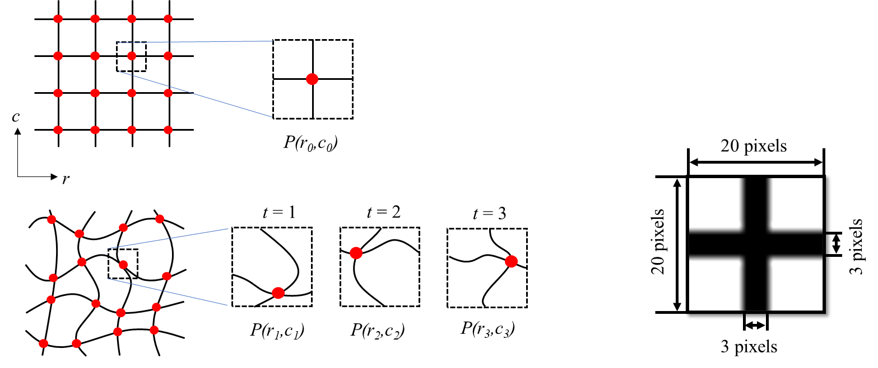
(a) Image of aligned grid pattern (b) Reference image

Fig. 6 Image of the distorted grid pattern and the reference image for the cross-correlation process

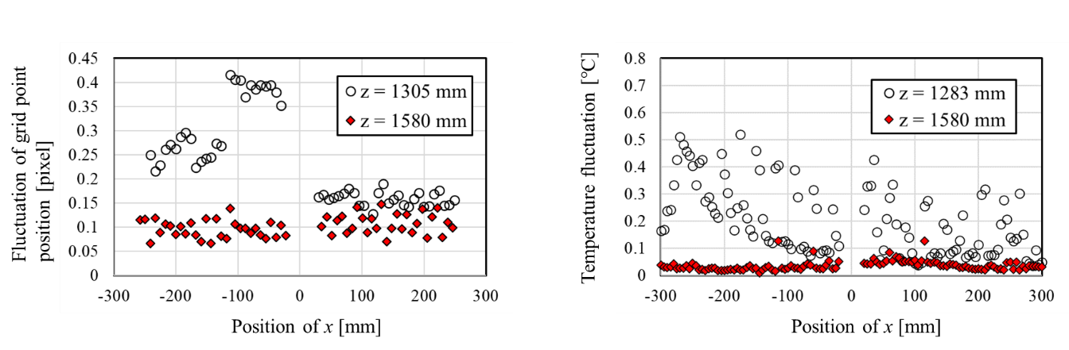
(b) Temperature fluctuation
(a) Fluctuation distribution in the vertical position of the grid point

Fig. 7 Fluctuation distribution in the vertical position of the grid point and temperature fluctuation in the horizontal axis at two vertical positions in the upper plenum

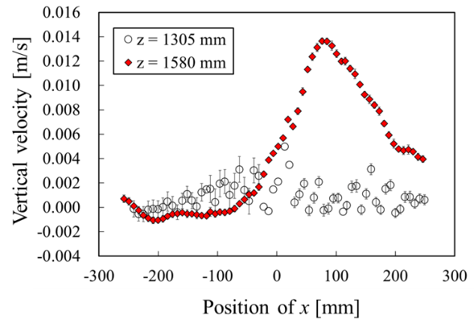
Fig. 8 Vertical velocity and uncertainty of velocity because of temperature fluctuation

3.2 RVACS operation

The natural circulation phenomena under operating RVACS conditions were investigated using the results of temperature measurements. RVACS cools the fluid from all circumferences of the reactor vessel in the upper and lower plenums, as shown in Fig. 1. The temperature measurement frequency was set to 100 Hz. The recording time for temperature measurements was set to approximately 330 s. Table 2 shows the heater power conditions under operating RVACS. The conditions of Cases A and B simulate that 20% and 80% of the core fuel fell to the lower plenum and accumulated on the core catcher, respectively. The total heater power of Case A is equal to that of Case B. Temperature measurements were conducted under stable conditions operating the RVACS and heaters.
Figure 9 shows the temperature distributions in the upper and lower plenums of Case A. The high-temperature region narrowed toward the center of the core as the vertical height in the upper plenum increased, as shown in Fig. 9-(a). Therefore, the flow through the core flowed upward while mixing with the surrounding fluid. However, the fluid temperature decreased with the decreasing vertical height in core Regions II and III on the reactor wall side. The results confirmed that the fluid temperature gradually decreased along the heat transfer tube of RVACS, and the flow cooled by RVACS reached the horizontal position of core Region II. The fluid temperature decreased with the decreasing vertical height on the reactor wall side of the lower and upper plenums, as shown in Fig. 9-(b). Furthermore, the temperature distributions on the debris were similar regardless of the vertical height owing to the relatively low heater power in the core catcher. Figure 10 shows the temperature distributions in the upper and lower plenums of Case B. The tendencies of the temperature distribution in the upper plenum of Case B were similar to those under Case A (Fig.10-(a)). The fluid temperature increased on the core center side of the debris at z = 210.5 mm. This tendency was because of the relatively high heater power in the core catcher.
Next, the average velocity V passing through the core is calculated using the core heater power P and temperature difference $∆T$ between the core’s inlet and outlet temperatures. The velocity V can be defined as

, (9)

where A is the channel area, ρ is the density with respect to the average temperature, and Cp is the specific heat with respect to the average temperature. From Eq. (9), the average velocities passing through the core under Cases A and B were approximately 3.3 and 6.3 mm/s, respectively. Because the heater power in the core catcher was relatively high, the difference in the heat transfer center height in Case B was larger than that in Case A. Therefore, because the natural circulation driving force in Case B was large, the average velocities passing through the core in Case B were larger than that in Case A.

TABLE 2. HEATER POWER CONDITIONS UNDER RVACS OPERATION

 | Core Region I [kW] | Core Region II [kW] | Core Region III [kW] | Core catcher [kW] | Upper plenum debris [kW]
Case A | 6.3 | 6.3 | 0.0 | 3.1 | 0.0
Case B | 1.6 | 1.6 | 0.0 | 12.6 | 0.0

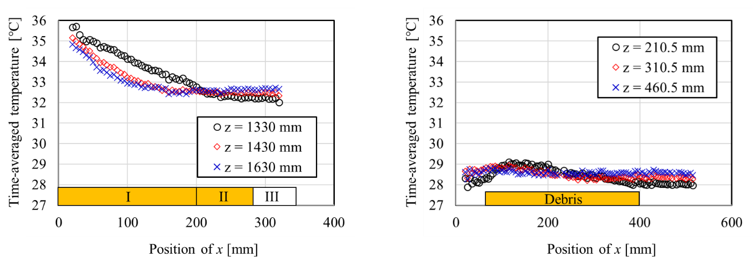
(a) Upper plenum (b) Lower plenum

Fig. 9 Time-averaged temperature distribution in Case A

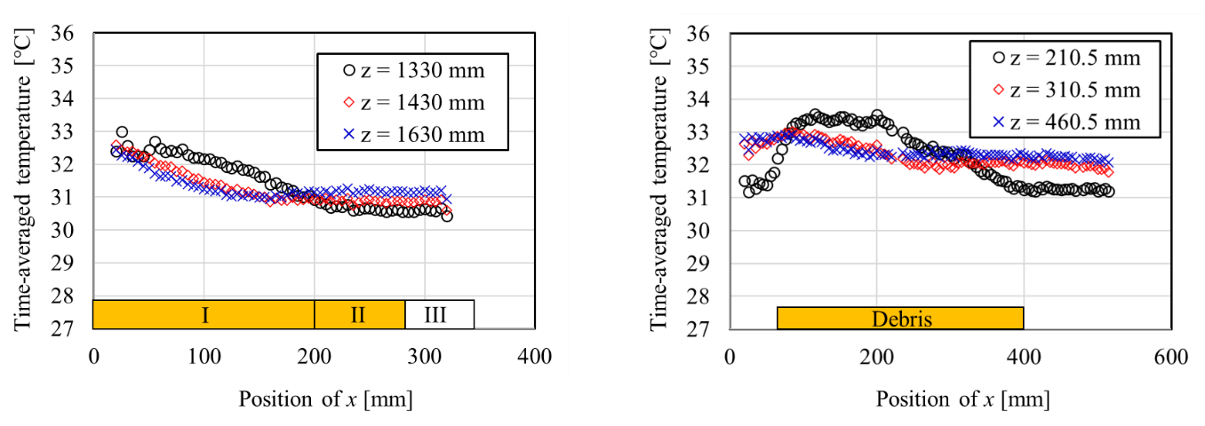
(a) Upper plenum (b) Lower plenum

Fig. 10 Time-averaged temperature distribution in Case B

CONCLUSIONS
Water experiments were conducted using 1:10 scale experimental apparatus simulating the reactor vessel of SFRs to investigate the natural circulation phenomena in the reactor vessel. The large-scale flow path driven by the density difference of fluid was observed using the PIV and temperature measurement results under dipped-type DHX operation. Furthermore, the natural circulation flow field in the reactor vessel was quantitatively clarified. Moreover, the effects of temperature fluctuation on the PIV measurement were quantitatively evaluated. Based on the results, the uncertainty of the vertical flow velocity was less than 5% in a region of the upward flow at z = 1580 mm. The temperature measurement results confirmed the characteristics of natural circulation flow field under RVACS operation. The effects of heater power on the flow field were also clarified.

References
- T. SUZUKI, K. KAMIYAMA, H. YAMANO and K. KOYAMA, A scenario of core disruptive accident for Japan sodium-cooled fast reactor to achieve in vessel retention, Journal of Nuclear Science and Technology, Vol.51 (2014),.4, pp.493-513.
- H. KAMIDE, M. ANDO and T. ITO, “JSFR design progress related to development of safety design criteria for generation IV sodium-cooled fast reactors (1) Overview”, Proceedings of ICONE-23, ICONE23-1666, Chiba, Japan, (2015).
- E. HOURCADE, F. CURNIER, T. MIHARA, B. FARGES, J. F. DIRAT and A. IDE, “ASTRID nuclear island design: advances in French-Japanese joint team development of Decay Heat Removal systems”, Proceedings of ICAPP 2016, pp. 1740-1745, San Francisco, USA, (2016).
- T. MURAKAMI, Y. EGUCHI, K. OYAMA and O. WATANABE, Reduced-scale water test of natural circulation for decay heat removal in loop-type sodium-cooled fast reactor, Nuclear Engineering and Design, 288, (2015), pp. 220-231
- V.M. MENTE, G.K. PANDEY, I. BANERJEE, S.A. KUMAR, G. PADMAKUMAR and K.K. RAJAN, Experimental studies in water for safety grade decay heat removal of prototype fast breeder reactor, Annals of Nuclear Energy, 65, (2014), pp114-121.
- H. HOFFMANN, D. WEINBERG, Y. IEDA, K. MARTEN, H. TSCHÖKE, H.H. FREY and K. DRES, Thermohydraulic Investigations of Decay Heat Removal Systems by Natural Convection for Liquid-Metal Fast Breeder Reactors, Nuclear Technology, 88:1, (1989), pp75-86.
- S. KOTAKE, Y.SAKAMOTO, T. MIHARA, S. KUBO, N. UTO, Y. KAMISHMA, K. AOTO and M. TODA, Development of advanced loop-type fast reactor in Japan, Nuclear Technology, 170:1, (2010), pp133-147.
- N. SAKAKIBARA and I. INOUE, Simultaneous measurements of two dimensional velocity and temperature field using correlation technique and LIF, flow visualization VI, Proceedings of the 6th International Symposium on Flow Visualization (ISFV6), (1992), pp677-681.

