Coolant flow monitoring with an Eddy Current Flow Meter at a mock-up of a liquid metal cooled fast reactor
N. KRAUTER
Helmholtz-Zentrum Dresden-Rossendorf
Dresden, Germany
Email: n.krauter@hzdr.de

F. STEFANI
Helmholtz-Zentrum Dresden-Rossendorf
Dresden, Germany

T. WONDRAK
Helmholtz-Zentrum Dresden-Rossendorf
Dresden, Germany

S. ECKERT
Helmholtz-Zentrum Dresden-Rossendorf
Dresden, Germany

G. GERBETH
Helmholtz-Zentrum Dresden-Rossendorf
Dresden, Germany

Abstract

The Eddy Current Flow Meter is an inductive velocity sensor which can be used in liquid metal applications, such as liquid metal cooled fast reactors. There it can be used as part of the safety instrumentation in order to monitor the coolant flow through subassemblies under normal operating conditions or to detect and locate blockages in case of a local freezing of the coolant. Typically the Eddy Current Flow Meter is used in pipe flows where the flow is mostly parallel to the sensor axis, whereas the flow angle may change significantly above subassemblies in a liquid metal cooled reactor. In the first part, the paper therefore deals with investigating the influence of varying flow angles on the performance of the Eddy Current Flow Meter. By performing measurements in a model experiment, the effect of different flow angles on the measured velocities will be demonstrated. In the second part of the paper, multiple Eddy Current Flow Meters in an array are used to detect and locate blockages in an array of seven subassemblies in the same model experiment. All experiments are carried out at room temperature with a liquid alloy of gallium, indium and tin.

INTRODUCTION
The Eddy Current Flow Meter (ECFM) is a reliable, simple and robust sensor which goes back to a patent by Lehde and Lang [1] from 1948 wherein a device for flow rate measurements in electrically conductive fluids was presented. Since then, many different designs, configurations and applications of the ECFM have emerged [2,3]. Although the physical and chemical properties of liquid metals such as their opacity, high melting temperatures and chemical aggressiveness make flow measurements a challenging task, many measurement techniques have been and are still being developed. The ECFM is part of a class of inductive flow rate sensors, which also include other sensors like the Electromagnetic Flowmeter [4], Phase Shift Flowmeter [5], Permanent Magnet Rotary Flowmeter [6] or measurement techniques like the Lorentz force velocimetry [7] and Contactless Inductive Flow Tomography [8-11], the latter allowing the reconstruction of complete three dimensional flows. The recently developed Transient Eddy Current Flow Meter aims at overcoming one of the most prominent disadvantages of the ECFM, namely the need for calibration of the sensor [12-14]. In addition to these inductive measurement techniques, ultrasound Doppler velocimetry (UDV) [15-17] is another option for flow measurements in liquid metals.
The ECFM is used to measure the mean flow rate or flow velocity in a certain volume around the sensor. Its operating principle is based on the induction of eddy currents in conductive materials such as liquid metals. As soon as there is relative motion between the sensor and the electrically conductive material, additional velocity-dependent eddy currents are induced, the amplitude or phase shift of which can be used to infer the velocity [18]. This is particularly simple in case of a linear relationship between the amplitude or phase of the eddy currents and the velocity [19]. The most common configuration of the ECFM consists of three solenoid coils positioned vertically one above the other. The central coil generates a magnetic field, which leads to the induction of eddy currents in the surrounding material. These in turn influence the so-called excitation field of the central coil. The outer coils detect the changes in the excitation field, which can be quantified using the output voltage of the two coils. In order to be able to assign a velocity to a certain output voltage, the ECFM must be calibrated. Depending on the application, the ECFM can be immersed in a pool of liquid metal to measure the mean flow velocity around the sensor, or it can be positioned around a pipe [20] to measure the average flow through that pipe.
For the ECFM there have been various nuclear applications in the past such as void detection at liquid metal cooled fast reactors (LMFR) [21] or general flow measurements in fast reactors [22]. During the operation of a LMFR, subassemblies (SA) may be blocked partially or completely by freezing coolant. As part of the safety instrumentation of the reactor, the ECFMs can be used to monitor the flow rate above the SAs. The extent to which they can be used to detect blockages of SAs as well as how they are influenced by changing flow directions will be investigated in this paper by performing measurements in a model experiment.

Experimental Setup
A model experiment based on the basic structure of a pool-type liquid metal cooled reactor was developed. It is a cylindrical PVC container with a diameter of 29 cm and a height of 32 cm. This container is filled with approximately 10.5 litres of the liquid metal alloy GaInSn which has a total weight of 70 kg. This liquid alloy allows experiments to be performed at room temperature while still having an electrical conductivity of 3.3 MS/m [23] which is in the same order of magnitude as for liquid sodium or lead. At half the height of the cylinder there is an additional middle plane that contains two holes at opposite sides close to its edge, where two identical pumps for generating the flow are inserted. Depending on the configuration, the middle plane also contains a flow channel for the measurements with varying flow angles (see Fig. 1a) or seven SAs (one central and six peripheral) at its centre (see Fig. 1b) for the measurements with an array of ECFMs. Each pump consists of a small motor and a propeller. The flow velocity can be adjusted via the motor voltage in the range from 0 V to 24 V, which corresponds to flow velocities in the range from 0 m/s to 0.24 m/s for configuration a). This was confirmed by UDV measurements in the centre of the flow channel. With the help of specially constructed guides, the ECFM can be inserted under angles between 0° and 45° into the flow channel from the top lid of the experiment. Numerical simulations of the flow within the model experiment [24] have shown that the flow inside the flow channel is almost completely in upward direction which is the ideal prerequisite for this part of the experiment. For a constant motor voltage of 12 V, the angle of the ECFM is changed and the measured velocities are recorded.

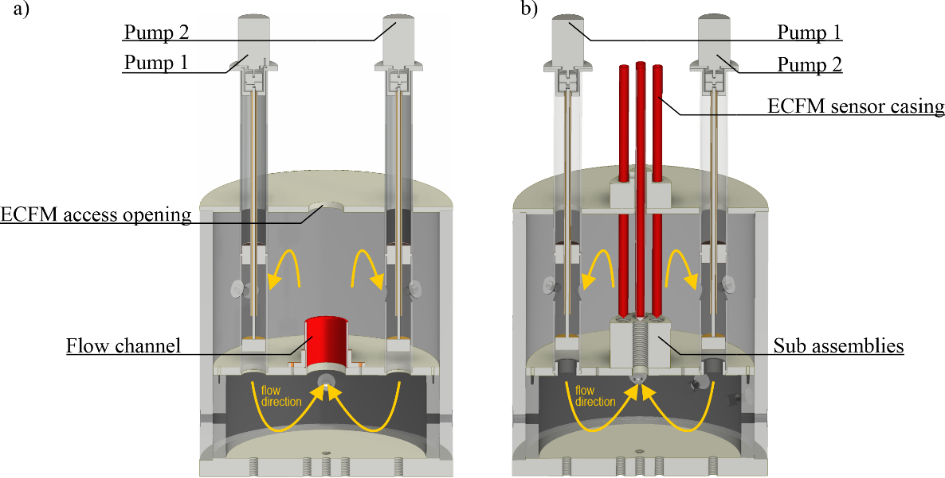
Fig. 1. Configuration of the model experiment: a) for the flow angle measurements and b) for the measurements with the ECFM array. The flow channel has a diameter of 45.2 mm for configuration a) and each SA has a diameter of 18 mm, a pitch of 22 mm and a height of 55 mm for configuration b).
For configuration b), seven 30 cm long sensor casings made of stainless steel with a wall thickness of 1 mm and a total diameter of 13 mm are attached to the lid of the model experiment, one for each SA. These contain the sensors and allow the ECFMs to be positioned directly above the SAs. The centres of adjacent SAs have a distance of 22 mm from each other. In order to simulate blockages, each of the SAs can be blocked individually with PVC screws. Different experimental cases with up to four blocked SAs will be investigated. The more SAs are blocked, the more the flow rate through the other SAs increases, for a constant motor voltage of the pumps. This has to be considered when evaluating the measurement results. It was decided to rather keep the motor voltage constant for all experimental cases than to adjust the motor voltage individually for each case. This ensures that the flow structure in the lower part of the vessel does not change significantly when SAs are blocked. Still, a turbulent flow in the bottom part of the vessel is expected which may result in an asymmetrical flow rate distribution through the different SA.
The ECFM sensors consist of three magnetic coils on a PVC coil holder (see Fig. 2), one active primary coil for the generation of the excitation field and two passive secondary coils that are used to detect velocity induced changes in the excitation field. The primary coil has a height of 10 mm and 290 turns of enamelled copper wire with a diameter of 0.25 mm. The secondary coils each have a height of 16 mm and 1150 turns of enamelled copper wire with a diameter of 0.15 mm. An excitation current with an rms of 250 mA and a frequency of 2 kHz is applied to the primary coil. Previous investigations with the ECFM have shown that the sensor has its highest sensitivity at this frequency. The sensor has a total length of 50 mm and a diameter of 10.6 mm.

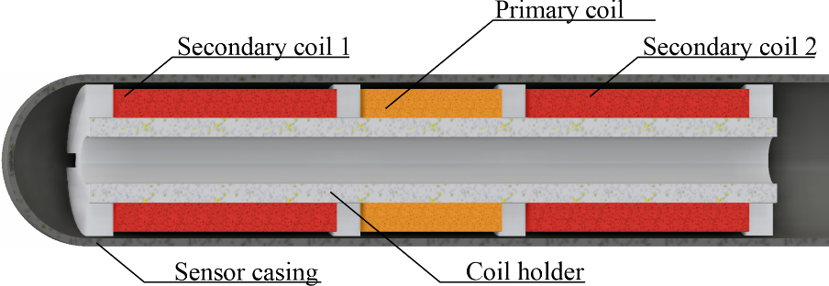
Fig. 2. Basic structure of the ECFM sensor (cross section).

The output signal of the ECFM is the voltage difference ΔU between both secondary coils, which has a linear dependence on the average flow velocity around the sensor. It has the same frequency f as the excitation current. Since the relevant signals are sinusoidal with a single frequency, a Lock-In Amplifier (LIA) is used for recording the measurements. It has the advantage that all signals with frequencies other than f are filtered out and therefore electromagnetic disturbances have a considerably smaller impact on the measured signals. This results in an increased overall measurement accuracy. The excitation current is generated with a signal generator in combination with a power amplifier in current source mode, such that the excitation current is kept constant even when the resistance of the coil wires is slightly changing because of temperature variations.

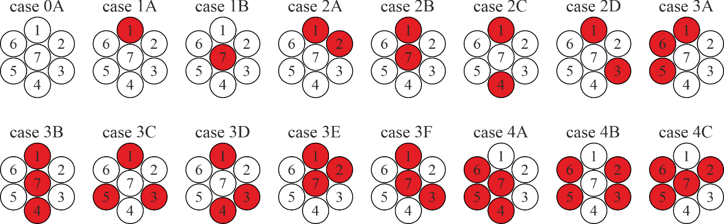
Fig. 3. Overview of the investigated cases and location of the numbered SAs. Blocked SAs are coloured red.

Several cases differing in the number and position of blocked SAs are investigated (see Fig. 3). Before each case, the vessel has to be partially drained in order to be able to access the SA. After the designated SAs have been blocked, the vessel can be refilled again and the measurements can be started. Measurements are performed successively for each SA (SA1-SA7) and ΔU is recorded over 60 seconds with one data point per second and subsequent calculation of the average value for ΔU. This is done once when the pumps are switched on and once when they are switched off. Under ideal circumstances it would be enough to measure ΔU once, when the pumps are running, but ΔU has a certain offset, which is slightly changing between cases due to draining, refilling and reattaching the top lid of the vessel. This voltage offset is sensitive to slight changes in the surroundings or position of the sensor but when the difference between ΔU for running and stopped pumps is calculated, the offset can be eliminated and only the velocity dependent part of the voltage remains. The resulting output voltage is called compensated output voltage U_{c}:
$$U_{c}={∆U}_{on}-{∆U}_{off}$$ | (1)
A total of 16 cases were investigated, with differences in position and number of blocked SAs. Since the motor voltage of the pumps is kept constant at 12 V regardless of how many SAs are blocked, the flow velocity through the unblocked SAs will be increasing the more SAs are blocked.

Measurement Results

ECFM performance for changing flow angles
In this section, the measurement results for flow angles between β = 0° and β = 45° are presented. It is presumed that the ECFM is insensitive to the x and y components of the flow velocity and since the flow direction within the channel is directed completely in z direction, the sensitivity of the ECFM would be decreasing with the cosine of the flow angle β. Therefore, the maximum measured flow velocity or sensitivity of the sensor is expected at β = 0°.
Up to β ≈ 30° there are only small deviations to the theoretically predicted sensitivity of the ECFM. For β ≥ 40° a clear deviation from the expected behaviour of the ECFM can be observed. The flow velocity v is decreasing at a much higher rate than predicted, as can be seen in Fig. 10 of [24]. Since the standard deviations of the measurements are relatively low, a pure measurement error can be ruled out as the cause for this result. The most likely cause for this effect is the increasing size of recirculation zones in the vicinity of the sensor, as was observed in the numerical simulation data. Their size is increasing with β and strongly influences the measurement results, since the ECFM is always measuring the mean flow velocity in a certain volume around the sensor. It is even possible that there are negative velocity components within the recirculation zones which would have an even stronger impact on the measured mean flow velocity. More detailed results of numerical simulations and measurements can be found in [24].

Detection of local blockages with an array of ECFMs
In this section, the measurement results for the experiments with the ECFM array are displayed and evaluated. A total of 16 cases differing in the position and number of blocked SA were investigated, they are named according to the number of blocked SA and an additional letter to distinguish between cases with the same number of blocked SA. For example, the case where none of the SA are blocked is named “0A”. The basis of the evaluation are the measured voltage magnitudes U_{c} for case 0A. Since the motor voltage is held constant, the flow velocity through the unblocked SA is increasing with the number of blocked SAs because the available cross section for a constant flow rate is reduced. Although the ECFMs are constructed in the same way, there are still minor differences concerning the geometrical and electrical parameters. Therefore, each ECFM has a different sensitivity to flow rate changes. In order to be able to compare the results more comfortably, relative changes in the signal strength of the respective ECFM are used instead of absolute voltages or velocities. The relative signal strength U_{rel} for each SA is calculated from the ratio of U_{c} for the respective case and U_{c} for the case 0A according to equation (2) where n stands for the number of blocked SAs and X for the case identifier (A to F):
$$U_{rel}=\frac{U_{c nX}}{U_{c 0A}}$$ | (2)
For each case, the expected signal strength that depends on the number of blocked SA is displayed. Because the SAs are relatively close together and the ECFM of a certain SA is always influenced by its neighbouring SAs, U_{rel} for a certain SA may be much higher than the expected signal strength. This is especially noticeable for the centre SA since it has the highest amount of direct neighbours, six instead of three. At the real reactor, this cross-talk between SA will be less or even disappear because the distance between sensors is usually larger than in this model experiment. Here, the distance between the centres of two SAs is 22 mm. By blocking certain SAs, the range of the ECFM can be estimated (see case 4A in Fig. 6). By blocking SAs the overall flow structure in the model experiment is changed, in some cases this may result in an asymmetrical distribution of the flow through the SAs due to the turbulent flow in the lower part of the vessel.
The measurement results are presented in Fig. 4, Fig. 5 and Fig. 6. Here the measured average U_{rel} for each SA is displayed as a circle. If a SA is blocked, the circle is coloured red, unblocked SAs are coloured white. The error bars of each data point indicate the empirical standard deviation s of the recorded measurement data. Each diagram contains a map that shows the location of the blocked SA or SAs. As a reference, the expected relative signal strength U_{exp} is indicated by a dashed red line. The following pages contain a short description and analysis of each case.
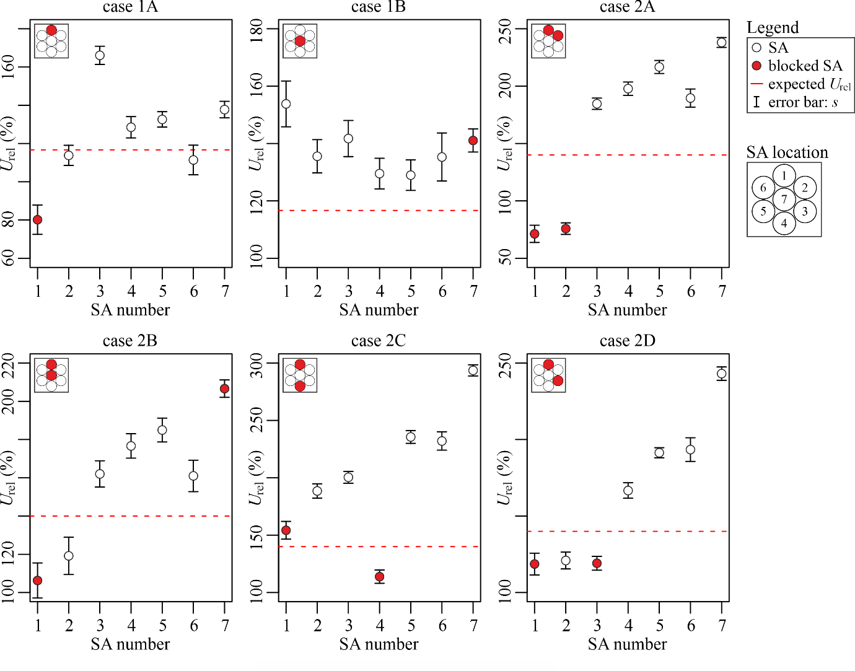
Fig. 4. Experimental results for the cases with one and two blocked subassemblies.

Case 1A: In case 1A in Fig. 4 the effect of one blocked peripheral SA can clearly be seen. For the blocked SA1 there is a significant drop in signal strength of the ECFM, while the neighbouring SA2 and SA6 only have a slightly decreased signal strength in regard to the expected U_{rel}. For the centre SA7, the effects are less prominent because its remaining neighbouring SAs are compensating with increased flow velocities.
Case 1B: When only the centre SA is blocked, it is difficult to detect the blockage because the increase in signal strength is comparable for all SAs. In frame of this model experiment where the initial flow velocity is constant, it can be concluded that one SA has to be blocked because of the overall increase in signal strength and that it has to be SA7 since all peripheral SAs exhibit a comparable increase in the detected flow velocity. When the distance between SAs is increased, it would be much easier to detect a blockage of the centre SA because the cross-talk between SAs is reduced.
Case 2A: When two neighbouring peripheral SAs are blocked, their location is easily detected because their signal strength is much lower compared to the remaining SAs. It can also be seen that the difference in signal strength between SA7 and its neighbouring SAs is further increasing due to the overall increase in flow velocity.
Case 2B: For the case of one blocked peripheral SA and a blocked centre SA the picture is not as clear as for case 2A. On the first glance, it appears that in addition to SA1 and SA7, SA2 is also blocked. However, the corresponding drop in signal strength of SA2 is caused by the removal of two of the neighbouring SAs. Because of the symmetrical arrangement of SAs, the same behaviour would be expected of SA6 but there seems to be a certain asymmetry of the flow, favouring the left SAs.
Case 2C: When two opposite peripheral SAs are blocked, they can be identified much easier than for example in case 2B. Although the detected flow velocity in SA1 is increased compared to the expected flow velocity, it is still much less in relation to the other unblocked SAs. Again, the asymmetry of flow rate distribution favouring the left side can be observed.
Case 2D: For this case, locating the blocked SA is not trivial. Apparently SA1, SA2 and SA3 seem to be blocked because they have a very similarly low signal strength. But if this would be the case, SA2 should have a much lower signal strength than SA1 and SA3 because it only has one neighbouring unblocked SA whereas SA1 and SA3 would have two. Therefore, there cannot be a blockage at SA2. This case demonstrates, that it is important to evaluate the data not only for a single SA but also for the other SAs in the vicinity.

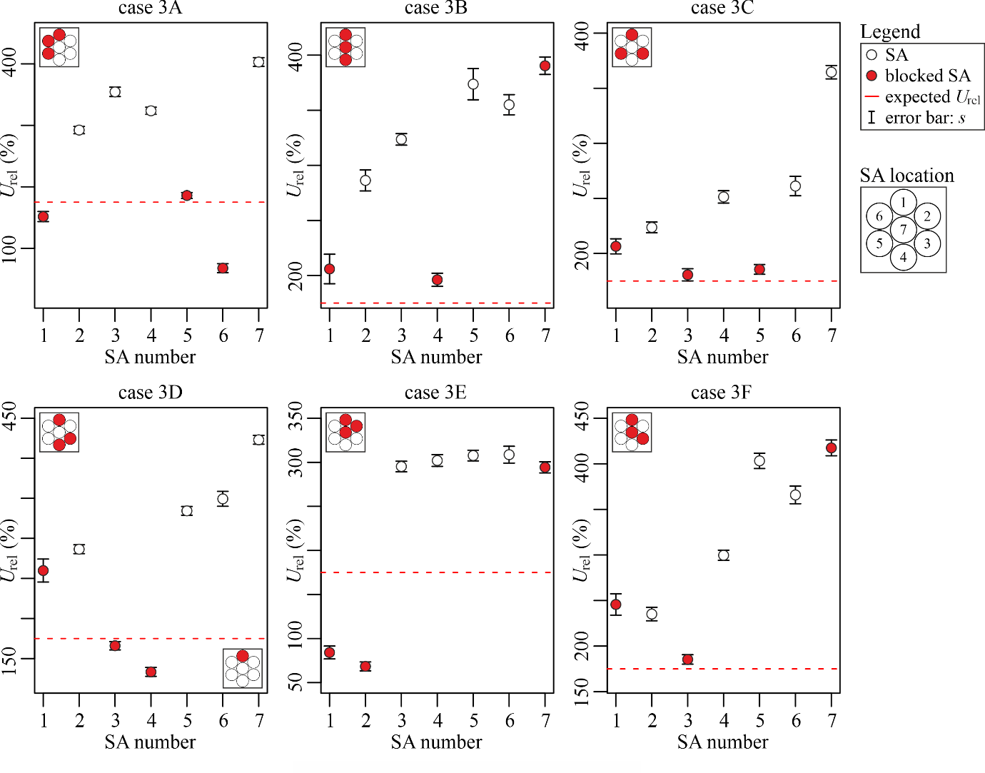
Fig. 5. Experimental results for the cases with three blocked subassemblies.

Case 3A: In this case which can be found in Fig. 5, three neighbouring peripheral SAs are blocked. They can be easily identified, since their signal strength is much lower compared to the other SA. Additionally, the difference to case 2D can be observed: SA6 with only one unblocked neighbouring SA has a considerably lower signal strength than the blocked SAs SA1 and SA5 with two neighbours each.
Case 3B: As we have seen in the previous cases, detecting the blockage of the central SA is not always as clear as for blocked peripheral SAs. In this case, three SAs in a row are blocked. While the low signal strength in SA1 and SA4 indicates that they are blocked, SA7 still has the highest overall signal strength. But with the knowledge from previous cases, we know that SA7 should have a much higher (factor of two or more) signal strength than the surrounding SAs if it is not blocked. Since this is not the case here, it can be concluded that SA7 must also be blocked.
Case 3C: In this case three of the peripheral SAs are blocked, each with one unblocked SA in between. From the signal strength it is clear that SA3 and SA5 are blocked. Unfortunately SA1 and SA2 have a comparable signal strength and therefore it cannot be determined without a doubt which one of them or even if both of them are blocked. Since the signal strength for SA1 is lower, it is most likely the blocked SA.
Case 3D: This case is similar to the previous case 3C with the difference that two of the blocked SAs are neighbours. What can be seen here is that the signal strength is dropping significantly when neighbouring SAs are blocked. In retrospect to case 3C, the correct blocked SA can now be identified on the basis of this behaviour. Because the drop in signal strength cannot be observed, SA2 can therefore be ruled out as the blocked SA in case 3C.
Case 3E: In this case two neighbouring SA and the central SA are blocked. From the distribution of the signal strength we can conclude that SA1 and SA2 are definitely blocked. SA7 must also be blocked because it exhibits the lowest signal strength of the remaining SA although it should have highest one if there was no blockage.
Case 3F: In this case it can be seen that SA4, SA5 and SA6 are definitely not blocked. But it is again not obvious if SA1 or SA2 are blocked. As we have seen in case 3D, the signal strength would be much lower if SA3 and SA2 were blocked, therefore SA1 can be identified as blocked instead. SA7 must also be blocked because it would have a much higher signal strength otherwise.

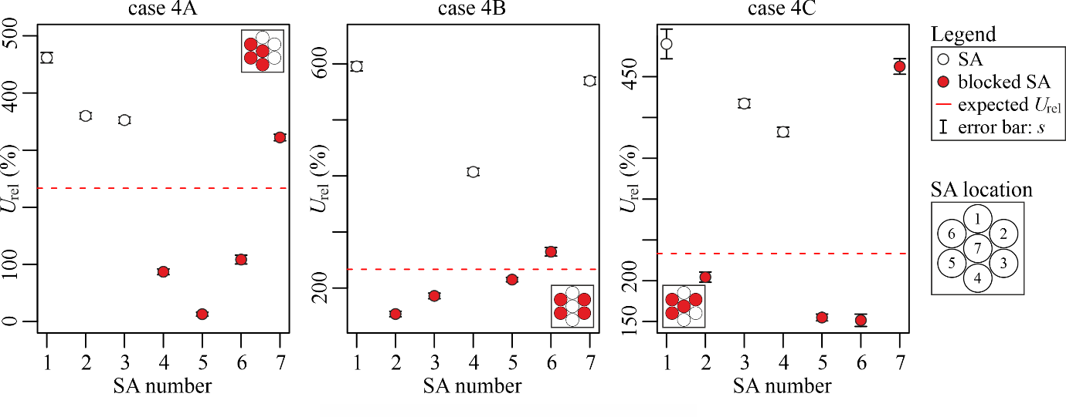
Fig. 6. Experimental results for the cases with four blocked subassemblies.

Case 4A: In this case which can be found in Fig. 6, a cluster of four SAs including the central SA are blocked. From what we have learned so far, it is clear which SAs are blocked. However, one important information that can be obtained from this case is based on the signal strength U_{rel} of SA5. Since it is almost zero, it can be concluded that the maximum range of the ECFM, where it is no longer influenced by its neighbouring SAs, is almost reached. Since two SAs have a distance of 22 mm to each other, the maximum range of the ECFM is slightly more than a radius of 44 mm around the sensor.
Case 4B: In this case four peripheral SAs are blocked, the two left and two right SAs. Again, the blocked SAs can be easily identified. What can be concluded from the distribution of the signal strength in this case confirms the observations from previous cases: the flow is not distributed equally throughout the SAs, it is stronger on the top left side (SA1 & SA6), although the model experiment is constructed symmetrically.
Case 4C: Here it can be seen again that two neighbouring blocked peripheral SAs result in a considerably reduced signal strength for SA5 and SA6. Whereas two unblocked neighbouring SAs have a much higher signal strength (see SA3 and SA4) which is caused by the cross-talk of SAs.
The results have shown that in order to detect blocked SAs, it is important to not only look at a single ECFM but to analyse the whole array and the relative changes in signal strength compared to the other sensors. Although the flow through the SAs is not distributed equally, it is still possible to detect reliably which of the SAs are blocked. Especially from the symmetrical cases like 1B, 2C or 3B it can be seen that there is a three- dimensional, asymmetrical flow through the SAs which is caused by slight asymmetries in the construction of the experiment and the turbulent flow in the lower part of the vessel. By blocking certain SAs, the flow angle with regard to the ECFM sensors may change, especially of those that lie above a blocked SA. Unfortunately, the extent to which these angles change cannot easily be determined experimentally with this setup. Numerical simulations are underway in order to analyse it. In tendency, steeper angles result in even lower signal strengths (see [24]), which in turn should simplify the identification of blocked SAs.
Although the flow velocities for this setup are relatively low, the performance of these sensors has been tested for up to 1.5 m/s in pipe flows of GaInSn. The linear relationship between velocity and sensor output voltage is still maintained at high velocities, therefore it is not necessary to utilize the full velocity measurement range of the sensor for the calibration. Since the magnetic fields penetrate only a few centimetres into the liquid metal, the calibration does not have to be performed inside the reactor. It would be much easier to construct a dedicated test rig or to use a suitable existing facility for the calibration of the sensors. By integrating a thermocouple into the coil holder of the ECFM and calibrating it for different temperatures, accurate measurements of the flow velocity are possible, even under changing environmental conditions. A high temperature prototype of this sensor has been constructed, using ceramic insulated nickel plated copper wire and a ceramic coil holder. It was tested in liquid sodium for up to 300 °C showing a similar performance to the low temperature ECFM, future tests will be performed for up to 720 °C.

Conclusions
With the presented model experiment it became possible to carry out novel measurements with the ECFM in real three-dimensional GaInSn flows at room temperature. Previous simulations and experiments did not account for changing flow angles, therefore the results that were obtained herein give important insights into the ECFM performance under realistic flow conditions, which can for example also be found above the subassemblies in liquid metal cooled fast reactors. It was demonstrated by numerical simulations as well as by measurements that the presence of the ECFM itself has a significant impact on the measured velocities, especially for flow angles above 40° with respect to the axis of the ECFM. Recirculation zones with very low flow velocities close to the ECFM strongly impact the output signal of the sensor and lead to a significant drop of the measured velocity of the sensor. For flow angles below 30° this effect is negligible, above 40° the sensitivity is reduced more than 50% compared to the sensitivity without an inclination of the sensor.
The model experiments with an array of ECFM sensors have demonstrated that these sensors can indeed be used to detect and localise blocked SAs as well as monitor changes of the flow rate under normal operating conditions. One or multiple blocked SAs result in a considerable change of signal strength in the respective sensors, although for some configurations it is not obvious that a certain SA is blocked. Therefore multiple cases with a different number and location of blocked SAs have been investigated. Only by taking the behaviour of the surrounding sensors of the array into account, an accurate and reliable detection of the blocked SA can be achieved. When the SAs or sensors are too close together, a single ECFM can be influenced by the flow through neighbouring SAs, which leads to a cross talk between adjacent sensors and SAs. This complicates the identification of blockages, although this problem will have considerably less impact in a real reactor since the size of the ECFM will stay the same but the size and pitch of the SAs as well as the expected flow velocity will be larger. From the experimental results it can be inferred that for this configuration of geometrical parameters, electrical conductivity of the liquid metal and excitation frequency of the ECFM, the sensor signal is influenced by flows in a distance of up to 44 mm from the centre of the ECFM. This distance is influenced by the electrical conductivity of the liquid metal and may change depending on which kind of metal is used as coolant. Additionally, temperature changes of the coolant may also influence the conductivity and thereby the maximum range of the ECFM. The sensor range can also be adjusted via the excitation frequency but this may result in a loss of sensitivity of the ECFM since it has its highest sensitivity to flow rate changes at excitation frequencies between 1 kHz and 2 kHz.
Future experiments in liquid sodium and with increased flow velocities will give further insights into the qualification for the ECFM as part of the safety instrumentation of liquid metal cooled fast reactors.
ACKNOWLEDGEMENTS
The authors gratefully thank Stefanie Sonntag, Heiko Kunadt and Bernd Nowak who constructed and built the experimental setup, as well as assisted with the measurements.
Results presented here have received funding from the Euratom research and training program 2014–2018 in frame of the project ESFR-SMART under the Grant Agreement No. 403 754501.F

References
- LEHDE, H., LANG, W. T., “Device for measuring rate of fluid flow”, Patent No. US2435043A, 1948
- SHERCLIFF, J. A., “The Theory of Electromagnetic Flow-Measurement”, Cambridge University Press, Cambridge, United Kingdom, 1962.
- BEVIR, M. K., “The Theory of Induced Voltage Electromagnetic Flowmeters”, J. Fluid Mech., 43(3), pp. 577–590.
- BUCENIEKS, I., “Electromagnetic induction flowmeter on permanent magnets” Proc. 5th Int. PAMIR Conf., Ramatuelle, France, Vol. II, pp. 103–105, 2002.
- PRIEDE, J., BUCHENAU, D., GERBETH, G., “Contactless electromagnetic phase-shift flowmeter for liquid metals”, Meas. Sci. Technol., 22, 055402, 2011.
- PRIEDE, J., BUCHENAU, D., GERBETH, G., “Force-free and contactless sensor for electromagnetic flowrate measurements”, Magnetohydrodynamics, 45, pp. 451–458, 2009.
- THESS, A., VOTYAKOV, E. V., KOLESNIKOV, Y., “Lorentz force velocimetry”, Phys. Rev. Lett., 96, 164501, 2006.
- STEFANI, F., GERBETH, G., “Velocity reconstruction in conducting fluids from magnetic field and electrical potential measurements”, Inverse Prob., 15, pp. 771–786, 1999.
- STEFANI, F., GERBETH, G., “On the uniqueness of velocity reconstruction in conducting fluids from measurements of induced electromagnetic fields” Inverse Prob., 16, pp. 1–9, 2000.
- STEFANI, F., GERBETH, G., “A contactless method for velocity reconstruction in electrically conducting fluids” Meas. Sci. Technol., 11, pp. 758–765, 2000.
- WONDRAK, T. et al., “Contactless inductive flow tomography for a model of continuous steel casting”, Meas. Sci. Technol., 21, 045402 2010.
- FORBRIGER, J., STEFANI, F., “Transient Eddy Current Flow Metering”, Meas. Sci. Technol., 26(10), 105303, 2015.
- KRAUTER, N., STEFANI, F., “Immersed Transient Eddy Current Flow Metering: A Calibration-Free Velocity Measurement Technique for Liquid Metals”, Meas. Sci. Technol., 28(10), 105301, 2017.
- LOONEY, R., PRIEDE, J., “Alternative Transient Eddy-Current Flowmetering Methods for Liquid Metals,” Flow Meas. Instrum., 65, pp. 150–157, 2019.
- BRITO, D. et al., “Ultrasonic Doppler velocimetry in liquid gallium”, Exp. Fluids, 31, pp. 653–663, 2001.
- ECKERT, S., GERBETH, G., “Velocity measurements in liquid sodium by means of ultrasound Doppler velocimetry” Exp. Fluids, 32, pp. 542–546, 2002.
- ECKERT, S., GERBETH, G., MELNIKOV, V. I., “Velocity measurements at high temperatures by ultrasound Doppler velocimetry using an acoustic wave guide”, Exp. Fluids, 35, pp. 381–388, 2003.
- SHARMA, P. et al., “Performance Prediction of Eddy Current Flowmeter for Sodium,” Proceedings of the COMSOL Conference, Bangalore, India, 2009.
- POORNAPUSHPAKALA, S., et al., “An Analysis on Eddy Current Flowmeter—A Review”, Recent Advances in Space Technology Services and Climate Change (RSTS & CC-2010), Chennai, India, pp. 185–188, 2010.
- PAVLINOV, A., KHALILOV, R., MAMIKYN, A., KOLESNICHENKO, I., “Eddy Current Flowmeter for Sodium Flow,” IOP Conf. Ser.-Mater. Sci. Eng., 208, 012031, 2017.
- NAKAMOTO, K. et al., “Application of an Eddy-Current Type Flowmeter to Void Detection at the LMFBR Core Exit”, Nucl. Eng. Des., 82(2–3), pp. 393–404, 1984.
- SURESHKUMAR, S. et al., “Utilization of Eddy Current Flow Meter for Sodium Flow Measurement in FBRs”, Nucl. Eng. Des., 265, pp. 1223–1231, 2013.
- PLEVACHUK, Y. et al., “Thermophysical Properties of the Liquid Ga–In–Sn Eutectic Alloy”, J. Chem. Eng. Data, 59(3), pp. 757–763, 2014.
- KRAUTER, N. et al., “Eddy Current Flow Meter Performance in Liquid Metal Flows Inclined to the Sensor Axis”, ASME J of Nuclear Rad Sci., NERS-20-1060, 2021.

