Estimation of mean charge on sodium metal aerosol in the bipolarly ionized argon and nitrogen gas

AMIT KUMAR
Radiological and Environmental Safety Division, Indira Gandhi Centre for Atomic Research
Kalpakkam, India.
Email: amitpatel@igcar.gov.in

USHA P.
Radiological and Environmental Safety Division, Indira Gandhi Centre for Atomic Research
Kalpakkam, India.

SUBRAMANIAN V.
Radiological and Environmental Safety Division, Indira Gandhi Centre for Atomic Research
Kalpakkam, India.

SRINIVAS C.V.
Radiological and Environmental Safety Division, Indira Gandhi Centre for Atomic Research
Kalpakkam, India.

VENKATESAN R.
Radiological and Environmental Safety Division, Indira Gandhi Centre for Atomic Research
Kalpakkam, India.

ATHMALINGAM S.
Health, Safety and Environment Group, Indira Gandhi Centre for Atomic Research
Kalpakkam, India.

VENKATRAMAN B.
Safety, Quality and Resource Management Group, Indira Gandhi Centre for Atomic Research
Kalpakkam, India.

Abstract

The cover gas region of sodium-cooled fast reactors is constantly subjected to an intense ionizing radiation field apart from radioactive aerosols and gases. The radiation produces significant ionization of the gas medium resulting in an enormous number of bi-polar ions. The acquisition of electrical charge by sodium metal aerosols in the cover region under a bipolar ion’s concentration draws particular attention. It modifies the dynamics of aerosol transport, deposition, coagulation, and process inside the cover gas space, which influence the thermal-hydraulics and deposition of aerosol in narrow gaps. The bipolar charging of sodium aerosols has been studied in argon and nitrogen gas environments. The average charge acquired by sodium aerosols in argon and nitrogen environment was investigated by considering ions mobility of argon and nitrogen, aerosols particle diameter, and bulk temperature of the cover gas region. The average number of elementary charges is negative polarity and increases with the increase of sodium pool surface temperature, i.e., sodium aerosol size for both gases. The average charge on sodium aerosol is more in argon gas when compared to nitrogen, which increases with sodium pool temperature, i.e., mean aerosol size. This is due to the ratio of positive to negative ions mobilities being more for nitrogen gas when compared to argon. The theoretically determined charge distribution is more asymmetric in argon gas compared to the nitrogen gas. Further, due to the lack of experimental data, a direct comparison cannot be possible. Nevertheless, the presence of gamma sources produces the ion-pairs, and they get attached with aerosols which promote higher collision and enhance surface deposition. The mean charge on the aerosol can be used to calculate coagulation and deposition rates which is essential for the realistic determination of aerosol characteristics in the cover gas region. The sodium aerosol characteristics under bipolar ionized gas in cover gas give significant insight to understanding the cover gas dynamics.

INTRODUCTION
In Sodium cooled Fast Reactors (SFRs), an essential design feature is a cover gas region between hot sodium pool surface and relatively cooled rooftop structure. The cover gas blanket is used to isolate the liquid sodium from surroundings, and coolant volume changes when reactor operating temperature varies [1]. Though there are many inert gases available for liquid sodium, argon, nitrogen, and helium are preferred for SFR application. The argon gas is used in most of the sodium-cooled fast reactors as a blanket between the sodium pool surface and the top shield. The argon gas is exchanged with helium gas in the cover gas region by more than 70 to 80 % [2] when Fast Breeder Test Reactor (FBTR) and RAPSODIE is/ was operating conditions [3]. The nitrogen gas is used in the space between the primary and safety vessels to prevent sodium fire and ensure a safe sodium level during sodium leakage from the main vessel in FBTR and PFBR [2]. Also, nitrogen gas was used in many applications in SFRs like between coaxial pipe of primary sodium circuit, cooling gas for winding of annular linear induction pump, and cooling gas for absorber bed for cover gas purification circuit, etc. The characteristics of aerosol in nitrogen gas play a significant role in deposition pattern and qualification of sensitivity of Sodium Aerosol Detector (SAD) for leak detection in many sensitive areas of SFRs. The temperature of the rooftop shield is maintained at 373 – 393 K, and sodium pool temperature varies from 473 to 823K depending upon whether the reactor is in regular operation or shutdown condition. The cover gas temperature depends on the temperature of the sodium pool, rooftop, nature of cover gas, and the dimension of the cover gas space (diameter of pool and height of the cover gas space). Liquid sodium evaporates from the hot sodium pool surface into the cover gas space, where it condenses and nucleate and subsequently form polydisperse sodium metal aerosols [4-5]. The evaporation rate and aerosol characteristics (concentration and size distribution) significantly depend on many parameters like sodium pool temperature, the temperature gradient across the cover gas region, aspect ratio of the cover gas space, and types of gas used [1, 6].
The heat transfer across the cover gas enclosure is of significant interest in determining the thermal load to the rooftop structure and the overall behavior of the reactor [1]. Meanwhile, the aerosol is transported by convective gas to the roof area and the aerosol will deposit in the colder parts of the rooftop, which needs the attention in safety consideration of the reactor. The presence of sodium aerosols will affect radiation and convection heat transfer, the density of argon and aerosol mixtures, and coolant leakage detection systems that monitor aerosol and vapor concentration [1]. The aerosols characteristics play a significant role to understand the fraction of activity bound with aerosol formed in the cover gas region under failed fuel conditions [7 - 8] and during severe accidents [9]. Most of the experimental and theoretical investigations on aerosol dynamics and thermal-hydraulics in cover gas were carried out during the 1980s – 1995s. The test facilities were typically cylindrical with an aspect ratio (height/ diameter) ranging from 0.5 to 4.5 [6], two orders higher compared to the reactor scale, i.e., the pool diameter two orders less. The characteristics of sodium aerosols in the cover gas region present in the literature show that the concentration and mean size increase with sodium pool temperature and vary spacially inside the cover gas space [4-5]. However, there was no significant influence of rooftop temperature on aerosol characteristics for a fixed pool temperature. The sodium aerosols characteristics and thermal-hydraulics inside the cover gas space are also sensitive to the aspect ratio of the cover gas space, exchange rate of gas and sodium, and cover gas (argon, helium, and nitrogen) combinations [3, 10]. In contrast, when argon gas was replaced by helium, the aerosol concentration stayed one order less [3]. There is a wealth of information available on the sodium–argon system. However, little investigation has been conducted on the sodium–helium system and hardly any literature is available on the sodium–nitrogen system. Here, the objective of selecting nitrogen gas is to compare the aerosol properties from argon gas, because it has a different asymmetry of mobility of ions.
Further, it is to be noted that the cover gas region of SFR is constantly being subjected to gamma radiation field apart from radioactive sodium aerosol and argon gas. The gamma radiation produces significant ionization of the medium resulting in an enormous number of bi-polar ions. The acquisition of electrical charge by sodium aerosols in the cover region under a bipolar ionic atmosphere draws specific attention. It modifies the dynamics inside the cover gas space due to coulomb, image, and Van der Waals (kinematic coagulation) forces in addition to Brownian coagulation [11 – 12]. Hence, the characteristics of sodium metal aerosols in cover gas space would change under bi-polar ions. Towards this, a study was conducted to characterize the sodium aerosols present in the argon cover gas region using a sodium loop facility called SILVERINA with and without gamma radiation field. The experiments demonstrated that the mean size of sodium aerosol is relatively higher, and mass concentration is lower in the gamma field than without gamma [13-14]. The experiments were repeated with nitrogen as cover gas without gamma field [10]. There is insufficient knowledge on sodium aerosol dynamics and thermal-hydraulics in the cover gas region documented in the open literature, particularly with the radiation field. The aerosol dynamics and thermal-hydraulics in the cover gas region are complex phenomena, and there is a clear need to develop physical understanding and model them. In this article, an attempt has been made to predict the average charge acquired by non-radioactive sodium metal aerosol for various sodium pool temperatures in argon and nitrogen cover gas region under a given radiation field. The average charge is theoretically estimated using different charging theories by considering the mobility of the positive and negative ions, bulk cover gas temperature, and various sodium pool temperature (aerosols size) for argon and nitrogen gas and presented in this paper.

Materials and methods

Experimental facility and data extraction
The experiments were conducted in Test Pot-1 (TP-1) of the SILVERINA loop at Fast Reactor Technology Group (FRTG) for argon and nitrogen gas [3 - 4, 10, 15]. The diameter and height of the cover gas region are 762 and 800 mm, respectively. The pressure inside the cover gas region ranges 0.3 - 0.4 bar above the atmosphere during the experiments. The sodium aerosol sample was drawn from near the top flange (200 mm) at 2.0 Lpm, and sampling time was kept according to sodium pool temperature. The details of sampling and characterization techniques and sodium metal aerosol characteristics in the argon as a cover gas region for pool temperatures in the range of 523 to 823 K are explained in our earlier work [3]. The experiments for sodium aerosol characterization in nitrogen gas are carried out for sodium pool temperatures 523 to 823 K. The results of experiments and analysis of sodium aerosol characteristics in nitrogen gas are discussed and compared with argon gas [10]. The average cover gas temperature largely remains constant in the middle region of gas space, and there is a steep gradient at the sodium pool and roof boundary layer. An empirical relation for average cover gas temperature has been proposed and agreed with measured gas temperature for argon gas and various sodium pool temperatures used for aerosols charge calculation [6].

Aerosol charging equations and distribution
The aerosol charging has been described in two ways viz. (i) aerosol carries average/ mean charge, which is representative of total aerosol, i.e., all aerosols carry the same charge, and (ii) aerosol carry distribution of charges and then the average charge can be derived from charge-size distribution. The researcher proposed many theories for the calculation of the magnitude of the average electric charge on aerosols. The experimentally determined charge distribution showed agreement with Boltzmann distribution, i.e., the charge distribution is symmetrical [16]. The Boltzmann charging equation is widely used for approximation to estimate the average charge on the aerosol particle under room temperature and pressure [17]. The Boltzmann distribution equation gives the number of particles carrying j number of charges:

$N_{j}=N_{t}\frac{e}{{(8π^{2}ε_{o}akT)}^{1/2}}\exp{(}\frac{{-j}^{2} e^{2}}{8πε_{o}akT}$), | (1)

Where N_{j} and N_{t} are the number of aerosols carrying j charge and the total number of aerosols, e is elementary charge value, is the permittivity of free space, a is the aerosol radius, k is Boltzmann constant, and T is the absolute temperature. An average charge on an aerosol particle can be calculated as:

$<j>=\frac{\sum_{0}^{∞}{{j N}_{j}}}{\sum_{0}^{∞}{N_{j}}}=\frac{\sqrt{8ε_{o}akT}}{e}$, | (2)

The charge distribution calculated from (equations 1 and 2) purely depends on the particle size for the given temperature. It does not include the effect of inequality in positive and negative ion concentrations and respective mobilities. Hussin et al., 1983 and Adachi et al., 1985 have shown that the bipolar charge distribution in atmospheric air is asymmetrical [18-19]. Further, the Boltzmann distribution does not consider the imbalance of ions properties, i.e., the fraction of negatively charged aerosols is higher than the fraction of positive charge aerosols. An alternative approach derived by Gunn 1954 showed that the properties of ions (mass, mobility, and concentration) also play an essential role in aerosol charging. The fraction of aerosol carrying j number of charges is given by Gaussian distribution and given as [20]:
$$N_{j}=N_{t}\frac{e}{{(8π^{2}ε_{o}akT)}^{1/2}}\exp{[}\frac{- {\{j-\frac{4πε_{o}akT}{e^{2}}\ln\left(\frac{n_{+}μ_{+}}{n_{-}μ_{-}}\right)\}}^{2}}{2(\frac{4πε_{o}akT}{e^{2}})}],$$ | (3)

Where µ₊, µ₋, n₊ and n₋ are mobility and concentration of positive and negative ions respectively. The corresponding average charge on aerosol is derived as:

$<j>=\frac{\sum_{-∞}^{+∞}{{j N}_{j}}}{\sum_{-∞}^{+∞}{N_{j}}}$, | (4)

Further, the degree of elementary charge attained by aerosol under steady-state charging condition is determined by Modified Boltzmann distribution for the given ion properties (the ratio of positive to negative ion mobilities and their relative concentrations), and it is presented as [21-23]:

$\frac{N_{j}}{N_{f}}={[\frac{n_{+}μ_{+}}{n_{-}μ_{-}}]}^{j}\frac{8πε_{o}akT}{{je}^{2}}sinh(\frac{{je}^{2}}{8πε_{o}akT})exp{(}\frac{{-j}^{2} e^{2}}{8πε_{o}akT}$), | (5)

Where N_{f} is a fraction of particles which are having zero charges, i.e., neutral, similarly, the average charge on the aerosol particle can be calculated as:

$<j>=\frac{\sum_{-∞}^{+∞}{{j N}_{j}}}{\sum_{-∞}^{+∞}{N_{j}}}=\frac{4πε_{o}akT}{e^{2}}\ln\left(\frac{n_{+}μ_{+}}{n_{-}μ_{-}}\right)$, | (6)

From the above equations, the aerosols average charge and distribution depends on aerosols size, the temperature of the gas environment, mobility of positive and negative ion and their concentration. Further, the mobility of ions also depends on the mass of ions, temperature, pressure, and gas of the environment where aerosols become charged. Hence, the mobility of ions should be correctly known to predict the mean charge on aerosols. Generally, the average mobility of negative ions is greater than the positive ions by about 10% in atmospheric conditions [24]. This difference is significant for charging the radioactive aerosol and will be more for getting charged inert aerosols by externally produced ions [24]. The relation between mobility, pressure and temperature is given as:

$μ=μ_{0}\frac{P_{0}}{P}\sqrt{\frac{T}{T_{0}}}$, | (7)

Where P_{o}, T_{o}, and μ_{o} are the atmospheric pressure, zero absolute temperature and mobility of ions at the same condition. From the above equation, the mobility of ions can be extrapolated for any pressure and temperature condition.

Results and discussion

Sodium metal aerosol characteristics
The sodium vapour becomes supersaturated at a particular sodium pool temperature, the pressure of the cover gas region, and aerosol particles are formed by homogeneous or heterogeneous nucleation and condensation. The size distribution and mass concentration of these aerosols depend on the sodium pool temperature, the temperature gradient between the sodium pool and the type of cover gas for the fixed geometry of the cover gas space. The measured mass concentration of sodium metal aerosol as a function of sodium pool temperature in argon and nitrogen cover gas is given in Fig.1. The mass concentration of aerosol increases with the increase of sodium pool temperature for both gases, and concentration is higher for argon gas than nitrogen gas. The difference in aerosol mass concentration between argon and nitrogen gas ranges from 25 to 55 % for 523 to 823 K sodium pool temperature. The maximum experimental error in aerosols mass concentration measurement is believed to be accurate within ± 10 %. The experimental data are fitted with a third-order polynomial with the R² value 0.99 for both gases separately, which can be used to estimate aerosol concentration. The difference in the formation of aerosol concentration in argon and nitrogen is due to the temperature gradient between sodium pool surface and cover gas (or rooftop). The aerosol is formed in the cover gas region during convection when vapour supersaturation occurs. The higher temperature gradient in the case of argon favours the supersaturation of sodium vapours, thereby resulting in higher aerosol concentration. The argon gas and sodium aerosol mixture have a specific weight lower than that of the argon alone, enhancing the convection. In the nitrogen gas case, the convection will be reduced relative to argon because nitrogen gas and aerosol mixture have a specific weight comparable to nitrogen.

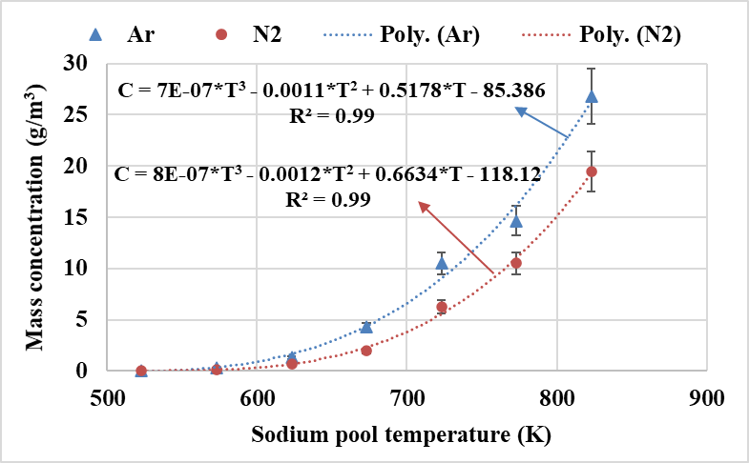

Fig. 1. Aerosol mass concentration as a function of sodium pool temperature for argon and nitrogen gas.

The sodium aerosol size distribution for both argon and nitrogen cover gas for sodium pool temperature 573 K and 673 K is shown in Fig.2. The aerosol size distribution is found to be a similar pattern, mono-model and polydisperse. The mode of size - distribution is shifted to the higher size range, and size distribution has become broader for nitrogen gas when compared to the argon gas case. The higher sodium pool temperature, the more evaporation of sodium and higher is the mean diameter and polydispersity of aerosols.

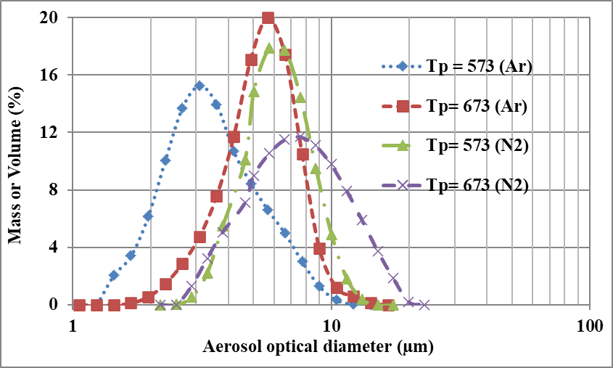

Fig. 2. Comparison of mass/ volume - size distribution of sodium aerosol in argon and nitrogen gas for 573 K and 673 K sodium pool temperature.
The MMD of sodium aerosol presence in nitrogen gas is more when compared to the argon gas for sodium pool temperature 573 K and 673 K. The standard deviation of the size distribution progressively increased when the sodium pool temperature increases from 573 to 673 K for both the cover gases (argon and nitrogen) and ranges from 1.4 - 1.6. Similarly, the MMD of sodium metal aerosol measured as a function of sodium pool temperature in argon and nitrogen cover gas is presented in Fig.3. The mean size of sodium metal aerosol (MMD) increases linearly with the increase of sodium pool temperature for both gases. The MMD of aerosol distribution is higher in nitrogen gas than argon gas, and the difference decreases with a rise in sodium pool temperature. The difference in the mean size of aerosol between argon and nitrogen gas ranges from 61 - 14% for the 523 to 823 K sodium pool temperature. The maximum error in average aerosols diameter is found to be accurate within ± 5 %. The experimental data fitted with linear fit with the R² value ⁓ 0.99 for nitrogen and argon separately, which can be used to estimate the MMD of sodium aerosols.

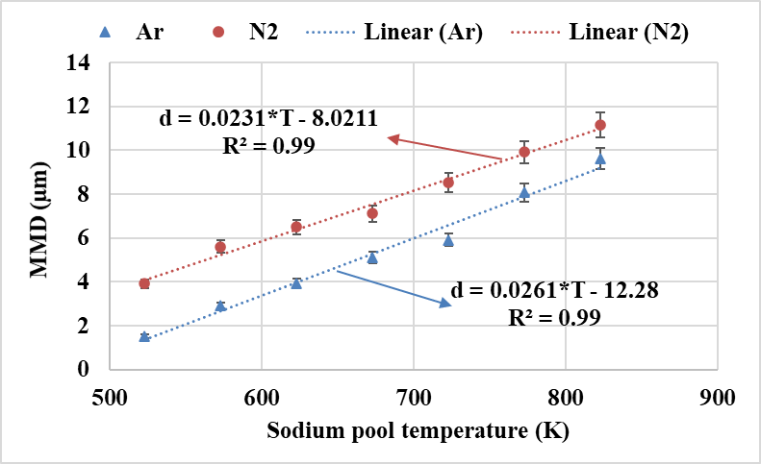

Fig. 3. Aerosol mean size (MMD) as a function of sodium pool temperature for argon and nitrogen gas.

The cover gas temperature decreases from pool surface to rooftop, and a steep temperature gradient exists near the pool and roof boundary layer. In the middle region of cover gas space, there is not much temperature variation. The mean temperature inside the bulk cover gas space as a function of sodium pool surface temperature for argon gas is shown in Fig.4. The mean temperature and standard deviation for the bulk temperature of cover gas increase with pool temperature, i.e., standard deviation ranges from ± 9 to ± 25. In contrast, when argon gas is replaced by nitrogen, the bulk cover gas temperature variation is less than the argon gas. The temperature gradient between sodium pool surface and top shield is more for argon than nitrogen due to the higher thermal conductivity of nitrogen than argon gas. The bulk cover gas temperature depends on the sodium pool temperature, the geometry of the cover gas space and the kind of gas. However, for charge calculation, the mean bulk cover gas temperature is considered for both gases.

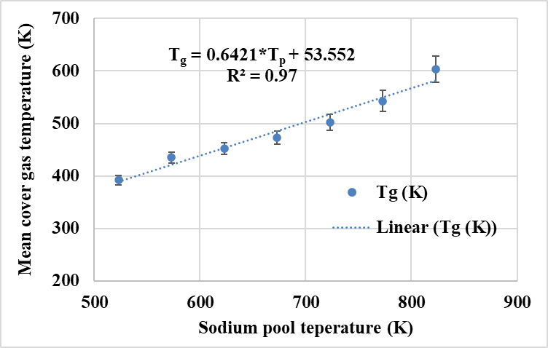

Fig. 4. Mean cover gas temperature as a function of sodium pool temperature.

The sodium aerosol size distribution in the cover gas region ranges from 1.0 to 40.0 μm for the 523 – 823 K range of pool temperature. Hence, the mean size of aerosols has been calculated for different pool temperatures and the average charge estimated for that size.

Mobility of ions and charge on sodium metal aerosol
Several experimental and theoretical studies have been conducted to understand the effect of gamma radiation on aerosol characteristics and dynamics [25-28]. The average charge of an aerosol in a bipolar ions field is negative polarity because of the high mobility of the negative ions. The magnitude of the electric charge on aerosol depends on the ratio between positive and negative ion’s electrical motilities and the ratio between their concentrations [29]. The positive and negative ions parameter needs to be determined to calculate the bipolar charge distribution on sodium metal aerosols in argon and nitrogen gases. The mobility of ions is a distribution function, but the average value has been taken for charge calculation. Wiedensohler and Fissan [30] given the mobility of positive and negative ions in argon and nitrogen gas room temperature and pressure. The ratio of positive and negative mobility is 0.824 and 0.930 for argon and nitrogen gas, respectively. The asymmetry ratio (µ₊/µ₋) may not change much with pressure and temperature because it is relative. The concentration of positive and negative ions is equal for the calculation of aerosol charge. The calculated average charge on sodium metal aerosols for argon and nitrogen gas by different theories is given in Table 1. The average charge on aerosol is negative polarity and increases with the increase of aerosol diameter, i.e., the temperature of the sodium pool. The calculated average charge on sodium metal aerosols in argon gas found to increase from 3.37 to 10.52, -3.47 to -33.71 and -3.65 to -33.05 with an increase of sodium pool temperature by Boltzmann, Gunn and MBD, respectively. Similarly, the calculated average charge on aerosols in nitrogen gas found to increase from 5.41 to 11.32, -3.33 to -14.55 and -3.46 to -14.63 with an increase of sodium pool temperature by Boltzmann, Gunn and MBD, respectively. The average charge calculated by Boltzmann theory is the magnitude of the charge on aerosols. The average charge calculated by Gunn and MBD theory almost matching and the variation between them is less than ± 5 %. The average charge on sodium aerosol is more in argon gas when compared to nitrogen, and this difference increases with sodium pool temperature, i.e., aerosol size. This is due to the ratio of positive to negative ions mobilities is higher for nitrogen gas when compared to argon gas. The collision efficiency of charged aerosols is modified even at a modest level of aerosol charging, and the coagulation time scale always less than the aerosol charging phenomenon [31]. So that the mean charge on the aerosol can be used to calculate coagulation rate and deposition rates. Further, it is to be understood from the literature that the charged aerosol would enhance Brownian coagulation and surface deposition. To get the coagulation enhancement factor of 5 times, the modest charging required by the aerosol particle is about eight elementary charges for the particles of radius 0.5 µm in each ion concentration [32]. Thus, it is understandable that the electrical forces caused by the Coulomb interaction between the charged aerosol particles are responsible for the enhanced coagulation. The average charge acquired by the aerosols would also depend on the number concentration of ion-pair and aerosols [33].

TABLE 1. Calculated average charge on sodium metal aerosols for both gases by various theories.

 | Argon gas (µ₊/µ₋=0.824) |  |  |  | Nitrogen gas (µ₊/µ₋=0.930)
T_{bg} (K) | MMD (µm) | Avergae charge (j) |  |  | MMD (µm) | Avergae charge (j)
 |  | Boltzmann | Gunn | MBD |  | Boltzmann | Gunn | MBD
392 | 1.52 | 3.37 | -3.47 | -3.65 | 3.91 | 5.41 | -3.33 | -3.46
435 | 2.92 | 4.91 | -7.35 | -7.49 | 5.60 | 6.80 | -5.25 | -5.39
452 | 3.95 | 5.84 | -10.40 | -10.51 | 6.51 | 7.50 | -6.38 | -6.52
473 | 5.10 | 6.78 | -14.02 | -14.10 | 7.11 | 8.01 | -7.28 | -7.42
502 | 5.92 | 7.53 | -17.31 | -17.36 | 8.52 | 9.04 | -9.28 | -9.41
543 | 8.07 | 9.14 | -25.47 | -25.45 | 9.91 | 10.13 | -11.65 | -11.77
603 | 9.62 | 10.52 | -33.71 | -33.08 | 11.15 | 11.32 | -14.55 | -14.63

Consequences of charged aerosol inside cover gas

The preliminary calculation has been performed to estimate the magnitude of electric charge on sodium aerosol in inert gases. We assume here that; the concentrations of the positive and negative ions are equal. The magnitude of the charge on aerosol is estimated based on the asymmetry of ion mobilities. Few other processes can modify the level of mean charge, like charging induced by photon interaction with sodium aerosol, diffusion of ions to the walls surface of cover gas space, and if aerosol particle and inert gas (in case of argon) itself radioactive. Considering the above factor, the consequence of the aerosol characteristics in cover gas space under ionizing radiation on the deposition of aerosol in the annular/ narrow gaps, sodium pool surface, and Cs trapping/ attachment to the aerosol is discussed here. The deposition of aerosol to the cooler part of the rooftop and the annular gap of the top shield will be enhanced under the ionic field because charged aerosol deposits faster rate on conducting surfaces based on the electrostatic deposition. Further, the aerosol deposition to the sodium pool will be also enhanced because aerosol distribution has become wider, and the mean aerosol size is also higher. Due to this, the suspended concentration of aerosol has been reduced under the ionic field. In the case of Cs trapping to the sodium aerosol, the aerosols are found to be neutral, positive, and negatively charged aerosols (based on modified Boltzmann distribution), and radioactive species. When the radioactive Cs are suspended in that medium, the Cs get themselves attached with charged aerosols due to coulomb or image forces and get attached with neutral aerosols. The Cs vapor are positively charge and magnitude of charge increase in lower aerosol concentration [24]. It is inferred that there will be additional trapping due to charged sodium aerosols when compared to uncharged aerosols.

Summary and Conclusion
The sodium metal aerosol characterization in high purity argon and nitrogen gas has been carried out in the SILVERINA loop facility. The average charge acquired by sodium aerosols in argon and nitrogen environment was determined theoretically by considering the mobility of argon and nitrogen with experientially measured sodium aerosols size and temperature of the cover gas region. The average sodium metal aerosol charge is negative due to the high asymmetry ratio of ion mobility in argon and nitrogen compared to atmospheric air. The average charge on sodium aerosol increases with the increase of aerosol diameter, i.e., the temperature of the sodium pool surface. The Boltzmann charge calculation does not consider ions properties. The average charge calculated by Gunn and MBD theory is more reliable because it will also consider the ions asymmetry. The average charge calculated by Gunn and MBD theory almost matching and the variation between them is less than ± 5 %. The average charge on sodium aerosol is more in argon gas when compared to nitrogen, which increases with sodium pool temperature, i.e., aerosol mean size.
There will be uncertainty in average charge calculation due to error in ions mobility of argon and nitrogen gas and bulk cover gas temperature. The mobilities of ions in argon and nitrogen gas used in the present work may not be accurate as of the cover gas region of reactor conditions. The temperature gradient between sodium pool surface and top shield is more for argon than nitrogen due to the higher thermal conductivity of nitrogen than argon. There is a lack of experimental data on sodium aerosol charge measurement in inert gases at high temperatures, so direct comparison is not conceivable. Nevertheless, gamma radiation produces the ion pairs, and they get attached with aerosols which promote more collision probability and enhance surface deposition. Hence, the bipolar charged aerosols have the size of the resultant aerosol to be large and have higher concentration depleting rates than without charged aerosols. These observations were supported by experimental results conducted in the SILVERINA loop. This study will be extended to assess the coagulation and deposition rate enhancement factor and their influence on aerosol characteristics and deposition of aerosol in the annular/ narrow gaps, sodium pool surface, and Cs trapping/ attachment to the aerosol inside cover gas space. Nonetheless, the deposition of aerosol in the narrow gaps, sodium pool surface, and Cs trapping to the aerosol will be enhanced under ionizing radiation.

ACKNOWLEDGEMENTS
The authors recognize the Director IGCAR for their encouragement and support to carry out this work. The authors wish to acknowledge Mr. S. Chandramouli and Mr. S. Krishnakumar for their help in conducting the experiments.
References
- Huang, X., & He, S., Numerical modeling of cover gas thermal-hydraulics in Sodium-cooled Fast Reactors. Nucl. Eng. Des., 355 (2019), 110347.
- REVATHI, S., Testing of sodium aerosol detector in a nitrogen environment, internal report, IGCAR, Kalpakkam, 2017.
- Minges, J., & Schütz, W., NACOWA experiments on LMFBR cover gas aerosols, heat transfer, and fission product enrichment, KFK-5250, Kernforschungszentrum Karlsruhe GmbH (Germany), Lab. fuer Aeroso lphysik und Filter technik (LAF), 1993.
- KUMAR, A., SUBRAMANIAN, V., KRISHNAKUMAR, S., Characterization of sodium aerosol in cover gas region of SILVERINA loop, Aero. Air Qua. Res., 15 (2015) 1813 -1822.
- KUMAR, A., SUBRAMANIAN, V., KRISHNAKUMAR, S., Studies on Geometrical effect on sodium aerosol characteristics in cover gas region, Aero. Air Qua. Res., 16 (2016) 1832-1840.
- Kumar, A., Sodium metal aerosols characterization in cover gas region', PhD thesis, Homi Bhabha National Institute, Mumbai, 2017.
- PASCALE, D., Technical committee meeting on ‘Evaluation of Radioactive Materials Release and Sodium Fires in Fast Reactors’, O-arai Engineering Center, PNC, 11-14 November 1996.
- Kumar, A., Kanagaraju, S., Shobhit, V., Characterization of sodium metal aerosols in cover gas region of primary sodium capacity of FBTR, Internal report, IGCAR, 2020.
- Patel, P. R., Arul, A. J., Pandikumar, G., Study of the impact of decay heat on the in-containment temperature and pressure evolution following a hypothetical severe accident in a SFR, Ann. Nucl. Energy, 138 (2020), 107189.
- Kumar, A., SUJATHA, P.N., USHA P., Comparison of sodium metal aerosol characteristics in inert gas, Proceedings of the IASTA-2018, 509-513, 2018.
- SUBRAMANIAN, V., BASKARAN. R., INDIRA, R., Experimental study on enhanced Brownian coagulation of sodium compound aerosol in the presence of gamma field, J. Aero. Sci., 39 (2008) 814-818.
- GHOSH, K., TRIPATHI S.N., JOSHI, M., Modeling studies on coagulation of charged particles and comparison with experiments, J. Aero. Sci., 105 (2017) 35 - 47.
- Kumar, A., SUBRAMANIAN, V., KRISHNAKUMAR, S., Effect of gamma radiation on sodium aerosol characteristics in cover gas region, Proceedings of the IARPIC-2016, 287, 2016.
- Kumar, A., KRISHNAKUMAR, S., SUBRAMANIAN, V., Influence of gamma radiation on sodium metal aerosol characteristics in inert gas, Proceedings of the IARPIC-2018, 78-79, 2018.
- Kumar, A., SUBRAMANIAN, V., BASKARAN R., Development and validation of a methodology for characterization of sodium aerosols in cover gas region, Aero. Air Qua. Res., 14, 1534 -1541, 2014.
- Liu, B.Y., & Pui, D.Y., Equilibrium bipolar charge distribution of aerosols, J. Colloid. and Interface. Sci., 49 (1974), 305-312.
- Keefe, D., Nolan, P.J., & Rich, T.A. Charge equilibrium in aerosols according to the Boltzmann Law, Proceedings of the Royal Irish Academy. Section A: Mathematical and Physical Sciences, 60 (1959) 27 - 45.
- Hussin, A.H.G.K.H.J., Scheibel, H.G., Becker, K.H., Bipolar diffusion charging of aerosol particles-I: experimental results within the diameter range 4–30 nm, J. Aero. Sci., 14 (1983), 671-677.
- Adachi, M., Kousaka, Y., & Okuyama, K., Unipolar and bipolar diffusion charging of ultrafine aerosol particles, J. Aero. Sci.,16 (1985), 109-123.
- Gunn, R., Diffusion charging of atmospheric droplet by ions, and resulting combination coefficients, J. Meterol., 11 (1954), 339-347.
- Gunn, R., & Woessner, R.H., Measurement of the systematic electrification of aerosols, J. Colloid. Sci., 11 (1956), 254-259.
- Harrison, G., Aerosol charging and radioactivity, Ph.D. thesis, London University, 1992.
- Clement, C.F., & Harrison, R.G., Clement and Harrison, The charging of radioactive aerosols, J. Aero. Sci., 23 (1992), 481-504.
- Clement, C.F., & Harrison, R.G., Electric charge effect on aerosols behaviour, OECD CSNI report No., 176, 449-461, 1990.
- Simones, M. P., Loyalka, S. K., Duffy, C., Measurement of the size and charge distribution of sodium chloride particles generated by an Aeroneb Pro pharmaceutical nebulizer, European Journal of Nanomedicine, 6 (2014), 29-36.
- Simones, M.P., & Loyalka, S.K., Measurements of Charged Aerosol Coagulation, Nuclear Technology, 189 (2015), 45-62.
- Dhanorkar, S., & Kamra, A.K., Effect of coagulation on the particle charge distribution and air conductivity, J. Geophys. Res. Atmos., 106 (2001), 12055–12065.
- Clement, C.F., & Harrison, R.G., Charge distribution on aerosols, Inst. Phys. Conf. Ser.,118 (1999), 275–280.
- Gunn, R., The statistical electrification of aerosols by ionic diffusion, J. Colloid. Sci., 10 (1955), 107-119.
- Wiedensohler, A., & Fissan, H. J., Bipolar charge distribution of aerosol particles in high-purity argon and nitrogen, Aero. Sci. Tech., 14 (1991), 358-364.
- Shahub, A.M., & Williams, M.M.R., Brownian collision efficiency, J. Phys. D. Appl. Phys., 21 (1988), 231-236.
- Subramanian, V., & Baskaran, R., Studies on Sodium Aerosol characteristics in the presence of Gamma radiation field, 7th Asian Aerosol Conference, 17-21, August 2011, Xi’an, China, 545-551, 2011.
- Subramanian, V., Kumar, A., Baskaran, R., An experimental study on the charging of non-radioactive aerosols with and without the presence of gamma radiation, J. Aero. Sci., 52 (2012), 98-108.

