# Overview of the R&D programs led

# by the past at IRSN on sodium fire

J.M. SUCH, A. NAZIH, O. BAUDRAND

IRSN

Fontenay-Aux-Roses, France

Email: [jean-marc.such@irsn.fr](mailto:jean-marc.such@irsn.fr)

**Abstract**

In the frame of the implementation of fast breeder reactors in France initiated in the 1960’s, a lot of studies have been conducted by CEA/IPSN[1] on sodium fires and risks potentially induced by sodium in general. The experimental studies started at a fundamental level, in order to understand the basic phenomena concerning sodium fire. From 1972, R&D programs dealt with small and mid-scale experiments aiming at gathering knowledge for the development of physical models and computer codes. Dedicated experimental facilities were built, in order to (1) explore pool and jet sodium fires in confined environment specific of the nuclear industry, atmospheric dispersion of the aerosols when released and sodium-concrete reaction, and (2) develop technological equipment (water scrubber, instrumentation for detection, active and passive mitigation systems, etc.). Gradually, the benefit from this R&D led to improve and qualify computer codes, and to improve the safety of fast breeder reactors and other facilities involving sodium. With the construction of the fast breeder reactor SUPERPHENIX in France, real scale tests appeared necessary with the objective of exploring scale effects and qualifying codes used for safety assessment. This was the aim of the ESMERALDA program launched in 1982 that consisted of performing, until 1989, 26 experiments for the purpose of the SUPERPHENIX safety assessment, apart high flowrate jet fires that were not included in the program from its start. Therefore, the additional test series IGNA 3600 and 2000 were performed in the ESMERALDA facility, aiming at extending the qualification field of the computer codes used in safety assessment and to bring modifications on the reactor. The presentation aims at giving an overview of these programs, and at sharing knowledge learned from these important tests, that can be profitable for improving risk analysis of generation IV SFRs including SMRs.

## INTRODUCTION

Assessment of the risks associated with sodium in an SFR relies mainly on the definition and study of potential sodium leaks and fires. Although sodium circuits have an essential function in cooling the reactor, a potential unavailability caused by a sodium leakage is mastered by design provisions like redundancies in the cooling system. Accordingly, sodium leaks and fires are considered essentially as initiators of internal hazards for the SSCs[2] of the nuclear plant.

The safety assessment of the risks induced by sodium has been supported by an extensive experimental program, to investigate the physical phenomena involved in sodium fires and their consequences, to develop computer codes and to design the detection and mitigation measures.

In practice, past experiment programs on sodium leaks and fires were shaped in connection with design and safety assessment of the French SFRs. In other words, experiments were most often developed to answer questions arising from the safety analyses of the reactor design. Such process can be assumed typical of the development of a new reactor technology, for which the risk analysis cannot be comprehensive at the first stage of the design of the prototype reactor and even for the FOAK[3] installation (like SUPERPHENIX). The experiment program provided not only data to establish and validate the numerical models but also brought out unforeseen phenomena and allows for testing accident scenarios.

This paper aims at giving an overview of the legacy of these experimental R&D programs, with the objective of promoting awareness on the importance of sodium fire experiments and potential use within future projects.

## The safety concerns

In case of sodium leak and fire, the main safety functions (control of core reactivity, residual power evacuation, radioactive material confinement) must be maintained. This implies in particular to ensure the integrity and the tightness of rooms hosting sodium equipment, taking into account the thermo-mechanical loads in order to avoid release of radioactive products and fire propagation in the facility. In general, structures that isolate sodium circuits and tanks from safety related SSCs should not be severely degraded by sodium fires.

The global fire scenario [1] is based on a leakage of liquid sodium in a room in air, either from the primary sodium (potentially contaminated) from the reactor vessel in the reactor building (dome, vault), or from a sodium leakage on the secondary circuit. Depending on its intensity, the leak may lead to self-ignition of liquid sodium, in a spray and/or a pool fire as described on Fig. 1.

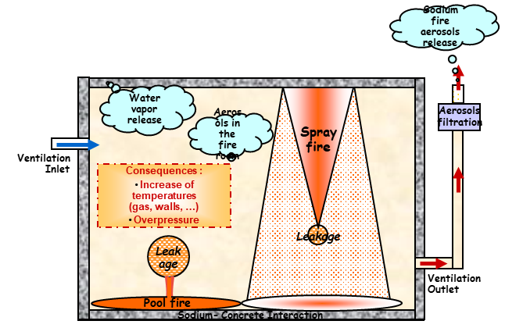

Fig. 1. Sodium fire scenarios and associated phenomena

Depending on the type of leakage and circuit configuration, a sodium pool fire or a spray fire can occur, or a combination of them. The fire makes the gas and wall temperature increase, as well as the gas pressure depending on the type and on the capacity of the ventilation network of the facility. Due to the heat transfer to the walls, the concrete can be damaged, leading to water steam release. Depending on the configuration of the room, a chemical reaction between the sodium and the concrete (floor, wall, structures) may occur, leading to the production of hydrogen, increasing therefore the level of risk with a possible hydrogen gas explosion. The aerosols produced by the fire can plug the filtering system (filters, scrubber) of the ventilation network, leading to potential bypass and to a release of toxic sodium aerosols in the environment.

In the room and possibly within the facility, most of the equipment, including safety related equipment, could be damaged or destroyed, either during the fire itself (temperature effect), or after, due to the chemical effects of the aerosols (which form soda) even though they were not affected during the fire by a temperature increase.

### Past safety concerns

At the beginning of the SFR development in France, the lack of scientific and technical knowledge made it impossible to quantify the effects of a sodium fire in a facility and to address safety concerns. It was therefore necessary to provide answers to the following open questions, structured here in 3 main items:

* Concerning the potential degradation of the plant confinement:
  + - * What could be the thermal and mechanical impact on the structures, due to the temperature rise into the fire room and possibly in adjacent rooms, leading to stresses on walls, structures, etc., but also due to the pressure evolution in the fire room and in rooms in connection, with the disturbance of the ventilation network at the ignition, but possibly also at the extinguishment of the fire?
      * In case of contact with the sodium or the flame, what could be the potential amount of water steam released, and what could be the possible intensification of the fire due to the additional fuel (hydrogen)?
* Concerning aerosol release in the plant:
  + - * What could be the degree of atmosphere opacity in the fire vicinity and the toxicity of fire products?
      * What is the risk of electrical equipment failure?
      * What could be the clogging rate of high efficiency filters?
* And concerning the aerosol release in the environment: what could be the effects on human health?

### How to evaluate the consequences?

In a reactor facility involving sodium, as RAPSODIE, PHENIX and SUPERPHENIX in France, there are a lot of connected premises via openings or via a ventilation network. Geometry and configuration of the premises are complex, moreover with many structures inside. This led to numerous possible accident scenarios depending on the type of fire (spray or pool), on the quantity of sodium involved and on the ventilation flow rate and the automation associated. Such a complex situation required, on the one hand, to perform experiments to reply to open questions, and to the other hand, to develop numerical simulations, with computer codes taking into account all the phenomena and being validated by completion of appropriate tests.

## The R&D programs - Topics and Approach

In order to address issues presented above, IRSN launched experimental programs to study the main following topics, [1]:

* The sodium spray fire and sodium pool fire consequences, including the development of technical solutions to reduce these consequences;
* The sodium fire aerosols, with notably their physical behaviour, the development of specific filtration system, the atmospheric dispersion and the behaviour of specific equipment (electrical motor, heat exchanger plugging, …);
* The concrete behaviour, with the release of water steam and the sodium-concrete interaction;
* The leak evolution and the leak detection.

The present paper is limited to the first topic.

### The sodium fire experimental programs

The sodium fire experiment programs were carried out in four main stages, as described in the following paragraphs.

#### The fundamental studies

This step was led on the basis of very small and small scale tests, in various laboratories up to more or less the year 1972. These tests allowed to understand the fundamentals of sodium combustion.

#### The comprehension studies

The comprehension studies (1972 – 1989), based on small and average scale experiments, were carried out to acquire knowledge to develop and qualify computer codes for safety analysis.

About 200 tests were performed at Cadarache Research Centre (France), step by step, in dedicated facilities, named CASTOR, POLLUX, MERCURE and PLUTON from the smaller to the bigger one (see § 4), Those experimental facilities were designed to study the fire in confined and ventilated configurations.

#### The scale effect studies

Large scale experiments became necessary in the frame of the safety assessment of the fast breeder reactor SUPERPHENIX in particular. This step was mainly based on the ESMERALDA R&D program, whose facility, also called ESMERALDA, was designed and constructed at Cadarache Research Centre. Its capability was to perform a full-scale test with 70 tons sodium pool fire, in a confined and ventilated configuration.

To better understand the willingness at this time to give to this R&D program a huge dimension, the acronym ESMERALDA meant in French “Essais Sodium avec les Moyens à l’Echelle du Réacteur”, that is to say “Sodium Tests within a Facility at reactor scale” (i.e. SUPERPHENIX).

In this frame, 26 experiments were performed during this program (1982-1989), always with the purpose to provide knowledge and data for the development and the qualification of computer codes.

#### Extra studies

As part of the safety assessment of SUPERPHENIX, it appeared necessary to extend the qualification of the codes to high-flow sodium spray fires and to study the effect of compartmentation, i.e. effect on the fire when the room is divided into small compartments connected to each other by openings of limited size.

This need has led to complete the previous programs with the IGNA 3600 and IGNA 2000 series of tests, carried out in the ESMERALDA facility specially adapted for the configurations studied (see Fig. 6). Three tests were performed during the year 1993.

## The IRSN experimental facilities

The facilities dedicated to small and average scale sodium fire experiments were gradually constructed in the building 327 at the Cadarache Research Center (South of France): first the VEGA, CASTOR, POLLUX and MERCURE steel vessels, then the PLUTON reinforced concrete vessel and its associated ventilation network on which scrubber and filtration means were developed at large scale.

To launch the program concerning the scale effect studies, the ESMERALDA facility was constructed (the whole building 346 at Cadarache) and was commissioned in 1981. It mainly consisted of:

* a big room called JUPITER, 3600 m3 in volume, withstanding 1 bar overpressure, on which is connected a ventilation network of high capacity (18000 m3.h-1 in flowrate);
* a tower named SATURNE (2000 m3), representing at mid-scale a steam generator building of the fast breeder reactor SUPERPHENIX.

An overview of these facilities is given on the Fig. 2, and more details about them are provided in Table 1.



Fig. 2. Overview of the main facilities dedicated to sodium fire experiments, located at Cadarache Research Center

TABLE 1. Summary of the IRSN sodium fire facilities [2]

|  |  |  |  |
| --- | --- | --- | --- |
| **Name of the vessel** | **Volume** | **Shape and wall** | **Confinement** |
| VEGA | 316 litres | Steel vessel | Airtight or ventilated |
| CASTOR | 4.4 m3 | Steel vessel | Airtight (3 bars) or ventilated |
| POLLUX | 4.5 m3 | Steel vessel (with an elongated shape) | Airtight (7 bars) or ventilated |
| MERCURE | 22 m3 | Steel vessel | Airtight (3 bars) or ventilated |
| PLUTON | 400 m3 | Concrete room | Airtight (250 mbars) or ventilated |
| SATURNE | 2000 m3 | Concrete room | Natural ventilation |
| JUPITER | 3600 m3 | Concrete room | Airtight (13 bars) or ventilated |

Furthermore, depending on the facility and on the experiment performed, extensive instrumentation was implemented in order to follow the time evolution of different parameters:

* In the fire room:
  + - * Sodium temperature (in pool fire), with thermocouples;
      * Gas temperature, with thermocouples;
      * Walls temperature, with thermocouples and platinum probes;
      * Wall heat fluxes (in some tests only), with heat flux-meter of different kinds;
      * Gas pressure, with pressure gauges of different ranges;
      * Gas velocities (in some tests only), with McCaffrey probes or Pitot tubes;
      * Aerosols concentration, with batteries of filters;
      * Aerosols size, with special loops based on ANDERSEN Mk III impactor;
* In the ventilation network:
  + - * Gas temperature, with thermocouples;
      * Wall pipes temperature, with thermocouples and platinum probes;
      * Wall pipes heat fluxes (in a very few tests only);
      * Gas flowrate in main branches;
      * Pressure at certain nodes of the network;
      * Pressure drops at the HEPA[4] filters and at the air scrubber terminals;
      * Aerosols concentration and aerosols size (Aerosol Mass Median Diameter, AMMD).

During the experiments, the data were recorded online (except the measurements concerning the aerosols, processed on samplings after the test) and are available today, as well as the detailed experiment reports produced.

In addition, photos and videos were taken during most of the experiments (sometime with high speed cameras), allowing a better understanding of the phenomena, directly from the pictures or through post processing (for example for the determination of the size of burning sodium droplets or the dimension and shape of sodium spray fire).

## The spray and pool fires

### Some illustrations

To illustrate what a sodium fire looks like, this section presents some pictures taken during or after experiments involving pool (see Fig. 4) and spray fires (see Fig. 5). An example of each type of experimental set-up is also shown in Fig. 3.

Although the few pictures presented in this paper can hardly depict powerful effects of jet fires, videos of these experiments displayed within the lecture, illustrated well the very fast combustion kinetics associated with jet fires. Only a few pictures and the accompanying text make it possible to give a first impression.

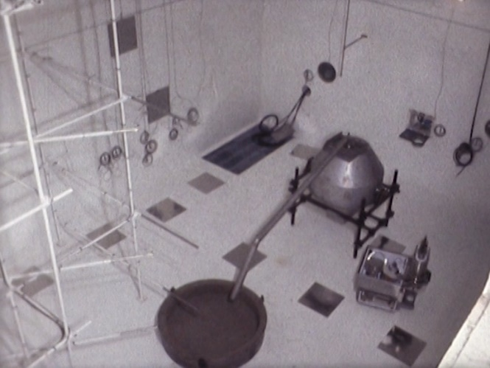 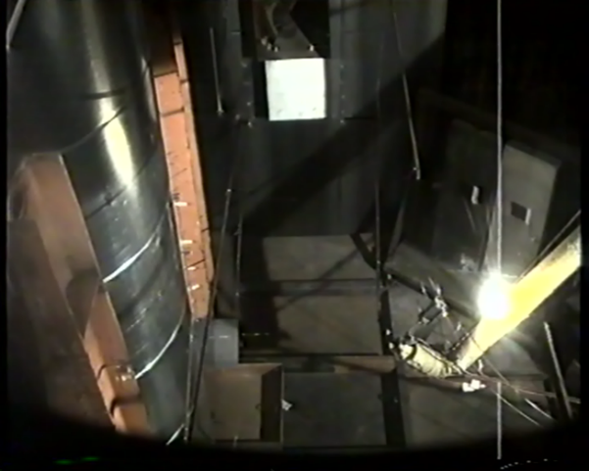

Fig. 3. A sodium pool fire experimental set up (on the left) and a sodium spray fire set up (IGNA 402, on the right)

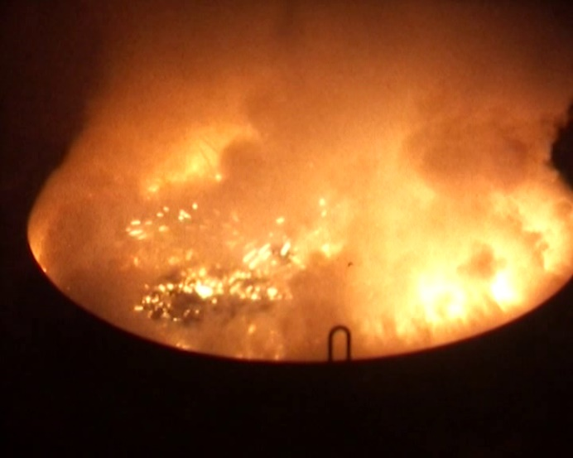 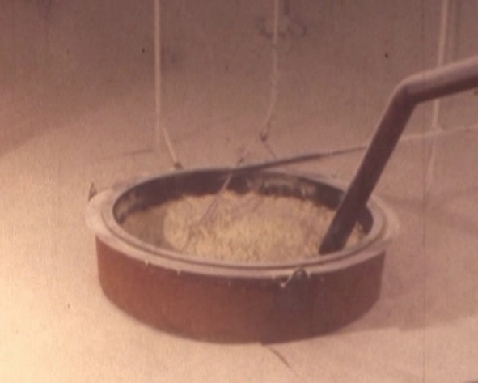

Fig. 4. During a sodium pool fire (on the left) and after[5] (on the right), performed in the PLUTON vessel

The biggest pool fire was performed into the JUPITER vessel during the ESMERALDA program and involved about 20 tons of sodium. Dedicated tests to study mitigation were also performed at large scale, in particular with the MARCALINA powder[6] specially developed in this purpose or to test passive systems like catch pans.

The Fig. 5 shows the very beginning of the IGNA 402 experiment, performed in the PLUTON vessel (400 m3 in volume) and involving a sodium jet (mass flowrate between 8.7 to 19 kg.s-1, initial temperature 340°C) impinging a pipe as an obstacle. The 4 pictures were taken respectively at 0.1, 0.2, 0.4 and 0.6 s after the start of the jet emission, giving an idea of the kinetics of this type of fire.

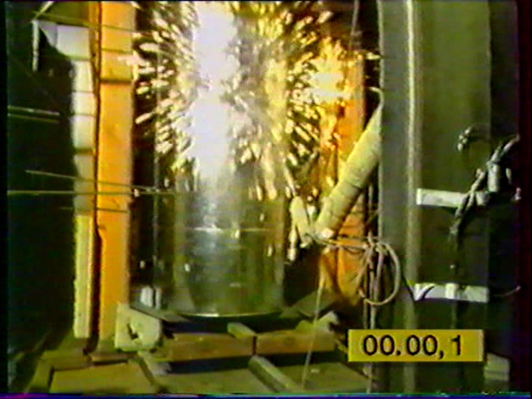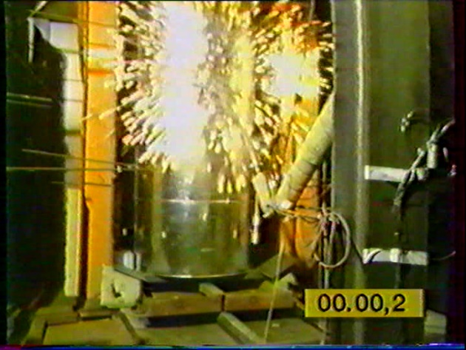

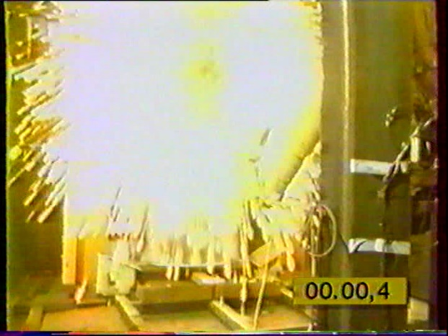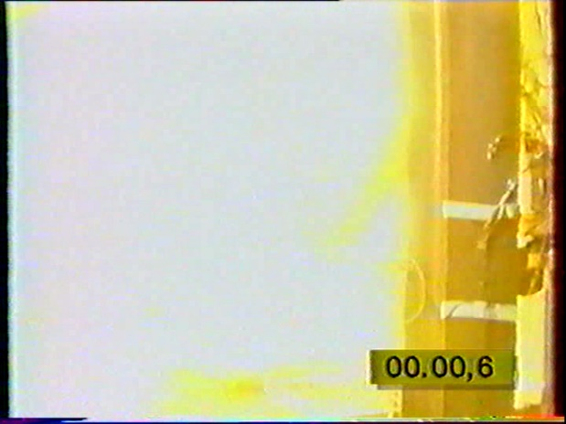

Fig. 5. IGNA 402 sodium jet fire test in PLUTON vessel (pictures at 0.1, 0.2, 0.4 and 0.6 s from the jet start)

Among the most spectacular experiments carried out are IGNA 3602 and IGNA 3604. As mentioned in the paragraph 3.3.4, they were performed in order to get data to extend the qualification field of the sodium fire computer codes (as FEUMIX yet used), especially for the high Reynolds number jets, in the frame of the safety assessment carried out for the re-start of SUPERPHENIX.

TABLE 2. main experimental specifications of IGNA 360 test [1]

|  |  |  |  |  |
| --- | --- | --- | --- | --- |
| Name of the test | Sodium jet mass flow rate | Direction of the jet | Jet duration | Reynolds number of the jet |
| IGNA 3602 | 90 kg.s-1 | Upward | ~4,5 s | ~5 106 |
| IGNA 3604 | 225 kg.s-1 | Upward | ~9 s | ~7 106 |

These experiments were performed into the JUPITER vessel (3600 m3 in volume, withstanding 1 bar overpressure) of the ESMERALDA facility (see paragraph 4), especially adapted with 4 pipes each equipped with a discharge membrane (see Fig. 6), instead of its usual ventilation network. The sodium was preheated in a tank, up to 550°C which corresponded to the nominal temperature in the hot legs of SUPERPHENIX main secondary sodium circuits, before being sent very quickly in a pipe up to an ejection nozzle. Then the sodium jet impinged an obstacle providing the “burst” of the jet. Such configuration was deemed envelope from a safety point of view.

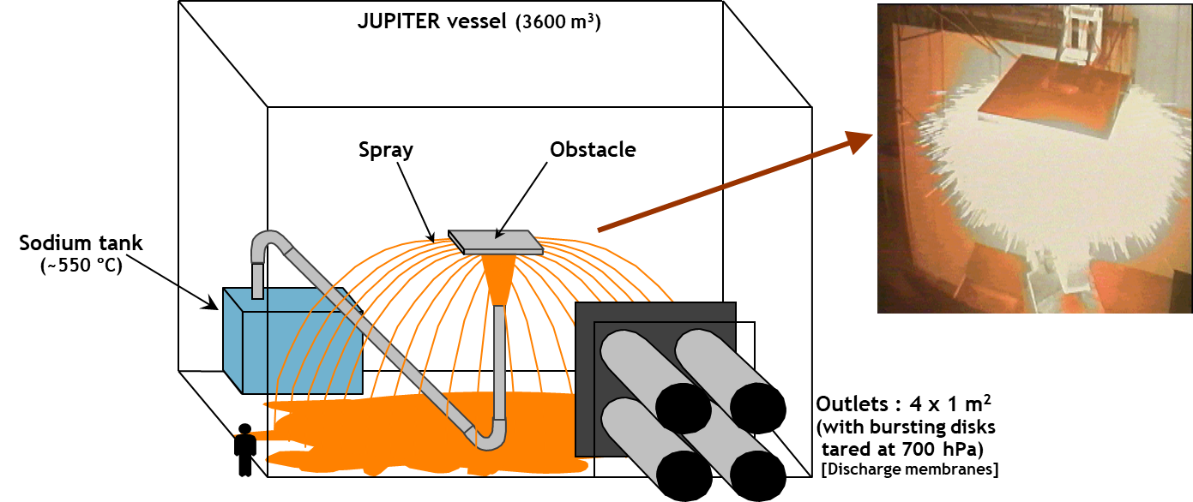

Fig. 6. The experimental setup for the IGNA 3602 and IGNA 3604 experiments on sodium spray fire

### Some results on sodium spray fire [1]

The spray fires are characterised by their fast combustion kinetic and their high heat release rate which is proportional to the surface of sodium in contact with air. This surface is very large in this case due to the great number of burning sodium droplets.

Among the knowledge acquired during these R&D programs, concerning the phenomenology, we can note that:

* The initial sodium temperature has an influence on the fire kinetics;
* The combustion of sodium in jets is governed by the diffusion of oxygen within the sprayed fraction (not all the ejected sodium forms droplets). Oxygen diffusion together with the natural capping of the sprayed sodium fraction in the jet limits the combustion rate when the ejected sodium flow increases;
* Except for the structures that are situated in the flame zone, the thermal impact in the room becomes significant after the overpressure peak.

In addition, the main lessons learned from these R&D programs concerning the fire management for a real situation or configuration are the following:

* Closure of inlet and outlet of the ventilation system of the room limits the available oxygen quantity for the combustion reaction and avoids any aerosol release. In this case, due the large variations in gas pressure during the fire, the room should be designed to withstand to overpressure and under-pressure combined with temperature loads;
* Reduction of the volume of fire room by compartmentation limits the amount of available oxygen in the room, thus reducing the impact of the fire on the whole facility. In this case, each compartment must withstand overpressure, under-pressure and temperatures, and it is necessary to take into account the possible transfer of ignited droplets to the adjacent compartment of the sectoring;
* Safety hatches or valves can be implemented to dampen the pressure peaks due to the fire. Pressure resistance of the room and opening criterion of the valves have then to be optimized to limit the release of aerosols and hot gases. Potential sharp under pressure phenomenon after fire extinguishment must be taken into account;
* Adopt adequate operation of ventilation network such as closing the air inlet as quick as possible and maintain the air extraction. This strategy allows to avoid a too large gas pressure amplitude within the room, but needs to implement on the facility an efficient filtration system to avoid aerosols release.

## Some financial considerations on ESMERALDA and IGNA3600 PROGRAMS

In order to associate a financial value to the programs performed in the past, the table 3 below gives the cost of the ESMERALDA project, considering the investment and the operating parts [3].

TABLE 3. Cost of the ESMERALDA experimental project

|  |  |  |
| --- | --- | --- |
| Range: from 1979 to 1988 | Cost after a simple conversion from Francs to Euros | Cost after updating between each year and 2020 |
| Investment | 15 M€ | 29 M€ |
| Operating | 10 M€ | 18 M€ |
| Total | 25 M€ | 57 M€ |
| Number of tests | 26 experiments | 26 experiments |
| Mean cost per test | ~1 M€/test | 2.2 M€/test |

On this basis, considering the total amount to perform 26 experiments, it leads to a mean cost per test of about 1 M€ at the time and of about 2.2 M€ after updating to 2020 (according to the calculation sheet provided by the French Institute INSEE [4]).

Following the same approach for the 2 tests performed in the IGNA 3600 series, whose total cost being about 2.1M€ on the basis of the year 1993 and 3M€ after updating to 2020, the mean cost is of 2M€ per test in current money.

These costs would certainly be higher today, not to mention that the know-how on the implementation of such tests, on such a large scale, is no longer as important as it used to be.

It is therefore important to take advantage of the availability of these results and of the remaining know-how, either for a direct use or to design and build new experimental facilities and associated research programs.

## Conclusion

The extensive R&D programs carried out in the past, at different scales, provided a huge amount of data used to improve knowledge in the field of sodium fires, and to develop and qualify computer codes. Along with the development of French SFRs, sodium fire experiments of increasing complexity have been performed in order to answer the questions raised during the safety assessment.

The spectacular videos concerning some large-scale experiments (as the IGNA 3600 tests series or IGNA 402) help to understand how it may remain difficult to perform such experimental research and why it is so important to consider the sodium risk in a real facility.

The legacy of sodium fire experiments is useful to inform designers on the key physical phenomena to be taken into account in the design of future sodium cooled reactors. Another major interest of these experiments lies in the database of results that can be used to validate new computer codes [5], thus reducing the global cost of qualification of these tools. Past experimental results can also be the basis for opening new research fields on still pending questions (the design of concrete protection for instance). Therefore, it is possible to take advantage of the IRSN research, investment and results to support the analysis of sodium risks in generation IV SFRs (including small and modular SFRs) and to justify the provisions taken to manage those risks.

References

1. CASSELMAN A, SOUCILLE M, Internal Report[7] « Les risques liés au sodium dans un réacteur à neutrons rapides refroidi au sodium - Etat des lieux des logiciels et des connaissances acquises par les programmes expérimentaux », Rapport Technique IRSN/DPAM/SEMIC/2009-0113 or Rapport Technique CEA/DEN/CAD/DTN/STPA/LTTS/2009/026), France, 2009
2. MALET JC et al, Internal Report « Les Feux de Sodium – Synthèse des résultats » – Rapport EF.21.95.R/90.043 – 01/02/1990, France, 1990
3. SOPHY Y, Internal Report « ESMERALDA Synthèse du programme » – IPSN/DERS/SESRU – Rapport ES.00.90.R/89.542 – 8/12/1989, France, 1989
4. National Institute of Statistics and Economic Studies (INSEE, France), <https://www.insee.fr/fr/information/2417794>
5. LEBEL L., COUSIN F., GIRAULT N., "New developments in sodium pool fire and SFR containment aerosol modelling with ASTEC-Na”, Annals of Nuclear Energy Volume 119, ELSEVIER, September 2018, Pages 229-239

1. CEA/IPSN became today IRSN
2. SSCs: Structures, Systems and Components
3. FOAK: First Of A Kind
4. HEPA filter: high-efficiency particulate air filter
5. The two pictures on the Fig. 4 come from two different experiments.
6. MARCALINA powder is a mixture of sodium carbonate, lithium carbonate and graphite.
7. This report includes, only for its first part (~100 pages on sodium fire experimentation), about 170 references.