MECHANISMS ENGINEERING TEST LOOP (METL) FACILITY

C.W. Grandy
Argonne National Laboratory (ANL)
Lemont, USA
E-mail: cgrandy@anl.gov

D.W. Kultgen
Argonne National Laboratory
Lemont, USA

E. F. Kent
Argonne National Laboratory
Lemont, USA

M.T. Weathered
Argonne National Laboratory
Lemont, USA

Abstract

The purpose of the paper is to present the Mechanisms Engineering Test Loop (METL) facility installed at U.S. DOE’s Argonne National Laboratory located outside of Chicago, Illinois. The METL facility is a multipurpose intermediate-scale 750-gallon (2839l) sodium test facility used for the testing of liquid metal systems and components in prototypic reactor-grade sodium conditions. Some examples of technologies that can be tested in METL includes components for advanced fuel handling systems, advanced sensors and instrumentation, in-service inspection and repair technologies, thermal hydraulic testing in a prototypic environment, components for reactivity control, and health monitoring technologies for liquid metal reactor applications.
The METL facility consists of two 18-inch (45.7-cm) test vessels, two 28-inch (71.1-cm) test vessels, an expansion tank, a dump tank, a purification loop, and a plugging loop. METL has a main piping loop that includes an electromagnetic pump and flow meter. This main loop provides flowing sodium to the four test vessels. The test vessels can be connected to the main loop in parallel operation, or a test vessel can be isolated from the main loop with its own sodium environment. Each test vessel can be drained independently to the dump tank without affecting the other on-going tests. The facility has a maximum operating temperature of 1000°F (537.7°C) with the larger test vessels capable of obtaining 1200°F (648.8°C). The facility dump tank was filled with reactor grade sodium in April 2018. Sodium piping, purification, plugging loop and expansion tank was filled on September 19, 2018. The facility has been in an operational state for over two and a half years. The paper discusses the overall design philosophy of the facility, the testing that has been performed in the facility, and the approaches used for inserting test articles (experiments) into and removing test articles from the facility.

INTRODUCTION
The Mechanisms Engineering Test Loop (METL) facility [1] is a multipurpose intermediate-scale sodium test facility located at Argonne National Laboratory with the capability to test small to intermediate-scale components and systems in a prototypic environment in order to develop advanced liquid metal technologies. Testing advanced systems and components in a prototypic environment is essential for the future of advanced fast reactors as it provides invaluable performance data and reduces the risk of equipment failures during plant operations.
Some examples of technologies that can be tested in METL include:
- Components of an advanced fuel handling system – Fuel handling systems are used for the insertion and removal of core assemblies located within the reactor vessel. Undoubtedly, these components are essential to the successful operation of fast reactors. For liquid metal applications, fuel handling systems need to work inside the primary vessel and typically penetrate through the cover gas of the primary system. As a result, fuel handling systems must address issues associated with ‘sodium-frost’ build-up.
- Mechanisms for self-actuated control and shutdown systems – These components have been conceived by various designers to provide added defense-in-depth for reducing the consequences of beyond-design-basis accidents. These self-actuated control and shutdown mechanisms include devices such as curie-point magnets and fusible linkages.
- Advanced sensors and instrumentation – Advanced fast reactors contain sensors and instrumentation for monitoring the condition of the plant. This category includes but is not limited to, sensors for the rapid detection of hydrogen presence in sodium (which is indicative of a leak), the detection of impurities in the coolant (i.e., improvement of plugging meters or oxygen sensors), alternative methods for leak detection, improved sensors for level measurement and other advanced sensors or instrumentation that improve the overall performance of advanced reactor systems.
- In-service inspection and repair technologies – These systems include visualization sensors (e.g., under-sodium viewing sensors) for immersed coolant applications and technologies for the welding and repair of structures in contact with the primary coolant. In addition, technologies for monitoring the health of piping and vessel systems for advanced reactors can be demonstrated at the METL facility.
- Thermal hydraulic testing in prototypic sodium environment – A thermal hydraulic test loop could be used to acquire distributed temperature data in the cold and hot pools of a small-scale sodium fast reactor during simulated nominal and protected/unprotected loss of flow accidents. This testing could include simulation of the core and hot pool regions (for a pool-type reactor) in order to parametrically investigate the effect of the IHX/core outlet height difference and its effect on thermal stratification of sodium in the hot pool. Ultimately this data will be used for validating CFD and systems level codes.

In addition, METL provides development opportunities for younger scientists, engineers, and designers who will ultimately lead the advancement of liquid metal technologies in the U.S. Hands-on experience with METL, both successes and perceived failures, will ultimately lead to better liquid metal technologies that can support the commercialization of advanced reactors. The following section provides an overview of the METL facility design.

METL FACILITY DESIGN OVERVIEW
The design philosophy behind METL was to allow for at least four independent experiments (immersed in sodium) occurring simultaneously while the system is in operation. These experiments can have their own independent sodium environment during testing. Any experiment can be removed and inserted into their respective test vessel without impacting the operations of the other experiments.
The design of the METL facility [1] consists of four test vessels connected in parallel to a main sodium loop (FIG. 1). The different vessels share an expansion tank, purification system, several electromagnetic (EM) pumps and flowmeters, and a dump tank. This flexible, consolidated design minimizes infrastructure requirements and allows for multiple experiments to be operated simultaneous in one facility. The facility design was divided into two phases. Phase 1 construction included two 18-inch (45.7-cm) test vessels and two 28-inch (71-cm) test vessels connected to the main piping loop. The future Phase 2 design allows for four additional 18-inch test vessels installed on the mezzanine. The METL facility is designed to handle both static and flowing sodium which permits each test vessel to be configured to suit the requirements for a particular experiment.
METL has an installed purification and diagnostic system. The purification system uses a mesh-filled counter flow cold trap that is cooled by air. There is a sodium-to-sodium heat exchanger (economizer) located upstream of the cold trap. The internal design of the cold trap is based upon the mesh-filled Experimental Breeder Reactor-II’s cold trap design. Impurity levels can be continuously monitored using an installed plugging meter which is designed as a separate piping circuit from the purification system.
All piping, test vessels, and tanks are equipped with electrical heaters and insulation that maintains the sodium temperatures in a range from room temperature to a maximum of 1000°F (537.8 °C). Two mineral-insulated cable heaters are installed on each piping run but only one is used for heating at a time with the other an installed spare. The vessels are heated with electric radiant band heaters. The large 28” test vessels are designed to contain static sodium up to 1200°F (648.9°C) (FIG. 3 – Right)) and are constructed from 304H stainless steel. The temperature for each individual vessel, tank, or component is adjusted by -controlled heaters to suit the particular needs of a test.
The density of sodium changes from ~920 kg/m³ (57.44 lb/ft³) to ~825 kg/m³ (51.5 lb/ft³) when heated from 208°F (97.8°C) to 1000°F (537.8°C). The additional volume is compensated for by an expansion tank that is connected to the main loop and is always on-line.

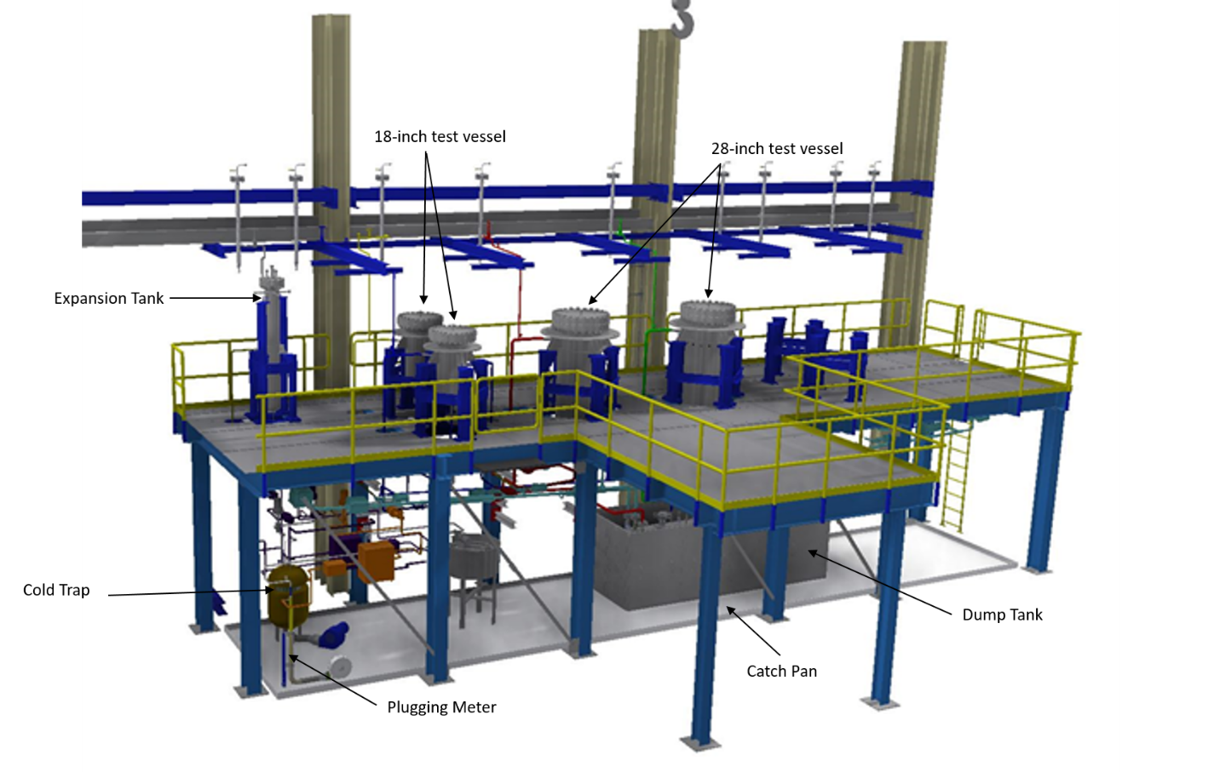
FIG. 1. A 3D model of METL after Phase I construction

As shown in FIG. 2, each test vessel is configured identically with dedicated lines for sodium supply, return, overflow, and drainage. Additionally, all test vessels are connected to an argon supply line (for argon cover gas) and a vent line that is connected to a vapor trap. The maximum sodium flowrate through a vessel is approximately 10gpm (37.85L/m). The sodium overflow line is used to control the sodium levels in the test vessels. A sodium drain from a given test vessel is carried out independently by opening the vessel’s dump valve. All vessels have their own dedicated argon gas supply, argon gas vent, sodium vapor trap, sodium filter, and pressure relief valve.
The large carbon steel catch pan (~1000gal / 3,785L) located under the mezzanine is designed to collect sodium in the event of a sodium leak. The catch pan maintains a metal barrier between the spilled sodium and the underlying concrete floor. In case of a leak, the B308 building houses a 30,000 cfm (849,480 L/m) air wet scrubbing unit for smoke control and to remove sodium aerosols from the air.
The piping system is made from 316/316L dual certified stainless steel and was designed and constructed to B31.3 ASME piping code. The METL piping system was designed for an ASME B31.3 class M high hazard fluid. In order to minimize sodium leaks, the facility is 100% welded construction with the exception of the few mechanical Grayloc connections for the main loop electromagnetic pump and for the pressure transducer diaphragms. Although a class M fluid requires 20% of the welds be radiographed, all of the welds for METL were radiographed as is custom for large-scaled liquid metal facilities in the U.S. All piping is Schedule 40; the main loop piping size is 1.5inch (38.1mm), while the smaller branch lines are ¾ inch (19.05mm). There are three electromagnetic pumps and three electromagnetic flow meters that control and monitor flow in the main loop, the purification loop, and the diagnostic loop, respectively. The overflow lines are at the same elevation for all of the test vessels so that the sodium elevation is maintained when they hold sodium. The expansion tank is the only vessel without an overflow line, but it is roughly twice as tall as the other vessels.

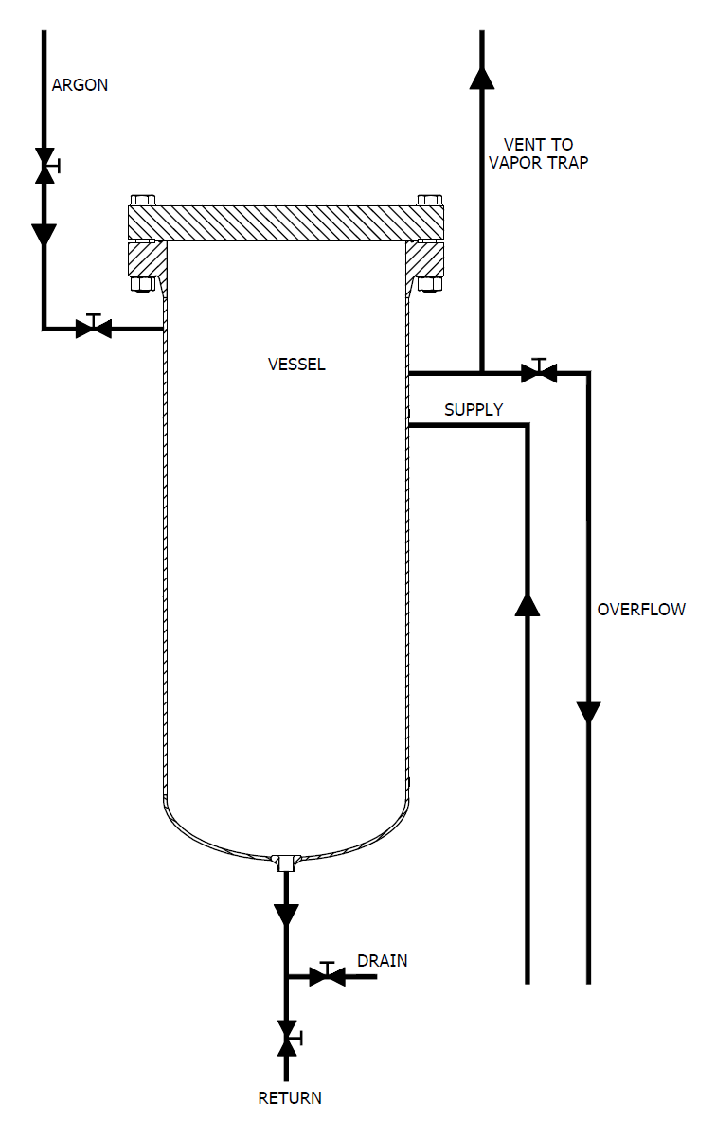

FIG. 2. A depiction of the various test vessel connections and their orientation

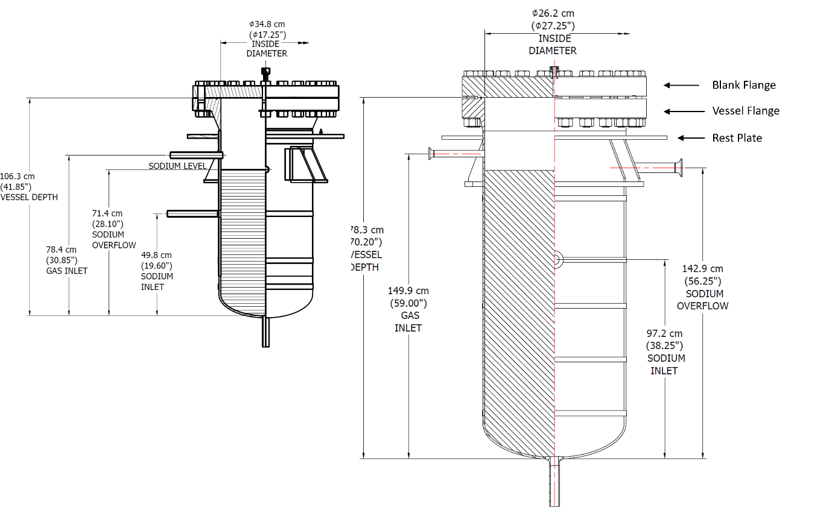
FIG. 3. 18-inch (45.7-cm) Test Vessel (left) and 28-inch (71.1-cm) Test Vessel (right)

TEST ARTICLE PREPARATION, INSERTION, AND REMOVAL
METL test articles are designed to fit on modified flanges which can be inserted into a vessel and bolted to the test vessel (FIG. 3). One of the first test articles designed in this way is the Gear Test Assembly (GTA) [2-3]. Before the GTA was inserted into METL, it underwent a design review, dry assembly, dry testing, and commissioning to ensure that the design was sound, it was compatible with the METL’s sodium environment, and it interfaced and sealed properly with one of the test vessels.
To support the assembly and testing of a test article before insertion into METL, the METL team, working with the Argonne engineering group, designed an A-frame test stand that allows for the efficient assembly and disassembly of a METL test article. This paper shows GTA bolted into the yellow A-frame test stand. Bolting the test article to the A-frame allows for the complete rotation (360 degrees) of the test article facilitating the assembly and removal of components that are attached to the flange. Thus, the test article can be fully rotated as needed for installation of heavy components that may need to be lifted with a crane. The A-frame is also designed to allow for the transportation of a test article from one building where it may have undergone assembly and testing to another building where METL is located on the Argonne site.
Each test article undergoes rigorous testing, qualification, and review before authorization is given for insertion of the test article into the METL facility. A test vessel is assigned to that test article to ensure that there is sufficient space on the mezzanine for support equipment such as instrumentation and control (I&C), motor controllers, etc.
After qualification of a test article, authorization is given for the experiment to be inserted into a METL test vessel and filled with sodium. Test articles are removed from the test stand using the building’s overhead bridge crane and inserted into a test vessel. FIG. 5 shows the GTA [7] being inserted into the Test Vessel 1 for the very first time (before the vessel had seen sodium service). The sodium in the test vessel is then purified with the installed METL cold trap. After sodium purification, the vessel is either kept connected to the main loop or is isolated depending upon the experimental test plan. For example, for the GTA test, after insertion into Test Vessel 1 and sodium purification, the vessel was isolated from the main loop and testing was conducted in this condition

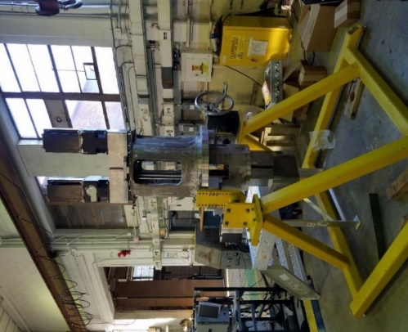
FIG. 4. GTA installed on the 18-inch test stand (notice the flange in the middle of the test article)

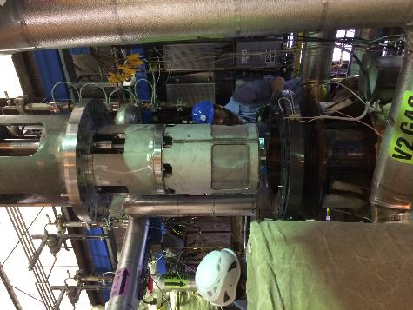
FIG. 5. GTA being inserted into Test Vessel 1 for first time (without sodium in the vessel)

After completion of the experiment, preparations are made to remove the test article from the vessel. First, the vessel is drained and allowed to cool to ambient temperature. Preparations are them made to remove the test article from the vessel for subsequent cleaning using moist carbon dioxide that converts the sodium residual to sodium bicarbonate.
A carbonation system was developed to deliver humidified carbon dioxide to a test article that contains residual sodium. The humidified carbon dioxide reacts with the residual sodium at ambient temperatures to form sodium bicarbonate. The process is slow, but it is complete. Once a test article has been subjected to cleaning for about 1-2 weeks, it is removed and disassembled, and the parts are cleaned with ethanol.
In order to remove (or insert) a test article from (into) a vessel that had seen sodium service, the METL team developed a system called the flexicask system [4]. This flexicask system maintains an argon environment around a test vessel and a test article during the insertion and removal of a test article from the vessel. The next section discusses this flexicask system.

Test Article Removal via the Flexicask System
During the design development of the METL facility, the engineers had to address contamination and resulting impurities which may migrate into a test vessel during the insertion and removal of a test article. Each test vessel was designed with a rest plate located beneath the vessel flange that is designed to interface with the flexicask system for the removal and insert of test articles.
The flexicask system consists of the following components: top support assembly, a duct, an upper gate assembly, a vessel seal plate, lower gate assembly, chain lanyard, hoist rings with platen, and miscellaneous fittings. The top support assembly is used to lift the overall flexicask assembly (via a crane) when it does not include a test article.

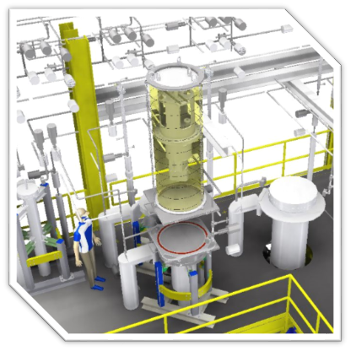
FIG. 6. CAD Model of Flexicask System – shown with test article located at METL Test Vessel 2
FIG. 6 shows the initial design of the flexicask prototype that was designed, fabricated, and tested. The flexicask mates and seals to a “rest plate” that is welded to each of the test vessels and is located right below the test vessel flange. An elastomeric gasket is used to seal the flexicask transition piece to the vessel’s rest plate.
The flexicask interfaces with a test vessel at the test vessel support ring. Originally, this support ring was larger in diameter but would have caused excessive force on the test vessel during heat-up and so the design was changed to a smaller diameter support ring which could easily fit under the test vessel insulation. In addition, physical space was required around the vessels to ensure that the flexicask system would not interfere with or damage the argon inert gas supply and vents lines that are located around the vessels.
FIG. 7 provides a depiction of the flexicask system operational sequence. The atmosphere within the flexicask is kept inerted using a constant argon purge. The flexicask system operates using the pre-existing crane in the building 308 high bay, as shown in FIG. 8. The following are the general steps for the removal of a component from METL test vessel (FIG. 7):

- The support plate is attached to the test article for lifting using the designed lifting points. This plate may be unique (with specific hole patterns) aligned to the lifting points of the test article.
- The flexicask is lowered over the test article with the sliding gates removed. In this condition, the bolts that hold the test article flange to the test vessel have been removed.
- The test article support flange is fastened to the cask top ring
- The crane is removed from the cask support ring and attached to the test article lifting points that are bolted through the top support plate to the test article. The flexicask is sealed to the test vessel support ring.
- The test article is lifted into the flexicask shroud and gates are installed and closed.
- The eyebolts holding the two gates together are loosened and moved to the open position to separate the two gates. The two gates are separated with the top gate sealing the flexicask and test article from the air atmosphere and the bottom gate sealing the test vessel. The steps are repeated in reverse order for inserting a test article into a test vessel.
During the commissioning of the flexicask system, some minor modifications and improvements were required. These alterations were performed by Argonne’s Central Shops and the flexicask assembly commissioning was completed. Initial tests to measure the flexicask’s ability to retain argon gas during different scenarios were also conducted and showed that the flexicask system maintained the atmosphere inside the flexicask to less that 10ppm oxygen.

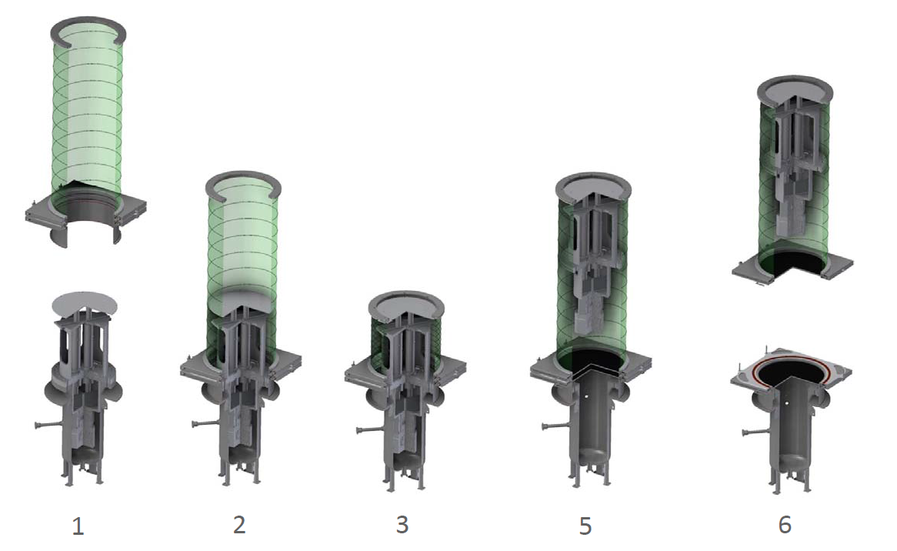
FIG. 7. A 3D model depicting of flexicask operation.

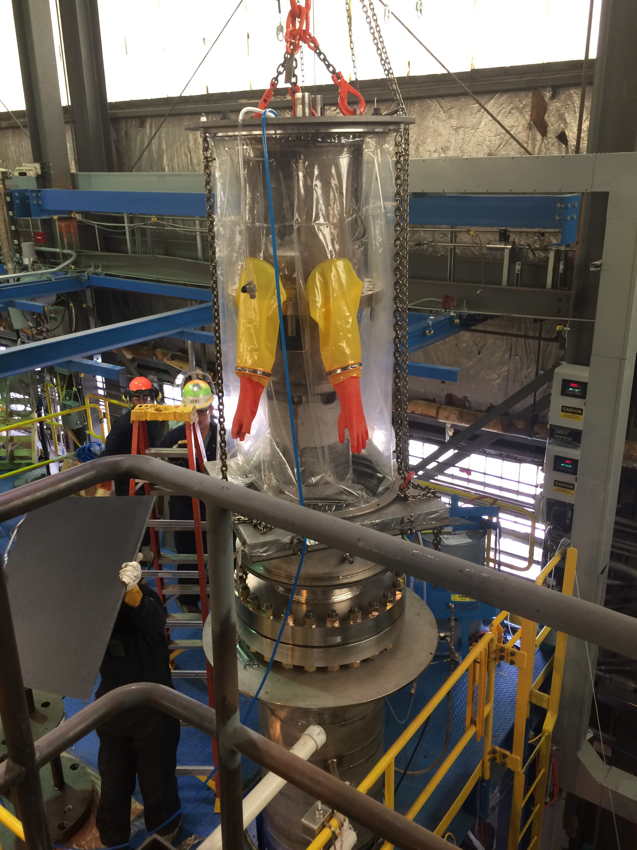
FIG. 8. Flexicask System with GTA installed interfacing with the vessel used for reacting residual sodium with moist carbon dioxide.

METL OPERATIONS AND TESTING PLANS
Commissioning of the METL facility was completed in early 2018 [5]. The facility was initially heated to ~1000°F (537.8°C) under vacuum to bake off any residual contaminants within the loop and test vessels. Some minor adjustments to METL piping hanger systems were performed to accommodate the relatively large expansion of the piping system (approximately 4 inches (10.16cm) in some locations). Following system bakeout and hanger adjustments, the dump tank was reheated in April 2018 and 15 55-gallon (208L) drums of sodium were transferred into the METL dump tank. This process took about two weeks with 50 gallons (189.3L) transferred from a shipping drum each day. Filling of all system components (i.e., piping, purification, diagnostic, and expansion tank systems) was completed on September 19, 2018. The system underwent about two weeks of purification through the cold trap and then was placed on hot standby until the first test article (the GTA) was installed in Test Vessel 1 and subsequently tested.
Since September of 2018, METL has successfully operated for approximately three years. Two experiments have been successfully performed in METL, i.e., gear testing in sodium for an advanced fuel handling system, and the testing of an inductive level sensor. Facility personnel have supported these two test programs. In addition, the facility has undergone various sodium purification campaigns and draining and filling of test vessels. As of February 2021, the two large test vessels have not been filled with sodium.
A third test article that has been designed and is undergoing commissioning, i.e., the Thermal Hydraulic Experimental Test Article (THETA) [6]. THETA is a 38-kW test vehicle that will be used to perform thermal-hydraulic testing in support of code validation efforts. THETA has been assembled in a 28-inch (71.1cm) test stand and has been tested in water. It is currently undergoing reassembly and will be installed in Test Vessel 4; see companion paper [7] for additional details on this test article. The fourth test article is a full-scale fuel handling gripper for use in an advanced fuel transfer machine design that will support advanced reactors such as the GEH Prism Reactor, the Versatile Test Reactor, the Advanced Reactor Concepts-100, and the Advanced Fast Reactor-100.

CONCLUSIONS
This paper documents the design, operations and testing that was performed at the Mechanisms Engineering Test Loop (METL). The METL facility has undergone three years of successful operations after its initial sodium system fill in September 2018. A number of auxiliary systems have been designed to support the assembly and commissioning of vessel test articles and to support the insertion and removal of vessel test articles. The first test article, the GTA has undergone testing three times in the METL test vessel 1. It has been inserted three times and removed and cleaned and dissembled three times. The moist carbonation process has been used to successful react residual surface sodium to a bicarbonate with subsequent cleaning with alcohol of the smaller pieces. In addition, METL is being prepared to support a second larger experiment, a thermal hydraulic experiment, called THETA which will simulate an electrically heated pool-type of sodium-cooled fast reactor with an air-dump heat exchanger. Lastly, the METL staff consist of 5 highly motived young engineers who represent the future of alkali metal technology in the U.S. For more information on METL and that the research and development conducted in METL, please go to https://www.anl.gov/nse/mechanisms-engineering-test-loop-facility. METL provides development opportunities for younger scientists, engineers, and designers who will ultimately lead the advancement of liquid metal technology in the U.S. Hands-on experience with METL, both successes and perceived failures, will ultimately lead to better liquid metal technologies that can support the commercialization of advanced reactors. The web site contains the annual reports on the METL design and operations, the GTA and THETA test article development and resources for liquid metal technology development.
ACKNOWLEDGEMENTS
Argonne National Laboratory’s work was supported by the U. S. Department of Energy Advanced Reactor Technology (ART) Program under Prime Contract No. DE-AC02-06CH11357 between the U.S. Department of Energy and UChicago Argonne, LLC. We gratefully acknowledge the support provided by Alice Caponiti of DOE-NE, Deputy Assistant Secretary, Office of Reactor Fleet and Advanced Reactor Deployment; Thomas Sowinski, Advanced Reactor Technologies, R&D Program Manager; Brian Robinson of DOE-NE, Advanced Reactor Technologies, Fast Reactor Manager, and Robert Hill of Argonne National Laboratory, ART R&D Fast Reactor National Technical Director.
The authors would like to extend their gratitude to METL team members Mike Hvasta, Andrew Borowski, Daniel Andujar, Dzmitry Harbaruk, Anthony Reavis, and Henry Belch for their original contribution to METL design and construction, for operating METL, as well as supporting the experimental work.

References
- Kultgen, D., Grandy, C., Hvasta, M., Lisowski, D., Toter, W., and Borowski, A. Mechanisms Engineering Test Loop - Phase 1 Status Report. United States: N. p., 2016. Web. doi:10.2172/1334794.
- Kent, E., Belch, H., Kultgen, D., Weathered, M., and Grandy, C. Gear Test Assembly - Status Report For FY2019. United States: N. p., 2019. Web. doi:10.2172/1565961.
- Kent, E., Belch, H., Grandy, C., Kultgen, D., and Weathered, M. Gear Test Assembly - Report on Experimental Testing (FY2020). United States: N. p., 2020. Web. doi:10.2172/1730948.
- Grandy, C., Kent, E., Kultgen, D., Weathered, M., Andujar, D., and Borowski, A. Mechanisms Engineering Test Loop - Flexicask Design and Testing Report. United States: N. p., 2020. Web. doi:10.2172/1603654.
- Kultgen, D., Weathered, M., Kent, E., and Grandy, C. Mechanisms Engineering Test Loop (METL) Operations and Testing Report - FY2020. United States: N. p., 2020. Web. doi:10.2172/1698024.
- Weathered, M., Kultgen, D., Kent, E., Grandy, C., Sumner, T., Moisseytsev, A., and Kim, T. Thermal Hydraulic Experimental Test Article - Status Report FY2020. United States: N. p., 2020. Web. doi:10.2172/1698027.
- Kent, E, Belch, H, et.al., Gear Test Assembly: First Liquid Metal Component Testing in METL, International Conference on Fast Reactors and Related Fuel Cycles, May 10-13, 2021, Working Paper
- Weathered, M., Grandy, C., Overview of a Sodium Fast Reactor Thermal Hydraulic Test Facility, International Conference on Fast Reactors and Related Fuel Cycles, May 10-13, 2021, Working Paper

The submitted manuscript has been created by UChicago Argonne, LLC, Operator of Argonne National Laboratory (“Argonne”). Argonne, a U.S. Department of Energy Office of Science laboratory, is operated under Contract No. DE-AC02-06CH11357. The U.S. Government retains for itself, and others acting on its behalf, a paid-up nonexclusive, irrevocable worldwide license in said article to reproduce, prepare derivative works, distribute copies to the public, and perform publicly and display publicly, by or on behalf of the Government.
In a similar manner, when designing an advanced reactor, space is needed on the reactor head for the enclosures that will be used to remove components from the reactor plant. This space needs to be designed into the overall reactor plant design for in-service inspection and maintenance.
Note – the lifting apparatus and appurtenances are not shown in the figure

