Complex of experimental facilities for design
and safety justification of fast reactors
with liquid metal coolants

Yu.A. KUZINA
IPPE JSC
Obninsk, Russian Federation
Email: ukyzina@ippe.ru

D.A. KLINOV, G.M. MIKHAILOV, A.P. SOROKIN
IPPE JSC
Obninsk, Russian Federation

Abstract

The report presents the description of measuring instruments and equipment characteristics, the feasibilities of the test facilities designed to perform research into the fields of hydrodynamics, heat transfer and coolant technology in support of design solutions and safety improvement, and to test equipment components and units for fast reactors with sodium, lead and lead-bismuth coolants, both in operation and under design, as well as for accelerator-driven and fusion-driven systems. A large-scale sodium test facility "SAZ" is under construction, which will make it possible to test full-scale prototypes of equipment and its components to substantiate fast sodium reactors. Besides, a set of fast critical facilities is described; it comprises two critical facilities – "BFS-1", as well as the largest in the world critical facility "BFS-2". The "BFS-2" facility is the only in the world experimental tool for full-scale simulation of nuclear reactor cores of various types (of any composition, geometry and configuration). The materials and design of the test facilities allow simulation of a core, blankets, reflectors and in-core safety systems, as well as the elements of fuel cycles and storage facilities for spent nuclear fuel and radioactive waste. Reactor materials of the facilities (metallic plutonium, highly enriched uranium metals and oxides, with uranium enrichment of 36 % and 90 % in uranium-235, hundreds of tons of fertile materials, structural materials, various coolants) make it possible to assemble both complex full-scale models of fast reactors, and benchmarks, the experiments for which are carried out to correct and adjust neutronic constants and improve computational methods. A large scope of experimental research has already been carried out and is currently planned at all the test facilities.

INTRODUCTION
The importance and necessity of a physical experiment in modern nuclear science and technology is beyond any doubt. Technological progress in the nuclear energy field leads not only to an increase in complexity of research objects, but also to enhance requirements for physics of processes and functions and interactions of components.
On May 31, 1946, the Institute for Physics and Power Engineering (IPPE) was founded to solve scientific and technical problems of nuclear power implementation and development. On the initiative of A.I. Leypunsky, the first test facilities with circulating sodium and sodium-potassium as coolants were constructed at the IPPE. That was the onset of studying heat transfer, technology and corrosion of structural materials in sodium.
Practical implementation of nuclear power plants (NPP) required the solution of a large number of organizational, scientific and technical problems: for the projects of fast reactors, such as BR-10, BOR-60, BN-350, BN-600, BN-800, etc., construction of experimental facilities [1].
All these things resulted in establishing the scientific school "Heat and Mass Transfer, Physical Chemistry and Technology of Coolants in Power Systems" at the IPPE, its main areas of research were: thermal hydraulics, mechanisms of turbulent heat transfer, liquid metal boiling and condensation, physical chemistry and technology of liquid metal coolants was profoundly developed as applied to high-temperature nuclear power systems for space purposes and fusion-driven systems [2].
Today, IPPE is a large multipurpose scientific organization that performs a comprehensive study of the issues related to designing and construction of reactors for nuclear power plants: fast neutron reactors with sodium coolant (BN-1200, MBIR), reactors with heavy liquid metal coolants, i.e. lead, lead-bismuth alloy (BREST, SVBR), high-temperature small-sized space reactors with direct energy conversion cooled with alkali metals.
A complex of more than 20 thermophysical test facilities was constructed at IPPE to justify design solutions, to improve safety and to test equipment and units of the plants under operation and design, with fast neutron reactors cooled with sodium, lead and lead-bismuth, as well as for accelerator-driven systems, fusion-driven systems and low-capacity nuclear power systems for space. These facilities are well-equipped with modern measuring instruments, automated experimental data acquisition, processing and control systems. They are of multiple profiles and purposes, including thermohydraulic, hydrodynamic and technological test facilities [3]:
- Thermal-hydraulic liquid metal test facilities – "6B" (Na, Na-K), "AR-1" (Na, Na-K), "Pluton" (Na), "SPRUT" (Na, Na-K, Pb, Pb- Bi, water).
- Technological liquid metal test facilities – "Protva-1" (Na), "Protva-2" (Na), "PUSCHM" (Na), "Armatura" (Na), "IK-MT" (Na), "SID" (Na), "BTS" (Na), "TT-1M" (Pb),"TT-2M" (Pb-Bi), "LIS-M" (Li).
- Hydrodynamic test facilities – "V-200" (water), "SGDI" (air), "SGI" (water), "V-2" (air), "GDK" (air).
A large-scale sodium test facility “SAZ” is under construction, it will allow full-scale prototypes of equipment and its elements to be tested with the aim to justify existing and future designs of fast sodium reactors.
Besides, IPPE has a set of fast critical facilities that includes two critical facilities – BFS-1 and the largest in the world critical facility BFS-2. The set of BFS critical facilities is the only in the world experimental tool for full-scale simulation of nuclear reactor cores of various types (of any composition, geometry and configuration) [4].
A large number of experimental research has already been carried out at all the test facilities and currently a large scope of work is being planned for the future.

IPPE JSC thermo-physical test facilities

Test facility "6B" (liquid metal test facility for thermal hydraulic studies)
To justify normal and emergency operating conditions for fast reactor cores and other components the test facility "6B" is the largest in Russia thermophysical test facility (Fig. 1) designed to perform thermo-hydraulic experimental studies with the use of core and other equipment for nuclear reactors with liquid-metal coolants (sodium, sodium-potassium, lead and lead-bismuth) [5].
Basic specifications of test facility: the "6B" facility consists of three loops: primary loop with sodium-potassium, secondary with sodium and tertiary with sodium-potassium (an auxiliary one). The installed capacity is 1200 kW, the flow rate up to 150 m³/h, the temperature in the circulation loop is 450 °С, its pressure is of 0.6 MPa, and head of 0.6 MPa.
The primary and secondary loops are meant to perform the experimental work with thermal models of cores and other equipment of fast reactors with liquid metal coolants. The tertiary (auxiliary) loop is designed to cool primary and secondary cold traps. To carry out measurements, special methods and techniques for studying the velocity and temperature fields in model fuel assemblies are used; they were developed at IPPE JSC on the basis of physical modeling of fuel elements and a local method for measuring coolant velocity and heat-release surface temperature.

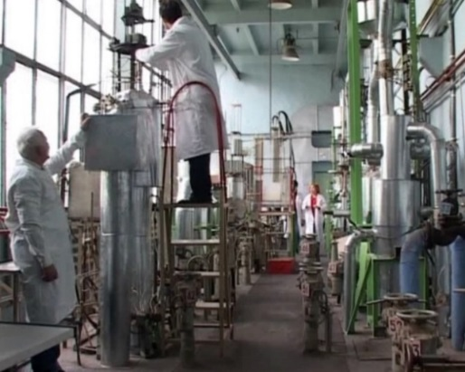
Fig. 1. General view of test facility "6B"

Performance capabilities of the test facility:
- Thermophysical studies of single-phase liquid metal flow regimes in the models of fast reactor fuel assemblies and equipment components as applied to various operating conditions (local measurements of coolant velocity and temperature of model fuel element, studies of temperature regimes in mixing chambers).
- Temperature testing of actuators of passive emergency shut-down systems (PAZ-T) in fast reactors based on various physical effects.
- Research into natural convection processes in liquid metal systems as applied to emergency cooling modes.
- Testing and calibration of level sensors, flow-rate sensors, pressure sensors, endurance tests of fast reactor equipment components.

Test facility "AR-1" (high-temperature liquid-metal test facility designed to investigate Accident
Regimes in fast neutron reactors operation)
The "AR-1" high-temperature liquid-metal test facility is designed to carry out research into thermohydraulic processes under emergency conditions of sodium-cooled fast reactors operation, including severe accident progression with sodium boiling in the core, as well as research into heat transfer in a decay heat removal system (DHRS) and DHRS heat transfer equipment testing by means of experimental models [6].
Basic specifications of test facility: the facility includes three circulation loops (sodium, Na-K eutectic alloy), the installed power is 750 kW. The primary sodium loop: maximum temperature – up to 1100 °C, sodium flow rate up to 5 m³/h. The secondary loop: maximum temperature – up to 700 °C, Na-K eutectics flow rate up to 25 m³/h.
The work performed:
- Experimental studies of the Na-K eutectics boiling in fuel assembly (FA) models under the conditions of coolant natural circulation.
- Experimental studies of sodium boiling processes in a FA model with a sodium plenum, in support of COREMELT calculation code [7] (Fig. 2).
- Research into heat transfer and testing of a sodium-air heat exchanger model as part of the fast reactor emergency cooling-down system;
- Research into heat transfer and temperature fields in the accelerator-driven system (ADS) target model with the use of Na-K alloy (Fig. 3).

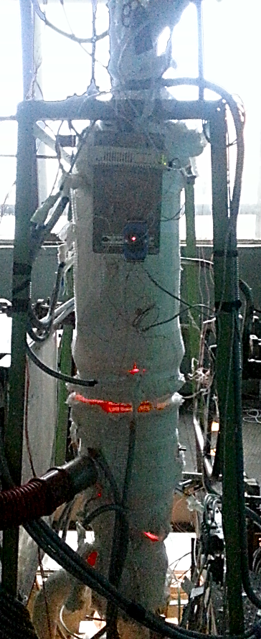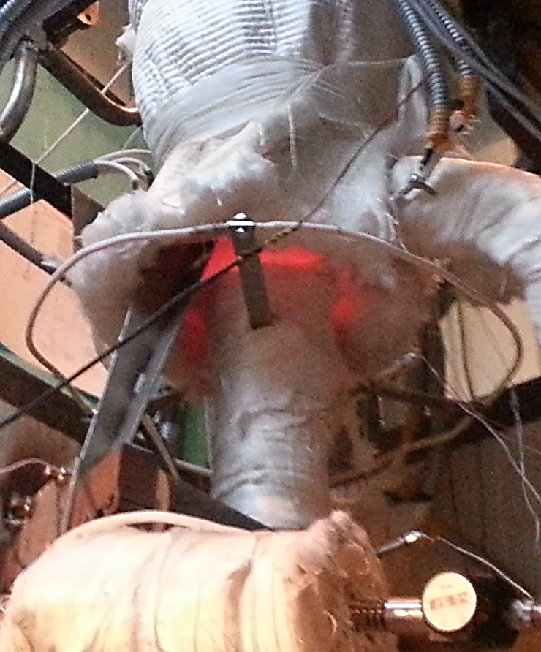 | 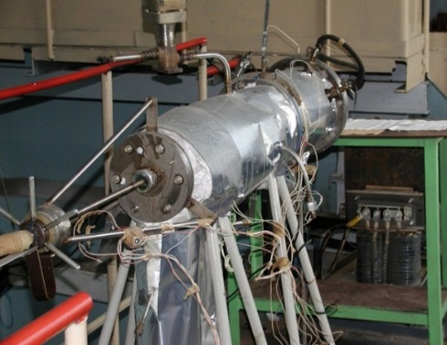
Fig. 2. Test model to study sodium boiling  in the FA in the core | Fig. 3. ADS target model

Performance capabilities of the test facility:
- Experimental modeling of thermohydraulic processes in two-phase liquid metal flows in the channels with fuel assemblies to substantiate fast neutron reactor safety under emergency conditions (UTOP, ULOF, etc.).
- Efficiency of heat exchange equipment operation under the conditions of emergency cooling, acquisition of data for verification of design codes.

Test facility "SPRUT" (multipurpose liquid metal test facility)
The "SPRUT" facility is designed to study thermal-hydraulic characteristics of steam generators in reactor plants with liquid metal coolants, as well as to study severe accidents to justify reactor designs of a new generation [8]. The "SPRUT" facility is the only one in Russia, which in parallel has a sodium coolant loop, loops with heavy coolants (lead, lead-bismuth alloy) and a water loop (Fig. 4, 5).

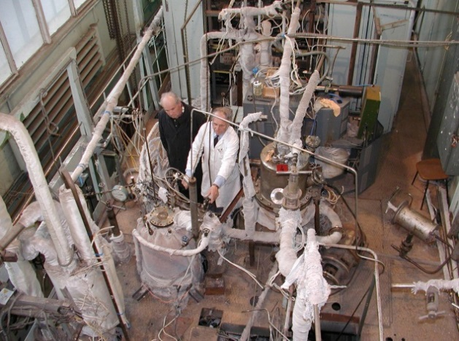 | 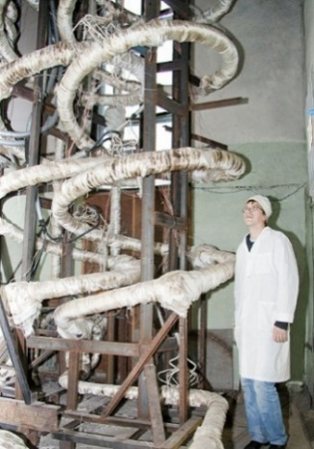
Fig. 4. Test section to study heat transfer  in a "sodium-water" steam generator | Fig. 5. Test section to study heat transfer in  a helical-coil steam generator with heavy coolant

Basic specifications of test facility:
Sodium loop: rated power 0.5 MW, coolant pressure up to 1.0 MPa, coolant temperature up to 600 ºС, coolant flow rate up to 10 m³/h, head up to 0.6 MPa.
Lead loop: rated power 1.0 MW, coolant pressure up to 1.5 MPa, coolant temperature up to 550 ºС, coolant flow rate up to 20 m³/h, head up to 1.5 MPa.
Lead-bismuth loop: rated power 0.5 MW, coolant pressure up to 1.0 MPa, coolant temperature up to 550 ºС, coolant flow rate from 10 m³/h, head up to 1.0 MPa.
Water loop: rated power 0.24 MW, coolant pressure up to 25 MPa, coolant temperature up to 550 ºС, coolant flow rate up to 8 m³/h, head up to 1.0 MPa.
The dimensions of the premises (height of 25 m) make it possible to install steam generator models of various reactors, full-scale in terms of their height.
Performance capabilities of the test facility:
- Research into steam-water flow characteristics in various channels (pipes (tubes), annular channels, Field channels, etc.).
- Studies of heat flux distribution and heat transfer coefficients along the length of steam-generating tubes under nominal and starting operation conditions, wall temperature pulsations, heat transfer and stability of operation of parallel channels, dynamic conditions (in case of fluctuating water flow), emergency conditions to justify steam generators of reactor plants with various liquid metal coolants.
- Research into corrosion resistance of steam generator tubes.
- Development of water chemistry and pipe (tube) flushing.
- Experimental testing of heat transfer enhancement methods.
- Studies of direct contact heat exchangers heated by lead- bismuth jets.

Test facility "Pluton"
The "Pluton" test facility is designed to experimentally study severe accidents with the use of simulated corium, to determine the conversion factors of thermal interaction and displacement of materials during thermal interaction of simulated corium and sodium, to study probability of fuel element cladding damage in the course of ULOF- type accidents, as well as to develop the measures to prevent severe accident progression at fast reactors with sodium coolant (Fig. 6, 7) [9].
Basic specifications of the test facility: coolant inventory in the loop – 0.12 m³, maximum power rating – 150 KW, maximum coolant temperature – 750 °С, maximum coolant pressure – 0.25 MPa, argon pressure in the gas cavity of the pump tank and drain tank (excess) – 0.08 MPa, maximum coolant flow rate – 10 m³/h.
The “Pluton” test facility has all the required auxiliary systems, which make it possible to maintain a preset level of coolant purity, to control the coolant composition, and automatically collect and store the information received.
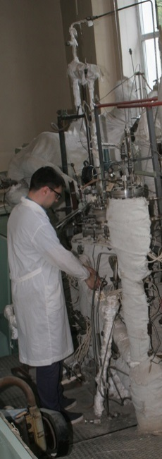 | 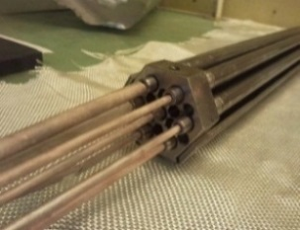  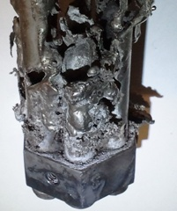 | 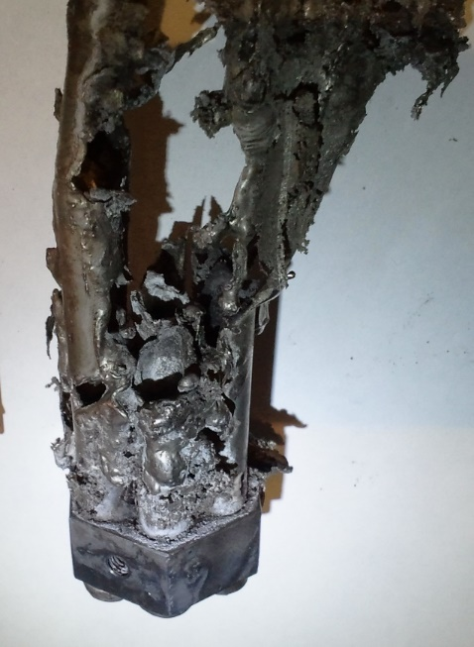
Fig. 6. Part of the "Pluton" test facility | Fig. 7. A model fuel rod bundle before and after the experiment

The work performed:
- Investigation of dynamic characteristics of the processes of interaction between simulated uranium-containing corium melt and sodium (thermite mixtures based on low-enriched uranium and molybdenum oxide) as a function of the initial parameters of experiments.
- Research into movement of materials in the course of interaction between simulated uranium-containing corium and sodium.
- Studies of fuel element cladding damage probability in the course of ULOF-type accidents.
- Investigation of behavior of reactor structure materials in case of their contact with corium.
Performance capabilities of the test facility:
- Studies of fuel element cladding damages in the course of ULOF or UTOP-type accidents.
- Research with the aim to justify in-pile corium traps.
- Studies of material behavior in case of their contact with high-temperature media.

Test facility "Protva-1"
Test facility "Protva-1" is designed to solve the problems of sodium coolant technology as applied to fast neutron reactor plants, including such tasks as to study mass transfer of impurities in a circulation loop with sodium (oxygen, hydrogen, water, mineral oil, corrosion products of structural materials, etc.), to study the improved methods for sodium purification (sorption and getter purification) from impurities , such as sodium-water interaction products and other impurities, to test the devices that control the content of impurities in the coolant and to justify a vibrio-acoustic system for leak detection in sodium-water steam generators (Fig. 8) [10].
Basic specifications of the test facility:
Primary loop: sodium as a coolant, coolant inventory in the loop – 0.9 m³, maximum sodium flow rate – 200 m³/h, maximum sodium temperature in the test section – 800 °С, maximum pressure in the gas loop – 0.6 MPa, maximum power rating – 800 kW, maximum sodium pressure – 0.4 MPa, maximum sodium temperature in the main loop – 580 °С.
Secondary loop: sodium-potassium as a coolant, coolant inventory in the loop – 0.15 m³, maximum coolant flow rate – 10 m³/h, coolant temperature – 350 °С, coolant pressure – 0.6 MPa, maximum coolant volume to be tested – 300 l.
The test facility has all the required auxiliary systems, which make it possible to perform the following operations:
- To control and maintain the coolant purification level.
- To perform controlled impurities supply to the coolant.
- To control coolant composition.
- To automatically maintain the preset thermal hydraulic conditions in the test section, including their cyclic variation in time.
- To automatically collect, process and store the information received.

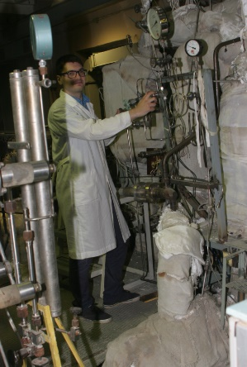 | The work performed:  - Studies of the composition and reactivity of deposits formed in the gas cavities of sodium systems due to oil vapor; research into behavior of the suspended phase of hydrocarbon impurities in sodium.  - Studies of transfer processes of deposits formed in the gas cavities of sodium systems to sodium.  - Study of the process of mass transfer of stainless steels corrosion products in sodium, determination of constants and closing relationships required for numerical implementation of codes that simulate the process of impurities mass transfer in sodium.  - Studies to substantiate new principles of sodium purification without a cooling system built into the reactor tank (sorption and getter purification).
Fig. 8. Part of the "Protva-1"
test facility (the ground level)

Performance capabilities of the test facility:
- Studies of impurities mass transfer (oxygen, hydrogen, water, organic impurities) in a high-temperature non-isothermal sodium loop. Studies of methods and tools to purify sodium coolant from impurities.
- Studies of methods and tools to control impurities in sodium coolant.

Test facility "TT-1M"
The "TT-1M" liquid metal test facility is designed for integrated research into the technology of heavy liquid metal coolants (lead-bismuth, Pb lead) related to the study of the processes involving automatic control and maintenance of the preset level of thermodynamic activity of oxygen in the coolant, maintaining the purity of the liquid metal loop (no deposits), filtration and sorption purification of the coolant [11] (Fig. 9).

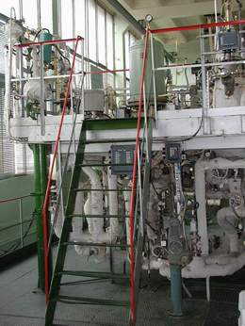  Fig. 9. General view of "TT-1M"  liquid metal test facility | Basic specifications of the test facility: the facility represents a combination of three systems: a liquid metal loop, a water loop and a gas system. The volume of the liquid metal loop is 250 l (lead-bismuth), 40 l (lead), the coolant flow rate is up to 6.5 m³/h (lead-bismuth), 1.0 m³/h (lead), the coolant temperature for the non-isothermal regime (lead-bismuth) is 200–600 °С, for the isothermal regime (lead) – 370–550 °С, the heating loop power is 200 kW, the total power is up to 350 kW.  Performance capabilities of the test facility:  Measurements in support of the research into the following issues:  - Maintaining purity of the coolant. Integrity control of the passivation films on the liquid metal loop surfaces.  - Steam generator leakage control in case of water ingress into the coolant. Mass transfer processes.

Tests:
- Full-scale models/mock-up specimens of coolant technology systems and devices.

Stand "TT-2M"
The "TT-2M" liquid metal test facility is designed to study the physicochemical processes occurring in the course of interaction of a heavy liquid metal coolant (lead-bismuth) with water, air, ceramic and composite materials, carbon, etc., as applied to the SVBR-100 reactor facility, advanced high-temperature systems for nuclear and non-nuclear application under development at the State Corporation Rosatom, as well as for research into the advanced non-nuclear lead-bismuth application units under development (a direct contact "lead-bismuth – water" steam generator, a high-performance hydrogen generator based on high-temperature electrolysis of water, a seawater desalination plant, organic waste pyrolysis with the production of polyfunctional nanopowders, catalysts, sorbents. – Fig. 10 [12].

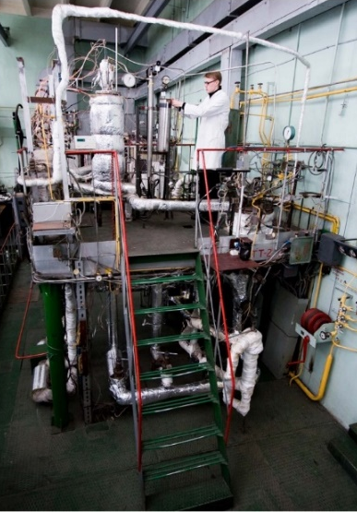  Fig. 10. General view of the liquid metal test facility "TT-2M" | Basic specifications of the test facility: the volume of the liquid metal loop is 200 l, the coolant flow rate is up to 5 m³/h, the coolant temperature for the non-isothermal regime is 200–550 °C, the total power is up to 250 kW.  Performance capabilities of the test facility:  Measurements in support of the research into the following issues:  - Maintaining purity of the coolant, inner surfaces of the loops and various-application equipment.  - Processes of coolant impurity composition control.  - Mass transfer processes.  - Release of coolant components to the gas phase.  Tests:  - Full-scale models/mock-up specimens of coolant technology systems and devices.  - Integrated automated systems for monitoring, prediction and control of the coolant condition.

- Various mass transfer devices. Corrosion testing of advanced materials for nuclear power systems.

Test facility "V-200"
The "V-200" test facility is designed for experimental research into thermal hydraulic processes (hydrodynamics of non-isothermal flow, distribution of velocity and temperature fields, stratification of coolant) in the volumes and equipment of the primary circuit of a fast reactor under various operating conditions; study of temperature gradients and fluctuations at stratified interfaces required for the calculation of thermal stresses, fatigue of the materials for the equipment, pipelines, vessel; justification of design decisions for passive emergency cooldown systems of advanced fast reactors (Fig. 11, 12) [13].

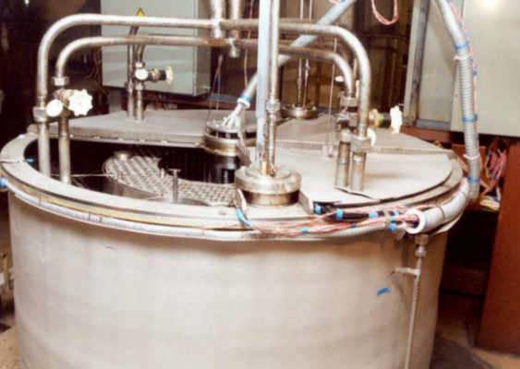 | 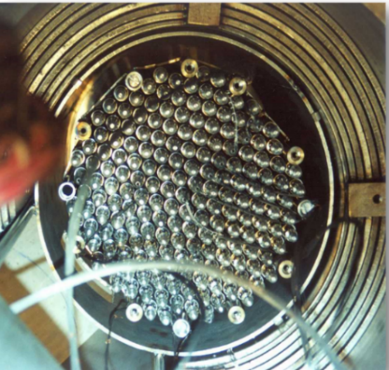
Fig. 11. General view of the integral model of fast reactor  at the "V-200" test facility | Fig. 12. Top view of the simulated core model  and shielding shells

Basic specifications of the test facility: water coolant, dimensions of the model tank – 2 m in diameter, 1.8 m high, pressure – 100 kPa, coolant flow rate – 20 m³/h, temperature – up to 90 °С, power of core simulators – 150 kW.
The primary circuit of the model consists of two parallel loops, each of them contains two intermediate heat exchanger models (IHX) and one simulated MCP-1 model.
The secondary circuit also represents a closed circulation system with a pump filled with distillate and designed to ensure heat removal from the models of the IHXs and autonomous heat exchangers (or emergency heat exchanger-EHX).
The work performed:
- A large amount of research was carried out on non-stationary temperature and velocity fields in the primary circuit elements for the BN-800 and BN-1200 reactors in various operating conditions: with forced circulation, in transients, under emergency cooldown conditions.
Performance capabilities of the test facility:
- Studies of the distribution of the velocity and temperature of stratified processes in the volumes and equipment of the primary circuit of fast reactors in various operating regimes to substantiate design solutions, safety and resource of fast reactors.

the "BFS" Complex of fast critical facilities

Fast critical facility "BFS-1"
The "BFS-1" critical facility is designed to study full-scale mock-ups of research and power fast reactors (thermal power up to 1000 MW(th) being designed, with different types of fuel, fertile materials and coolants (sodium, lead, lead-bismuth, water, gas), various core and blanket layouts; and to conduct research into neutronic characteristics of the assemblies with a simple composition (benchmarks) and experimental studies carried out to justify nuclear safety of fuel cycle technologies and fuel cycle facilities (Fig. 13) [14].

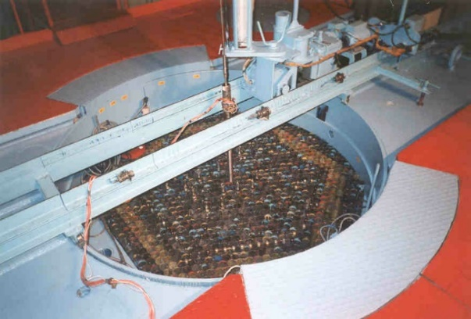 | Basic specifications of the critical facility: power to 0.2 kW; simulated coolants are sodium, lead, lead-bismuth, water, gas; moderators for light-water reactor simulation are distillate, boric acid solution, polyethylene; reflectors are uranium, uranium dioxide, lead, lead-bismuth, steel; fast neutron flux density, max to 10¹⁰ cm⁻²·s⁻¹; core cooling by natural convection or forced air cooling. The dimensions of the "BFS-1" critical facility tank make it possible to assemble full-scale models of the research reactors and power fast reactors being designed with a capacity of up to 1000 MW(th).
Fig. 13. Part of the "BFS-1" critical facility

Sensors and instrumentation:
- Neutron flux distribution measurements over the critical assembly volume in the course of critical assembly studies are performed using small-size fission chambers that are placed inside intertube gaps of the core and the blankets and moved with the help of a measuring device.
- Neutron spectra, as well as models of accelerator-driven systems are measured by the time-of-flight method with the use of the electron accelerator MI-30.
Performance capabilities of the critical facility:
- Metal, oxide, monocarbide and nitride fuel can be simulated at the "BFS-1" critical facility. The quantity of fissile materials is sufficient for assembling full-scale mock-ups of low- and medium-power fast reactor cores and blankets.

Fast critical facility "BFS-2"
At present, the "BFS-2" critical facility is the largest operating critical test facility in the world (Fig. 14, 15); its dimensions allow full-scale simulation of fast reactor cores and blankets with a capacity up to 3000 MW(e), as well as in-vessel shielding and in-vessel storages with different types of fuel, fertile materials, coolants (sodium, lead, lead-bismuth) and with various core and blanket layouts [15].
Basic specifications of the critical facility: power to 1 kW; simulated coolants are sodium, lead, lead-bismuth; moderators for light-water reactor simulation are distillate, boric acid solution, polyethylene; reflectors are uranium, uranium dioxide, lead, lead-bismuth lead, steel; fast neutron flux density, max to 10⁹ cm⁻²·s⁻¹; core cooling by natural convection or forced air cooling.

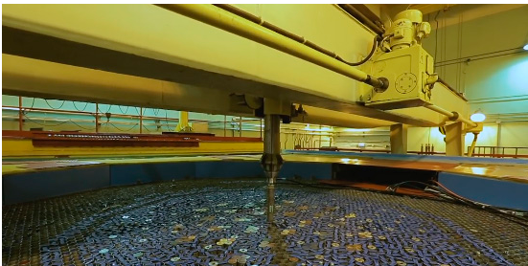 | 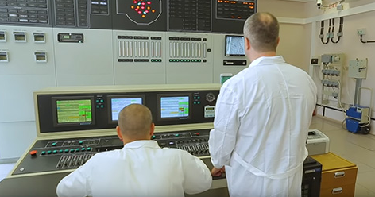
Fig. 14. Reactor box of the "BFS-2" critical facility | Fig. 15. Control room of the "BFS-2" critical facility

The "BFS-2" facility in terms of design is similar to "BFS-1", but it is of a larger size, which makes it possible to assemble high-power fast reactor models with the power up to 7000 MW(th) at the facility. The tank is 5 m in diameter and 3.3 m in height, the number of tubes (fuel rods) in the tank is about 10000. The tubes have the same diameter as those at the "BFS-1" critical facility and they are filled with the same disks. A collection of disks containing plutonium and/or uranium, and/or uranium dioxide (enrichment to 36 % and/or 90 % U ²³⁵) with disks containing fertile materials.
Performance capabilities of the critical facility:
- Study of neutronic characteristics of reactors being designed. Special experiments at the test facility in the simplest geometries and with a minimum set of materials (the so-called integral experiments).

Conclusion
The experimental facilities available at the IPPE make it possible to carry out investigations in a wide range of tasks in order to justify the design characteristics and safety of fast reactors with various liquid metal coolants. Information about the purpose of the facilities and the goal of the investigations is presented in the table. Information about the possibilities of conducting investigations and the range of parameters is given in the text of the report.

TABLE 1. EXPERIMENTAL FACILITIES IN THE IPPE

Facilities | Purpose of the facility | Goal of the investigations
6 B | Thermal-hydraulic studies of the core and equipment  of fast reactors | Justification of nominal and  non-nominal regimes
AR-1 | Thermal-hydraulic investigations of accident regimes with sodium boiling in fast reactor core | Justification of fast reactor safety
SPRUT | Thermal-hydraulic investigations of steam generators of reactor plants with liquid metal coolants, the development of severe accidents | Justification of design parameters and safety of fast reactors
Pluton | Investigations of severe accidents of the ULOF type, thermal interaction of corium with sodium, to fuel cladding damage | Justification of the fast reactor safety
Protva-1 | Investigations of sorption and getter purification of sodium in fast reactors, mass transfer of impurities in circuits | Investigations of the sodium coolant technology, mass transfer of impurities
TT-1M | Investigations of the heavy liquid metal coolant technology, substantiation of devices for heavy coolant technology | Tests of full-scale samples of apparatuses and devices for heavy coolant technology
TT-2M | Investigations of physical and chemical processes of interaction of a heavy liquid metal coolant with water, air, carbon, etc. for SVBR-100, non-nuclear installations | Regulation of the heavy coolant composition. Testing of coolant technology devices
V-200 | Thermal-hydraulic investigations of the primary circuit of fast reactors | Justification of the decay heat removal system in fast reactors
BFS-1 | Investigations of the neutron-physical characteristics of fast reactor the core | Justification of nuclear safety of fuel cycle technology
BFS-2 | Full-scale simulation of fast reactor cores | Investigations of neutronic characteristics of reactors
References
- Rachkov V.I., Kalyakin S.G., Kukharchuk O.F., Orlov Yu.I., Sorokin A.P. From the First Nuclear Power Plant to Fourth-Generation Nuclear Power Installations (on the 60th anniversary of the world's first nuclear power plant). Thermal Engineering. 2014. Vol. 61. No. 5. P. 327–336.
- Rachkov V.I., Arnol'dov M.N., Efanov A.D., Kalyakin S.G., Kozlov F.A., Loginov N.I., Orlov Y.I., Sorokin A.P. Use of liquid metals in Nuclear and Thermonuclear Engineering, and in other Innovative Technologies. Thermal Engineering. 2014. No. 5. P. 337–347.
- Thermophysical Test Facilities of the Nuclear Power Industry in Russia and Kazakhstan. Edited by: Pershukov V.A., Arkhangelskiy A.V., Kononov O.E., Sorokin A.P. Sarov: FSUE RFNC – VNIIEF. 2016. 160 p.
- Klinov D.A., Gulevich A.V., Eliseev V.A., Malysheva I.V., Buryevsky I.V. Features of the Advanced Fast Reactor Cores. Problems of Atomic Science and Technology. Series: Nuclear Reactor Constants. 2020. No. 2. https://vant.ippe.ru/year2020/2/html.
- Bogoslovskaya G.P., Cevolani S., Ninokata H., Rinejski A.A., Sorokin A.P., Zhukov A.V. LMFR Core and Heat Exchanger Thermohydraulic Design: Former USSR and Present Russia Approaches. IAEA–TECDOC–1060. Vienna: IAEA. 1999.
- Sorokin A.P., Kuzina Yu.A., Ivanov E.F. Characteristics of Heat Transfer During Boiling of Liquid Metal in the Fuel Assemblies of Fast Reactors in Emergency Regimes. Atomic Energy. 2019. Vol. 126. Issue 2. P. 69–76.
- Ashurko Yu.M., Volkov A.V., Raskach K.F., Solomonova N.V. Influence of the neutron-physical model on the calculation of a severe accident with sodium boiling in a fast reactor. Atomic Energy. 2017. Vol. 122. Issue 4. P. 183–189.
- Grabezhnaya V.A., Kalyakin S.G., Mikheev A.S., Sorokin A.P. Testing a Steam Generator Model with Lead Heated Twisted Tubes. Thermal Engineering. 2014. No. 11. P. 9–15.
- Zagorulko Yu.I., Zhmurin V.G. Volov A.N. et al. Experimental Studies of Thermal Interaction of Simulated Corium with Coolants (Sodium, Water). Thermal Engineering. 2008. No. 3. P. 48–58.
- Kozlov F.A., Sorokin A.P., Alekseev V.V. Development of Sodium Technology as a Coolant for Fast Reactors. Atomic Energy. 2014. Vol. 116. Issue 4. P. 228–234.
- Liquid Metals: from the First Thermophysical Test Facility to Large-Scale Nuclear Power Energineering. Collection of Articles. Edited by A.D. Efanov, F.A. Kozlov. Obninsk: FSUE "SSC RF – IPPE". 2001.
- Askhadullin R.Sh., Gulevsky V.A., Ivanov K.D., Legkikh A.Yu., Melnikov V.P., OrlovYu.I., Posazhennikov A.M., Ulyanov V.V., Yagodkin I.V. Analysis of the Current Status of Work on the Technology of Heavy Liquid-Metal Coolants (Pb, Pb-Bi). Atomic Energy. 2014. Vol. 116. Issue 4. P. 234–240.
- Sorokin A.P., Opanasenko A.N., Kuzina Yu.A., Denisova N.A., Razuvanov N.G., Sviridov E.V., Belyaev I.A. Experimental Studies of Stratification Processes in the Circulation Loop Elements of Nuclear Power Plants of Various Types. Collection of Reports of the V International Scientific and Technical Conference "Innovative Projects and Technologies of Nuclear Energy (MNTK NIKIET – 2018)". M.: JSC NIKIET. 2018. P. 890–901.
- Kochetkov A.L., Matveenko I.P., Khomyakov Y.S. BFS Critical Experiments for the Minor Actinides Data Correlation. International Conference on Reactor Physics "PHYSOR 2006 – Advances in Nuclear Analysis and Simulation". Vancouver. Canada. September 14–16. 2006.
- Jaewoon Yoo. et. al. Analysis of BFS Critical Assemblies with Metallic Fuel and Justification of Characteristics of the Korean Fast Sodium Reactor. Proceedings of the International Conference "50 Years of the BFS". 28.02–02.03.2012. Obninsk: FSUE "SSC RF – IPPE". 2012. P. 27–28.

