# heterogeneous burning of minor actinides in a fast reactor

I.Yu. Zhemkov, A.L. Izhutov, Yu.V. Naboishchikov, A.A. Tuzov

RIAR JSC,

Dimitrovgrad, Russia

niiar@niiar.ru

**Abstract**

The transmutation of minor actinides (MA) through irradiation in a reactor allows for improving the nuclear fuel (NF) efficiency due to energy produced by the MA fission, mitigating the problem of spent nuclear fuel (SNF) long-term activity as well as producing and extracting useful radionuclides.

The homogeneous MA transmutation and heterogeneous burning of MA are feasible in a fast reactor (FR). The concept of heterogeneous MA burning involves their inclusion into inert matrices to eliminate the secondary MA formation and their placement in specific pins in the FR core or blanket. Heterogeneous burning of MA in the FR blanket has a more flexible MA handling strategy and can be used to achieve high MA burning rates.

In Russia, there is a unique opportunity for the MA transmutation in the existing FRs (BN-600, BN-800). Therefore, the overall study is focused on the developing the technology for heterogeneous burning of MA.

In Russia, there is a unique opportunity for the MA transmutation in the existing FRs (BN-600, BN-800). Therefore, the overall study is focused on the developing the technology for heterogeneous burning of MA.

## INTRODUCTION

The reactor operation results in the accumulation of fission products in the nuclear fuel and plutonium and minor actinides (MA). The nuclide composition of SNF from various reactors differs significantly and depends on its initial composition and burnup, duration of irradiation and cooling after irradiation. Over time, the problem of SNF and radwaste (RW) becomes more and more relevant for nuclear power. To date, the world has accumulated about 400 thousand tons of SNF. The main problem in SNF disposal (in the range from 200 to 5000 years) is MA, which share in SNF is ~0.1%, i.e. about 400 tons [[1], [2]]. The key ways of the MA accumulation are shown in Figure 1.

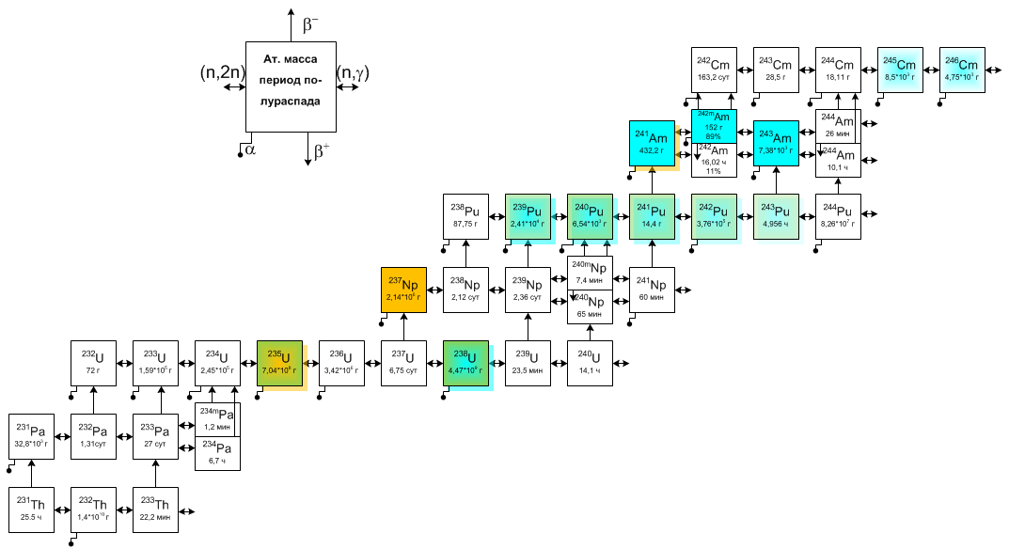

At. Mass

Half-life

Figure 1 – MA accumulation during irradiation of U and U-Pu nuclear fuel

SNF from a thermal reactor consists of uranium (94.5%), fission products (4.4%), plutonium (1.1%), and MA (~0.1%) [1]. A 1GW thermal reactor (VVER, PWR) accumulates about 20 kg/year of MA with a composition of Np 45÷70%, Am 25÷50%, Cm <10%. Having long half-lives, MA determine the long-term activity and radiotoxicity of SNF and RW. A long-term storage of SNF and RW requires special materials, containers, reliable storage facilities and multi-barrier protection. Moreover, it is impossible to ensure the safe disposal of MA for hundreds and thousands of years. The only effective way to resolve the current situation is the recycling of MA.

The main goal of MA recyclingl is to reduce the volume of high-level waste, the residual heat release and the long-term component of SNF radioactivity.

At present, when there is no closed nuclear fuel cycle, there is no any unified strategy for the MA disposal and the main ways for MA handling are:

- MA fractioning with possible commercial use.

- MA immobilization into matrices and geological storage;

- *MA transmutation* (fuel cycle closure planned for the implementation in the next 10-20 years).

The MA transmutation in a reactor is their transformation into other actinides as a result of nuclear reactions of radiative neutron capture and radioactive decay as well as into fission products as a result of nuclear fission reactions.

The MA burning is their fission in a nuclear reactor caused by neutrons of different energies to convert MA into fission products.

The efficient MA transmutation can be implemented in purposely-designed advanced nuclear systems (accelerators, molten salt reactors, high-temperature reactors, actinide burners). A current lack of such systems postpones the solution of MA-related problem for decades. The MA transmutation can be implemented in the next 10-20 years in the existing and designed fast reactors.

## CONCEPTS FOR MA TRANSMUTATION IN A FR

There are two concepts for MA transmutation in a FR [[3], [4]]:

- homogeneous transmutation in the core;

- heterogeneous burning in the blanket, possibly in the axial breeding blanket.

The homogeneous transmutation of MA is done in standard fuel assembly. This concept implies the inclusion of a small amount of MA (up to 2%) into nuclear fuel, as well as the use of a standard design of fuel pins and fuel assemblies (FA). A small amount of MA is necessary to minimize changes in the FA and FR parameters.

The heterogeneous burning of MA (HBMA) is done in MA-burning pins, that are MA in an inert matrix, which makes it possible to eliminate the MA-producing nuclides. MA-burning pins are installed in specific assemblies (SUMA) inserted into the blankets that are currently not in demand for plutonium accumulation.

The single problem of MA in RBN is most optimally solved with the simultaneous use of both options

The implementation of both concepts can address the challenge of MA recycling in a FR: the core is for the homogeneous transmutation of MA (FR fuel cycle closure), and the blanket is for the heterogeneous burning of MA accumulated in thermal reactors. This approach allows for minimizing the MA effect on reactor parameters and achieving high rates of MA transmutation.

It should be noted that the MA transmutation and burning require a large scope of feasibility studies, development and refinement of technological processes, computational and experimental studies and reactor experiments to justify the performance and safety of MA recycling in the FR. Thus, this is a cross-cutting task that includes:

1. Chemical and technological activities:

- isolation of MA from SNF (possibly radwaste as well);

- production of MA-containing fuel (homogeneous transmutation) and MA-based fuel (HTMA);

- production of MA-containing pins and MA-burning pins;

- production of MA fuel assemblies (MAFA) and SUMA;

- reprocessing of SNF with MA (recycle or single irradiation in case of achieving more than 90% MA burnup).

2. Storage and transportation of FA with MA and SUMA (containers, cooling of assemblies, radiation safety).

3. Reactor activities:

- handling of MAFA and SUMA at the reactor facility before and after irradiation;

- irradiation in the reactor (efficiency, burnup, performance of MA-containing pins and MA-burning pins);

- influence of MA mass on the reactor parameters.

## DEVELOPMENT OF A TECHNIQUE FOR HBMA IN A FR

To increase the HBMA efficiency, the conditions for MA irradiation in the SUMA can be optimized by increasing the MA fraction in the MA-burning pin (up to 100%) and “softening” the neutron spectrum (Sn) in the FR blanket. Thus, the advantages of the HBMA in the FR blanket are as follows:

- at present, the blanket for plutonium accumulation is not in demand, so SUMA will be loaded instead of breeding or steel assemblies.

- it is possible to minimize the influence of MA mass on the reactor parameters.

- it is possible to optimize the MA irradiation conditions (Sn “softening”).

- it is possible to place a large number of SUMA (replacement of all breeding or steel blanket assemblies).

The HBMA only enables separating the flows of “clean” (MA-free) and “non-clean” (MA-containing) fuel and ensure radiation safety at a relatively small area for production of MA-containing fuel and MAFA, MA-burning pins and SUMA. As part of the development and justification of the technology for HBMA in a FR, the following have been completed to date:

- Computational and experimental justification of MA (Np, Am) recycling in a sodium-cooled FR.

- Development of MA-burning pins, their manufacture by vibro-packing, irradiation in the BOR-60 reactor in various neutron spectra and post-irradiation examinations.

- Development of the BN-800 SUMA design.

- Development of manufacture process for BN-800 MA-burning pins and SUMA.

A site for producing AmO2 and NpO2 granulates has been arranged at RIAR. An experimental facility has been designed and manufactured for MA vibro-packing for further irradiation in the BOR-60 (Figure 2), and pilot batches of MA have been manufactured and qualified (Figure 3).

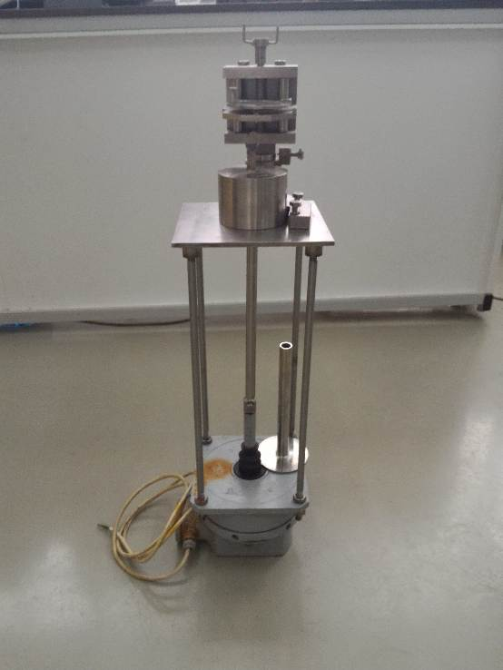 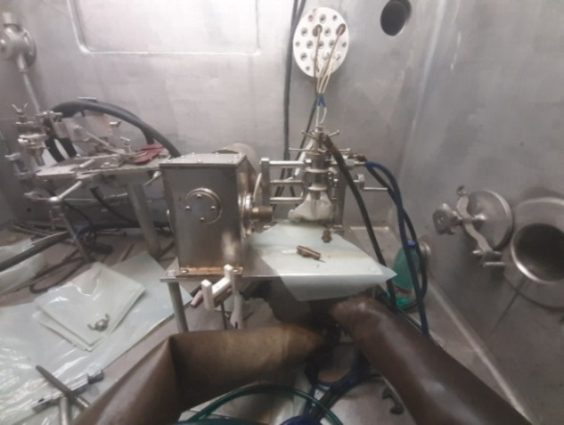

a) b)

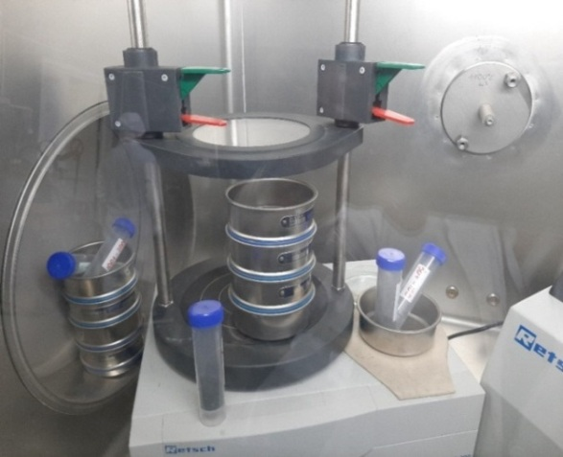 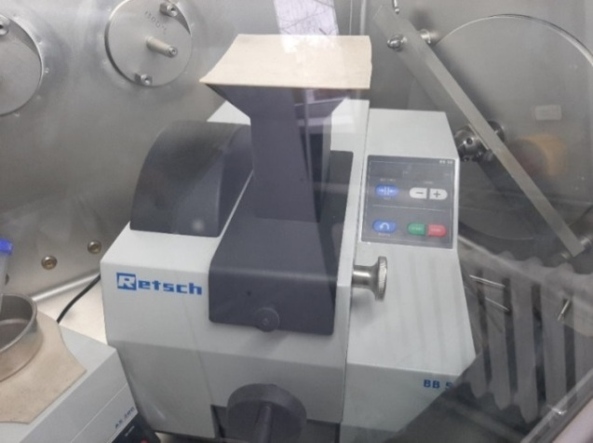

c) d)

Figure 2 – Area to manufacture MA and MA-burning pins

1. Vibro-packing facility, b) Welding facility, c) Sieving facility in a glove box, d) oxide grinding facility in a glove box

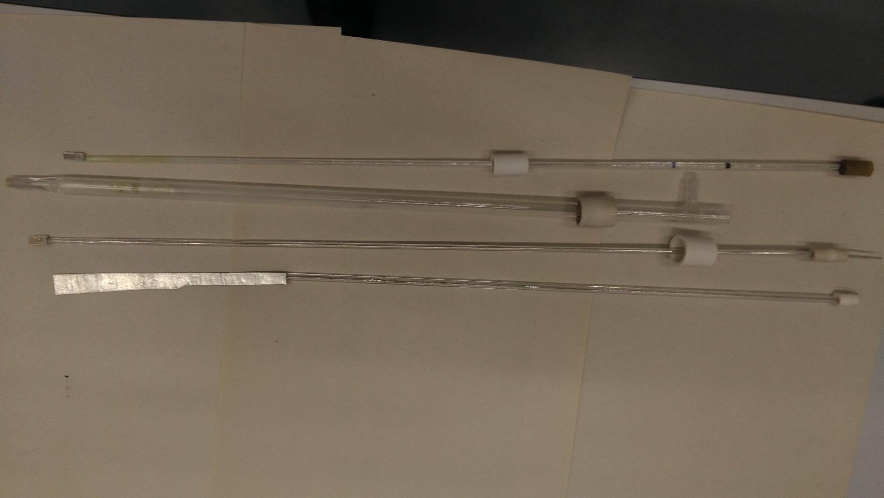

a)

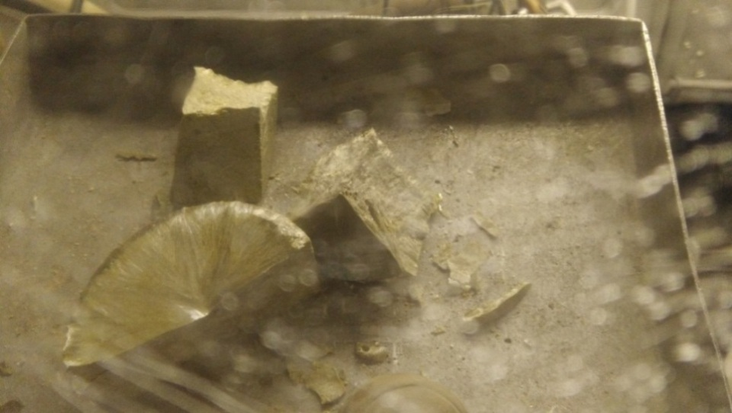 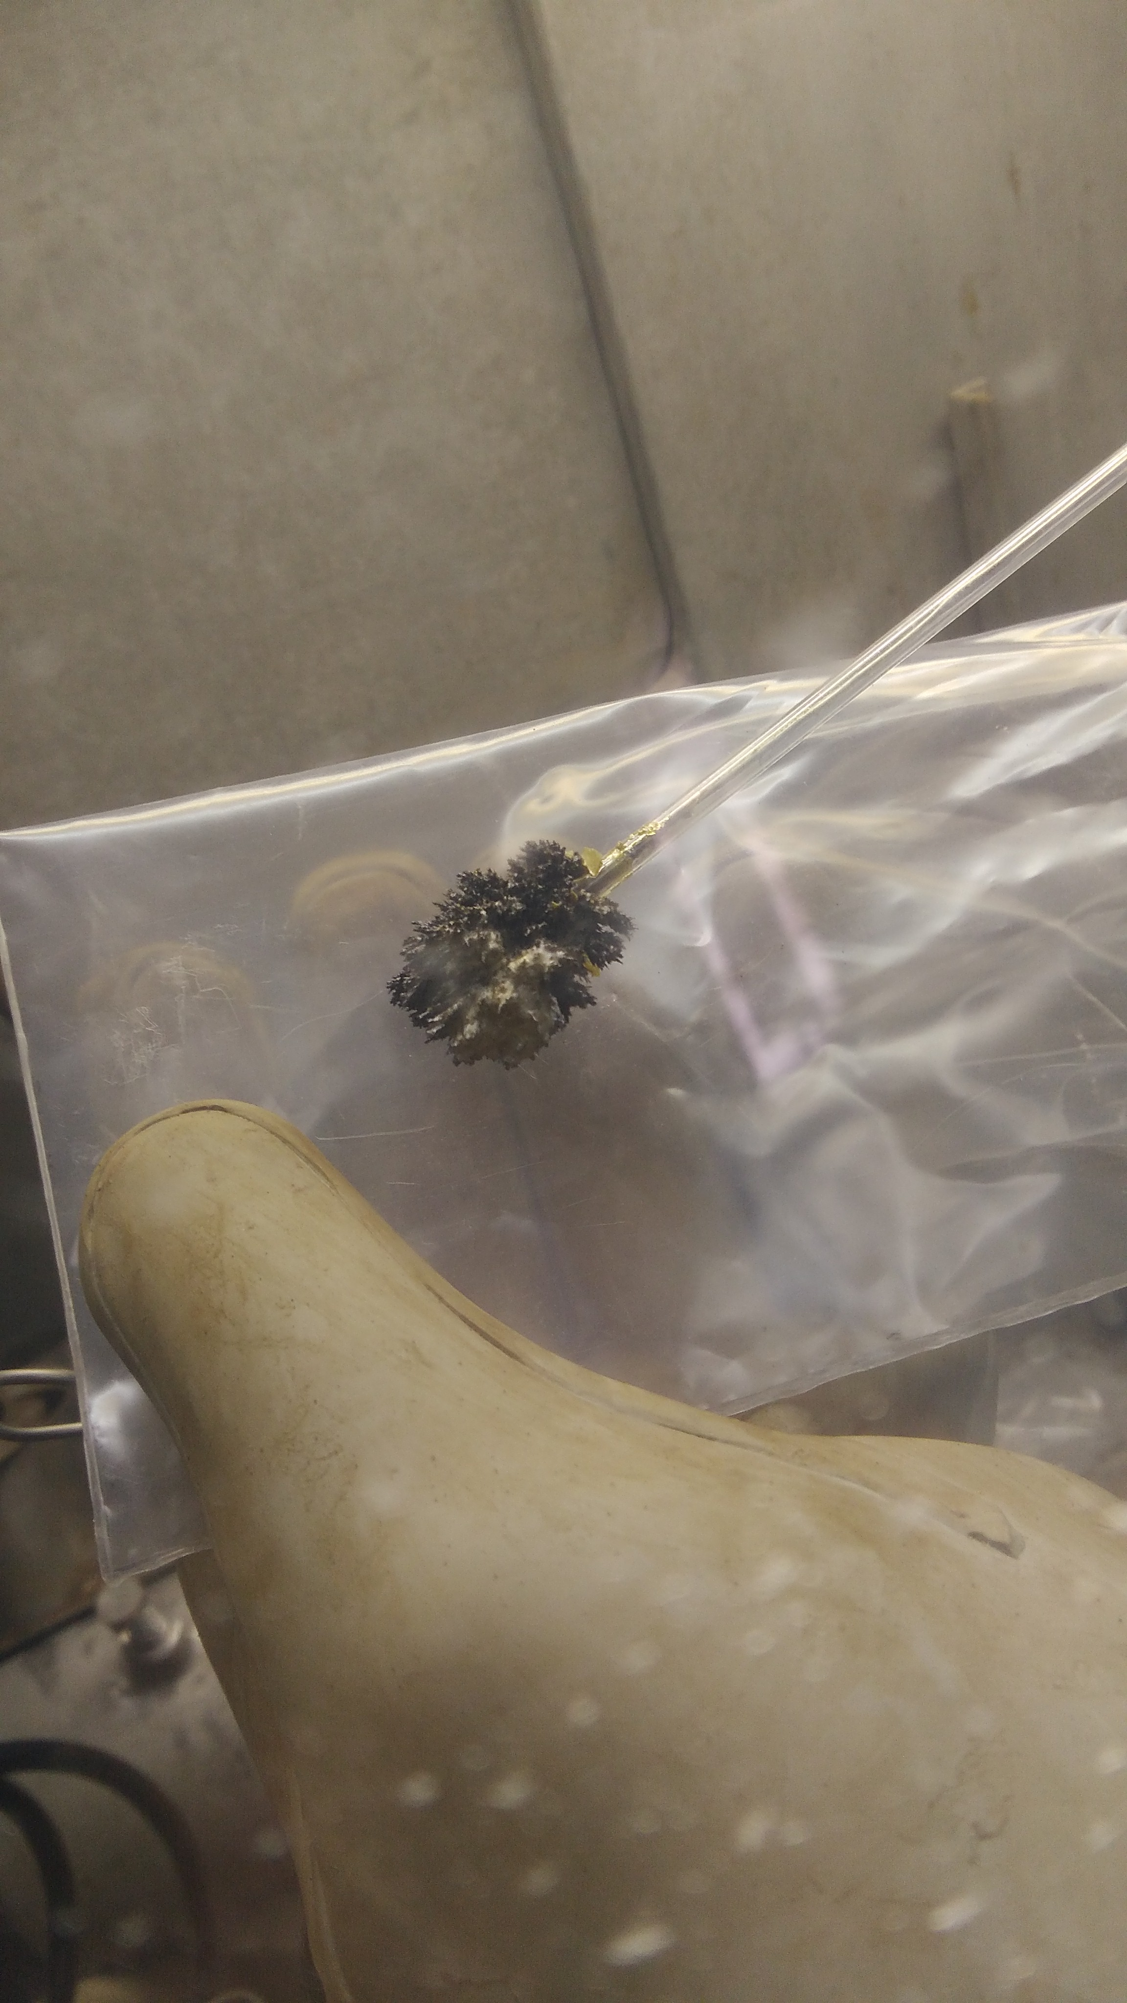

b) c)

Figure 3 –Np and Am extraction

1. cathode, reference electrode and anode (top – bottom), b) electrolyte with Np molybdate,

в) cathode deposit

Eight AmO2 and NpO2 MA-burning pins for two irradiation rigs (IR) and three ZrH1.85 IRs with a moderator (IR M) were manufactured for the BOR-60 testing. To experimentally determine the MA burning efficiency, there was selected a 9th row BOR-60 cell (cell B10), surrounded with 3 IRs M, and a 7th row cell (cell B30) at the core-blanket boundary without a moderator.

In 2020, two IRs with MA-burning pins were loaded into the BOR-60 reactor (Figure 4) for irradiation. The BOR-60 tests of MA-burning pins in two IRs cover the neutron spectra range in the BN-800 SUMA. Figure 5 shows the neutron spectra in the BOR-60 IRs. In May 2021, two MA-burning pins (Np and Am) from each IR were unloaded from the BOR-60 reactor for post-irradiation examinations.

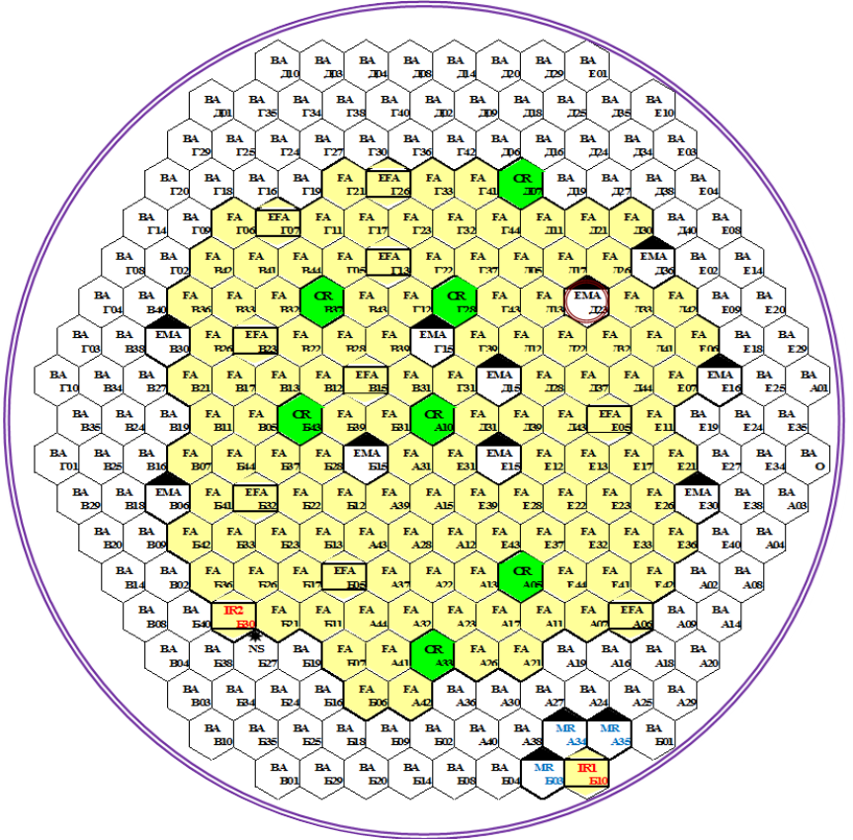

Figure 4 – BOR-60 core arrangement of the year 2020



Figure 5 – Normalized neutron spectrum (Sn) in IR-1 and IR-2

The BOR-60 irradiation results for the first batch of AmO2 MA-burning pins are presented in Figure 6 and Table 1.



Figure 6 – Computation results vs. experimental results for the AmO2 MA-burning pins after the first irradiation stage.

TABLE 1. NUCLIDE COMPOSITION OF AMERICIUM AFTER THE FIRST STAGE OF MA FUEL IRRADIATION IN THE BOR-60 REACTOR, %

|  |  |  |
| --- | --- | --- |
| Nuclide | Experimental value | Calculated value |
| IR-1 | | |
| 241Am | 96.68±0.04 | 97.87 |
| 242mAm | 0.950±0.005 | 1.62 |
| 243Am | 2.37±0.03 | 0.51 |
| IR-2 | | |
| 241Am | 99.54 | 99.3 |
| 242mAm | 0.425 | 0.49 |
| 243Am | 0.039 | 0.28 |

As evidenced by the conducted irradiation tests, burning of minor actinides is more efficient in the moderated (softened) neutron spectrum.

Given in Fig. 7 and Table 2 below are the experimental data for the first batch of MA fuel with NpO2 that was under irradiation testing in the BOR-60 reactor. At this stage, errors attributable the calculation of isotopic kinetics in the steel lateral blanket of the BOR-60 reactor and with the moderator rods in the neighboring positions are estimated to be in the range of 15% to 20%.



Figure 7. Comparison of calculated and experimental data for MA fuel with NpO2 after the first stage of irradiation testing.

TABLE 2. NUCLIDE COMPOSITION OF NEPTUNIUM AFTER THE FIRST STAGE OF MA FUEL IRRADIATION IN THE BOR-60 REACTOR, %

|  |  |  |
| --- | --- | --- |
| Isotope | Experimental value | Calculated value |
| 238Pu | 94.77±0.13 | 95.3 |
| 239Pu | 4.55±0.11 | 4.45 |
| 240Pu | 0.33±0.02 | 0.28 |
| 241Pu | 0.35±0.03 | 0.012 |
| 238Pu/Np | 2.4×10-2 | 2.6×10-2 |

The remaining MA-burning pins are still under irradiation testing in the same irradiation positions of the BOR-60 reactor to achieve higher burning of minor actinides. Table 3 below demonstrates the comparison of specifications and operating conditions for the BOR-60 and BN-800 reactors. According these data, the BN-800 capabilities for MA transmutation are much better compared to the BOR-60 reactor.

TABLE 3. MAIN SPECIFICATIONS AND OPERATING CONDITIONS OF THE BOR-60 AND BN-800 REACTORS

|  |  |  |
| --- | --- | --- |
| Specifications | BOR-60 | BN-800 |
| Operation cycle, full-power days | 50–60 | 155 |
| Number of fuel assemblies | 110–120 | 565 |
| Number of fuel rods per standard fuel assembly | 37 | 127 |
| Fuel height in fuel assembly, mm | 450 | 900 |
| Width across flats × shroud thickness, mm | 44×1 | 96×2 |
| Diameter and thickness of fuel cladding, mm | 6.0×0.3 | 6.9×0.4 |
| Fuel enrichment, % | 70 | 18.5–24 |
| Number of irradiation positions in the steel lateral blanket for SUMA | No more 48 | 90 + 96 |
| Maximum neutron-flux density, 1015 cm-2s-1 | 2.6 | 8.2 |
| Neutron-flux density in the steel lateral blanket, 1015 cm-2s-1 | 0.9–1.6 | 1.2–2.2 |
| Maximum damage rate per year, dpa | 18 | 60 |

Calculated data analysis was performed to estimate the HBMA efficiency in the lateral blanket of the BN-800 reactor. It was revealed that 90 SUMA assemblies with neptunium (SUMA-N) can be loaded in the first line of the lateral blanket, and 96 SUMA assemblies with neptunium, americium and moderators (SUMA-NA) can be loaded in the second line of the lateral blanket. The proposed design of SUMA-NA makes it possible to optimize the efficiency of HBMA process in a wide range by changing the neutron spectrum (number of moderator rods) and MA loading (number of MA pins containing neptunium and americium). Designs of test SUMA-N and SUMA-NA assemblies were developed to conduct irradiation tests and to prove the efficiency of HBMA in the BN-800 reactor (see Fig. 10 below). The main engineering decisions for the SUMA design were made proceeding from their unification with the design of the BN-800 fuel assemblies.

The schematic arrangements of BN-800 core and of the SUMA in the lateral of the reactor are shown in Fig. 8 below.

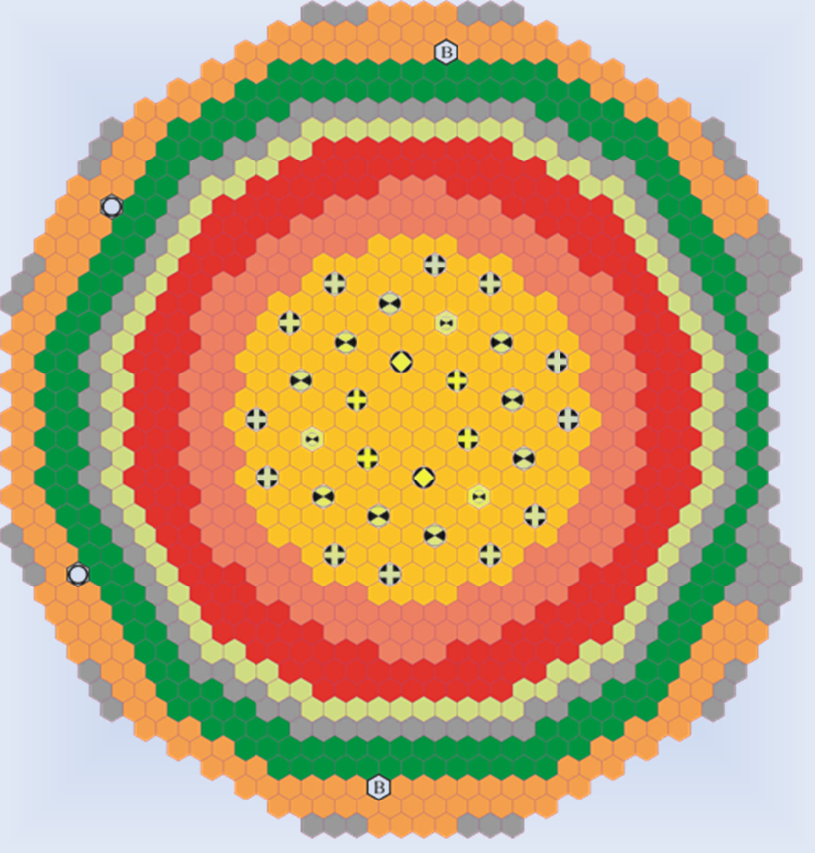

SUMA-N (line 1, lateral blanket, 90 pcs.)

SUMA-NA (line 2, lateral blanket, 96 pcs.)

Figure 8. BN-800 core schematic arrangement and proposed layout of SUMA assemblies.

The neutron spectrum in the BOR-60 reactor is harder and the average neutron energy is respectively higher than in the BN-800 reactor, but they change wide enough in the BOR-60 reactor and encompass the entire region that can be in the BN-800 reactor and other fast reactors (see Fig. 9 below). Thus, the irradiation tests can be conducted in the BOR-60 reactor not only to confirm the HBMA in the lateral blanket, but also to transmute MA in the fast reactor core.



Figure 9. Neutron spectra in the lateral blankets of the BN-800 and BOR-60 reactors.

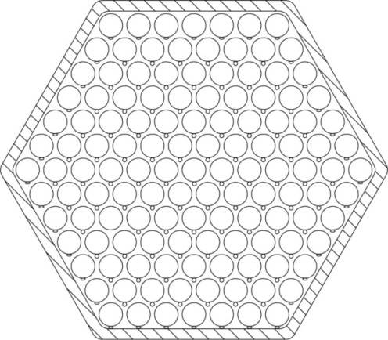 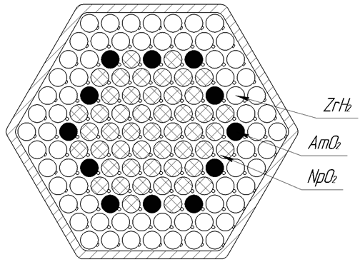

a) b)

Figure 10. Design concept of SUMA-N and SUMA-NA for BN-800

a) SUMA-N schematic arrangement (127 burning pins with Np), b) SUMA-NA schematic arrangement (12 burning pins with Am, 49 pins with Np, 66 pins with ZrHx).

Figure 11 below shows the calculated data for HBMA efficiency in SUMA-N and SUMA-NA assemblies in relation to the damage dose. According to the figure, burning of MA is better in the softened neutron spectrum (SUMA-NA). The rate of MA burning in SUMA-NA increases in a non-linear manner with irradiation time, which is due to the formation of actinides, whose fission rate is better than that of the starting Np and 241Am. Thus, extended irradiation of MA burning pins in the reactor contributes to higher efficiency of the HBMA process.



Figure 10. Efficiency of MA burnout in the SUMA assemblies for the BN-800 reactor.

Table 4 gives values for the normalized change in the mass of the major MAs when SUMA assemblies were under irradiation testing in the BN-800 reactor for 9 reactor operation cycles (90dpa were achieved for the SUMA-N assemblies and 50dpa for the SUMA-NA assemblies).

TABLE 4. CHANGE IN MASS OF MAJOR MA AND PU, KG/YEAR

|  |  |  |
| --- | --- | --- |
| SUMA | SUMA-N | SUMA–NA |
| Number of SUMA assemblies, pcs. | 90 | 96 |
| Number of MA burning pins | 127 NpO2 | 49 NpO2, 12 AmO2 |
| Number of moderator rods | – | 66 ZrHx |
| Np | -90 | -60 |
| Am | – | -18 |
| МА | -90 | -78 |

To increase the absolute performance of MA burning, it is necessary to increase the following parameters:

- Loading of MA into MA burning pins by increasing the initial density;

- Duration of SUMA irradiation to achieve higher damage rates;

- Loading of Am in SUMA-NA by increasing the number of MA burning pins (12 MA burning pins with americium in SUMA-NA).

## conclusion

1. It was experimentally proved that the heterogeneous MA burning could be done in the lateral blanket of fast reactors.
2. The irradiation testing of first batch of MA-burning pins was accomplished in the BOR-60 reactor.
3. The first post-irradiation examination data were obtained for the irradiated AmO2 and NpO2 granulates in different neutron spectra in the BOR-60 reactor.
4. The calculated data analysis is being completed for the first batch of MA burning pins that were under irradiation in the BOR-60 reactor.
5. These results confirm that MA burning can be effective in lateral blanket of the fast reactor.
6. The second batch of MA burning pins is under irradiation testing in the BOR-60 reactor to achieve higher burnup.
7. Technical designs of assemblies for MA recycling (SUMA) with AmO2 and NpO2 containing vibro-packed pins have been developed.
8. Feasibility of MA large-scale recycling was demonstrated in the BN-800 lateral blanket without significant impact on the reactor performance.

**References**

1. [] Baldev Raj, P. Chellapandi, P.R. Vasudeva Rao “Sodium Fast Reactors with Closed Fuel Cycle” CRC PressTaylor & Francis Group, 2015.
2. [] International Atomic Energy Agency. Status and Trends in Spent Fuel and Radioactive Waste Management. VIENNA: IAEA, 2018. IAEA nuclear energy series no. NW-T-1.14. ISBN 978–92–0–108417–0.
3. [] I.Yu. Zhemkov. Transmutation of minor actinides as a way to reduce high-level waste in nuclear power industry. Proceedings of RIAR JSC, 2020. Edition 4. P. 3-11..
4. [] Yu. Zhemkov, A. L. Izhutov, Yu. V. Naboyshchikov and A. A. Tuzov. Heterogeneous burning of minor-actinides in a fast reactor. Collection of Reports of the Industrial Scientific and Technical Conference, Sochi, 28–29 October 2021. P. 137-146.