FEASIBILITY STUDY OF HETEROGENEOUS
TRANSMUTATION OF AMERICIUM IN FAST
REACTORS

A.V. GULEVICH
State Scientific Center of the Russian Federation - Leypunsky Institute for Physics and Power Engineering, Joint-Stock Company (IPPE JSC)
Obninsk, Russian Federation
Email: gulevich@ippe.ru

D.A. KLINOV
IPPE JSC
Obninsk, Russian Federation

V.A. ELISEEV
IPPE JSC
Obninsk, Russian Federation

L.V. Korobeynikova
IPPE JSC
Obninsk, Russian Federation

M.V. LEVANOVA
IPPE JSC
Obninsk, Russian Federation.

E.M. DZUGKOEVA
IPPE JSC
Obninsk, Russian Federation

Abstract

Americium is considered as the most dangerous of the minor actinides. Transmutation of external americium in the fuel of a fast reactor is possible when its content is higher than 1% h. at., with a lower content of americium, on the contrary, it will accumulate. However, curium isotopes with high heat release are formed from it, complicating the unloading operation of reactor spent assemblies. Therefore, the content of americium in the fuel should not exceed 1% (which corresponds to the equilibrium state and actually closes the possibility of transmutation of external americium), and the duration of such a fuel in the in-reactor storage should be at least 2 years. Many researchers believe that heterogeneous transmutation of americium in separate assemblies or in fast reactor blanket is preferable. However, the concentration of americium transmutation products in a small number of burner assemblies will lead to a manifold increase in the residual heat release in them, and unloading of such assemblies from the reactor will become very problematic.
Heterogeneous transmutation in the blanket in devices with a strong moderator (zirconium or yttrium hydride) seems to be more rational. Theoretically, this method makes it possible to convert all loaded americium into fission products during one campaign, eliminate the need for multiple handling of it and its transmutation product - curium, and also eliminate the problem of high residual heat release. In this way, all "own" americium, which is formed in the fast reactor, can be converted into fission products.
At the same time, it seems economically expedient to burn in fast reactors not americium itself, but its predecessor ²⁴¹Pu. This is possible due to the use of "fresh" plutonium extracted from VVER spent nuclear fuel, which will allow to reduce the annual formation rate of americium by almost 2 times without developing expensive technologies.
1. INTRODUCTION
A serious problem in nuclear power is the accumulation of spent nuclear fuel, which, due to its high activity and heat release, requires special methods of handling. Spent nuclear fuel (SNF) consists of uranium, fission products, plutonium, minor actinides (MA), and construction materials. After regeneration, uranium can be used again as a nuclear fuel (for example, in Russia, regenerated uranium from VVER is used in RBMK reactors). The activity of fission products decreases after 30 years, and they can be disposed of as medium-level waste. Plutonium is used in European and Japanese light water reactors in MOX fuel, Russia is mastering the production of MOX fuel for the fast reactor (BN-800). However, the question with minor actinides is still open. There are many studies on their handling, but there is no practical global experience on their disposal yet[1–5].
The most dangerous of the minor actinides is americium because of its high activity, as well as because of its large amount. Americium is formed mainly not in reactors, but in SNF storage facilities of thermal reactors due to β-decay of ²⁴¹Pu. It is distinguished by strong gamma radiation, heat release (115 W / kg), and volatility at high temperatures (above 1700 ° C, for example, when sintering fuel pellets). All this seriously complicates the technology for fabrication pellet fuel with americium. In addition, it influences the safety-relevant effects and reactivity coefficients of the reactor.
Americium from SNF of thermal reactors is represented mainly by two isotopes - ²⁴¹Am and ²⁴³Am. The first is formed during the decay of the ²⁴¹Pu, the second - by capture of a neutron in ²⁴²Pu and its subsequent decay chain. These isotopes are threshold (their fission threshold is ~ 0.8 MeV), therefore, in thermal reactors, these isotopes do not undergo fission, and in fast reactors with MOX fuel they undergo fission weakly because oxygen significantly slows down neutrons. However, a fast sodium reactor using metallic fuel with americium is theoretically possible [6]. There is also a third isotope of americium - ²⁴²Am, it undergoes actively fission in any neutron spectrum, therefore its fraction among the threshold isotopes ²⁴¹Am and ²⁴³Am is small (less than 0.5%).
Americium is burning mainly due to its transmutation into other nuclides, among which there are fissile ones. For example, after neutron capture ²⁴¹Am turns into a short-lived fissile isotope ²⁴²Am, which, in turn, through β-decay turns into ²⁴²Cm, and then through α-decay (with a half-life of ~ 165 days) - into ²³⁸Pu. The latter isotope is a threshold isotope, but in a fast reactor it fissions almost as efficiently as ²³⁹Pu.
In a fast reactor, americium not only transmutes into other nuclides, but is also formed from the higher plutonium isotopes ²⁴¹Pu and ²⁴²Pu. Therefore, an equilibrium americium content is established in the reactor, which depends on the isotopic composition of the loaded plutonium. If the content of americium in the fuel is below equilibrium, the process of its formation will prevail. The burning of americium becomes possible only when its content in the fuel exceeds the equilibrium one [7]. When determining the equilibrium amount of americium, one should take into account its formation not only in a reactor under irradiation, but also when fresh fuel is held in a storage, when spent fuel is kept in a storage facility, and so on, as a result of which the equilibrium amount of americium doubles due to the decay of ²⁴¹Pu.
Americium can also be transmuted in a thermal reactor, but because of the low neutron flux, the process will be very long, and due to the absence of an excess of neutrons it is necessary to load extra amount of ²³⁵U: for each kilogram of americium about 3–4 kg of ²³⁵U has to be added to the thermal reactor fuel. Therefore, fast reactors are supposed to be used for burning americium. They are distinguished by a high neutron flux (2 orders of magnitude higher than thermal ones) and a significant excess of neutrons.
2. POSSIBILITIES OF HETEROGENEOUS BURNING OF AMERICIUM
According to many researchers, heterogeneous transmutation of americium in separate fuel elements or fast reactor assemblies is economically preferable. This makes it possible to have a "clean" fuel (fuel without americium) and manufacture it at the existing facilities, and build additionally a specialized low-power shops specially for americium. Thus, all americium will be concentrated in a small number of assemblies, which can be located both in the blanket and in the core, and the occurrence of problems with the manufacture of these assemblies will not affect the fuel supply and operation of the reactor [8].
The higher the concentration of americium, the more effectively it is transmuted [9, 10]. Consequently, in the case of heterogeneous burning, the transmutation of americium in the burner assemblies will occur much more effectively than in the case of its homogeneous placement in the fuel. At the same time, in the "clean" fuel of a fast reactor, americium will be formed from higher isotopes of plutonium. Therefore, the total efficiency of homogeneous transmutation in fuel or heterogeneous transmutation in special assemblies (taking into account the generation of americium in "clean" fuel) turns out to be close [11].
Since americium consists almost entirely of threshold isotopes, instability of heat release in burner assemblies (BA) becomes a serious problem in heterogeneous option. At the beginning of the campaign, the heat release in the BAs is weak (due to the capture of neutrons), but with the accumulation of fissile isotopes, it increases by many times. Thus, the installation of burner assemblies leads to increase in heat release in the "clean" fuel assemblies of the reactor. Therefore, the number of burner assemblies should be limited - no more than 10% of the core fuel assemblies, and their location in the core should not distort the heat release distribution and does not lead to a loss of efficiency of the control rods. An illustration of one of the possible locations of 42 burner assemblies with americium (marked with "ticks") in the core of a commercial sodium fast reactor [11] is shown in Figure 1.

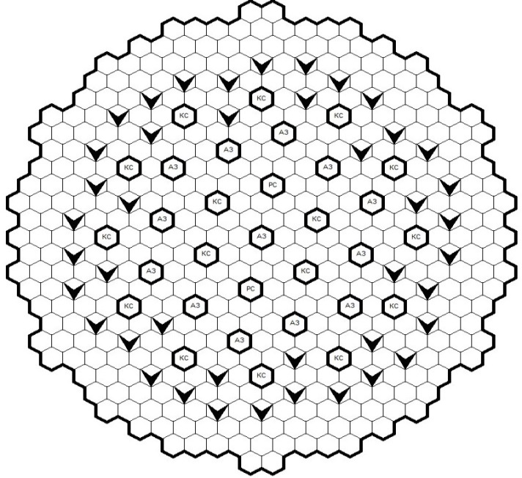
FIG. 1. Location of 42 BAs in the core
The fabrication of fuel elements for BAs using only americium oxide will lead to their overheating, so americium oxide should be diluted with some kind of matrix. The matrix can be made of both inert materials (for example, magnesium and aluminum oxides) and uranium oxide. [12]
Only a third part of americium loaded into the fuel is transmuted. The remaining two thirds must be separated from the spent fuel and transmuted repeatedly. Table 1 provides an illustration of the amounts of loaded and resulting americium (in terms of 1 year of reactor operation) in the process of its heterogeneous burning in a fast reactor [8]. The results are obtained by using TRIGEX and CARE codes.

TABLE 1. COMPARISON OF THE QUANTITIES OF LOADED, TRANSMUTED AND REMAINING AMERICIUM IN FUEL AND BURNER ASSEMBLIES (KG / YEAR)

Am amount in 1 BA, kg | Amount of Am loaded, kg/year |  |  | Amount of Am transmuted, kg/year |  |  | Amount of remaining Am, kg/year
 | Fuel | BAs | Total | Fuel | BAs | Total | Fuel | BAs | Total
0 | 6,6* | - | 6,6 | 29,9 | - | 29,9 | 36,5 | - | 36,5
5,3 | 5,9 | 55,6 | 61,5 | 32,4 | -16,3** | 16,1 | 38,3 | 39,5 | 77,8
9,9 | 5,9 | 104 | 110 | 32,4 | -32,8 | -0,4 | 38,3 | 71,2 | 109
28,0 | 5,9 | 294 | 210 | 32,4 | -90,3 | -57,9 | 38,3 | 204 | 242
*) Americium in the fuel was formed within 1 year of delay since plutonium re-purification to reactor start-up
**) The sign "-" (minus) indicates the decrease of americium because of transmutation

The first line of this Table shows the formation of americium in "clean" fuel. During the time since plutonium re-purification to SNF unloading from the spent fuel pool ~ 36.5 kg of americium is formed in the fuel, of which 6.6 kg - for 1 year delay since plutonium re-purification before reactor start-up, and ~ 29.9 kg – for fuel campaign in the reactor and 3 years of fuel kept in the in-reactor storage and in water pool. The calculation results of the second option (with 5.3 kg of americium loaded in one BA) show that in the BAs during the same time out of 55.6 kg of loaded americium (which is ~ 0.5% of the total load of heavy atoms into the core fuel), only ~ 16 kg are transmuted. However, in the "clean" fuel ~ 38 kg of americium are formed during the same time.
It will be possible to speak about burning one's own americium if the amount of americium in the BAs is increased by more than 2 times. Thus, when ~ 9.9 kg of americium are loaded into one BA the amounts of generated and transmuted americium approach each other (38 and 33 kg / year). To burn external americium its loading into BA must be even greater (more than 12 kg per BA). For example, with a load of ~ 28 kg of americium in one BA about 90 kg of americium per year will be transmuted, and at the same time ~ 38 kg of its own americium are formed, therefore the annual transmutation rate will be ~ 52 kg.
3. FACTORS LIMITING THE BURNING OF AMERICIUM
Both americium itself and the products of its transmutation are distinguished by high heat release from radiation decay. Heat release of ²⁴¹Am is 115 W / kg, ²³⁸Pu - 570 W / kg, ²⁴⁴Cm - 2.8 kW / kg, ²⁴²Cm - 120 kW / kg. The concentration of these materials in a small number of burner assemblies leads to increased heat release in the latter [8, 13].
At the same time, both the loading and unloading paths of the reactor have limitations on the heat release of the fuel assemblies. For example, storage and loading of fuel assemblies with a heat release of more than 500 W without forced cooling seem to be very problematic, and this is not provided for either in operating reactors or in reactors under development. Therefore, heterogeneous burning of even own americium seems impossible due to the unacceptably high heat release of a fresh burner assembly.
Even more serious problems can arise when handling spent BAs in a gaseous environment (i.e., when they are under refueling). With long storage of fuel assemblies in the in-reactor storage (at least 2 years), almost all of ²⁴²Cm decays and turns into ²³⁸Pu, the heat release of which is 450 times lesser [9]. However, if the storage is short, for example, as in BN-800 (155 days) [10, 14], then only half of ²⁴²Cm decays during this time. An illustration of the residual heat release in fresh and spent BAs depending on the amount of americium in them and the duration of storage after irradiation is presented in Table 2.

TABLE 2. RESIDUAL HEAT GENERATION IN FRESH AND SPENT BAs WITH AMERICIUM

Am amount, % in one BA, kg | Heat release, kW
 | Fresh BA | Spent BA storage time
 |  | 0.5 year | 2 years
0 (“clean fuel”)  5.3  9.9  28.0 | 0.24  0.77  1.22  2.95 | 4.9  14.1  21.8  48.6 | 1.7  3.5  5.2  11.0

From Table 2 it can be seen that BA even with a minimum content of americium (~ 5 kg per BA), cannot be loaded or unloaded by standard systems either in the operating or in the projected commercial reactor, since their heat release exceeds the design limits. Therefore, the heterogeneous burning of even own americium (not to say about external one) in the designed and operating reactors is impossible due to the too high heat release of both fresh and spent BAs. Note that in the French ASTRID project there forced cooling of spent assemblies was provided [15-16], where the permissible power of the unloaded fuel assemblies was justified to 5.5 kW, and it was planned to increase it to 7.5 kW, but this project in France was stopped.
4. ALTERNATIVE METHODS OF AMERICIUM BURNING
An alternative heterogeneous method of americium burning in a blanket with using a strong moderator (metal hydride) is known [17]. For this, americium and moderator must be placed in irradiation devices (ID). An illustration of one of the possible options of such devices (in which ⁶⁰Co was produced in the BN-600 reactor) is shown in Figure 2 [18, 19].
Theoretically, this method makes it possible to convert all americium into fission products in one campaign, which eliminates the need for multiple handling of unburnt americium and its transmutation products - plutonium and curium. Here we can no longer talk about transmutation, but about burning of americium, i.e. transformation into fission products. However, such irradiation devices with moderator cannot be installed in the core because they lead to unacceptable local disturbances in the heat generation field. In the BN-600 they were installed in the blanket and separated from the core by steel assemblies (or elements with europium oxide).

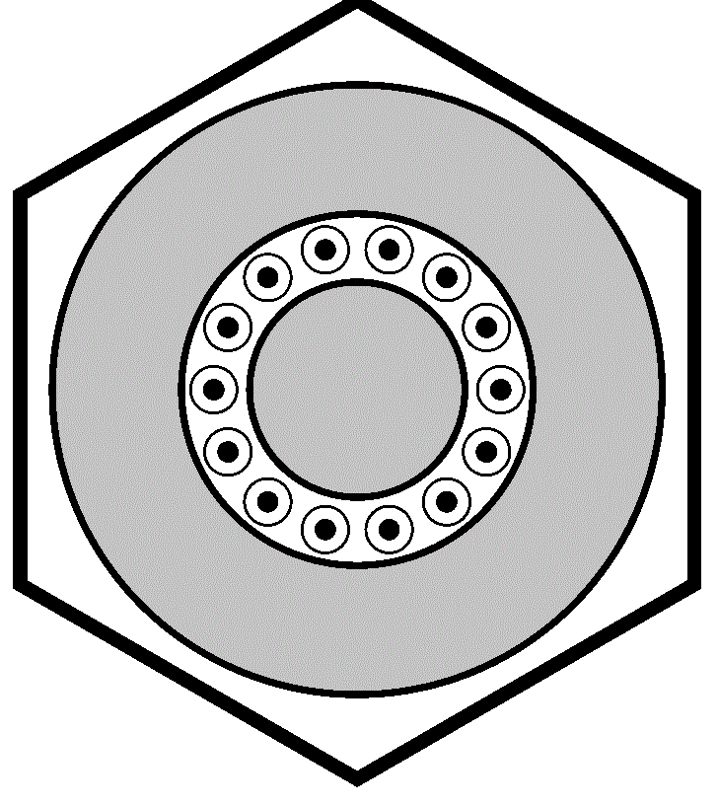
moderator
americium
FIG. 2. Irradiation device with moderator
Due to the deep burning of MA such devices do not have problems with high residual heat release. If americium is placed in an inert (stone-like) matrix [20], then spent irradiation devices with burnt americium will be suitable for direct burial without reprocessing.
The ID design and methods of their use, which are optimal for BN-600 and BN-800, are inapplicable for a commercial reactor with a large fuel assembly and a relatively low neutron flux in the blanket. For such a reactor, another design is optimal, in which the moderator is placed in the center of the assembly, americium (in an inert matrix) in the outer rows. The assemblies themselves should be placed in the first row of the blanket.
The depth of americium transmutation in such devices depends on the amount of americium loaded. If we load 2.7 kg of americium into one ID (or ~ 28 kg per year - see Table 3), the transmutation fraction will be 93% (i.e., only 7% of the initially loaded americium will remain in the irradiated devices), and the “burnup” will be 67% (two-thirds of americium amount will be converted to fission products). The annual volume of americium transmutation will be 26 kg.

TABLE 3. TRANSMUTATION OF AMERICIUM IN ID WITH MODERATOR IN FAST REACTOR BLANKET (PER YEAR)

Am amount in one ID | Loaded, kg/year | Transmuted, kg/year | “Burnt”, kg/year | Left in ID, kg/year
2.7 | 28 (100%) | 26 (93%) | 17 (33 %) | 2 (7%)
5.4 | 55 (100%) | 49 (89%) | 26 (46 %) | 6 (11%)

An increase in americium loading to 5.4 kg in one ID (55 kg per year) will increase the volume of transmutation to ~ 50 kg per year. In this case, 11% of the initially loaded americium will remain in the irradiated devices, and its burnup will decrease to 46%.
But if we take into account that americium was formed in the “clean” fuel (in the amount of 36.5 kg / year), then the resulting transmutation volume will be much less. In the first case, burning of americium in the blanket will not cover its formation in the core; in the second case, the rate of burning of external americium will be only 12.5 kg per year (see table 3).
The transmutation of americium is associated with a large release of helium from α-decay of transmutation products, mainly from the short-lived ²⁴²Cm. The concentration of americium in a small number of assemblies will lead to a proportional increase in the yield of helium in them, which can also limit their working efficiency. For these two reasons, heterogeneous transmutation requires new technical solutions for the handling of discharged assemblies or the development of specialized reactor facilities.
Taking into account all the difficulties noted, it seems most rational to burn in fast reactors not americium, but its predecessor, ²⁴¹Pu, due to the use of plutonium from spent nuclear fuel of thermal reactors with the minimum possible storage time. Let us consider this using the example of plutonium from VVER-TOI (after five-year storage of spent nuclear fuel in the water pool) containing 13.4% ²⁴¹Pu [5]. Compare two methods of handling such plutonium: its long-term storage as part of spent nuclear fuel or a one-cycle burning in a fast reactor.
A fast reactor consumes about 2 tons a year of plutonium from VVER-TOI, incl. ~ 270 kg of ²⁴¹Pu. If this amount of plutonium is simply stored, ~ 270 kg of ²⁴¹Am is formed with time. If this plutonium (in the form of MOX fuel) is used in a fast reactor, ~ 50 kg of ²⁴¹Am will be formed in the reactor itself (taking into account delays in in-vessel storage, etc.), and 130 kg of ²⁴¹Pu will remain, in total - 180 kg. Thus, a one-cycle burning of plutonium from a VVER-TOI in a fast reactor reduces the potential formation of ²⁴¹Am by 90 kg per year. This is by factor 6 greater than the maximum (technically feasible) heterogeneous burning rate in a blanket with moderator, and does not require handling of americium itself.
5. CONCLUSION
Heterogeneous transmutation methods make it possible to use "clean" fuel with traditional manufacturing technologies, and concentrate the handling of minor actinides on specialized industries. The high concentration of americium in the burner assemblies leads to its efficient transmutation. This is an undoubted advantage of heterogeneous transmutation. However, the concentration of transmutation products in a limited number of burner assemblies is also the main disadvantage of this method.
The products of americium transmutation are distinguished by high heat release, and their concentration in a small number of burner assemblies leads to a manifold increase in the residual heat release in them. The forced cooling of the unloaded fuel assemblies in the gaseous environment of the unloading path is not provided for in the operating and projected Russian fast reactors. Therefore, for a commercial reactor (with the duration of spent fuel storing in the in-reactor storage for 2 years), one can speak only about homogeneous burning of americium in fuel, and only for own americium.
An alternative method for the heterogeneous burning of americium is the use of irradiation devices with a strong moderator (zirconium hydride). This makes it possible to remove the problem of high residual heat generation in unloaded assemblies. The depth of americium transmutation in such devices depends on the amount of americium loaded. For example, loading 5.4 kg into one device (55 kg of americium per year) will provide the volume of its transmutation up to ~ 49 kg per year. Considering that 36.5 kg of americium is produced in the "clean" fuel in the core, the annual volume of external americium transmutation in this case will be only 12.5 kg.
Taking into account the above, the most rational way is the burning in fast reactors not of americium itself, but of its predecessor ²⁴¹Pu, due to the use of plutonium from spent nuclear fuel of thermal reactors with the minimum possible storage time. Thus, one fast reactor will reduce the annual formation of americium by 90 kg per year, which is 6 times more than the technically possible burning in a blanket with moderator, and does not require the development of expensive technologies for handling americium.
References
- ADAMOV E.O., GANEV I.KH., LOPATKIN A.V. et al. Transmutation fuel cycle in large-scale nuclear power in Russia. Monograph. M.: GUP NIKIET, 1999.
- LOPATKIN A.V., ORLOV V.V., LUKASEVICH I.B. et al. Possibilities for the development of BREST reactors and the transmutation fuel cycle in the context of the implementation of modern plans for the development of nuclear energy // Atomic Energy. - 2007. - T.103. - Issue 1. - S. 21-28.
- Transmutation in Japanese - a heterogeneous version [Electronic resource AtomInfo. Ru]. - 15.07.2019. - URL: http://atominfo.ru/newsy/z0950.htm
- DEKUSAR V.M., ZRODNIKOV A.V., ELISEEV V.A., MOSEEV A.L. On the issue of accumulation and reactor utilization of americium in nuclear power // VANT. Nuclear reactor constants. Issue No. 1. - 2019.S. 215-223.
- KAGRAMANYAN V.S., KALASHNIKOV A.G., KAPRANOVA E.N., PUZAKOV A.YU. Comparison of characteristics of fuel cycles of stationary nuclear power based on VVER-TOI and BN-1200 reactors // Izvestiya vuzov. Nuclear energy. - 2014. - No. 4 - P. 92-100.
- KOROBEINIKOV V.V., KOLESOV V.V., TEREKHOVA A.M., KARAZHELEVSKAYA YU.E. Investigation of the possibility of burning out minor actinides in a fast reactor with metallic fuel based on only minor actinides. Abstracts of reports. Scientific and technical conference "Neutronika-2019", November 27-29, 2019, Obninsk, 2019. p. 6-7.
- ANDREEVA K. A., ELISEEV V. A., KOROBEINIKOVA L. V. et al. MOX-fueled core with the use of minor actinides for a fast sodium reactor of the BN-1200 type. In collection of abstracts: "Interdepartmental XXIII seminar" Neutron-physical problems of nuclear power with a closed fuel cycle (Neutronika-2012) ", October 30-November 2, Obninsk, p.52-53.
- GULEVICH A.V., ELISEEV V.A., KLINOV D.A. et al. On the possibility of burning americium in fast reactors // Atomic Energy. - 2020. - T. 128. - P. 82-87.
- MATVEEV V.I., KHOMYAKOV YU.S. Technical physics of sodium-cooled fast reactors. / Textbook for universities. Ed. Corresponding Member RAS V.I. Rachkova. MPEI Publishing House, Moscow, 2012.
- Nuclear power plants with sodium-cooled fast reactors. Textbook edited by S.E. Sheklein and O.L. Tashlykov. Part 1. // Yekaterinburg, UrFU, 2012.
- ELISEEV V.A., KOROBEYNIKOVA L.V., LEVANOVA M.V., et al. Possibilities of utilization of minor actinides in a promising sodium fast reactor of high power. In Proc. Of the Int. conf. GLOBAL 2009, Paris, September 6-11, 2009.
- TROYANOV V.M., KISLYI V.A. The use of pyroelectrochemical granulation and vibration compaction technologies for the utilization of americium // Atomic Energy. - 2018.- T. 124. - Issue. 5. - P. 261-265.
- GANEV I.KH., LOPATKIN A.V., ORLOV V.V. Heterogeneous transmutation of Am, Cm, Np in the core of a BREST-type reactor // Atomic Energy. - 2000. - T. 89. - Issue 5. - P.362—365.
- VASILIEV B.A., FARAKSHIN M.R., BELOV S.B., KUZNETSOV A.E. Prospects for the development of the BN-800 reactor core. In collection of the 10th International Scientific and Technical Conference MNTK 2016, Rosenergoatom, Moscow, May 25-27, 2016. - P. 34-36.
- GROUILLER P., COQUELET C., VENARD C. Plutonium recycling capabilities of ASTRID reactor. IAEA-CN-245-348. 2017.
- Homogeneous versus Heterogeneous Recycling of Transuranics in Fast Nuclear Reactors. Nuclear Science, ISBN 978-92-64-99177-4, OECD 2012. NEA No. 7077, p. 52
- POPLAVSKAYA E.V., ELISEEV V.A. Possibilities of deep burning of minor actinides in the core of a fast reactor with incomplete fuel loading without uranium-238 // Atomic Energy. - 2004. - Volume 96. - Issue 3. - P.193-199.
- MALTSEV V.V., KARPENKO A.I., CHERNOV I.A., GOLOVIN V.V. Experience of ⁶⁰Co production in BN-600 // Atomic Energy. - 1999. - T.86. - Issue 3. - p. 216 - 219.
- GOLUBEV V.I. et al. Computational and experimental studies to substantiate irradiation devices for the production of cobalt-60 // VANT, ser. Nuclear constants. - 1991. - Issue 4. - S. 56-70.
- BURYEVSKY I.V., ELISEEV V.A., KRIVITSKY I.YU. et al. Conceptual studies of ROX fuel in fast sodium power reactors. Preprint IPPE 2958, 2002, 34 p.

38 kg / year is generated in 390 “clean” assemblies. Note that the production of own americium depends on the isotopic composition of plutonium in MOX fuel. The more isotopes ²⁴¹Pu and ²⁴²Pu in it, the more americium will be generate

