Root Cause Analysis of FBTR Failed Fuel Pin

D. NAGA SIVAYYA, T. RAJKUMAR, S. RAGHUPATHY
Indira Gandhi Centre for Atomic Research, Kalpakkam, India

Email contact of corresponding author: dnsiva@igcar.gov.in

Abstract

India has been operating Fast Breeder Test Reactor (FBTR) with Mixed Carbide Fuel as the driver fuel since 1985. Mixed Carbide was chosen as the fuel due to its high stability with Pu rich fuel, compatibility with coolant and for its better thermal performance. Being a unique fuel of its kind without any irradiation data, it was decided to use the reactor itself as the test bed for this driver fuel. The fuel has performed extremely well, with the peak burn-up reaching 165 GWd/t. In the year 2011, MK-1 fuel SA that reached 148.3 GWd/t burnup in III ring of FBTR core had a single pin failure which was identified by both cover gas detectors as well as bulk Delayed Neutron Detectors (DND). Subsequently, Post Irradiation Examination (PIE) was carried out on the Failed Fuel Subassembly. A performance analysis of the failed fuel was carried out for the estimation of Fission gas pressure & Fuel Clad Mechanical Interaction induced stress, clad strains, Clad Cumulative Damage Fraction (CDF) etc. at different axial levels as a function of burnup. Studies were also carried out to find out the reasons for the ovality of the pins after irradiation. Above parameters are analyzed for the Failed fuel SA and the results are compared with first ring MK-1 fuel SA so as to assess whether failed fuel SA has experienced any abnormalities. From the results, it is confirmed that the vital parameters to assess the pin life are within the design limits, the CDF estimated was 0.0005 which was considerably less than the limiting value of 1. From the analysis, it is concluded as pin failure in the failed fuel SA could be random in nature than a generic one.

INTRODUCTION
The Fast Breeder Test Reactor (FBTR) at Indira Gandhi Centre for Atomic Research (IGCAR), Kalpakkam, is a loop type, sodium cooled fast reactor. Its main aim is to provide experience in fast reactor operation, large scale sodium handling and to serve as a test bed for irradiation of fast reactor fuels & materials. India has been operating FBTR with Mixed Carbide Fuel as the driver fuel since 1985. Mixed Carbide was chosen as the fuel due to its high stability with Pu rich fuel, compatibility with coolant and for its better thermal performance [1]. Being a unique fuel of its kind without any irradiation data, it was decided to use the reactor itself as the test bed for this driver fuel. The fuel has performed extremely well, with the peak burn-up reaching 165 GWd/t. In the year 2011, MK-1 fuel SA that reached 148.3 GWd/t burnup in III ring of FBTR core had a single pin failure which was identified by both cover gas detectors as well as bulk DND detectors. Subsequently the SA was discharged and Post Irradiation Examination (PIE) was carried out on the Failed Fuel Subassembly (Hence forth referred as FFSA) [2].
In the present work, the performance analysis of fuel pin is carried out as a function of burnup along with corresponding dose levels on the fuel pin at different axial elevations of active core region. The major parameters of the performance which assess the life of the fuel pin are :
• Fission gas pressure & Fuel Clad Mechanical Interaction (FCMI) induced stress on pin
• Clad strains
• Clad residual ductility
• Clad Cumulative Damage Fraction (CDF)
• Subassembly flow reduction
Above parameters are analyzed for the FFSA and the results are compared with first ring (01, 01) MK-1 fuel SA (henceforth referred as FRSA) which reached 154 GWd/t [3,4] burnup so as to assess whether FFSA has experienced any abnormalities w.r.t. FRSA. Also, an attempt has been made to bridge gap areas between the PIE observations and the analysis results of the FFSA to ascertain the reasons for the failure.

FFSA POSITION AND IRRADIATION CONDITIONS
The MK-1 SA consists of 61 fuel pins made up of SS 316 M clad tube with 5.1 mm OD and 4.36 mm ID. Solid fuel pellet of 4.18 mm diameter is housed inside a clad tube to a length of 320 mm. The spacer wire diameter is 0.76 mm. The FFSA was irradiated in (03, 07) position in FBTR core up to a burn-up of 116.2 GWd/t and then shifted to (03, 06) core position and was operating till failure happened at 148.3 GWd/t burnup. The FBTR fuel pin schematic and failed fuel SA position in the FBTR core is shown in Fig. 1 and 2 respectively and the fuel pin numbering scheme is given in Fig. 3. The pin no. 39 is the failed fuel pin in FFSA.
The FFSA remained in the core right from FBTR criticality and the maximum Linear Heat Rating (LHR) it operated was 306.2 W/cm. The maximum and average inlet temperatures experienced by FFSA were 381 ⁰C and 331 ⁰C respectively. Similarly, the maximum and the average coolant flow rate through FFSA were 2.6 and 2.37 kg/s respectively.
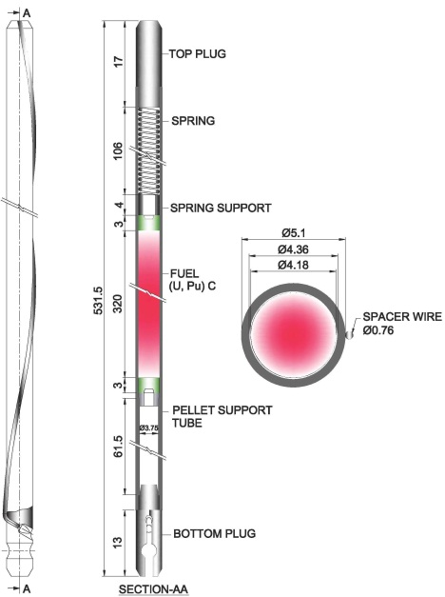
Fig. 1. FBTR fuel pin

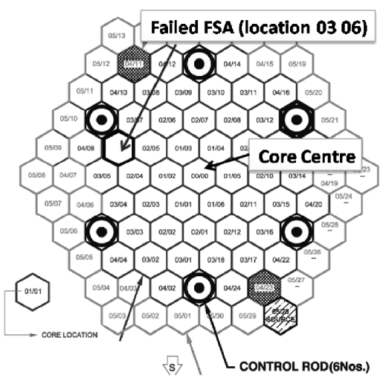

Fig. 2. FBTR Core configuration

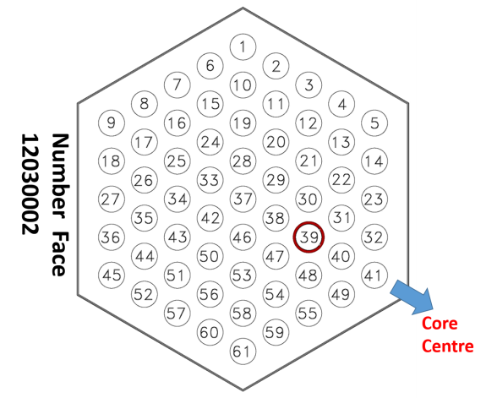
Fig. 3. Pin position in FBTR core

PERFORMANCE ANALYSIS OF FAILED FUEL PIN
The analysis of the failed fuel pin was carried out to assess the major parameters listed in Section 1 on the irradiation performance of FFSA w.r.t. FRSA. Current analysis was carried out with the in-house developed code CAMCODE (CArbide fuel Modeling CODE) is an indigenously developed 1.5D fuel modelling code which is used to assess the performance of FBTR Mixed Carbide fuel pins. The code calculates the fission gas pressure, fission gas release, radial temperature distribution, clad swelling, clad strains, Fuel clad mechanical interaction etc. It is also capable of predicting the life of the fuel pin based on the operating conditions. The code was validated with FBTR pin irradiation data and with a benchmark exercise jointly carried out with CEA, France and safety criteria was established for Carbide fuels [5]. The results of FFSA carried out with CAMCODE are discussed below:

Fission Gas Release
The average fission gas (FG) release in the failed fuel pin as a function of burnup is shown in Fig. 4. The percentage of gas release is estimated as 13% and the maximum pin pressure during operation is 3.44 MPa. The pin pressure estimated at the PIE conditions is 1.44 MPa (vertical line in Fig. 4). The pin pressure estimated for the MK-1 fuel pin in FRSA is 1.5 MPa at the end of the life at cold condition. The lower fission gas estimation in the FFSA is attributed to the lower operating LHR compared to first ring (400 W/cm). A comparison of the operating LHR with burnup for FRSA and FFSA is shown in Fig. 5.

Temperature Distribution
The temperature distribution in the fuel pin at different elevations as a function of burnup is shown in Fig. 6. The maximum centerline temperature is 1281 ⁰C which occurs at 240 mm from Bottom of Fuel Column, BFC. The maximum centerline temperature is at the same burnup where the LHR is maximum. The maximum centreline temperature for FRSA is 1252 °C at 6.6 at % burnup at 160 mm from core bottom. The pellet drop increases from BOL to EOL due to reduction in the pellet thermal conductivity.

Gap and Gap Conductance
The pellet-clad gap and gap conductance variation as a function of burnup is shown in Fig. 7 for 160 mm from BFC. The gap conductance decreases due to dilution of the fission gas and increases due to decrease in the pellet clad gap. At 80 and at 160 mm from BFC, gap closure is noticed due to low swelling of the clad (discussed in section 3.5). At top of the fissile column, there is no gap closure observed and hence low gap conductance.
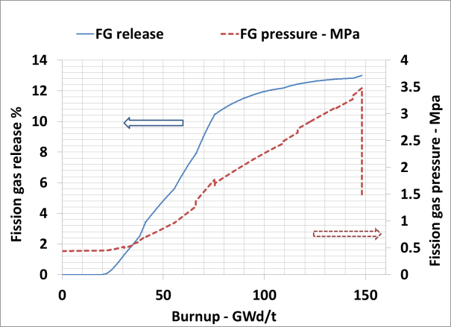
Fig. 4. Average fission gas release and pin pressure in the fuel pin in FFSA
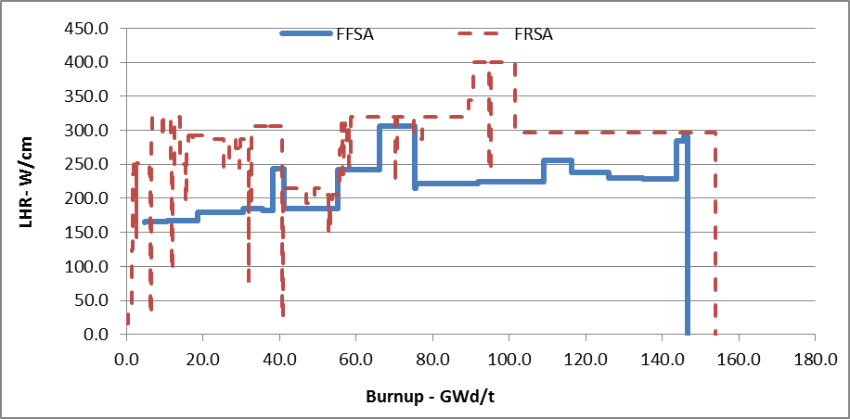
FIG.. 5. Operating LHR as a function of Burnup for FRSA and FFSA
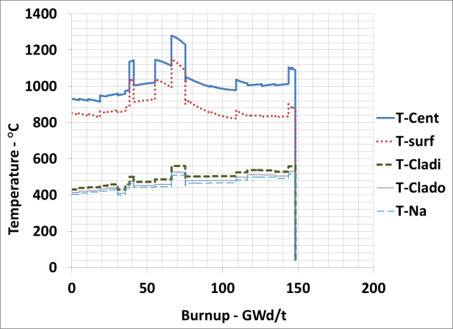
Fig. 6. Temperature distribution in FFSA fuel pin at 240 mm from BFC

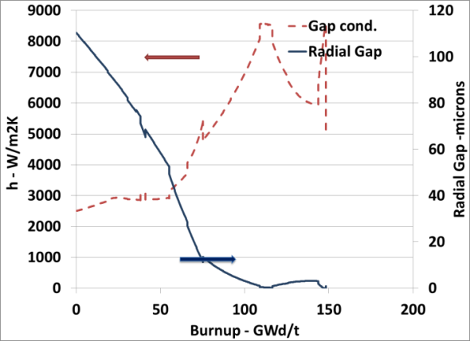
Fig. 7. Gap and Gap conductance variation as a function of burnup at 160 mm from BFC

Fuel Clad Mechanical Interaction
Carbide fuels show higher swelling rates due to their lower fission gas release. The swelling rate is also a strong function of the fuel temperature [6]. Swelling of the fuel leads to interaction with clad which results in fuel Clad mechanical interaction stress. FCMI pressure (in MPa) at 80 mm from BFC where it is observed to be maximum is shown in Fig. 8. It is to be noted that the average fuel centreline temperature in the FFSA is lower than the FRSA due to its lower LHR and hence the swelling of the pellet is also correspondingly less. There is no FCMI observed at BFC, 160 mm, 240 mm & 320 mm from BFC. At 80 mm, FCMI is observed due to swelling of the fuel higher than that of clad swelling (refer Section 3.5). At 160 mm, there is no FCMI during operation and interaction pressure developed only due to shutdown. At top axial levels, due to clad swelling, FCMI is absent. For FRSA, the FCMI stresses are present at 160 mm to 240 mm from BFC with a peak value of 7 MPa. The axially varying hoop stress of the clad is shown in Fig. 9. It is observed that the only at 80 mm location, the FCMI induced pressure is observed and other locations, the hoop stress is mainly due to fission gas induced pressure.
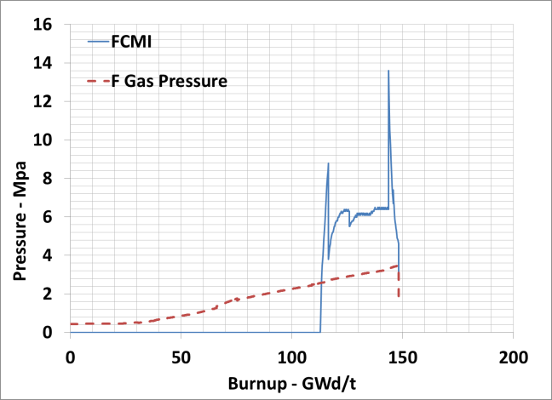
Fig. 8. FCMI pressure on clad at 80 mm from BFC as a function of burnup

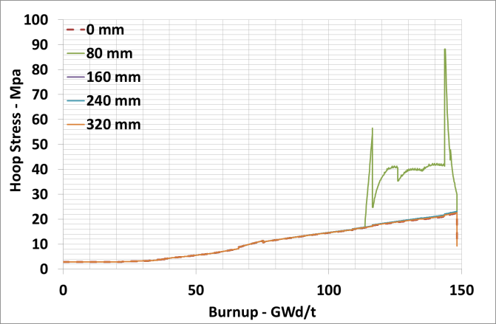
Fig. 9. Hoop stress on clad at different axial locations from BFC as a function of burnup

Void Swelling

The permanent increase in the volume of the material due to irradiation induced voids (n,α reaction with Nickel gives rise to He bubbles which settles in the vacancy clusters) in Austenitic stainless steel is called void swelling. Void swelling is a function of temperature and dose of the material. At temperatures (< 430 ⁰C & > 680 ⁰C), the swelling of the SS 316 is insignificant. Hence, the clad swelling is very less at BFC, 80 mm & 320 mm from BFC. The maximum clad swelling computed is 6.8 % at 240 mm from BFC.

Clad Strains
Clad strain is due to void swelling and irradiation creep. One third of the void swelling contributes to the increase in diametrical clad strain. Irradiation creep strain is computed from fission gas induced stress and FCMI stress (if present). For the operating temperature range of clad, thermal creep is insignificant in the fuel clad when compared to the irradiation creep and hence ignored. The total permanent strain is the summation of swelling strain and creep strain. The peak clad strain computed is 2.83 % (swelling strain= 2.1 %; creep strain=0.73%) at 240 mm from BFC. The lower creep strain is due to lower FG pressure and lack of FCMI stress at 240 mm location. At 80 mm from BFC, due to FCMI stress, the creep strain comparable to the swelling strain. At BFC, swelling strain is negligible due to very low void swelling of the clad. For FRSA, the peak clad strain computed was 3.2 %. The permanent clad strain as a function of burnup is shown in Fig. 10.

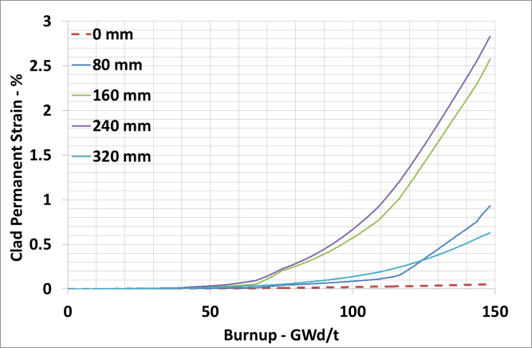
Fig. 10. Clad permanent strain at different axial locations from BFC as a function of burnup

Cumulative Damage Fraction
Cumulative Damage Fraction (CDF) is life fraction rule employed to compute the damage of clad as a function of stress and temperature. CDF is a strong function of temperature and varies significantly for nominal and hotspot conditions. The peak CDF computed at the top of the pin is only 0.0005 in hotspot conditions. For FRSA, the peak CDF computed was 0.035.

In summary, based on the overall performance analysis of the pin, the FRSA experienced less damage compared to FFSA.

Comparison with PIE results

Fission Gas Release
The fission gas release measurement of FFSA by PIE ranges from 8.4 % to 19.2 % for different pins. The highest release is found in pin No. 48 which is next to failed fuel pin. For the Pin No. 60, which is at mid of the SA from core centre and peripheral row within the SA, the release is minimum. The gas release estimated in this work for the pin No. 39 is 13 %. The observed gas release for the pins near failed fuel pin are quite greater than the estimation and even it is higher than the FRSA (PIE measurement is 16 % at 155 GWd/t) which operated at much higher power rating than the FFSA (Fig. 5). For the given burnup, the FFSA residence time is higher than the FRSA and this could be one of the reasons for such behaviour.

Volumetric Swelling
The volumetric swelling of the clad at different axial locations of the pin is measured by PIE. At 240 mm from BFC location, the estimated volumetric swelling is 6.8 % (72 DPA, and clad midwall temperature of 547 ⁰C in the last campaign). For a similar DPA location (74 DPA), volumetric swelling of clad in the PIE estimation is 7.4 % (at 544 ⁰C). At 160 mm from BFC, the estimated clad swelling is 6.2 % whereas, the PIE measured around is 7.2 %. It is observed that there is a reasonable agreement between the estimated swelling values and the observed PIE values.

Clad Strains
The measured peak clad strains for the FFSA ranges from 3.6 % to 6.2 %. The computed clad strains are lower than the PIE observed clad strains. The peak estimated clad strain is only 2.8 % for the failed fuel pin. There is a good match between the theoretical and PIE values w.r.t volumetric swelling of the clad. Hence, the difference could be attributed to irradiation creep strain of the pin. In Fig. 11, the measured clad strain along the length of the pin No. 47 (adjacent to pin No. 39) is shown along with the measured swelling component. The difference between the strains is attributed to irradiated creep strain because of FG induced pressure and FCMI.
To analyse the individual contribution of the FG and FCMI components in the irradiation creep, creep strain computed with actual FG pressure (2.5 MPa) reported by PIE which is shown in Fig. 11. The triangular points show combined swelling and irradiation strain with FG pressure (PIE). The difference in the measured clad strain and the triangular points is un-accounted creep strain which can be attributed to FCMI induced creep.
For the FRSA it was reported that up to 50 GWd/t burnup, there is no gap closure observed. At 100 GWd/t, radial gap just closed and at 155 GWd/t, severe FCMI was observed which was revealed by complete closure of the pores [3]. On comparing FRSA and FFSA micrographs [7], it is observed that the FCMI is not much severe in FFSA compared to FRSA.
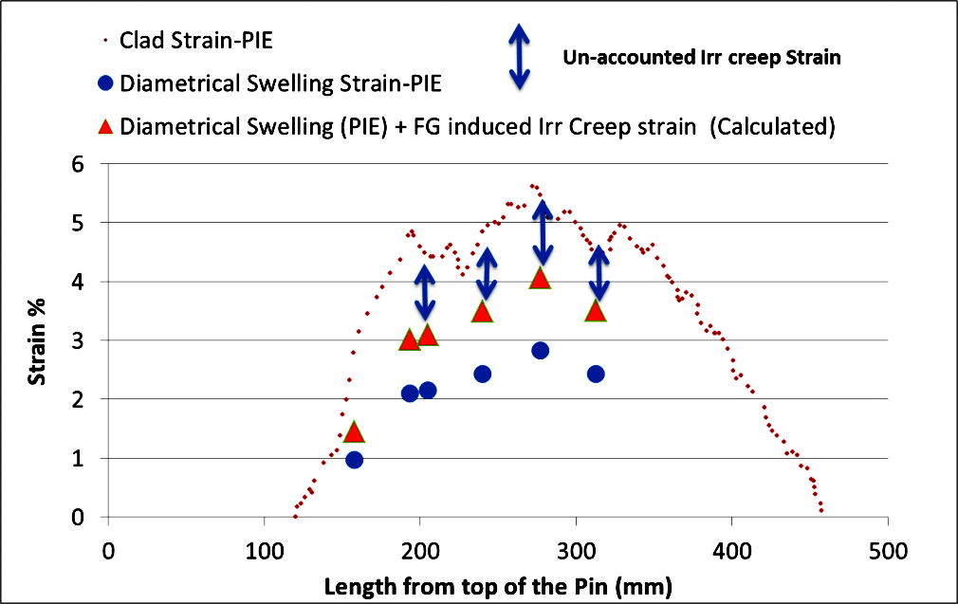
Fig. 11. Computed irradiation strain with FG pressure and the un-accounted irradiation creep strain for Pin No. 47

Ovality in the Fuel Pin
Pin ovality and bending was observed in PIE. Ovality can be caused due to differential swelling of the clad due to asymmetric temperature distribution in the pin. Asymmetric temperature distribution can be due to flow variations in channels surrounding the pin.
Due to the location of the FFSA in third (also last) ring, the variation in the flux along the width across flat of hexcan is high. Also the linear power varies from inner end to outer end. Due to variation of flux and temperature, the swelling along the circumference of the pin is not uniform. The peak LHR in the FFSA is 310 W/cm towards centre and the minimum LHR is 250 W/cm at periphery of the core. The variation in dose across the walls of the SA is 22 DPA. Due to such large variation in the dose within the SA, the pin ovality is possible.
The maximum dose variation estimated in the failed fuel pin along the circumference is 2.8 DPA. Due to different flow channels in the fuel pin bundle and variation in the power generation, the temperature variation along the circumference of the pin is 2 ⁰C, 3 ⁰C and 7 ⁰C at 160 mm, 240 mm and 320 mm from BFC respectively. With the varied dpa and temperature across the fuel pin, the swelling of the pin is calculated at different axial locations of the pin. The variation in the clad permanent expansion along the circumference at 160 mm from BFC is 7 %. At the 320 mm location, the variation is ~16% which is the cause for the pin ovalization. Since FBTR core is small and flux gradient across the SA and pin is very high compared to the power reactor. Also for the third row fuel SAs, absorber rod is present in the fourth row and hence, more flux gradient is expected for the failed fuel SA.

Residual Ductility of Pin and Clad Corrosion
The minimum total strain reported is 5.7 % corresponding to a void swelling of 7.3 % which shows considerable ductility remains in the fuel pin [2]. There is about 50 % reduction with respect to the un-irradiated conditions at operating conditions. Hence, the failure is not due to loss of ductility.
From PIE of failed fuel pin, clad microstructure did not indicate any carburization. Micro hardness measurements also confirms the same. Severe Fuel Clad Chemical Interaction was also not observed.

FLOW REDUCTION
Due to gross deformations in the fuel pin bundle, the coolant flow in the SA reduces which increases the clad temperature by 10° C. The increase in temperature due to flow reduction with burnup is within the design limits and may not cause any clad failure due to available margins on the CDF. Due to bend in the fuel pins, there may be local flow stagnation which may result in the increase in the clad temperature. To ascertain this, thermal analysis of fuel pin with different degree of non-cooling on the clad circumference is carried out. It is found that for 30° non-cooling surface case, the increase in clad temperature was around 85 °C. The typical temperature distribution with non-cooling of 30 ° clad surface is shown in Fig. 12. Hence, with even local non cooling of the pins due to bending will not exceed the DSL of the clad. The above analysis assume complete loss of cooling for 30 ° clad surface area in actual it is very unlikely due to the presence of spacer wire. Also in the PIE there are no observations of blockage in the pins. Hence, local flow reduction is not attributed to the cause of the failure.
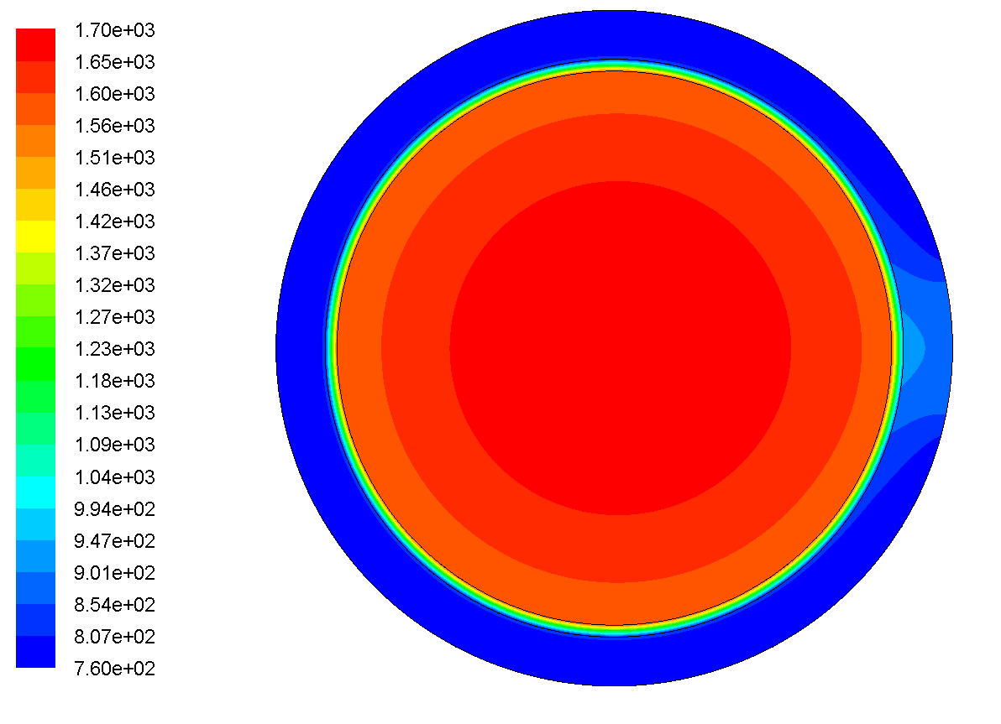
Fig. 12. Temperature (K) variation in the pin 30° non cooling surface on clad

SUMMARY and CONCLUSION
Mixed Carbide, MK-1 fuel SA that reached 148.3 GWd/t burnup in the third ring of FBTR core had a single pin failure. Subsequently, PIE was carried out on the FFSA which showed ovality and bending on the failed pin. It was initially postulated that either flow reduction locally or severe FCMI could have led to the failure of the pin. A preliminary analysis on the effect of distortion of fuel pins and hexcan on the coolant flow reduction showed that even if 30⁰ surface area of the pin remains devoid of coolant (un-cooled), it does not result in any pin failure. Hence, a detailed analysis of the pin was carried out to understand performance of fuel pin with irradiation and to identify possible causes for its failure. The performance analysis was carried out as a function of burnup and dose levels on the fuel pin at different axial levels of active core region. The life of the pin is dictated by: Fission Gas (FG) pressure & Fuel Clad Mechanical Interaction (FCMI) induced stress on pin; Clad strains; Clad residual ductility; Clad Cumulative Damage Fraction (CDF). The above parameters were derived for the FFSA and the results were compared with a MK-1 FRSA, which had attained 154 GWd/t burnup without any failure. This was done to have a comparative assessment of FFSA vis a vis FRSA.
The percentage of fission gas release is estimated as 13% and the maximum pin pressure during operation is 3.44 MPa (1.44 MPa in cold conditions). However, PIE observation showed that FG release was 19% / 9% for pins located near / far away from the failed fuel pin. The analysis indicated absence of any FCMI in the top region of the pin. However moderate FCMI (13.6 MPa) was observed at 80 mm from bottom of the fissile column. The ovaility observed in the pin was due to differential swelling of the clad across section due to variation in the dose and surrounding channel temperatures. The maximum variation in the clad permanent expansion at mid and top axial levels is 7 % and 16 % respectively along the circumference which could lead to ovality of the pin. This behaviour is typical for the third ring SAs due to variation in the flux across opposite faces of the hexcan.
It is observed from PIE reports that there is adequate residual ductility (min 5 % at operating temperature) and clad strains that could lead to pin failure are well within the limits and also no FCCI reported. The CDF estimated is also well within the limits. Hence, it is concluded form the analysis that there is no specific reason that can be attributed to the pin failure in FFSA. Thus, as major aspects related to pin failures including differential swelling have been verified, it is concluded that the failure of the fuel pin in the FFSA could be random in nature than a generic one.

ACKNOWLEDGEMENTS
The Authors are very thankful for the Reactor Facilities Group for providing the input data required for carrying out the analysis and Metallurgy and Materials Group for the PIE results which showed very deep insights on the behaviour of the fuel pin.
References
- S. GOVINDARAJAN, et. al, “Performance of FBTR mixed carbide fuel”, IAEA proceedings IAEA-TECDOC-1039 on “Influence of high dose irradiation on core structural and fuel materials in advanced reactor”, 47, 1998.
- C.N. VENKITESWARAN, et.al., “Report on analysis of failure of FBTR fuel SA (FSA No. 12030002) after burn-up of 148.3 GWd/t”, IGC/MMG/PIED/FFSA/12030002/R-0, Internal Report, Indira Gandhi Centre for Atomic Research, Kalpakkam, 2014.
- C.N. VENKITESWARAN, et. al., “Irradiation Behavior of FBTR Mixed Carbide Fuel at Various Burn-ups, Energy Procedia, Volume 7, 2011, Pages 227-233.
- K.V.KASIVISWANATHAN, et. al., “Performance Assessment of Fuel and Core Structural Materials Irradiated in FBTR”, Energy Procedia, Volume 7, 2011, Pages 129-139.
- P. PUTHIYAVINAYAGAM et. al., “Implementing Agreement on the Fuel Safety Criteria”, CEA/DEN/CAD/DEC/SESC/DIR NT 17-003 – Indice0, 2017.
- Mikailoff, H. (1974). L’element Combustible Carbure a Joint Helium Pour la Fillerea Neutrons Rapides: Problems Poses par le gonflement du combustible. BIST 196.
- V. KARTHIK, et. al., “Investigation of failure of high burn up carbide fuel pin of fbtr through post-irradiation examination”, HOTLAB-2015, Leuven, Belgium.

