# Towards design guidelines for fast reactor oxide fuel pins with high Pu content: driving post irradiation examination by benchmarking European fuel performance codes

V. BLANC1, S. VAN TIL2, E. DE VISSER-TÝNOVÁ2, F. CHARPIN-JACOBS2, C. VENARD1, P. GUBERNATIS1, E. DEVEAUX1, M. LAINET1, B. PERRIN3, S. GICQUEL-PETIT4, A. DEL NEVO5, C. FIORINA6, S. GIANFELICI7, J. GADO8, L. LUZZI9, K.MIKITYUK10, S. LEMEHOV11, J. KLOUZAL12, J. PELTONEN13, S. BEBJAK14, J. LAVARENNE15, L. FAYETTE1, F. MARTIN1, D. STAICU16, F. ALVAREZ-VELARDE17, B. FONTAINE1, J. LAMONTAGNE1, N. CHAUVIN1

1 CEA/DES/IRESNE/, Cadarache, France

2 NRG, Petten, Netherland

3 FRAMATOME, Lyon, France

4 EDF, Les Renardières, France

5 ENEA FSN-ING-SIS, Brasimone, Italy

6 EPFL, Lausanne, Switzerland

7 KIT, Karlsruhe, Germany

8 MTA-EK, Budapest, Hungary

9 POLIMI, Milano, Italy

10 PSI, Villingen, Switzerland

11 SCK-CEN, Boeretang, Belgium

12 UJV, Husinec, Czech Republic

13 VTT, Espoo, Finland

14 VUJE, Trnava, Slovakia

15 JACOBS, Dorchester, United Kingdom

16 JRC, Brussels, Belgium

17 CIEMAT, Madrid, Spain

Corresponding author: victor.blanc@cea.fr

**Abstract**

In the framework of the European Commission call for proposal “Horizon 2020”, the project Plutonium Management for More Agility, called PuMMA, is granted. This project started in October 2020 and will last four years. A work package is dedicated to the behaviour and safety of mixed oxide fuels with high plutonium content, which is essential for plutonium multi-recycling or plutonium burning in fast reactors. This paper describes main goals, planning and status of this work package. Major task is the comparison of a large set of European fuel performance codes (FPC) on the basis of three passed experimental irradiations of oxide fuel pins containing around 45% of plutonium: CAPRIX, irradiated in Phénix French Reactor, TRABANT1 and TRABANT2, irradiated in High Flux Reactor, HFR, in the Netherlands.

The first phase of the work consists in the definition of irradiation conditions for fuel pins simulation, involving CEA and NRG. In a second phase, 9 various FPCs will be used by 13 European nuclear research organizations in order to simulate these three irradiations: GERMINALPLEIADES, SIMMER-V, TRANSURANUS, 3D-OFFBEAT, FEMAXI, FUROM, FRED, MACROS and TRAFIC. Results will be compared in terms of global and local quantities: fission gas release, fuel pin elongation, profilometry, central hole radius, Pu redistribution, internal corrosion, etc. Moreover, this first set of simulations will be used to define the post-irradiation examinations programme, which will be carried out in the framework of the PuMMA project in JRC-ITU and CEA facilities. In a third phase, simulation tools will integrate new thermal properties measurements to be realized in PuMMA (other workpackage), the back-up of first comparisons, and these irradiations simulations will be re-launched and compared to experimental measurements. This mixed approach simulation/examination will allow improving FPC reliability and to reduce uncertainties in the design process of this kind of fuel, which is outside of the validation area of all the existing codes. The experimental programme will be devoted to FPC validation as well as knowledge improvement. Last part of the work package will also tend to propose specific safety recommendations for the design of this kind of fuel.

## INTRODUCTION

Plutonium management is a major issue for the nuclear industry. During the 1990’s years, a European coordinated programme targeting to use SFRs to burn the existing stock, named the CAPRA project began [1]. In this framework, experimental irradiations of nuclear fuels containing high percentage of Pu were launched, in the French SFR Phénix and in the High Flux testing Reactor in Petten (HFR). First results have been obtained in the 90’s [2], but the CAPRA project ended early with to the end of the Superphénix project in 1998.

In 2020, a new European project called PuMMA for “Plutonium Management for More Agility” was launched [3] in order to re-explore the topic of the Pu management with a SFR fleet, particularly on the basis of old irradiations performed in the CAPRA project. Three experimental fuel pins based on uranium-plutonium mixed oxide are considered in PuMMA: CAPRIX (45% Pu), TRABANT1 (45% Pu) and TRABANT2 (40% Pu). After a simulation of irradiation conditions, post-irradiation examinations (PIE) of these pins will be carried out in the PuMMA project by three European institutions, NRG (Netherlands), JRC-Karlsruhe (Germany), CEA-Cadarache (France). These PIE will be performed in a benchmark with the objective to extend the validation database of various fuel performance codes. In the last phase of this work, an analysis of the design criteria of fuel pins regarding this high Pu content will be proposed.

## Description of the irradiations studied

### TRABANT1 and TRABANT2

Since the 1970s the High Flux Reactor in Petten, the Netherlands contributes to fast reactor fuel research by means of irradiation tests. As part of this research programme, two series of three fast reactor fuel pins were irradiated in the TRABANT-series, which has the focus on the irradiation behaviour of MOX with high content of Pu in the oxide to medium burn-up. Each fuel pin is placed in its own closed sample holder, where it is submerged in a column of stagnant sodium to obtain a proper heat dissipation from the clad into the sodium (FIG. 1). The sample holder is instrumented with flux monitors and thermocouples to monitor the experimental response during irradiation. The sample holder is placed in an irradiation rig which occupies an in-core position in the HFR. The HFR is a (thermal) MTR and is primarily cooled by water, which also flows along the outside of the sample holder in the irradiation rig and dissipates the sample holder heat.

As the HFR is a thermal MTR, the irradiation rig is lined with a cadmium wire to reduce the thermal neutron density at the location of the fuel pin to suppress (thermal) fission power and shape the radial power profile more towards fast reactor conditions. Moreover, instrumentation in the rig allows deriving the deposited heat from the fuel pin to estimate an average power density of the fuel stack.

TRABANT is a series of experiments which focuses on the behaviour of mixed oxide fuel with Pu-contents of up to 45% in the oxide. Within PUMMA, post irradiation examinations are carried out on two pins from these series:

* Pin 1/1 had a Pu content of 45% and a projected maximum linear heat rate (LHR) of 507 W·cm-1 ;
* Pin 2/2 had a Pu-content of 40% and a maximum projected LHR of 450 W·cm-1.

Pin 1/1 was found to have failed during irradiation and parts of the fuel had melted, cf. section 3.1.2, while pin 2/2 showed a dislocation of the central hole (i.e. fuel movement), but the pin was intact. First phase of this project will reconstruct the irradiation histories of both pins in detail thanks to MCNP-4C3 calculations and continues with detailed post irradiation investigations to explain these earlier observations.

TABLE 1 summarizes TRABANT 1/1, TRABANT 2/2, and CAPRIX fuel pins specifications.

TABLE 1. SPECIFICATIONS OF THE FUEL PINS STUDIED IN PUMMA WP2

|  |  |  |  |
| --- | --- | --- | --- |
| Name of Irradiation | TRABANT1/1 | TRABANT2/2 | CAPRIX1 |
| Fuel pin number | 1/1 | 2/2 | CAP01 |
| Manufacturer | CEA | JRC | CEA |
| Type | (U,Pu)O2 | (U,Pu)O2 | (U,Pu)O2 |
| Pu/metal (%)* | 45 | 40 | 45 |
| U/metal (%) | 55 | 60 | 55 |
| 238Pu (%) | 0.872 | 0.146 | 0.872 |
| 239Pu (%) | 65.000 | 75.436 | 65.000 |
| 240Pu (%) | 23.512 | 22.085 | 23.512 |
| 241Pu (%) | 7.140 | 1.615 | 7.140 |
| 242Pu (%) | 3.476 | 0.719 | 3.476 |
| Am (% tot. Pu mass) | 0.220 | 1.46 | 0.220 |
| 235U (%235U /U) | 0.248 | 0.3359 | 0.248 |
| Pellet density (g/cc) | 10.45 | 10.42 | 10.41 |
| Percentage T.D. (%) | 95.5 | 93.5 | 94.53 |
| Pellet O.D. (mm) | 5.42 | 5.43 | 5.42 |
| Pellet I.D. (mm) | 2.5 | 2.4 | 2.0 |
| Fuel weight (g) | 64.530 | 65.870 | 176.29 |
| Pu-weight (g) | 26.010 | 22.890 | 68.89 |
| U-weight (g) | 31.230 | 34.746 | 84.27 |
| Fuel column length (mm) | 340 | 340 | 850 |
| Fuel cladding | 15/15 Ti | | AIM1 |
| Cladding O.D. (mm) | 6.55 | | 6.55 |
| Cladding I.D. (mm) | 5.65 | | 5.65 |
| *(%) = weight-percentage (w/o) | | |  |

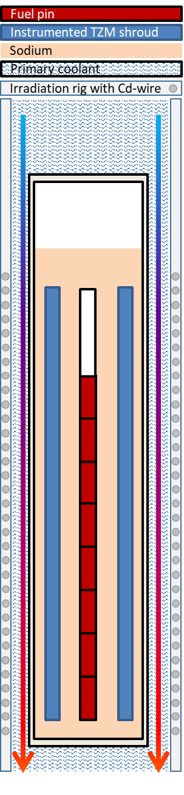

Fig. 1. A schematic axial section of the irradiation rig, carrying the sodium-filled sample holder, which holds the fuel pin

### CAPRIX

The CAPRIX experiment was carried out within the framework of the CEA’s "CAPRA" project [1] as well. The purpose of this irradiation was the experimental validation of an oxide fuel with a high plutonium content (45%) in a sodium fast reactor, PHENIX. Two CAPRIX pins (CAP01 and CAP02) were placed in a 19 standard fuel pins capsule contained in a DCC2 carrier fuel sub-assembly (see FIG. 2). The irradiation was performed in the PHENIX reactor during about 360 efpd up to a burnup of 12% FIMA. The maximal linear heat rate of CAPRIX pins were about 380 W/cm. The CAPRIX capsule was irradiated from January 1995 to January 2006. It was discharged out of the reactor in March 2006. In the framework of the PuMMA Project [3], transportation of CAP01 and CAP02 from PHENIX reactor (CEA Marcoule) to the LECA facility (CEA Cadarache) was carried out in 2020, with the objective to perform requested examinations for fuel performance code validation.

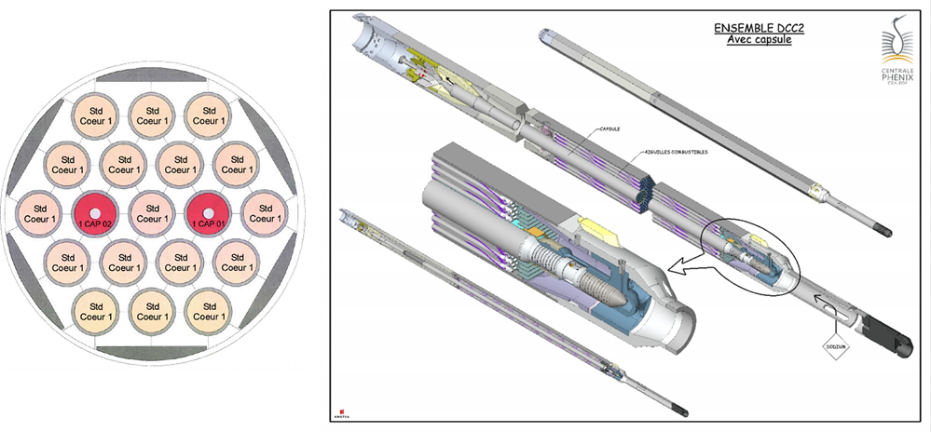

*Fig. 2.* CAPRIX experimental capsule description

## Coupling Simulation and examination

### Benchmark of fuel performance codes

The key aim of the benchmark exercise is to extend the domain of validity of fuel performance codes to fuels with higher plutonium content using the results of the examination programme and the analysis of thermal properties of the three fuel pins. This benchmark is in the task 2.2 of the work package 2. Fourteen organizations are involved in the benchmark exercise from various countries. These are Jacobs from the United Kingdom (task leader), CEA, Framatome and EDF from France, ENEA and POLIMI from Italy, EPFL and PSI from Switzerland, KIT from Germany, MTA-EK from Hungary, SCK from Belgium, UJV from the Czech Republic, VTT from Finland and VUJE from Slovakia. They will be using the following 9 fuel performance codes:

* FUROM (MTA-EK);
* GERMINALPLEIADES (CEA, Framatome and EDF);
* GERMINALPLEIADES-SIMMER V (CEA);
* MACROS (SCK);
* FRED (PSI);
* 3D-OFFBEAT(EPFL)
* TRANSURANUS (POLIMI, ENEA, UJV and VUJE);
* FEMAXI SIMMER (KIT);
* TRAFIC (VTT).

Prior to calculation, all the participants of the benchmark have filled a first common expression of needs, which was sent to teams which have to compute and to define the irradiation conditions (NRG and CEA), in order to have all the requested data for the benchmark. A second expression of needs was also sent to the experimenters (NRG, CEA and JRC) in order to have adequate experimental data for code comparison.

The benchmark exercise is then divided into two phases:

* The first phase will take place between September 2021 and September 2022. The aims of this phase are to build models of all three pins using the 9 fuel performance codes and perform a code-to-code comparison to ensure the results are sensible and the models accurate. In addition, sensitivity analysis will be performed to investigate the impact of various uncertainties on measurement parameters, irradiation and input parameters. During this phase a first feedback towards experimenters will also be very useful in order to precise axial and radial position for destructive examination.
* The second phase will start after the examination of the three pins have been completed and the results shared, in July 2023. This phase will also take benefits of new experimental measurement of thermal properties on CAPRIX irradiated cuts planned at JRC, and of new recommendations for mechanical properties for High Pu content oxide fuel. All these data will be carried out in the work package 3 of PuMMA. The aims of this phase are to compare the code results to the experimental results and make improvements to the codes if required to extend their validation domain. It will be done by analysing the differences between code results and experimental data. The potential causes of the discrepancies will be investigated which will lead to a list of code improvements to be made in order to improve the code predictions.

### Examination programme and first results

#### Examination programme on TRABANT 1/1, TRABANT2/2 and CAPRIX

Post-irradiation examination (PIE) will be performed in the framework of the WP2 task 2.3 of PuMMA project. Non-destructive and destructive examinations will be done on the three pins:

* in JRC-Karlruhe for TRABANT1 Pin 1;
* in NRG’s Hot Cell Laboratory for TRABANT2 Pin 2;
* in the CEA-LECA hot cell facility for CAPRIX Pin CAP01 (CAP02 pin will be used for dissolution tests in CEA-ATALANTE facility in the work package 5 of the PuMMA project).

The examination programme is planned since October 2020 until end of 2022. Each facility will perform profilometry, gamma scanning, and visual observation for non-destructive examination, puncturing (except for TRABANT1/1 whose clad failed), ceramographies, density, and SEM or/and EPMA measurement at various axial cuts. Thus, experimental results as strain deformation, plenum gas pressure, Pu/M distribution, etc. will be used in the second phase of the benchmark in order to validate the FPC results.

#### First examination results on TRABANT 1

In the TRABANT1 experiment, the pin 1 with 45 at.% Pu content ((U0.55Pu0.45)O2) was selected for examination. The burn-up of 9.5 at.% was reached after approximately 9 cycles in HFR. Overheating was observed during irradiation after the 6th cycle which suggests that pin failure occurred during that cycle. A preliminary PIE was done in the framework of the CAPRA project for this pin in the period 1998-2000, whose results are shown here [4] in FIG. 3. Ceramographic examinations were done at two failure points, with a non-failed section at the lower end of the pin. The rod failure was observed at the upper end of the fuel column.

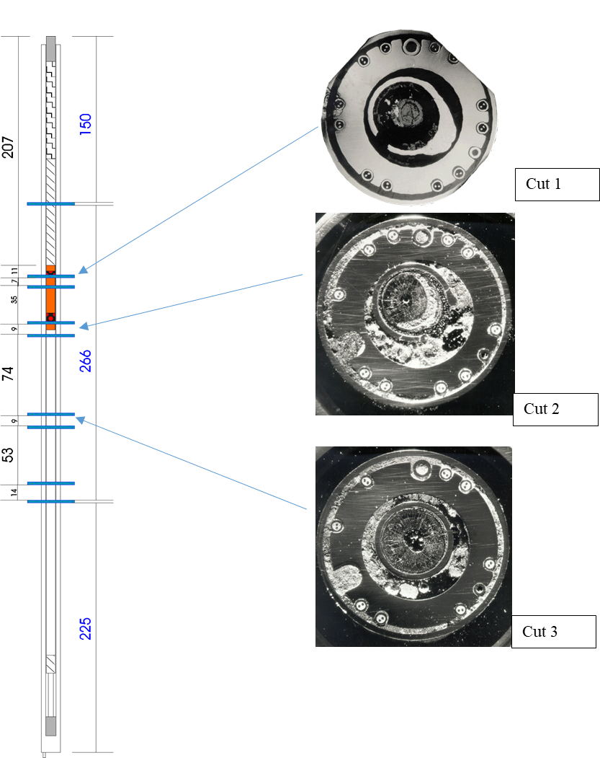

FIG. *3*. TRABANT 1 Pin 1: cutting plan and macrographs showing three axial positions [4]

The rupture of the stainless steel cladding resulted in the dispersion of fuel and caused a blockage of the Na coolant in the upper part, as revealed by radiography and γ-scannings of the fuel rod. A smaller secondary fracture of the cladding was observed by γ-scanning at the mid region of the pin (~320 mm/bottom, see FIG. 4).

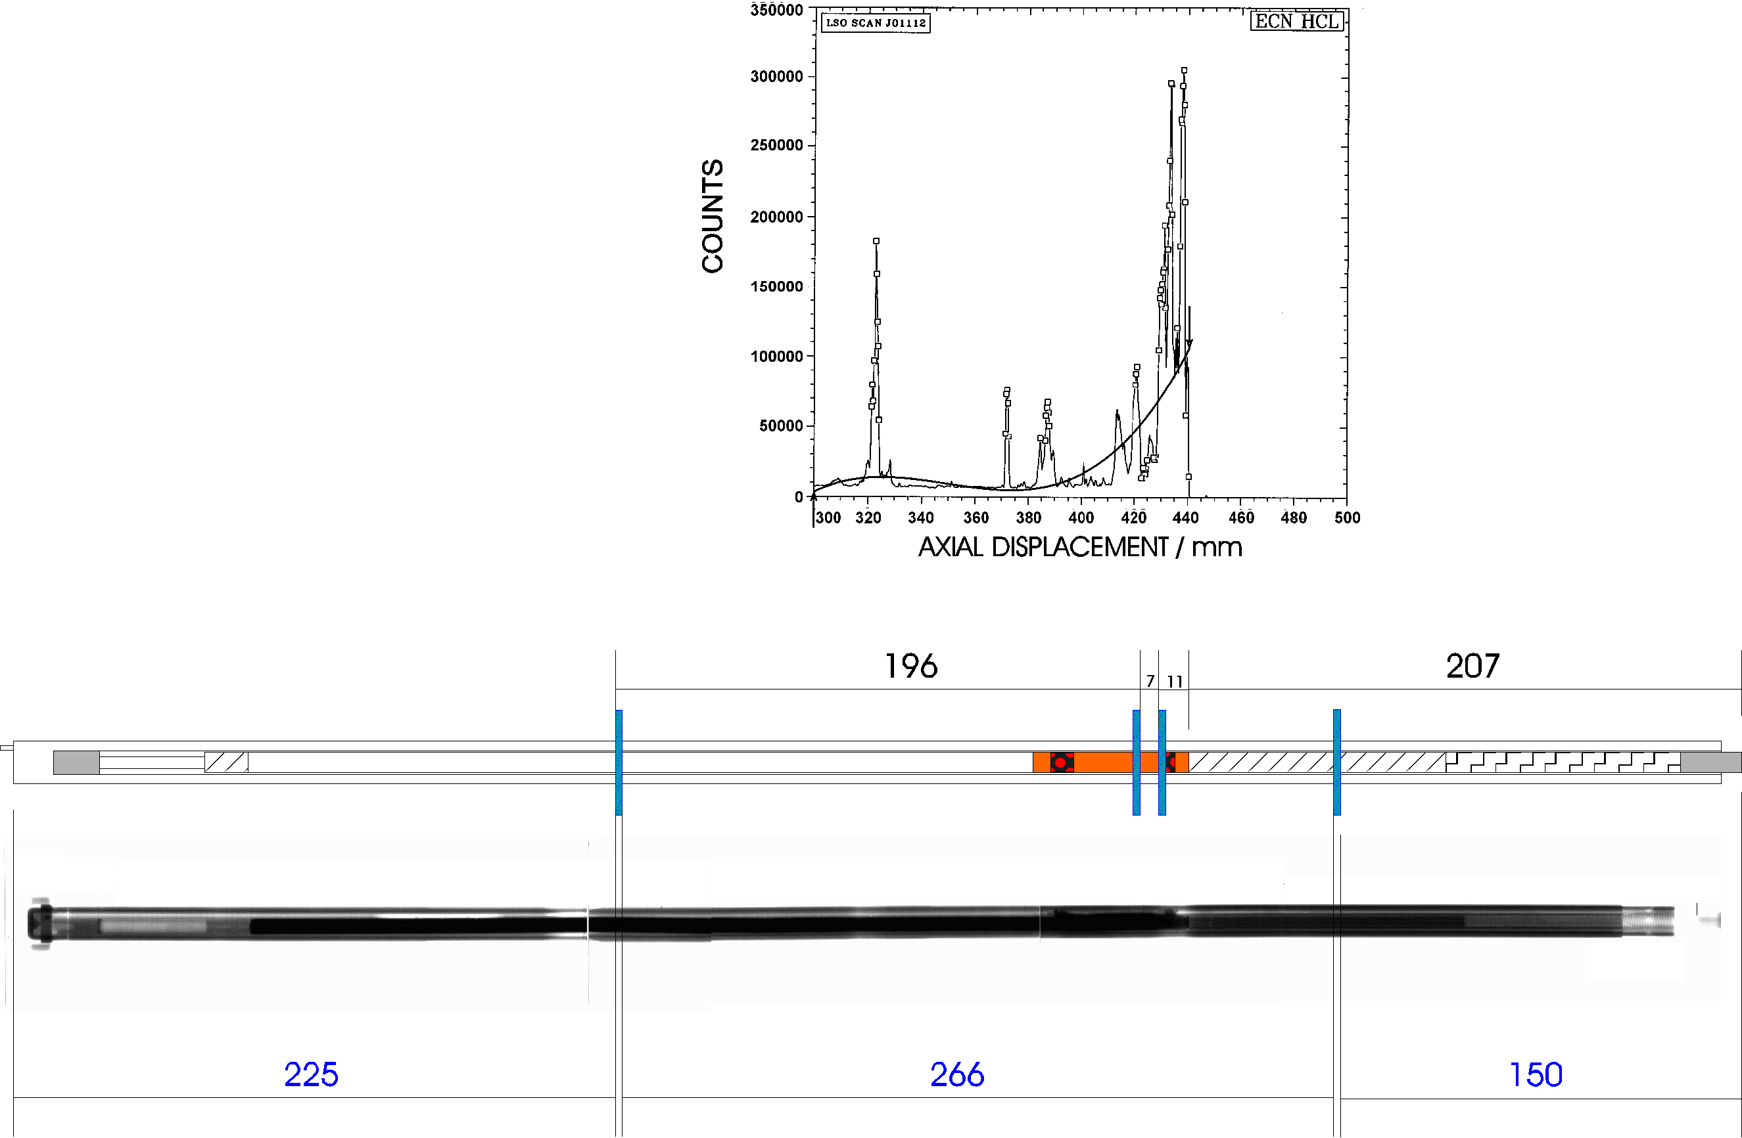

FIG. . Gamma scanning of TRABANT1 fuel pin along fissile region [5]

The cross-sectional ceramography of the major failure point revealed a blocked channel, extensive fuel-cladding interaction with cladding rupture and regions of molten cladding. Within the PuMMA project, the regions of interest will be defined and supplementary ceramographies before and after chemical etching will be obtained, as well as EPMA, density and thermal diffusivity characterisations. These observations will be compared to fuel performance code predictions with the objective of development or improvement of models.

#### First examination results on CAPRIX

Non-destructive examinations were carried out on the CAPRIX CAP01 fuel pin in a hot cell of LECA facility with the VENDAUM bench in September and October 2020. The visual examination carried out on several angular positions does not show any damage. The two crimped spacers are identifiable. Spacer wire traces and other various traces are illustrated in FIG. 5. The gamma spectrometry examinations were recorded along the entire length of the pin. The axial distributions of counting rate for all energies and of isotopes present in this pin - whose count rates are sufficient to be significant (such as 137Cs, 154Eu, 60Co) - have been measured.

Fissile column start and end positions were established from the axial distribution of 154Eu (1274.42 keV). The length of the fissile column is 852.0 mm+/- 1 mm.

The axial distribution of 137 Cs does not show migration of 137Cs up and down the fissile column. Regular peaks are visible at the inter-pellets. More pronounced 137Cs peaks in the central zone (~1050 mm to ~1310 mm) and 137Cs accumulation over ~9 mm at ~1298 mm are present (FIG. 6)

A correlation between some 137Cs peaks and 154Eu decrease (probable migration of 137Cs to colder points) can be established (FIG. 7).

|  |  |  |
| --- | --- | --- |
|  |  |  |
| Crimped spacer  Screenshot axial level: ~ 487 mm  Screenshot angular position: ~ 0° | Spacer wire trace  Screenshot axial level: ~ 90 mm  Screenshot angular position: ~ 0° | Spot with clear edge  Screenshot axial level: ~ 226 mm  Screenshot angular position: ~ 180° |

FIG. 5. Examples of visual examinations on CAP01 pin

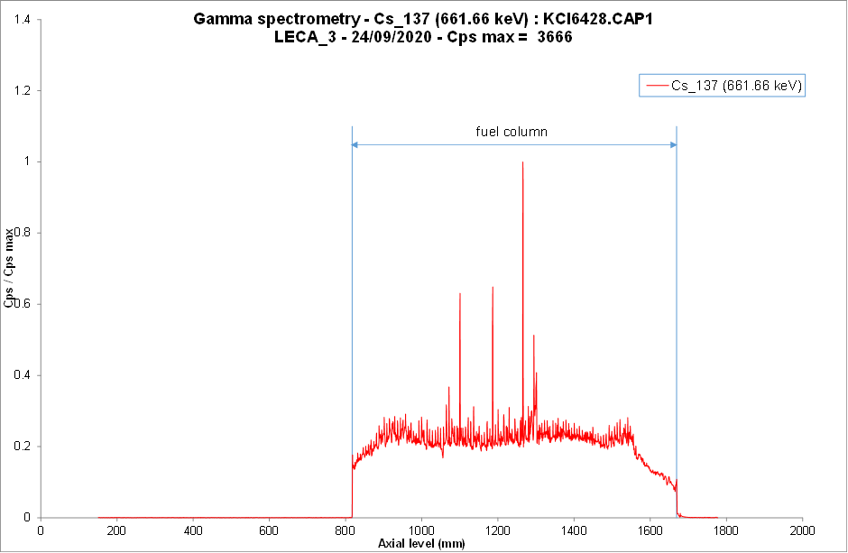

FIG. 6. Axial distribution of 137Cs (661.66 keV) along CAP01 pin



*FIG. 7*. Axial distributions of 137Cs (661.66 keV) and 154Eu (1274.42 keV) along the fissile column of CAP01

## Conclusion

The PuMMA project is a great opportunity to broaden the knowledge of oxide fuels with high plutonium content. Three passed irradiations, heritage from the CAPRA project, have been identified for this purpose: TRABANT1, TRABANT2 and CAPRIX. A large community is involved in the work package 2, with the common objective to improve fuel performance codes and oxide behaviour knowledge. First analysis of experimental conditions being done in 2021, neutronic calculations are in progress in order to define accurate input data for the benchmark. Post-irradiation examinations have started, and have been planned and discussed in order to provide validation data for the second phase of the benchmark. The next step will start in September 2022, with the FPC simulation of the three irradiation experiments. The last step of this work, which is planned in 2024, will be the proposal of new safety standard for high Pu content fuels.

ACKNOWLEDGEMENTS

The authors are grateful for the European support, and obliged to all persons who have contributed to the experiments of the CAPRA project.

References

1. T. D’ALETTO, A. LANGUILLE, “Development of fast reactor fuel for plutonium burning irradiation programme”, Proc. GLOBAL’93 (1993).
2. E. PICARD, J. NOIROT, J. ROUAULT, A. LANGUILLE, H. PLITZ, R. MOSS, G. DASSEL, “High plutonium content oxide fuel for Pu burning in fast reactors. CAPRA irradiation programme and first in pile experimental results”. Proc. Int. Conf. on Future Nuclear Systems., GLOBAL’97 (1997)
3. N. CHAUVIN, PUMMA proposal, Call NFRP-2019-2020 (2019).
4. D.SAICU, JRC-Karlruhe, unpublished data (2021).
5. G. DASSEL, H.A. BUURVELD, J.C.PLACKMAN, “Gamma spectrometries of TRABANT291-1”, Report ECN-CX-96-108 (1997)

### APPENDIX : Glossary

|  |  |
| --- | --- |
| Terms | Sense |
| efpd | Equivalent full power days |
| FIMA | Fissions per Initial Metal Atom |
| FPC | Fuel Performance Code |
| HFR | High Flux Reactor (Petten) |
| MTR | Materials Testing Reactor |
| PIE | Post-irradiation Examination |
| SFR | Sodium Fast Reactor |
| TZM shroud | Titanium-Zirconia-Molybdenum shroud |