Design of metal fuel pin for test

irradiation in FBTR &for future reactors

T. RAJKUMAR, D. NAGA SIVAYYA, S. RAGHUPATHY

Indira Gandhi Centre for Atomic Research, Kalpakkam, India

Email contact of corresponding author: rajkumar_t@igcar.gov.in

Abstract

In India, a structured R&D program on the development of metallic fuel and associated fuel cycle for Fast Breeder Reactors (FBRs) is undertaken so as to realize commercial metal fuel FBRs in the future. The program involves test irradiation of various binary and ternary metal fuels in Fast Breeder Test Reactor (FBTR). Towards this, test irradiation of sodium bonded metal fuel pins in FBTR core was proposed with various fuel compositions. For a typical composition (EU-23%Pu-6%Zr), the design details including the thermal and mechanical design of the pin are discussed in the paper. Also during transients, the maximum allowable flow reduction in the test Subassembly (SA) containing the metal fuel pins are discussed which helped in arriving at the blockage limits. During manufacturing of sodium bonded metal fuel pin, gas bubbles get entrapped inside the bond sodium. The effect of this bubble on heat transfer and the maximum allowable bubble size inside the pin are discussed. For the design basis transients, the design safety limits for the metal fuel pin (fuel and clad) are arrived at by analysis. Also, as a part of safety studies, a 2-D transient mathematical model has been developed for predicting fuel melting and movement of melt interface with respect to time. It is seen that fuel melting starts when the reactor power reaches 1.45 times the nominal power. Based on the above inputs, for a power reactor fuel composition, the thermal and mechanical design of sodium bonded metal fuel pin was carried out and the details are discussed. Overall, the paper details about the design aspects of sodium bonded metal fuel pin which includes arriving at the length of fuel pin including the fission gas plenum, allowable linear power, allowable bubble size in the bond sodium and the safety limits for transient events.

INTRODUCTION
In India, metal fuel developmental program is undertaken towards realizing commercial FBRs in the future. The program involves test irradiation of various binary and ternary metal fuels in FBTR followed by Post Irradiation Examination (PIE) of the test metal fuel pins. Towards this, initially test irradiation of sodium bonded metal fuel pins in FBTR core was proposed with various compositions. The compositions include Natural U- 6%Zr, Enriched U -6%Zr, Natural U-19%Pu-6%Zr and Enriched U-23%Pu-6%Zr. For all the compositions, metal fuel pin design was completed and they are currently being irradiated in FBTR.
In the work, the design details of sodium bonded metal fuel pin for a typical fuel composition which is being test irradiated in FBTR is discussed including the thermal & mechanical design of metal fuel pin. Also, during FBTR reactor operation, in particular during transients, the allowable and detectable flow reduction values based on fuel & clad temperature limits are worked out which has ensured safe operation of the metal fuel pins up to the target burn-up. As a part of the safety studies, the following works are carried out with respect to power reactor i.e. 500 MWe reactor having a peak linear power of 450 W/cm.
- Allowable bubble size in a sodium bonded metal fuel pin is arrived at based on analysis;
- During reactor transients, the design safety limits for fuel & clad which are to be respected for safe operation;
- Determination of the melting linear power for a given over power event and their results.
With all these inputs, the design of sodium bonded metal fuel pin for a power reactor is carried out and the details are briefly discussed in the work.

Design of test pin for irradiation in FBTR
The design details of sodium bonded metal fuel pin for test irradiation in FBTR including the selection of fuel, smear density, clad material are given below.

Fuel pin
The development of the metal fuel was initiated mainly in EBR II with uranium-zirconium binary alloy as driver fuel. About six hundred uranium-plutonium-zirconium (U-Pu-Zr) ternary alloy experimental elements were irradiated and attained a maximum burn up of ~200 GWd/t [1]. This fuel has superior properties such as high density and high thermal conductivity. This fuel is also compatible with the pyro-metallurgical reprocessing technologies such as electro-refining and injection casting. The metal fuel cycle with U-Pu-Zr as fuel shows good promise and hence selected as the driver fuel for the future fast reactors in India.
Zirconium addition to U-Pu fuel would result in a ternary fuel with an adequately high solidus temperature and good compatibility with austenitic stainless steel cladding. But, Zirconium addition decreases the breeding ratio & thermal conductivity of fuel and also it increases the fissile specific inventory. Hence, Zirconium content has to be selected judiciously based on the requirement of solidus temperature, migration within the fuel with burn-up as well as the breeding ratio. As zirconium % changes, Plutonium content required in the fuel also changes correspondingly. Based on the studies [2], ternary fuel with 6 wt% Zr is chosen. Fuel composition of U-19%Pu-6%Zr is selected for power reactors and U-23%Pu-6%Zr is selected for test reactor with metal as driver fuel.
Modified 9Cr-1Mo ferritic steel is selected as clad material as it has high swelling resistance and moderate creep strength.
For the present target burn-up of ~ 100 GWd/t, the smeared density is selected as 75%which will ensure open porosity at the time when the fuel reaches the cladding. This interconnected porosity facilitates the release of fission gases. Experiments from literature [3] show that for a smear density of 85%, there is a large increase in cladding diameter mainly due to Fuel Clad Mechanical Interaction (FCMI).

Sodium bonded metal fuel pin in test Subassembly (SA) of FBTR
In the test fuel pin with ternary fuel (EU-23%Pu-6%Zr), the metallic fuel is housed inside a modified 9Cr-1Mo (T91) steel cladding tube of size 6.6 mm OD & 5.7 mm ID. The chosen smear density is 75% and hence the fuel diameter works out to be 4.94 mm. The length of the metal fuel slug is 160 mm and its top is aligned with middle of FBTR core. In order to position the metal fuel slug in the FBTR active core region, a blanket slug (U-6%Zr) of length 51.5 mm is provided below the metal fuel slug. Also, a top fission gas plenum length of 245 mm is provided to accommodate the fission gases and sodium is filled inside the pin from bottom up to 20 mm above the metal fuel slug height. Three such pins of length 531.5 mm are arranged inside a capsule. This capsule is kept inside a special test SA. The flow in the test SA is 1.09 kg/s and flow inside the irradiation capsule is 0.16 kg/s. The schematic of the sodium bonded metal fuel pin is shown in Fig. 1 [4].
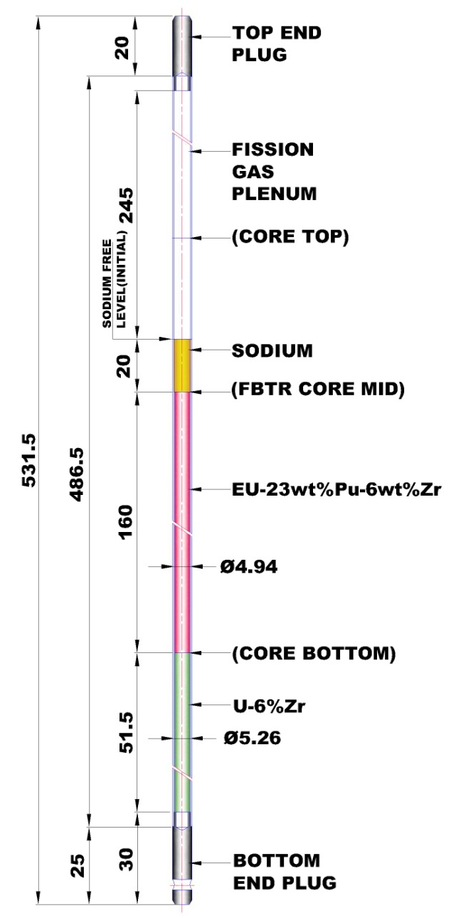
FIG. 1.Schematic of sodium bonded metal fuel pin for irradiation in FBTR

Design criteria
- The clad inside hotspot temperature shall not exceed 923 K (650°C) under normal operating conditions to avoid fuel forming eutectic with clad material;
- The centreline temperature of fuel at 116% peak power under hotspot conditions shall not exceed its melting point i.e. 1273 K (1000°C) [5];
- Cumulative Damage Fraction (CDF) under normal operation shall be ≤ 0.25 to preserve clad integrity.

Thermal design
The maximum fuel centreline temperature occurs at the active core top i.e. at the end of 160 mm fuel column (which is aligned with FBTR core-mid) where the coolant temperature also reaches to a maximum value. For an LHR of 318 W/cm (with 16% overpower), the fuel hotspot centreline temperature is estimated as 889.3°C which is less than the fuel melting point (1000°C). Also, the clad inside hotspot temperature at normal operating conditions is estimated as 540.1°C which is less than 650°C limit for a flow of 0.16 kg/s inside the irradiation capsule. The melting linear power is estimated as 620 W/cm and the design safety limit considering the margin for uncertainties is derived as 483 W/cm. Considering an over power margin of 16%, the allowable linear power for this metal fuel pin is estimated as 416 W/cm.

Mechanical design
The fuel pin consists of 160 mm fissile column, 51.5 mm of bottom axial blanket to position the fuel in active core region. A top fission gas plenum of 195 mm is provided in the fuel pin for limiting the fission gas pressure. Further additional space is required for accounting the following:
- The axial fuel growth due to fission gas swelling is expected to be around 2-4% and is expected to be saturated within ~10-20 GWd/t burn-up. In the present design, the maximum possible axial growth of 4% is conservatively taken [6]. Also, taking into account of blanket swelling, a minimum length of 9 mm of sodium is required above the fuel column;
- Pores are generated in the fuel due to irradiation due to fission gas precipitation. The sodium that is squeezed out of the fuel column when the fuel comes in contact with the clad due to radial swelling, rises inside the pin to a length of ~ 39 mm (assuming 20% fuel pores are infiltrated by sodium).
Considering sodium expansion due to temperature (2 mm), total plenum length of (195+9+39+2 = 245 mm) 245 mm is provided at top of the fuel pin. Apart from the above, a free sodium level of 20 mm is provided above the fuel column to ensure that the metal fuel slug is immersed in the sodium which will also take care of thermal change in fuel and blanket column lengths. The total pin length is arrived as 531.5 mm. With the fission gas plenum length of 195 mm, considering 100% fission gas release rate conservatively, the fission gas pressure at End of Life (EOL-100 GWd/t) is estimated as ~ 7 MPa. With the clad mid-wall temperature of 525°C, based on the creep rupture properties of T91 clad, the CDF is found to be 1.07 x 10⁻⁵ for the target peak burn-up of 100 GWd/t. This ensures the safe operation of metal fuel pin up to target burn-up.

Allowable and detectable flow reduction in the test SA containing metal fuel pins
Temperature distribution of fuel, clad and sodium during normal operating condition of the reactor have been determined to ensure adequacy of cooling. However during transients such as loss of flow events, the flow in the test SA will be reduced and the fuel, clad & sodium temperatures will rise. The flow up to which the design safety limits of fuel, clad & sodium are respected is the allowable flow reduction. The thermocouple which is kept above the SA will detect the increased sodium temperature and will send the SCRAM signal and the flow at which this happens is the detectable flow reduction. To ensure safe operation, detectable flow reduction should be less than the allowable flow reduction.
For the test SA with three metal fuel pins, the maximum allowable flow reduction in the SA is estimated from clad, fuel and coolant point of view. From clad temperature limit point of view, the allowable flow reduction is estimated as 60.3% (with respect to the clad temperature limit of 720°C). From fuel temperature limit point of view (melting point of fuel is 1000°C) & sodium temperature limit point of view (1153 K), the allowable flow reduction is estimated as 74%. Also, the minimum detectable flow reduction in test SA is estimated as 30% based on pool hydraulics study [7]. Hence, a safe detection of test SA with ternary metal fuel pins is ensured within 30% of flow reduction in the SA.

Safety Studies in metal fuel pin
Towards the safety studies in metal fuel pin, determination of allowable bubble size in pin, design safety limits for transients & determination of melting linear power are carried out. The reference linear power for these studies is taken as 450 W/cm corresponding to a 500 MWe power reactor and the fuel column height of 1000 mm is considered for the studies.

Allowable bubble size inside sodium bonded metal fuel pin
During the manufacturing of sodium bonded metal fuel pin in inert atmosphere, there is a possibility that helium (inert gas) bubbles gets entrapped in the sodium between the fuel and clad. This may cause a rise in fuel centreline temperature due to the lower thermal conductivity of Helium when compared to sodium. Hence the size of helium bubble that can be permitted in the manufacture of sodium bonded pin has to be specified. In this regard, a study has been carried out to study effect of helium bubble size on centreline temperature of fuel for a sodium bonded metallic fuel pin.
The metal fuel slug can be eccentric or concentric within the clad with Helium entrapped in the gap (in sodium) as shown in Fig. 2. Hence, analysis was carried out for both cases viz. eccentric metal slug & concentric metal slug. In case of concentric metal fuel slug, for a He bubble of size ~ 2 mm i.e. the transverse bubble length (with bubble thickness equal to the gap of 0.38 mm as shown in Fig. 2 (b)), the nominal fuel centreline temperature is raised by ~24°C with respect to the without He bubble case and the nominal peak clad inside temperature is raised by ~12°C. In case of eccentric metal fuel slug, for a He bubble of size ~ 2 mm i.e. the transverse bubble length (with thickness equal to the eccentric gap of 0.73 mm as shown in Fig. 2 (a)), the nominal fuel centreline temperature is raised by ~33°C with respect to the without He bubble case and the nominal peak clad inside temperature is raised by less than ~3°C. Fig. 3 shows the temperature distribution inside the metal fuel pin with bubble (eccentric slug) during operation. Based on the analysis and literature, maximum helium bubble size with a transverse bubble length of 2.2 mm is allowed in a sodium bonded metallic fuel pin. Since the longitudinal length of bubble will not affect the fuel centreline temperature, 1.5 times the transverse length i.e., up to 3.3 mm of longitudinal bubble length is allowed.
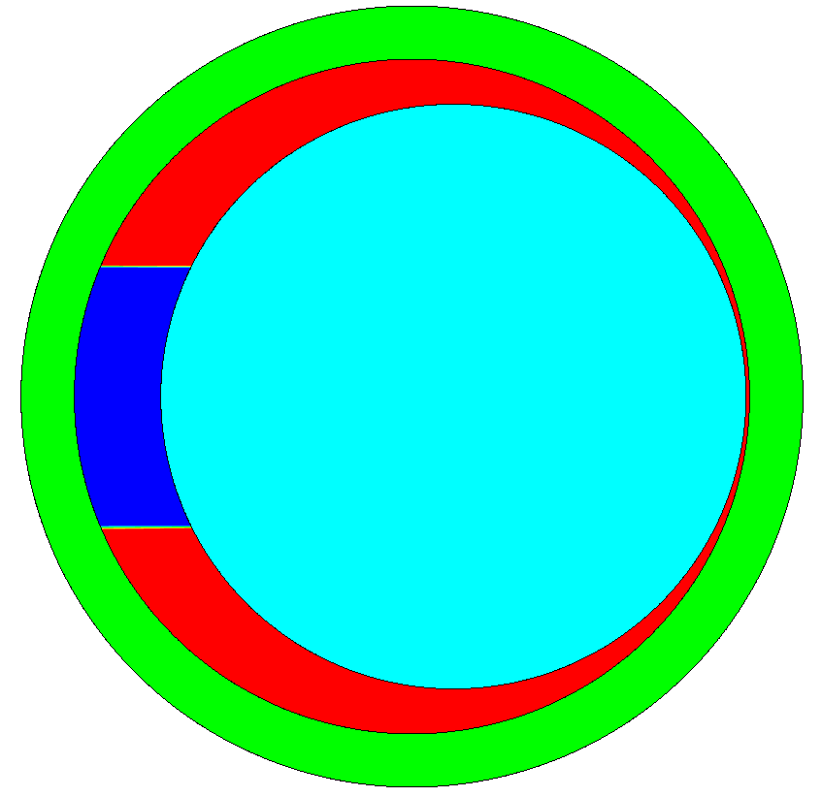
Bubble
Clad
Fuel
Sodium
Bubble
Clad
Fuel
Sodium

~ 2 mm
0.38 mm
~ 2 mm
0.73 mm

FIG. 2.Schematic figure showing pin with entrapped bubble in (a) eccentric fuel slug (b) concentric fuel slug

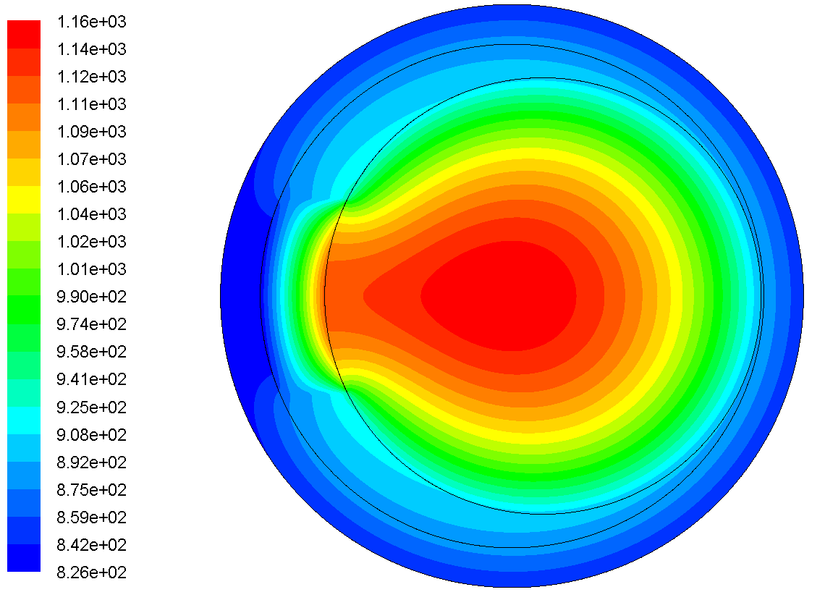
FIG. 3.Temperature distribution (K) in metal fuel pin with entrapped bubble

Design safety limits during transients
All the design basis events occurring during the lifetime of the components concerned are classified in to four categories based on the frequency of occurrences. The design approach followed in determining the Design Safety Limit (DSL) temperature limits for clad is that the pin deemed to have failed if Cumulative Damage Fraction (CDF), based on creep rupture data under operating pressure & temperature conditions, reaches 1.0. This CDF limit is applied uniformly across the categories, viz., CDF of 0.25 is to be respected for each of the category – 1, 2 & 3 events each and the rest 0.25 is allocated for SA during handling & in internal storage. A time- temperature limit for clad is drawn for category 2 & 3 events for which the clad has to withstand the given loading of pressure & temperature. Accordingly, based on the occurrence of events, it is considered that the time of transient events is 30 minutes for category-2 event and 2 minutes for catergory-3 events under respective temperature limits.
Considering the fission gas pressure loads, clad thinning due to inter-diffusion of fission product & clad composition and time to rupture of clad material, the temperature limits for each is arrived at. For category-2 event, the clad inside hotspot temperature is limited to 993 K and for catergory-3 events, it is restricted to 1043 K and category-4 event, it is restricted to 1243 K. The details are given in reference [8]. Similarly, the limits for fuel and coolant are also arrived at. These limits will be fine tuned based on the out-pile and in-pile experiments planned in the future.

Power to melt for metal fuel pin
Literature reveals that metal fuels are having the inherent safety features and they have benign response to unprotected transients. To ascertain the metal fuel performance during unprotected transients (over power events in particular), it is required to estimate the transient temperature distribution in a metal fuel pin. Towards this, a 2-D transient mathematical model has been developed for predicting fuel melting and movement of melt interface with respect to time. An enthalpy based formulation has been adopted for this purpose, which encompasses fuel and clad. The enthalpy equation is coupled with 1-D transient energy equation for sodium flow. The coupled system of equations is solved by an Implicit Finite Difference Method and a code has been developed in C-language. The discretization equations are solved by Gauss-Siedel method. The code has been validated for 1-D heat conduction, for which analytical solution is available. Both steady state and transient simulations have been carried out using the C-code.
In the 2-D transient analysis, the temperature distribution all along the length of the fuel column (1000 mm height for a 500 MWe power reactor) is calculated by considering the axial power profile and the sodium temperature increase along the length. The peak linear power of 450 W/cm occurs at the core-mid and the sodium temperature will be maximum at the core top. An Unprotected Transient Overpower Accident (UTOPA) event with heat generation increase from 8 MWt to 16 MWt in 200 seconds is given as the input. The fuel is discretized into 26 nodes, gap and clad are divided in to 4 & 5 nodes respectively. Axially the fuel column is divided in to 40 nodes. A time step of 1 second is used. A constant value of fuel thermal conductivity and specific heat is considered in the analysis. Due to the axial variation in heat generation and due to high thermal conductivity of bond sodium & fuel, the peak metal fuel centreline temperature occurs slightly above the core mid i.e. at 625 mm from the active core bottom. At 625 mm, the temperature distribution in metal fuel pin with respect to time is shown in Fig. 4. It can be inferred that the fuel crosses its melting point (1273 K) after 75 seconds.

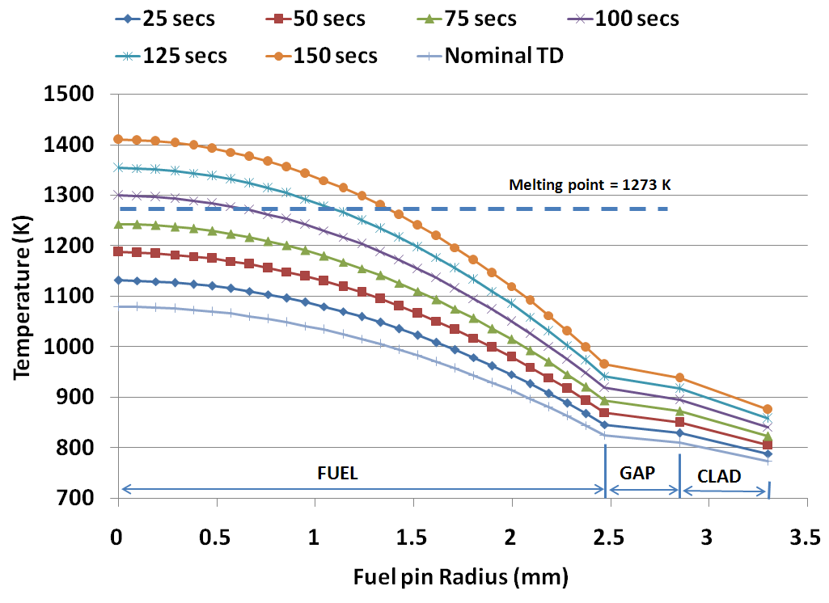
FIG. 4. Temperature distribution (K) in metal fuel pin (at 625 mm) with respect to time

The power at which the fuel starts melting is found out as 11.56 MWt which is 1.445 times the nominal power. After melting, the melt interface propagation along the fuel radius with respect to time is shown in Fig. 5 starting from 100 seconds. It is assumed that the melt would stay in its position due to the outer solid fuel fraction. The bond sodium temperature is within its boiling point for the corresponding fuel pin pressure. The clad temperatures are less than their corresponding melting point. The code will be further extended to study the fission gas release during transients.
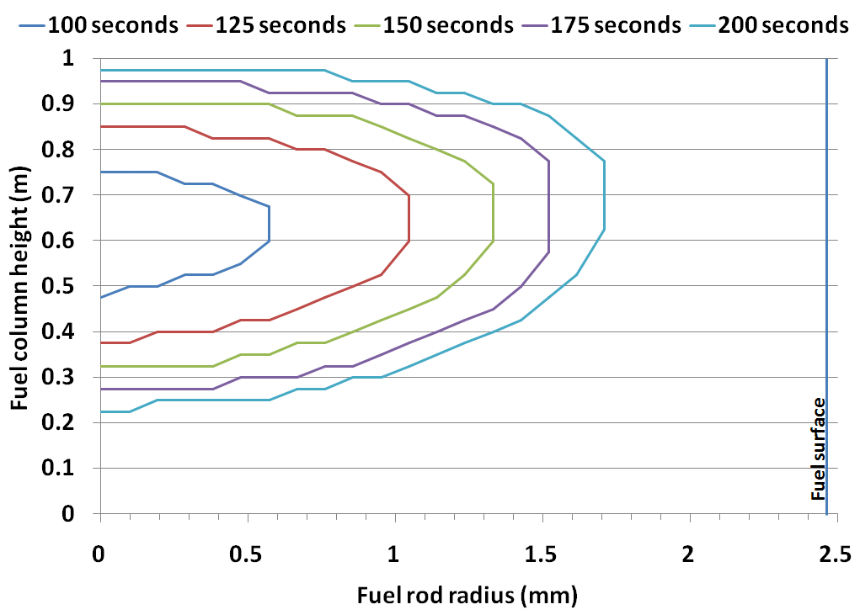
FIG. 5.Melt interface movement in metal fuel pin with respect to time (8 to 16 MWt in 200 seconds)

DESIGN OF METAL FUEL PIN FOR POWER REACTOR
Based on the above inputs, the conceptual design of metal fuel pin for 500 MWe reactor has been carried out for a peak Linear power of 450 W/cm with a pin diameter of 6.6 mm for a target burn-up of 100 GWd/t. Sodium bonded pin with a smeared density of 75% & fuel composition of U-19w%Pu-6w%Zr is selected. From the thermal design analysis, it is found that the clad inside surface hotspot temperature reaches maximum at ~ 900 mm from core bottom and its value is ~ 649°C (922 K) and hence it satisfies the design criteria. It is found that the fuel hotspot centreline temperature reaches maximum at ~ 625 mm from core bottom and its value is ~ 984°C (1257 K) and found to be less than its limiting value. From the mechanical design, the fission gas plenum length required at the fuel pin top is arrived as 1430 mm for a target peak burn-up of 100 GWd/t. Considering the fuel axial growth, sodium squeezing out of the fuel column, sodium expansion, etc. a total plenum length of 1795 mm is provided. The overall pin length is arrived at 3495 mm. The schematic of the metal fuel pin is shown in Fig. 6.

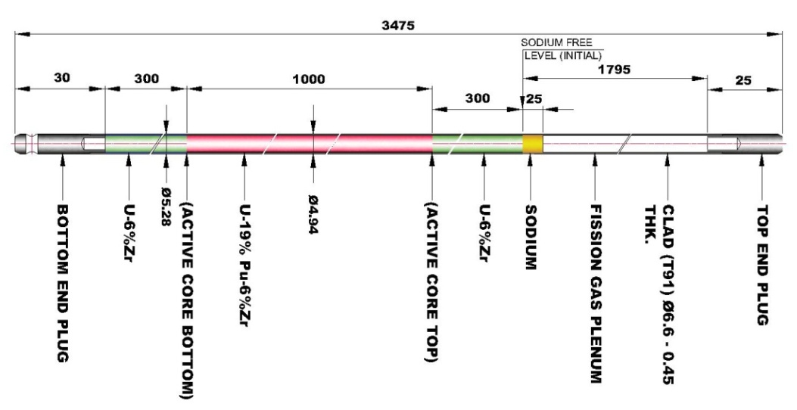
FIG. 6.Schematic of sodium bonded metal fuel for power reactor

SUMMARY
The design aspects of sodium bonded metal fuel pin which includes arriving the size of fuel pin, fission gas plenum length, allowable linear power, allowable bubble size in the bond sodium and the safety limits for transient events are discussed. Also, the safety studies related to metal fuel melting and details of the power reactor metal fuel pin are briefly discussed.
References
- HOFMAN G.L., et al., “Metallic fast reactor fuels, Materials Science and Technology”, A Comprehensive Treatment in Nuclear Materials, Vol. 10A, Part 1, (1994).
- RIYAS A., et. al., “Studies on physics parameters of metal (U-Pu-Zr) fuelled FBR cores, Annals of Nuclear Energy, 35 (2008) 87–92.
- TSAI H., et.al., “Irradiation performance of U-Pu-Zr metal fuels for liquid metal cooled reactors”, CONF-950426-6, ANL/ET/CP-82776, (1994).
- RAJKUMAR T., et al., “Design of sodium bonded metallic fuel pin for test irradiation in FBTR”, Internal report, IGCAR, Kalpakkam, (2017).
- “Note on thermo-physical properties on metal fuel”, Internal report, IGCAR, Kalpakkam, (2017).
- CLEMENT RAVICHANDAR S., et al., “Design of metallic fuel pin for future FBRs”, Internal report, IGCAR, Kalpakkam, (2008).
- RAJKUMAR T., et al., “Allowable and detectable flow reduction of ternary metal fuel in special subassembly”, Internal report, IGCAR, Kalpakkam, (2018).
- CLEMENT RAVICHANDAR S., et al., “Design Safety Limits for clad during transients in a metal fuelled reactor”, Paper IAEA-CN-245-364, FR17, Yekaterinburg, Russian Federation, (2017).

