Selection, testing and development of qualification procedure for ALLEGRO gas-cooled fast reactor fuel

Z. HÓZER¹, L. ILLÉS¹, D. KIM², W-J. KIM², M. KIRÁLY¹, T. NOVOTNY¹, E. PEREZ-FERÓ¹, A. PINTÉR-CSORDÁS¹, M. HORVÁTH¹, M. SCHYNS³, E. SLONSZKI¹, P. SZABÓ¹, R. DELVILLE³

¹Centre for Energy Research, Budapest, Hungary
²Korea Atomic Energy Research Institute, Daejeon, Korea
³SCK∙CEN Belgian Nuclear Research Centre, Mol, Belgium

Email contact of corresponding author: hozer.zoltan@ek-cer.hu

Abstract

On the basis of detailed review, the fuel types were proposed for the new design of the ALLEGRO gas-cooled fast reactor. The first core will be built with MOX or UOX fuel in 15-15Ti stainless steel cladding. These fuel types have been widely used in different sodium-cooled fast reactors. The second core of ALLEGRO will use refractory fuel. The primary candidate is carbide fuel – (UPu)C or UC – in SiC cladding.
Qualification procedures have been proposed for the start-up and refractory ALLEGRO fuel. The technology readiness level approach was applied and the basic steps of qualification procedure were identified. Using the currently available information the further needs were specified, which include experimental activities, design work, development of numerical models, technology developments, establishment of fuel fabrication capabilities, irradiation in research reactors and post-irradiation examination of fuel.
15-15Ti and SiC_{f}/SiC type claddings were tested in high temperature helium atmosphere in order to investigate the effect of high temperature treatment and impurities on the mechanical load bearing capabilities of these cladding materials. Ballooning tests were performed with 15-15Ti cladding tubes and it was shown that they can keep their integrity at high temperature. The failure pressure of samples tested at 960-1000 °C was above 18 MPa.

INTRODUCTION
A gas-cooled fast reactor (GFR) has never been built until today, but GFR projects were launched in different countries since the 1960s [1]. Those GFR designs included probably the most diverse fuel types for nuclear reactors [2][3].
- The first GFR designs were based on the Liquid Metal Fast Breeder Reactor (LMFBR) experience and included conventional pin-type, stainless steel cladded fuel assemblies with oxide pellets and with roughened external cladding surface to enhance heat exchange.
- Coated particles were considered in some European designs with different geometrical arrangements (e,g. cylinders with perforated annuli or “stack of saucers” geometry). The proposed materials for structural elements were SiC and stainless steel.
- In the Soviet Union chromium dispersion fuel pins were proposed with small inclusions of U metal or UO₂ in a matrix of chromium for the gas-cooled fast reactors with corrosive, dissociating N₂O₄ coolant.
- In Japan coated particle fuel with nitride fuel kernels TiN sealing layers was considered. In one assembly type the coated particles were arranged in an annular bed. The other design featured large prismatic blocks filled with a mixture of coated particles and matrix material (TiN, SiC or ZrC). The material of the structural parts was SiC.
After 2000 new interests were expressed by several countries to develop gas-cooled fast reactor designs following the Generation IV International Forum (GIF) initiative [4][5]. Important step of these developments was the design of a small demonstration plant which has subsequently become known as ALLEGRO [6][7] and which was intended to develop and qualify the innovative refractory fuel based on two successive core configurations. At first, the standard MOX core with metallic clad would be implemented at moderate temperature in order to irradiate some innovative refractory fuel at full scale. After this preliminary phase, a full refractory core, representative of the GFR, would be implemented.

Selection of fuel for the ALLEGRO start-up and refractory cores
Four nuclear research organizations of the Visegrád cooperation (V4) in 2013 established the V4G4 Centre of Excellence for the coordination of technical, experimental and other ALLEGRO-related issues. The French CEA joined the consortium as an associated member. The first phase of the V4G4 ALLEGRO Project aims to develop the Conceptual Design of the ALLEGRO reactor and answering all safety related and other technical issues. Within this work the potential candidates for the start-up and refractory cores were analysed. Since the reactor will operate at high temperature and the core components will receive high fast neutron doses, the selection of appropriate fuel materials and the qualification of fuel is a key action in the design and development process.
- The first core of ALLEGRO will be built with MOX or UOX fuel in 15-15Ti stainless steel (SS) cladding. These fuel types have been widely used in different sodium-cooled fast reactors, including NPP reactors. In a recent study [8] the main characteristics of ASTRID (MOX) and BN-600 (UOX) fuel were summarised in order to support the selection of fuel for the first core of ALLEGRO reactor. The on-going feasibility studies indicate that from reactor-physical point of view both MOX and UOX fuel could be used in the first core of the ALLEGRO reactor. Beyond the operational experience the information on experimental data and results of post-irradiation examinations were considered as very important for the qualification of ALLEGRO fuel. The review of production capabilities showed that the today the UOX fuel could be more easily fabricated than the MOX. The use of UOX fuel with low enriched uranium could be a great advantage from proliferation point of view. It is clear that the parallel development of these fuel types will require almost double efforts, since the overlaps are rather limited. For this reason, the further design of ALLEGRO reactor needs a decision on the pellet type, since it will be the starting point for the design of fuel elements, core geometry, control rods and other reactor components.
- There are several fuel types that theoretically could be applied in the second core of ALLEGRO and their advantages and limitations were reviewed in a recent study [9]. The review showed that the most suitable candidates for the second ALLEGRO core are the carbide and nitride fuel pellets. Taking into account the aspects of fuel production and irradiation experience it was proposed to consider carbide fuel in the design of the second ALLEGRO core. The refractory fuel for the second core of ALLEGRO reactor could be composed of UC or (U,Pu)C pellets in SiC_{f}/SiC cladding. SiC_{f}/SiC is a ceramic fiber-reinforced silicon-carbide composite. The availability of more data on irradiated fuel and the larger fabrication experience supports this decision. The SiC_{f}/SiC cladding in principle meets the ALLEGRO and GFR requirements, however its production for nuclear fuel components is still in the phase of laboratory scale development.

GFR FUEL QUALIFICATION PROCEDURE
The qualification process for nuclear fuel is not a standard procedure today. It depends on the reactor and fuel type, and on the actual requirements of the nuclear authority in a given country [18][19][20][21].
In this chapter the available fuel qualification methods, approaches will be reviewed. The steps of GFR refractory fuel qualification will be proposed making use of the combination of existing methodologies. Finally, the points of decision making in the qualification process will be identified.

The TRL approach
A Technology Readiness Assessment (TRA) evaluates technology maturity using the Technology Readiness level (TRL) scale and was pioneered by NASA [13] in the 1980s for space technology. In 2007 the Department of Energy (DoE) adopted the TRLs and applied the methodology to nuclear fuels and material systems.
The TRL concept is used as a program management and communications tool and is not meant as an absolute quantitative measure of maturity. There is naturally a level of subjectivity in defining and in evaluating the TRLs. Carmack et al. [14] provided proposed attributes and categorization for nuclear fuel system technology readiness level definition. The used TRL scale ranged from 1 (basic principles observed) through 9 (total system used successfully in project operations).
- TRL levels 1-3 correspond to proof-of-concept phase. A new fuel concept is proposed (TRL 1). The technical options have been identified and preliminary evaluation is underway (TRL 2). Concepts are verified through laboratory scale experiments and characterization (TRL 3).
- The proof-of-principle phase (TRL levels 4-6) requires establishing fabrication capability for representative material at least at the laboratory scale and progressing to in-pile irradiation testing. At TRL 4 fabrication of samples using stockpile materials at bench-scale yielding small fuel elements, rodlets for in-pile and out-of pile testing, and small scale pin configurations. TRL 5 includes the fabrication of full scale fuel elements using laboratory scale fabrication capabilities with subsequent pin-scale irradiation testing conducted in relevant prototypic steady-state irradiation environments. At TRL 6 fabrication of engineering-scale test pins using prototypic feedstock materials is conducted. Fuel pin irradiation testing and performance verification is conducted in prototypic irradiation environments.
- In the proof-of-performance phase (TRL levels 7-9) the scale of fabrication reaches engineering and commercial scales. TRL 7 represents the established capability to fabricate test assemblies using prototypic feedstock materials at engineering-scale and using prototypic fabrication processes. TRL 8 designates that a few core loads of fuel have been fabricated and full core operation of a prototype reactor with such fuel has been accomplished. TRL 9 designates that the fuel technology is routinely conducted at commercial-scale and normal operations are underway.
D. Sheperd [15] pointed out that the original NASA TRLs were defined for systems for individual space missions and the terminology is not always suitable for nuclear industry applications. It was proposed to introduce an additional level: TRL 10 to cover the experience from operating many actual systems (long term use of fuel in nuclear power plants). Similar proposal was developed by Straub [13] for aerospace applications, too (proven operation).

The main steps ALLEGRO fuel qualification
The main steps fuel qualification process for ALLEGRO reactor were identified using the TRL methodology. The general schemes presented in Fig. 1., Fig. 2. and Fig. 3. include the basic actions and needs that are necessary to produce reliable fuel and operate the gas cooled fast reactor with these fuel types. The present study summarised the qualification procedure for fuel types of first and second cores of ALLEGRO.
- The first core will include MOX or UOX type fuel. It is clear that the parallel development of these fuel types will require almost double efforts, since the overlaps are rather limited. For this reason, the selection of fuel type and the specification of fuel rod parameters (e.g. geometry, enrichment, axial profile) should be done in the early phase of reactor development.
- The fuel candidate for the second core includes carbide pellets in 15-15Ti stainless steel cladding. This fuel type is much less mature compared to UOX or MOX and will need larger development activities and the involvement of more new technologies.
- The proposed procedure drives through the TRL levels from the selection of promising fuel materials up to the long term use of commercial fuel. Important intermediate objectives are the confirmation of the reliable operation of fuel rods and subassemblies under representative reactor conditions.
- The listed “available information” items were collected during an extended literature review and large part of information was based on international co-operations and data exchange.
- The specified “further needs” include different activities (e.g. design, technology development, production, in-pile and out-of-pile testing, post irradiation examination, numerical modelling) and some of them may need launching individual projects to reach the given objectives.
- The presented procedure is shown as a straightforward process. Iterations are not indicated, but they may take place after unsuccessful steps. Some actions may have to be changed and repeated with other conditions. This is a natural concomitant of such a complex procedure.
- Several items of the ALLEGRO fuel qualification for the first and second cores could be done parallel, but obviously the last steps of refractory fuel qualification (i.e. irradiation in the ALLEGRO reactor) will have to follow the qualification of first core fuel.
- The presented qualification process valid only for rod-like fuel geometry. In case of any other geometrical arrangement the procedure beyond TRL 4 must be modified.

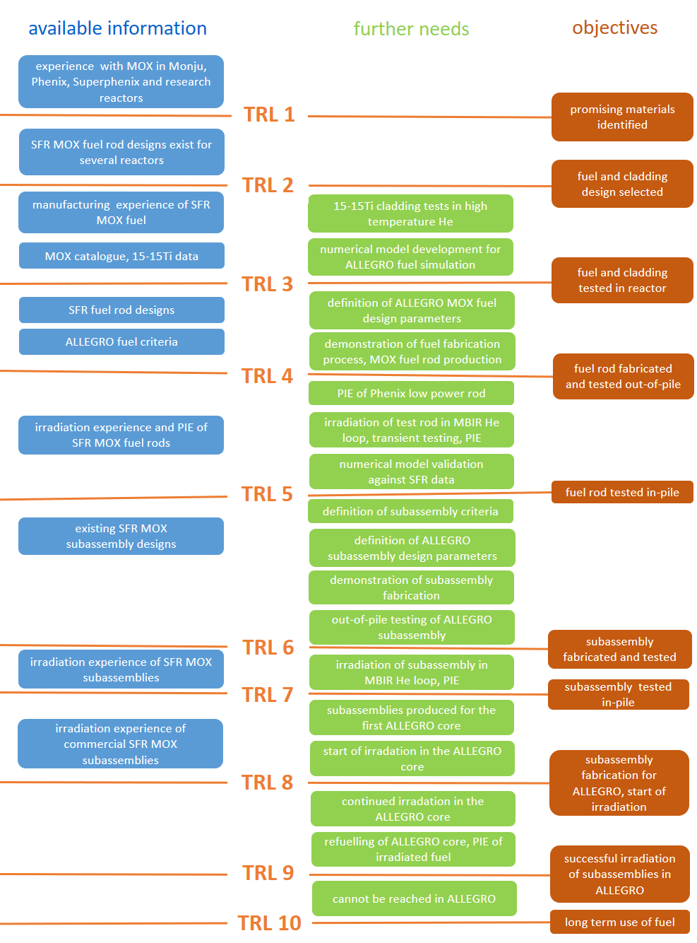

Fig. 1. Summary on MOX fuel qualification process for ALLEGRO
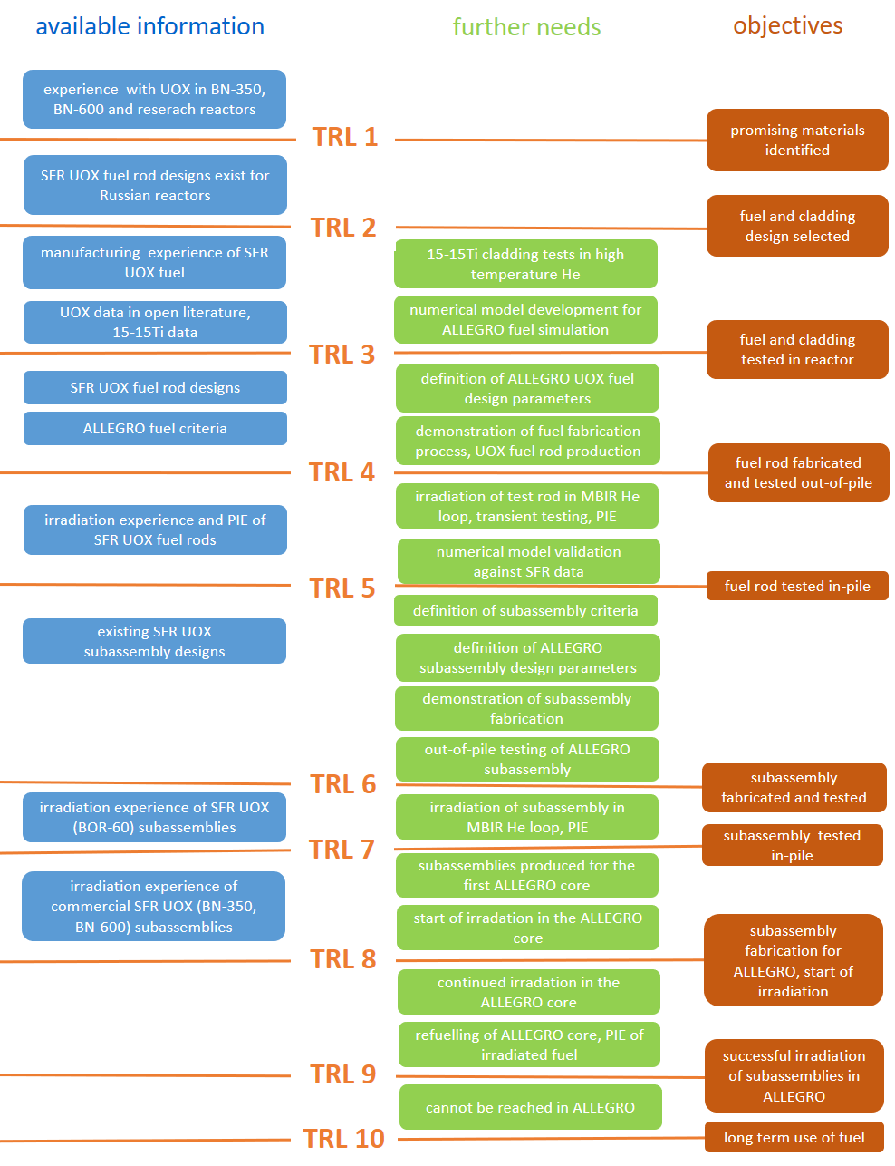

Fig. 2. Summary on UOX fuel qualification process for ALLEGRO

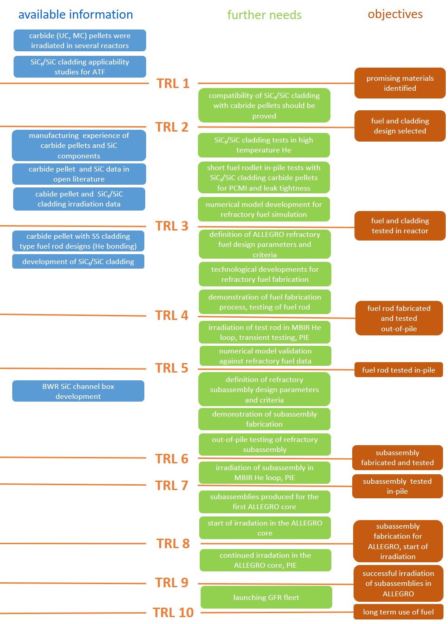

Fig. 3. Summary on refractory fuel qualification process for ALLEGRO

Testing cladding materials for allegrO fuel
During the development of qualification procedure several gaps (missing information) were identified and this motivated the execution of new experimental programmes. The fuel related tests within the V4G4 consortium were started with cladding materials for the start-up and refractory fuel. The cladding tubes were received in the framework of international co-operations.
- The cladding material DIN 1.4970 (15-15Ti) austenitic stainless steel was provided by SCK∙CEN, as support by the MYRRHA project for ALLEGRO. This cladding material was developed as part of the MYRRHA-project. The Ti-stabilized DIN 1.4970 (15-15Ti) austenitic stainless steel cladding tubes [16] were manufactured in 2013 by Sandvik.
- SiC_{f}/SiC cladding tubes were produced at KAERI and their behaviour was tested in the framework of extensive experimental series [17][18]. Duplex (two-layer composite) and Triplex (three-layer composite with polished external surface) type specimens were provided for additional testing under representative conditions for GFRs.

Experiments with 15-15Ti cladding
The test series addressed the investigation of titanium stabilized DIN 1.4970 stainless steel claddings in high temperature helium atmosphere. Special attention was payed to the impurities, which may be present in the helium atmosphere of the gas-cooled fast reactor. Considering the review of potential impurities for the helium cooled HTR-10 reactor [19] N₂, H₂ and CH₄ components were selected for the high temperature (1000 °C) tests. High content (10%) of impurities were chosen in order to enhance the potential chemical reactions and testing in pure helium was also included in the test program. The treatment was applied for 7 hours for each sample in a horizontal resistance furnace. After the high temperature treatment, the mass change of samples was determined by weighing.
The pure helium atmosphere resulted in small (0.3%) mass gain. The hydrogen content in the atmosphere seemed to have no effect on the mass change of samples compared to pure helium. The presence of nitrogen in helium showed 0.3% mass gain for the sample. The highest mass gain was measured in the case of methane impurity: the mass of the sample increased by 7.7% and it was caused by carbon deposition on the specimen surfaces. Ring compression tests showed brittle failure for the sample treated in He+CH₄ atmosphere. The samples after treatment in pure helium, in He+H₂ and in He+N₂ atmosphere remained ductile.
Ballooning and burst test were performed to investigate the failure of 15-15Ti cladding tubes in accident conditions. The maximum internal pressure in the cladding tubes was 19 MPa and it could cause cladding burst at 960-1000 °C temperature (Fig. 4).

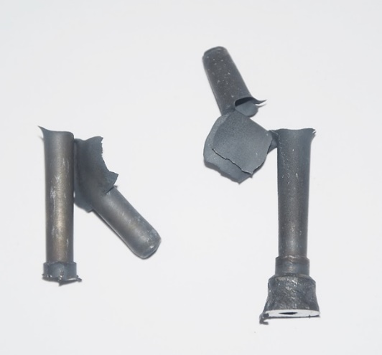
Fig. 4. View of 15-15Ti cladding tubes after burst

Experiments with SiC_{f}/SiC cladding
The test conditions for SiC_{f}/SiC were similar to that of 15-15Ti: the He atmosphere contained 10% of N₂, H₂ and CH₄ impurities in the 7 hours long tests at 1000 °C, and additional tests were done in pure He. The pure helium atmosphere resulted in small (0.02-0.04%) mass reduction for both Duplex and Triplex samples. The hydrogen content in the atmosphere seemed to have no effect on the mass change of samples compared to pure helium. In case of methane impurities the mass gain was 1.7% for the Duplex and 0.3% for the Triplex specimens. The presence of nitrogen in helium showed 0.03% mass reduction for the Triplex sample and no mass change for the Duplex one.
The ring compression tests showed that the Triplex tubes had much higher compression resistance capability than that of Duplex tubes. The analyses of load-displacement curves showed that for the SiC_{f}/SiC samples much less energy was needed to cause failure compared to 15-15Ti samples.
The fibers and the matrix materials in SiC_{f}/SiC tubes create a rather heterogeneous microstructure (Fig. 5) and that highly influences the load bearing capability of the cladding.

Fig. 5. SEM images of SiC_{f}/SiC cladding

summary and conclusions
According to the current design, the start-up core of the ALLEGRO gas-cooled fast reactor will use MOX or UOX fuel in 15-15Ti stainless steel cladding. In the refractory core carbide fuel in SiC_{f}/SiC cladding will be applied.
The introduction of fuel for the ALLERGRO cores will need a detailed qualification programme, including not only experimental and numerical activities, but also taking into account the aspects of determination of safety limits and manufacturing of fuel materials and assemblies. It is proposed to use the technology readiness level approach in the qualification process. The potential steps of fuel qualification were drafted for the three selected fuel types.
High temperature experiments in helium atmosphere were carried out with 15-15Ti and SiC_{f}/SiC claddings. The experimental results indicated the applicability of these materials in the ALLEGRO demonstrator gas-cooled fast reactor.

ACKNOWLEDGEMENTS
The activities presented in the paper were supported by the National Research, Development and Innovation Office of Hungary (National Nuclear Research Programme, VKSZ_14-1-2015-0021) and by the EU H2020 SafeG project (No. 945 041).

References
- STAINSBY, R. et al. “Gas Cooled Fast Reactor Research and Development in the European Union”, Science and Technology of Nuclear Installations, Volume 2009, Article ID 238624, 7 pages
- VAN ROOIJEN, W. F. G.: “Gas-Cooled Fast Reactor: A Historical Overview and Future Outlook”, Science and Technology of Nuclear Installations, Volume 2009, Article ID 965757, 11 pages
- VAN ROOIJEN, W. F. G.: “Improving Fuel Cycle Design and Safety Characteristics of a Gas Cooled Fast Reactor”, Ph.D. thesis, Delft University of Technology, Delft, The Netherlands, 2006, (ISBN 1-58603-696-3)
- RICHARD, P. et al.: “Status of the Pre-Design Studies of the GFR Core”, Proceedings of the PHYSOR 2008 Conference, paper 459, Switzerland (2008).
- MALO, J. Y. et al.: “Gas Cooled Fast Reactor 2400 MWth ; Status on the conceptual design studies and preliminary safety analysis”, Proceedings of ICAPP’09 , paper 9109, Japan (2009)
- POETTE, C., MORIN, F., BRUN-MAGAUD, V., PIGNATEL, J.F. : “ALLEGRO 75 MW cores definition at start of GoFastR (MOX + ceramic cores)”, Deliverable D1.2-1, 2010.
- KVIZDA, B., MAYER, G., VÁCHA, P., MALESA, J., HATALA, B.: “ALLEGRO Gas-cooled Fast Reactor (GFR) demonstrator thermal hydraulic benchmark”, Nuclear Engineering and Design, Volume 345, 2019, Pages 47-61
- SLONSZKI, E., HÓZER, Z.: “On the selection of fuel for the first core of ALLEGRO gas cooled fast reactor”, Technical Report, MTA EK-FRL-2016-218-1-2-M0, Centre for Energy Research, Budapest, 2016
- SLONSZKI, E., HÓZER, Z.: “On the selection of fuel for the second core of ALLEGRO gas cooled fast reactor”, Technical Report, MTA EK-FRL-2017-218-1-1-M0, Centre for Energy Research, Budapest, 2016
- DOUGLAS, C. et al: “An approach to fuel development and qualification”, Journal of Nuclear Materials 371 (2007) 232–242.
- PETTI, D.: “Fuel Development and Qualification”, DOE-NRC 2016 Advanced Reactor Workshop, INL,160608.
- SANNEN, L., VAN DEN BERGHE, S., VERWERFT, M.: “50 years of fuel qualification at SCK·CEN”, ENC2012, Manchester, 9-12 December, 2012.a
- STRAUB, J.: “In search of technology readiness level (TRL) 10”, Aerospace Science and Technology 46 (2015) 312–320
- CARMACK, W.J. , BRAASE, L.A. , WIGELAND, R.A., TODOSOW, M.: “Technology readiness levels for advanced nuclear fuels and materials development”, Nuclear Engineering and Design 313 (2017) 177–184
- SHEPHERD, D.: “Technology readiness level (TRL) assessment of cladding alloys for advanced nuclear fuels”, Structural Materials for Innovative Nuclear Systems (SMINS-3), Workshop Proceedings Idaho National Laboratory, Idaho Falls, United States 7-10 October 2013, NEA/NSC/WPFC/DOC(2015)9 pp. 108-116.
- CAUTAERTS, N. et al.: “Thermal creep properties of Ti-stabilized DIN 1.4970 (15-15Ti) austenitic stainless steel pressurized cladding tubes”, Journal of Nuclear Materials, 2017, 493: 154-167.
- KIM, D.; KIM, W. J., PARK, J. Y.: “Compatibility of CVD SiC and SiC_{f}/SiC Composites with High Temperature Helium Simulating Very High Temperature Gas-Cooled Reactor Coolant Chemistry”, Oxidation of Metals, 2013, 80.3: 389-401.
- KIM, D. et al.: “Fabrication and measurement of hoop strength of SiC triplex tube for nuclear fuel cladding applications”, Journal of Nuclear Materials, 2015, 458: 29-36.
- YAO, M. S. et al.: “The helium purification system of the HTR-10”, Nuclear Engineering and Design, 2002, 218.1-3: 163-167.

